Supplemental Materials

Low-PI Experiment: Control Analysis for Online vs. In-person Testing
In the Low-PI Experiment, participants completed all experiments either online on their home computers, or in person, on a computer, in our laboratory. For each test group (Young FA, older FA and young DA), ANOVA was performed with location of testing (In Person vs. Online) as between-subject factor and probe-type as within-subject factor (probe 1, probe-2-stay, probe-2-switch). This is to examine whether our key factor of interest (probe-type) interacted with the location of the test. The results and means and results are listed below in Supplemental Figure 4. Despite slightly worse performance in the online testing methods, none of the interactions were statistically significant (see Supplemental Figure 1). For the young adult FA group, there was no main effect of testing location, F(2, 56)= 0.71, p = 0.495, η_{p}² = 0.025, and no interaction with probe-type, F(1,28) = 0.04, p =0.849, η_{p}² = 0.001. For the older adult FA group there was no main effect of testing location, F(2,50) = 7.58, p = 0.001, η_{p}² = 0.233, and no interaction, F(1,25) = 1.50, p =0.233, η_{p}² = 0.057. For the young DA group, there was a main effect of testing location, F(2, 54)= 9.18, p = 0.005, η_{p}² = 0.254, but no interaction with probe-type, F(1,27) = 3.04, p =0.056, η_{p}² = 0.101.
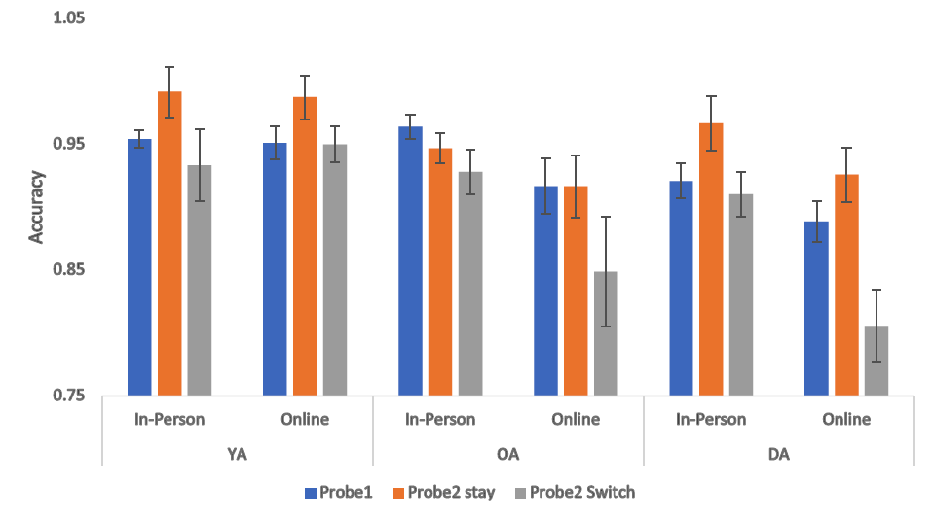
Supplemental Figure 1: WM analyses separated by location of testing (online vs. in-person)

Low-PI Experiment: Control Analysis excluding the participants with 3 digits to verify during the DA task
As noted in footnote 4, two young DA participants had exceptionally fast and accurate performance on the odd-even digit-parity task during the initial training and titration phase. Therefore, they had to respond to 3 digits during each of the maintenance and cueing phases of the WM test trials; this was because their titrated presentation rate was less than 1.2 seconds per digit. To determine if this difference in the number of digits presented affected the results, we reanalyzed the data without these two participants. The analysis revealed a similar pattern as the analysis discussed in the main text. See Supplemental Figure 2 and the ANOVA results below.

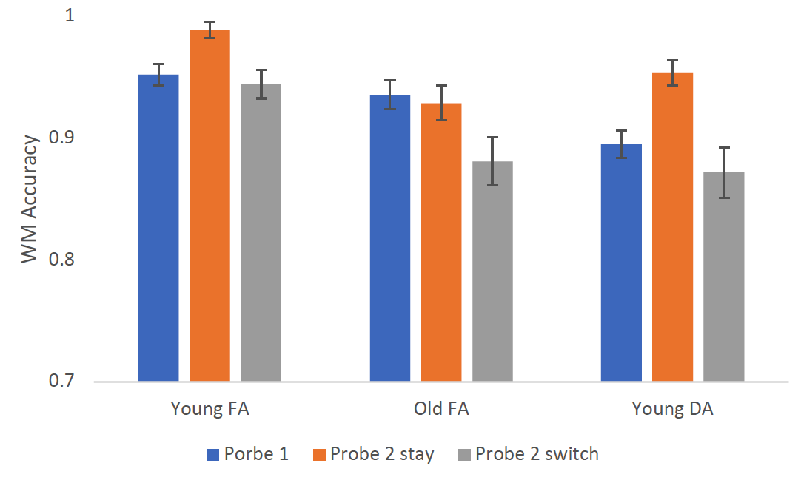
Supplemental Figure 2. The Low-PI Experiment WM accuracy excluding the two young DA participants who had to verify 3 digits during each delay.

Young FA vs Young DA: probe-type: F(2,110)=26.53, p < 0.001, η_{p}²=0.325; Group: F(1,55)=17.16, p < 0.001, η_{p}²=0.238; probe-type*Group F(2,110)=2.16, p=0.121, η_{p}² =0.038.

Older FA vs Young DA: probe-type: F(2,104)=18.56, p < 0.001, η_{p}²=0.263; Group: F(1,52)=0.25, p=0.622, η_{p}²=0.005; probe-type*Group F(2,104)=4.69, p=0.011, η_{p}² =0.083.

Supplemental Analysis of Response Times
The pattern of repeated lure error rates and accuracy is consistent with our hypothesis that, as PI accrued, older adults transitioned from a reactive, familiarity-based mode of responding, to a more proactive-mode of processing, likely by using the retrocues to prioritize the maintenance of the cued-item and prepare for the presentation of the recognition probe, which was most difficult to reject when it was a repeated lure. A related, somewhat alternative account of this transition is that older adults may have switched from a reactive, familiarity-based mode of responding upon presentation of the recognition probe to a more conservative, recollection-based mode of retrieval upon presentation of the recognition probe. That is, older adults’ reduced error rates may not have been due to a change in the nature of the maintenance processes that were engaged during the delay; it may have resulted due to a change in their recognition decision response criterion as a function of block as PI accumulated. Indeed, one effective way to reduce error rates to repeated lures would be to adopt a more conservative response criterion when making the match/non-match recognition decision. However, adopting this approach would come with some costs.
If older adults reduced their error rates simply by adopting a more conservative response criterion during their recognition decisions then this would be evidenced by two pieces of data. First, adopting a more conservative response criterion would also be associated with a reduced hit rate as a function of block. This was not observed in older adults accuracy data for probe-1, probe-2-stay, and probe-2-switch trials as a function of block (see Figure 3B and analyses in the Retrocue Effects section). Second, older adults’ RTs to repeated lures would be slower on blocks 3 and 4 of the High-PI Experiment, when they had eliminated their elevated error rates relative to the young FA group, compared to both the Low-PI Experiment and block 1 of the High-PI Experiment, especially for the within-trial repeated lures, which were the probes that were most difficult to reject. To test this alternative account of the findings, we first investigated how older adults’ median RT to repeated lures changed between the Low-PI and High-PI Experiment, and then as a function of block in the High-PI Experiment.
We first conducted a t-test between the older FA group’s median RT on the Low-PI Experiment and on median RT on the High-PI Experiment for the average of the third and fourth blocks (when they had eliminated their error rates relative to the young FA group). The results showed that there was no difference between the older FA group’s median RT to within-trial and between-trial repeated lures on the Low-PI Experiment and the average of their median RTs on the third and fourth blocks on the High-PI Experiment [ts(58)< 1.47, ps>0.062]. The mean of the older FA group's median RTs on within-trial repeated lures on the Low-PI Experiment, the first block on the High-PI Experiment, and on the last two blocks of the High-PI Experiment are 1.087, 1.171, and 1.004 seconds, respectively. The mean of the older FA group's median RTs on between-trial repeated lures on the Low-PI Experiment, first block of the High-PI Experiment and last two blocks of the High-PI Experiment are 1.087, 0.991 and 0.980 seconds, respectively. Second, we conducted a t-test comparing the mean of the older FA groups’s median RTs on the first block of the High-PI Experiment to the mean of their median RTs on the third and fourth blocks of the High-PI Experiment. For between-trial repeated lures, there was a non-significant difference between the mean of the older FA group’s median RT on the first block of the High-PI Experiment and on the mean of their median RT on the third and fourth blocks of the High-PI Experiment [t(32)=0.39, p=0.7]; for within-trial repeated lures, the mean of the older FA group’s median RT on the first block of the High-PI Experiment was significantly slower than the mean of their median RT on the third and fourth blocks [t(32)=4.20, p<0.01].
Next an ANOVA on the High-PI Experiment’s RT data with lure-type (between-trial repeated lures and within-trial repeated lures), group (young FA, older FA and young DA) and block as factors was conducted. This revealed significant main effects of group [F(2,94)=25.24, p<0.001,η_{p}²=0.35], lure-type [F(1,94)=13, p<0.001, η_{p}²=0.12], and block [F(3,282)=18.27, p<0.001, η_{p}²=0.16]. The interactions between group and lure-type, between group and block, between lure-type and block, and between the three factors were not significant (Fs<1.01, ps>0.11, η_{p}²>0.02).
ANOVAs were also conducted to specifically test the hypothesis that older adults’ RTs may have slowed as a function of block, especially for the repeated lure probes. The results showed that the effect of block was significant only for the older FA group on within-trial repeated lures [F(1,130)=10.6, p=0.001, η_{p}²=0.08], but follow-up t-test comparisons between older adults within-trial repeated lure RTs on each block showed that this was because older adults’ RTs to within-trial repeated lures on blocks 3 and 4 were significantly faster - not slower - than that on block 1 [t(32)s>3.63, ps<0.006]. [The effect of block on RTs for both lure-types was also significant for the young DA group [F(1,122)>5.11, p<0.026, η_{p}²>0.04]. This was because the young DA group’s RTs on both between-trial and within-trial repeated lures were significantly faster - not slower - on both block 3 and 4 than on block 1 [between-trial repeated lures: t(30)s>3.48, ps<0.002) and t(30)s>3.25, ps<0.02)].
Therefore, as the older adults reduced their repeated lure error rates as a function of block, their RTs were not slowed as a function of block. This is inconsistent with the notion that the older adults reduced their error rates by adopting a more conservative response criterion.

Low-PI Experiment: Response Time Data and Analyses
Median RTs and SEMs for the different probe types for each group are reported in Supplemental Table 1. Analysis of young and older adults’ mean RT for the different probe types generally converged with interpretation of the accuracy data and helps address a potential concern about the age differences being due to a difference in how liberal or conservative the groups were with their response criterion. An ANOVA on error rates for the trials with repeated vs. non-repeated lures, showed that there was no main effect of lure-type [F(1,55)=0.6, p=0.442, η_{p}²=0.011], or an interaction with group [F(1,55)=0.84, p=0.364, η_{p}²=0.015], which is inconsistent with a potential age-difference in response criterion for repeated vs. non-repeated lures. There was an effect of group [F(1,55)=53.17, p < 0.001, η_{p}²=0.492]. Taken together, the results suggest that the older adults responded slower than the young adults regardless of the lure-type, consistent with age-related slowing of information processing speed.
An ANOVA on RTs with probe-type (probe-1, probe-2-stay, probe-2-switch) as a within-subjects factor and group (Young vs. Older) as a between-subjects factor revealed main effects of both probe-type [F(2,110)=45.93, p < 0.001, η_{p}²=0.46], and group [F(1,55)=78.01, p < 0.001, η_{p}²=0.59]. RTs were faster for young than older adults. As can be seen in Supplemental Table 1, the interaction between probe-type and group was not significant [F(2,110)=2.09, p < 0.129, η_{p}²=0.04]. Again, this is inconsistent with a potential age-difference in response criterion for the different probe-types. Similar to the accuracy data, the RT data suggest that the retrocues resulted in different performance.
Supplemental Table 1. Low-PI Experiment: Median (SEM) RTs on correct trials for Young and Older Adult groups with Full Attention and the Young Adult group with Divided Attention.
Group | Probe 1 | Probe 2 Stay | Probe 2 Switch
Young FA | 0.670(0.006) | 0.572(0.011) | 0.671(0.008)
Older FA | 0.902(0.008) | 0.838(0.017) | 0.921(0.010)
Young DA | 1.016(0.007) | 0.900(0.015) | 1.090(0.011)

High-PI Experiment: Response Time Data and Analysis
An ANOVA on median RT with lure-type (repeated vs. non-repeated lures) and group (young FA, young DA, older FA) as factors on each block revealed an effect of the group [Fs(2,94)>14.42, ps<0.001, η_{p}²>0.235] on RT for all four blocks, and an effect of lure-type in the first two blocks [Fs(1,94)>4.56, ps<0.05, η_{p}²>0.05] (Supplemental Table 2). The median (SEM) RT data are in Supplemental Figure 3. There was no effect of lure-type in the last two blocks [Fs(2,94)<0.944, ps>0.05,η_{p}²>0.01], or an interaction with group [Fs(1,94)>0.03, p>0.05, η_{p}²>6x10⁻⁴]. Taken together, the results suggest that the older adults responded more slowly than the young adults regardless of the lure-type in the first two blocks; however in the last two blocks, as older adults engaged proactive-control, their difference in RT was eliminated (Supplemental Table 3).

Supplemental Table 2. Two-way ANOVAs and Bayes Factors results comparing the young FA, older FA and young DA groups’ response time on repeated and non-repeated lure trials.
Block | Main Effect of Group | Main Effect of Lure-type | Group x Lure-type Interaction
Block 1 | F(2,91)=28.93, p<0.001, η_{p}²= 0.38, BF₁₀=65466544 | F(1,93)=18.57, p<0.001, η_{p}²= 0.17, BF₁₀=265.91 | F(2,93)=5.29, p=0.007, η_{p}²= 0.1, BF₁₀=12.43
Block 2 | F(2,91)=14.42, p<0.001, η_{p}²= 0.24, BF₁₀=5221.17 | F(1,93)=4.56, p=0.035, η_{p}²= 0.05, BF₀₁=2.90 | F(2,93)=1.39, p=0.254, η_{p}²= 0.03, BF₀₁=1.69
Block 3 | F(2,91)=18.19, p<0.001, η_{p}²= 0.28, BF₁₀=72125 | F(1,93)=1.75, p=0.190, η_{p}²= 0.02, BF₀₁=2.90 | F(2,93)=0.07, p=0.932, η_{p}²= 0, BF₀₁=4.73
Block 4 | F(2,91)=21.23, p<0.001, η_{p}²= 0.31, BF₁₀=550838 | F(1,93)=0.94, p=0.334, η_{p}²= 0.01, BF₀₁=4.20 | F(2,93)=0.03, p=0.97, η_{p}²= 0, BF₀₁=4.86
Note. BF₀₁ = Bayes Factors favoring the null hypothesis; BF₁₀ favors the alternative.
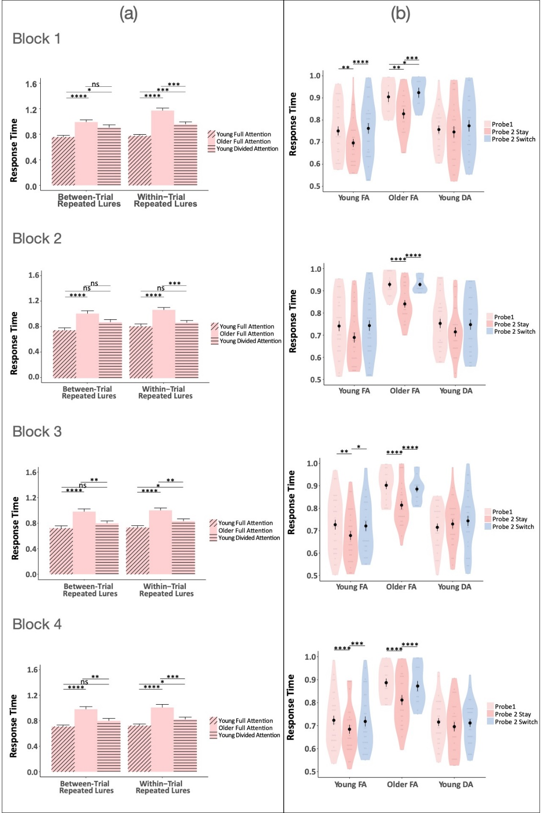
Supplemental Figure 3. High-PI Experiment RTs on the WM test for (A) between- and within-trial repeated lures, and (B) correct responses on probe-1, probe-2-stay, and probe-2-switch trials for young and older adults with full attention (FA) and young adults with divided attention (DA) during the cueing and delay periods. Error bars are the standard error of mean.
Supplemental Table 3. Median (SEM) RT on within-trial repeated lures and between-trial repeated lures and t-tests and BFs comparing each age group on each block.

 | Error rate Mean(SE) |  |  | t-test
Block | Young FA | Older FA | Young DA | Young FA vs. Older FA | Older FA vs. Young DA | Young FA vs. Young DA
Within-trial repeated lures
Block 1 | 0.77(0.02) | 1.17(0.04) | 0.96(0.04) | t(60)= -9.01, p<0.001, BF₁₀= 9832059599 | t(61)=4.00, p<0.001, BF₁₀=140.58 | t(61)=-4.20, p<0.001, BF₁₀= 288.72
Block 2 | 0.81(0.04) | 1.07(0.04) | 0.87(0.04) | t(60)=-5.01, p<0.001, BF₁₀= 684.61 | t(61)=4.04, p<0.001, BF₁₀=2.16 | t(61)=-1.18, p=0.72, BF₁₀= 2.08
Block 3 | 0.73(0.0.3) | 1.00(0.04) | 0.83(0.04) | t(60)=-5.90, p<0.001, BF₁₀= 76469 | t(61)=3.40, p=0.004, BF₁₀= 26.67 | t(61)=-2.19, p=0.09, BF₁₀= 1.90
Block 4 | 0.72(0.03) | 1.01(0.05) | 0.82(0.04) | t(60)=-5.26, p<0.001, BF₁₀= 7931.30 | t(61)=3.09, p=0.009, BF₁₀= 11.64 | t(61)=-2.30, p=0.07, BF₀₁= 2.36
Between-trial repeated lures
Block 1 | 0.76(0.03) | 0.99(0.04) | 0.91(0.04) | t(60)=-5.35, p<0.001, BF₁₀= 10779 | t(61)=1.65, p=0.31, BF₀₁= 1.23 | t(61)=-2.96, p=0.01, BF₁₀= 9.81
Block 2 | 0.75(0.04) | 1.01(0.04) | 0.88(0.04) | t(60)=-4.52, p<0.001, BF₁₀= 3430.61 | t(61)=2.27, p=0.03, BF₁₀= 160.01 | t(61)=-2.25, p=0.03, BF₀₁= 2.18
Block 3 | 0.72(0.04) | 0.98(0.04) | 0.80(0.04) | t(60)=-4.71, p<0.001, BF₁₀= 1269.15 | t(61)=3.21, p=0.006, BF₁₀= 16.15 | t(61)=-1.53, p=0.13, BF₀₁= 1.47
Block 4 | 0.71(0.02) | 0.98(0.04) | 0.80(0.04) | t(60)= -5.93, p<0.001, BF₁₀= 84859.95 | t(61)=3.36, p=0.004, BF₁₀= 24.24 | t(61)=-1.92, p=0.18, BF₁₀= 1.22
Note. BF₀₁ = Bayes Factors favoring the null hypothesis; BF₁₀ favors the alternative.

An ANOVA on median RT with probe-type (probe-1, probe-2-stay, probe-2-switch) and group (young FA, young DA, older FA) as factors on each block revealed significant main effects of both probe-type [Fs(2,94)>21.99, ps < 0.001, η_{p}²>0.19], and group [Fs(2,170)>41.07, ps<0.001, η_{p}²>0.47], and an interaction between probe-type and group [Fs(4,170)>2.60, ps<0.05, η_{p}²>=0.05] in each of the four blocks. A summary of the ANOVA results can be seen in Supplemental Table 4. The interactions were because the young FA and older FA groups showed retrocue effects in that RT was faster on probe-2-stay trials than probe-1 and probe-2-switch trials for each block (except block 2 for young FA), whereas the young DA group showed no significant differences between probe-types. The main effect of group was because RTs were faster for both the young FA and DA groups than the older adult group overall (Supplemental Table 5). For the ease of comparison between the RT and the accuracy data, we also conducted t-test comparisons on probe-1, probe-2-stay and probe-2-switch trials for the young FA, older FA and young DA groups; these results are summarized in Supplemental Table 6.
Supplemental Table 4. High-PI Experiment: Two-way ANOVAs and Bayes Factors results comparing the young FA, older FA and young DA groups’ response time on probe-1, probe-2-stay, and probe-2-switch trials.
Block | Main Effect of Group | Main Effect of Probe-type | Group x Probe-type Interaction
Block 1 | F(2,91)=41.07, p<0.001, η_{p}²= 0.47, BF₁₀=32306582209 | F(2,184)=29.13, p<0.001, η_{p}²= 0.24, BF₁₀=1865589727 | F(2,93)=2.60, p=0.05, η_{p}²= 0.05, BF₀₁=1.11
Block 2 | F(2,91)=44.43, p<0.001, η_{p}²= 0.51, BF₁₀=63844649942 | F(2,184)=26.96, p<0.001, η_{p}²= 0.21, BF₁₀=73722504 | F(2,93)=6.86, p<0.001, η_{p}²= 0.127, BF₁₀=4394
Block 3 | F(2,91)=43.48, p<0.001, η_{p}²= 0.48, BF₁₀=4253372750 | F(2,184)=21.99, p<0.001, η_{p}²= 0.19, BF₁₀=4490508 | F(2,93)=14.81, p<0.001, η_{p}²= 0.24, BF₁₀=1819421
Block 4 | F(2,91)=50.19, p<0.001, η_{p}²= 0.52, BF₁₀=268255112582 | F(2,184)=34.55, p<0.001, η_{p}²= 0.27, BF₁₀=150073082766 | F(2,93)=13.41, p<0.001, η_{p}²= 0.22, BF₁₀=4549184
Note. BF₀₁ = Bayes Factors favoring the null hypothesis; BF₁₀ favors the alternative.

Supplemental Table 5. High-PI Experiment: t-tests comparing RTs between groups for probe-1 (top), probe-2-stay(middle) and probe-2-switch (bottom).
Comparison | Young FA vs. Older FA | Young DA vs. older FA | Young FA vs. Young DA
Probe-1
Block 1 | t(64)=-9.52, p<0.001, BF₁₀= 46818101616 | t(62)=7.26, p<0.001, BF₁₀=19115203 | t(62)=-1.39, p=0.51, BF₀₁= 1.84
Block 2 | t(64)=-9.37, p<0.001, BF₁₀= 7698599393 | t(62)=8.84, p<0.001, BF₁₀= 2144959055 | t(62)=-0.52, p=1, BF₀₁=3.62
Block 3 | t(64)= -8.50, p<0.001, BF₁₀= 419906110 | t(62)=9.69, p<0.0 01, BF₁₀= 2655665895 | t(62)=0.77, p=1, BF₀₁= 3.82
Block 4 | t(64= -9.87, p<0.001, BF₁₀= 76896788389 | t(62)=9.43, p<0.001, BF₁₀= 12458945139 | t(62)= =0.19, p=1, BF₀₁= 3.68
Probe-2-stay
Block 1 | t(64)=-6.40, p<0.001, BF₁₀= 901885.3 | t(62)=3.64, p=0.002, BF₁₀= 64.64 | t(62)=-2.13, p=0.113, BF₀₁= 1.91
Block 2 | t(64)=-5.54, p<0.001, BF₁₀= 17636.93 | t(62)=5.04, p<0.001, BF₁₀= 839.57 | t(62)==0.76, p=1, BF₀₁= 2.45
Block 3 | t(64)= -5.31, p<0.001, BF₁₀= 4828.893 | t(62)=3.61, p=0.002, BF₁₀= 34.36 | t(62)= -1.73, p=0.267, BF₀₁= 1.30
Block 4 | t(64)= -6.14, p<0.001, BF₁₀= 130912.8 | t(62)= 4.40, p<0.001, BF₁₀= 181.59 | t(62)= -1.61, p=0.339, BF₁₀= 1.06
Probe-2-switch
Block 1 | t(64)=-8.82, p<0.001, BF₁₀= 9024202940 | t(62)=7.18, p<0.001, BF₁₀=16514241 | t(62)=-1.06, p=0.879, BF₀₁ = 2.51
Block 2 | t(64)=-9.38, p<0.001, BF₁₀= 29123504079 | t(62)=8.74, p<0.001, BF₁₀= 693384678 | t(62)=-0.37, p=1, BF₀₁= 3.52
Block 3 | t(64)=-7.71, p<0.001, BF₁₀= 43092791 | t(62)= 7.88, p<0.001, BF₁₀= 21897305 | t(62)= -0.10, p=1, BF₀₁= 3.67
Block 4 | t(64)=-8.02, p<0.001, BF₁₀= 98469663 | t(62)= 8.24, p<0.001, BF₁₀= 171058811 | t(62)= 0.36, p=1, BF₀₁= 3.77
Note. BF₀₁ = Bayes Factors favoring the null hypothesis; BF₁₀ favors the alternative.

Supplemental Table 6. High-PI Experiment: Median(SE) RT in seconds (top) and t-test comparisons (bottom) on probe-1, probe-2-stay and probe-2-switch trials for the young FA, older FA and young DA groups.
 | Young Full Attention |  |  |  | Older Full Attention |  |  |  | Young Divided Attention
Comparison | Block 1 | Block 2 | Block 3 | Block 4 | Block 1 | Block 2 | Block 3 | Block 4 | Block 1 | Block 2 | Block 3 | Block 4
probe-1 | 0.75 (0.02) | 0.75 (0.02) | 0.54 (0.02) | 0.72 (0.02) | 1.05 (0.02) | 1.04 (0.02) | 1.00 (0.02) | 1.02 (0.02) | 0.80 (0.03) | 0.76 (0.02) | 1.02 (0.03) | 0.73 (0.02)
probe-2 stay | 0.69 (0.02) | 0.71 (0.03) | 0.69 (0.02) | 0.66 (0.02) | 0.96 (0.04) | 1.06 (0.03) | 0.87 (0.03) | 0.88 (0.03) | 0.78 (0.04) | 0.75 (0.03) | 0.73 (0.02) | 0.72 (0.03)
probe-2 switch | 0.78 (0.03) | 0.74 (0.02) | 0.73 (0.03) | 0.73 (0.03) | 1.10 (0.03) | 0.92 (0.03) | 1.02 (0.03) | 1.05 (0.03) | 0.82 (0.03) | 0.76 (0.03) | 0.74 (0.03) | 0.72 (0.03)
probe-1 vs. probe-2 stay | t(32)= -1.79, p= 0.247, BF₀₁=1.21 | t(32)= 0.06, p= 1, BF₀₁=4.17 | t(32)= 0.62, p= 1, BF₀₁=4.76 | t(32)= -0.78, p= 1, BF₀₁=3.03 | t(32)= -2.98, p= 0.016, BF10=4.84 | t(32)= -1.27, p= 0.636, BF₀₁=2.33 | t(32)= -0.39, p= 1, BF₀₁=4.17 | t(32)= -1.41, p= 0.501, BF₀₁=1.14 | t(30)= -1.45, p= 0.471, BF₀₁=1.69 | t(30)= 0.46, p= 1, BF₀₁=5.00 | t(30)= -1.47, p= 0.453, BF₀₁=2.50 | t(30)= 0.58, p= 1, BF₀₁=4.76
probe-1 vs. probe-2 switch | t(32)= 4.13, p= 0.001, BF₁₀=48.37 | t(32)= 2.07, p= 0.139, BF₁₀=2.09 | t(32)= 3.68, p= 0.003, BF₁₀=35.20 | t(32)= 4.21, p= 0.001, BF₁₀=879.48 | t(32)= 3.44, p= 0.005, BF₁₀=23.17 | t(32)= 4.77, p= 0, BF₁₀=2545.43 | t(32)= 7.44, p= 0, BF₁₀=118441.80 | t(32)= 6.74, p= 0, BF₁₀=108837.4 | t(30)= 1.09, p= 0.855, BF₀₁=3.85 | t(30)= 1.92, p= 0.191, BF₀₁=2.38 | t(30)= -2.33, p= 0.08, BF₀₁=3.23 | t(30)= 0.44, p= 1, BF₀₁=4.55
Probe-2 stay vs. probe-2 switch | t(32)= -6.31, p<0.001, BF₁₀= 33034.26 | t(32)=-2.21, p=0.10, BF₁₀= 1.25 | t(32)= -2.56, p=0.05, BF₁₀= 4.06 | t(32)=-4.11, p<0.001, BF₁₀= 564.89 | t(32) =-4.53, p<0.001, BF₁₀= 153.16 | t(32)=-4.91, p<0.001, BF₁₀= 4547 | t(32)= -5.10, p<0.001, BF₁₀= 3520.11 | t(32)= -6.38, p<0.001, BF₁₀= 451382.1 | t(30)=-1.70, p=0.30, BF₀₁= 1.86 | t(30)= -1.41, p=0.51, BF₀₁= 3.47 | t(30)= 0.53, p=1, BF₀₁= 5.20 | t(30)= 0.04, p=1, BF₀₁= 5.19
Note. BF₀₁ = Bayes Factors favoring the null hypothesis; BF₁₀ favors the alternative

Low-PI Experiment: Control Analysis assessing change of performance across block
To assess if a similar shift in pattern of performance as observed in the high-PI Experiment was present in the Low-PI Experiment, ANOVAs on accuracy and error rate data were reanalyzed with an additional within-subject factor of block. Specifically, we conducted an ANOVA on accuracy of all probe-types with block and probe-type as within-subject factors and group as between factors. Another ANOVA was conducted on error rates for repeated vs. non-repeated lures, with block and lure-type as within-subject factors and group as between factors.
Results showed that, for error rates, block did not significantly interact with the effects of group and lure-type [F(2,85)=0.35, p>0.05, BF, n_{p}²=0.001], and there was no significant main effect of block [F(1,85)=1.59, p=0.211, n_{p}²=0.004]. This suggested that the error rates for all three groups on repeated and non-repeated lures did not change across blocks. For accuracy, block did not interact with the effects of group and probe-type on accuracy [F(3,140)=0.53, p>0.05, BF, n_{p}²=0.012]. There was a main effect of block [F(1,85)=6.76, p=0.01, n_{p}²=0.006]; however, follow-up tests of the main effect suggest that the effect of block was only significant in the older FA group [F(1,27)=7.23, p=0.01, n_{p}²=0.021], likely because their overall accuracy improved from block 1 to block 2. In summary, with the exception of an initial improvement in older adults’ overall accuracy between blocks 1 and 2, we did not observe a similar shift away from a reactive mode of processing in the older FA group in the Low-PI Experiment as we did in the High-PI experiment.

High-PI Experiment: Control Analysis for Usage of Verbal Labeling in Older Adults
As briefly discussed in the general discussion, to account for the usage of verbal labeling in older adults, an ANOVA was conducted to compare the average accuracy of the young FA and older FA groups for each stimulus-category. This ANOVA had group (Older FA, young FA) as between-subject factor and probe-type, block and stimulus-category as within-subject factors. In the High-PI Experiment, because the frequency of each category (face, name, places) that was presented in the experiment was counterbalanced for every 96 trials (two blocks), this control analysis was performed by comparing the accuracy of the first 96 trials (averaged over block 1 and 2) to the second 96 trials (averaged over block 3 and 4).
Mean (SEM) accuracy of each group for each stimulus category in all three probe-types are summarized in Supplemental Table 7. The ANOVA showed significant main effects of stimulus-category, block, and probe-type [Fs>11.68, ps<0.001, η_{p}²s>0.154]. Additionally, there was a significant interaction between group, block and stimulus-category [F(1,64)=10.61, p=0.002, η_{p}²=0.14]; likely because of the significant interaction between block and stimulus-category in only the older FA group [F(1,64)= 12.34, p<0.001], but not the young FA [F(1,60)=0.513, p=0.48]. Mean accuracies revealed that the significant block by stimulus-category interaction was because the older FA group showed significantly higher accuracy for non-verbal stimuli in the last two blocks for all three probe-types, but not for verbal-stimuli (Supplemental Figure 4). Meanwhile, the young FA’s accuracy did not significantly change across blocks for all three probe-types. This supported our hypothesis that older adults reduced the age-related difference in the last two blocks because of their use of labeling on non-verbal items. The overall interaction between group, stimulus-category, probe-type and block was not significant [F(2,99)=1.91, p=0.16, η_{p}²=0.029].

Supplemental Table 7. Mean(SE) accuracy of each group for each stimulus-category in all three probe-types.
 |  | Non-verbal Stimuli |  | Verbal Stimuli
Probe-type | Block | Older FA | Young FA | Older FA | Young FA
probe 1 | Block 1-2 | 0.90(0.01) | 0.92(0.01) | 0.93(0.01) | 0.93(0.01)
probe 1 | Block 3-4 | 0.94(0.01) | 0.93(0.02) | 0.94(0.01) | 0.94(0.01)
probe-2-stay | Block 1-2 | 0.92(0.01) | 0.94(0.01) | 0.94(0.01) | 0.95(0.02)
probe-2-stay | Block 3-4 | 0.97(0.01) | 0.94(0.02) | 0.97(0.02) | 0.96(0.02)
probe-2-switch | Block 1-2 | 0.85(0.02) | 0.91(0.01) | 0.89(0.02) | 0.89(0.02)
probe-2-switch | Block 3-4 | 0.9(0.02) | 0.9(0.02) | 0.89(0.02) | 0.9(0.02)
Supplemental Figure 4: Average accuracy of each stimulus category for each probe-type on the first two blocks vs. the last two blocks in the High-PI Experiment for the young FA and older FA groups.
We also compared the older FA and the young FA groups’ average error rates on lure trials for each stimulus-category (See mean error rate for each lure-type in Supplemental Figure 5 and Supplemental Table 8). An ANOVA was conducted on error rates, with group (older FA, young FA) as a between-subject factor and lure-type, block and stimulus-category as within-subject factors. Results showed a significant main effect of lure-type, block and stimulus-category [F(1,64)s>6.92, ps<0.001, η_{p}²> 0.11]. Stimulus-category did not interact with any other factors [F(1,64)=0.86, p=0.36, η_{p}²=0.01].
The older FA group showed a significant decrease in error rate for both verbal and non-verbal stimuli from earlier blocks to later blocks on repeated lure trials (Supplemental Figure 5). Meanwhile, the older FA’s error rates for non-repeated lure did not change significantly over the course of the experiment, for both verbal and non-verbal stimuli. Similarly, the difference was not significant for the young FA group for both verbal and non-verbal stimuli. In sum, results on error rates supported our hypothesis that older adults’ use of verbal labels helped reduce the age-related difference in the last two blocks for the non-verbal stimuli as they learned to associate verbal labels with the stimuli.

Supplemental Table 8. Mean(SE) accuracy of each group for each stimulus-category in all three probe-types.
 |  | Non-verbal Stimuli |  | Verbal Stimuli
Lure-type | Block | Older FA | Young FA | Older FA | Young FA
Repeated lures | Block 1-2 | 0.37(0.04) | 0.19(0.03) | 0.26(0.05) | 0.1(0.03)
Repeated lures | Block 3-4 | 0.15(0.02) | 0.18(0.03) | 0.14(0.04) | 0.14(0.04)
Non-repeated lures | Block 1-2 | 0.14(0.03) | 0.15(0.02) | 0.12(0.04) | 0.1(0.02)
Non-repeated lures | Block 3-4 | 0.13(0.03) | 0.11(0.03) | 0.11(0.04) | 0.12(0.04)
Supplemental Figure 5: Average error rate of each stimulus category for each lure-type on the first two blocks vs. the last two blocks in the High-PI Experiment for the young FA and the older FA groups.

High-PI Experiment: Individual Differences among Older Adults in the Reactive-Proactive Mode of Responding Index and Associations with WM Performance, the Retrocue Effect, Age, and Cognitive Function.
Supplemental Figure 6. Individual differences among older adults in the change in the reactive-proactive index across testing blocks: (a) Each line represents an individual older adult’s reactive-proactive index. The black lines represent all of the individuals’ trajectories. Four key examples are highlighted: the dark blue line depicts an individual whose reactive-proactive index declined over the blocks (i.e. an older adult who shifted from a reactive to proactive mode of processing over the experimental blocks and approached zero, meaning no age difference relative to young adults with full attention); the green line depicts an individual who started the experimental trials with a low reactive-proactive index (i.e. no age difference relative to young adults with full attention), and remained low throughout the experimental blocks; the red line depicts an individual whose trajectory started with high reactive-proactive index (i.e. a large age difference relative to young adults with full attention) and remained high throughout the experimental blocks; the light blue line depicts an individual whose reactive-proactive index increased across blocks (i.e. an older adult who shifted from a more proactive to reactive mode of processing as proactive interference accumulated across the experimental blocks ). (b-d) panels b-d show all of the older adult individuals in separate figures for those whose reactive-proactive index (slope) significantly declined across blocks (b); did not significantly change over blocks (the slope’s 95% confidence intervals overlapped with 0), with red lines for those individuals who started and remained in a reactive mode of processing throughout the experiment, and green lines for those who started and remained in a proactive mode (c); and for those whose reactive-proactive index significantly increased across blocks as PI accumulated (d).
Because of this individual variability in the reactive-proactive index shift, we tested if there were associations between the nature of the shift and WM performance, the retrocue effect, age, and an independent measure of cognitive function (the TICS). That is, was there systematic variation that might help explain the differences between those older adults who started in a reactive mode and shifted to a proactive mode, those who started and remained reactive, those who started and remained proactive, and those who started proactive and shifted to a reactive mode)? To test this, we summed the reactive-proactive index over all 4 blocks for each older adult and correlated it with their WM accuracy on probe 1, probe 2 stay, and probe 2 switch trials (Supplemental Figure 7). Because the reactive-proactive index was calculated from the age difference in error rates from these trial types, the scores are not redundant with (i.e., the inverse of) the accuracy scores, but they are not completely independent. Therefore, we also assessed our index of the “retrocue effect” (probe 1 - probe 2 switch accuracy) to see if the shift in the reactive-proactive index can help explain variability in the size of the retrocue effect over all four experimental blocks. We also correlated the summed reactive-proactive index with age within the older adult group and with a completely independent measure of immediate memory recall (the TICS neuropsychological screening assessment).
The summed reactive-proactive index was negatively correlated with WM accuracy for each probe type (rs<-0.71, ps<0.001, See supplemental Figure 7), and positively correlated with the retrocue effect measured as the difference in accuracy between probe-1 and probe-2-switch trials (r=0.48, p=0.004) [but not with the difference probe-2-stay and probe-2-switch trials (r=0.29, p=0.102), see Supplemental Figure 8]. The summed index was also positively correlated with age (r=0.48, p=0.005) and negatively correlated with immediate recall on the TICS (r=-0.48, p=0.005).
Collectively, these individual differences analyses and results provide further evidence that is consistent with our hypothesis that the size of age differences in retrocue effects and WM performance depend on the extent to which individuals engage a reactive or proactive mode of processing, which is sensitive to the accumulation of PI when feedback is provided. They also reveal that, while most older adults started at, or shifted to, using a proactive mode of processing, there were some individuals, particularly the oldest individuals among the older adult group and those who scored poorly on the TICS immediate recall test, who did not (or could not) shift from a reactive to proactive mode of processing over the blocks of trials as PI accumulated. The experimental manipulations, performance indices, and analyses that we introduce here provide a novel and potentially fruitful approach for assessing age and individual differences in the use of reactive vs. proactive modes of processing on WM assessments. This approach may be useful for exploring variation in WM and relations with other measures of higher order cognitive functioning in healthy and disordered populations.

Supplemental Figure 7. Scatterplots with the line of best fit and R² between older adults’ summed reactive-proactive index and their accuracy on probe 1 (top), probe 2 stay (middle), and probe 2 switch trials (bottom).
Supplemental Figure 8. Scatterplots with the line of best fit and R² between older adults’ summed reactive-proactive index and their retrocue effect (top), age (middle), and immediate recall performance on the TICS (bottom).

High-PI Experiment: Supplemental Details about the Pre-registered Analyses & Results
As discussed in the main text, the pre-registered analyses were conducted to assess performance averaged across all four blocks of trials. These data are reported in Supplemental Figure 9. The full two-way ANOVA on error rates for between- vs. within-trial repeated lures with all three groups compared as a between-subjects factor revealed significant main effects of group [F(2,94)=12.56, p <0.05, η_{p}²=0.17, BF₁₀=1.41x10³] and lure-type [F(1,94)=40.15, p <0.05, η_{p}²=0.17, BF=6.71x10⁵], with a nonsignificant interaction [F(2,94)=3.06, p>0.05, η_{p}²=0.02, BF₀₁=2.17]. Simple main effects showed the effect of lure-type was significant for the older FA and young DA group [Fs>14.9, ps<0.006, η_{p}²s>0.33], but not for the young FA group [F(1,32)=4.89, p=0.10, η_{p}²=0.13]. Follow-up t-tests showed both the older FA and young DA groups showed higher error rates for within-trial repeated lures than for between-trial repeated lures (ts>-3.20, ps<0.001, BF₁₀>54.92), while the young FA group did not show difference in error rates between within-trial repeated lures and between-trial repeated lures [t(64)=-1.23, p=0.22, BF₀₁=1.56]. This suggested both the older FA and the young DA group engaged more reactive-control and relied on familiarity signals, while the young FA group engaged more proactive-control.
The full two-way ANOVA on WM accuracy averaged across blocks showed a significant main effect of group [F(2,94)=6.06, p<0.01, η_{p}²=0.10, BF₁₀ =12.11] and probe-type [F(2,149)=79.90, p<0.01, η_{p}²=0.11, BF₁₀=6.27 ], and a significant interaction between the two factors [F(3,149)=3.12, p=0.02, η_{p}²=0.01, BF₁₀=5.70]. Follow-up t-tests showed that all three groups had significantly lower accuracy on probe-2-switch trials compared to probe-1 trials [young FA: t(64)=4.30, p<0.05, BF₁₀=1.97x10²; older FA: t(64)=1.59, p<0.05, BF₁₀=1.85x10⁶; young DA: t(60)=4.85, p<0.05, BF₁₀=8.07x10²]. Furthermore, with regards to the hypothesized testing effect, only the young DA group showed such effect [t(60)=3.33, p<0.05, BF₁₀=16.51].
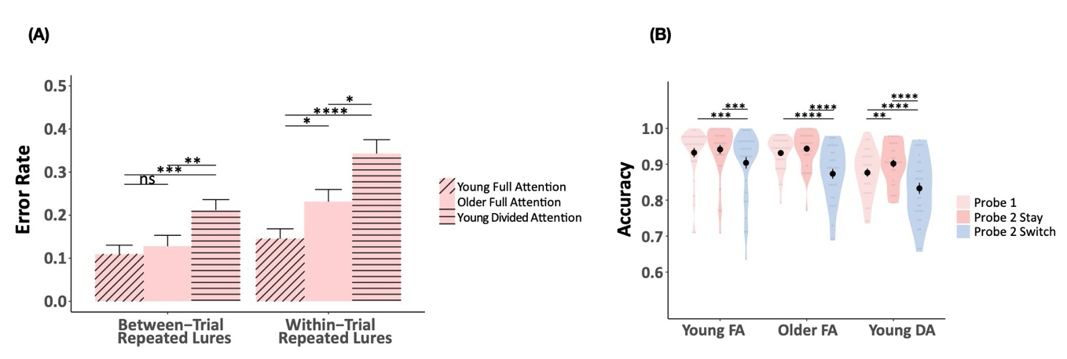
Supplemental Figure 9. (A) Error rate for the within-trial repeated lures and between-trial repeated-lure trials in the High-PI Experiment, (B) Accuracy (hits) for the working memory test in the High-PI Experiment. FA means full attention; DA suggests divided attention. Error bars indicate the standard error of mean. Between-trial repeated-lure trials are when probe-1 is a non-match and probe 2 is a match; Within-trial repealed lures trials are when both probe-1 and probe 2 are non-match. Error bars=SEM *p<.05, **p<.01, ***p<.001, ns>.05

High-PI Experiment: Control analyses using alternative data exclusion criteria
The analyses for the High-PI Experiment used the pre-registered exclusion criterion for detecting and excluding outliers, which utilized a uniform cut-off point (accuracy < 0.55) for all groups. A potential concern with this approach is that using the same cutoff may have differentially impacted the different groups or conditions with lower accuracies (e.g., older adults or young adults with DA). Therefore, to ensure that the pattern of results that were observed were not due to the particular data exclusion criteria that were proposed and used for the pre-registered analyses, we also considered an alternative, more principled and conservative data exclusion criteria. For this control (re)analysis, we applied outlier detection (with R, using rstatix package identify_outliers function) within each group, and removed these identified outliers from the analysis. Detailed methods, results are below. Most importantly, the results converged with those of the pre-registered exclusion criterion.

Method
Note that, to address potential skewness in the distributions of participants’ error rates on within-trial repeated lures and between-trial repeated lures, or their average accuracies or median RTs on probe-1, probe-2-stay, probe-2-switch trials, the data for each condition were square-root transformed. If the square-root of a participant’s average (or median RT) in any condition was more than 1.5 times of interquartile range from the median of the group, the participants’ data were excluded from the analyses. This procedure flagged five young FA, three older FA and nine young DA participants to be excluded from analysis either because they had accuracy values in one or more conditions (probe-1, probe-2-stay, probe-2-switch, probe-2-stay, within-trial repeated lures or between-trial repeated lures) that were beyond 1.5 times the interquartile range from the median of that condition, or because their accuracy in the secondary task was below 70%. One older FA participant was excluded because their TICS score was below 34. Two of the participants in the young FA group did not complete the experiment because of technical issues. In comparison to the original exclusion criteria, this alternative exclusion criteria flagged four more young FA and two more older FA as outliers.

Results using the alternative data exclusion criteria
Within-Trial vs. Between-Trial Repeated Lure Error Rates. A summary of the results of the ANOVAs on error rates are reported in Supplemental Table 9. The reanalysis showed the same general pattern as the original analyses. The two-way ANOVAs on error rates for the lure-type (within- vs. between-trial repeated lures) and group (young FA, older FA, young DA) for each block are identical to the ones reported previously in the High-PI Experiment result section, except for the interactions between lure-type and group for the first two blocks. In the original analysis, the interactions between the two factors were significant for the first two blocks, [Fs>3.28, ps<0.042, η_{p}²>0.08, BF₁₀>414], because the differences between the within- and between-trial repeated lures was significant for both the older adult [block 1: between-trial repeated lures vs. within-trial repeated lures (SEM) = 0.154(0.036) vs. 0.372(0.051)] and young adult DA groups [block 1: between-trial repeated lures vs. within-trial repeated lures (SEM) = 0.158(0.029) vs. 0.345(0.044)], but was not for the young FA group [block 1: between-trial repeated lures vs. within-trial repeated lures (SEM) = 0.111(0.026) vs. 0.152(0.028)] (Supplemental Table 10). These interactions did not reach significance for the first two blocks [Fs<2.24, ps>0.112, η_{p}²<0.04] in the reanalysis . However, Bayes factor analysis indicated stronger evidence against the null [BF₁₀>1.19]. Follow-up t-tests comparing the difference between within- and between-trial repeated lures suggests that for the first two blocks, the difference between within- and between-trial repeated lures was still significantly larger for both the older FA [block 1 between-trial repeated lures vs. within-trial repeated lures mean (SEM) = 0.15(0.04) vs. 0.34 (0.05)] and the young DA groups [block 1 between-trial repeated lures vs. within-trial repeated lures mean (SEM) = 0.16(0.03) vs. 0.35(0.04)] compared to the young FA group [block 1 between-trial repeated lures vs. within-trial repeated lures mean (SEM) = 0.09(0.03) vs. 0.13(0.03)], but in the last two blocks, the difference between within- and between-trial repeated lures relative to the young FA group was no longer significant for the older FA group (as in the Reactive-Proactive Index, see Figure 4). Therefore, the reanalysis with more conservative data exclusion criteria aligned with the original analysis.
The other exception was that in the current version, on block 2, the young FA group’s error rate on within-trial repeated lures was not significantly different from the older FA group’s (t=-2.2, p=0.09). This difference was significant in the original version.

Supplemental Table 9. High-PI Experiment with alternative data exclusion criteria: Two-way ANOVAs and Bayes Factors results comparing the young FA, older FA and young DA groups’ accuracy on repeated and non-repeated lure trials.
Block | Main Effect of Group | Main Effect of Lure-type | Group x Lure-type Interaction
Block 1 | F(2,91)=5.81, p=0.04, η_{p}² = 0.12, BF₁₀= 7.26 | F(1,93) = 33.07, p<0.001, η_{p}² = 0.27, BF₁₀= 115049 | F(2,93) = 2.22, p=0.12, η_{p}²=0.05, BF₁₀= 1.20
Block 2 | F(2,91)=9.8, p<0.001, η_{p}²=0.18, BF₁₀= 46.67 | F(1,93)=16.72, p<0.001, η_{p}²=0.16 , BF₁₀=511.11 | F(2,93)=2.24, p=0.112, η_{p}²=0.05, BF₁₀=1.60
Block 3 | F(2,91)=11.74, p<0.001, η_{p}²=0.21, BF₁₀=737.01 | F(1,93)= 5.1, p=0.026, η_{p}²=0.06, BF₁₀=1.48 | F(2,93)= 1.21, p=0.304, η_{p}²=0.03, BF₀₁= 1.86
Block 4 | F(2,91)=21.8, p<0.001, η_{p}²=0.33, BF₁₀= 294213 | F(1,93)=3.11, p=0.082, η_{p}²=0.03, BF₀₁= 1.41 | F(2,93)=0.1, p=0.901, η_{p}²=0, BF₀₁= 4.23
Note. BF₀₁ = Bayes Factors favoring the null hypothesis; BF₁₀ favors the alternative

Supplemental Table 10. Mean (SEM) erro rate on within-trial repeated lures and between-trial repeated lures and t-tests and BFs comparing each age group on each block.
 | Error rate Mean(SE) |  |  | t-test
Block | Young FA | Older FA | Young DA | Young FA vs. Older FA | Young FA vs. Young DA | Older FA vs. Young DA
Between-trial repeated lures
Block 1 | 0.09(0.03) | 0.15(0.04) | 0.16(0.03) | t(61)= -1.14, p=0.518, BF₀₁=-1.25 | t(60)= -1.87, p=0.202, BF₀₁=10.1 | t(61)= -0.61, p=0.543, BF₁₀=-1.19
Block 2 | 0.11(0.03) | 0.10(0.03) | 0.21(0.04) | t(61)= 0.32, p=0.753, BF₁₀=-1.29 | t(60)= -1.8, p=0.156, BF₀₁=-71.43 | t(61)= -2.1, p=0.119, BF₀₁=2.08
Block 3 | 0.05(0.02) | 0.13(0.03) | 0.21(0.03 | t(61)= -2.27, p=0.054, BF₀₁=1.33 | t(60)= -4.64, p=0, BF₁₀=6.64 | t(61)= -2.08, p=0.054, BF₀₁=2.22
Block 4 | 0.08(0.03) | 0.07(0.02) | 0.26(0.04) | t(61)= 0.28, p=0.781, BF₁₀=-1.3 | t(60)= -4.11, p=0, BF₁₀=5.13 | t(61)= -4.58, p=0, BF₁₀=6.65
Within-trial repeated lures
Block 1 | 0.13(0.03) | 0.34(0.05) | 0.35(0.04) | t(61)= -3.5, p=0.003, BF₁₀=3.48 | t(60)= -3.46, p=0.003, BF₁₀=3.37 | t(61)= -0.01, p=0.991, BF₁₀=-1.35
Block 2 | 0.13(0.03) | 0.25(0.04) | 0.38(0.05) | t(61)= -2.2, p=0.06, BF₀₁=1.56 | t(60)= -4.65, p=0, BF₁₀=6.85 | t(61)= -2.23, p=0.06, BF₀₁=1.43
Block 3 | 0.10(0.03) | 0.13(0.03) | 0.31(0.05) | t(61)= -0.4, p=0.689, BF₁₀=-1.26 | t(60)= -3.56, p=0.002, BF₁₀=3.61 | t(61)= -3.07, p=0.006, BF₁₀=2.47
Block 4 | 0.10(0.03) | 0.12(0.03) | 0.34(0.05) | t(61)= -0.28, p=0.78, BF₁₀=-1.3 | t(60)= -4.25, p=0, BF₁₀=5.56 | t(61)= -3.91, p=0, BF₁₀=4.65
Note. BF₀₁ = Bayes Factors favoring the null hypothesis; BF₁₀ favors the alternative

WM accuracy. A summary of the results of the ANOVAs on accuracy are reported in Supplemental Table 11. Reanalysis of WM accuracy showed the same pattern as the original analyses regarding the effects of group and probe-type for each block (Supplemental Table 11). Two of the follow-up t-test comparisons comparing average accuracy of each probe-type for each group showed different results from the original analyses (Supplemental Table 12). The first difference was at block 2, in the original version, the young FA group’s accuracy on probe-2-stay was not significantly different from that on probe-2-switch trials. In the current version, probe-2-stay trials showed higher accuracy than probe-2-switch trials. The second difference was at block 4, the older FA groups’ accuracy on probe-1 are significantly lower than that on probe-2-stay trials. In the original version, they are not significantly different. We also compared mean(SE) accuracy between the probe-types within each group (Supplemental Table 13); results were consistent with the original analyses.

Supplemental Table 11. High-PI Experiment with alternative data exclusion criteria: Two-way ANOVAs and Bayes Factors results comparing the young FA, older FA and young DA groups’ response time on probe-1, probe-2-stay, and probe-2-switch trials.
Block | Main Effect of Group | Main Effect of Probe-type | Group x Probe-type Interaction
Block 1 | F(2,91)= 8.34, p<0.001, η_{p}²=0.16, BF₁₀= 57.61 | F(2, 184)=22.06, p<0.001, η_{p}²=0.2, BF₁₀=3863353 | F(4,184)=1.88, p=0.128, η_{p}²=0.04, BF₀₁=2.96
Block 2 | F(2,91)=16.19, p<0.001, η_{p}²=0.27, BF₁₀=16336.34 | F(2,184)=27.83, p<0.001, η_{p}²=0.24, BF₁₀= 343317187 | F(4,184)=1.48, p= 0.218, η_{p}²=0.03, BF₀₁=5.34
Block 3 | F(2,91)= 21.87, p<0.001, η_{p}²=0.33, BF₁₀= 644302 | F(2,184)=25.28, p<0.001, η_{p}²=0.22, BF₁₀= 33910215 | F(4,184)=2.28, p=0.07, η_{p}²=0.05, BF₀₁= 1.61
Block 4 | F(2,91)=13.61, p<0.001, η_{p}²=0.24, BF₁₀= 2604.36 | F(2,184) = 20.58, p<0.001, η_{p}²=0.19, BF₁₀= 1183219 | F(4,184)=2.26, p=0.076, η_{p}²=0.05, BF₀₁= 1.67
Note. BF₀₁ = Bayes Factors favoring the null hypothesis; BF₁₀ favors the alternative
Supplemental Table 12. High-PI Experiment with alternative data exclusion criteria: Mean(SE) accuracy (top) and comparisons between the conditions (probe-1, probe-2-stay and probe-2-switch trials) within each group (young FA, older FA and young DA) (bottom).
Condition | Young Full Attention |  |  |  | Older Full Attention |  |  |  | Young Divided Attention
 | Block 1 | Block 2 | Block 3 | Block 4 | Block 1 | Block 2 | Block 3 | Block 4 | Block 1 | Block 2 | Block 3 | Block 4
probe-1 | 0.95(0.01) | 0.95(0.01) | 0.96(0.01) | 0.97(0.01) | 0.90(0.01) | 0.94(0.01) | 0.95(0.01) | 0.96(0.01) | 0.90(0.01) | 0.88(0.02) | 0.86(0.02) | 0.87(0.02)
probe-2-stay | 0.96(0.01) | 0.97(0.01) | 0.97(0.01) | 0.97(0.01) | 0.91(0.02) | 0.95(0.01) | 0.96(0.01) | 0.98(0.01) | 0.87(0.02) | 0.90(0.02) | 0.82(0.02) | 0.92(0.02)
probe-2 switch | 0.92(0.01) | 0.93(0.01) | 0.93(0.02) | 0.94(0.02) | 0.83(0.02) | 0.89(0.01) | 0.91(0.01) | 0.90(0.02) | 0.84(0.02) | 0.82(0.02) | 0.91(0.01) | 0.85(0.02)
probe-1 vs. probe-2-stay | t(29)=-1.34, p=0.573, BF₀₁= 2.25 | t(29)=-1.62, p=0.348, BF₀₁= 1.42 | t(29)=-0.81, p=1, BF₀₁= 3.42 | t(29)=0.29, p=1, BF₀₁= 4.93 | t(31)=-0.61, p=1, BF₀₁= 4.26 | t(31)=-0.54, p=1, BF₀₁= 4.40 | t(31)=-0.34, p=1, BF₀₁=4.85 | t(31)=-2.93, p=0.02, BF₀₁= 6.92 | t(31)=1.1, p=0.84, BF₀₁= 3.31 | t(31)=-1.27, p=0.645, BF₀₁= 2.33 | t(31)=-3.45, p=0.005, BF₁₀= 19.27 | t(31)=-2.97, p=0.018, BF₁₀= 10.79
probe-1 vs. probe-2-switch | t(29)=2.75, p=0.031, BF₁₀= 4.47 | t(29)=2.13, p=0.126, BF₁₀= 1.32 | t(29)=2.78, p=0.029, BF₁₀= 4.77 | t(29)=2.78, p=0.029, BF₁₀= 4.78 | t(31)=4.37, p=<0.001, BF₁₀= 229.59 | t(31)=4.54, p<0.001, BF₁₀= 284.01 | t(31)=3.54, p=0.004, BF₁₀ = 25.26 | t(31)=3.54, p=0.004, BF₁₀= 26.64 | t(31)=4.15, p<0.001, BF₁₀= 107.39 | t(31)=3.2, p=0.01, BF₁₀ = 12.32 | t(31)=2.33, p=0.08, BF₁₀ = 1.80 | t(31)=1.02, p=0.948, BF₀₁= 3.55
probe-2-stay vs. probe-2-swtich | t(29)=4.34, p<0.001, BF₁₀= 176.45 | t(29)=2.87, p=0.023, BF₁₀= 6.27 | t(29)=2.99, p=0.017, BF₁₀= 8.34 | t(29)=1.59, p=0.369, BF₀₁= 1.63 | t(31)=3.72, p=0.002, BF₁₀= 43 | t(31)=3.94, p=0.001, BF₁₀= 75.99 | t(31)=3.53, p=0.004, BF₁₀= 26.95 | t(31)=4.53, p=<0.001, BF₁₀= 409.85 | t(31)=1.94, p=0.186, BF₁₀= 1.29 | t(31)=3.93, p=0.001, BF₁₀ = 78.97 | t(31)=4.16, p=<0.001, BF₁₀= 117.72 | t(31)=3.33, p=0.007, BF₁₀= 18.35641
Note. BF₀₁ = Bayes Factors favoring the null hypothesis; BF₁₀ favors the alternative.

Supplemental Table 13. High-PI Experiment with alternative data exclusion criteria: t-test comparisons between groups for probe-1 (top), probe-2-stay(middle) and probe-2-switch (bottom).
Comparison | Young FA vs. Older FA | Young FA vs. Young DA | Young DA vs. older FA
Probe-1
Block 1 | t(58)=2.74, p=0.025, BF₁₀= 5.66 | t(58)=2.58, p=0.038, BF₁₀ = 4.24 | t(60)=-0.37, p=1, BF₀₁=3.67
Block 2 | t(58)=0.66, p=1, BF01= 3.20 | t(58)=4.33, p=<0.001, BF₁₀= 355.82 | t(60)=3.76, p=0.001, BF₁₀= 87.82
Block 3 | t(58)=1.04, p=0.915, BF₀₁= 2.40 | t(58)=6.03, p<0.001, BF₁₀= 71239.49 | t(60)=5.53, p<0.001, BF₁₀ = 20537.54
Block 4 | t(58)=1.37, p=0.528, BF₀₁= 1.80 | t(58)=6.12, p=0, BF₁₀= 109255.8 | t(60)=4.97, p=0, BF₁₀= 3396.53
Probe-2-stay
Block 1 | t(58)=2.72, p=0.027, BF₁₀ = 4.76 | t(58)=2.92, p=0.017, BF₁₀= 7.73 | t(60)=0.81, p=1, BF₀₁= 3.03
Block 2 | t(58)=0.95, p=1, BF₀₁= 2.62 | t(58)=3.42, p=0.004, BF₁₀= 26.47 | t(60)=2.6, p=0.036, BF₁₀= 4.31
Block 3 | t(58)=0.92, p=1, BF₀₁= 2.52 | t(58)=3.54, p=0.002, BF₁₀= 50.74 | t(60)=2.98, p=0.013, BF₁₀= 9.42
Block 4 | t(58)=-1.43, p=0.48, BF₀₁= 1.60 | t(58)=2.07, p=0.132, BF₁₀= 1.48 | t(60)=3.12, p=0.011, BF₁₀ = 15.26
Probe-2-switch
Block 1 | t(58)=4.07, p=<0.001, BF₁₀= 133.17 | t(58)=3.67, p=0.002, BF₁₀= 42.80 | t(60)=-0.38, p=1, BF₀₁= 3.64
Block 2 | t(58)=2.03, p=0.14, BF₁₀= 1.50 | t(58)=4.83, p=<0.001, BF₁₀= 1576.28 | t(60)=3.19, p=0.007, BF₁₀= 14.73
Block 3 | t(58)=1.11, p=0.816, BF₀₁= 2.15 | t(58)=4.17, p<0.001, BF₁₀= 210.78 | t(60)=3.52, p=0.003, BF₁₀= 34.41
Block 4 | t(58)=1.5, p=0.417, BF₀₁= 1.50 | t(58)=3.19, p=0.007, BF₁₀= 15.59 | t(60)=1.75, p=0.255, BF₀₁= 1.05
Note. BF₀₁ = Bayes Factors favoring the null hypothesis; BF₁₀ favors the alternative.

High-PI Experiment: Control Analysis for the Relationship between Initial Probe Response on Second Probe Accuracy
To assess the extent to which the errors on between-trial repeated lures and control condition were affected by participant’s response on probe 1, we looked at the error rates on between-trial repeated lures and within-trial repeated lures, separated by whether the response on probe-1 were correct or incorrect on probe-1. Results showed that when participants were correct on probe-1 (Supplemental Figure 10(A)), the pattern of error rates for between-trial and within-trial repeated lures is the same as in Figure 3. Supplemental Figure 10(B) showed the average error rates when participants were incorrect on probe-1 for the young FA, older FA and young DA groups. Note that when participants were incorrect on probe-1, analysis of these error rates was complicated by the fact that few participants were incorrect on probe-1 for few of the trials, so there were not many data points contributing to each cell of the design for this analysis. On within-trial repeated lures trials, for all three groups, when they had a false alarm to a lure on probe-1 and when the same lure was repeated on probe-2, they were more likely to false alarm again, even though they had received feedback. However, strong conclusions should not be drawn from this analysis given that only a few participants contributed to the observation to each cell for this analysis (Supplemental Table 14).
Supplemental Figure 10. (A) Error rate for the within-trial repeated lures and between-trial repeated-lure trials in the High-PI Experiment when probe-1 response was correct, (B) Error rate for the within-trial repeated lures and between-trial repeated-lure trials in the High-PI Experiment when probe-1 response was incorrect. FA means full attention; DA suggests divided attention. Error bars indicate the standard error of mean. Between-trial repeated-lure trials are when probe-1 is a non-match and probe 2 is a match; Within-trial repealed lures trials are when both probe-1 and probe 2 are non-match. Error bars=SEM *p<.05, **p<.01, ***p<.001, ns>.05
Supplemental Table 14. Trials count of repeated lures and repeated lures trials when participants in the young FA, older FA or young DA group made correct or incorrect responses on Probe 1.
 | Probe 1 Correct Trials
Group | Lure-type | Young FA | Older FA | Young DA
Block 1 | Within-Trial Repeated | 191 | 174 | 196
Block 1 | Between-Trial Repeated | 191 | 176 | 214
Block 2 | Within-Trial Repeated | 177 | 177 | 206
Block 2 | Between-Trial Repeated | 185 | 175 | 193
Block 3 | Within-Trial Repeated | 196 | 196 | 189
Block 3 | Between-Trial Repeated | 176 | 174 | 189
Block 4 | Within-Trial Repeated | 179 | 173 | 195
Block 4 | Between-Trial Repeated | 188 | 191 | 224
 | Probe 1 Incorrect Trials
 |  | Young FA | Older FA | Young DA
Block 1 | Within-Trial Repeated | 22 | 33 | 33
Block 1 | Between-Trial Repeated | 16 | 40 | 33
Block 2 | Within-Trial Repeated | 18 | 24 | 45
Block 2 | Between-Trial Repeated | 16 | 17 | 37
Block 3 | Within-Trial Repeated | 18 | 15 | 58
Block 3 | Between-Trial Repeated | 17 | 24 | 38
Block 4 | Within-Trial Repeated | 14 | 23 | 35
Block 4 | Between-Trial Repeated | 23 | 18 | 27

