Supplemental Materials
Personal and Collective Mental Time Travel across the Adult Lifespan during COVID-19
Lois K. Burnett*, Tori Peña*, Suparna Rajaram, Lauren L. Richmond
Department of Psychology, Stony Brook University, Stony Brook, NY 11794-2500, USA

In the mental time travel task, participants reported up to five events for each year, valence, and domain prompt (positive personal 2019, positive personal 2021, negative personal 2019, negative personal 2021, positive collective 2019, positive collective 2021, negative collective 2019, negative collective 2021).
See Table S1 for the average number of events by domain, year, and age group. In order to further characterize the events reported by participants across the adult lifespan in response to these prompts, we conducted the following descriptive analysis. This analysis is meant to supplement the main analysis for the mental time travel task detailed in the manuscript by providing a more nuanced look at the broad categories of events reported by each age group.
Finally, we examined racial differences in the total number of positive minus negative responses reported for this task to better understand the degree to which our age-related differences may have been driven by differences in racial composition across age group.
Method
Our goal was to identify categories of reported events. Categories were initially identified using pilot data that were collected prior to the main survey. Categories were further refined during coding of the first 20% of survey data. Items that could not be classified into any of the categories were coded as “Other.”
The personal and collective data were coded by separate pairs of coders who were unaware of the study purpose and hypotheses. Two research assistants coded the data for personal events, and two different research assistants coded the data for collective events. For each domain (collective/personal), both coders first coded a randomly selected 20% of the data working independently of one another to complete coding on this initial subset. Interrater reliability was checked once both coders had completed their coding of the initial 20%. Both pairs of coders achieved good interrater reliability (Personal: Cohen’s kappa = .899; Collective: Cohen’s kappa = .884). Subsequently, each coder independently coded 40% of the remaining data within their domain (collective/personal).
Results and Discussion
We present descriptive data for category coding. There was a larger variety of categories for personal events compared to collective events (see Figure S1 for a breakdown of personal event categories across age groups and Figure S2 for collective event categories). In the personal domain, young adults reported events related to their career and education more often than middle-aged and older adults. Outside of career and education, participants of all ages reported on a range of event categories, including social events (e.g., marriages) and financial events (e.g., getting a raise), at roughly equal rates.
In the collective domain, responses related to the pandemic dominated the projected events for 2021 in both the positive and negative categories. Negative events often consisted of projections regarding increased COVID-19 cases, a failure to develop better treatments and methods of prevention for COVID-19, and continued lockdowns. Examination of positively valenced responses revealed that people often reported on projected advancements in terms of treating and preventing COVID-19, return to normal life, and economic improvements.
Together, these data suggest a fair degree of similarity in the types of events reported across age groups in terms of year (2019, 2021), domain (personal, collective), and valence (positive, negative). Interestingly, both positive and negative COVID-relevant events were projected for the collective future, suggesting that people from all age groups had both hope and despair for the collective future as it related to the pandemic, a pattern also observed for responses in the Future Excitement and Worry Task.
Overall, these data suggest that age differences in the positive and negative event difference scores reported in the main text of the manuscript were not driven by young, middle-aged, and older adults reflecting on different types of events. Instead, these data bolster the interpretation that age differences in mental time travel are based on differences in the number of events produced in response to each prompt rather than the types of events produced.
Finally, we tested age-related and race-related differences in the Mental Time Travel task (i.e., the number of positive events subtracted by the number of negative events) in our young adult (Black: n = 19; White: n = 91 ; Asian: n = 106) and middle-aged adult (Black: n = 15; White: n = 117; Asian: n = 5) age groups. There was no significant main effect of race, WJ(2, 69.52) = 2.01, p = .141, and the age by race interaction was not significant, WJ(2, 69.52) = 1.61, p = .207. These findings lend tentative support to the conclusion that age-related differences observed in our study were not driven by racial differences across age groups.

Table S1
Average Number of Positive and Negative Events by Domain, Year, and Age Group
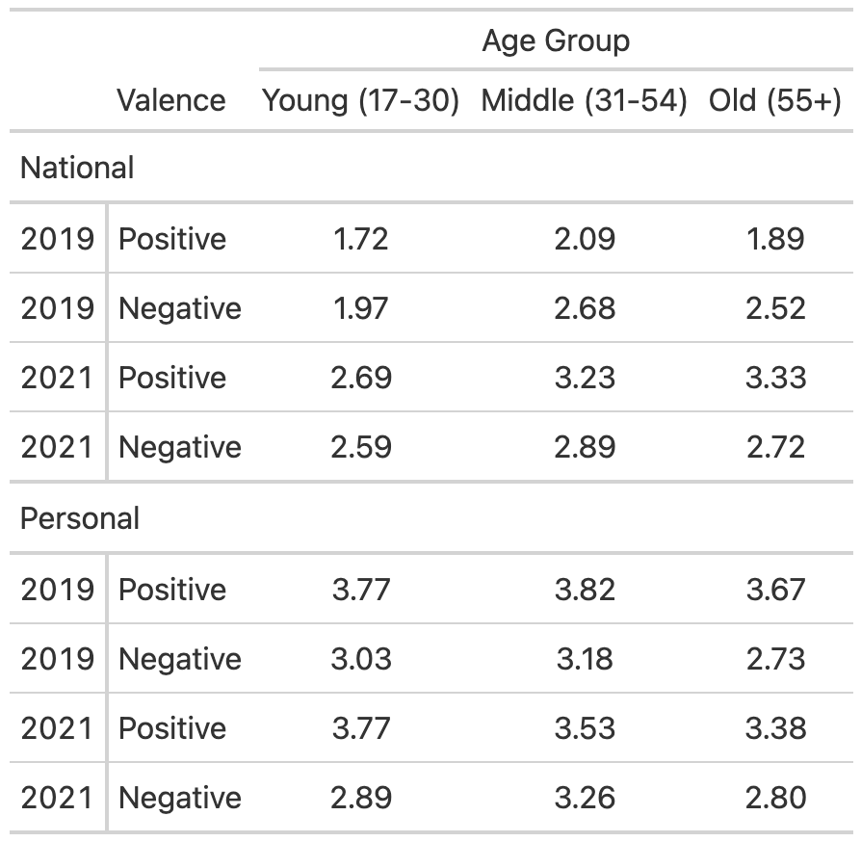
Note. This table presents the mean number of positive and negative events reported for the Mental Time Travel task by domain (personal, national), year (2019, 2021), and age group (young adults, middle-aged adults, older adults).

Figure S1
Personal Event Categories Across Age Groups
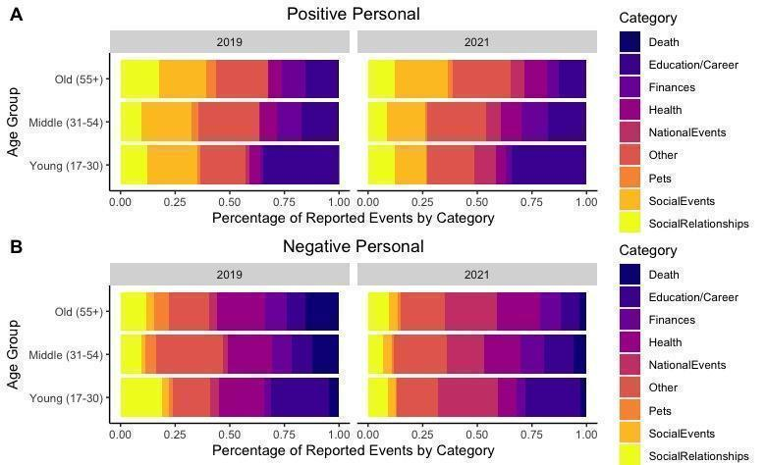
Note. This figure provides a breakdown of the percentage of categories belonging to each of 9 categories in the personal domain across age groups, years, and valence. Panel A represents positive personal events. Panel B represents negative personal events.

Figure S2
Collective Event Categories Across Age Groups
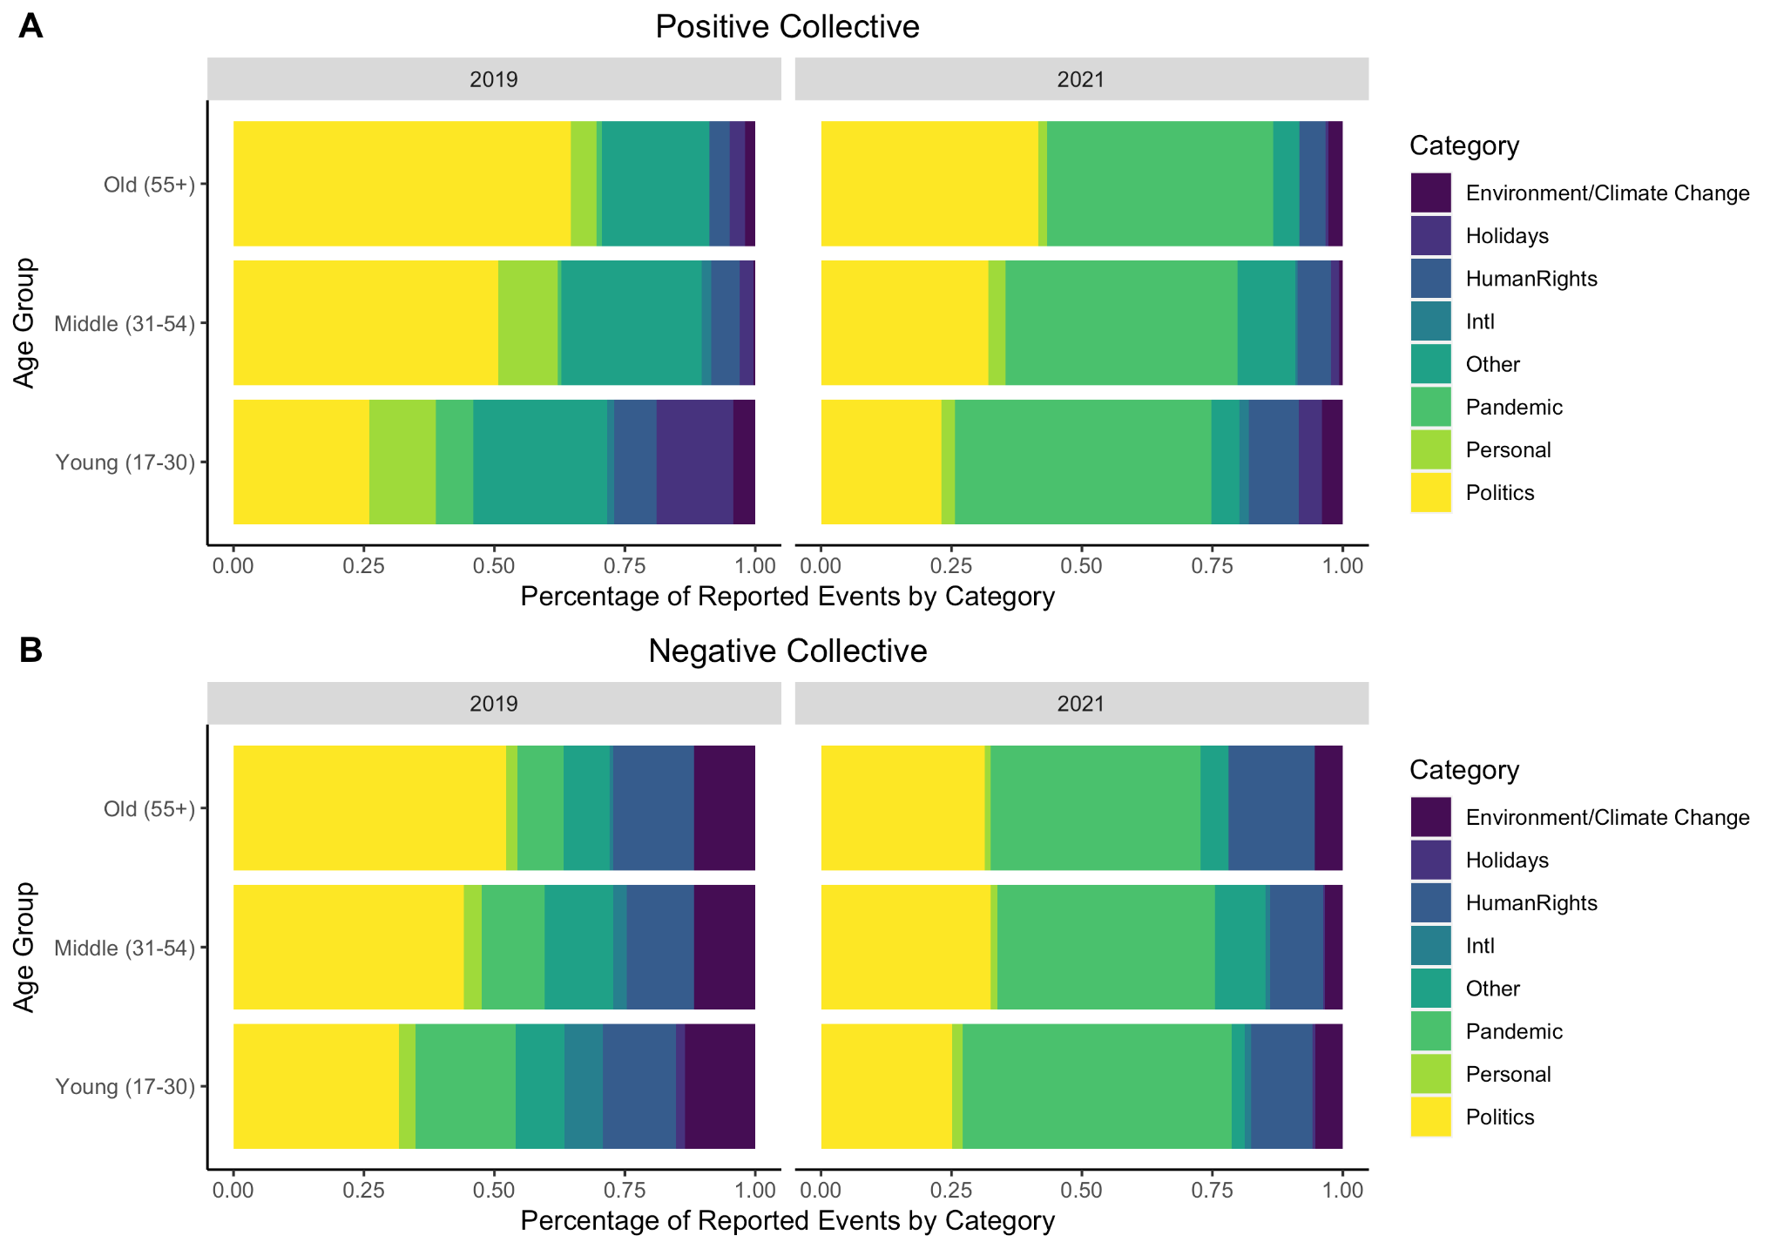
Note. This figure provides a breakdown of the percentage of categories belonging to each of 8 categories in the collective domain across age groups, years, and valence. Panel A represents positive national events. Panel B represents negative national events.

