SUPPLEMENTAL MATERIALS
Table S1: Demographic characteristics of responders, non-responders, and US population.
Demographic characteristic | Responders  (N=5,376) | Non-responders  (N=1,771) | Test of difference
Mean (SD) age | 51.11 (15.64) | 46.38 (15.79) | t(7137)=11.00, p<.001
Percent male | 43% | 42% | χ(1)=.25, p=.62
Percent white | 80% | 77% | χ(1)=9.76, p<.01
Percent college degree | 39% | 38% | χ(1)=.43, p=.51
Percent affiliated with religion | 70% | 71%ª | χ(1)=.78, p<.38
Median household income | $50,000-$59,999 | $50,000-$59,999 | MW z=.72, p=.47
MW=Mann-Whitney test.

Table S2: Correlation matrix.
 | 1. Mortality-salience condition | 2. Age | 3. Dona-tion | 4. Fear of death | 5.  Charity for next generation | 6. National charity | 7. Male | 8. White | 9.  Col-lege | 10.  Reli-gion
- Mortality-salience condition  (vs. control) | -
- Age | .01 | -
- Donation | .06*** | .14*** | -
- Fear of death | .03* | -.21*** | .00 | -
- Charity for next generation (vs. not) | .01 | .02 | .03* | .00 | -
- National charity  (vs. international) | .01 | -.02 | .02 | .00 | .01 | -
Demographic control variables
- Male (vs. female) | -.01 | .14*** | .03* | -.12** | .01 | -.01 | -
- White (vs. non-white) | .00 | .13*** | .08*** | -.01 | .00 | .01 | .05*** | -
- College-educated (vs. not) | .00 | .02 | .11*** | -.07*** | .02 | .01 | .07*** | .06*** | -
- Affiliated with religion (vs. not) | .02 | .16*** | .03* | -.07*** | .00 | .01 | -.03* | .05** | .06*** | -
- Household income | -.01 | .01 | .16*** | -.02 | .02 | .01 | .15*** | .15*** | .42*** | .06***

Note: Mortality salience (vs. control), charity for next generation (vs. not), and national (vs. international) charity were randomized conditions. Charities were Boys and Girls Club of America (next generation, national), UNICEF (next generation, international), American Red Cross (not next generation, national), International Red Cross (not next generation, international). Household income was divided into five categories (Table 1).

Table S3: Linear regression models predicting donations and fear of death: interactions.
 | Model 1:  Donations |  |  | Model 2:  Fear of death
 | B (se) | β |  | B (se) | β
Two-way interactions
Mortality salience x Age (linear) | -.01  (.02) | -.10 |  | .01  (.01) | .16
Mortality salience x Age (quadratic) | .00  (.00) | .04 |  | .00  (.00) | -.07
Mortality salience x Charity for next generation | .13  (.11) | .03 |  | .03  (.06) | .01
Mortality salience x National charity | -.13  (.11) | -.03 |  | .02  (.06) | .01
Age (linear) x Charity for next generation | -.02  (.02) | -.24 |  | -.01  (.01) | -.20
Age (quadratic) x Charity for next generation | .00  (.00) | .17 |  | .00  (.00) | .14
Age (linear) x National charity | .00  (.02) | .03 |  | .00  (.02) | -.01
Age (quadratic) x National charity | .00  (.00) | -.03 |  | .00  (.00) | .02
Three-way interactions
Mortality salience x Age (linear) x Charity for next generation | .01  (.04) | .16 |  | .05*  (.02) | 1.09*
Mortality salience x Age (quadratic) x Charity for next generation | .00  (.00) | -.14 |  | .00*  (.00) | .64*
Mortality salience x Age (linear) x National charity | -.01  (.04) | -.15 |  | .06*  (.02) | 1.21*
Mortality salience x Age (quadratic) x National charity | .00  (.00) | .11 |  | .00*  (.00) | -.69*
Mortality salience x Charity for next generation x National charity | -.04  (.22) | -.01 |  | .08  (.12) | .02
Age (linear) x Charity for next generation x National charity | .06  (.04) | .66 |  | .02  (.02) | .39
Age (quadratic) x Charity for next generation x National charity | .00  (.00) | -.43 |  | .00  (.00) | .29
Four-way interactions
Mortality salience x Age (linear) x Charity for next generation x National charity | .02  (.09) | .16 |  | .00  (.04) | -.02
Mortality salience x Age (quadratic) x Charity for next generation x National charity | .00  (.00) | .07 |  | .00  (.00) | -.06

Note: Two-way interactions were added in a regression step conducted after the models presented in Table 1, and three-way interactions were added in a subsequent regression step.

Table S4: Linear regression models predicting donations: role of fear of death.

 | B (se) | β
Predictor variables
Donations | .07**  (.02) | .04**
Mortality-salience condition (vs. control) | .24***  (.05) | .06***
Age (linear) | .02***  (.00) | .14***
Age (quadratic) | .00  (.00) | -.05
Charity for next generation (vs. not) | -.06  (.08) | -.02
National charity (vs. international) | -.08  (.08) | -.02
Charity for next generation (vs. not) x National charity (vs. international) | .35***  (.11) | .07***
Demographic control variables
Male (vs. female) | -.03  (.06) | -.01
White (vs. non-white) | .22**  (.07) | .04**
College degree (vs. not) | .22**  (.06) | .05**
Affiliated with religion (vs. not) | -.04  (.06) | -.01
Household income $25k-$49,999 (vs. <$25k) | .23***  (.08) | .05***
Household income $50k-$74,999 (vs. <$25k) | .52***  (.09) | .10***
Household income $75k-$149,999 (vs. <$25k) | .67***  (.09) | .15***
Household income >$150k (vs. <$25k) | .70***  (.11) | .11***

ª Fear of death questions were answered before the donation questions in the mortality-salience condition and after the donation questions in the control condition.
^{b} Quadratic age was B=-.0004 and se=.0001.
Note: Unstandardized estimates (B), standard errors (se), and standardized estimates (β) are presented for each model. Mortality salience and charity type were randomized conditions. Age was mean-centered. Charities were Boys and Girls Club of America (national, next generation), UNICEF (international, next generation), American Red Cross (national, not next generation), International Red Cross (international, not next generation). Adding any second-order and higher-level interactions of linear age or quadratic age, mortality salience, type of charity, and their combination yielded no significant results (p>.05). Adding donations x mortality salience interaction revealed no significant (B=.03, se=.04, β=.01, p=.50).

Figure S1: Flow of participants through each stage of the experiment.
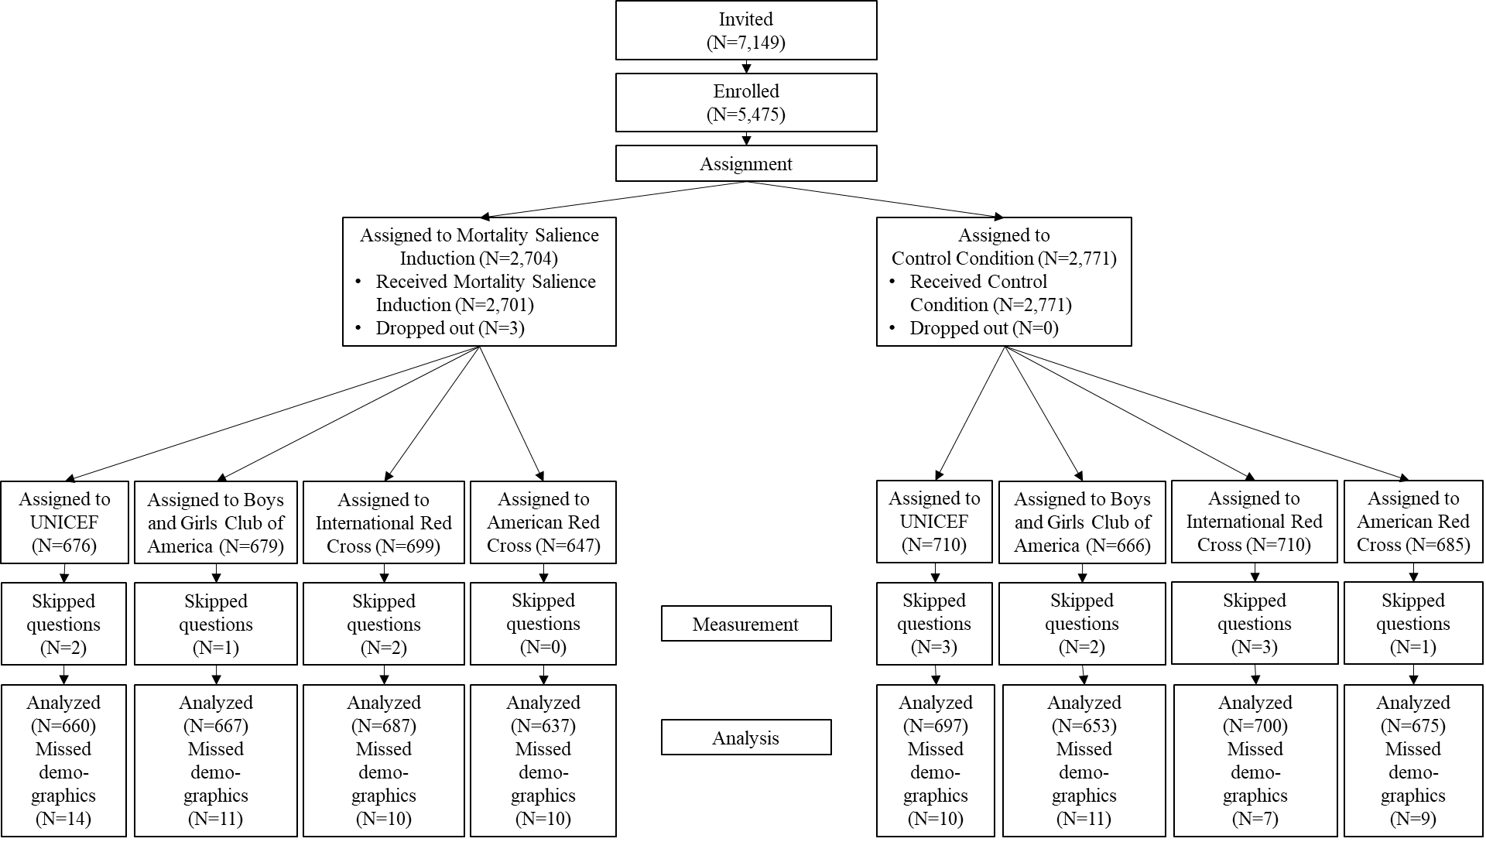
Note: In the mortality salience induction, questions asked about fear of death and donations. In the control condition, the same questions were asked in the opposite order. Demographics were answered separately and merged with our data in the analysis phase

Figure S2: Fear of death by age, mortality salience and charity focused on the next generation vs. not.

Note: Charities were Boys and Girls Club of America (national, next generation), UNICEF (international, next generation), American Red Cross (national, not next generation), International Red Cross (international, not next generation).
Figure S3: Fear of death by age, mortality salience and national vs. international charity.

Note: Charities were Boys and Girls Club of America (national, next generation), UNICEF (international, next generation), American Red Cross (national, not next generation), International Red Cross (international, not next generation).

