Online Supplement 1. Inclusion criteria
General inclusion criteria
- 65 ≤ age ≤ 75 years at study start
- General availability during the study period (maximum of two scheduled absent classes prior to study start)
- Adequate hearing
- Normal eye-sight or, if needed, glasses or contact lenses
- No prior experience of participation in studies of cognitive function
- Swedish as mother tongue
- Monolingual
- No or minimal prior knowledge of any Romance languages (French, Spanish, Italian, Portuguese, Latin). Prior knowledge was self-assessed, where sufficient prior knowledge for exclusion was on the level of being able to ask and understand rudimentary questions (e.g. asking for directions, or asking what time it is, and then understanding the answer).
- MMSE score > 25
- No color-blindness
- No use of psychotropic medication less than 6 months prior to study start
- Not sought medical care for any of the following diagnoses within the last 5 years, or received medical treatment within 1 year:
  - Attention deficit hyperactivity disorder (ADHD)
  - Bipolar disorder (BPD)
  - Major depressive disorder (MDD)
  - Generalized anxiety (GAD)
  - Panic disorder (PD)
  - Post-traumatic stress disorder (PTSD)
  - Psychotic symptoms (e.g., hallucinations, delusions)
  - Social phobia (SP)
  - Obsessive compulsive disorder (OCD)
- No prior history of diagnosed
  - Tinnitus
  - Dyslexia
  - Stroke
  - Epilepsy
  - Alzheimer’s Disease
  - Dementia
  - Multiple sclerosis

For MR eligibility
- No metallic or ferromagnetic implants, including pacemaker, heart stimulator or stent
- No claustrophobia
- Being right-handed
- Weight ≤ 120 kilograms
- No self-reported or diagnosed hearing impairment
- No life history of concussion, loss of consciousness (longer than 10 minutes).

Online Supplement 2. Consort flow chart

CONSORT 2010 Flow Diagram

Enrollment

Allocation
Randomized (n=170)
Excluded (n=11)
♦ Not meeting inclusion criteria (n=10)
♦ Declined to participate (n=1)
Assessed for eligibility (n=181)

Allocated to intervention (n=74)
♦ Received some allocated intervention (n=74)
♦ Dropped out during pretest before intervention start (n=0)

Discontinued /lost to follow up (n=4)

Allocated to intervention (n=96)
♦ Received some allocated intervention(n=95)
♦ Dropped out during pretest before intervention start (n=1)

Follow-Up
Discontinued /lost to follow up (n=5)
Analyzed (n= 70)
♦ Excluded from analysis (n=0)

Analyzed (n= 90)
♦ Excluded from analysis (n=0)

Analysis
Online Supplement 3. Detailed task descriptions
Domain | Task | Task description | Dependent measure | Max score
Item-associative memory task | Word-word/  Face-name/  Picture-picture | During encoding phase 40 word/face-name/picture pairs were shown, one at a time, in the middle of the screen for 6000 ms.  During item recognition phase, 40 singular words/faces/pictures were presented, one at a time, and the subject was to indicate whether the word/face/picture was present as part of a pair in the encoding phase (20 targets) or not (20 foils).  During associative recognition phase, 40 word/face-name/picture pairs were presented on screen, one at a time, and the subject was to indicate whether the pair was an already-seen pair from the encoding phase (20 targets) or a new pair using re-arranged items from the encoding phase (20 foils). | Proportion hits – proportion false alarms | 1.0
Spatial intelligence | Raven’s progressive matrices | The task involved completing as many of the 18 trials within a 12-minute time limit. Each trial consisted of increasingly complex visual geometric designs with a missing piece. The task was to select the missing piece from eight alternatives. | Number correct within time limit | 18
Spatial intelligence | WASI-II matrices | The task involved completing as many of the 30 trials within a 15-minute time limit. Each trial consisted of increasingly complex visuospatial objects with a missing piece. The task was to select the missing piece from five alternatives. | Number correct within time limit | 30
Verbal intelligence | ETS kit verbal inference | The task involved completing as many of the 20 verbal inference trials as possible within a 12-minute time limit. The task involved selecting the valid conclusion given the information given in a verbal statement.  Example trial: One year a particular farmer’s stand of wheat yielded 40 bushels per acre.  1) The farmer’s land is extremely fertile  2) The farmer has raised wheat on his land  3) The weather that year was unfavourable for growing wheat  4) Forty bushels per acre is a high yield  5) The field would be more suitable for some other crop | Number correct within time limit | 20
Verbal intelligence | BIS analogies | The task involved completing as many of the twelve analogies within a 5-minute time limit. The task involved finding completing analogies.  Example trial: Newspaper is to text as speaker is to:  1) sound  2) song  3) news  4) listening  5) stereo | Number correct within time limit | 12
Verbal intelligence | Syllogisms | The task involved completing as many of the 30 syllogism trials within a 20-minute time limit. The task on each trial was to decide whether the conclusion that followed the premises was logically valid or not. Absurd examples were chosen to emphasize the formal structure of the task.  Example trial: All trees are fish. All fish are horses. Therefore all trees are horses.  1) valid conclusions  2) invalid conclusions | Number correct within time limit | 30
Working memory | N-back | The test consisted of four runs of single 2-back and four runs of single 3-back. The stimuli set consisted of shapes, which was used during training. 192 stimuli were shown, of which 64 were targets (33%). Completion time was approximately 15 minutes. | (Number hits / total targets) + (number correct rejections/ total foils) | 1.0
Working memory | Numerical updating | Four single digits (ranging from 1 to 9) were presented simultaneously in a row of four cells situated horizontally for 3000 ms. After an inter-stimulus interval of 250 ms, a sequence of eight updating operations were presented in a second row of four cells below the first row. These updating operations were additions and subtractions within a range -9 to +9. Each updating operation was applied to a different cell from the one a step earlier in the sequence, so that no two updating operations had to be applied to one cell in a sequence. Those updating operations had to be applied to the digits memorized from the corresponding cells above and the updated results had to be memorized. Ten trials were included in the test. Completion time was approximately 10 minutes. | Proportion correct | 1.0

Online Supplement 4. Graphical illustration of a latent change score model.
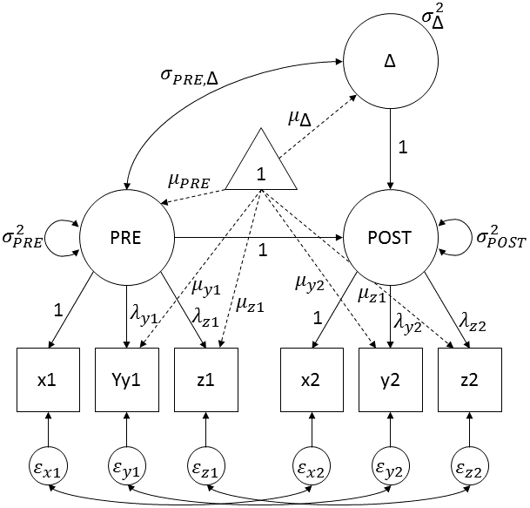
Note: Three indicators (X, Y, Z) were used for verbal intelligence, associative memory and item memory, while two indicators (X, Y) were used for spatial intelligence and working memory.

Online Supplement 5. Nested model comparison for configural, weak, strong, strict measurement invariance. Models with 2 indicators (Working memory, Spatial intelligence) are unidentified at the configural and weak level of invariance. We therefore started testing at the level of strong measurement invariance.

Domain | Comparison | Δχ² | ΔDf | p
Associative memory | Configural vs weak | 4.67 | 6 | .589
Associative memory | Weak vs strong | 1.79 | 6 | .938
Associative memory | Strong vs Strict | 8.18 | 9 | .517
Item memory | Configural vs weak | 4.20 | 6 | .650
Item memory | Weak vs strong | 11.18 | 6 | .083
Item memory | Strong vs Strict | 15.02 | 9 | .090
Verbal intelligence | Configural vs weak | 9.61 | 6 | .142
Verbal intelligence | Weak vs strong | 7.93 | 6 | .243
Verbal intelligence | Strong vs Strict | 14.30 | 9 | .112
Working memory | Strong vs Strict | 2.52 | 6 | .866
Spatial intelligence | Strong vs Strict | 3.64 | 6 | .725

Online Supplement 6. Bayesian triplots (prior, likelihood and posterior) and Bayes factors for informed prior, N ~ half-normal(0, 0.2) and reference prior, N ~ half-normal(0, .707). Bayes factors were approximated using the maximum likelihood estimate obtained from the uninformed model.

 |  | σ = 0.2 | σ = 0.707
Associative  memory | Face-name | 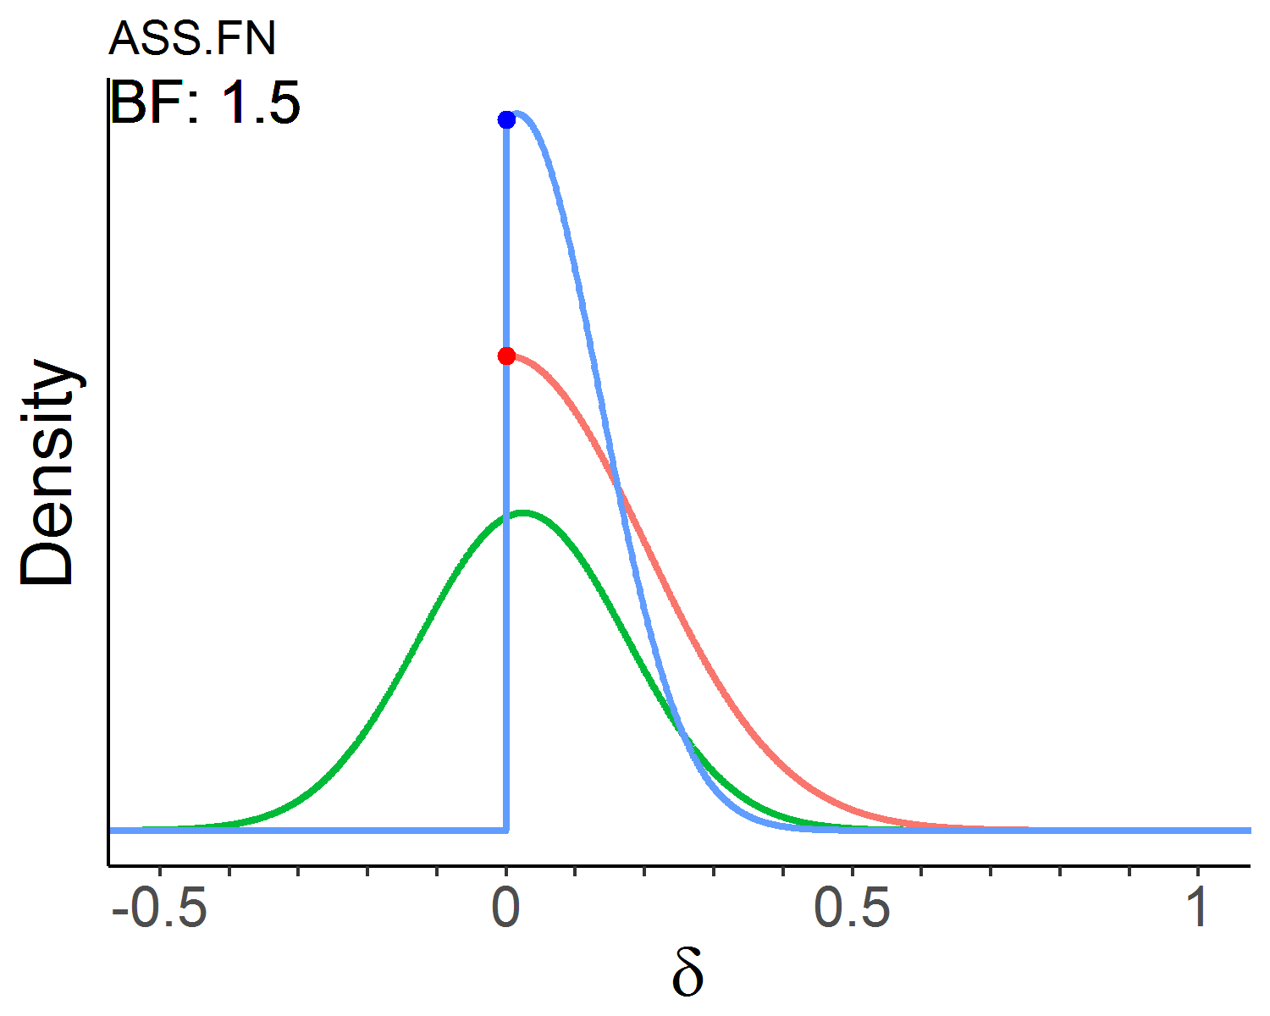 | 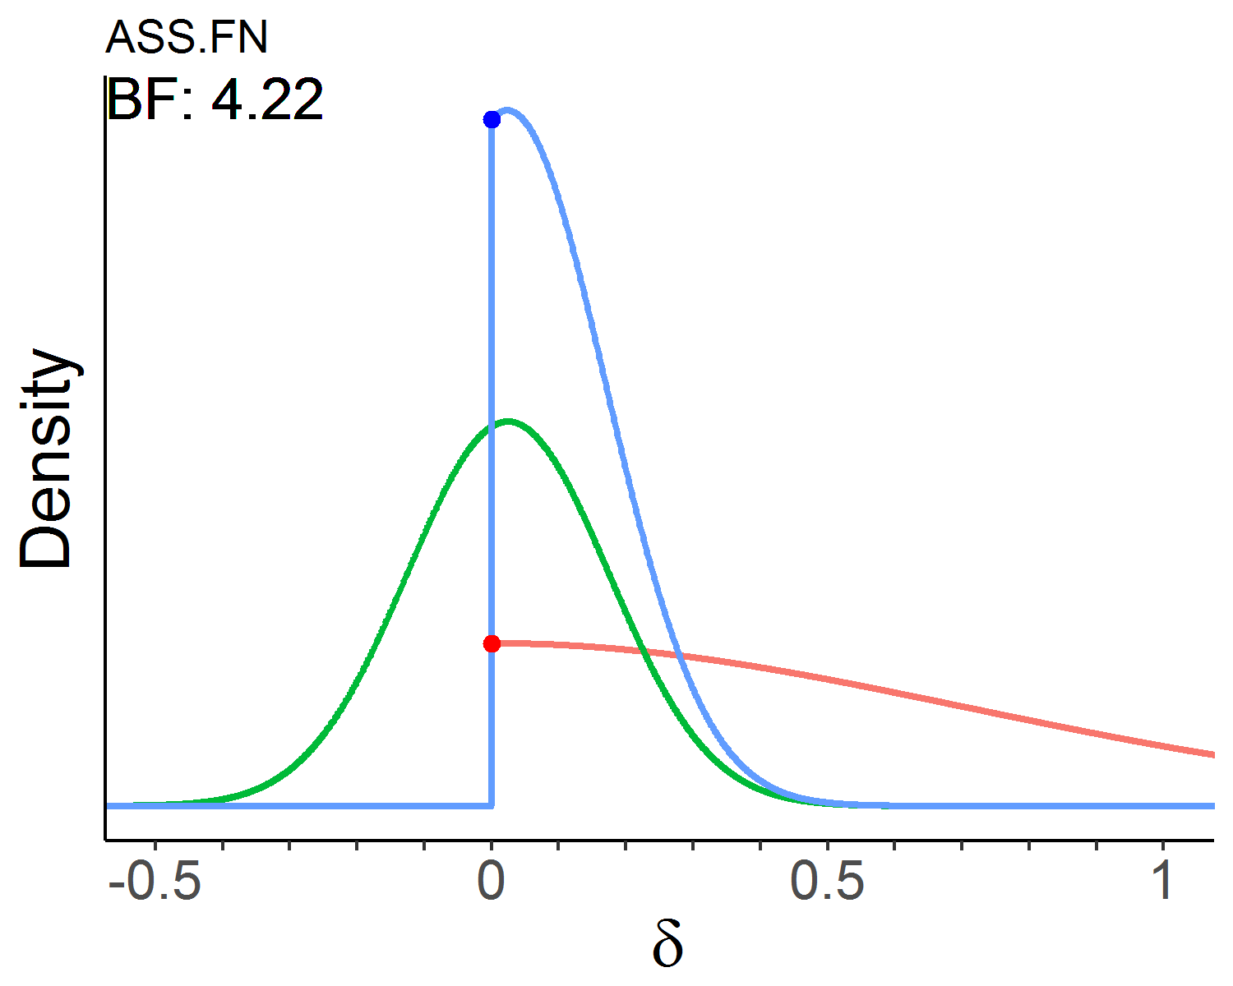
Associative  memory | Picture-picture | 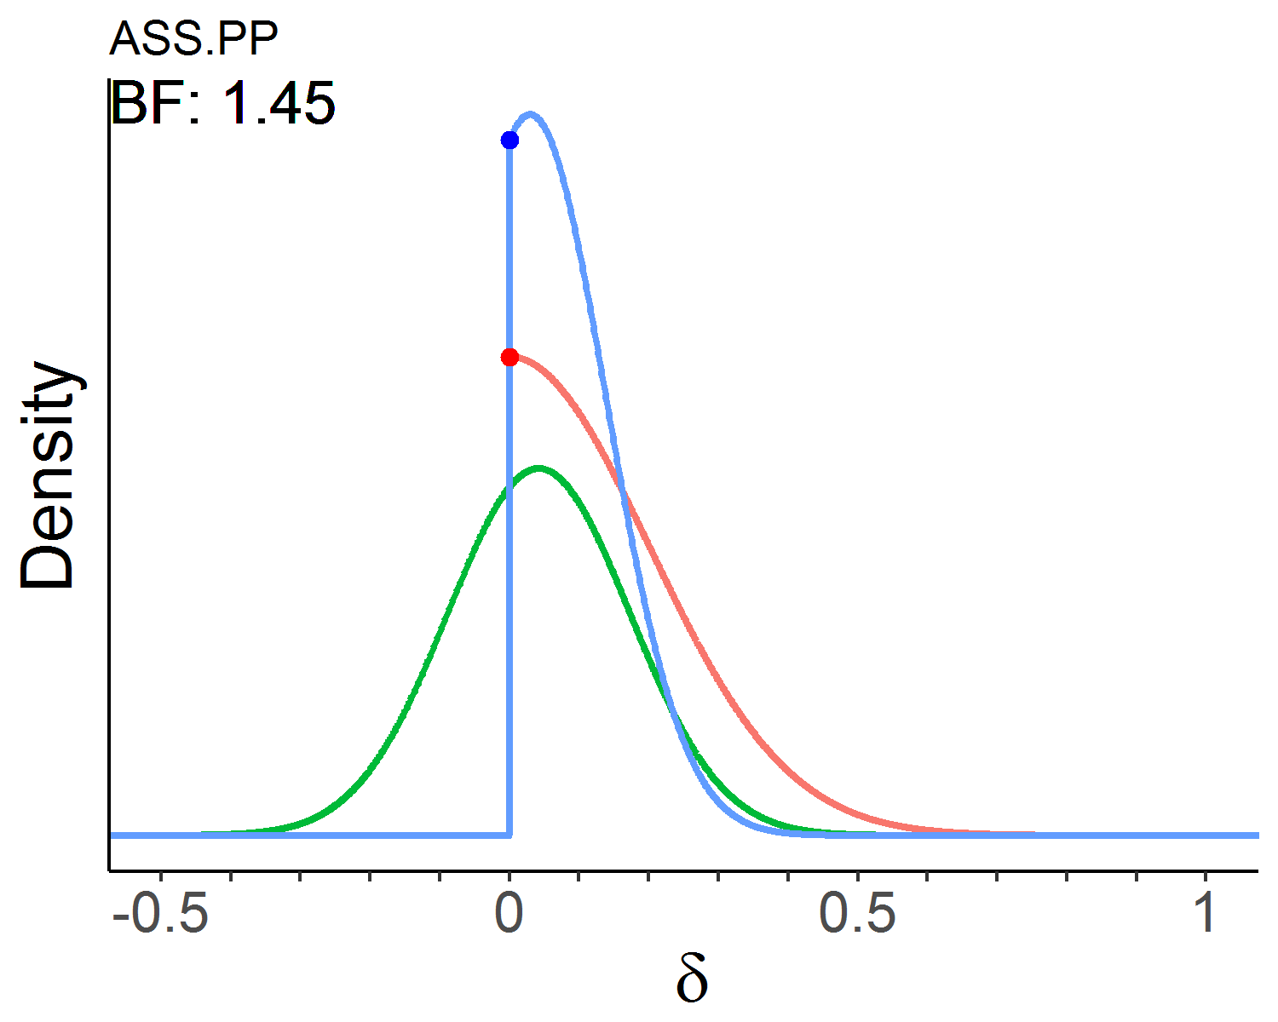 | 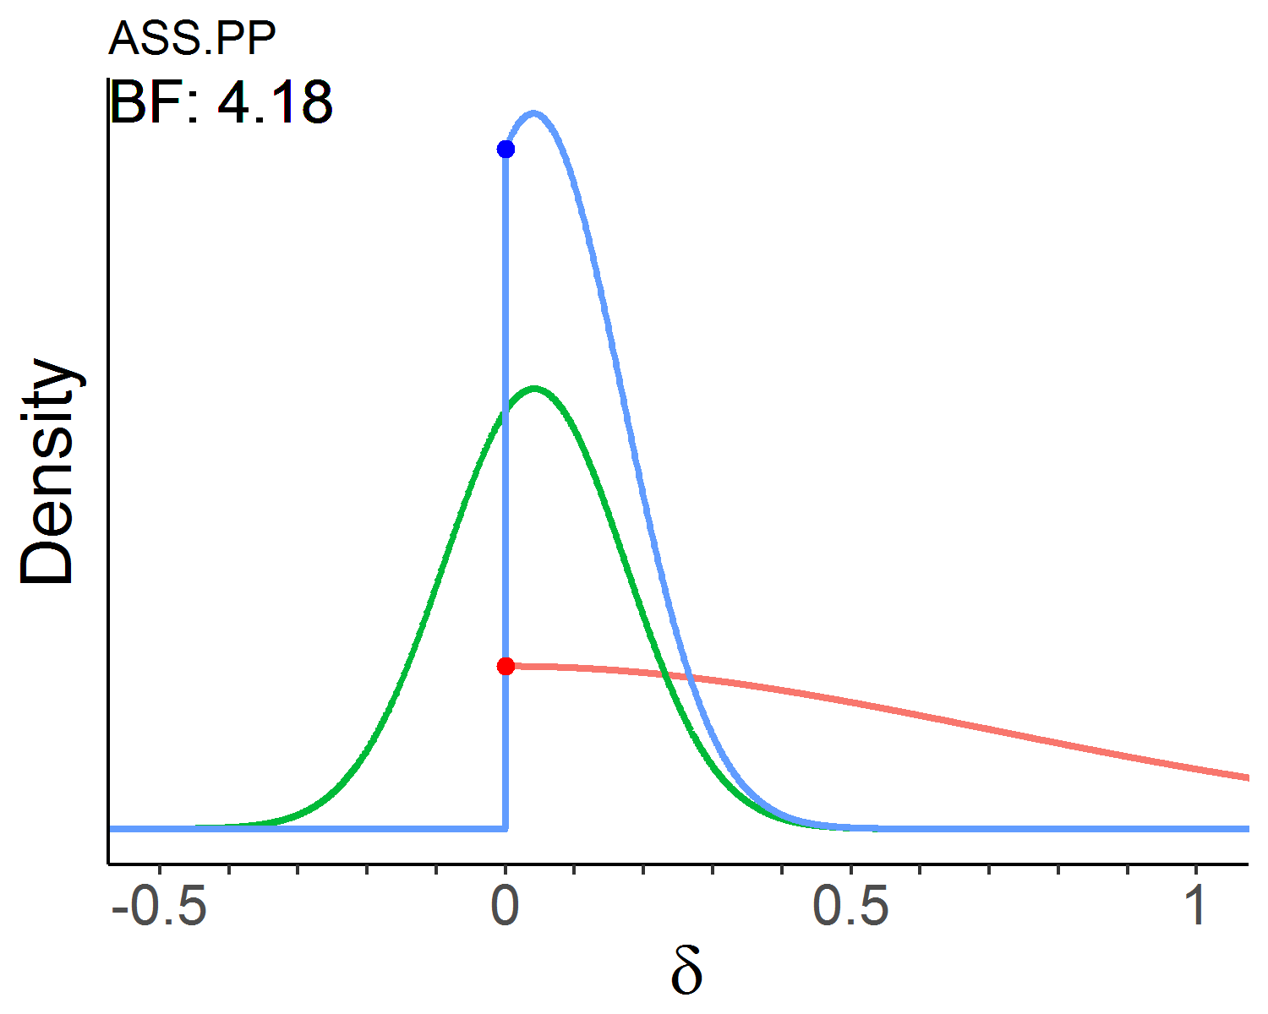
Associative  memory | Word-word | 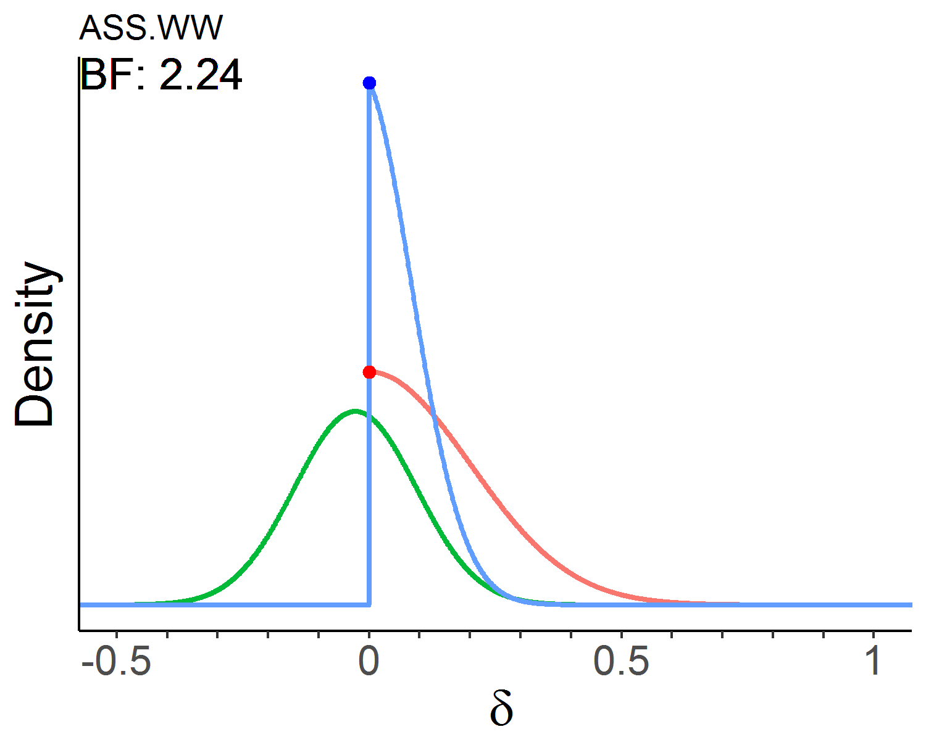 | 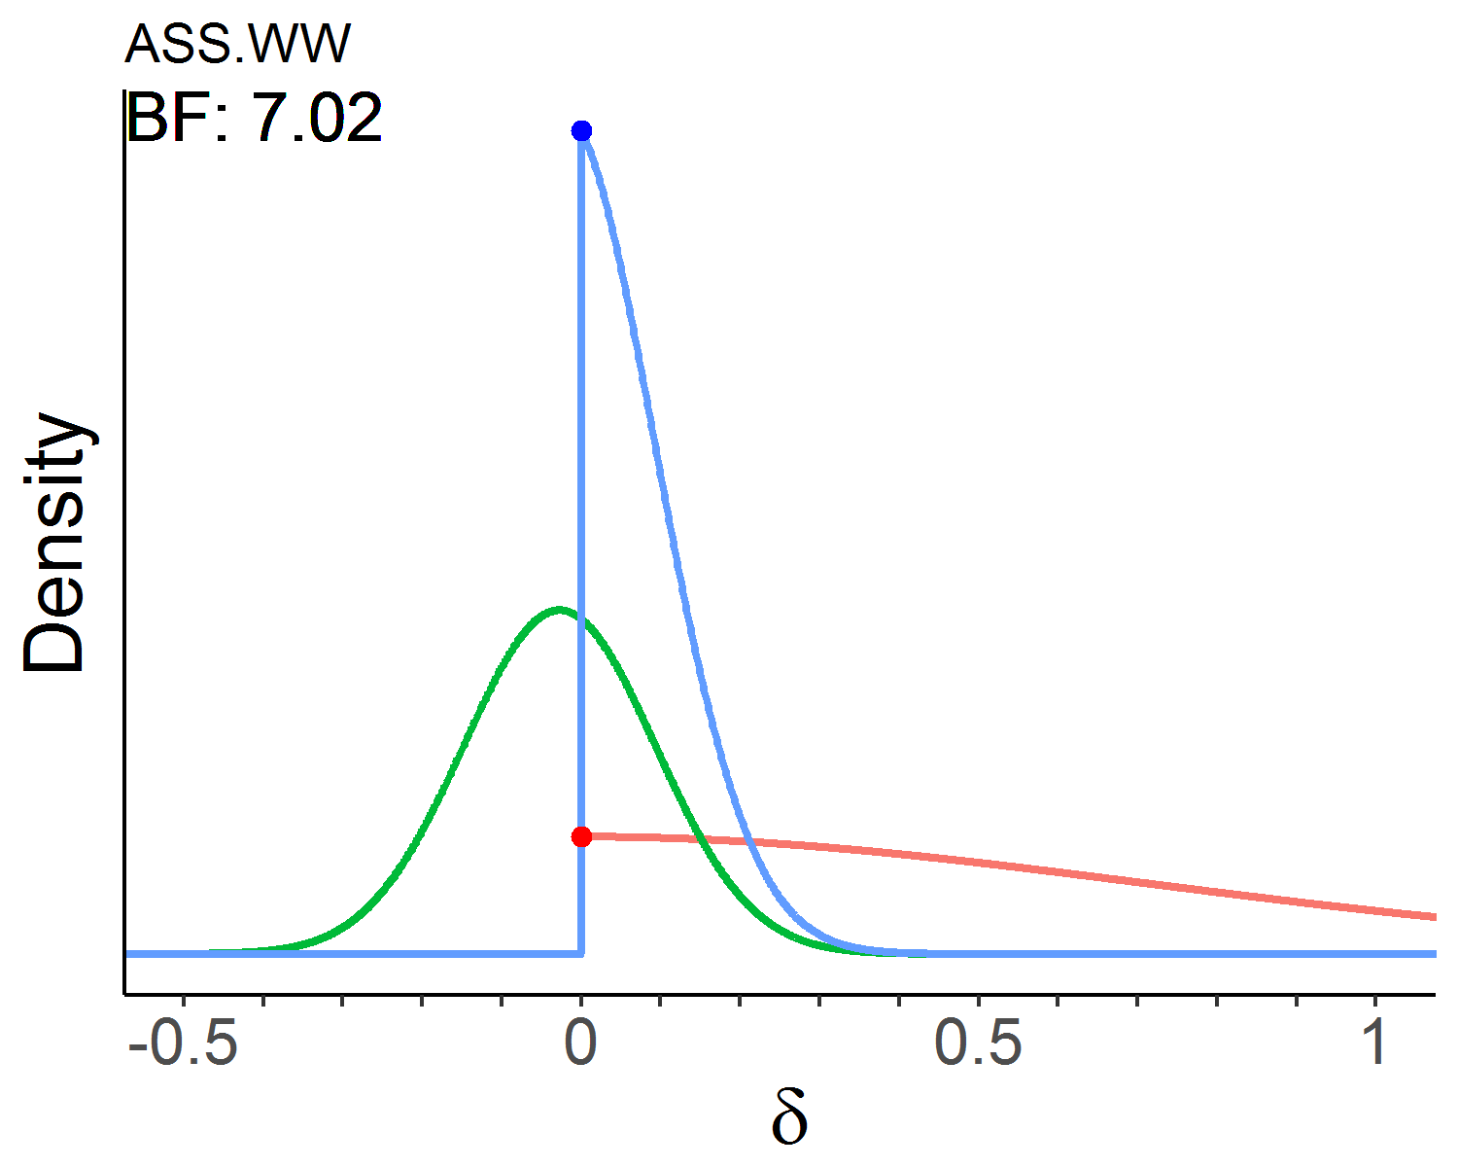
Item memory | Face-name | 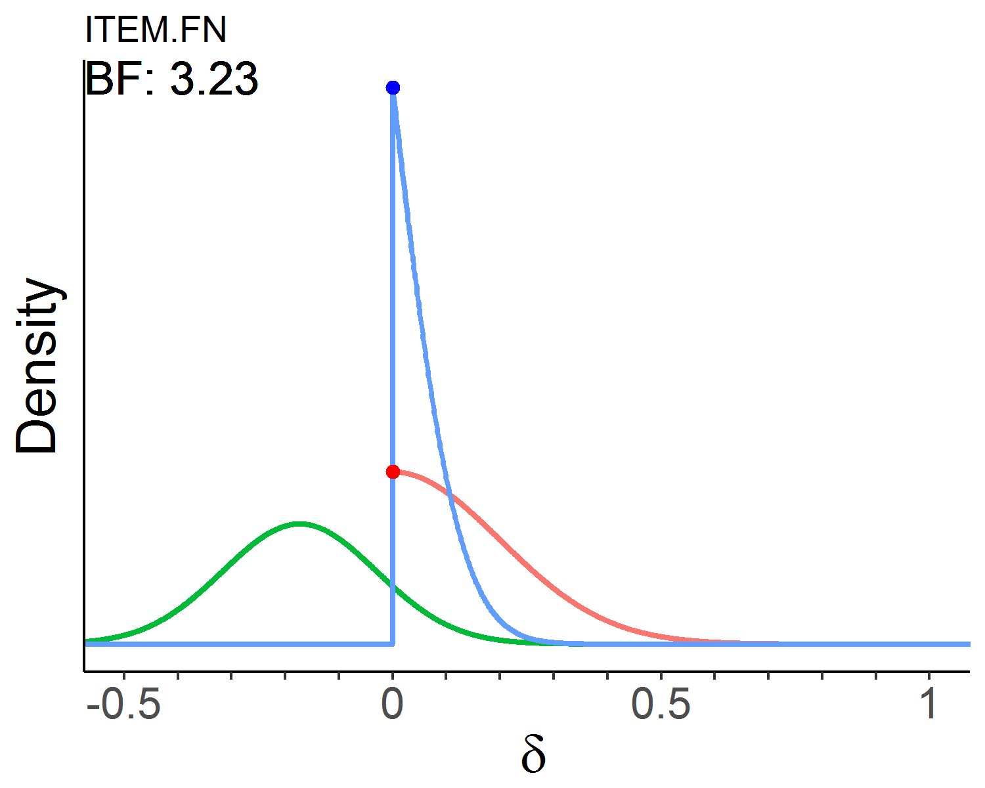 | 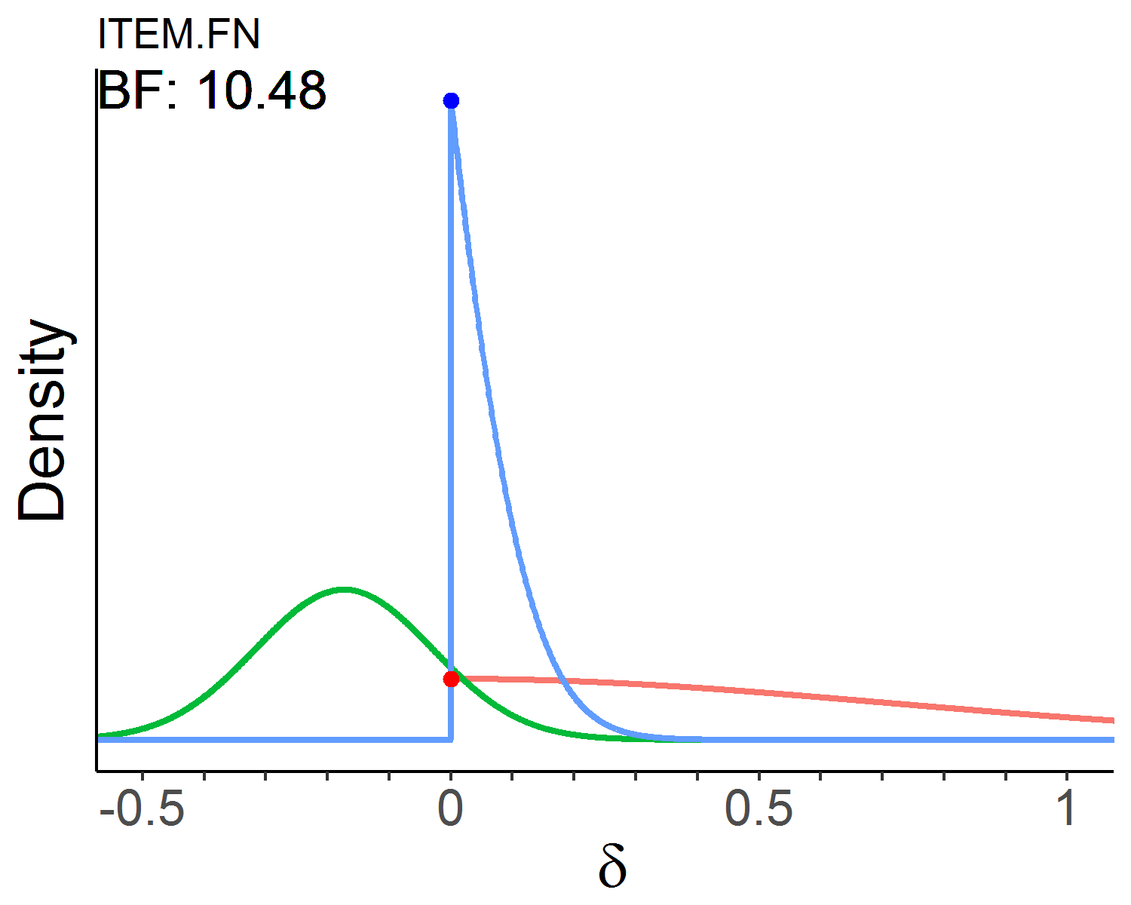
Item memory | Picture-picture | 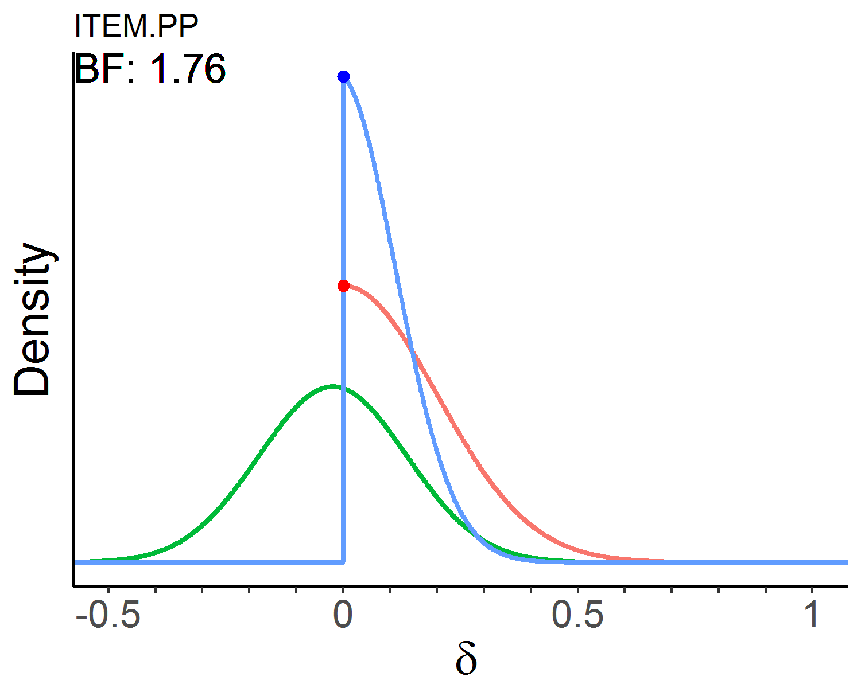 | 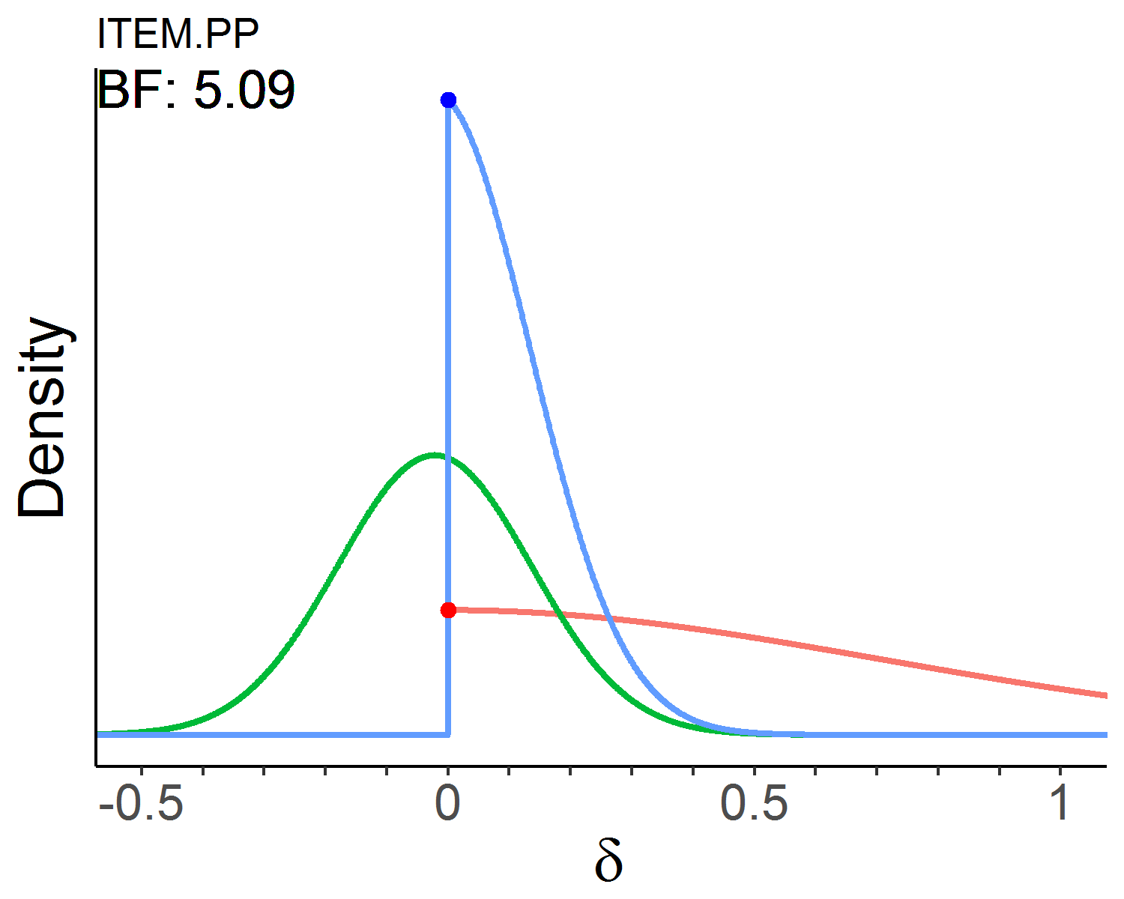
Item memory | Word-word | 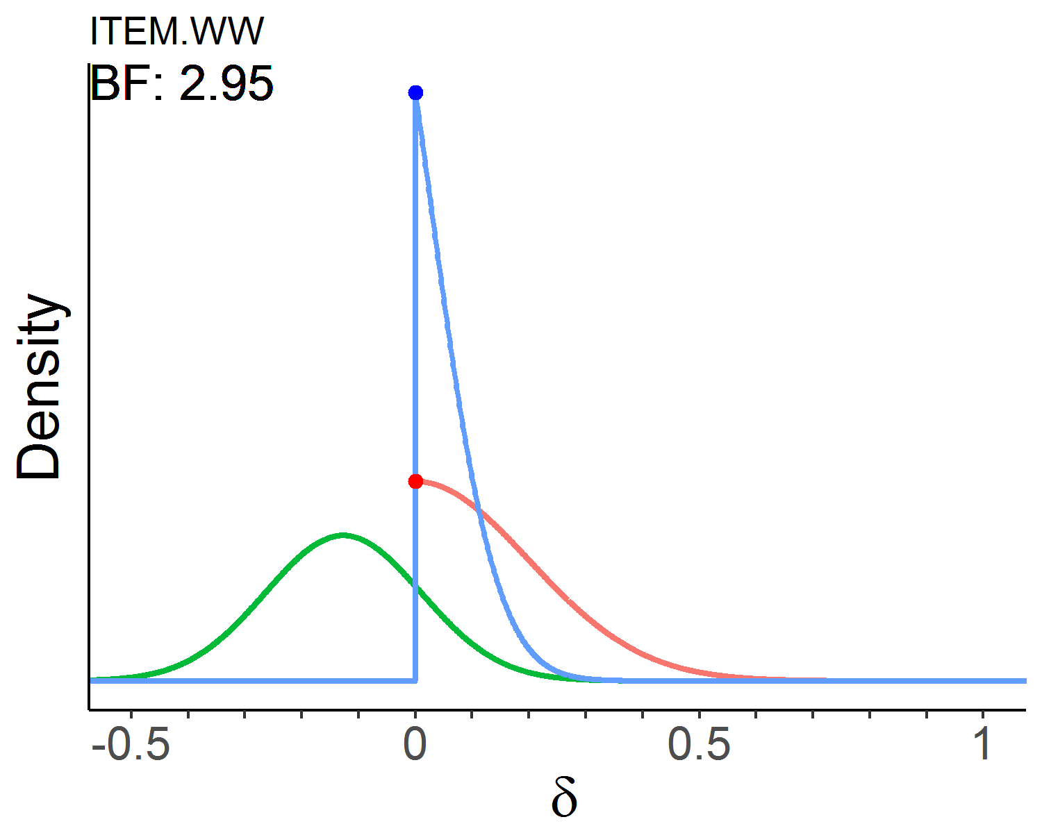 | 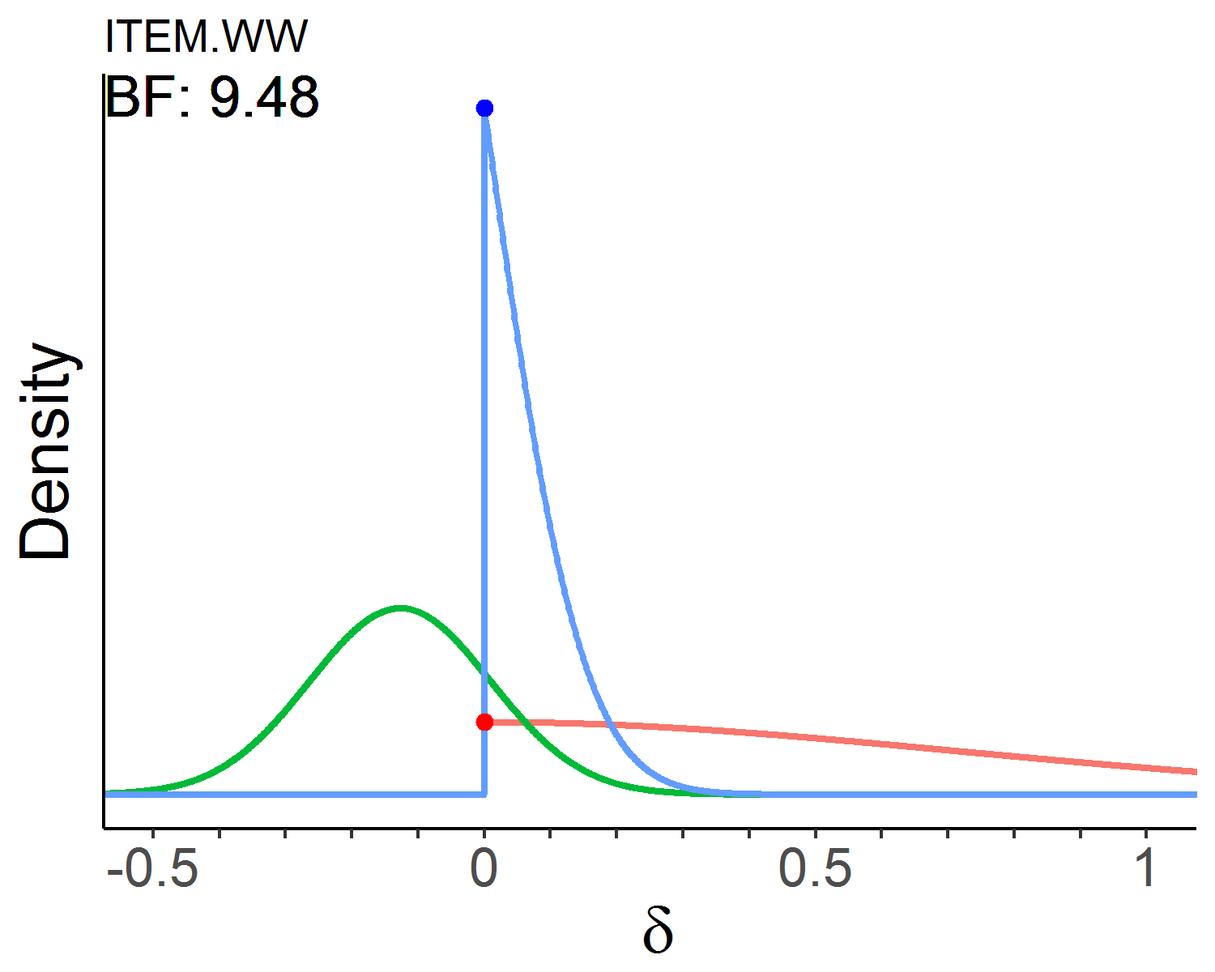
Verbal intelligence | Analogies | 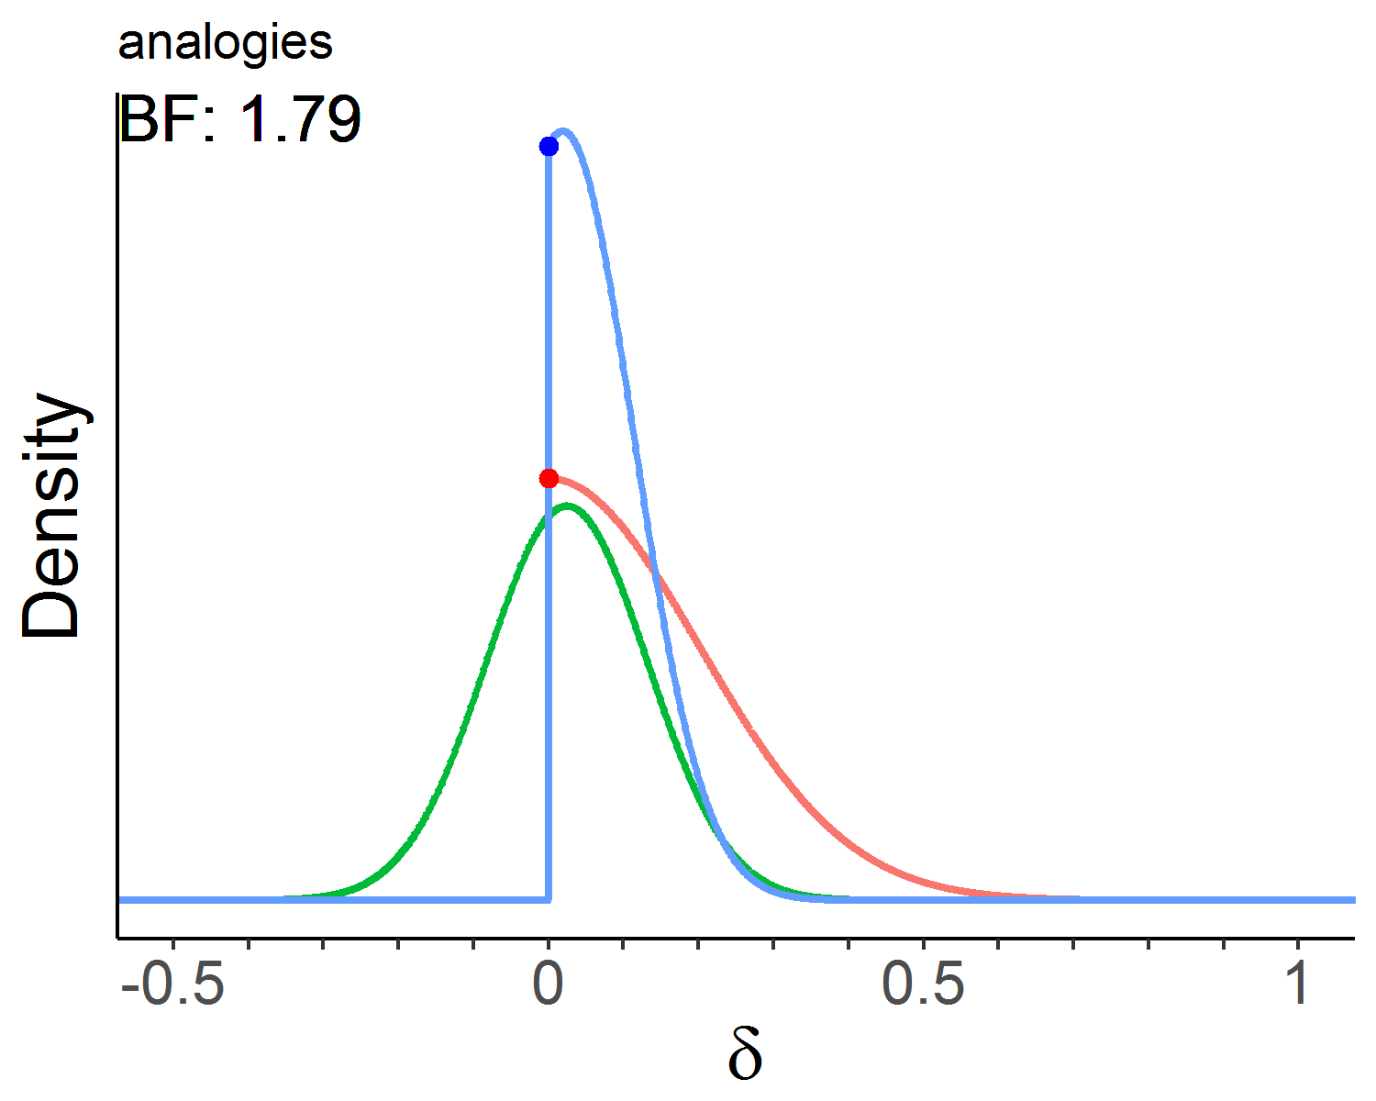 | 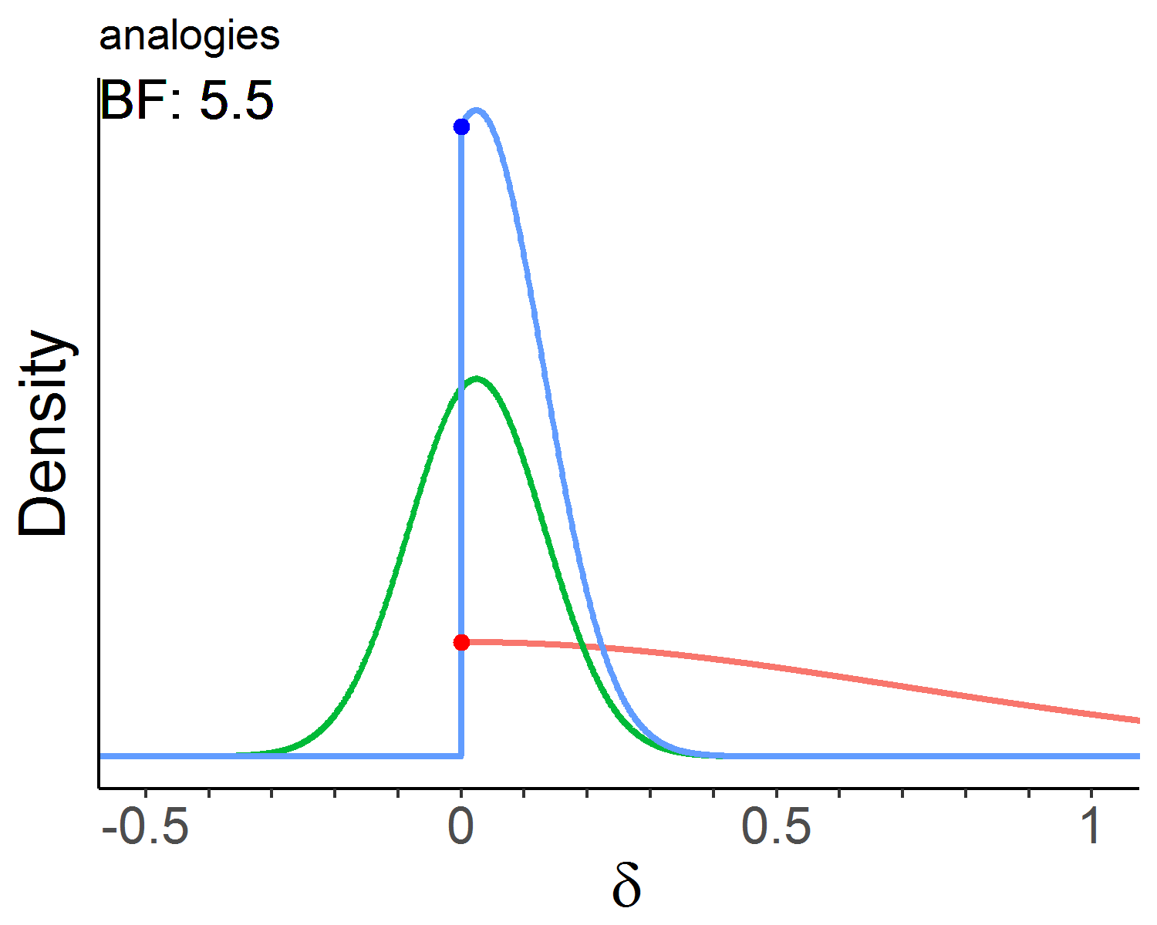
Verbal intelligence | Syllogism | 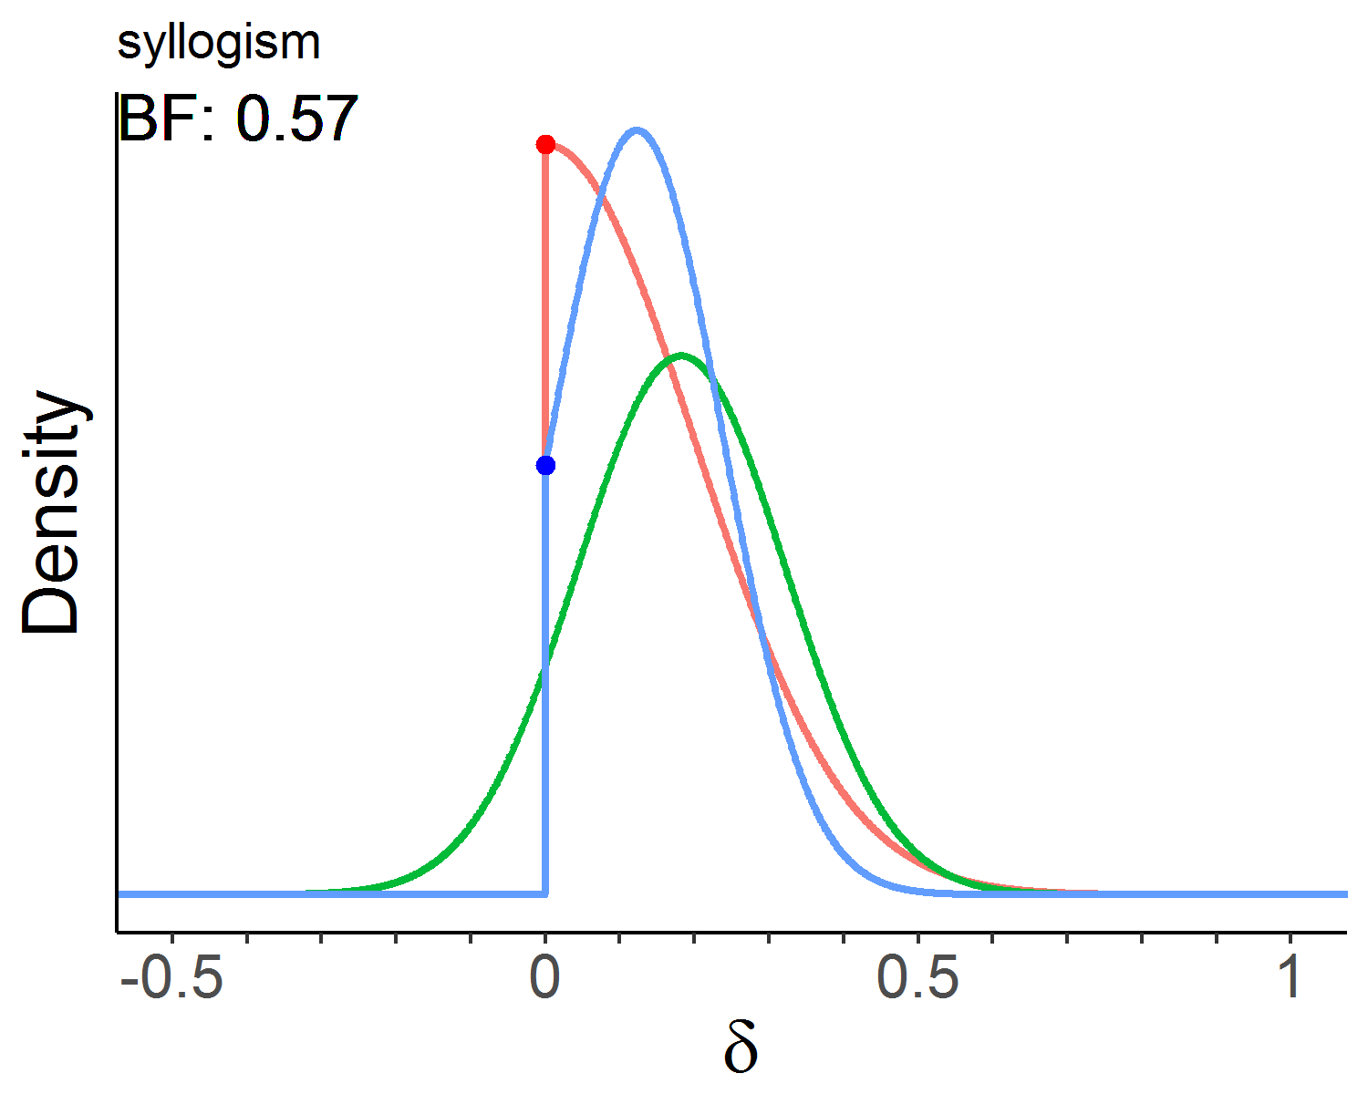 | 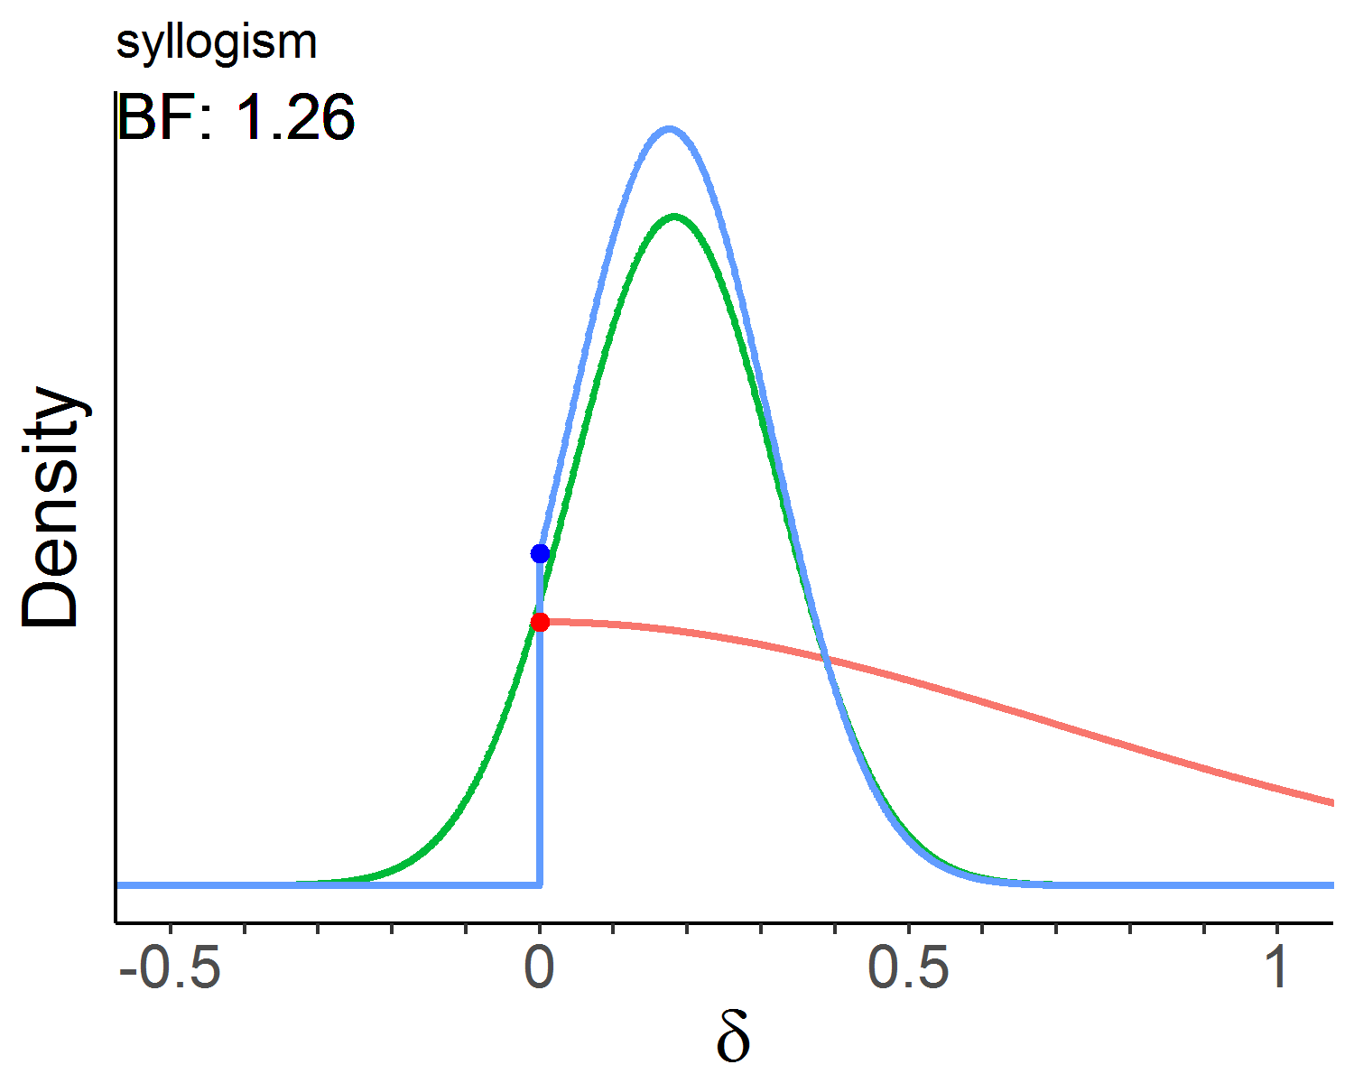
Verbal intelligence | Verbal inference | 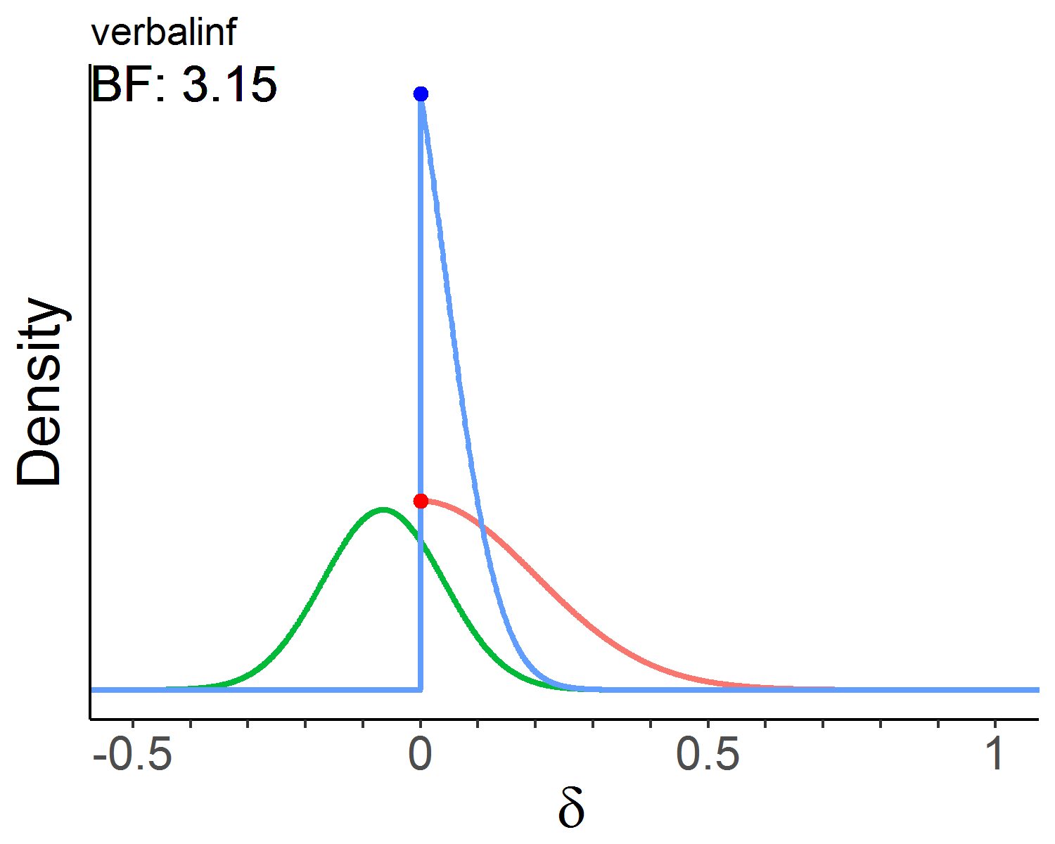 | 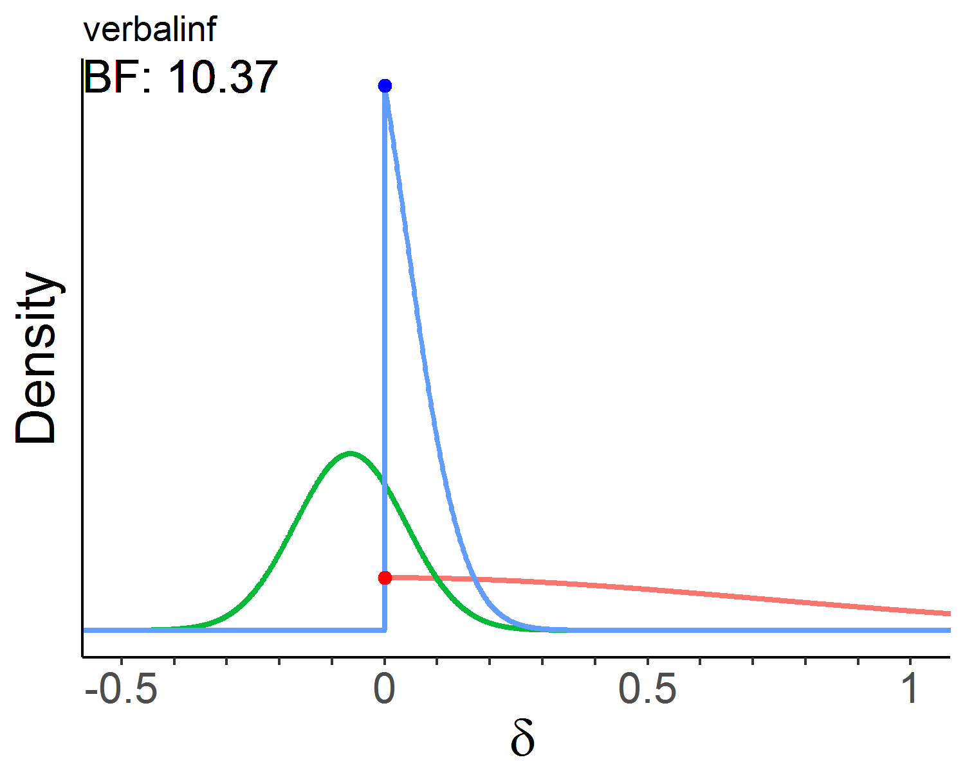
Working memory | N-back | 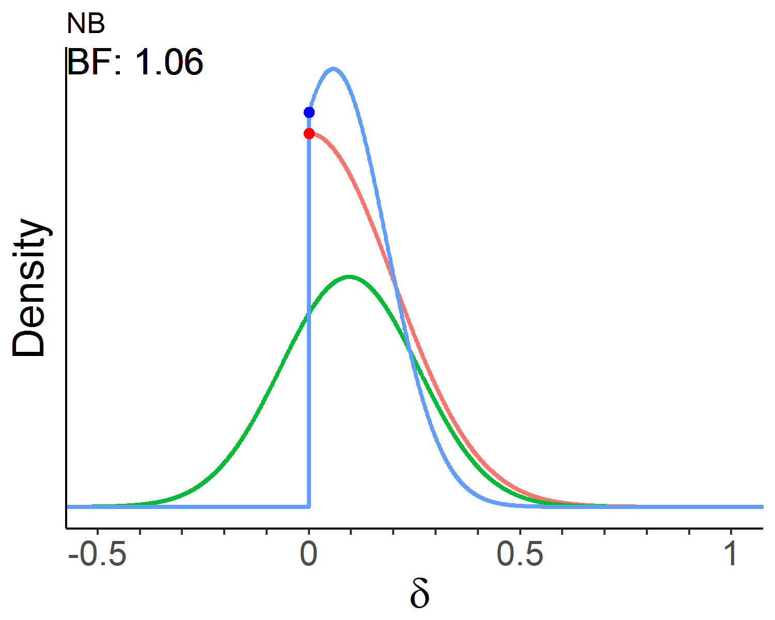 | 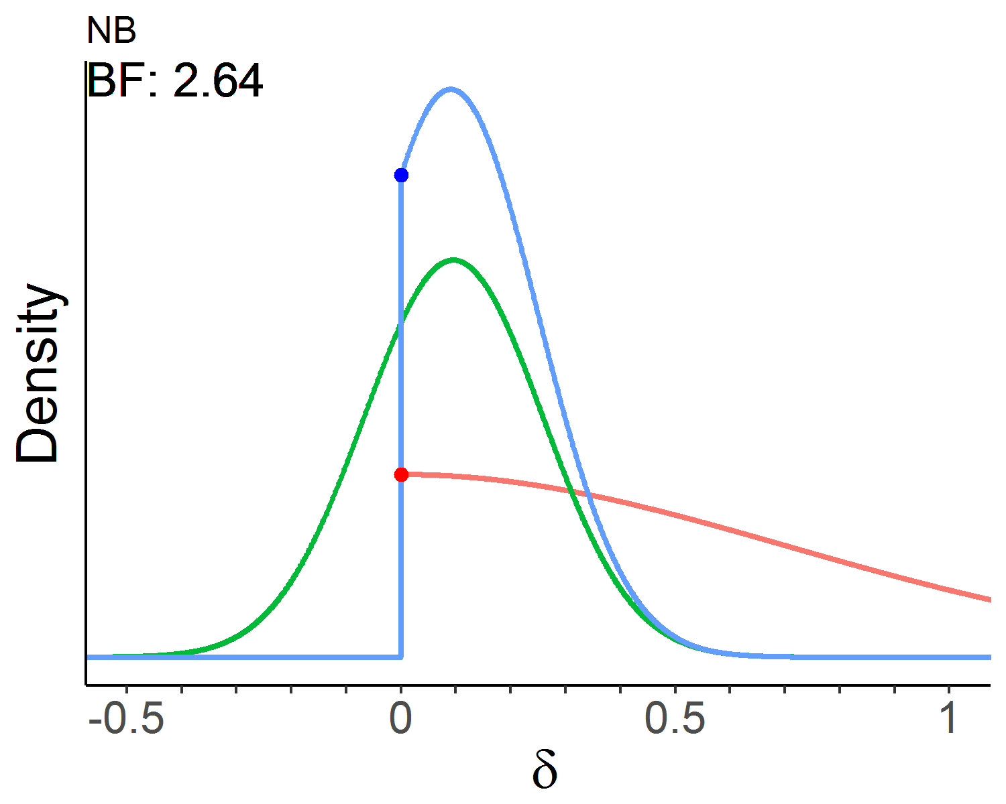
Working memory | Numerical updating | 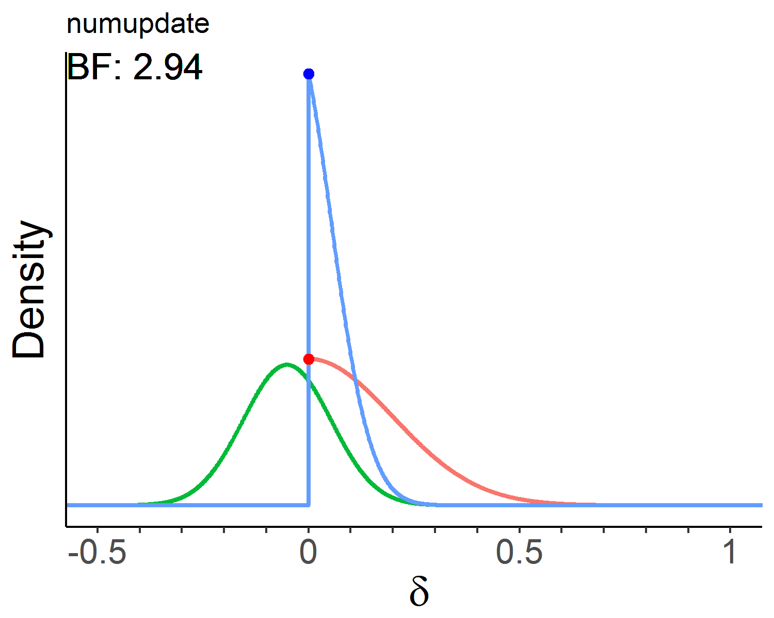 | 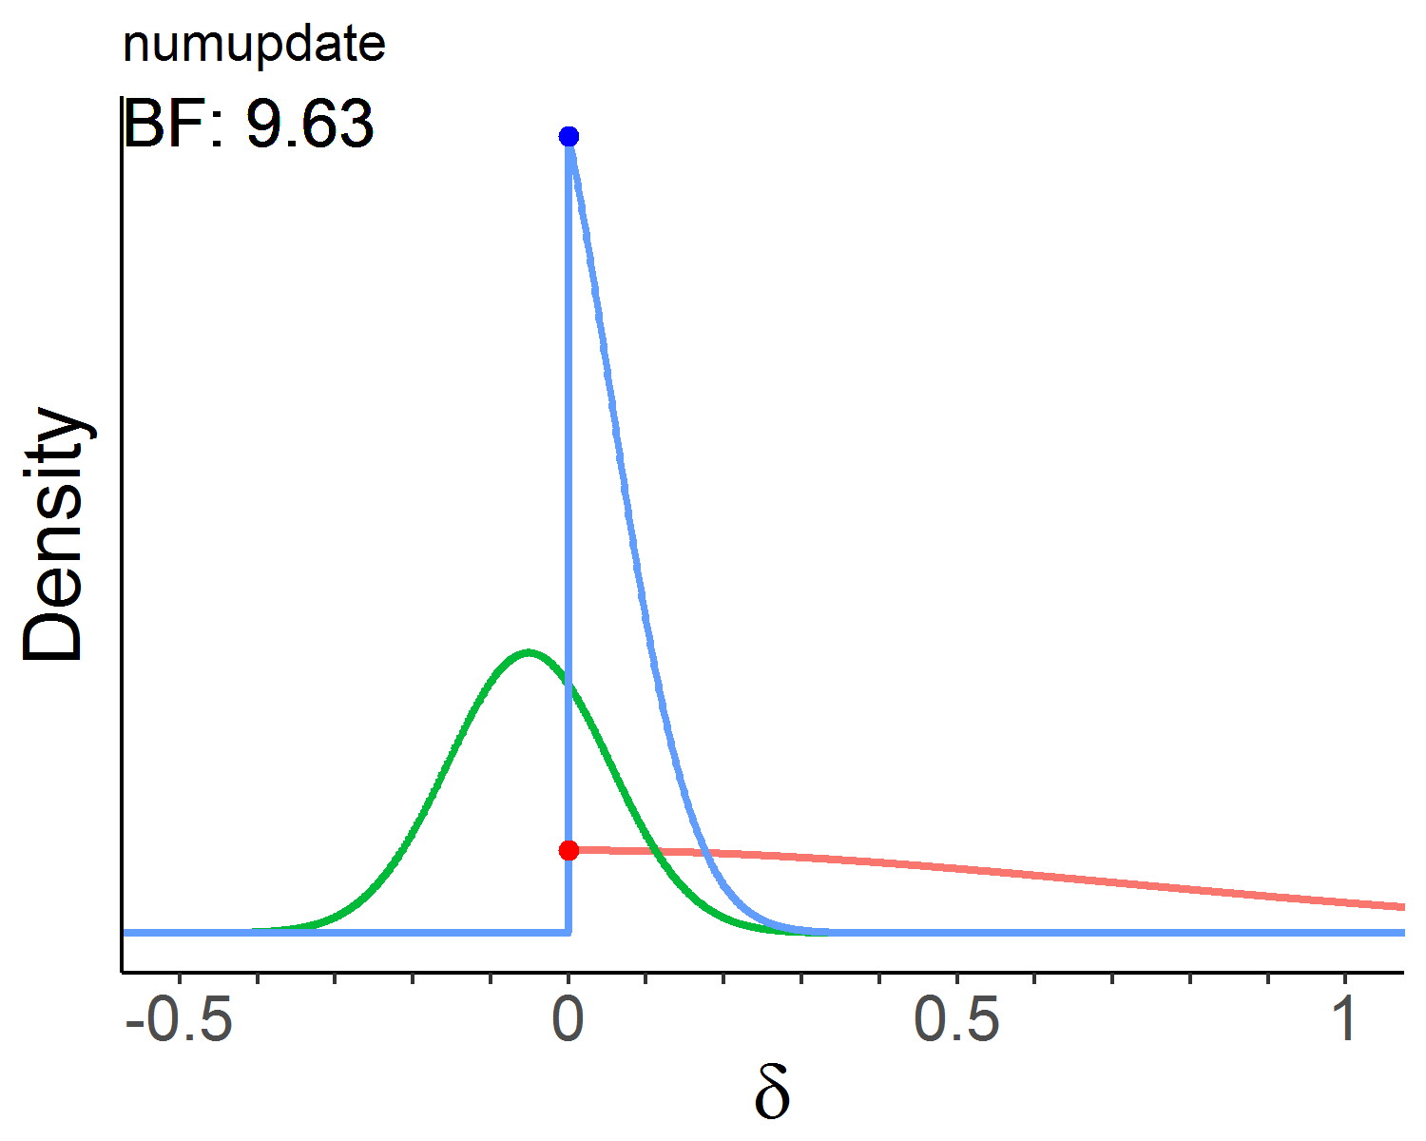
Spatial intelligence | Raven’s | 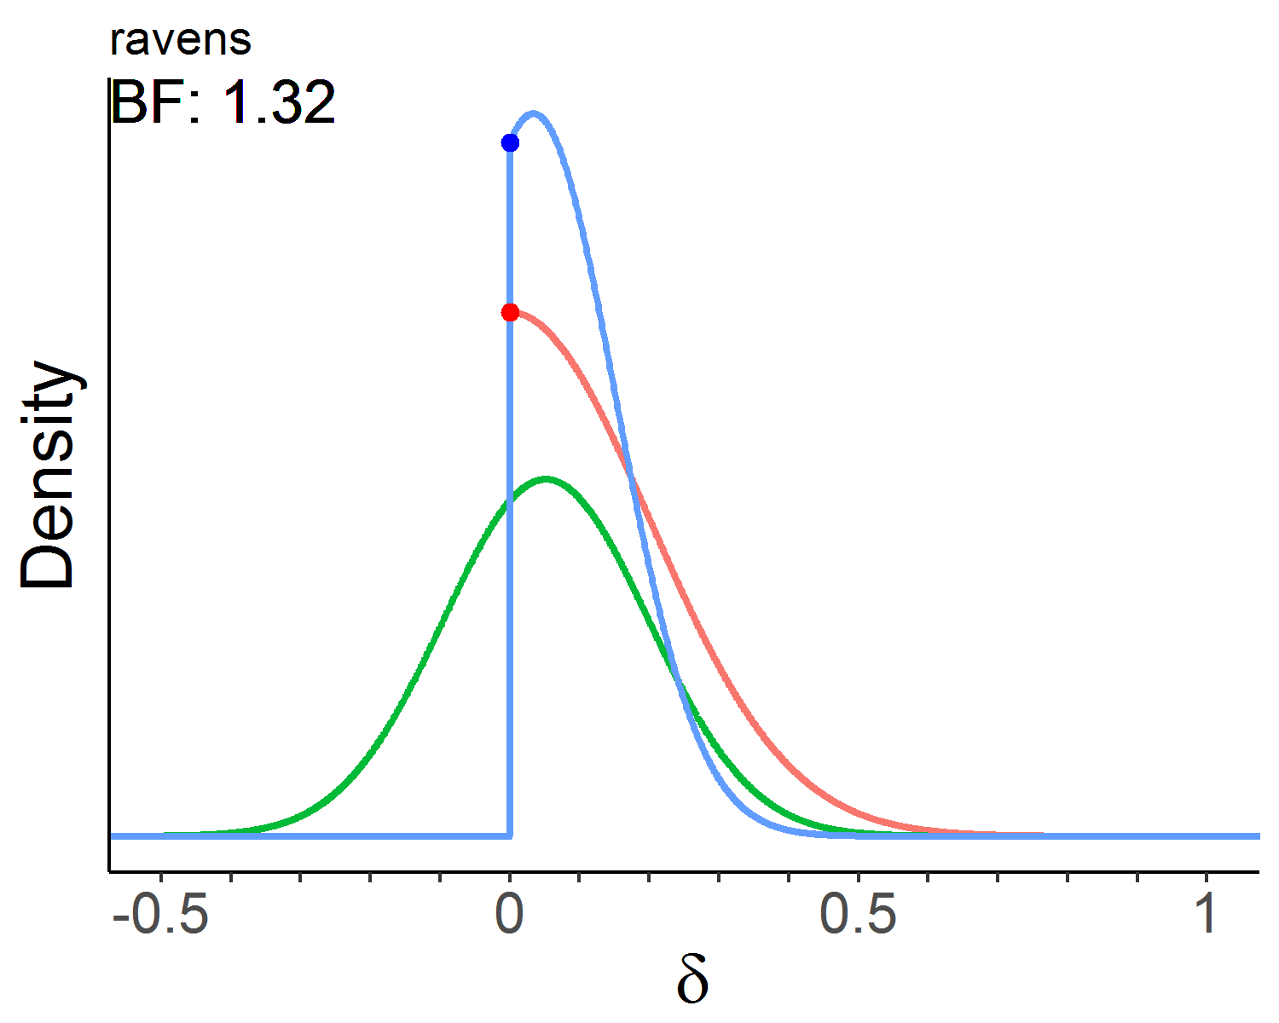 | 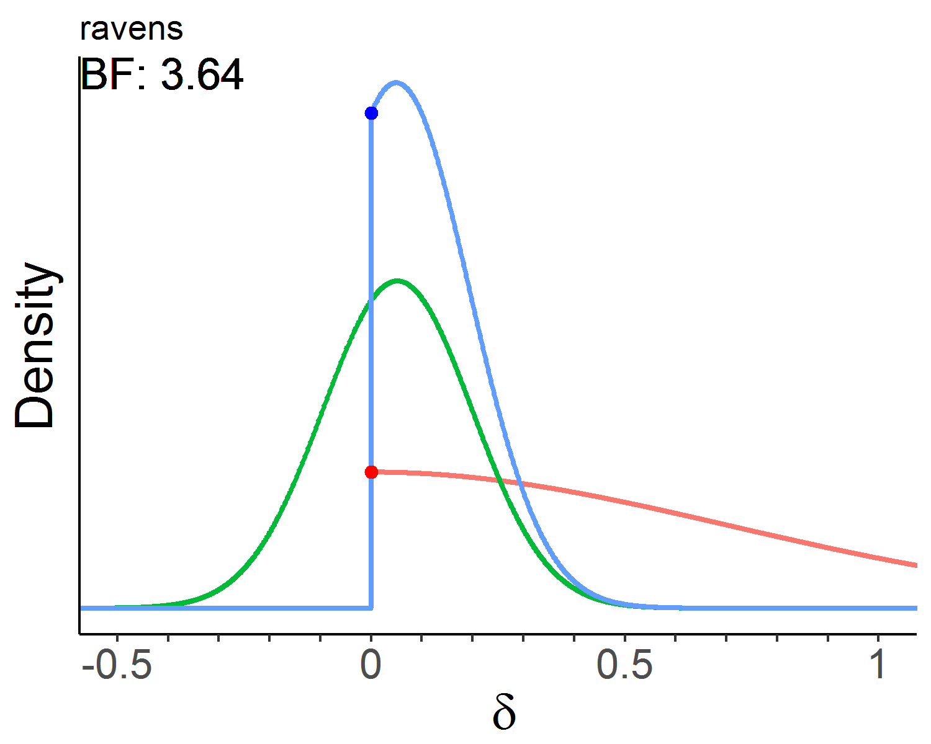
Spatial intelligence | WASI | 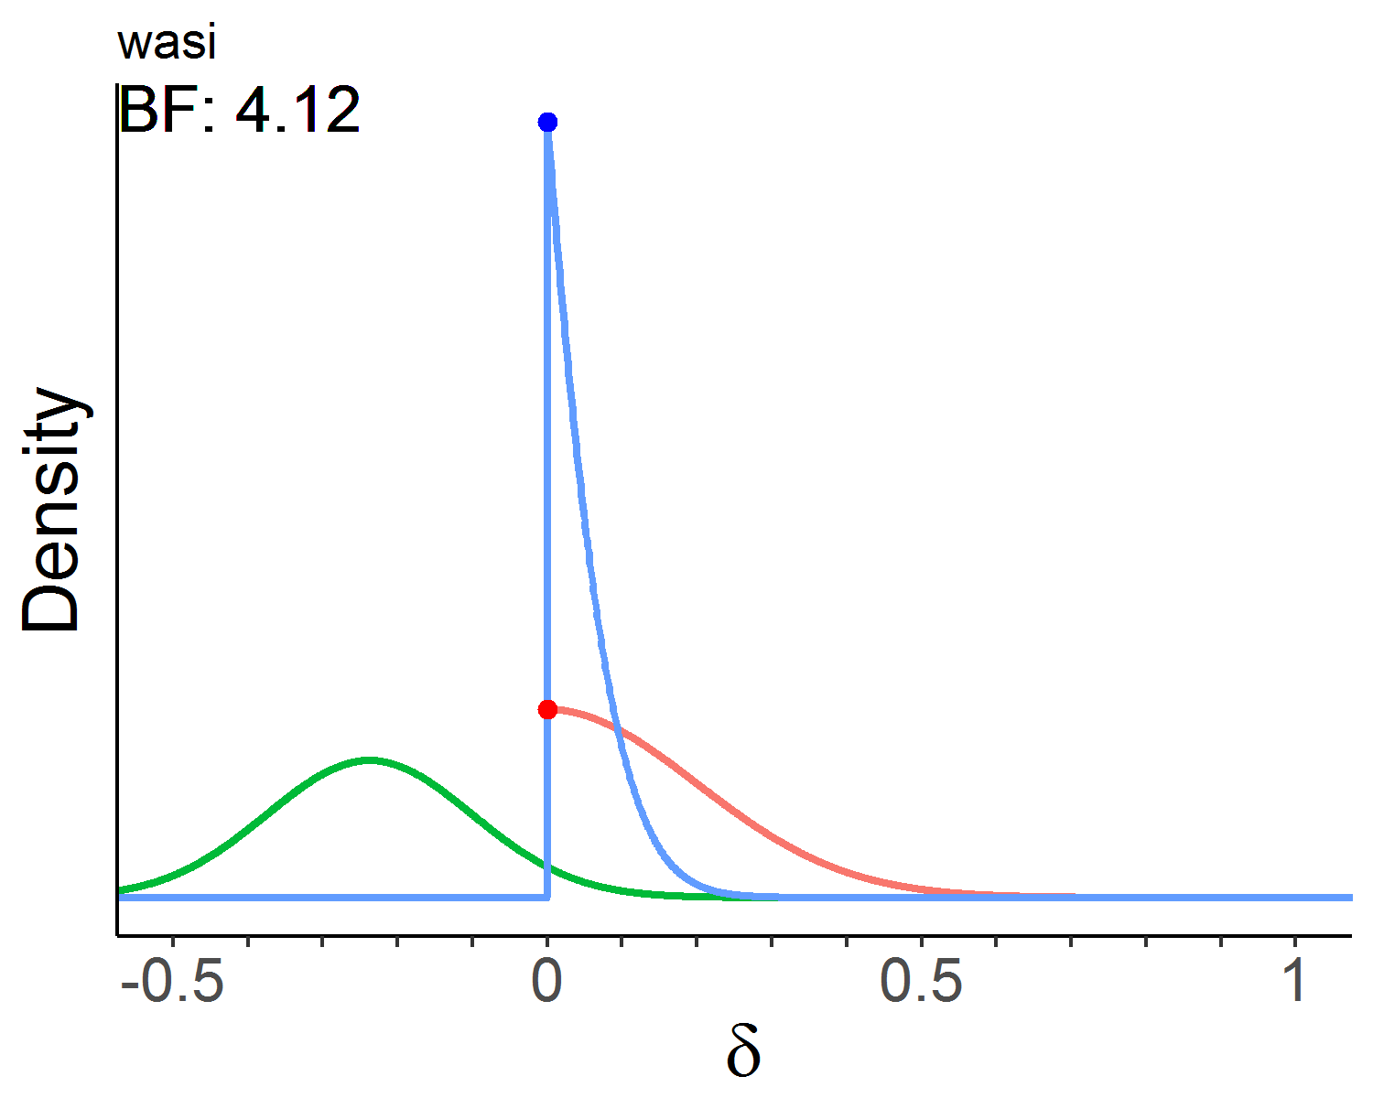 | 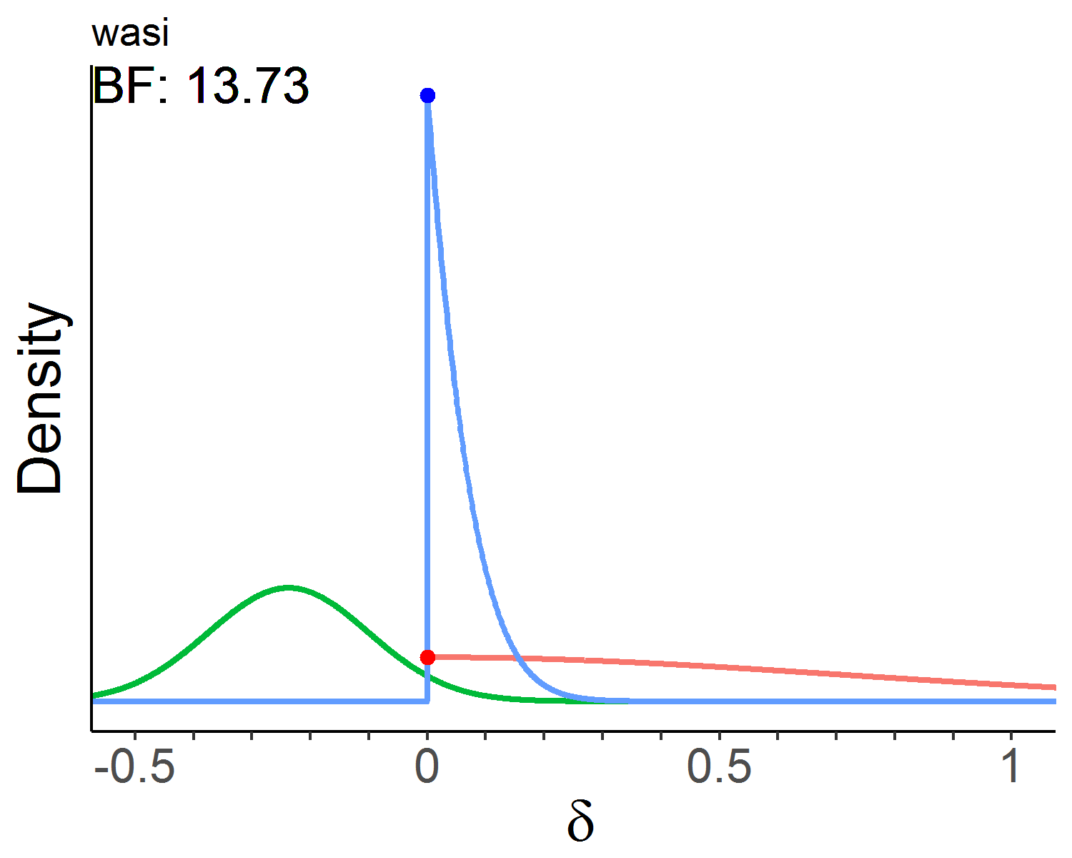

Online Supplement 7. Likelihood ratio χ² test of equality constrained Δ model vs unconstrained Δ model. p-values are calculated from the χ² distribution on 1 degree of freedom, χ²(1), with a critical value of 3.84. Non-significant findings suggest that there is no evidence of differential pre-post change between treatment groups.

Domain | Δχ² | p
Associative memory | 0.04 | .841
Item memory | 1.90 | .168
Verbal inference | 0.10 | .748
Working memory | 0.04 | .836
Spatial intelligence | 2.56 | .110

