Supplemental Material: Sample of HRN’s Social Media Listening Search Parameters

How Right Now
Covid
covid19
covid-19
coronavirus
corona virus
covid_19
covid 19
https://howrightnow.org/
link:https://howrightnow.org/
howrightnow
Que Hacer Ahora
quehacerahora
Caretaker
Elderly
Existing Condition
Financial Hardship
Exposed to Violence
Sad
Afraid
Angry
Grieving
Lonely
Stressed
worried
Resilient
Relieved
Thankful
Glad
Coping
Together
Optimistic
Resiliente
Alivio
Agradecido
Agradecimiento
Contento
Contenta
Feliz
Sobrellevar
Sobrellevando
Juntos
Optimista
Optimismo

Supplemental Material: HRN Survey Instrument with Images
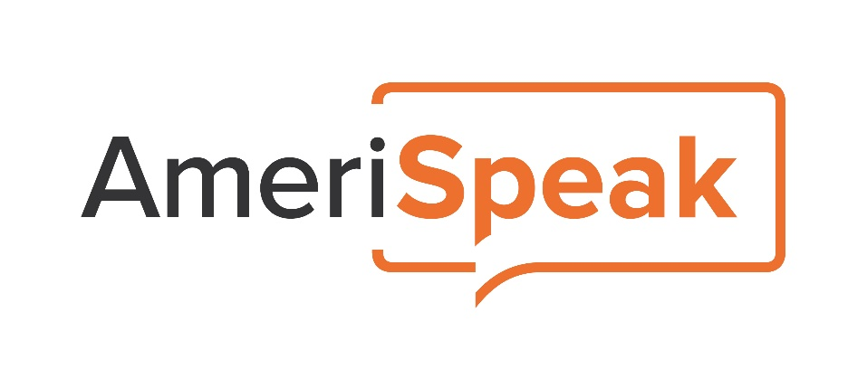

Standard demographic preloads:
Var Name | Include on Preload Testing-page? | Var Type | Var length | Variable Label
S_AGE | Y | Numeric | 5 | Age
S_GENDER | Y | String | 8 | Gender
S_RACETH | Y | Numeric | 8 | Race/ethnicity
S_EDUC | N | Numeric | 6 | Education
S_EDUC5 | Y | Numeric | 4 | 5-level education
S_MARITAL | Y | Numeric | 9 | Marital Status
S_EMPLOY | Y | Numeric | 8 | Current employment status
S_INCOME | Y | Numeric | 8 | Household income
S_HHINC_4 | N | Numeric | 4 | 4-level income
S_HHINC_9 | N | Numeric | 9 | 9-level income
S_STATE | Y | String | 7 | State
S_METRO | N | Numeric | 7 | Metropolitan area flag
S_INTERNET | N | Numeric | 10 | Household internet access
S_HOUSING | N | Numeric | 9 | Home ownership
S_HOME_TYPE | N | Numeric | 11 | Building type of panelist’s residence
S_PHONESERVC | N | Numeric | 11 | Telephone service for the household
S_HHSIZE | N | Numeric | 8 | Household size (including children)
S_HH01 | N | Numeric | 6 | Number of HH members age 0-1
S_HH25 | N | Numeric | 6 | Number of HH members age 2-5
S_HH612 | N | Numeric | 7 | Number of HH members age 6-12
S_HH1317 | N | Numeric | 8 | Number of HH members age 13-17
S_HH18OV | N | Numeric | 8 | Number of HH members age 18+
S_file_date | N | Date | 11
S_GENFRACE | N | Numeric | 8 | GenF custom race
These populated as a pre-load when the panelists get sampled into the survey

Standard sample preloads
Variable Name | Include on Preload Testing-only page? | Variable Type | Variable Label
Username | N | Numeric | Analogous to Member_PIN
P_Batch | N | Numeric | Batch Number (if only one assignment, then everyone will be 1)
Dialmode | N | Numeric | CATI Dialmode (predictive, preview, etc)
P_LCS | N | Numeric | Life cycle stage, 0=released but not touched
Y_FCELLP | N | String
Surveylength | N | Numeric | Estimated length of survey
SurveyId | N | Numeric | Survey ID# in A4S
Incentwcomma | N | String | Study specific
P_Hold01 | N | Numeric | Prevents dialing cases without phone numbers
PANEL_TYPE | Y | Numeric | 1 AmeriSpeak  2 Next Generation  3 GenF Extended (not in use)  4 AmeriSpeak Teen Panel  11 UTellUs converted  20 Lucid  21 SSI  50 Household 13-17  51 Household < 13  52 Household Adult  53 RDS Spawned Adult  60 ABS

Custom survey-specific preloads
Variable Name |  |  | Program in VCC? |  |  | Include on Preload Testing-only page? |  |  | Variable Type |  |  | Variable Label
LANG |  |  | YES |  |  | YES |  |  | String |  |  | EN=English  ES=Spanish
LANGUAGE |  |  | YES |  |  | YES |  |  | String |  |  | EN=English  ES=Spanish
P_ENGLISHTALK |  |  | Y |  |  | Y |  |  | Numeric |  |  | 1 Very well  2 Well  3 Not well  4 Not at all
P_ENGLISHREAD |  |  | Y |  |  | Y |  |  | Numeric |  |  | 1 Very well  2 Well  3 Not well  4 Not at all
P_LANG_OTHER1 |  |  | Y |  |  | Y |  |  | Numeric |  |  | 1 Yes  2 No
P_LANG_OTHER2 |  |  | Y |  |  | Y |  |  | Numeric |  |  | 1 SPANISH  2 ARABIC  3 CHINESE  4 FRENCH  5 GERMAN  6 KOREAN  7 POLISH  8 RUSSIAN  9 TAGALOG  10 VIETNAMESE  11 Other Language(Please specify)
P_LANG_OTHER2_OE |  |  | Y |  |  | N |  |  | String |  |  | TEXTBOX from LANG_OTHER2
P_LANG_OTHER3 |  |  | Y |  |  | Y |  |  | Numeric |  |  | 1 English  2 [fill in language selected at LANGOTHER2NEW]
P_LANG_PREF |  |  | Y |  |  | Y |  |  | Numeric |  |  | 1 English, or  2 Spanish
P_ACCULTURATION |  |  | Y |  |  | Y |  |  | Numeric |  |  | 1  2  3
P_GENDER_BIRTH |  |  | Y |  |  | Y |  |  | Numeric |  |  | 1 Male  Female
P_GENDER_TRANS |  |  | Y |  |  | Y |  |  | Numeric |  |  | 1 Transgender, male to female  2 Transgender, female to male  3 Transgender, gender non-conforming  4 Other (please specify)
P_GENDER_CONF |  |  | Y |  |  | Y |  |  | Numeric |  |  | 1 Yes  2 No
P_GENDER_CURRENT |  |  | Y |  |  | Y |  |  | Numeric |  |  | 1 Male  2 Female  3 Transgender  4 Do not identify as male, female, or transgender
P_LGBT |  |  | Y |  |  | Y |  |  |  |  |  | 1 Lesbian or gay  2 Straight, that is, not lesbian or gay  3 Bisexual  4 Something Else  5 I don’t know the answer
P_SOCMEDIA1_T |  |  | Y |  |  | Y |  |  |  |  |  | 1 Yes  2 No
P_SOCMEDIA1_F |  |  | Y |  |  | Y |  |  |  |  |  | 1 Yes  2 No
P_SOCMEDIA1_ I |  |  | Y |  |  | Y |  |  |  |  |  | 1 Yes  2 No
P_SOCMEDIA1_S |  |  | Y |  |  | Y |  |  |  |  |  | 1 Yes  2 No
P_HISPAN |  | YES |  |  | YES |  |  | Numeric |  |  | 1 No, I am not  2 If Yes, is that Mexican, Mexican-American, Chicano or  3 Puerto Rican or  4 Cuban  5 Central American or  6 South American or  7 Caribbean or  8 Other Spanish/Hispanic/Latino
RACE | Yes |  |  | Yes |  |  | Numeric |  |  | 1 "White"  2 "Black or African American"  3 "American Indian or Alaska Native"  4 "Asian Indian"  5 "Chinese"  6 "Filipino"  7 "Japanese"  8 "Korean" 9 "Vietnamese"  10 "Other Asian"  11 "Native Hawaiian"  12 "Guamanian or Chamorro"  13 "Samoan"  14 "Other Pacific Islander"  15 "Some other race"  16 "Multirace" .

This survey will use the following RND_xx variables:
Note, these are randomized in the script (NOT preloads)
RND_xx | Associated survey Qs
RND_00
RND_01
RND_02
RND_03
RND_04
RND_05
RND_06

Please code refusals in CAWI:
98 IMPLICIT REFUSAL, WEB SKIP
Do not code 77 Don’t Know/99 Refused options in CAWI unless written in item response options

Text shown in green includes researcher notes and should not be included in the programming.
Text shown in purple indicates Spanish translation that should be incorporated into the Spanish version of the survey

[START OF SURVEY]

CREATE DATA-ONLY VARIABLE: QUAL
1=Qualified Complete
2=Not Qualified
3=In progress

AT START OF SURVEY COMPUTE QUAL=3 “IN PROGRESS”

CREATE MODE_START
1=CATI
2=CAWI

(Project name) Draft
Date: (Quex start date)

PER CHRIS’ NOTES-WE ARE ADDING LOGIC INTO THE SURVEY TO POPULATE LANG BASED ON $L (SYSTEM LANGUAGE) FOR EVERY CAWI AND CATI CASE WHEN IT IS OPENED.

IF $L=EN THEN SET LANG=EN
IF $L==2 THEN SET LANG=ES
IF $L=ES THEN SET LANG=ES

PROGRAMMING NOTE: USE QUOTA FUNCTIONALITY IN A4S AND VOXCO, NOT SYNCHED, ACTIVATE QUOTAS IN VCC AND A4S.

QUOTA TARGETS AS FOLLOWS:

IF MEMBER_TYPE=1 AND LANG=EN = 1,020

[DISPLAY - QUOTA_MET]
Thank you for your interest in our survey. At this time we have reached the desired number of completed interviews. Please continue to check your member portal for the next available survey. Thank you and have a great day!
Gracias por su interés en nuestra encuesta. En este momento hemos alcanzado el número deseado de entrevistas completas. Por favor, visite el portal de miembros para la próxima encuesta disponible. ¡Gracias y que tengas un buen día!

EXIT AS QUOTA MET/CLOSED

[DISPLAY – WINTRO_1]
Thank you for agreeing to participate in our new AmeriSpeak survey! To thank you for sharing your opinions, we will give you a reward of [INCENTWCOMMA] AmeriPoints after completing the survey. As always, your answers are confidential.
¡Gracias por participar en nuestra nueva encuesta de AmeriSpeak! Para agradecerle por compartir su opinión, le daremos una recompensa de [INCENTWCOMMA] AmeriPoints después de completar esta encuesta. Como siempre, sus respuestas son confidenciales.
Please use the "Continue" and "Previous" buttons to navigate between the questions within the questionnaire. Do not use your browser buttons.
Por favor utilice los botones “Continuar” y “Anterior” para navegar entre las preguntas del cuestionario. No utilice los botones de su navegador.

INSERT ITEM TIMESTAMPS: TIME_START, DATE_START

[SHOW IF MODE=CAWI]
[MP]
PH1.
Which of the following are true for you?
¿Cuál de los siguientes casos aplica para usted?

[remove bold] <i> Select all that apply.</i>
[remove bold] <i>Seleccione todas las opciones que correspondan.<i>

RESPONSE OPTIONS, RANDOMIZED:
  - I am a caregiver for a family member aged 65 or older
  - I have been told by a health professional that I have any of the following: lung condition (like moderate to severe asthma), heart disease, obesity, high blood pressure, diabetes, mental health condition (like anxiety or depression), weakened immune system, chronic kidney or liver disease, substance abuse disorder (like alcohol or other drugs)
  - I have experienced violence and/or am at risk of experiencing violence (including intimate partner violence, sexual violence, elder abuse, or thoughts of hurting myself or others)
  - I am experiencing financial hardship that makes it hard to meet my basic daily needs and/or the basic daily needs of my family
  - None of the above [SP]

- Soy cuidador de un familiar mayor de 65 años.
- Un profesional de las salud me ha dicho que tengo algo de lo siguiente: enfermedad pulmonar (como asma moderada o grave), enfermedad cardiaca, obesidad, presión arterial alta, diabetes, condición de salud mental (como ansiedad o depresión), sistema inmunitario débil, enfermedad renal o hepática crónica, o trastorno de abuso de sustancias (como alcohol u otras drogas).
- He sido víctima de violencia o estoy en riesgo de serlo (incluso violencia por parte de mi pareja íntima, violencia sexual, abuso de personas mayores o ideas de hacerme daño a mí mismo o a otras personas).
- Estoy pasando por problemas económicos que hacen difícil el satisfacer mis necesidades básicas diarias o las de mi familia.
- Ninguna de las anteriores [SP]

[MP]
PH2.
Which, if any, of the following apply to you?
¿Cuál de las siguientes situaciones, si alguna, aplica para usted?

[remove bold] <i> Select all that apply.</i>
[remove bold] <i>Seleccione todas las opciones que correspondan.<i>

RESPONSE OPTIONS:
      - I am currently pregnant
      - I am deaf or have serious difficulty hearing
      - I am blind or have serious difficulty seeing, even when wearing glasses
      - Because of a physical, mental, or emotional condition, I have serious difficulty concentrating, remembering, or making decisions
      - I have serious difficulty walking or climbing stairs
      - I have difficulty dressing or bathing
      - Because of a physical, mental, or emotional condition, I have difficulty doing errands alone such as visiting a doctor’s office or shopping
      - None of the above [SP]

- Estoy actualmente en embarazo.
- Soy sordo o tengo bastante dificultad para oír.
- Soy ciego o tengo bastante dificultad para ver, incluso usando anteojos.
- Debido a una condición física, mental o emocional, tengo bastante dificultad para concentrarme, recordar o tomar decisiones.
- Tengo bastante dificultad para caminar o subir escaleras.
- Tengo dificultad para vestirme o bañarme.
- Debido a una afección física, mental o emocional, tengo dificultad para hacer quehaceres solo, como ir a una cita médica o ir de compras.
- Ninguna de las anteriores [SP]

[SP]
PH3.
We are interested in your opinion about how your life has been and will be impacted by the COVID-19 pandemic.
Nos interesa conocer su opinión sobre cómo su vida ha sido y será afectada por la pandemia del COVID-19.
[SPACE]
Have you received a COVID-19 vaccine?
¿Ha recibido una vacuna contra COVID-19?

RESPONSE OPTIONS:
            - Yes
            - No

[SHOW IF PH3=2]
[SP]
PH3A.
Once a vaccine to prevent COVID-19 is available to you, would you…
Una vez esté disponible para usted una vacuna para prevenir la COVID-19, usted ...

RESPONSE OPTIONS:
- Definitely get a vaccine
- Probably get a vaccine
- Be unsure about getting a vaccine
- Probably <u>not</u> get a vaccine
- Definitely <u>not</u> get a vaccine

- Definitivamente se aplicará la vacuna
- Probablemente se aplicará la vacuna
- No está seguro/a de querer vacunarse
- Probablemente <u>no</u> se aplicará la vacuna
- Definitivamente <u>no</u> se aplicará la vacuna

[MP]
PH4a.
Next, we are interested in your feelings and experiences regarding the COVID-19 pandemic in the United States.
Siguiente, nos interesan sus sentimientos y experiencias relacionadas con la pandemia del COVID-19 en los Estados Unidos.
[SPACE]
Which of the following are you experiencing during the COVID-19 pandemic?
¿Cuál de las siguientes situaciones está viviendo durante la pandemia del COVID-19?

[remove bold] <i> Select all that apply.</i>
[remove bold] <i>Seleccione todas las opciones que correspondan.<i>.

RESPONSE OPTIONS, RANDOMIZED:
            - Exposed/Exposure to COVID-19 (e.g., through your work or workplace)
            - Had/Having COVID-19 symptoms
            - Having been tested for COVID-19
            - Having been diagnosed with COVID-19
            - Change to daily life patterns as compared to before COVID-19
            - Loved one with COVID-19
            - Death or loss of a loved one
            - Personal financial loss (e.g., lost wages, job loss, investment/retirement loss, travel-related cancelations)
            - Being unable to meet basic food needs and/or housing needs
            - Being unable to access to medications or healthcare
            - Having symptoms of “long COVID” (e.g., lingering symptoms following COVID-19 such as fatigue, loss of smell, body aches)
            - None of the above [SP]

- Exposición al COVID-19 (como por medio del empleo o en el sitio de trabajo)
- Tener síntomas de COVID-19
- Haberse hecho la prueba de COVID-19
- Haber sido diagnosticado con COVID-19
- Cambiar las rutinas de la vida diaria que tenía antes del COVID-19
- Un ser querido con COVID-19
- Muerte o pérdida de un ser querido
- Pérdida económica personal (como la pérdida de salario, pérdida del empleo, pérdida de inversiones o pensión, o cancelaciones relacionadas con viajes)
- No poder satisfacer las necesidades básicas de alimentación y/o de vivienda
- No poder acceder a medicamentos o atención médica
- Tener síntomas de "long COVID (efectos prolongados de COVID) " (por ejemplo, síntomas persistentes después de COVID-19 como fatiga, pérdida de olfato, dolores corporales)
- Ninguna de las anteriores [SP]

[MP]
PH4B.
Which of the following are you experiencing during the COVID-19 pandemic?
¿Cuál de las siguientes situaciones está viviendo durante la pandemia del COVID-19?

[remove bold] <i> Select all that apply.</i>
[remove bold] <i>Seleccione todas las opciones que correspondan.<i>.

RESPONSE OPTIONS, RANDOMIZED:
- Childcare challenges
- Difficulty caring for a chronic condition (yours or other’s)
- Emotional or physical abuse from others
- People treating me negatively because they think I have COVID-19, symptoms, or a diagnosis
- Worry about getting COVID-19
- Worry about giving COVID-19 to someone else
- Worry about not being able to get testing
- Worry about the impacts on my life from a second wave of COVID-19
- Worry that others are not taking precautions seriously
- Worry about the physical, financial, or emotional health of others (e.g. friends and family)
- Feelings of frustration about trying to get the COVID-19 vaccine
- Feelings of shame or embarrassment because I think I might need mental health help, support or resources
- None of the above [SP]

- Problemas para el cuidado de los niños
- Dificultad para atender una enfermedad crónica (propia o de otra persona)
- Abuso emocional o físico por parte de otras personas
- La gente me trata negativamente porque cree que tengo COVID-19, síntomas o un diagnóstico
- Preocupación por contraer el COVID-19
- Preocupación por trasmitirle el COVID-19 a alguien más
- Preocupación por no poder hacerse la prueba
- Preocupación sobre cómo puede afectarme la vida una segunda ola de COVID-19
- Preocupación porque otras personas no se están tomando en serio las medidas de precaución
- Preocupación sobre la salud física, económica o emocional de otras personas (como amigos y familiares)
- Sentimientos de frustración al intentar obtener la vacuna contra COVID-19
- Sentimientos de vergüenza o pena porque creo que puedo necesitar ayuda, apoyo o recursos de salud mental
- Ninguna de las anteriores [SP]

[MP]
PH4C.
Which of the following are you experiencing during the COVID-19 pandemic?
¿Cuál de las siguientes situaciones está viviendo durante la pandemia del COVID-19?

[remove bold] <i> Select all that apply.</i>
[remove bold] <i>Seleccione todas las opciones que correspondan.<i>

RESPONSE OPTIONS, RANDOMIZED:
- Feelings of frustration
- Feelings of boredom
- Increased anxiety
- Increased depression
- More sleep, less sleep, or other changes to your normal sleep pattern
- Changes in eating and/or challenges maintaining healthy eating habits (<u>not</u> related to food availability)
- Increased alcohol or other substance use
- Increased feelings of isolation or loneliness
- Confusion about what COVID-19 is, how to prevent it, or why social distancing, isolation, or quarantines are needed
- Concern about an allergic reaction or possible side effects from the COVID-19 vaccine
- None of the above [SP]

- Sentimientos de frustración
- Sentimientos de aburrimiento
- Más ansiedad
- Más depresión
- Más sueño, menos sueño u otros cambios en el patrón normal de sueño
- Cambios en la alimentación o dificultad para mantener hábitos alimenticios saludables (que <u>no</u> están relacionados con la disponibilidad de alimentos)
- Mayor consumo de alcohol o de otras sustancias
- Más sentimientos de aislamiento o soledad
- Confusión sobre qué es el COVID-19, cómo prevenirlo o por qué son necesarios el distanciamiento social, el confinamiento o las cuarentenas
- Preocupación por una reacción alérgica o posibles efectos secundarios de la vacuna contra el COVID-19
- Ninguna de las anteriores [SP]

[MP]
PH4D.
Which of the following are you experiencing <u>since the start of 2021</u>?
¿Cuál de las siguientes situaciones está viviendo <u>desde el comienzo de 2021</u>?

[remove bold] <i> Select all that apply.</i>
[remove bold] <i>Seleccione todas las opciones que correspondan.<i>

RESPONSE OPTIONS, RANDOMIZED:
- Increased feelings of hope
- Increased feelings of gratitude
- Increased belief that we will bounce back
- Increased sense of community
- Increased feelings of relief because a COVID-19 vaccine is available
- None of the above [SP]

- Aumento de los sentimientos de esperanza
- Aumento de los sentimientos de gratitud
- Mayor convicción de que nos recuperaremos
- Mayor sentido comunitario
- Mayor sensación de alivio por la disponibilidad de la vacuna contra el COVID-19
- Ninguna de las anteriores [SP]

[SHOW PH5A AND PH5B ON SAME SCREEN]
[SP]
For the following questions, please rate how much the COVID-19 pandemic has changed your life in the following ways:
En las siguientes preguntas, califique qué tanto le ha cambiado la vida por el COVID-19 de las siguientes formas:

PH5A.
Overall experiences of stress related to the COVID-19 pandemic:
Experiencias de estrés en general relacionadas con la pandemia del COVID-19:

RESPONSE OPTIONS:
- None.
- Mild. Occasional worries and/or minor stress-related symptoms (such as feeling a little anxious, sad, and/or angry; mild/rare sleeping problems).
- Moderate. Frequent worries and/or moderate stress-related symptoms (such as feeling moderately anxious, sad, and/or angry; moderate/occasional sleeping problems).
- Severe. Persistent worries and/or severe stress-related symptoms (such as feeling extremely anxious, sad, agitated, and/or angry; severe/frequent sleeping problems).

- En nada.
- Poco. Preocupaciones ocasionales o síntomas leves relacionados con el estrés (como sentirse un poco ansioso, triste o disgustado; o presentar problemas leves o poco frecuentes de sueño).
- Moderadamente. Preocupaciones frecuentes o síntomas moderados relacionados con el estrés (como sentirse moderadamente ansioso, triste o disgustado; o presentar problemas moderados u ocasionales de sueño).
- Mucho. Preocupaciones constantes o síntomas intensos relacionados con el estrés (como sentirse extremadamente ansioso, triste, agitado o disgustado; o presentar problemas graves o frecuentes de sueño).

PH5B.
Stress and discord in the family:
Estrés y discordia en la familia:

RESPONSE OPTIONS:
- None.
- Mild. Family members occasionally short-tempered with one another; no physical violence.
- Moderate. Family members frequently short-tempered with one another; and/or children in the home getting in physical fights with one another.
- Severe. Family members frequently short-tempered with one another, feeling threat of physical violence, and/or adults in the home throwing things at one another, and/or knocking over furniture, and/or hitting and/or harming one another.

- En nada.
- Poco. Los familiares en ocasiones se irritan mutuamente; no hay violencia física.
- Moderadamente. Los miembros de la familia con frecuencia se enojan mutuamente; o los niños de la casa pelean físicamente entre sí.
- Mucho. Los miembros de la familia con frecuencia se enojan entre sí, siente la amenaza de violencia física, y/o los adultos de la casa se tiran cosas unos a otros, y/o tumban los muebles, y/o se golpean y/o se hacen daño.

[SP]
PH6.
Many people, even those who are strong or resilient, sometimes feel hopeless in certain situations.
Muchas personas, incluso aquellas que son fuertes y resilientes, algunas veces se sienten sin esperanza en ciertas situaciones.
[SPACE]
On a scale of 1 to 5, where a one is never and a five is very often, how often have you felt hopeless during the COVID-19 pandemic?
En una escala de 1 a 5, en la que 1 es nunca y 5 es muy a menudo, ¿con qué frecuencia se ha sentido sin esperanza durante la pandemia del COVID-19?

RESPONSE OPTIONS:
- 1 – Never
- 2
- 3
- 4
- 5 – Very often

- 1 – Nunca
- 2
- 3
- 4
- 5 – Muy a menudo

[MP]
PH7.
Which of the following activities are you doing to cope with the COVID-19 pandemic?
¿Cuál de las siguientes actividades está realizando para sobrellevar la pandemia del COVID-19?

[remove bold] <i>Select all that apply.</i>
[remove bold] <i>Seleccione todas las opciones que correspondan.<i>

RESPONSE OPTIONS, RANDOMIZE KEEP 2&3 TOGETHER:
- Calling a crisis hotline
- Speaking with a healthcare provider
- Speaking with a mental health provider or therapist
- Using telehealth (such as a video call) to access healthcare or mental health services
- Filing for unemployment insurance or other types of financial assistance
- Taking breaks from watching, reading or listening to news stories
- Making a plan to meet up with others later in the year
- Connecting with family and friends using the phone, video technology, internet or social media
- Taking care of your body (such as exercising, stretching, eating well and/or getting plenty of sleep)
- Setting aside time for hobbies or other activities you enjoy (such as home projects, gardening, cooking, playing or listening to music, running or hiking, crafting)
- Meditating and/or taking deep breaths
- Praying or engaging in other faith-based activities
- Other – please specify: [TEXTBOX] [ANCHOR]
- None of the above [SP][ANCHOR]

- Llamar a un teléfono de ayuda para las crisis
- Hablar con un proveedor de atención médica
- Hablar con un proveedor de atención de salud mental o un terapeuta
- Usar telesalud (como una videollamada) para acceder a los servicios de atención médica y de salud mental
- Solicitar seguro de desempleo u otro tipo de ayuda económica
- Tomarse descansos de ver, leer o escuchar las noticias
- Hacer un plan para encontrarse con otras personas más adelante durante el año
- Comunicarse con familiares y amigos por teléfono, videollamada, Internet o redes sociales
- Cuidarse el cuerpo (como hacer ejercicio, estirarse, comer saludablemente o dormir suficiente)
- Sacar tiempo para dedicarse a sus pasatiempos u otras actividades que disfrute (como trabajar en proyectos en el hogar, hacer jardinería, cocinar, tocar o escuchar música, correr o caminar en el campo, o hacer manualidades)
- Meditar o respirar profundamente varias veces
- Orar o realizar actividades religiosas
- Otro - Por favor, especifíque: [TEXTBOX] [ANCHOR]
- Ninguna de las anteriores [SP][ANCHOR]

[SP]
PH8.
Do you have a lot of confidence, some confidence, a little confidence, or no confidence that you can stay emotionally healthy during the COVID-19 pandemic?
¿Tiene mucha confianza, algo de confianza, un poco de confianza o ninguna confianza en que puede mantenerse emocionalmente sano durante la pandemia de COVID-19?

RESPONSE OPTIONS:
      - A lot of confidence
      - Some confidence
      - A little confidence
      - No confidence

- Mucha confianza
- Algo de confianza
- Poco de confianza
- Ninguna confianza

[SHOW IF PH7<>14,77,98,99]
[GRID 5,4,4; SP]
PH9.
To what extent have each of these activities helped you manage your emotional well-being amid the COVID-19 pandemic?
¿En qué medida cada una de estas actividades lo ha ayudado a manejar su bienestar emocional en medio de la pandemia del COVID-19?
[SPACE]
For each item, please indicate if it has helped a lot, helped somewhat, helped a little, or has not helped at all.
Para cada actividad, indique si le ha ayudado mucho, le ha ayudado en algo, le ha ayudado un poco o no le ha ayudado para nada.

GRID ITEMS:
- [INSERT IF PH7=1] Calling a crisis hotline
- [INSERT IF PH7=2] Speaking with a healthcare provider
- [INSERT IF PH7=3] Speaking with a mental health provider or therapist
- [INSERT IF PH7=4] Using telehealth to access healthcare or mental health services
- [INSERT IF PH7=5] Filing for unemployment insurance or other types of financial assistance
- [INSERT IF PH7=6] Taking breaks from watching, reading or listening to news stories
- [INSERT IF PH7=7] Making a plan to meet up with others later in the year
- [INSERT IF PH7=8] Connecting with family and friends using the phone, video technology, internet or social media
- [INSERT IF PH7=9] Taking care of your body
- [INSERT IF PH7=10] Setting aside time for hobbies or other activities you enjoy
- [INSERT IF PH7=11] Meditating and/or taking deep breaths
- [INSERT IF PH7=12] Praying or engaging in other faith-based activities
- [INSERT IF PH7=13] [TEXTBOX RESPONSE]

- [INSERT IF PH7=1] Llamar a un teléfono de ayuda para las crisis
- [INSERT IF PH7=2] Hablar con un proveedor de atención médica
- [INSERT IF PH7=3] Hablar con un proveedor de atención de salud mental o un terapeuta
- [INSERT IF PH7=4] Usar telesalud para acceder a los servicios de atención médica y de salud mental
- [INSERT IF PH7=5] Solicitar seguro de desempleo u otro tipo de ayuda económica
- [INSERT IF PH7=6] Tomarse descansos de ver, leer o escuchar las noticias
- [INSERT IF PH7=7] Hacer un plan para encontrarse con otras personas más adelante durante el año
- [INSERT IF PH7=8] Comunicarse con familiares y amigos por teléfono, videollamada, Internet o redes sociales
- [INSERT IF PH7=9] Cuidarse el cuerpo
- [INSERT IF PH7=10] Sacar tiempo para dedicarse a sus pasatiempos u otras actividades que disfrute
- [INSERT IF PH7=11] Meditar o respirar profundamente varias veces
- [INSERT IF PH7=12] Orar o realizar actividades religiosas
- [INSERT IF PH7=13] [TEXTBOX RESPONSE]

RESPONSE OPTIONS:
- Helped a lot
- Helped somewhat
- Helped a little
- Has not helped at all

- Me ayudó mucho
- Me ayudó en algo
- Me ayudó un poco
- No me ayudó para nada

[GRID, 3,3; SP]
PH10.
In this section, we are interested in your views about how you and your community will manage the COVID-19 pandemic.
En esta sección, estamos interesados en sus opiniones sobre cómo usted y su comunidad manejarán la pandemia del COVID-19.
[SPACE]
When thinking about <u>yourself</u> during the COVID-19 pandemic, how confident are you about each of the following:
Cuando piensa en <u>sí mismo<u> durante la pandemia del COVID-19, ¿qué tan confiado se siente y que tanto en cada uno de los siguientes aspectos:

GRID ITEMS:
- I will bounce back quickly from these hard times
- I will have a hard time making it through these stressful events
- It will not take me long to recover from these stressful events
- It will be hard for me to snap back if something bad happens
- I will come through these difficult times with little trouble
- It will take a long time to get over set-backs in my life

- Me recuperaré rápidamente de estos tiempos difíciles
- Tendré dificultades para superar estos eventos estresantes
- No me tomará mucho tiempo para recuperarme de estos eventos estresantes
- Será difícil para mí volver a la normalidad si algo malo sucede
- Atravesaré estos tiempos difíciles con pocos problema
- Me tomará mucho tiempo superar los contratiempos que han aparecido en mi vida

RESPONSE OPTIONS:
- A lot of confidence
- Some confidence
- A little confidence
- No confidence

- Bastante confiado
- Algo confiado
- Poco confiado
- No estoy confiado

[GRID 3, 4; SP]
PH11.
How strongly do you agree or disagree with the following: I have been able to cope with the COVID-19 pandemic by…
¿En qué medida está de acuerdo o en desacuerdo con lo siguiente: He sido capaz de hacer frente a la pandemia del COVID-19...

GRID ITEMS:
- Focusing on the areas of my life I can control
- Knowing that I have the ability to get through
- Using strategies to take care of my physical and emotional well-being
- Feeling confident that I will get through
- Supporting and giving back to my community and people around me
- Being supported by my community and people around me
- Understanding that these are tough times and it’s OK to <i>not</i> be OK

- Enfocándome en las áreas de mi vida que yo pueda controlar
- Sabiendo que yo tengo la capacidad de superarlas
- Usando estrategias para cuidar de mi bienestar físico y emocional
- Sintiéndome confiado de que yo la superaré
- Apoyando y devolviendo a mi comunidad y a la gente a mi alrededor
- Recibiendo el apoyo de mi comunidad y de la gente a mi alrededor
- Entendiendo que estos son tiempos difíciles y que está bien <i>no</i> estar bien

RESPONSE OPTIONS:
- Strongly agree
- Somewhat agree
- Neither agree nor disagree
- Somewhat disagree
- Strongly disagree

- Totalmente de acuerdo
- Algo de acuerdo
- Ni en acuerdo ni en desacuerdo
- Poco de acuerdo
- Muy en desacuerdo

[SP]
PH12.
Have you tried to find any information or resources to support your emotional health during the COVID-19 pandemic (such as crisis information, therapy, treatment for mental health or substance abuse, coping strategies)?
¿Ha tratado de buscar información o recursos para apoyar su salud emocional durante la pandemia del COVID-19 (como información en caso de crisis, terapia, tratamiento para la salud mental o la adicción a sustancias, o estrategias de afrontamiento)?

RESPONSE OPTIONS:
- Yes
- No

- Sí
- No

[SHOW IF PH12=1]
[MP]
PH13.
What types of information or resources have you tried to find to support your emotional health during the COVID-19 pandemic (such as crisis information, therapy, treatment for mental health or substance abuse, coping strategies)?
¿Qué tipo de información o recursos ha tratado de encontrar para apoyar su salud emocional durante la pandemia del COVID-19 (como información en caso de crisis, terapia, tratamiento para la salud mental o la adicción a sustancias, o estrategias de afrontamiento)?

[remove bold] <i>Select all that apply.</i>
[remove bold] <i>Seleccione todas las opciones que correspondan.<i>

RESPONSE OPTIONS:
- Help line or crisis information
- Support groups (such as recovery groups)
- Types of treatment for mental health and substance abuse problems
- Accessing or refilling medication for mental health or substance abuse recovery
- Accessing mental health services remotely
- Insurance coverage for mental health services
- How to access therapists or other mental health professionals
- Resources to help with coping, health, and caring for one’s self (such as online wellness classes, healthy recipes)
- Resources related to grieving and loss
- Social support groups (such as community networks)
- Other – please specify: [TEXTBOX]
- None [SP]

- Una línea telefónica de ayuda e información para crisis
- Grupos de apoyo (como grupos de recuperación)
- Tipos de tratamiento para la salud mental y los problemas de adicción a sustancias
- Acceso o recarga de medicamentos para la salud mental o la recuperación de la drogadicción
- Acceso a servicios de salud mental a distancia
- Cobertura del seguro para servicios de salud mental
- Cómo tener acceso a terapeutas u otros profesionales de salud mental
- Recursos para ayudar a afrontar situaciones, para la salud y para cuidarse a sí mismo (como clases de bienestar en línea o recetas saludables)
- Recursos relacionados con el duelo y la pérdida
- Grupos de apoyo social (como redes comunitarias)
- Otro - Por favor, especifique: [TEXTBOX]
- Ninguno [SP]

[SHOW IF PH13<>12,77,98,99]
[GRID MAX 6,5; SP]
PH14A.
Were you able to find the information you needed about….?
¿Logró obtener la información que necesitaba sobre…?

GRID ITEMS:
- [INSERT IF PH13=1]Help line or crisis information
- [INSERT IF PH13=2]Support groups
- [INSERT IF PH13=3]Types of treatment for mental health and substance abuse problems
- [INSERT IF PH13=4]Accessing or refilling medication for mental health or substance abuse recovery
- [INSERT IF PH13=5]Accessing mental health services remotely
- [INSERT IF PH13=6]Insurance coverage for mental health services
- [INSERT IF PH13=7]How to access therapists or other mental health professionals
- [INSERT IF PH13=8]Resources to help with coping, health, and caring for one’s self
- [INSERT IF PH13=9]Resources related to grieving and loss
- [INSERT IF PH13=10]Social support groups
- [INSERT IF PH13=11] [TEXTBOX RESPONSE]

- [INSERT IF PH13=1]Una línea telefónica de ayuda e información para crisis
- [INSERT IF PH13=2]Grupos de apoyo
- [INSERT IF PH13=3]Tipos de tratamiento para la salud mental y los problemas de adicción a sustancias
- [INSERT IF PH13=4]Acceso o recarga de medicamentos para la salud mental o la recuperación de la drogadicción
- [INSERT IF PH13=5]Acceso a servicios de salud mental a distancia
- [INSERT IF PH13=6]Cobertura del seguro para servicios de salud mental
- [INSERT IF PH13=7]Cómo tener acceso a terapeutas u otros profesionales de salud mental
- [INSERT IF PH13=8]Recursos para ayudar a afrontar situaciones, para la salud y para cuidarse a sí mismo
- [INSERT IF PH13=9]Recursos relacionados con el duelo y la pérdida
- [INSERT IF PH13=10]Grupos de apoyo social
- [INSERT IF PH13=11] [TEXTBOX RESPONSE]

RESPONSE OPTIONS:
- Yes
- No

- Sí
- No

[SHOW IF AT LEAST 1 PH14AA-PH14AK=1]
[GRID, SP]
PH14B.
To what extent did these resources help you manage your emotional well-being?
¿En qué medida estos recursos lo ayudaron a manejar su bienestar emocional?

GRID ITEMS:
- [INSERT IF PH14AA=1]Help line or crisis information
- [INSERT IF PH14AB=1]Support groups
- [INSERT IF PH14AC=1]Types of treatment for mental health and substance abuse problems
- [INSERT IF PH14AD=1]Accessing or refilling medication for mental health or substance abuse recovery
- [INSERT IF PH14AE=1]Accessing mental health services remotely
- [INSERT IF PH14AF=1]Insurance coverage for mental health services
- [INSERT IF PH14AG=1]How to access therapists or other mental health professionals
- [INSERT IF PH14AH=1]Resources to help with coping, health, and caring for one’s self
- [INSERT IF PH14AI=1]Resources related to grieving and loss
- [INSERT IF PH14AJ=1]Social support groups
- [INSERT IF PH14AK=1] [TEXTBOX RESPONSE]

- [INSERT IF PH14AA=1]Una línea telefónica de ayuda e información para crisis
- [INSERT IF PH14AB=1]Grupos de apoyo
- [INSERT IF PH14AC=1]Tipos de tratamiento para la salud mental y los problemas de adicción a sustancias
- [INSERT IF PH14AD=1]Acceso o recarga de medicamentos para la salud mental o la recuperación de la drogadicción
- [INSERT IF PH14AE=1]Acceso a servicios de salud mental a distancia
- [INSERT IF PH14AF=1]Cobertura del seguro para servicios de salud mental
- [INSERT IF PH14AG=1]Cómo tener acceso a terapeutas u otros profesionales de salud mental
- [INSERT IF PH14AH=1]Recursos para ayudar a afrontar situaciones, para la salud y para cuidarse a sí mismo
- [INSERT IF PH14AI=1]Recursos relacionados con el duelo y la pérdida
- [INSERT IF PH14AJ=1]Grupos de apoyo social
- [INSERT IF PH14AK=1] [TEXTBOX RESPONSE]

RESPONSE OPTIONS:
- Helped a lot
- Helped somewhat
- Helped a little
- Has not helped at all

- Ayudaron mucho
- Ayudaron en cierto modo
- Ayudaron un poco
- No han ayudado para nada

[GRID, SP]
PH15.
How much, if at all, would you trust information from the following groups on how to improve the mental health and emotional well-being of people living in the U.S. and the communities they live in?
¿Cuánto confiaría, si es que lo hace, en la información de los siguientes grupos sobre cómo mejorar la salud mental y el bienestar emocional de las personas que viven en los Estados Unidos y de las comunidades en las que viven?

GRID ITEMS, RANDOMIZED:
- Healthcare organizations such as Humana or Kaiser Permanente
- Groups and foundations working in health such as the American Cancer Society, the Alzheimer’s Association, or the National Alliance on Mental Illness
- Centers for Disease Control and Prevention (CDC)
- State or local elected officials
- National elected officials
- National nongovernmental organizations such as AARP (American Association of Retired Persons), NAACP (National Association for the Advancement of Colored People), or USHCC (United States Hispanic Chamber of Commerce)
- Organizations in your community
- Celebrities or influences you follow on social media

- Organizaciones de atención medica como Humana o Kaiser Permanente
- Grupos y fundaciones que trabajan en el ámbito de la salud, como la Sociedad Americana del Cáncer, la Asociación de Alzheimero la Alianza Nacional de Enfermedades Mentales
- Los Centros para el Control y la Prevención de Enfermedades (CDC)
- Funcionarios electos estatales o locales
- Funcionarios nacionales elegidos
- Organizaciones no gubernamentales nacionales como la AARP (Asociación Estadounidense de Jubilados), la NAACP (Asociación Nacional para el Progreso de las Personas de Color) o la USHCC (Cámara de Comercio Hispana de Estados Unidos)
- Organizaciones de su comunidad
- Celebridades o influencers que sigue en las redes sociales

RESPONSE OPTIONS:
      - Completely
      - Somewhat
      - Not very much
      - Not at all

      - Completamente
      - Algo
      - No mucho
      - Nada en absoluto

DISPLAY_PH1.
In this section, we are interested to know how familiar you are with the <u>How Right Now Campaign</u>.
Nos interesa saber hasta qué punto conoce la campaña <u> Qué Hacer Ahora (How Right Now).</u>.

[SP]
PH16.
Have you ever seen or heard of the How Right Now Campaign?
¿Ha visto u oído hablar alguna vez de la campaña Qué Hacer Ahora (How Right Now)?

RESPONSE OPTIONS:
- Yes
- No
- I’m not sure

- Sí
- No
- No estoy seguro/a

RANDOMIZE ORDER OF PH17, PH18, PH19, PH20

[SP]
PH17.
Below is a screenshot from the How Right Now website. Have you visited the How Right Now campaign website, <u>in the past 6 months</u>?
A continuación se muestra una foto de pantalla del sitio web de “Qué Hacer Ahora”. ¿Ha visitado el sitio web de la campaña “Qué Hacer Ahora”, <u>en los últimos 6 meses</u>?

[SHRINK IMAGE BY 30%]
IF LANGUAGE=EN INSERT Image 1 _ Screenshot of Website_EN.png
IF LANGUAGE=ES INSERT Image 1 _ Screenshot of Website_ES.png

RESPONSE OPTIONS:
            - No, I have <u>not</u> visited this website
            - I probably have <u>not</u> visited this website
            - I have probably visited this website
            - Yes, I have definitely visited this website
- Unsure/Don’t know

- No, yo <u>no</u> visité el sitio web
- Probablemente <u>no</u> he visitado el sitio web
- Probablemente he visitado el sitio web
- Sí, definitivamente visité el sitio web
77. No estoy seguro(a)/No lo sé

[SHOW IF PH17=3,4]
[SP]
PH17a.
On a scale of 1 to 5, How often have you visited the website in the past 2 months?
En una escala del 1 al 5, ¿Cuántas veces ha visitado el sitio web en los últimos 2 meses?

[SHRINK IMAGE BY 30%]
IF LANGUAGE=EN INSERT Image 1 _ Screenshot of Website_EN.png
IF LANGUAGE=ES INSERT Image 1 _ Screenshot of Website_ES.png

RESPONSE OPTIONS:
1. 1 - Never
2. 2
3. 3
4. 4
5. 5 – Very Often

1. 1 - Nunca
2. 2
3. 3
4. 4
5. 5 – Muy a menudo

[SHOW IF PH17=3,4]
[SP]
PH17B.
To what extent did the How Right Now Campaign messages and resources help you manage your emotional well-being?
¿En qué medida los mensajes y recursos de la campaña "Qué Hacer Ahora" lo ayudaron a manejar su bienestar emocional?

RESPONSE OPTIONS:
      - Helped a lot
      - Helped somewhat
      - Helped a little
      - Has not helped at all

- Ayudaron mucho
- Ayudaron en cierto modo
- Ayudaron un poco
- No han ayudado para nada

PROGRAMMING NOTE:

COMPUTE DOV_HRN1

RANDOMLY ASSIGN DOV TO DISPLAY 2 OUT OF 3 QUESTIONS TO BE SHOWN FROM PH18 PH19 PH20

IF SHOWN PH18 & PH19 DOV_HRN1=1
IF SHOWN PH18 & PH20 DOV_HRN1=2
IF SHOWN PH19 & 20 DOV_HRN1=3

DISPLAY DOV_HRN1

[SHOW IF DOV_HRN1=1,2]
[SP]
PH18.
Have you seen a message like this, <u>in the past 6 months</u>?
¿Ha visto un mensaje como este, <u>en los últimos 6 meses</u>?

SHRINK IMAGE BY 30%]
IF LANGUAGE=EN INSERT Image 2 _ take five_EN.png
IF LANGUAGE=ES INSERT Image 2 _ take five _ES.png

RESPONSE OPTIONS:
1. No, I have <u>not</u> seen a message like this
2. I probably have <u>not</u> seen a message like this
3. I have probably seen a message like this
4. Yes, I have definitely seen a message like this
77. Unsure/Don’t know

1. No, yo <u>no</u> he visto mensajes como este
2. Probablemente <u>no</u> he visto mensajes como este
3. Probablemente he visto mensajes como este
4. Sí, definitivamente vi mensajes como este
77. No estoy seguro(a)/No lo sé

[SHOW IF DOV_HRN1=1,3]
[SP]
PH19.
Have you seen a message like this, <u>in the past 6 months</u>?
¿Ha visto un mensaje como este, <u>en los últimos 6 meses</u>?

[SHRINK IMAGE BY 30%]
IF LANGUAGE=EN INSERT Image 3 _ Grief_EN.png
IF LANGUAGE=ES INSERT Image 3 _ Grief_ES.png

RESPONSE OPTIONS:
1. No, I have <u>not</u> seen a message like this
2. I probably have <u>not</u> seen a message like this
3. I have probably seen a message like this
4. Yes, I have definitely seen a message like this
77. Unsure/Don’t know

1. No, yo <u>no</u> he visto mensajes como este
2. Probablemente <u>no</u> he visto mensajes como este
3. Probablemente he visto mensajes como este
4. Sí, definitivamente vi mensajes como este
77. No estoy seguro(a)/No lo sé

[SHOW IF DOV_HRN1=2,3]
[SP]
PH20.
Have you seen a message like this, <u>in the past 6 months</u>?
¿Ha visto un mensaje como este, <u>en los últimos 6 meses</u>?

[SHRINK IMAGE BY 30%]
IF LANGUAGE=EN INSERT Image 4 _ Feeling Low_EN.png
IF LANGUAGE=ES INSERT Image 4 _ Feeling Low_ES.png

RESPONSE OPTIONS:
1. No, I have <u>not</u> seen a message like this
2. I probably have <u>not</u> seen a message like this
3. I have probably seen a message like this
4. Yes, I have definitely seen a message like this
77. Unsure/Don’t know

1. No, yo <u>no</u> he visto mensajes como este
2. Probablemente <u>no</u> he visto mensajes como este
3. Probablemente he visto mensajes como este
4. Sí, definitivamente vi mensajes como este
77. No estoy seguro(a)/No lo sé

DISPLAY_PH2.
In this section, we are interested in your thoughts on the effectiveness of the How Right Now Campaign website and key messages.
En esta sección, nos interesa conocer su opinión sobre la eficacia del sitio web y los mensajes clave de la campaña Qué Hacer Ahora (How Right Now).

[SHOW IF PH17=3,4]
[GRID, 4,4,4; SP]
PH21.
Please indicate your level of agreement with the following statements about the message below.
Por favor, indique su nivel de acuerdo con las siguientes declaraciones sobre el mensaje que figura a continuación.

[SHRINK IMAGE BY 30%]
IF LANGUAGE=EN INSERT Image 1 _ Screenshot of Website_EN.png
IF LANGUAGE=ES INSERT Image 1 _ Screenshot of Website_ES.png

GRID ITEMS:
- The website is believable
- The website is telling me something new
- The website is attention grabbing
- The website is worth remembering
- The website is relevant to people like me
- The website is meaningful to people like me
- The website is clear (or understandable)
- The website is informative
- The website motivates me to “bounce back” from hard times
- The website persuades me to take actionable steps to cope with emotional distress during COVID-19
- The website motivates me to seek resources to take care of my emotional well-being
- The website motivates me to share How Right Now Campaign information with other people

- El sitio web es creíble
- El sitio web me muestra algo nuevo
- El sitio web llama la atención
- El sitio web vale la pena recordarlo
- El sitio web es relevante para personas como yo
- El sitio web es significativo para personas como yo
- El sitio web es claro (fácil de entender)
- El sitio web es informativo
- El sitio web me motiva a “reponerme” de momentos difíciles
- EL sitio web me persuade a tomar nuevos pasos para enfrentar el estrés y la carga emocional durante el COVID-19
- El sitio web me motiva a buscar recursos para cuidar de mi bienestar emocional
- El sitio web me motiva a compartir información de la Campaña Qué Hacer Ahora (How Right Now) con otras personas

RESPONSE OPTIONS:
- Strongly disagree
- Disagree
- Neither agree or disagree
- Agree
- Strongly agree

- Totalmente en desacuerdo
- En desacuerdo
- Ni de acuerdo , ni en desacuerdo
- De acuerdo
- Totalmente de acuerdo

PROGRAMMING NOTE:

COMPUTE DOV_HRN2

RANDOMLY ASSIGN DOV TO DISPLAY 2 OUT OF 3 QUESTIONS TO BE SHOWN FROM PH22 PH23 PH24

IF SHOWN PH22 & PH23 DOV_HRN2=1
IF SHOWN PH22 & PH24 DOV_HRN2=2
IF SHOWN PH23 & 24 DOV_HRN2=3

DISPLAY DOV_HRN2

[SHOW IF DOV_HRN2=1,2]
[GRID 4,4,4 SP]
PH22.
Please indicate your level of agreement with the following statements about the message below.
Por favor, indique su nivel de acuerdo o desacuerdo respecto a las siguientes declaraciones sobre el mensaje que figura a continuación.

[SHRINK IMAGE BY 30%]
IF LANGUAGE=EN INSERT Image 2 _ take five_EN.png
IF LANGUAGE=ES INSERT Image 2 _ take five_ES.png

GRID ITEMS:
- This message is believable
- This message is telling me something new
- This message is attention grabbing
- This message is worth remembering
- This message is relevant to people like me
- This message is meaningful to people like me
- This message is clear (or understandable)
- This message is informative
- This message motivates me to “bounce back” from hard times
- This message persuades me to take actionable steps to cope with emotional distress during COVID-19
- This message motivates me to seek resources to take care of my emotional well-being
- The message motivates me to share How Right Now Campaign information with other people

- El mensaje es creíble
- El mensaje me muestra algo nuevo
- El mensaje llama la atención
- El mensaje vale la pena recordarlo
- El mensaje es relevante para personas como yo
- El mensaje es significativo para personas como yo
- El mensaje es claro (fácil de entender)
- El mensaje es informativo
- El mensaje me motiva a “reponerme” de momentos difíciles
- EL mensaje me persuade a tomar nuevos pasos para enfrentar el estrés y la carga emocional durante el COVID-19
- Este mensaje me motiva a buscar recursos para cuidar de mi bienestar emocional
- El mensaje me motiva a compartir información de la Campaña Qué Hacer Ahora (How Right Now) con otras personas

RESPONSE OPTIONS:
- Strongly disagree
- Disagree
- Neither agree or disagree
- Agree
- Strongly agree

- Totalmente en desacuerdo
- En desacuerdo
- Ni de acuerdo, ni en desacuerdo
- De acuerdo
- Totalmente de acuerdo

[SHOW IF DOV_HRN2=1,3]
[GRID 4,4,4, SP]
PH23.
Please indicate your level of agreement with the following statements about the message below.
Por favor, indique su nivel de acuerdo con las siguientes declaraciones sobre el mensaje que figura a continuación.

[SHRINK IMAGE BY 30%]
IF LANGUAGE=EN INSERT Image 3 _ Grief_EN.png
IF LANGUAGE=ES INSERT Image 3 _ Grief_ES.png

GRID ITEMS:
- This message is believable
- This message is telling me something new
- This message is attention grabbing
- This message is worth remembering
- This message is relevant to people like me
- This message is meaningful to people like me
- This message is clear (or understandable)
- This message is informative
- This message motivates me to “bounce back” from hard times
- This message persuades me to take actionable steps to cope with emotional distress during COVID-19
- This message motivates me to seek resources to take care of my emotional well-being
- This message motivates me to share How Right Now Campaign information with other people

- El mensaje es creíble
- El mensaje me muestra algo nuevo
- El mensaje llama la atención
- El mensaje vale la pena recordarlo
- El mensaje es relevante para personas como yo
- El mensaje es significativo para personas como yo
- El mensaje es claro (fácil de entender)
- El mensaje es informativo
- El mensaje me motiva a “reponerme” de momentos difíciles
- EL mensaje me persuade a tomar nuevos pasos para enfrentar el estrés y la carga emocional durante el COVID-19
- Este mensaje me motiva a buscar recursos para cuidar de mi bienestar emocional
- Este mensaje me motiva a compartir información de la Campaña Qué Hacer Ahora (How Right Now) con otras personas

RESPONSE OPTIONS:
- Strongly disagree
- Disagree
- Neither agree or disagree
- Agree
- Strongly agree

- Totalmente en desacuerdo
- En desacuerdo
- Ni de acuerdo, ni en desacuerdo
- De acuerdo
- Totalmente de acuerdo

[SHOW IF DOV_HRN2=2,3]
[GRID 4,4,4, SP]
PH24.
Please indicate your level of agreement with the following statements about the message below.
Por favor, indique su nivel de acuerdo con las siguientes declaraciones sobre el mensaje que figura a continuación.

[SHRINK IMAGE BY 30%]
IF LANGUAGE=EN INSERT Image 4 _ Feeling Low_EN.png
IF LANGUAGE=ES INSERT Image 4 _ Feeling Low_ES.png

GRID ITEMS:
- This message is believable
- This message is telling me something new
- This message is attention grabbing
- This message is worth remembering
- This message is relevant to people like me
- This message is meaningful to people like me
- This message is clear (or understandable)
- This message is informative
- This message motivates me to “bounce back” from hard times
- This message persuades me to take actionable steps to cope with emotional distress during COVID-19
- This message motivates me to seek resources to take care of my emotional well-being
- This message motivates me to share How Right Now Campaign information with other people

- El mensaje es creíble
- El mensaje me muestra algo nuevo
- El mensaje llama la atención
- El mensaje vale la pena recordarlo
- El mensaje es relevante para personas como yo
- El mensaje es significativo para personas como yo
- El mensaje es claro (fácil de entender)
- El mensaje es informativo
- El mensaje me motiva a “reponerme” de momentos difíciles
- EL mensaje me persuade a tomar nuevos pasos para enfrentar el estrés y la carga emocional durante el COVID-19
- Este mensaje me motiva a buscar recursos para cuidar de mi bienestar emocional
- Este mensaje me motiva a compartir información de la Campaña Qué Hacer Ahora (How Right Now) con otras personas

RESPONSE OPTIONS:
- Strongly disagree
- Disagree
- Neither agree or disagree
- Agree
- Strongly agree

- Totalmente en desacuerdo
- En desacuerdo
- Ni de acuerdo, ni en desacuerdo
- De acuerdo
- Totalmente de acuerdo

[TEXTBOX]
PH25.
Please share any additional thoughts you have about the How Right Now Website or two messages presented above.
Por favor comparta cualquier idea adicional que tenga sobre el sitio web de Qué Hacer Ahora (How Right Now) o los dos mensajes expuestos anteriormente.

[MEDIUM TEXTBOX]

DISPLAY_PH3.
Now that you’ve seen a few messages from How Right Now, we would like to ask you a couple of questions again.
Ahora que ha visto algunos mensajes de Qué Hacer Ahora (How Right Now), quisiéramos volver a hacerle un par de preguntas.

[GRID, SP]
PH26.
When thinking about <u>yourself</u> during the COVID-19 pandemic, how confident are you about each of the following:
Cuando piensa en <u>sí mismo/a</u> durante la pandemia del COVID-19, ¿qué confianza tiene sobre cada uno de los siguientes aspectos:

GRID ITEMS, RANDOMIZED:
      - I will bounce back quickly from these hard times.
      - I will have a hard time making it through these stressful events.
      - It will not take me long to recover from these stressful events.
      - It will be hard for me to snap back if something bad happens.
      - I will come through these difficult times with little trouble.
      - It will take a long time to get over set-backs in my life.

- Me recuperaré rápidamente de estos tiempos difíciles.
- Tendré dificultades para superar estos eventos estresantes.
- No me tomará mucho tiempo recuperarme de estos eventos estresantes.
- Será difícil para mí volver a la normalidad si algo malo sucede.
- Atravesaré estos tiempos difíciles con pocos problemas.
- Me tomará mucho tiempo superar los contratiempos de mi vida.

RESPONSE OPTIONS:
- A lot of confidence
- Some confidence
- A little confidence
- No confidence

- Mucha confianza
- Algo de confianza
- Un poco de confianza
- Ninguna confianza

[GRID, SP]
PH27.
How strongly do you agree or disagree with the following: I have been able to cope with the COVID-19 pandemic by…
¿En qué grado está de acuerdo o en desacuerdo con lo siguiente: He podido hacer frente a la pandemia del COVID-19…

GRID ITEMS, RANDOMIZED:
- Focusing on the areas of my life I can control.
- Knowing that I have the ability to get through.
- Using strategies to take care of my physical and emotional health.
- Feeling confident that I will get through.
- Supporting and giving back to my community and people around me.
- Being supported by my community and people around me.
- Understanding that these are tough times and it’s OK to <i>not</i> be OK.

- Enfocándome en las áreas de mi vida que yo pueda controlar
- Sabiendo que yo tengo la capacidad de superarla
- Usando estrategias para cuidar de mi salud física y emocional.
- Sintiéndose confiado/a de que yo la superaré.
- Apoyando y devolviendo a mi comunidad y a la gente a mi alrededor.
- Recibiendo el apoyo de mi comunidad y de la gente a mi alrededor.
- Comprendiendo que estas son épocas duras y que está bien <i>no</i> sentirse bien.

RESPONSE OPTIONS:
- Strongly agree
- Somewhat agree
- Neither agree nor disagree
- Somewhat disagree
- Strongly disagree

- Muy de acuerdo
- Algo de acuerdo
- Ni de acuerdo ni en desacuerdo
- Algo en desacuerdo
- Muy en desacuerdo

PROGRAMMING NOTE:
Please add a footer text to PH27
[center – remove bold] If you are experiencing distress or discomfort, see this list of resources for help
[center – remove bold] Si está experimentando angustia o incomodidad, vea esta lista de recursos para la ayuda
[IF LANGUAGE=EN “resources for help” link to: 7783_Omnibus_HRN_RESOURCES.pdf]
[IF LANGUAGE=ES link to: 7783_Omnibus_HRN_RESOURCES_ES]

[DISPLAY]
DEMOS.
Thank you for sharing your experiences on COVID-19 and emotional well-being!
[SPACE]
Finally, we want to make sure we have the most updated information about who you are as a person.
¡Gracias por compartir sus experiencias sobre el COVID-19 y el bienestar emocional!

En esta sección, queremos asegurarnos de tener la información más actualizada sobre quién es usted como persona.

PID1.
Do you consider yourself a Democrat, a Republican, an Independent or none of these?
¿Se considera usted Demócrata, Republicano, Independiente o ninguno de estos?

RESPONSE OPTIONS:
- Democrat
- Republican
- Independent
- None of these
- Demócrata
- Republicano/a
- Independiente
- Ninguno de los anteriores

[SHOW IF PID1=1]
[SP]
PIDA.
Do you consider yourself a strong or not so strong Democrat?
¿Se considera demócrata convencido/a o no tan convencido/a?

RESPONSE OPTIONS:
01 Strong Democrat
02 Not so strong Democrat
01 Demócrata muy convencido/a
02 Demócrata no tan convencido/a

[SHOW IF PID1=2]
[SP]
PIDB.
Do you consider yourself a strong or not so strong Republican?
¿Se considera republicano/a convencido/a o no tan convencido/a?

RESPONSE OPTIONS:
01 Strong Republican
02 Not so strong Republican
01 Republicano/a convencido/a
02 Republicano/a no tan convencido/a

[SHOW IF PID1=3, 4, 77, 98, 99]
[SP]
PIDi.
Do you lean more toward the Democrats or the Republicans?
¿Se inclina usted más hacia los Demócratas o los Republicanos?

RESPONSE OPTIONS:
1. Lean Democrat
2. Lean Republican
3. Don’t lean
1. Inclinación hacia Demócrata
2. Inclinación hacia Republicano
3. Sin inclinación

[SP]
D3.
Generally speaking, do you consider yourself to be a liberal, moderate, or conservative?
En términos generales, ¿se considera liberal, moderado o conservador?

RESPONSE OPTIONS:
1. Liberal
2. Moderate
3. Conservative

1. Liberal
2. Moderado
3. Conservador

[SHOW IF D3=1]
[SP]
D4.
Do you consider yourself:
¿Usted se considera:

RESPONSE OPTIONS:
1. Very liberal
2. Somewhat liberal
1. Muy liberal
2. Algo liberal

[SHOW IF D3=3]
[SP]
D5.
Do you consider yourself:
¿Usted se considera:

RESPONSE OPTIONS:
1. Very conservative
2. Somewhat conservative
1. Muy conservador
2. Algo conservador

[SHOW IF MISSING P_GENDER_BIRTH]
[SP]
GENDER1.
What sex were you assigned at birth, on your original birth certificate?
¿Qué sexo se le asignó al nacer, en su certificado de nacimiento original?

RESPONSE OPTIONS:
      - Male
      - Female

- Masculino
- Femenino

[SHOW IF MISSING P_GENDER_CURRENT]
[SP]
GENDER2.
How do you describe yourself?
¿Cómo se describe a sí mismo?

RESPONSE OPTIONS:
      - Male
      - Female
      - Transgender
      - Do not identify as male, female, or transgender

- Masculino
- Femenino
- Transgénero
- No se identifica como hombre, mujer o transgénero

[SHOW IF AND (MISSING P_GENDER_TRANS AND P_GENDER_CURRENT=3) OR GENDER2=3]
[SP]
GENDER3.
Would you say you are?
¿Diría que usted es?

RESPONSE OPTIONS:
      - Transgender, male to female
      - Transgender, female to male
      - Transgender, gender non-conforming
      - Other (please specify) [TEXTBOX]

- Transgénero, hombre a mujer
- Transgénero, mujer a hombre
- Transgénero, no conforme con el género
- Otro (por favor, especifique) [TEXTBOX]

[SHOW IF MISSING P_LGBT]
[SP]
LGBT.
This next question is about sexual orientation. Which of the following best represents how you think of yourself?
La próxima pregunta es sobre su orientación sexual. ¿Cuál de los siguientes representa mejor como usted se ve a sí mismo?

RESPONSE OPTIONS:
1 [IF GENDER1=2 OR S_GENDER=1 DISPLAY] Gay [IF GENDER2<>1 OR S_GENDER<>1 DISPLAY] Lesbian or gay
2 [IF GENDER2=1 OR S_GENDER=1 DISPLAY] Straight, that is, not gay [IF GENDER2<>1 OR S_GENDER<>1 DISPLAY] Straight, that is, not lesbian or gay
3 Bisexual
4 Something Else
77 I don’t know the answer

1 [IF GENDER2=1 DISPLAY] Gay [IF GENDER2<>1 OR S_GENDER<>1 DISPLAY] Lesbiana o gay
2 [IF GENDER2=1 OR S_GENDER=1 DISPLAY] Heterosexual, es decir, no gay [IF GENDER2<>1 OR S_GENDER<>1 DISPLAY] Heterosexual, es decir, no lesbiana ni gay
3 Bisexual
4 Otra
77 No sé la respuesta

[SHOW IF MISSING P_SOCMEDIA1_T OR MISSING P_SOCMEDIA1_F OR P_SOCMEDIA1_I OR P_SOCMEDIA1_S]
SOCMEDIA1.
Do you currently use…
¿Usas actualmente…

GRID ITEMS:
T. [IF MISSING P_SOCMEDIA1_T] Twitter
F. [IF MISSING P_SOCMEDIA1_F] Facebook
I. [IF MISSING P_SOCMEDIA1_I] Instagram
S. [IF MISSING P_SOCMEDIA1_S] Snapchat

RESPONSE OPTIONS:
- Yes
- No

- Sí
- No

PM PLEASE ALWAYS HAVE THIS AND THE FOLLOWING LOGIC FOLLOW THE FINAL SUBSTANTIVE QUESTION OF THE SURVEY, AHEAD OF QFINAL
INSERT ITEM TIMESTAMPS: TIME_END, DATE_END

COMPUTE TEST_TIME
TEST_TIME = TIME_END – TIME_START

COMPUTE TEST_DATE = DATE_END

DISPLAY TESTING-ONLY SCREEN WITH VALUE FOR TEST_TIME & TEST_DATE

RE-COMPUTE QUAL=1 “COMPLETE”

SET CO_DATE, CO_TIME, CO_TIMER VALUES HERE

CREATE MODE_END
1=CATI
2=CAWI

SCRIPTING NOTES: PUT QFINAL1, QFINAL2, QFINAL3 in the same screen.
[SINGLE CHOICE]
QFINAL1.
Thank you for your time today. To help us improve the experience of AmeriSpeak members like yourself, please give us feedback on this survey.
Gracias por su tiempo hoy. Para ayudarnos a mejorar la experiencia de los miembros de AmeriSpeak como usted, por favor envíenos sus comentarios sobre esta encuesta.

[RED TEXT – CAWI ONLY] If you do not have any feedback for us today, please click “Continue” through to the end of the survey so we can make sure your opinions are counted and for you to receive your AmeriPoints reward.
[RED TEXT – CAWI ONLY] Si usted no tiene ningún comentario para nosotros hoy, por favor haga clic en "Continuar" hasta el final de la encuesta para que podamos hacer que sus opiniones sean contadas y para que usted pueda recibir su recompensa de AmeriPoints.

Please rate this survey overall from 1 to 7 where 1 is Poor and 7 is Excellent.
Por favor califique esta encuesta en términos generales del 1 al 7, siendo 1 Deficiente y 7 Excelente.

Poor |  |  |  |  |  | Excellent
1 | 2 | 3 | 4 | 5 | 6 | 7

Pobre |  |  |  |  |  | Excelente
1 | 2 | 3 | 4 | 5 | 6 | 7

[SINGLE CHOICE – CAWI ONLY]
QFINAL2.
Did you experience any technical issues in completing this survey?
¿Experimentó algún inconveniente técnico al completar esta encuesta?

- Yes – please tell us more in the next question
- No

  - Sí - por favor, cuéntenos más en la próxima pregunta
- No

[TEXT BOX] [CATI version needs “no” option]
QFINAL3.
Do you have any general comments or feedback on this survey you would like to share? If you would like a response from us, please email support@AmeriSpeak.org or call (888) 326-9424.
QFINAL3. ¿Tiene algún comentario u observación sobre esta encuesta que le gustaría compartir con nosotros? Si desea recibir una respuesta de nosotros, por favor envíe un mail a ayuda@AmeriSpeak.org o llámenos al (888) 326-9424.

[DISPLAY]
END.
[CATI version]
Those are all the questions we have. We will add [INCENTWCOMMA] AmeriPoints to your AmeriPoints balance for completing the survey. If you have any questions at all for us, you can email us at support@AmeriSpeak.org or call us toll-free at 888-326-9424. Let me repeat that again: email us at support@AmeriSpeak.org or call us at 888-326-9424. Thank you for participating in our new AmeriSpeak survey!
Esas fueron todas las preguntas. Agregaremos [INCENTWCOMMA] AmeriPoints a su saldo de AmeriPoints por completar esta encuesta. Si tiene alguna pregunta, puede enviarnos un correo electrónico a ayuda@AmeriSpeak.org o llamarnos al número gratuito 888-326-9424. Permítame repetirlo nuevamente: envíenos un correo electrónico a ayuda@AmeriSpeak.org o llámenos al 888-326-9424. ¡Gracias por participar en nuestra nueva encuesta AmeriSpeak!

[CAWI version]
Those are all the questions we have. We will add [INCENTWCOMMA] AmeriPoints to your AmeriPoints balance for completing the survey. If you have any questions at all for us, you can email us at support@AmeriSpeak.org or call us toll-free at 888-326-9424. Thank you for participating in our new AmeriSpeak survey!
Esas fueron todas las preguntas. Agregaremos [INCENTWCOMMA] AmeriPoints a su saldo de AmeriPoints por completar la encuesta. Si tiene alguna pregunta, puede enviarnos un correo electrónico a ayuda@AmeriSpeak.org o llamarnos al número gratuito 888-326-9424. ¡Gracias por participar en nuestra nueva encuesta AmeriSpeak!

You can close your browser window now if you wish or click Continue below to be redirected to the AmeriSpeak member website.
Ya puede cerrar la ventana de su explorador si lo desea o puede hacer clic en Continuar para ser redireccionado al sitio de usuario de AmeriSpeak.
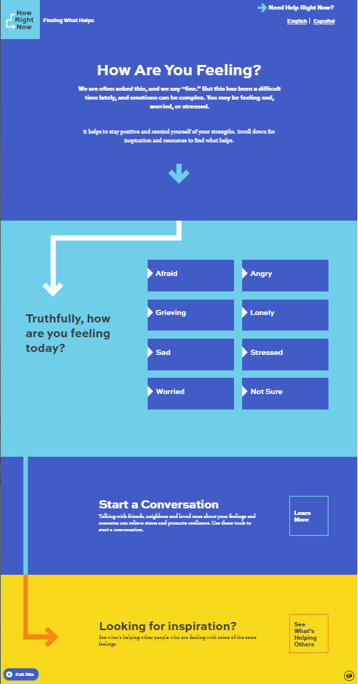
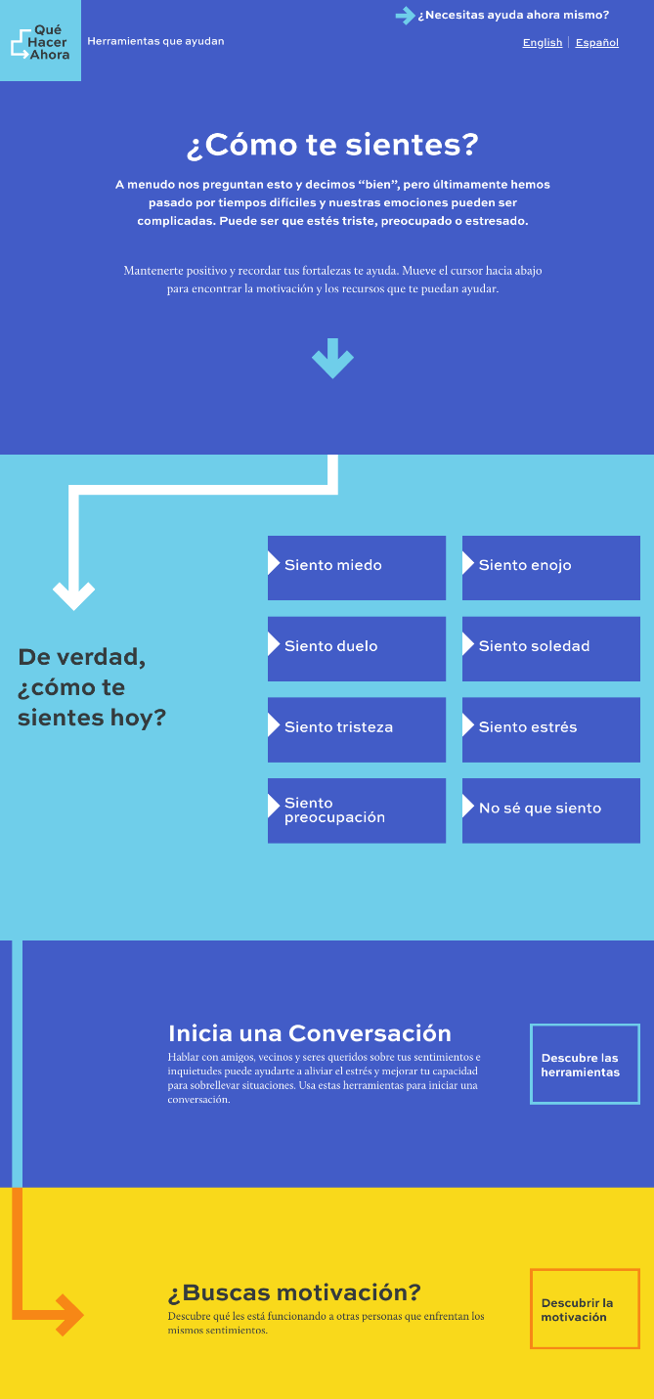
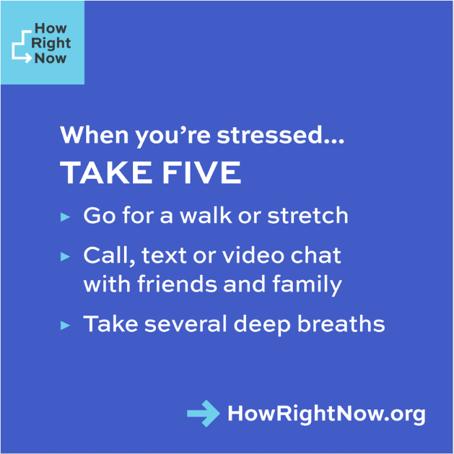

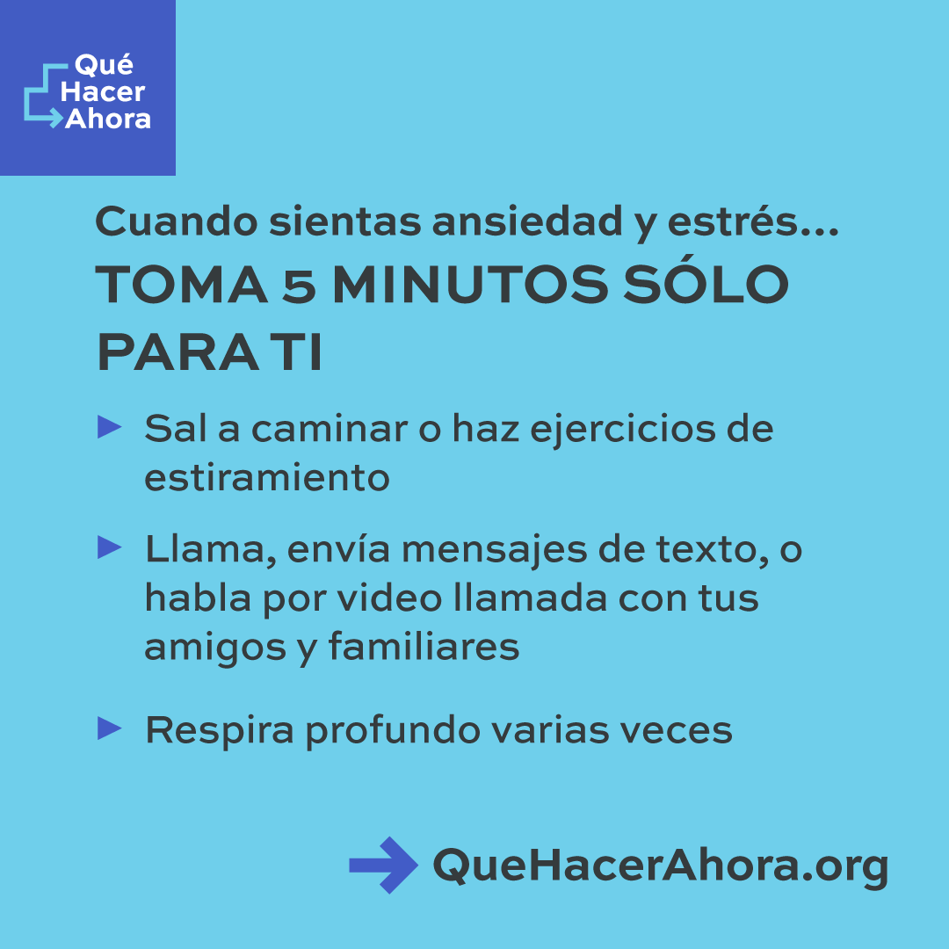
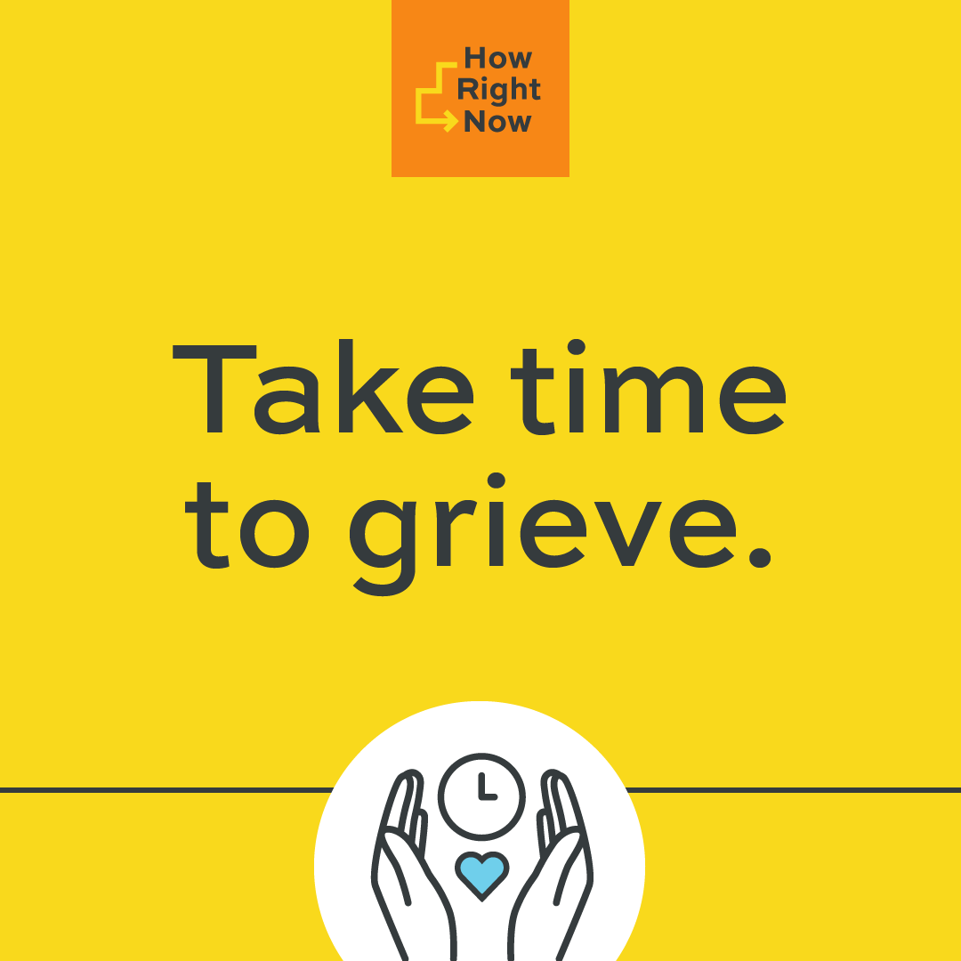
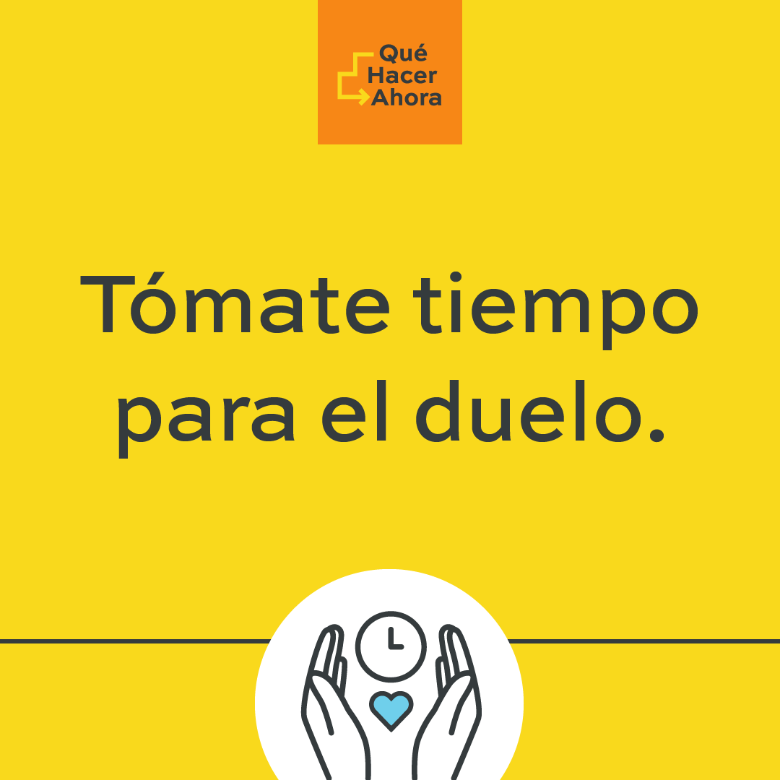
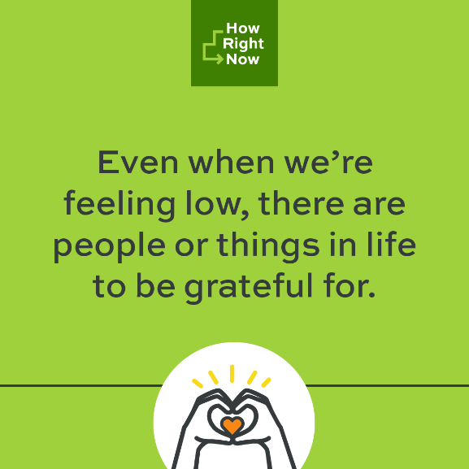

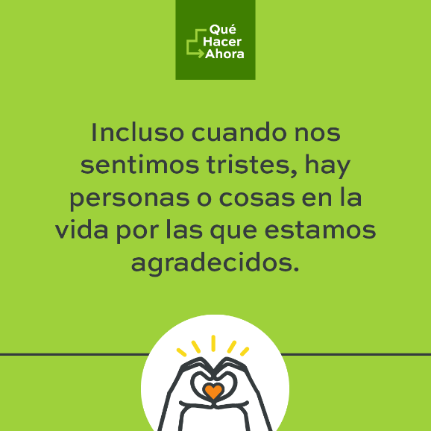

Supplemental Material: “Feeling Low” Message

