Online Supplement

- Mplus Code for Main Analyses

- Research question 1

DATA: File = Data.dat ;
Variable:
names =
id1 !cluster id
sex
age
child
DT_fri !Detachment on Friday
DT_sat ! Detachment on Saturday
DT_sun ! Detachment on Sunday
sol_fric ! Problem-solving conversations on Friday centered
sol_frimean ! Problem-solving conversations on Friday person-mean
sw_finish_frc ! Supplemental work to finish unfinished tasks on Friday centered
sw_finish_frmean! Supplemental work to finish unfinished tasks on Friday person-mean
FAT_Mo ! Fatigue on Monday morning
isi_Mo ! Sleep impairment on Monday morning
ENG_Mo ! Engagement on Monday
missing = all(-99);
cluster = id1;
usevar = DT_fri DT_sat DT_sun;
classes = c(3); ! change classes from 1 to 6
analysis: TYPE = Mixture COMPLEX;
starts = 100 20;
Model:
%overall%
i s q | DT_fri@0 DT_sat@1 DT_sun@2 ;
i-q@0;
output: sampstat tech1 tech11;
Savedata:
save = cprob;
file = Classmembership;
Plot: SERIES = DT_fri DT_sat DT_sun (S); TYPE = PLOT3;

- Research question 2
DATA: File = Data.dat ;
Variable:
names =
id1 !cluster id
sex
age
child
DT_fri !Detachment on Friday
DT_sat ! Detachment on Saturday
DT_sun ! Detachment on Sunday
sol_fric ! Problem-solving conversations on Friday centered
sol_frimean ! Problem-solving conversations on Friday person-mean
sw_finish_frc ! Supplemental work to finish unfinished tasks on Friday centered
sw_finish_frmean! Supplemental work to finish unfinished tasks on Friday person-mean
FAT_Mo ! Fatigue on Monday morning
isi_Mo ! Sleep impairment on Monday morning
ENG_Mo ! Engagement on Monday
missing = all(-99);
cluster = id1;
usevar = DT_fri DT_sat DT_sun ;
classes = c(3);
Auxiliary = (R3Step) sol_fric sol_frimean sw_finish_frc sw_finish_frmean;
analysis: TYPE = Mixture COMPLEX;
starts = 100 20;
Model:
%overall%
i s q | DT_fri@0 DT_sat@1 DT_sun@2 ;
i-q@0;
output: sampstat tech1 tech11;
Plot: SERIES = DT_fri DT_sat DT_sun (S); TYPE = PLOT3;

- Research question 3
DATA: File = Data.dat ;
Variable:
names =
id1 !cluster id
sex
age
child
DT_fri !Detachment on Friday
DT_sat ! Detachment on Saturday
DT_sun ! Detachment on Sunday
sol_fric ! Problem-solving conversations on Friday centered
sol_frimean ! Problem-solving conversations on Friday person-mean
sw_finish_frc ! Supplemental work to finish unfinished tasks on Friday centered
sw_finish_frmean! Supplemental work to finish unfinished tasks on Friday person-mean
FAT_Mo ! Fatigue on Monday morning
isi_Mo ! Sleep impairment on Monday morning
ENG_Mo ! Engagement on Monday
missing = all(-99);
cluster = id1;
usevar = DT_fri DT_sat DT_sun FAT_Mo isi_Mo ;
classes = c(3);
Auxiliary = (DU3Step) FAT_Mo isi_Mo;
analysis: TYPE = Mixture COMPLEX;
starts = 100 20;
Model:
%overall%
i s q | DT_fri@0 DT_sat@1 DT_sun@2 ;
i-q@0;
output: sampstat tech1 tech11;
Plot: SERIES = DT_fri DT_sat DT_sun (S); TYPE = PLOT3;
DATA: File = Data.dat ;
Variable:
names =
id1 !cluster id
sex
age
child
DT_fri !Detachment on Friday
DT_sat ! Detachment on Saturday
DT_sun ! Detachment on Sunday
sol_fric ! Problem-solving conversations on Friday centered
sol_frimean ! Problem-solving conversations on Friday person-mean
sw_finish_frc ! Supplemental work to finish unfinished tasks on Friday centered
sw_finish_frmean! Supplemental work to finish unfinished tasks on Friday person-mean
FAT_Mo ! Fatigue on Monday morning
isi_Mo ! Sleep impairment on Monday morning
ENG_Mo ! Engagement on Monday
missing = all(-99);
cluster = id1;
usevar = DT_fri DT_sat DT_sun FAT_Mo isi_Mo;
classes = c(3);
Auxiliary = (DU3Step) ENG_Mo;
analysis: TYPE = Mixture COMPLEX;
starts = 100 20;
Model:
%overall%
i s q | DT_fri@0 DT_sat@1 DT_sun@2 ;
i-q@0;

output: sampstat tech1 tech11;
Plot: SERIES = DT_fri DT_sat DT_sun (S); TYPE = PLOT3;

- Figure B1: Different class solutions (N = 421 weekends)
- Two classes  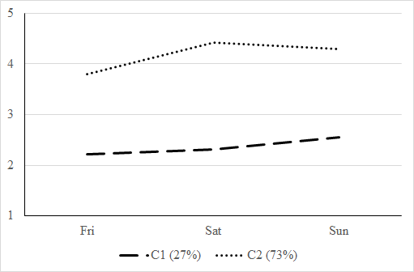 | - Three classes (Selected solution)  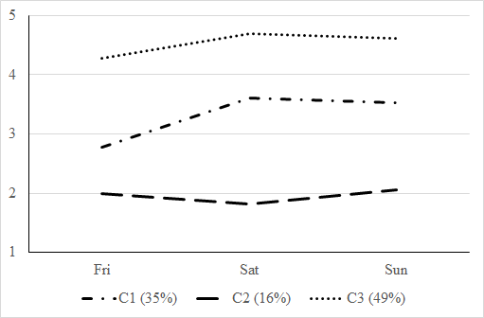 | - Four classes  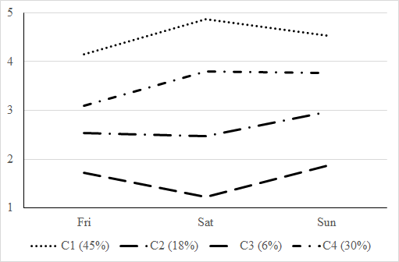
- Five classes  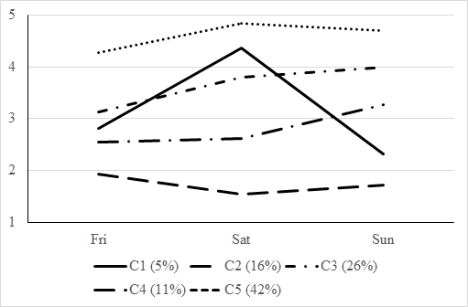 | - Six classes  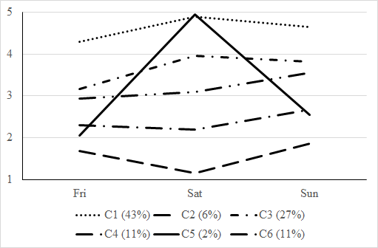
Note. Observed sample means are displayed for each trajectory class.

