Cognitive Limits in Project Management: An fMRI Study on the Relationship Between Information Load, Mental Effort, and Decision Quality
– Supplemental Material –

Table I. Summary statistics of demographics and dependent variables for n = 125 participants in the pre-study.

Demographics
Gender | male | 78
 | female | 47
Age | mean (median) | 24.73 (24)
 | min./max. | 19/40
Study program | business administration (technical oriented) | 68
 | architecture and urban planning | 28
 | technology management | 7
 | other | 22

Variable name |  | mean (SD) | median | min. | max.

Mental Effort ME 1
 | condition 1 (n = 14) | 3.86(1.56) | 4 | 1 | 6
 | condition 2 (n = 14) | 4.43(1.51) | 4.5 | 2 | 7
 | condition 3 (n = 14) | 4.36(1.23) | 5 | 2 | 6
 | condition 4 (n = 14) | 5.00(0.96) | 5 | 4 | 7
 | condition 5 (n = 14) | 4.36(1.34) | 4 | 2 | 6
 | condition 6 (n = 13) | 5.31(1.11) | 6 | 3 | 6
 | condition 7 (n = 14) | 4.86(1.41) | 5 | 2 | 7
 | condition 8 (n = 14) | 4.43(0.94) | 5 | 3 | 6
 | condition 9 (n = 14) | 4.64(1.08) | 5 | 2 | 6

Mental Effort ME 2
 | condition 1 (n = 14) | 4.14(1.46) | 4 | 2 | 7
 | condition 2 (n = 14) | 4.93(1.73) | 5 | 2 | 7
 | condition 3 (n = 14) | 5.07(1.00) | 5 | 4 | 7
 | condition 4 (n = 14) | 5.79(1.19) | 6 | 3 | 7
 | condition 5 (n = 14) | 4.50(1.51) | 5 | 1 | 7
 | condition 6 (n = 13) | 5.15(1.35) | 6 | 3 | 7
 | condition 7 (n = 14) | 4.93(1.50) | 5.5 | 2 | 7
 | condition 8 (n = 14) | 5.14(1.03) | 5 | 3 | 7
 | condition 9 (n = 14) | 5.29(1.33) | 6 | 2 | 7
Note: Participants rated their subjectively experienced mental effort on a 7-point Likert-scale responding to two questions: ‘‘Please indicate how much mental effort you invested in studying information.’’(ME1), “Please indicate how much mental effort you invested to understand the information’’ (ME2).

Table II. Tests of between-subjects effects in the pre-study. Dependent variable: ME1 and ME2; (n = 125, 3 x 3 design)

ME1 | sum of square | df | mean square | F | p
Corrected Model | 19.830ª | 8 | 2.479 | 1.591 | .135
Intercept | 2622.696 | 1 | 2622.696 | 1683.655 | <.001***
Graphs | 9.675 | 2 | 4.837 | 3.105 | .049**
Data points | 2.759 | 2 | 1.380 | .886 | .415
Graphs * Data points | 7.735 | 4 | 1.934 | 1.241 | .297
Error | 180.698 | 116 | 1.558
Total | 2818.000 | 125
Corrected Total | 200.528 | 124
*< .1; **< .05; ***<.01
ªR Squared = .099 (Adjusted R Squared = .037)

ME2 | sum of square | df | mean square | F | p
Corrected Model | 24.371ª | 8 | 3.046 | 1.647 | .119
Intercept | 3114.921 | 1 | 3114.921 | 1683.577 | <.001***
Graphs | 4.895 | 2 | 2.447 | 1.323 | .270
Data points | 2.132 | 2 | 1.066 | .576 | .564
Graphs * Data points | 17.282 | 4 | 4.321 | 2.335 | .060*
Error | 214.321 | 116 | 2
Total | 3354 | 125
Corrected Total | 239.992 | 124
*< .1; **< .05; ***<.01
ªR Squared = .102 (Adjusted R Squared = .040)

Table III. Tests of between-subjects effects in the pre-study. Dependent variable: ME1 and ME2; (n = 42; graphs: 4 or 6)
ME1 | sum of square | df | mean square | F | p
Corrected Model | .048ª | 2 | .024 | .014 | .986
Intercept | 814.881 | 1 | 814.881 | 496.014 | <.001***
Graphs | .048 | 2 | .024 | .014 | .986
Error | 64.071 | 39 | 1.643
Total | 879.000 | 42
Corrected Total | 64.119 | 41
*< .1; **< .05; ***<.01
ªR Squared = .001 (Adjusted R Squared = -.051)

ME2 | sum of square | df | mean square | F | p
Corrected Model | 3.000ª | 2 | 1.500 | .712 | .497
Intercept | 990.857 | 1 | 990.857 | 470.442 | <.001***
Graphs | 3.000 | 2 | 1.500 | .712 | .497
Error | 82.143 | 39 | 2.106
Total | 1076.000 | 42
Corrected Total | 85.143 | 41
*< .1; **< .05; ***<.01
ªR Squared = .035 (Adjusted R Squared = -.014)

Table IV. Tests of between-subjects effects in the pre-study. Dependent variable: ME1 and ME2; (n = 41; data points: 2, 4 or 8)

ME1 | sum of square | df | mean square | F | p
Corrected Model | 6.407ª | 2 | 3.203 | 2.435 | .101
Intercept | 978.511 | 1 | 978.511 | 743.914 | <.001***
Data points | 6.407 | 2 | 3.203 | 2.435 | .101
Error | 49.984 | 38 | 1.315
Total | 1032.000 | 41
Corrected Total | 56.390 | 40
*< .1; **< .05; ***<.01
ªR Squared = .114 (Adjusted R Squared = .067)

ME2 | sum of square | df | mean square | F | p
Corrected Model | 11.573ª | 2 | 5.786 | 3.161 | .054*
Intercept | 1084.629 | 1 | 1084.629 | 592.613 | <.001***
Data points | 11.573 | 2 | 5.786 | 3.161 | .054*
Error | 69.549 | 38 | 1.830
Total | 1167.000 | 41
Corrected Total | 81.122 | 40
*< .1; **< .05; ***<.01
ªR Squared = .143 (Adjusted R Squared = .098)

Table V. Multiple comparison (Tukey’s HSD test) in the pre-study. Dependent variable ME1 and ME2; (n = 41; data points: 2, 4 or 8)

ME1
conditions | Mean difference | Std error | Sig.
2 vs. 4 data points | .64 | .433 | .310
2 vs. 8 data points | -.31 | .424 | .767
4 vs. 2 data points | -.64 | 433 | .310
4 vs. 8 data points | -.95 | .442 | .093*
8 vs. 2 data points | .31 | .424 | .767
8 vs. 4 data points | .95 | .442 | .093*

ME2
conditions | Mean difference | Std error | Sig.
2 vs. 4 data points | 1.29 | .511 | .042**
2 vs. 8 data points | .63 | .521 | .453
4 vs. 2 data points | -1.29 | .511 | .042**
4 vs. 8 data points | -.65 | .521 | .429
8 vs. 2 data points | -.63 | .521 | .453
8 vs. 4 data points | .65 | .521 | .429

Figure I. The figure shows the mean values of the self-reported mental effort collected in a pre-study. Participants rated the experienced mental effort using a 7-point Likert-scale responding to two questions: ‘‘Please indicate how much mental effort you invested in studying the information.’’(ME1), “Please indicate how much mental effort you invested to understand the information’’ (ME2). We found evidence for an U-shaped relation between data points and mental effort, thus somewhat a mirror image of the activation of the left putamen in our main study.
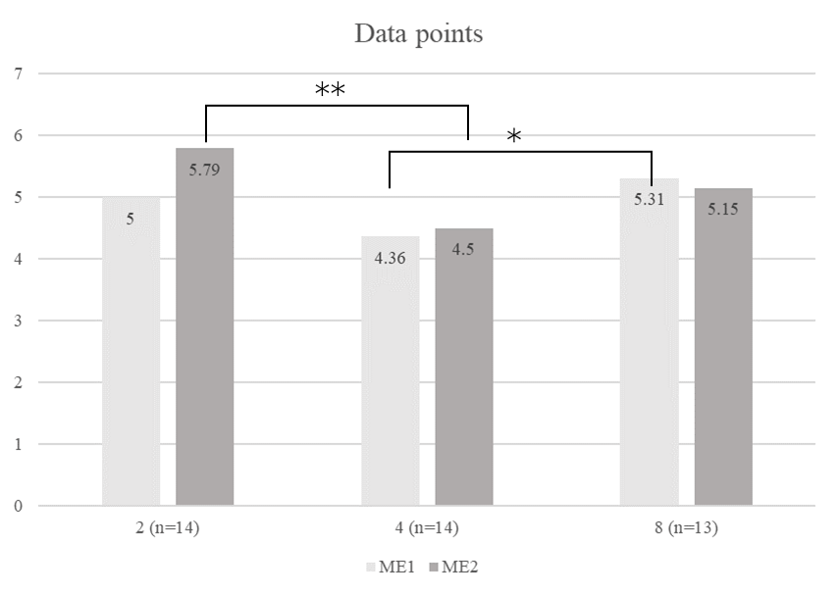

Appendix I. Data Preprocessing
For each participant, we obtained a T1-weighted MP-RAGE (magnetization-prepared rapid-acquisition gradient echo) anatomical scan of the whole brain (176 slices; slice thickness = 1 mm; gap = 0.5 mm; in-plane voxel size = 1 ∙ 1 mm; repetition time = 2,300 ms; echo time = 2.92 ms; field of view = 256 ∙ 256 mm; resolution = 256 ∙ 256 voxels; flip-angle = 8°) as well as T2*-weighted EPI (echo planar imaging) scans (30 axial slices; slice thickness = 3.2 mm; gap = 0.8 mm; in-plane voxel size = 3 ∙ 3 mm; repetition time = 2,000 ms; echo time = 35 ms; field of view = 192 ∙ 192 mm; resolution = 64 ∙ 64 voxels; flip angle = 90°) for the functional MRI analysis. Overall, we obtained 1 anatomical image of the brain and 1,360 EPIs per subject, which were collected during the four sessions. The EPI images covered the cerebral cortex as well as most subcortical structures. The more posterior aspects of the cerebellum were dropped in several of our subjects. Image processing was conducted using SPM5 (Welcome Department of Cognitive Neurology, London, UK). The functional images were realigned by the first scan as a reference. For co-registration, we used T1 anatomical and the mean image of the functional scans and then aligned to the SPM T1 template in MNI space (Montreal Neurological Institute, mean brain). For spatial normalization, three-dimensional transformation was applied to all images. The images were then spatially smoothed with a Gaussian filter with 7 x 7 x 7 mm³ (FWHM = full-width at half-maximum). In the subject-specific analysis (first level), we used a general linear model (GLM) including variables (regressors) for each trial period (exposure, delay, response) and for the different treatment conditions. The variables were convolved with the default canonical hemodynamic response function. The six motion-parameters obtained by the rigid-body motion correction procedure were additionally entered as regressors of no interest.

Table VI. H1 results
Repeated-measure ANVOVAs – Dependent variable: BOLD signa in the left putamen during exposure and delay period
 | Exposure |  |  |  |  |  |  | Delay
 | sum of square | df | mean square | F | p | eta² |  | sum of square | df | mean square | F | p | eta²
information | .066 | 1 | .066 | 3.150 | .090* | .130 |  | .028 | 1 | .028 | 2.213 | .152 | .095
information*  education | .070 | 1 | .070 | 3.330 | .082* | .137 |  | .088 | 1 | .088 | 7.070 | .015** | .252
error | .439 | 21 | .021 |  |  |  |  | .262 | 21 | .012
project type | .006 | 1 | .006 | .212 | .650 | .010 |  | .013 | 1 | .013 | 1.121 | .302 | .051
project type*  education | .005 | 1 | .005 | .201 | .659 | .009 |  | .002 | 1 | .002 | .140 | .712 | .007
error | .568 | 21 | .027 |  |  |  |  | .235 | 21 | .011
information* project type | .043 | 1 | .043 | 1.966 | .176 | .086 |  | .054 | 1 | .054 | 7.878 | .011** | .273
information*  project type*  education | .002 | 1 | .002 | .097 | .758 | .005 |  | .028 | 1 | .028 | 3.976 | .059* | .159
error | .462 | 21 | .022 |  |  |  |  | .145 | 21 | .007

