Supplemental Online Material

Cover Story 3D printer
You and a team of fellow students develop a board game idea. The team decides to put the idea into practice and builds a prototype. In a collaborative effort, you design the game pieces in a 3D software. Now you want to evaluate these models.
For the production, your team decides to purchase a 3D printer. However, an abundance of different printer variants exists. A company called 3D Print Workshop Inc. offers you the opportunity to evaluate their 3D printers in a virtual environment. Now, you put on VR glasses and enter the showroom of 3D Print Workshop Inc. In the virtual environment, you will see decision criteria which your team considers important. Furthermore, you will see several 3D printers with their properties.
Your task is to choose the right product.

Cover Story Washing Powder
You share your apartment with several roommates. It is your turn to do the grocery shopping and realize that the washing powder is empty. Therefore, you ask all your roommates to note down what kind of washing powder they prefer. Of course, you are not going to the supermarket in real world. Instead, you use your VR headset and order the product in Virtual Reality. In the virtual environment, you will see decision criteria which your roommates consider important.
Your task is to choose the right product.

Choices for Desired Help Types
Product comparison matrix
Product recommendations
Reviews of other consumers
Product feature highlighting
Hiding irrelevant products

Help Timing Questions
The experimenter will show you a video of your purchase decision. While watching the video, please determine when you would have appreciated help during the task ( (X) by a digital human consultant in the VR environment / (Y) (by an algorithm in the VR environment) ). After watching the video, please answer the questions below.
(X) What time would be the best moment for an algorithmic decision support to appear?
(Y) What time would be the best moment for a digital human consultant to appear?

Product Knowledge Items
1) Compared to others, how familiar do you think you are with the product?
2) Do you know precisely what attributes of the product decide the function of the product?
3) Do you think you can make a satisfactory purchase of the product based on only your own knowledge, without another person's help?
7-point Likert Scale: 1 – absolutely not; 7 – absolutely yes

Supplemental Figures
Figure 7
Correlation analysis for ET and ECG features.
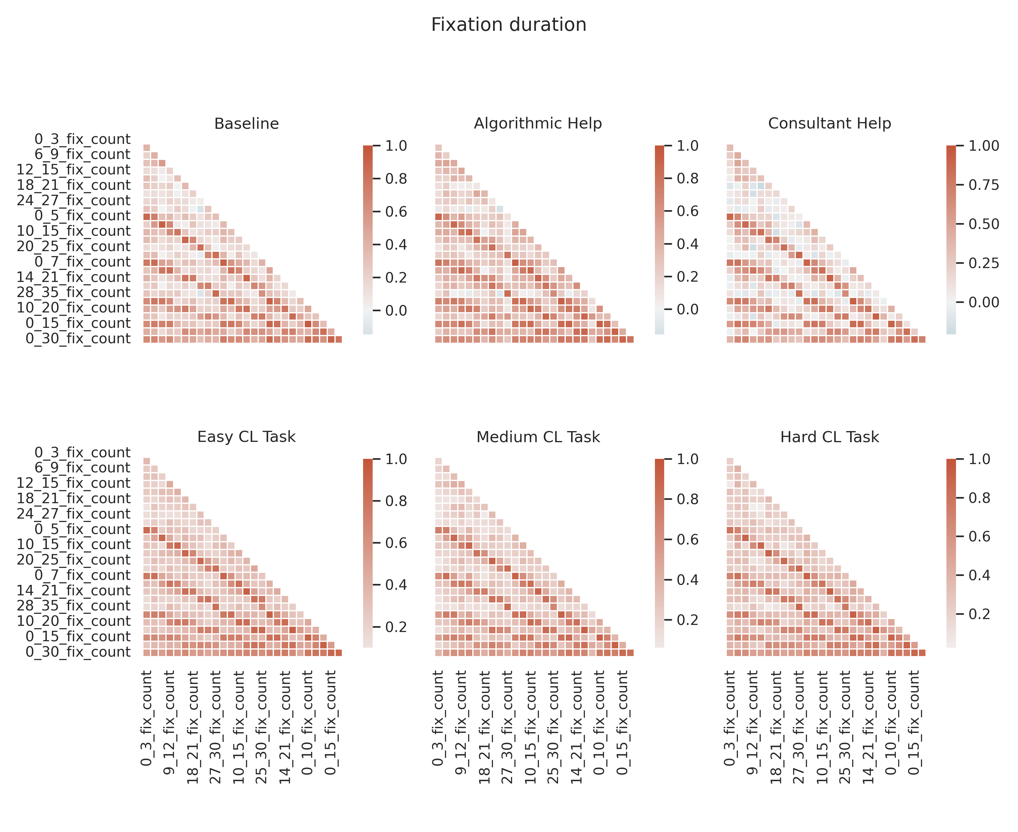
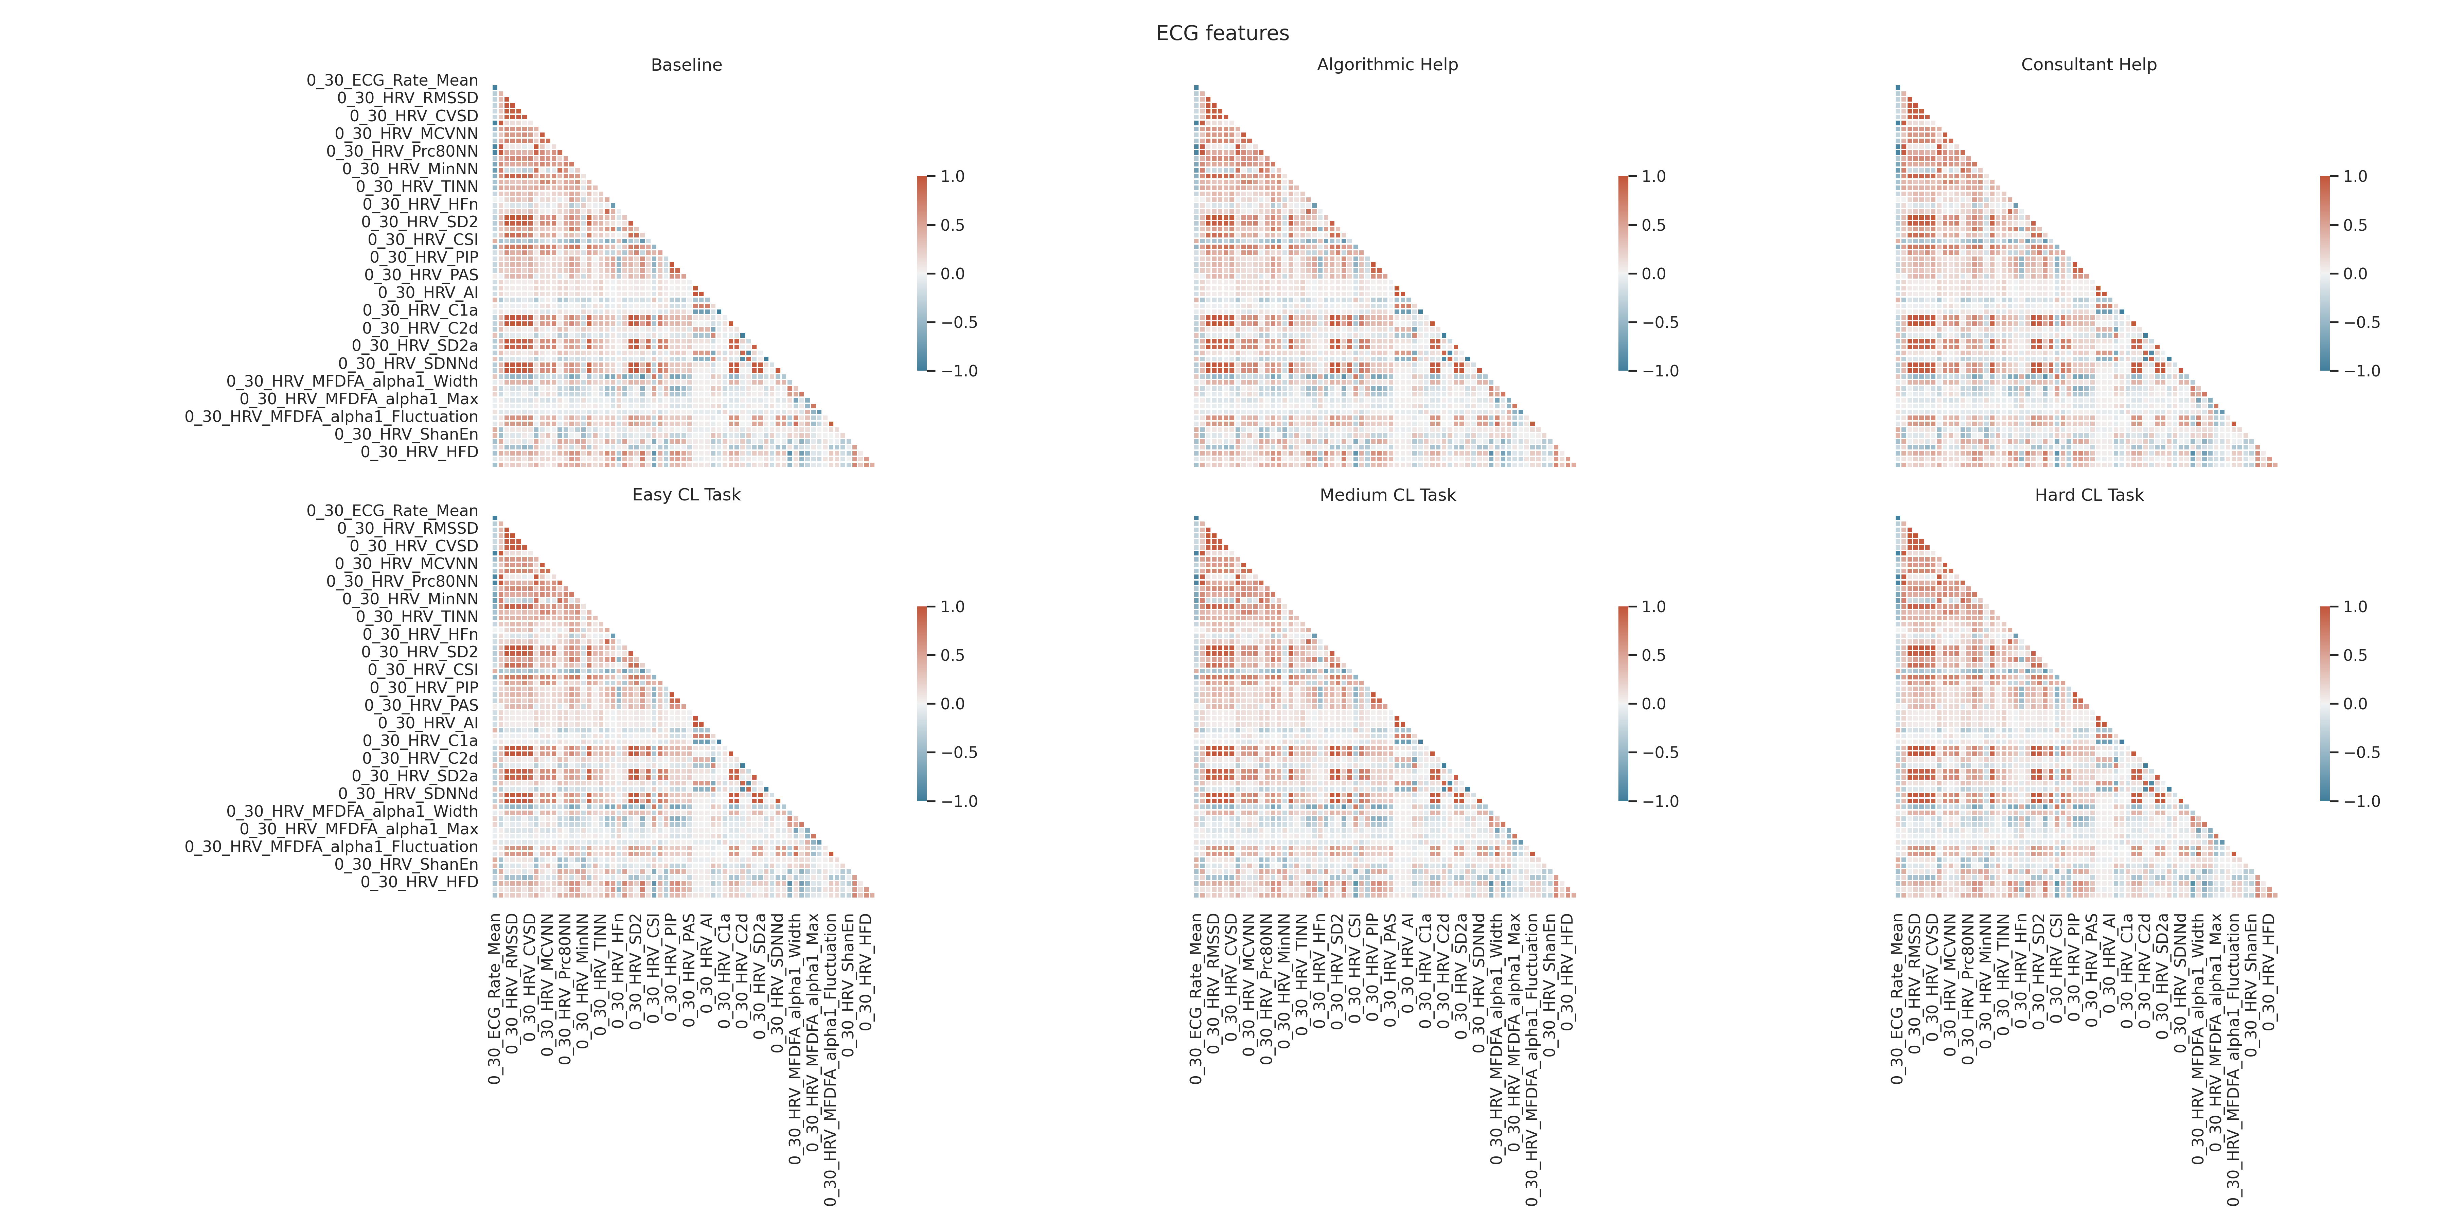

Figure 8
Desired algorithmic UAS help type stratified by groups.
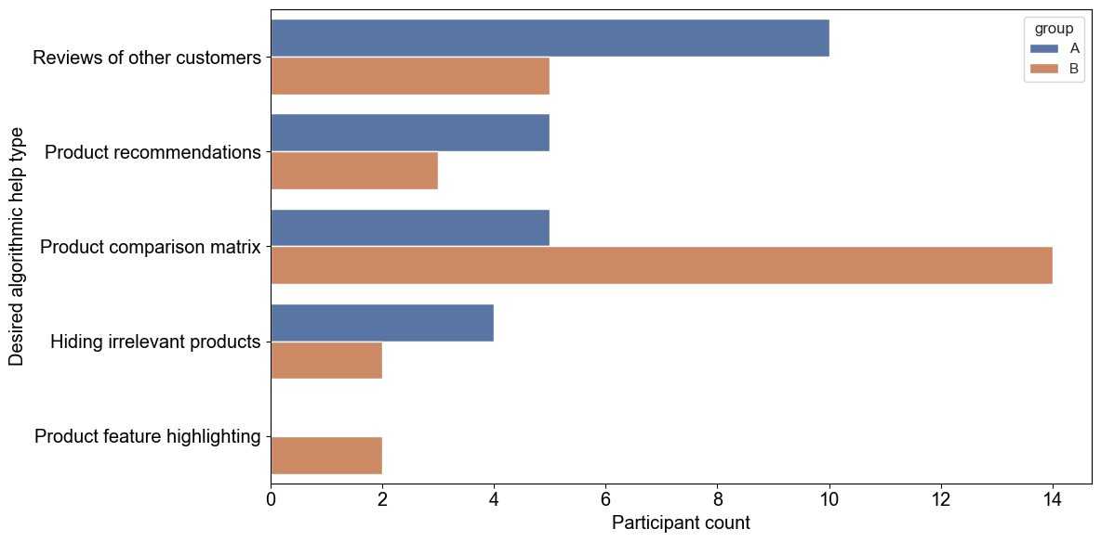
Figure 9
Boxplot showing the mental strain among the different tasks.
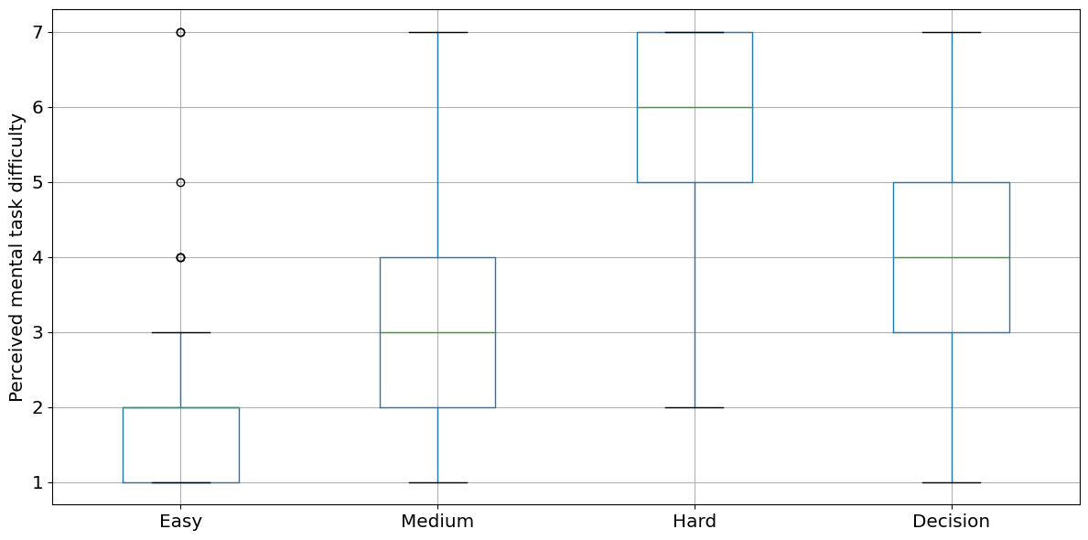

Figure 10
Mean absolute SHAP values explaining the multitasking classification model for the test set.
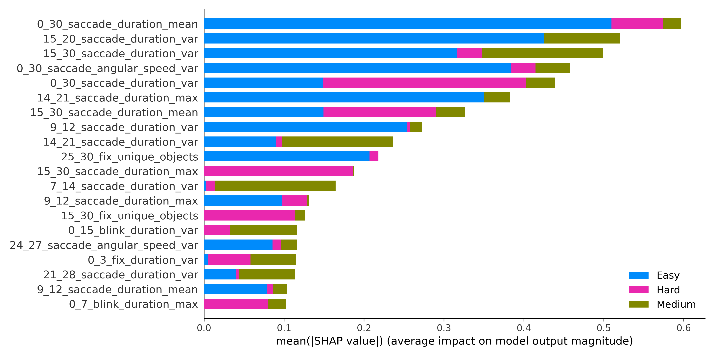

Supplemental Tables
Table 5
Hyper parameter space for the XGBoost model.
Parameter | Values
colsample_bytree | [0.6, 0.7, 0.8, 0.9]
gamma | [0, 0.1, 0.2, 0.3, 0.4]
learning_rate | [0.0005, 0.001, 0.005, 0.01, 0.05, .1, 0.5]
max_depth | [3, 5, 7, 9, 11, 13, 15, 17, 19]
min_child_weight | [1, 3, 4, 7, 9]
n_estimators | [25, 50, 75, 100, 125, 150, 175, 200]
reg_alpha | [0, 0.001, 0.005, 0.01, 0.05]
subsample | [0.6, 0.7, 0.8, 0.9]
Table 6
Eye-tracking feature overview.
Feature* |  | Comment
Blink count
Blink duration | Max, Mean, Var
Fixation count
Fixation duration  Saccade count  Saccade duration  Saccadic angular speed | Max, Mean, Var  Max, Mean, Var  Min, Max, Mean, Var
Dominant pupil iris ratio | Min, Max, Mean, Var
Unique object count
* ET features were calculated for the different time windows 3, 5, 7, 10, 15, and 30 seconds.
Table 7
ECG feature overview.
Feature* |  | Comment
Time domain
NN | Min, Max, Mean, Median, MAD
SDNN, SDSD, RMSSD, Prc20NN, Prc80NN, pNN20, pNN50, HTI, TTIN

Frequency domain
HF, VHF, LnHF, HFn, LFn

Time-frequency domain
STFT, WT, WVD, SWVD

Nonlinear domain
SD1, SD2, SD1/SD2, S, C, C1, C2, CSI, CVI, CSI_Modified, PIP, CD, HFD, KFD, LZC, CVNN, CVSD, MCVNN, IQRNN, IALS, PSS, PAS, GI, SI, AI, PI, DFA_alpha1, ApEn, ShanEn, FuzzyEn
MFDFA_alpha1 | Width, Peak, Mean, Max, Delta, Asymmetry, Fluctuation, Increment
* ECG features were only calculated for the full 30 second time windows.
Table 8
Product criteria classification.
Category |  | - 3D printer |  | - Washing powder
Rather easy | - Easy device setup  - Large model print size  - PETG material printable |  | - Allows for 100 washing cycles  - Conserve colors  - Efficient dirt removal
Rather hard | - Fast print speed  - High print quality  - The device should not catch fire |  | - Environmentally friendly  - Allow high washing temperature  - Little powder amount per wash cycle
Table 9
Overall task difficulty and test results for normality and for consistency among NASA TLX items.
Task | Mean | SD | Shapiro-Wilk W | Shapiro-Wilk p | Cronbach’s α
Easy | 2.89 | 0.727 | .897 | <.01** | .629
Medium | 3.60 | 0.767 | .974 | .345 | .574
Hard | 4.57 | 0.910 | .967 | .169 | .582
Decision | 2.98 | 0.972 | .946 | .024* | .699
Note. *p < .05, **p < .01

Table 10
Mental task difficulty descriptive analysis and test results for normality.
Task | Mean | SD | Shapiro-Wilk W | Shapiro-Wilk p
Easy | 2.14 | 1.385 | .740 | <.01**
Medium | 3.46 | 1.343 | .913 | <.01**
Hard | 5.74 | 1.226 | .849 | <.01**
Decision | 3.86 | 1.539 | .939 | .012*
Note. *p < .05, **p < .01
Table 11
Pairwise task comparison for differences in mental difficulty.
Task 1 | Task 2 | Mann-W. U | Mann-Whitney p  (Bonf. corrected) | SD
Hard | Medium | 2201.5 | <.01** | 1.773
Hard | Easy | 2364.5 | <.01** | 2.752
Hard | Decision | 2073 | <.01** | 1.351
Medium | Easy | 1976 | <.01** | 0.967
Medium | Decision | 1032.5 | .76 | -0.277
Easy | Decision | 483.5 | <.01** | -1.175
Note. *p < .05, **p < .01

