Supplementary Information:
Supplementary Methods
Supplementary Analyses
S1 – S7 Figs

Supplementary Methods
Pre-training & Shaping
Thirsty rats completed three stages of 30-minute pre-training sessions in the testing chambers to shape the nosepoke behavior. First, rats were trained to associate a simultaneous (‘gain’) tone-light cue at the reward magazine with delivery of 0.15 ml liquid reward (0.3% sodium saccharin w/v) (2 sessions). Rats were not required to nosepoke to earn reward in the first stage of pre-training. Thereafter, rats were shaped to nosepoke in any single pseudo-randomly lit nosepoke hole of the five-hole array in order to receive the cued reward (3 sessions). Finally, the animals were trained to complete a sequence of 2 nosepokes in the lit holes in order to receive the cued reward (17 sessions).
Stage 1
In two 30-minute sessions, rats were trained to associate a paired light and tone as conditioned stimuli of reward availability at the reward magazine (without nosepoking). Trial onset (unsignaled to the rat) was followed by a random delay (1, 6, 11, 16, 21, 26, 31 seconds), which was selected at the trial start without replacement. After the delay period, the light and tone were presented and 0.15 ml reward was made available for delivery at the reward spigot. The light and tone remained on until the reward delivery ended. Once the full 0.15 ml reward had been delivered, the trial ended once the rat ceased licking at the reward spigot. The end of a lick bout was operationally defined as an inter-lick interval greater than 300 msec. We imposed a minimum trial length of 7 seconds, and a new trial began after a 1-second inter-trial interval.
Stage 2
Rats were then trained to nosepoke into a lit hole to earn reward. At trial onset, one hole of the 5-hole array was randomly selected (without replacement) and the discriminative stimulus was illuminated. After correctly nosepoking into the lit hole, the conditioned light-tone stimuli at the reward magazine immediately signaled reward availability (0.15 ml). The trial ended once licking at the reward spigot had ceased (or after the minimum trial length of 7 seconds), followed by a 1-second inter-trial interval. No error feedback was provided in the event that the rat nosepoked at one of the 4 remaining unlit holes, but the errors were recorded. If the rat failed to nosepoke into a lit hole after a randomly-selected time period (120, 180, 140 seconds), the conditioned stimulus was presented and a 0.15 ml reward was delivered. After three 30-minute sessions, all rats were nosepoking into lit holes with 90% accuracy or greater and advanced as a group to the next stage of training.
Stage 3
In the third stage, rats were trained to perform two sequential forced-choice nosepokes to earn reward where the first discriminative stimulus was a blinking nosepoke hole and the second discriminative stimulus was a lit (but not blinking) hole. Before trial onset, one of the three center holes of the 5-hole array (i.e. either hole 2, 3, or 4) was selected at random as the available forced-choice hole. The start of a trial was signaled by the onset of a blinking (2 Hz) LED as the first discriminative stimulus within the available hole. Once the rat nosepoked into the blinking hole (first reponse), the LED light was immediately extinguished for 2 seconds. After the 2-second pause, either the previously lit hole, or one of the immediately adjacent holes on either side of the previously lit hole, was randomly selected and illuminated (not blinking). For example, if the first nosepoke response was made in hole 4, then hole 3, 4, or 5 would be randomly selected as the available hole for the second response. Alternatively, if hole 2 was available for response 1, then either hole 1, 2, or 3 would be available on the second response. After the rat nosepoked into the lit non-blinking hole (second response), the LED was extinguished and the conditioned light-tone stimuli at the reward magazine immediately signaled the availability of 0.15 ml reward. The trial ended once the rat ceased licking at the reward spigot (or after the minimum trial duration of 7 seconds), and a new trial began after a 1-second inter-trial interval. As before, erroneous nosepokes into unlit or unblinking holes (at either the first or second response in the sequence, or during the 2-second inter-poke pause) were recorded but no error feedback was given. Training continued until all rats achieved 90% accuracy or greater (17 sessions).

Supplementary Analyses

Trading vs. holding
When a rat chose to hold a selected stock instead of a trade option, it received a dividend payout. Dividends were calculated as a percentage of the rats’ current holdings of the selected stock. The percentage paid was sufficiently small that the expected value of a hold option was on average distinctly lower than that of either a buy or a sell option. The average reward earned per trial second was analyzed using a repeated-measures ANOVA with Option (3 levels: Buy, Hold and Sell) as the within-subject variable. We found that the proportion of trials on which each option was selected had a highly significant effect on rate of reward, F_{(2,46)} = 48.30, η_{p}² = .68, p < .001. Both trading options were nearly 50% more profitable than the hold option (p < .001 for both contrasts), with the hold option averaging 1.73 μl/trial sec, and the buy and sell options averaging 2.69 μl/trial sec and 2.84 μl/trial sec, respectively. Neither buying more nor selling more resulted in significantly greater payoff rates than the other (M_{Difference} = 0.14 μl/trial sec, p = .33).

The transaction cost of trading within the task
Within the operant boxes, the spatial location of the buy and sell options on either side of the hold option may have added a temporal/effort disadvantage to trading. However, this increased cost can be viewed as the ‘transaction cost’ of trading, similar to those incurred by traders in real markets. To quantify the ‘transaction cost’ of trading vs. holding, we analyzed the inter-poke interval (IPI) between the stock selection nosepoke and the option selection nosepoke. On average, we found that the IPI was shorter on hold trials (M = 2.42 sec, SEM = 0.05 sec) compared to buy (M = 2.76 sec, SEM = 0.06 sec) and sell (M = 2.66 sec, SEM = 0.07 sec) trials. A repeated measures ANOVA with Option (3 levels: buy, hold, and sell) as a within-subjects factor revealed that there was a significant main effect of Option on IPI, F_{(2,46)} = 7.81, η_{p}² = .25, Greenhouse-Geisser adjusted p < .01. Planned contrasts determined that this effect was primarily due to the significant differences between hold trials vs. both buy (p < .001) and sell (p < .01) trials. We found no significant difference between buy and sell IPI’s. Thus, while the added cost of trading compared to holding may be small (M_{Difference} = 285.5 msec), it is nonetheless significant. Given that the 2 sec pause allows ample time to move between spatial locations, it may also be possible that this difference represents deliberation time. Although the task design does not allow us to conclude this with certainty, supporting evidence lies in the discrepancy between IPI after a gain (M = 2.49 sec, SEM = 0.08) vs. after a loss (M = 2.79, SEM = 0.11). A 2-way repeated-measures ANOVA of IPI with Previous Outcome and Current Option indicated that both Previous Outcome (F_{(1,23)} = 4.54, η_{p}² = .17, p < .05) and Current Option (F_{(2,46)} = 6.06, η_{p}² = .21, Greenhouse-Geisser adjusted p = .01) had significant main effects on IPI. The interaction term was not significant (F_{(2,46)} = 1.50, p = .23). Therefore, rats take longer to deliberate between options on trials preceded by a loss, and this effect is independent of option choice.
The effect of hole location on stock choice
The location of the nosepoke hole within the center three holes of the 5-hole array was randomly assigned at the beginning of each session. Location did appear to have an impact on stock choice. Rats were more likely to choose Stock 1 when it was associated with hole 4 (b = 1.18, t = 6.03, p < .001) but not hole 3 (b = 0.13, p > .05), and Stock 2 when it was located in hole 3 (b = 0.29, t = 3.99, p < .001) but not hole 4 (b = 0.36, p > .05. Given that the preferred hole location switched between stocks, this result suggests that rats tended not to perseverate in any one particular hole across sessions (see Fig S4 for subject-wise graphs).
The effect of perseveration on stock choice
We added perseveration choice as a predictor in order to quantify the effect of repeating a stock choice on free choice trials. We found that rats were more likely to perseverate than switch to a similar degree in both stocks 1 (b = 0.13, t = 2.18, p < .05) and 2 (b = 0.13, t = 2.16, p < .05). This behavior indicates that rats tended to develop a preference for a particular stock within a session (see Fig S3 for subject-wise graphs).
The effect of blink rate on stock choice
In order to determine whether rats might choose stocks based on the current blink rate (rather than change in blink rate), we included the chosen blink rate (Hz) as a predictor in the model. Interestingly, our results indicate that rats were more likely to choose stock 1 (but not stock 2) at significantly lower blink rates relative to stock 3 (b = -0.54, t = -5.69, p < .001). Given this significant effect, we can rule out a large effect of the potential strategy in which rats always chose the stock associated with either the slowest or the highest blink rate (see Fig S5 for subject-wise graphs).

Rats exhibit the disposition effect
As often observed in human studies, we found that individual subjects exhibited a range of disposition effect strengths, calculated as the proportion of gains realized (PGR) minus the proportion of losses realized (PLR), or PGR - PLR. Mean disposition effect sizes ranged from -.09 to .23 (M = .04, SEM = .02), with higher positive values indicating stronger tendencies towards holding losses too long and selling gains too quickly. PGR and PLR were not correlated within subjects (S1b Fig). This effect was not significantly correlated with greater average volumes of reward per trial second (Pearson’s r = .10, p = .65). There were also no correlations between disposition effect strength and subjects’ average proportion of sales per session (Pearson’s r = .13, p = .53) or overall proportion of trades (vs. holds) per session (Pearson’s r = .30, p = .15).

Supplementary Figs

A B
S1 Fig: Measures of suboptimal behavior. (A) On average, rats earned almost twice as much reward per trial second when selecting a trade option (buy or sell) as compared to a hold option. (B) The proportion of gains realized (PGR) and the proportion of losses realized (PLR) were not significantly correlated within individual subjects (Pearson’s r = .33, p = .12). Error bars represent 95% CI’s.

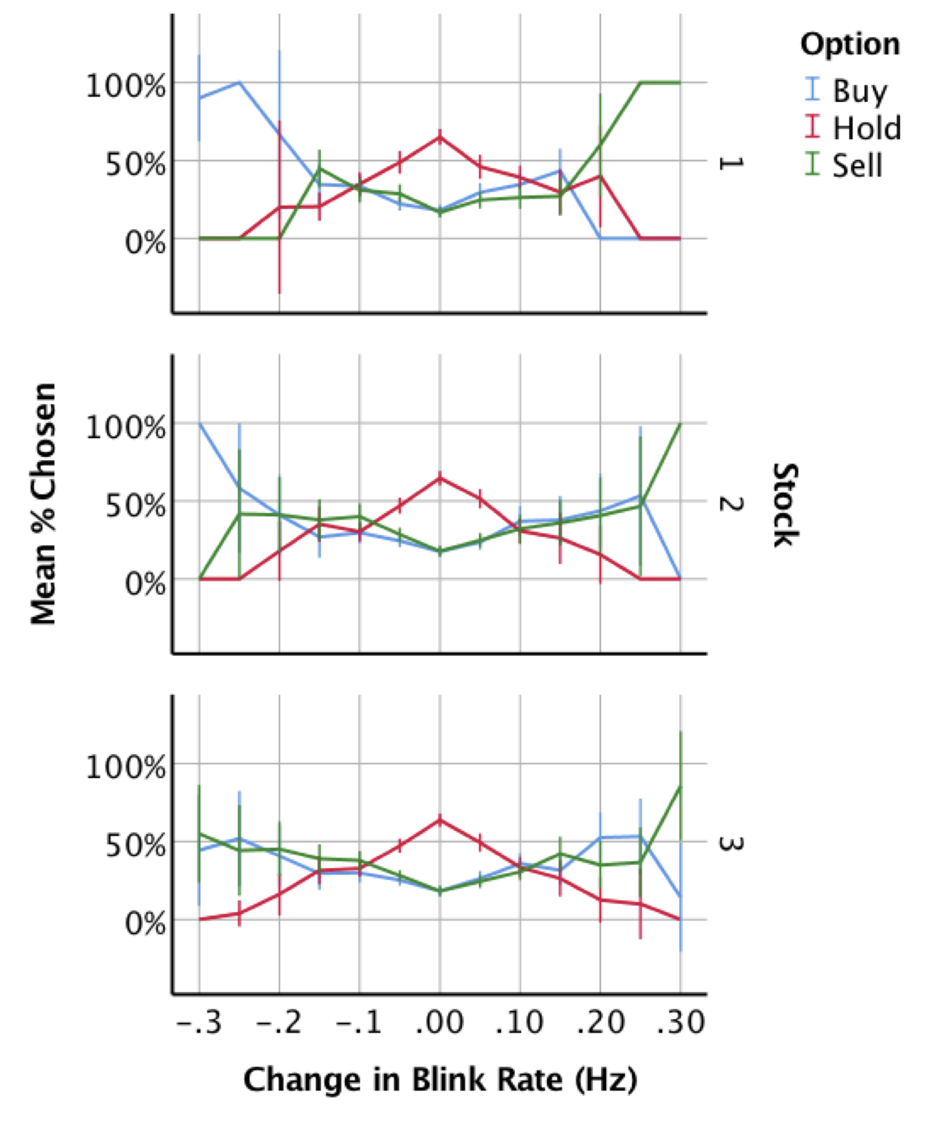
S2 Fig: Option choice by blink rate (Hz) change in each stock. Within the task, rats had an option of three different stocks on free-choice trials. Overall, rats showed stable responses to changes in blink rate (i.e. changes in price) at each of the three stocks. Rats chose the hold option at no change or at ± 0.5 Hz significantly more than the buy or sell option in all three stocks. Rats began to trade more (buy or sell) as the change in blink rate exceeded 0.15 Hz. Rats demonstrated some variability in option choice at large negative changes in blink rate between stocks, although the overall pattern remained the same.

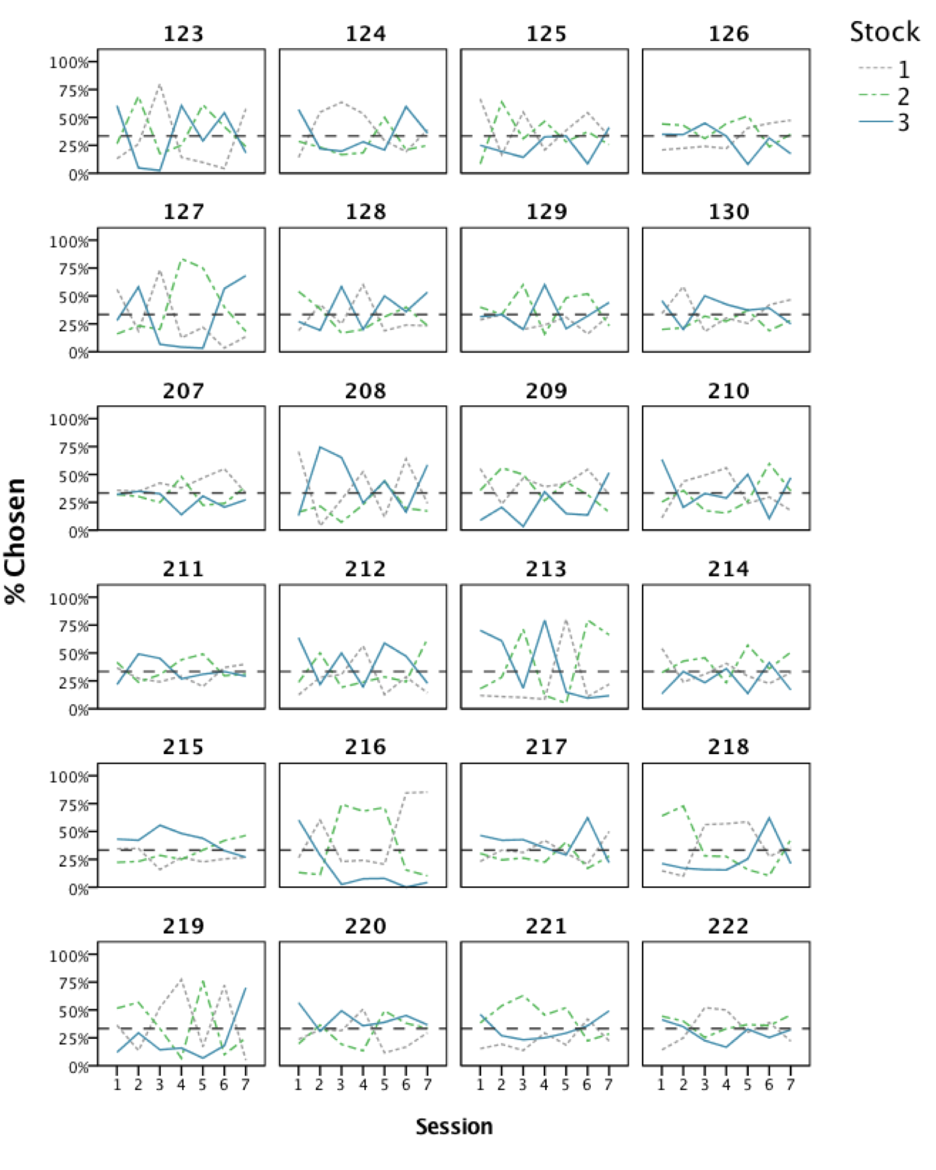
S3 Fig: Individual choice of stock by session. Each rat’s (N=24) proportion of stock choice was inspected for biases over the course of the analyzed sessions.
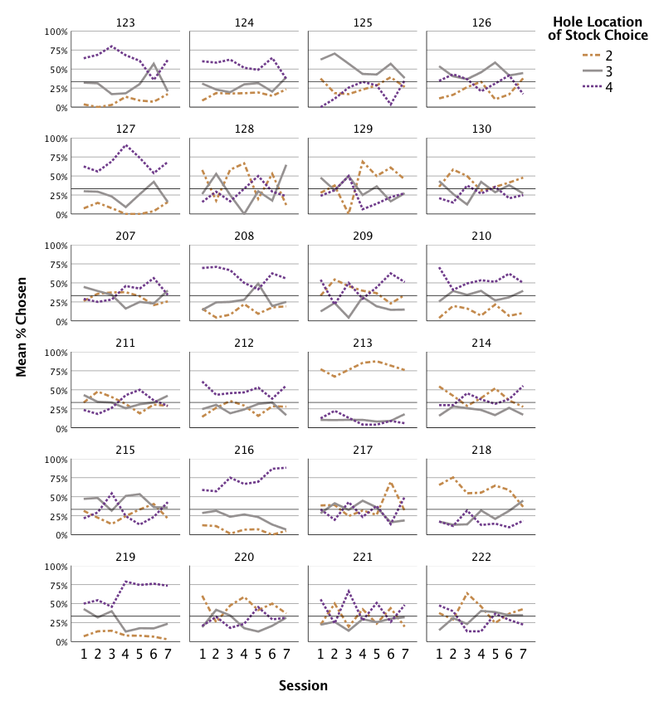
S4 Fig: Individual choice of hole location by session. Most rats did not show an individual bias towards a specific hole during choice of a stock on free-choice trials across sessions. Notable exceptions are rats 213 and 216, who demonstrated a preference for hole 2 and hole 4, respectively. Given the majority of rats do not show such a bias, we were satisfied that rats’ average responses in the task did not reflect a simple heuristic (e.g. repeating a pattern of returning to the same hole on every trial).
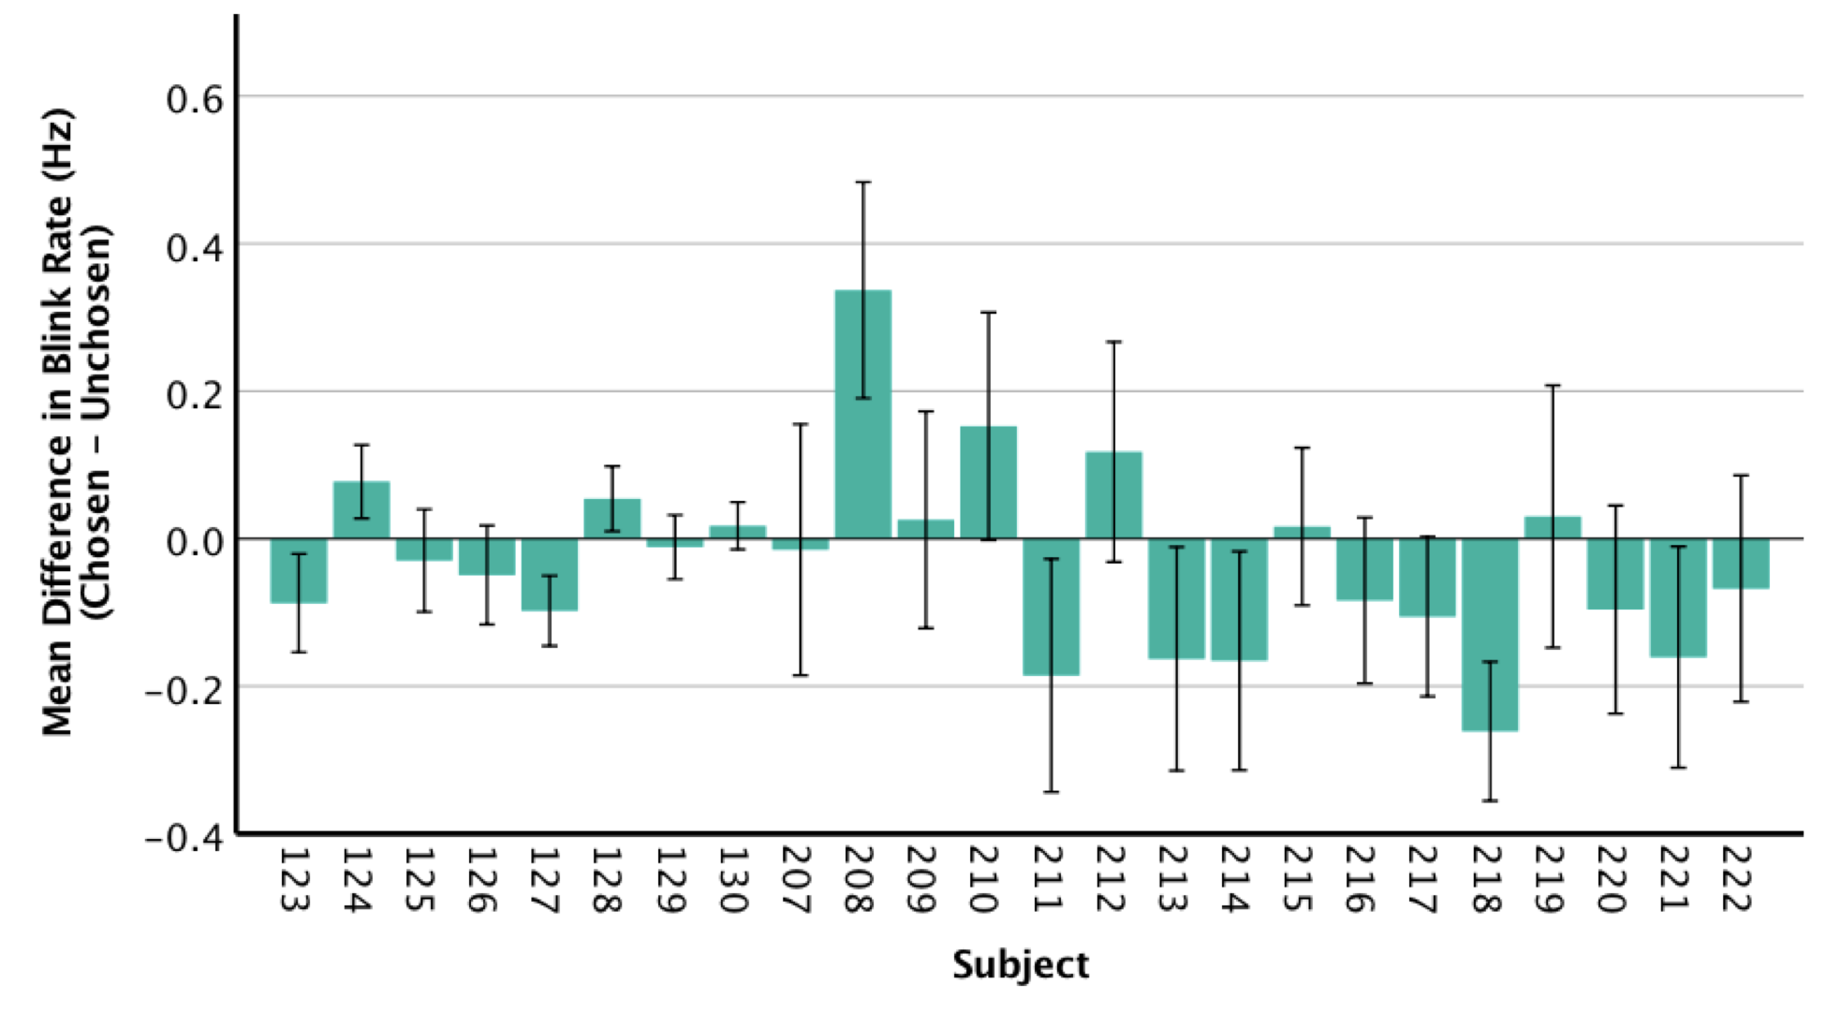
S5 Fig: Average difference in blink rate of chosen hole relative to unchosen holes per individual rat. Some rats (e.g. 124 and 208) demonstrated a significant preference for choosing stocks that increased in price (faster blink rates), while others (e.g. 211 and 218) preferred stocks with decreasing prices (slower blink rates). Most rats showed no preference for stocks based purely on blink rate, suggesting that rats might have been (correctly) choosing based on changes in blink rate from one trial to the next.

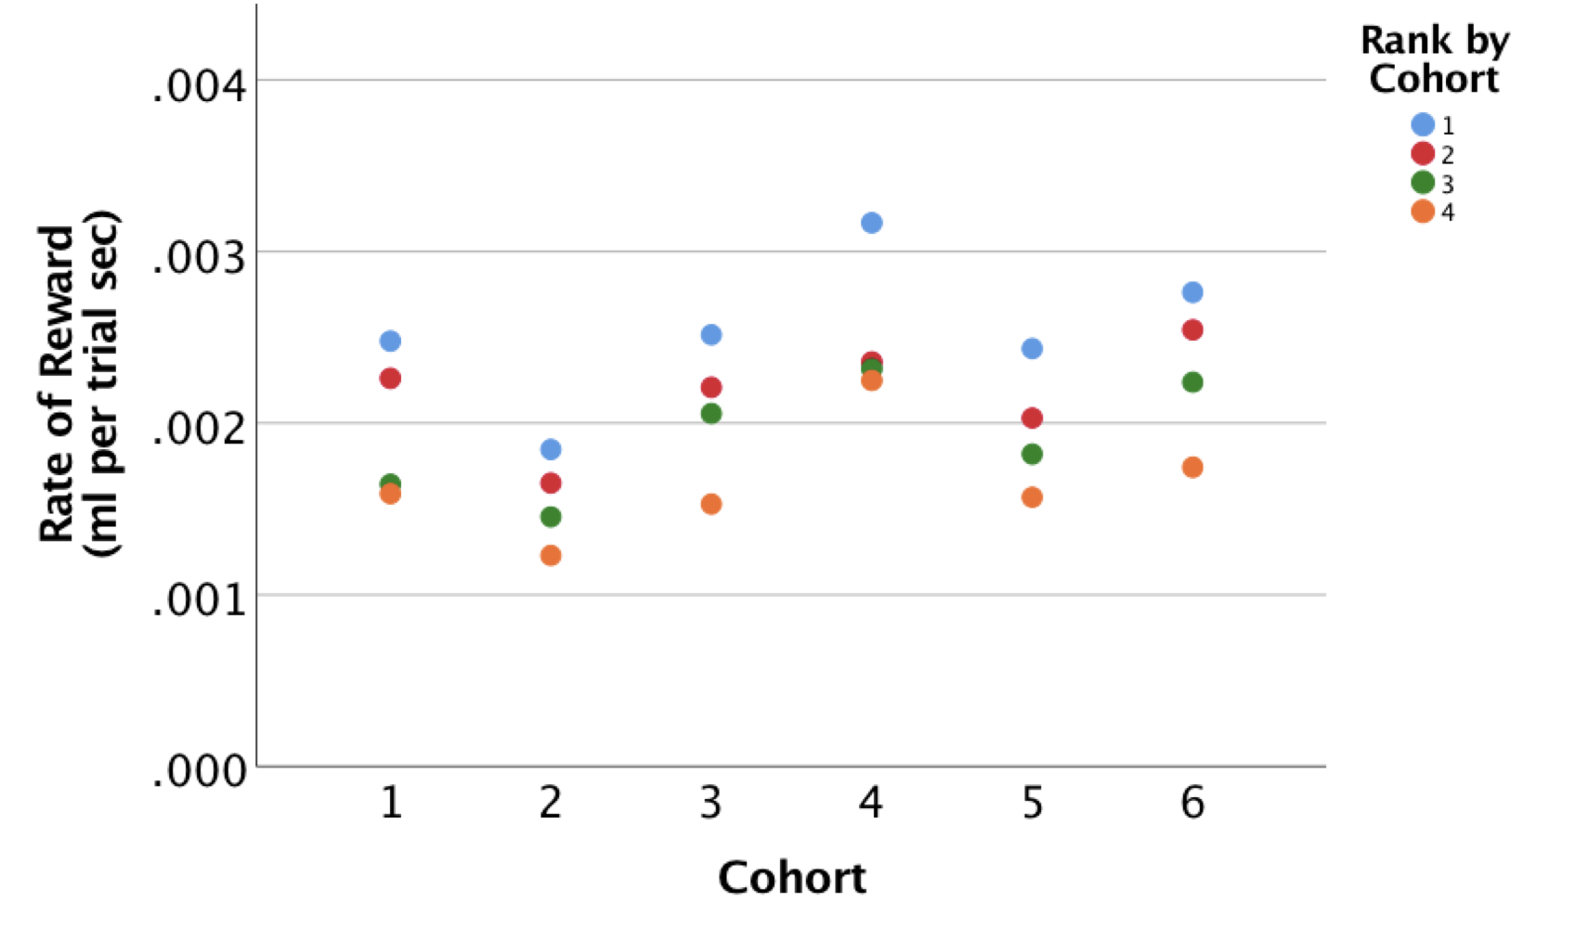
S6 Fig: Mean rate of reward per subject by cohort. Each rat (N = 24) was assigned to a cohort of 4 ‘trading’ partners, with a total of 6 cohorts in all. On average, rats received about 0.002 ml of liquid reward per trial sec. Cohort 4 exceeded the average, mainly due to a top-performer (blue circle) rather than the other three members of the cohort (red, green and orange circles). By contrast, all of the members of cohort 2 underperformed relative to average.

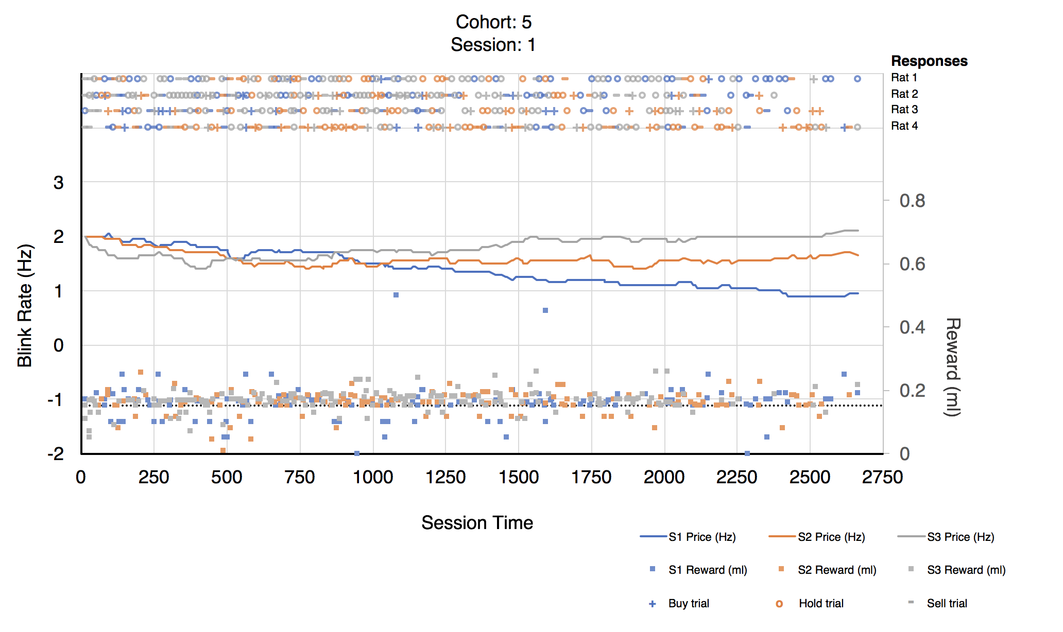
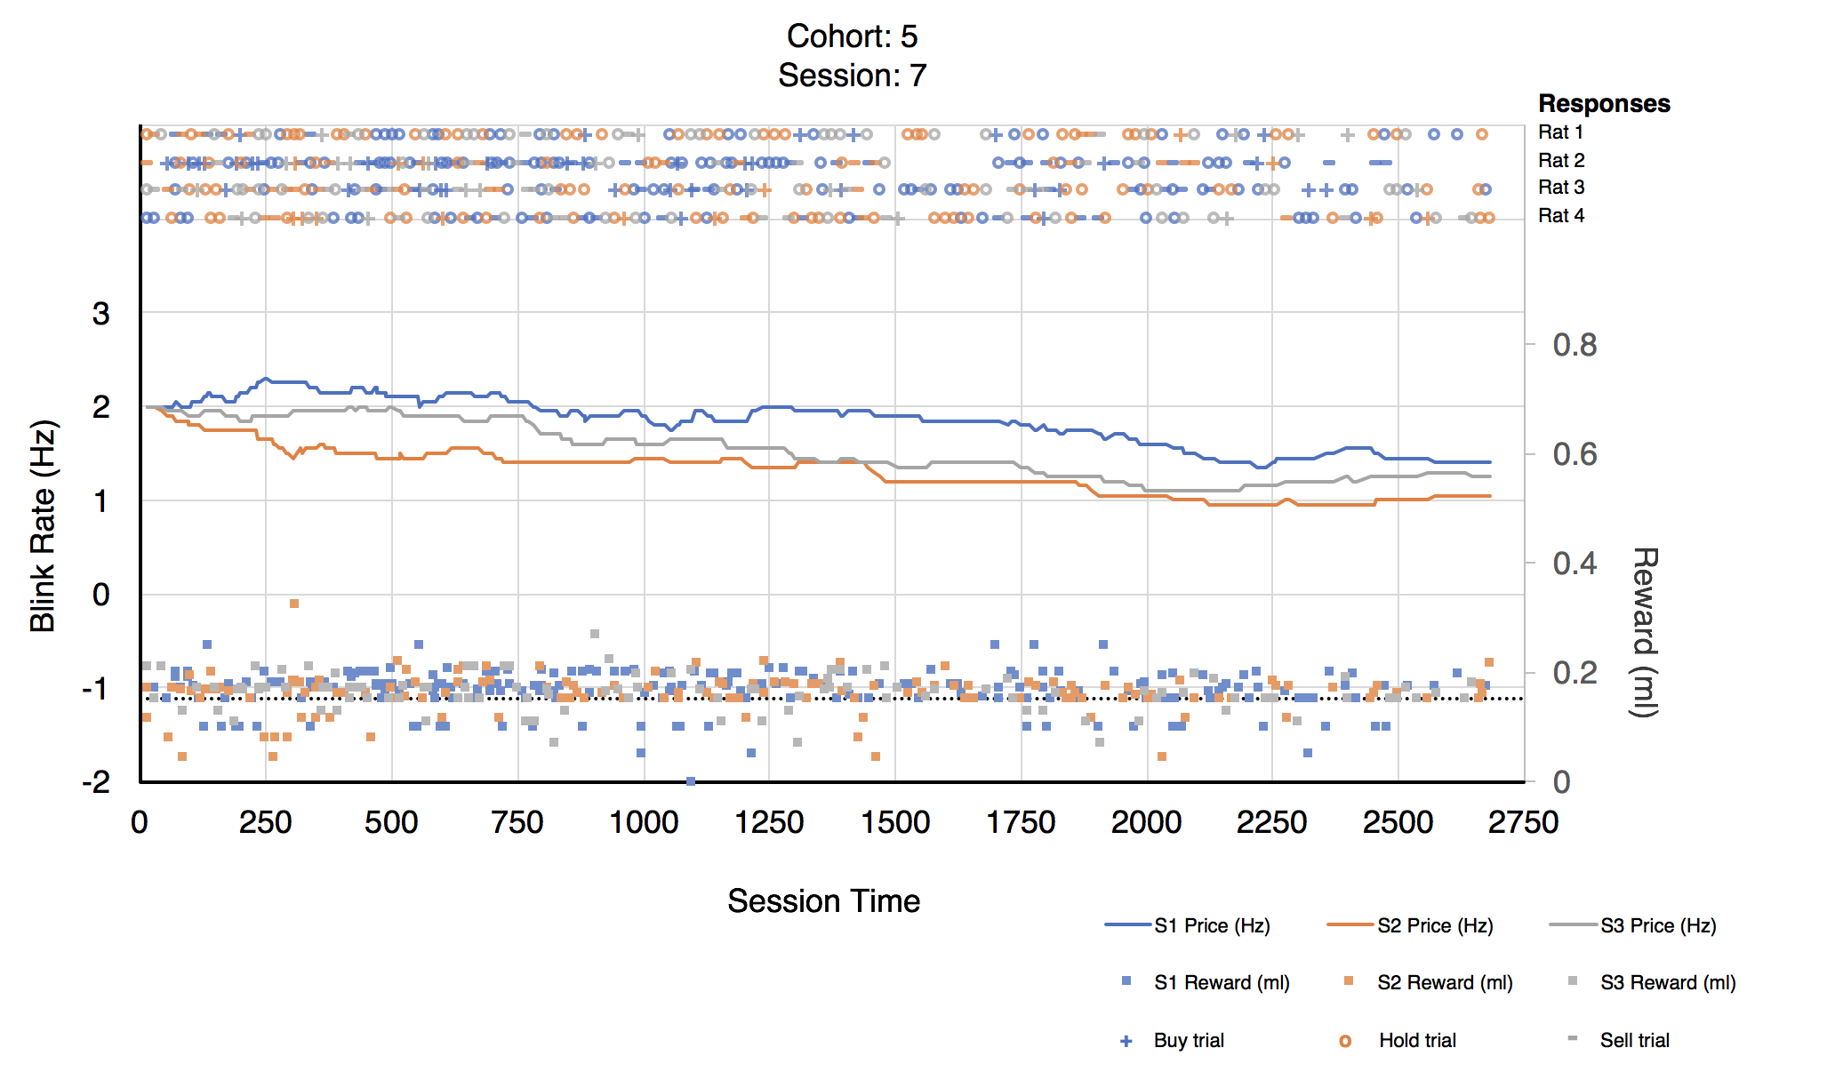

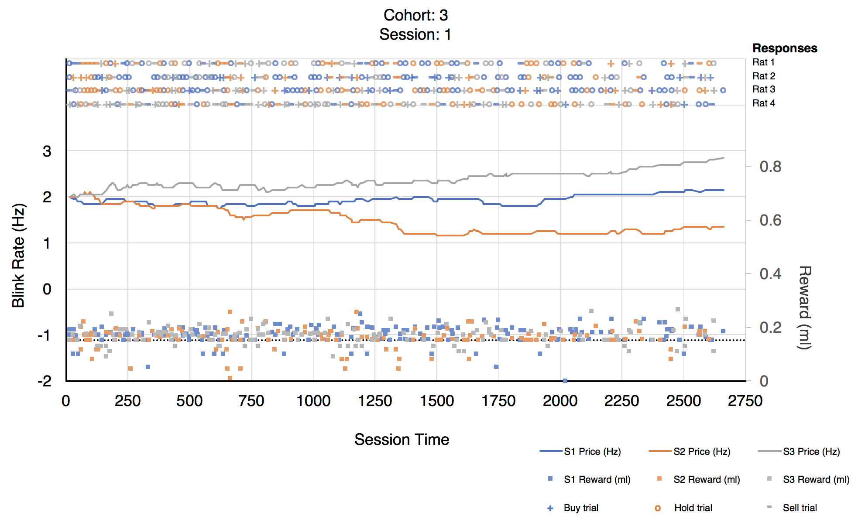
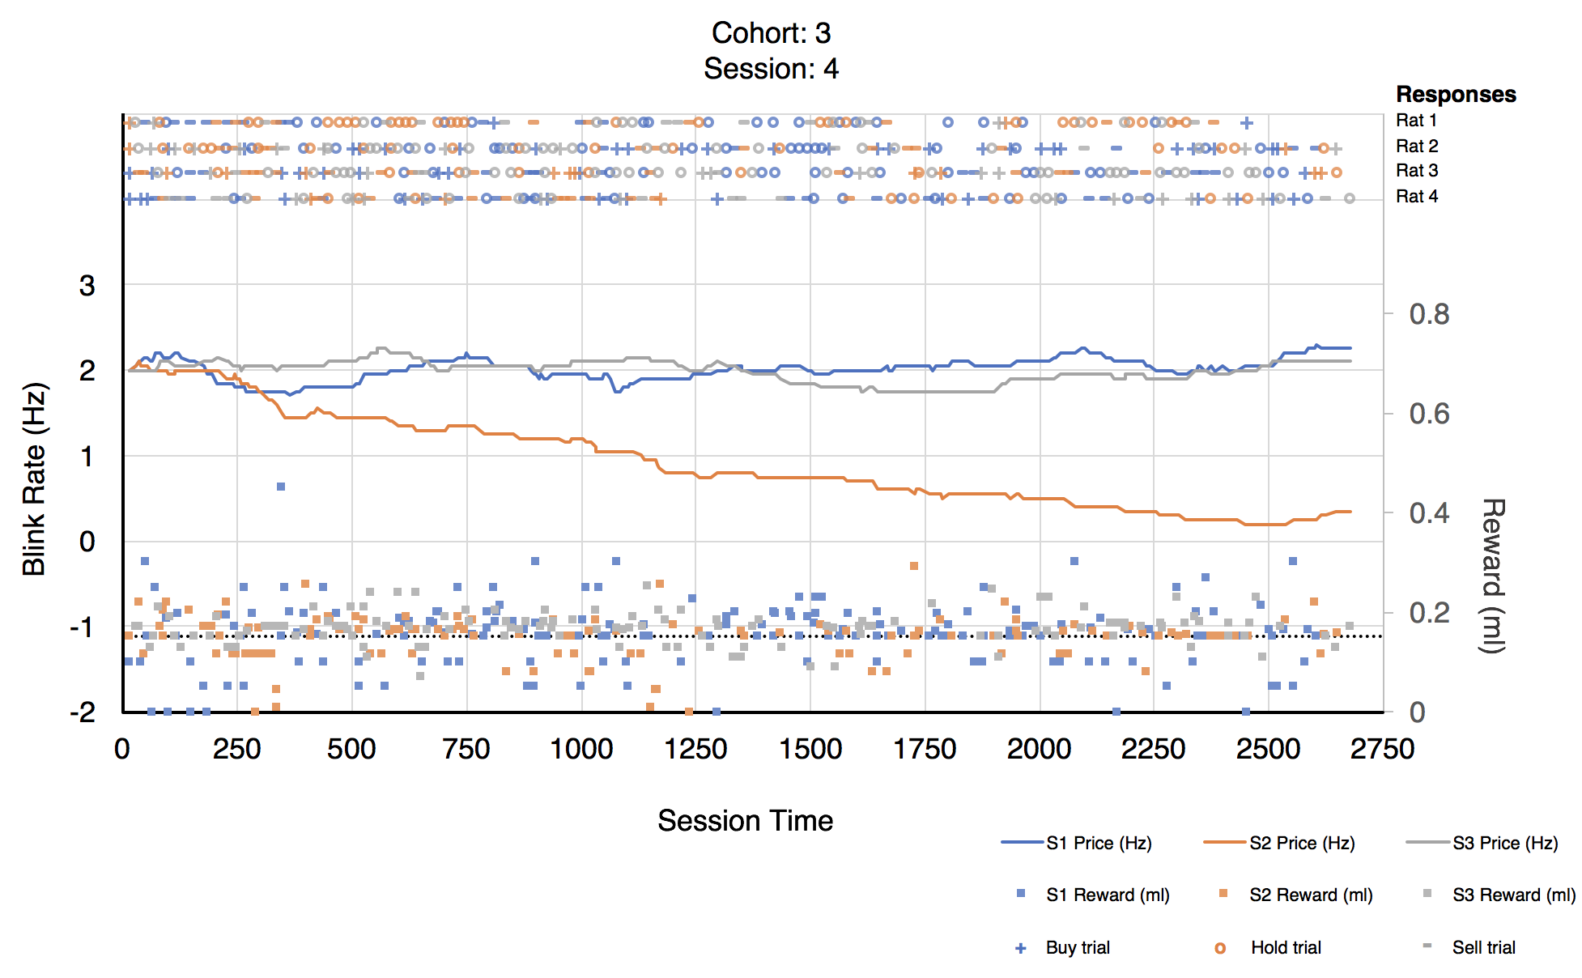

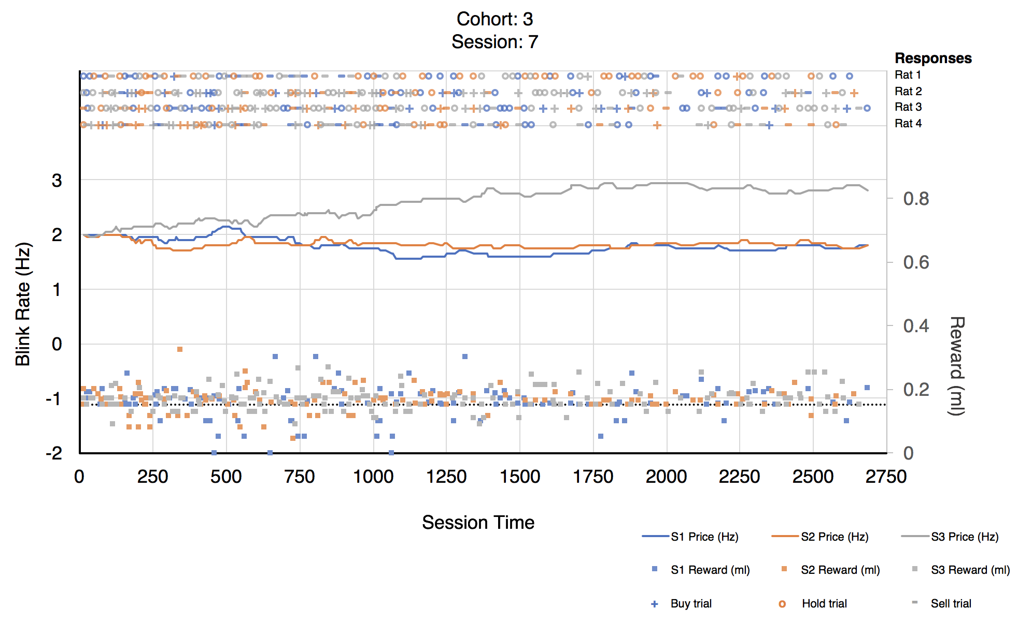
S7a-e Figs: Example sessions. Cohorts of four rats chose to ‘buy’ (+), hold (o), or sell (-) one of three stocks (S1, S2, and S3) over the course of a single 45-minute session. Blink rate for all three stocks started at 2 Hz. Resulting changes in blink rate (Hz, solid lines) from rat’s responses can be seen to go up, down, or remain stable across trials and sessions. Reward (ml) received in each stock can be seen in colored squares along the bottom of the graph. The black dotted line represents the reference point (RP) of 0.15 ml.

