Figure S2. Correlations among test scores and participant characteristics
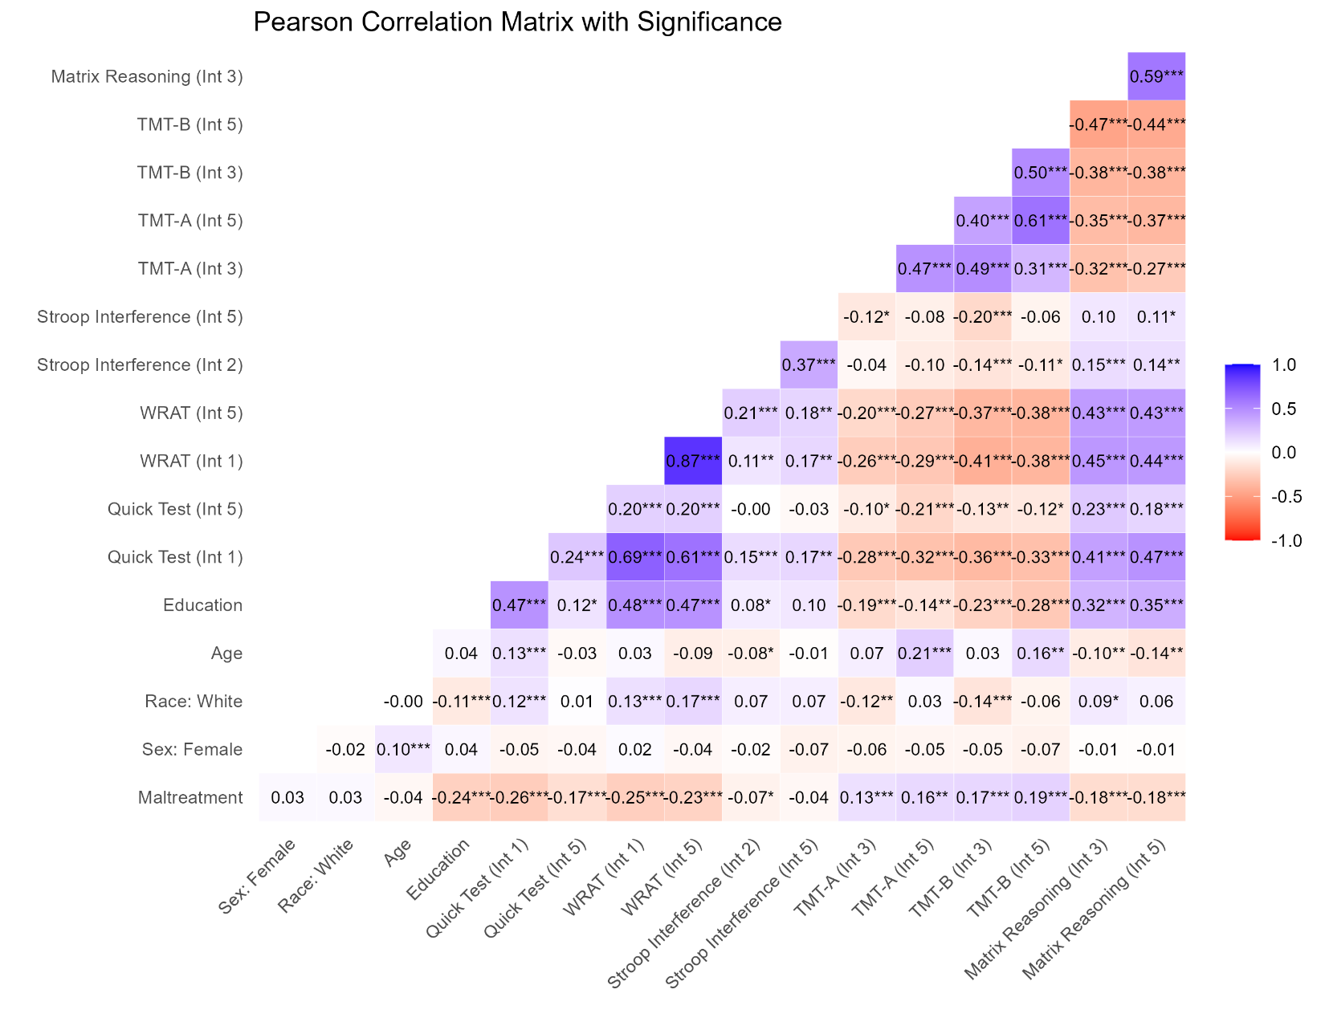Note: Correlogram of Pearson correlation coefficients of demographic characteristics and cognitive test scores. WRAT = Wide Range Achievement Test, TMT-A = Trail Making Test A, TMT-B = Trail Making Test B. Int = Interview). For Trail Making A & B, higher scores indicate worse performance. Positive correlations are displayed in blue and negative correlations in red color. Size of correlation coefficients are visually represented by the intensity of color of each square.
*p < .05, **p < .01, ***p < .001.

Supplementary Table 1. Results of unadjusted linear mixed-effects models comparing cognitive functioning measures between maltreated individuals and controls at two time points
Test |  | Fixed Effects |  |  | Random Effects
Quick Test  (Int 1 and 5) |  | Coeff. | SE | 95% CI |  | Variance | SD
Quick Test  (Int 1 and 5) | Intercept | 73.86*** | 0.76 | 72.37, 75.34 | Subject | 66.15 | 8.13
Quick Test  (Int 1 and 5) | Group | -8.01*** | 0.99 | -9.96, -6.06 | Residual | 428.39 | 20.70
Quick Test  (Int 1 and 5) | Time | -9.55*** | 0.93 | -11.37, -7.73 | ICC | 0.119
Quick Test  (Int 1 and 5) | Group x Time | 0.96 | 1.20 | -1.40, 3.32
WRAT
(Int 1 and 5)
WRAT  (Int 1 and 5) | Intercept | 58.62*** | 0.86 | 56.93, 60.30 | Subject | 312.90 | 17.69
WRAT  (Int 1 and 5) | Group | -10.09*** | 1.14 | -12.33, -7.86 | Residual | 127.00 | 11.27
WRAT  (Int 1 and 5) | Time | -3.76*** | 0.51 | -4.75, -2.77 | ICC | 0.806
WRAT  (Int 1 and 5) | Group x Time | -3.41*** | 0.66 | -4.70, -2.13
Stroop
(Int 2 and 5)
Stroop  (Int 2 and 5) | Intercept | 48.21*** | 0.65 | 46.94, 49.47 | Subject | 70.20 | 8.38
Stroop  (Int 2 and 5) | Group | -1.36 | 0.85 | -3.03, 0.31 | Residual | 270.10 | 16.44
Stroop  (Int 2 and 5) | Time | 10.28*** | 0.74 | 8.84, 11.73 | ICC | 0.209
Stroop  (Int 2 and 5) | Group x Time | 0.12 | 0.96 | -1.76, 1.99
Matrix Reasoning (Int 3 and 5)
Matrix Reasoning (Int 3 and 5) | Intercept | 59.65*** | 1.04 | 57.90, 61.99 | Subject | 263.80 | 16.24
Matrix Reasoning (Int 3 and 5) | Group | -8.65*** | 1.38 | -11.34, -5.96 | Residual | 545.20 | 23.35
Matrix Reasoning (Int 3 and 5) | Time | -13.77*** | 1.05 | -15.82, -11.72 | ICC | 0.357
Matrix Reasoning (Int 3 and 5) | Group x Time | -0.41 | 1.36 | -3.07, 2.25
Trail Making A (Int 3 and 5)
Trail Making A (Int 3 and 5) | Intercept | 10.50*** | 0.59 | 9.35, 11.65 | Subject | 70.89 | 8.42
Trail Making A (Int 3 and 5) | Group | 2.69*** | 0.78 | 1.18, 4.21 | Residual | 198.33 | 14.08
Trail Making A (Int 3 and 5) | Time | 4.32*** | 0.63 | 3.08, 5.55 | ICC | 0.421
Trail Making A (Int 3 and 5) | Group x Time | 1.17 | 0.82 | -0.43, 2.78
Trail Making B (Int 3 and 5)
Trail Making B (Int 3 and 5) | Intercept | 31.10*** | 1.08 | 28.99, 33.22 | Subject | 244.80 | 15.65
Trail Making B (Int 3 and 5) | Group | 4.65** | 1.42 | 1.86, 7.44 | Residual | 656.90 | 25.63
Trail Making B (Int 3 and 5) | Time | -1.39 | 1.15 | -3.64, 0.86 | ICC | 0.461
Trail Making B (Int 3 and 5) | Group x Time | 5.15*** | 1.49 | 2.23, 8.08
Note. ICC = Intraclass correlation coefficient; Unstandardized coefficients and standard errors (SEs) are reported. Missing data across interviews were imputed through Multiple Imputation by Chained Equation (MICE). For Trail Making A & B, higher scores indicate worse performance. Analyses use inverse probability weighting. †p < 0.10, *p < 0.05, **p < 0.01, ***p<0.001

Supplementary Table 2. Results of complete case analysis of linear mixed-effects models comparing cognitive functioning measures between maltreated individuals and controls at two time points (N = 248)
Test |  | Fixed Effects |  |  | Random Effects
Quick Test  (Int 1 and 5) |  | Coeff. | SE | 95% CI |  | Variance | SD
Quick Test  (Int 1 and 5) | Intercept | 33.98*** | 7.88 | 18.53, 49.44 | Subject | 45.59 | 6.75
Quick Test  (Int 1 and 5) | Group | -6.60** | 2.04 | -10.60, -2.60 | Residual | 455.73 | 21.35
Quick Test  (Int 1 and 5) | Time | -9.09*** | 1.93 | -12.87, -5.31 | ICC | 0.098
Quick Test  (Int 1 and 5) | Age | 0.40 | 0.22 | -0.03, 0.83
Quick Test  (Int 1 and 5) | Sex: Female | 0.27 | 1.56 | -2.78 3.32
Quick Test  (Int 1 and 5) | Race: White | 4.62** | 1.63 | 1.43, 7.81
Quick Test  (Int 1 and 5) | Group x Time | 3.09 | 2.48 | -1.78 7.95
WRAT
(Int 1 and 5)
WRAT  (Int 1 and 5) | Intercept | 22.27* | 9.90 | 2.88, 41.67 | Subject | 200.40 | 14.16
WRAT  (Int 1 and 5) | Group | -6.68** | 2.18 | -10.95, -2.40 | Residual | 158.60 | 12.59
WRAT  (Int 1 and 5) | Time | -5.60*** | 1.14 | -7.83, -3.37 | ICC | 0.757
WRAT  (Int 1 and 5) | Age | -0.48 | 0.28 | -1.03, 0.06
WRAT  (Int 1 and 5) | Sex: Female | 0.52 | 2.00 | -3.40, 4.44
WRAT  (Int 1 and 5) | Race: White | 10.37*** | 2.08 | 6.28, 14.45
WRAT  (Int 1 and 5) | Group x Time | -0.25 | 1.46 | -3.12, 2.62
Stroop
(Int 2 and 5)
Stroop  (Int 2 and 5) | Intercept | 45.58*** | 7.79 | 30.31, 60.85 | Subject | 74.03 | 8.60
Stroop  (Int 2 and 5) | Group | 0.01 | 1.91 | -3.73, 3.74 | Residual | 311.35 | 17.65
Stroop  (Int 2 and 5) | Time | 12.07*** | 1.59 | 8.95, 15.19 | ICC | 0.137
Stroop  (Int 2 and 5) | Age | -0.26 | 0.22 | -0.69, 0.17
Stroop  (Int 2 and 5) | Sex: Female | -0.95 | 1.55 | -3.99, 2.09
Stroop  (Int 2 and 5) | Race: White | 3.60* | 1.62 | 0.42, 6.78
Stroop  (Int 2 and 5) | Group x Time | -1.55 | 2.05 | -5.57, 2.47
Matrix Reasoning (Int 3 and 5)
Matrix Reasoning (Int 3 and 5) | Intercept | 43.48*** | 11.85 | 20.25, 66.71 | Subject | 213.80 | 14.62
Matrix Reasoning (Int 3 and 5) | Group | -6.68* | 2.80 | -12.16, -1.20 | Residual | 537.10 | 23.17
Matrix Reasoning (Int 3 and 5) | Time | -14.90*** | 2.09 | -19.00, -10.80 | ICC | 0.322
Matrix Reasoning (Int 3 and 5) | Age | -0.68* | 0.33 | -1.33, -0.03
Matrix Reasoning (Int 3 and 5) | Sex: Female | 2.72 | 2.37 | -1.93, 7.37
Matrix Reasoning (Int 3 and 5) | Race: White | 5.86* | 2.48 | 1.00, 10.73
Matrix Reasoning (Int 3 and 5) | Group x Time | -0.22 | 2.70 | -5.50, 5.06
Trail Making A (Int 3 and 5)
Trail Making A (Int 3 and 5) | Intercept | 15.27* | 5.97 | 3.58, 26.97 | Subject | 40.54 | 6.37
Trail Making A (Int 3 and 5) | Group | 2.42 | 1.47 | -0.47, 5.31 | Residual | 195.44 | 13.98
Trail Making A (Int 3 and 5) | Time | 4.07** | 1.26 | 1.60, 6.54 | ICC | 0.171
Trail Making A (Int 3 and 5) | Age | 0.17 | 0.17 | -0.15, 0.50
Trail Making A (Int 3 and 5) | Sex: Female | -2.03 | 1.19 | -4.35, 0.30
Trail Making A (Int 3 and 5) | Race: White | -1.79 | 1.24 | -4.23, 0.64
Trail Making A (Int 3 and 5) | Group x Time | 0.38 | 1.63 | -2.81, 3.56
Trail Making B (Int 3 and 5)
Trail Making B (Int 3 and 5) | Intercept | 41.83*** | 11.00 | 20.26, 63.39 | Subject | 156.40 | 12.51
Trail Making B (Int 3 and 5) | Group | 7.54** | 2.67 | 12.77 | Residual | 583.20 | 24.15
Trail Making B (Int 3 and 5) | Time | 3.18 | 2.18 | -1.10, 7.45 | ICC | 0.331
Trail Making B (Int 3 and 5) | Age | 0.43 | 0.30 | -0.17, 1.03
Trail Making B (Int 3 and 5) | Sex: Female | -5.49* | 2.19 | -9.79, -1.19
Trail Making B (Int 3 and 5) | Race: White | -7.10** | 2.30 | -11.60, -2.60
Trail Making B (Int 3 and 5) | Group x Time | 1.50 | 2.81 | -4.01, 7.00
Note. Analyses control for age, sex, race, and education. Education = highest grade of school completed; ICC = Intraclass correlation coefficient; Unstandardized coefficients and standard errors (SEs) are reported. Results for complete case analysis only uses individuals who had no missing data across all timepoints (N = 248). For Trail Making A & B, higher scores indicate worse performance. Analyses use inverse probability weighting.
*p < 0.05, **p < 0.01, ***p<0.001

