Supplemental Materials
Table S1
Overview of neuropsychological test battery and measurement aim
Test | (Sub)test description | Main measurement aim
Dutch version of the Auditory Verbal Learning Task (Van der Elst, van Boxtel, van Breukelen, & Jolles, 2005) | Immediate recall | Consolidation
 | Delayed recall | Verbal episodic memory
Visual Association Test (Lindeboom, Schmand, Tulner, Walstra, & Jonker, 2002) | Naming | Semantic knowledge
 | Immediate recall | Associative episodic memory
Rey–Osterrieth Complex Figure Test (Meyers & Meyers, 1995) | Figure copy | Visual spatial construction and organization
Rey–Osterrieth Complex Figure Test (Meyers & Meyers, 1995) | Recall (3 minutes) | Visual episodic memory
Trail Making Test (Reitan & Wolfson, 1995) | TMT-A | Visual scanning and processing speed
Trail Making Test (Reitan & Wolfson, 1995) | TMT-B | Mental flexibility
Stroop color-word test (Stroop, 1935) | Stroop card I (word reading) | Verbal and attentional processing speed
Stroop color-word test (Stroop, 1935) | Stroop card II (color naming) | Verbal and attentional processing speed
Stroop color-word test (Stroop, 1935) | Stroop card III (color-word incongruent condition) | Response inhibition
Digit Span-test (Lindeboom & Matto, 1994) | Forward | Attention and immediate memory
Digit Span-test (Lindeboom & Matto, 1994) | Backward | Working memory
Letter fluency (Lezak, Howieson, Bigler, & Tranel, 2012) | Three letters (combined to a total score) | Verbal fluency and cognitive flexibility
Behavioural Assessment of the Dysexecutive Syndrome (Wilson, Alderman, Burguess, Emslie, & Evans, 1996) | Rule shift cards condition | Set shifting
Letter digit substitution test (van der Elst, van Boxtel, van Breukelen, & Jolles, 2006) | As many digits in 90 seconds | Processing speed
Animal fluency (Luteijn & van der Ploeg, 1982) | One minute animal fluency | Verbal fluency and semantic memory
Visual Object and Space Perception battery (Warrington & James, 1991) | Fragmented Letters | Visual perception

Table S2
Demographic and clinical characteristics of reference group
 |  | SCD A-
N |  | 258
A+ (%) |  | 0 (0.0)
Age, years (mean (SD)) |  | 59.3 (7.7)
Female gender (%) |  | 102 (39.5)
Education, years (mean (SD)) |  | 11.7 (2.9)
Everyday functioning
A-IADL-Q-30 |  | 58.6 (7.0)
Visual attention, mental flexibility, visuoconstruction
TMT-A* |  | -36.2 (15.4)
TMT-B* |  | -95.0 (53.1)
RCFT copy |  | 34.0 (2.8)
VOSP fragmented letters |  | 19.2 (1.2)
LDST |  | 45.4 (10.3)
Stroop I* |  | -45.9 (13.0)
Memory
AVLT immediate recall |  | 40.5 (9.9)
AVLT delayed recall |  | 8.1 (3.1)
VAT |  | 11.5 (1.0)
RCFT recall |  | 19.0 (5.3)
 | Working memory, shifting, fluency, inhibition
Digit span forward |  | 12.7 (3.1)
Digit span backward |  | 8.9 (2.9)
Letter fluency |  | 35.2 (12.4)
Stroop III* |  | -107.6 (43.8)
BADS card rule shift* |  | -1.2 (1.8)
Naming
Animal fluency |  | 22.8 (6.2)
VAT naming |  | 11.9 (0.5)
Stroop II* |  | -63.3 (17.2)
Note. Scores of tests with a * are inverted, so all test scores are in the same direction. Higher scores indicate better performance.

Table S3
Checklist for SEM by Kang&Ahn (2021)
Topic | Item | Guide questions
Model setting | 1 | Measurement of observed variables  - –  Are the observed variables measured by a valid and reliable measurement tool?
Model setting | 2 | Measurement model setting  - -  Do observed variables represent each latent variable?  - -  Do the observed variables that define each latent variable measure the same concept?  - -  Is each latent variable defined to represent a single concept (or meaning)?  - -  Can the sizes of the latent variables be compared? Or, is it possible to compare the size of the measurements of the latent variable? Or, can you tell the size (large/small) of each latent variable?
Model setting | 3 | Structural model setting  - -  Are there any missing causal relationships or associations between latent variables?  - -  Are causal relationships or associations between latent variables based on theory and empirical facts or results?
Evaluation and modification of the model | 4 | Do most GFIs show reasonable fitness?
Evaluation and modification of the model | 5 | Have all the relatively large modification indices been considered?
Evaluation and modification of the model | 6 | Has the parsimony of the model been pursued?
Evaluation and modification of the model | 7 | Have the equivalent and alternative models been considered?
Evaluation and modification of the model | 8 | Has the relationship between measurement and endogenous error variables been reviewed?
Interpretation and reporting of the model | 9 | Have all the descriptive statistics and correlation coefficients of the observed variables been reviewed?
Interpretation and reporting of the model | 10 | Have major GFIs been reported?
Interpretation and reporting of the model | 11 | Have the main results of the measurement model been presented appropriately?
Interpretation and reporting of the model | 12 | Were the main results for the structural model adequately presented?
Interpretation and reporting of the model | 13 | Have the major results of the mediating effect been reported appropriately?

Table S4
Correlation coefficients and standard deviations
 | AVLT-i | AVLT-d | VAT | RCFT recall | TMT-A | TMT-B | Stroop I | Stroop II | Stroop III | DS-fw | DS-bw | Letter fluency | BADS card rule shift | LDST | Animals | Naming | RCFT copy | VOSP fl | A-IADL-Q-30
AVLT-i | 1
AVLT-d | 0.72 | 1
VAT | 0.55 | 0.61 | 1
RCFT recall | 0.55 | 0.66 | 0.66 | 1
TMT-A | 0.39 | 0.21 | 0.34 | 0.36 | 1
TMT-B | 0.40 | 0.22 | 0.34 | 0.35 | 0.96 | 1
Stroop I | 0.39 | 0.21 | 0.33 | 0.25 | 0.71 | 0.71 | 1
Stroop II | 0.44 | 0.23 | 0.30 | 0.28 | 0.71 | 0.71 | 0.78 | 1
Stroop III | 0.46 | 0.25 | 0.31 | 0.34 | 0.55 | 0.56 | 0.58 | 0.71 | 1
DS-fw | 0.42 | 0.12 | 0.16 | 0.15 | 0.35 | 0.38 | 0.40 | 0.42 | 0.46 | 1
DS-bw | 0.50 | 0.24 | 0.30 | 0.29 | 0.49 | 0.52 | 0.50 | 0.52 | 0.56 | 0.61 | 1
Letter fluency | 0.49 | 0.26 | 0.25 | 0.23 | 0.43 | 0.45 | 0.52 | 0.55 | 0.56 | 0.49 | 0.54 | 1
BADS card rule shift | 0.41 | 0.21 | 0.40 | 0.37 | 0.45 | 0.50 | 0.45 | 0.43 | 0.60 | 0.39 | 0.52 | 0.44 | 1
LDST | 0.49 | 0.30 | 0.40 | 0.45 | 0.72 | 0.74 | 0.65 | 0.62 | 0.66 | 0.44 | 0.6 | 0.56 | 0.61 | 1
Animals | 0.60 | 0.41 | 0.38 | 0.40 | 0.47 | 0.48 | 0.49 | 0.56 | 0.60 | 0.41 | 0.49 | 0.59 | 0.54 | 0.61 | 1
Naming | 0.33 | 0.16 | 0.19 | 0.13 | 0.29 | 0.29 | 0.46 | 0.56 | 0.43 | 0.25 | 0.28 | 0.36 | 0.35 | 0.29 | 0.46 | 1
RCFT copy | 0.33 | 0.17 | 0.31 | 0.42 | 0.79 | 0.77 | 0.61 | 0.60 | 0.57 | 0.30 | 0.49 | 0.37 | 0.46 | 0.72 | 0.44 | 0.33 | 1
VOSP fl | 0.33 | 0.19 | 0.34 | 0.32 | 0.72 | 0.69 | 0.61 | 0.56 | 0.43 | 0.26 | 0.41 | 0.35 | 0.42 | 0.6 | 0.45 | 0.45 | 0.7 | 1
A-IADL-Q-30 | 0.42 | 0.36 | 0.45 | 0.40 | 0.40 | 0.41 | 0.35 | 0.36 | 0.41 | 0.22 | 0.35 | 0.29 | 0.39 | 0.48 | 0.42 | 0.22 | 0.39 | 0.39 | 1
SD | 1.09 | 1.12 | 4.06 | 1.17 | 4.86 | 3.65 | 2.15 | 3.1 | 2.24 | 0.97 | 0.92 | 1.01 | 1.88 | 1.24 | 1.04 | 3.1 | 2.9 | 3.41 | 9.26

Table S5
SEM path coefficients for observed variables
Latent variables | Observed variables | Standardized estimates
Visual attention, mental flexibility and visuoconstruction | TMT-A | 0.88
Visual attention, mental flexibility and visuoconstruction | TMT-B | 0.88
Visual attention, mental flexibility and visuoconstruction | RCFT copy | 0.85
Visual attention, mental flexibility and visuoconstruction | VOSP-FL | 0.78
Visual attention, mental flexibility and visuoconstruction | LDST | 0.85
Visual attention, mental flexibility and visuoconstruction | Stroop I | 0.78
Memory | AVLT delayed | 0.78
 | VAT | 0.79
 | RCFT recall | 0.83
 | AVLT immediate | 0.73
Working memory, shifting, fluency, inhibition | Digit Span forward | 0.57
Working memory, shifting, fluency, inhibition | Digit Span backward | 0.72
Working memory, shifting, fluency, inhibition | Letter fluency | 0.70
Working memory, shifting, fluency, inhibition | Stroop III | 0.82
Working memory, shifting, fluency, inhibition | BADS rule shift | 0.71
Naming | Animal fluency | 0.74
 | VAT naming | 0.54
 | Stroop II | 0.81

Table S6
Model path coefficients for explanatory variables per subgroup
Subgroup | Endogenous variable | Explanatory variable | Estimate | Standardized estimate | p-value
Non-dementia | IADL | Visual attention, mental flexibility, visuoconstruction | 4.74 | 0.65 | 0.06
Non-dementia |  | Memory | 1.52 | 0.21 | 0.03
 |  | Working memory, shifting, fluency, inhibition | -2.68 | -0.37 | 0.30
 |  | Naming | -0.59 | -0.08 | 0.69
Dementia | IADL | Visual attention, mental flexibility, visuoconstruction | 2.56 | 0.30 | <0.01
 |  | Memory | 2.11 | 0.25 | <0.01
 |  | Working memory, shifting, fluency, inhibition | 1.45 | 0.17 | 0.26
 |  | Naming | -1.20 | -0.14 | 0.49
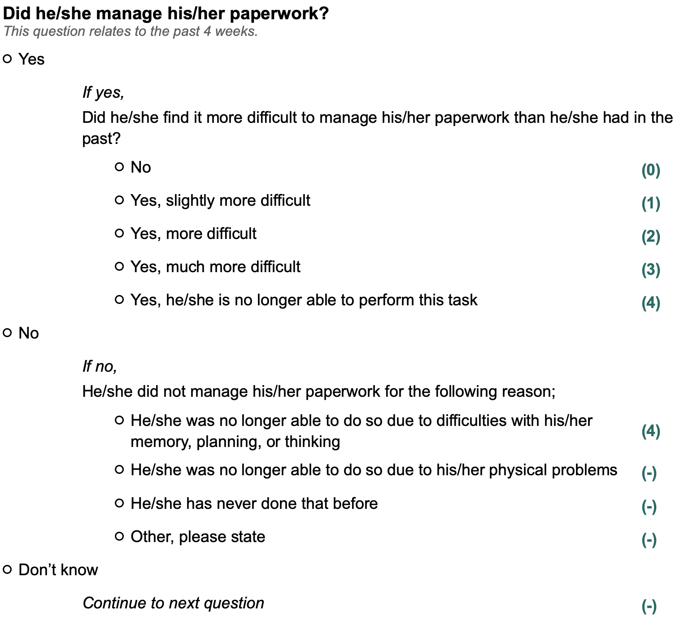
Figure S1. Example item of the Amsterdam-IADL-Questionnaire with the corresponding scores displayed between brackets on the right, (-) means that this option is scored as missing.
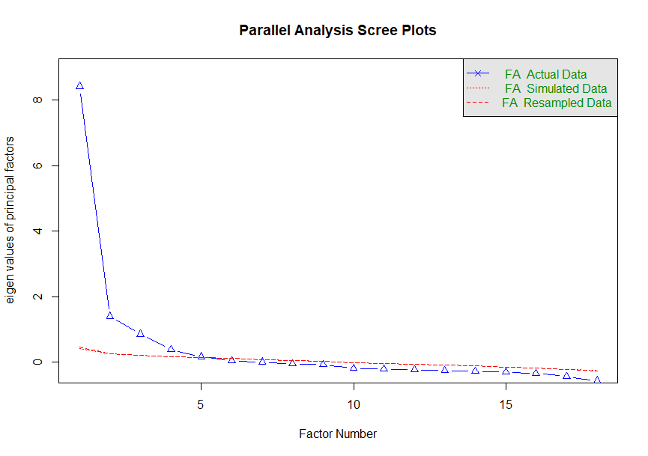
Figure S2. Scree plot for factor analysis

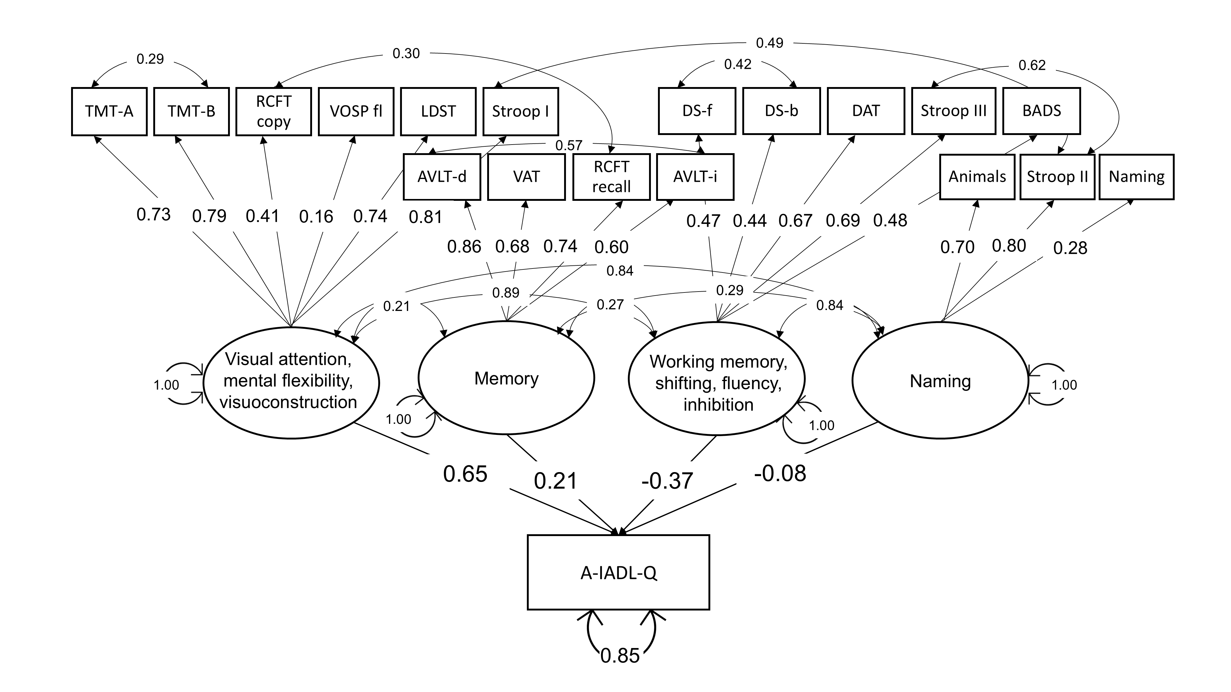
Figure S3A. Structural equation model of the cognitive domains and everyday functioning for non-dementia groups
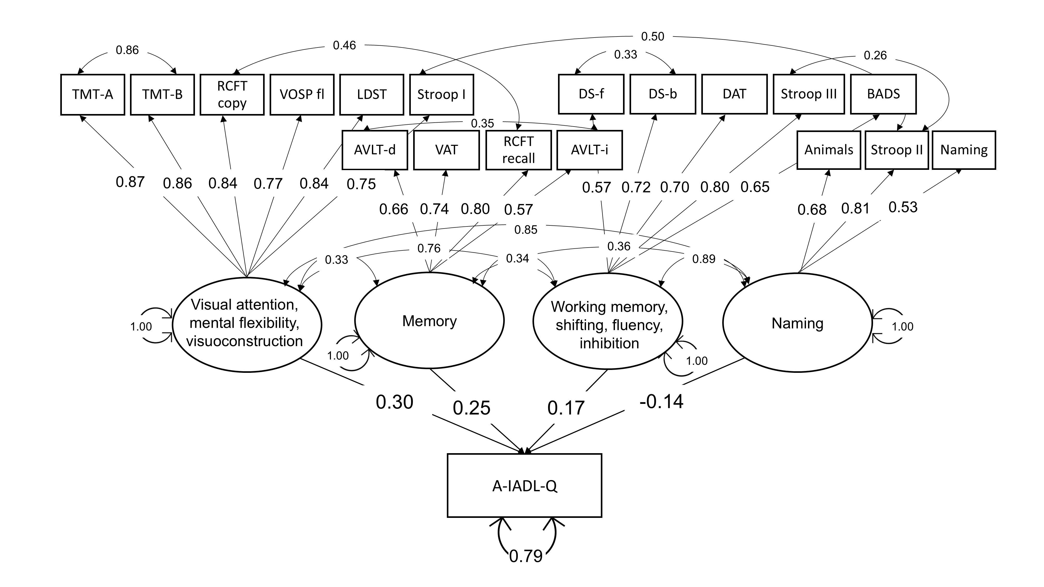
Figure S3B. Structural equation model of the cognitive domains and everyday functioning for dementia

References
Lezak, M., Howieson, D., Bigler, E., & Tranel, D. (2012). Neuropsychological Assessment. New York, NY: Oxford University Press.
Lindeboom, J., & Matto, D. (1994). [Digit series and Knox cubes as concentration tests for elderly subjects]. Tijdschr Gerontol Geriatr, 25(2), 63-68. Retrieved from https://www.ncbi.nlm.nih.gov/pubmed/8197598
Lindeboom, J., Schmand, B., Tulner, L., Walstra, G., & Jonker, C. (2002). Visual association test to detect early dementia of the Alzheimer type. J Neurol Neurosurg Psychiatry, 73(2), 126-133. doi:10.1136/jnnp.73.2.126
Luteijn, F., & van der Ploeg, F. A. E. (1982). GIT: Groninger Intelligentie Test (in Dutch). Lisse: Swets & Zeitlinger.
Meyers, J. E., & Meyers, K. R. (1995). Rey complex figure test under four different administration procedures. The Clinical Neuropsychologist, 9(1), 63-67. doi:https://doi.org/10.1080/13854049508402059
Reitan, R. M., & Wolfson, D. (1995). Category Test and Trail Making Test as Measures of Frontal-Lobe Functions. Clinical Neuropsychologist, 9(1), 50-56. doi:Doi 10.1080/13854049508402057
Stroop, J. R. (1935). Studies of interference in serial verbal reactions. Journal of Experimental Psychology, 18(6), 643-662. doi:https://doi.org/10.1037/h0054651
Van der Elst, W., van Boxtel, M. P., van Breukelen, G. J., & Jolles, J. (2005). Rey's verbal learning test: normative data for 1855 healthy participants aged 24-81 years and the influence of age, sex, education, and mode of presentation. J Int Neuropsychol Soc, 11(3), 290-302. doi:10.1017/S1355617705050344
van der Elst, W., van Boxtel, M. P., van Breukelen, G. J., & Jolles, J. (2006). The Letter Digit Substitution Test: normative data for 1,858 healthy participants aged 24-81 from the Maastricht Aging Study (MAAS): influence of age, education, and sex. J Clin Exp Neuropsychol, 28(6), 998-1009. doi:10.1080/13803390591004428
Warrington, E. K., & James, M. (1991). The Visual Object and Space Perception Battery. Bury St Edmunds, England: Thames Valley Test Company.
Wilson, B. A., Alderman, N., Burguess, P. W., Emslie, H., & Evans, J. J. (1996). Behavioural Assessment of the Dysexecutive Syndrome (BADS). Cognição.

