Supplementary material

Table S1: Outcome measure calculation.

Colour Mix, Think Back, Mind Reading, Face Match, Sum Up, Picture Pair, and Line Judgement | Average reaction time (s): Calculated by averaging the time taken in seconds to respond and select each stimulus across the total number of trials completed in each of these tasks.
 | Total correct: Calculated by totalling the number of correct trials of those completed.
 | SAT score: the total number of correct items completed divided by the average reaction time in seconds.
Swipe Out | Flanker effect (ms): calculated by subtracting the average reaction time of trials where the flanking arrows are congruent (same direction as central arrow) from the average reaction time of trials where the flanking arrows are incongruent (different direction to central arrow).
Balloon Fair | The total amount of money earned: The total amount of money accrued in the bank at the end of the task, accounting for any incurred losses by burst balloons.
Card Sort | The number of correct categories achieved: (out of a possible total of six) was calculated. A category can only be completed when six consecutive correct rules have been provided. It was not possible to differentiate between perseverative and non-perseverative errors in the Ignite data due to the structure of the raw data output, therefore the number of correct categories achieved was used as an equivalent measure of frontal dysfunction.
Path Finder | Time to complete (s): The total time taken to complete the task.
Time Tap | The below measures were generated based on the Wing and Kristofferson (47) model of motor response timing, which proposes that the variance in finger tapping is determined by both a “clock” and motor system delay. The clock represents a cognitive internal timekeeper which provides the trigger to initiate a given response or tap, whereas the motor delay is the time between the clock trigger and the response. These systems are thought to be independent processes and vary between responses. Another assumption of the Wing and Kristofferson (47) model is that although each inter-response interval (IRI) is determined by only the clock for that response it is also determined by the motor delay of that response plus the preceding response. This dependency of the motor delay on the previous response imposes a negative correlation between consecutive IRI’s, meaning a shorter IRI is followed by a long IRI or vice versa.  Both the clock and motor delay values are calculated from the estimated variance output from an autoregressive model allowing for the correlation of a variable with its past and future values. The Prais-Winsten method was adopted, which iterates over different values of the autocorrelation coefficient to find one that minimises the sum of squared errors (48). The Prais model was fitted to model inter-response interval for each condition (paced and self-paced) for each participant. To allow for relatively complex drifts in IRI, quadratic terms were fitted for stimulus number for paced and self-paced conditions (49). For both conditions, the first two taps were removed to eliminate atypical early responses and IRI’s that were more than three standard deviations from the predicted value of the model were also excluded since these were thought to be due to measurement error (i.e., missed, or accidental double taps). Clock variance and absolute drift were used as the outcome measures of interest as previous research demonstrated the greatest differences in these measures between bvFTD and controls (13), whereas a measure of motor delay was considered less important for cognitive impairment in FTD.  Clock variance (C): Calculated from the Prais model estimation of the residual variance (G0) and covariance between consecutive residuals (G1), as follows: C= G0 + 2*G1  Absolute drift: Calculated as the difference in the first and last tap from the modelled IRI regardless of the direction, to provide a measure of the magnitude of the drift.

Table S2: Ignite Z-score transformations. Transformations were chosen based on which method achieved the best normal distribution for that test (i.e., the highest p-value of a Shapiro-Wilk test).
Test | Outcome measure | Transformation
Path Finder Level 1 | Time to complete (s) | Inverse
Path Finder Level 2 | Time to complete (s) | Log
Colour Mix Level 1 | Average reaction time (s) | Inverse
Colour Mix Level 2 | Average reaction time (s) | Inverse
Colour Mix Level 3 | Average reaction time (s) | Inverse
Colour Mix Level 4 | Average reaction time (s) | Log
Colour Mix Level 4 | SAT score | Square root
Think Back Level 1 | Average reaction time (s) | 1/Square root
Think Back Level 1 | SAT score | Square root
Think Back Level 2 | Average reaction time (s) | Log
Think Back Level 2 | SAT score | Log
Swipe Out | Average reaction time (s) | 1/Square root
Mind Reading | Average reaction time (s) | 1/Square root
Mind Reading | SAT score | Square root
Face Match | Average reaction time (s) | 1/Square root
Picture Pair | Average reaction time (s) | Log
Line Judge | Average reaction time (s) | Log
Line Judge | SAT score | Square root
Sum Up | Average reaction time (s) | 1/Square root
Sum Up | SAT score | Square root

Table S3: Outputs from linear regression models used for normative data estimation with p-values and R-squared values reported. Results are reported from the first model including linear terms for demographic factors only, and a second model with a quadratic term for age (Age²) added for each Ignite outcome measure.
Test Name | Outcome measure | Age (p-value) | Education (p-value) | Sex (p-value) | R-squared | Age² (p-value) | R-squared
Sum Up | Total correct | 0.418 | 0.001 | 0.000 | 0.046 | 0.001 | 0.051
Sum Up | Average RT | 0.103 | 0.003 | 0.000 | 0.044 | 0.000 | 0.050
Sum Up | SAT score | 0.191 | 0.002 | 0.000 | 0.047 | 0.001 | 0.053
Colour Mix Level 1 | Total correct | 0.000 | 0.316 | 0.000 | 0.332 | 0.718 | 0.333
Colour Mix Level 1 | Average RT | 0.000 | 0.423 | 0.000 | 0.341 | 0.399 | 0.341
Colour Mix Level 1 | SAT score | 0.000 | 0.477 | 0.001 | 0.352 | 0.090 | 0.352
Colour Mix Level 2 | Total correct | 0.000 | 0.725 | 0.026 | 0.312 | 0.800 | 0.312
Colour Mix Level 2 | Average RT | 0.000 | 0.681 | 0.041 | 0.322 | 0.891 | 0.322
Colour Mix Level 2 | SAT score | 0.000 | 0.882 | 0.070 | 0.328 | 0.200 | 0.329
Colour Mix Level 3 | Total correct | 0.000 | 0.000 | 0.002 | 0.217 | 0.474 | 0.217
Colour Mix Level 3 | Average RT | 0.000 | 0.125 | 0.015 | 0.324 | 0.836 | 0.324
Colour Mix Level 3 | SAT score | 0.000 | 0.013 | 0.006 | 0.317 | 0.826 | 0.317
Colour Mix Level 4 | Total correct | 0.000 | 0.000 | 0.124 | 0.335 | 0.090 | 0.335
Colour Mix Level 4 | Average RT | 0.000 | 0.037 | 0.105 | 0.322 | 0.078 | 0.323
Colour Mix Level 4 | SAT score | 0.000 | 0.001 | 0.183 | 0.355 | 0.539 | 0.355
Think Back Level 1 | Total correct | 0.000 | 0.005 | 0.553 | 0.189 | 0.125 | 0.189
Think Back Level 1 | Average RT | 0.000 | 0.050 | 0.741 | 0.209 | 0.997 | 0.209
Think Back Level 1 | SAT score | 0.000 | 0.019 | 0.811 | 0.211 | 0.694 | 0.211
Think Back Level 2 | Total correct | 0.000 | 0.128 | 0.011 | 0.094 | 0.171 | 0.095
Think Back Level 2 | Average RT | 0.000 | 0.915 | 0.000 | 0.090 | 0.087 | 0.090
Think Back Level 2 | SAT score | 0.000 | 0.365 | 0.002 | 0.091 | 0.228 | 0.091
Path Finder Level 1 | Completion time | 0.000 | 0.001 | 0.185 | 0.255 | 0.000 | 0.260
Path Finder Level 2 | Completion time | 0.000 | 0.000 | 0.023 | 0.177 | 0.000 | 0.189
Face Match | Total Correct | 0.000 | 0.140 | 0.000 | 0.163 | 0.406 | 0.163
Face Match | Average RT | 0.000 | 0.657 | 0.001 | 0.252 | 0.404 | 0.252
Face Match | SAT score | 0.000 | 0.626 | 0.000 | 0.266 | 0.494 | 0.266
Mind Reading | Total Correct | 0.000 | 0.896 | 0.000 | 0.176 | 0.987 | 0.177
Mind Reading | Average RT | 0.000 | 0.018 | 0.734 | 0.201 | 0.513 | 0.201
Mind Reading | SAT score | 0.000 | 0.226 | 0.008 | 0.235 | 0.193 | 0.235
Picture Pair | Total Correct | 0.000 | 0.001 | 0.002 | 0.243 | 0.332 | 0.243
Picture Pair | Average RT | 0.000 | 0.614 | 0.154 | 0.229 | 0.247 | 0.229
Picture Pair | SAT score | 0.000 | 0.517 | 0.191 | 0.174 | 0.296 | 0.174
Line Judge | Total Correct | 0.000 | 0.000 | 0.000 | 0.129 | 0.648 | 0.130
Line Judge | Average RT | 0.000 | 0.074 | 0.000 | 0.216 | 0.569 | 0.216
Line Judge | SAT score | 0.000 | 0.000 | 0.000 | 0.243 | 0.573 | 0.243
Balloon Fair | Total earned | 0.000 | 0.019 | 0.000 | 0.124 | 0.066 | 0.124
Swipe Out | Flanker effect (ms) | 0.000 | 0.402 | 0.008 | 0.012 | 0.270 | 0.012
Swipe Out | Average RT | 0.000 | 0.001 | 0.000 | 0.416 | 0.070 | 0.416
Card Sort | Number of categories completed | 0.000 | 0.002 | 0.486 | 0.074 | 0.054 | 0.074

Table S4: The number of individual datasets excluded per test based on the number of trials attempted. Data was excluded if the number of trials completed was less than 3 standard deviations below the population mean for that age group.
Test | N excluded (<3 SD’s) | Total data points included
Path Finder Level 1 | 0 | 2004
Path Finder Level 2 | 0 | 2004
Colour Mix Level 1 | 2 | 2002
Colour Mix Level 2 | 1 | 2003
Colour Mix Level 3 | 4 | 2000
Colour Mix Level 4 | 1 | 2003
Think Back Level 1 | 7 | 1997
Think Back Level 2 | 4 | 2000
Swipe Out | 0 | 2004
Mind Reading | 0 | 2004
Face Match | 2 | 2002
Picture Pair | 0 | 2000
Line Judge | 3 | 2001
Sum Up | 0 | 2004
Time Tap | 0 | 2004
Card Sort | 0 | 2004
TOTAL | 24

Table S5: Ignite normative values. CI=confidence interval, RT=reaction time in seconds, Time=completion time in seconds, SAT= speed accuracy trade-off, F=Female, M=Male. Adjusted means represent observed coefficients output from the regression models.

 |  | Age bin |  |  |  |  |  | Education bin |  |  |  | Sex
 |  | 20-29 | 30-39 | 40-49 | 50-59 | 60-69 | 70-80 | 0-9 | 10-12 | 13-16 | >17 | F | M
Path Finder Level 1  Time | Adjusted mean | 12.0 | 13.0 | 14.2 | 15.2 | 16.9 | 20.7 | 18.3 | 16.7 | 16.2 | 15.7 | 15.9 | 16.4
Path Finder Level 1  Time | Lower 95% CI | 11.1 | 12.1 | 13.3 | 14.5 | 16.4 | 20.0 | 16.7 | 16.0 | 15.6 | 15.2 | 15.6 | 15.9
Path Finder Level 1  Time | Upper 95% CI | 12.9 | 13.9 | 15.0 | 15.8 | 17.4 | 21.3 | 19.9 | 17.4 | 16.7 | 16.1 | 16.3 | 16.9
Path Finder Level 2  Time | Adjusted mean | 24.7 | 27.1 | 29.3 | 33.3 | 36.9 | 47.5 | 37.0 | 38.6 | 34.7 | 34.1 | 34.4 | 36.7
Path Finder Level 2  Time | Lower 95% CI | 22.3 | 24.7 | 27.1 | 31.6 | 35.5 | 45.8 | 32.9 | 36.7 | 33.3 | 33.0 | 33.5 | 35.3
Path Finder Level 2  Time | Upper 95% CI | 27.1 | 29.5 | 31.5 | 35.0 | 38.3 | 49.3 | 41.2 | 40.5 | 36.0 | 35.2 | 35.3 | 38.0
Colour Mix Level 1  Average RT | Adjusted mean | 1.01 | 1.09 | 1.18 | 1.26 | 1.32 | 1.48 | 1.28 | 1.29 | 1.26 | 1.26 | 1.25 | 1.30
Colour Mix Level 1  Average RT | Lower 95% CI | 0.97 | 1.06 | 1.15 | 1.23 | 1.30 | 1.45 | 1.22 | 1.27 | 1.25 | 1.25 | 1.24 | 1.28
Colour Mix Level 1  Average RT | Upper 95% CI | 1.04 | 1.12 | 1.21 | 1.28 | 1.34 | 1.50 | 1.34 | 1.32 | 1.28 | 1.28 | 1.26 | 1.32
Colour Mix Level 1  Total correct | Adjusted mean | 29.6 | 27.4 | 25.3 | 24.0 | 22.8 | 20.6 | 23.6 | 23.6 | 24.1 | 24.1 | 24.3 | 23.5
Colour Mix Level 1  Total correct | Lower 95% CI | 29.1 | 26.9 | 24.8 | 23.6 | 22.5 | 20.2 | 22.7 | 23.2 | 23.8 | 23.9 | 24.1 | 23.2
Colour Mix Level 1  Total correct | Upper 95% CI | 30.1 | 27.9 | 25.8 | 24.3 | 23.1 | 20.9 | 24.5 | 24.0 | 24.4 | 24.4 | 24.5 | 23.8
Colour Mix Level 1  SAT score | Adjusted mean | 30.5 | 26.1 | 22.3 | 20.1 | 18.1 | 15.0 | 19.6 | 19.9 | 20.5 | 20.6 | 20.8 | 19.7
Colour Mix Level 1  SAT score | Lower 95% CI | 29.6 | 25.3 | 21.5 | 19.4 | 17.6 | 14.3 | 18.1 | 19.2 | 20.1 | 20.2 | 20.4 | 19.2
Colour Mix Level 1  SAT score | Upper 95% CI | 31.3 | 27.0 | 23.1 | 20.7 | 18.6 | 15.6 | 21.1 | 20.6 | 21.0 | 21.0 | 21.1 | 20.2
Colour Mix Level 2  Average RT | Adjusted mean | 0.93 | 0.97 | 1.03 | 1.10 | 1.15 | 1.23 | 1.12 | 1.13 | 1.09 | 1.10 | 1.12 | 1.10
Colour Mix Level 2  Average RT | Lower 95% CI | 0.91 | 0.95 | 1.01 | 1.09 | 1.13 | 1.22 | 1.08 | 1.11 | 1.08 | 1.09 | 1.10 | 1.09
Colour Mix Level 2  Average RT | Upper 95% CI | 0.95 | 1.00 | 1.06 | 1.12 | 1.16 | 1.25 | 1.16 | 1.14 | 1.11 | 1.11 | 1.13 | 1.11
Colour Mix Level 2  Total correct | Adjusted mean | 32.1 | 30.5 | 28.9 | 27.2 | 26.1 | 24.3 | 27.0 | 27.0 | 27.5 | 27.4 | 27.1 | 27.5
Colour Mix Level 2  Total correct | Lower 95% CI | 31.6 | 30.0 | 28.5 | 26.8 | 25.8 | 23.9 | 26.2 | 26.6 | 27.2 | 27.1 | 26.8 | 27.3
Colour Mix Level 2  Total correct | Upper 95% CI | 32.6 | 31.0 | 29.4 | 27.5 | 26.4 | 24.7 | 27.9 | 27.3 | 27.8 | 27.6 | 27.3 | 27.7
 |  | Age bin |  |  |  |  |  | Education bin |  |  |  | Sex
 |  | 20-29 | 30-39 | 40-49 | 50-59 | 60-69 | 70-80 | 0-9 | 10-12 | 13-16 | >17 | F | M
Colour Mix Level 2  SAT score | Adjusted mean | 35.7 | 32.2 | 28.9 | 25.5 | 23.6 | 20.5 | 25.3 | 25.5 | 26.4 | 26.7 | 25.6 | 26.2
Colour Mix Level 2  SAT score | Lower 95% CI | 34.8 | 31.3 | 28.1 | 24.8 | 23.0 | 19.8 | 23.7 | 24.7 | 25.8 | 25.9 | 25.1 | 25.9
Colour Mix Level 2  SAT score | Upper 95% CI | 36.7 | 33.2 | 29.8 | 26.2 | 24.1 | 21.2 | 26.9 | 26.2 | 26.9 | 26.9 | 26.2 | 26.6
Colour Mix Level 3  Average RT | Adjusted mean | 1.22 | 1.37 | 1.44 | 1.54 | 1.67 | 1.86 | 1.66 | 1.64 | 1.56 | 1.57 | 1.62 | 1.56
Colour Mix Level 3  Average RT | Lower 95% CI | 1.18 | 1.32 | 1.40 | 1.51 | 1.65 | 1.83 | 1.58 | 1.60 | 1.53 | 1.55 | 1.59 | 1.55
Colour Mix Level 3  Average RT | Upper 95% CI | 1.26 | 1.41 | 1.48 | 1.57 | 1.70 | 1.89 | 1.74 | 1.67 | 1.58 | 1.59 | 1.64 | 1.58
Colour Mix Level 3  Total correct | Adjusted mean | 45.0 | 42.2 | 39.4 | 37.1 | 34.3 | 29.8 | 34.7 | 34.7 | 36.4 | 37.1 | 35.5 | 36.9
Colour Mix Level 3  Total correct | Lower 95% CI | 43.8 | 41.0 | 38.2 | 36.2 | 33.6 | 28.9 | 32.5 | 33.8 | 35.8 | 36.6 | 34.8 | 36.4
Colour Mix Level 3  Total correct | Upper 95% CI | 46.3 | 43.4 | 40.6 | 38.0 | 35.0 | 30.6 | 36.8 | 35.7 | 37.1 | 37.7 | 36.2 | 37.3
Colour Mix Level 3  SAT score | Adjusted mean | 43.3 | 40.8 | 37.1 | 34.8 | 32.0 | 26.4 | 32.1 | 31.5 | 33.6 | 34.4 | 32.9 | 34.6
Colour Mix Level 3  SAT score | Lower 95% CI | 41.1 | 38.6 | 35.1 | 33.2 | 30.7 | 24.8 | 28.3 | 29.9 | 32.4 | 34.4 | 31.7 | 33.8
Colour Mix Level 3  SAT score | Upper 95% CI | 45.5 | 43.0 | 39.1 | 36.4 | 33.3 | 27.9 | 35.9 | 33.2 | 34.8 | 36.4 | 34.1 | 35.5
Colour Mix Level 4  Average RT | Adjusted mean | 1.46 | 1.71 | 1.86 | 2.05 | 2.30 | 2.74 | 2.18 | 2.32 | 2.08 | 2.12 | 2.19 | 2.12
Colour Mix Level 4  Average RT | Lower 95% CI | 1.36 | 1.61 | 1.77 | 1.98 | 2.24 | 2.67 | 2.01 | 2.24 | 2.02 | 2.08 | 2.13 | 2.08
Colour Mix Level 4  Average RT | Upper 95% CI | 1.56 | 1.81 | 1.95 | 2.12 | 2.36 | 2.81 | 2.35 | 2.39 | 2.13 | 2.17 | 2.24 | 2.16
Colour Mix Level 4  Total correct | Adjusted mean | 39.3 | 34.8 | 31.8 | 28.8 | 25.6 | 21.0 | 26.5 | 26.4 | 28.7 | 28.9 | 28.0 | 28.5
Colour Mix Level 4  Total correct | Lower 95% CI | 38.2 | 33.7 | 30.8 | 28.0 | 25.0 | 20.2 | 24.6 | 25.5 | 28.1 | 28.4 | 27.4 | 28.1
Colour Mix Level 4  Total correct | Upper 95% CI | 40.4 | 35.9 | 32.8 | 29.6 | 26.3 | 21.8 | 28.4 | 27.2 | 29.3 | 29.4 | 28.6 | 29.0
Colour Mix Level 4  SAT score | Adjusted mean | 28.6 | 22.3 | 18.9 | 15.7 | 12.8 | 9.1 | 14.0 | 14.7 | 16.4 | 16.1 | 15.7 | 16.0
Colour Mix Level 4  SAT score | Lower 95% CI | 27.6 | 21.3 | 18.0 | 15.0 | 12.2 | 8.3 | 12.2 | 13.9 | 15.8 | 15.7 | 15.1 | 15.6
Colour Mix Level 4  SAT score | Upper 95% CI | 29.7 | 23.4 | 19.9 | 16.5 | 13.4 | 9.8 | 15.8 | 15.5 | 16.9 | 16.6 | 16.3 | 16.4
Think Back Level 1  Average RT | Adjusted mean | 0.93 | 1.07 | 1.17 | 1.27 | 1.36 | 1.59 | 1.27 | 1.36 | 1.30 | 1.26 | 1.31 | 1.28
Think Back Level 1  Average RT | Lower 95% CI | 0.87 | 1.01 | 1.11 | 1.22 | 1.32 | 1.55 | 1.16 | 1.31 | 1.26 | 1.23 | 1.28 | 1.26
Think Back Level 1  Average RT | Upper 95% CI | 1.00 | 1.14 | 1.22 | 1.31 | 1.39 | 1.64 | 1.38 | 1.41 | 1.33 | 1.29 | 1.35 | 1.31
 |  | Age bin |  |  |  |  |  | Education bin |  |  |  | Sex
 |  | 20-29 | 30-39 | 40-49 | 50-59 | 60-69 | 70-80 | 0-9 | 10-12 | 13-16 | >17 | F | M
Think Back Level 1  Total correct | Adjusted mean | 39.0 | 36.4 | 34.9 | 32.9 | 31.0 | 27.8 | 32.3 | 31.3 | 32.4 | 33.2 | 32.4 | 32.6
Think Back Level 1  Total correct | Lower 95% CI | 38.0 | 35.4 | 34.0 | 32.2 | 30.4 | 27.1 | 30.6 | 30.6 | 31.8 | 32.7 | 31.9 | 32.3
Think Back Level 1  Total correct | Upper 95% CI | 40.0 | 37.4 | 35.8 | 33.6 | 31.6 | 28.5 | 33.9 | 32.1 | 32.9 | 33.6 | 33.0 | 33.0
Think Back Level 1  SAT score | Adjusted mean | 45.7 | 38.4 | 34.4 | 30.1 | 26.4 | 20.8 | 28.6 | 28.1 | 30.0 | 31.1 | 30.3 | 30.1
Think Back Level 1  SAT score | Lower 95% CI | 43.7 | 36.4 | 32.5 | 28.7 | 25.3 | 19.3 | 25.2 | 26.5 | 28.9 | 30.2 | 29.2 | 29.3
Think Back Level 1  SAT score | Upper 95% CI | 47.7 | 40.4 | 36.2 | 31.5 | 27.6 | 22.2 | 32.0 | 29.6 | 31.1 | 32.0 | 31.5 | 30.8
Think Back Level 2  Average RT | Adjusted mean | 1.51 | 1.78 | 1.88 | 2.04 | 2.03 | 2.32 | 2.04 | 2.01 | 1.99 | 1.98 | 1.91 | 2.03
Think Back Level 2  Average RT | Lower 95% CI | 1.39 | 1.66 | 1.77 | 1.96 | 1.96 | 2.24 | 1.83 | 1.92 | 1.92 | 1.93 | 1.85 | 1.98
Think Back Level 2  Average RT | Upper 95% CI | 1.63 | 1.89 | 1.98 | 2.12 | 2.09 | 2.40 | 2.24 | 2.10 | 2.05 | 2.04 | 1.98 | 2.07
Think Back Level 2  Total correct | Adjusted mean | 25.9 | 23.2 | 22.4 | 21.0 | 20.7 | 18.8 | 20.5 | 21.0 | 21.2 | 21.6 | 21.9 | 21.1
Think Back Level 2  Total correct | Lower 95% CI | 25.0 | 22.3 | 21.5 | 20.3 | 20.2 | 18.1 | 18.9 | 20.3 | 20.7 | 21.2 | 21.4 | 20.7
Think Back Level 2  Total correct | Upper 95% CI | 26.8 | 24.1 | 23.2 | 21.6 | 21.2 | 19.4 | 22.0 | 21.7 | 21.7 | 22.0 | 22.4 | 21.4
Think Back Level 2  SAT score | Adjusted mean | 21.1 | 17.1 | 15.4 | 13.2 | 12.9 | 10.8 | 13.7 | 14.4 | 14.0 | 14.0 | 15.3 | 13.5
Think Back Level 2  SAT score | Lower 95% CI | 19.7 | 15.8 | 14.1 | 12.2 | 12.1 | 9.8 | 11.3 | 13.4 | 13.3 | 13.4 | 14.6 | 13.0
Think Back Level 2  SAT score | Upper 95% CI | 22.5 | 18.5 | 16.7 | 14.2 | 13.7 | 11.8 | 16.1 | 15.5 | 14.8 | 14.7 | 16.1 | 14.0
Balloon Fair  Total money | Adjusted mean | 1354 | 1306 | 1284 | 1150 | 1112 | 908 | 1124 | 1103 | 1140 | 1162 | 1202 | 1116
Balloon Fair  Total money | Lower 95% CI | 1297 | 1249 | 1231 | 1109 | 1078 | 867 | 1025 | 1059 | 1108 | 1136 | 1169 | 1094
Balloon Fair  Total money | Upper 95% CI | 1412 | 1363 | 1338 | 1191 | 1146 | 949 | 1224 | 1148 | 1171 | 1189 | 1234 | 1138
Swipe Out  Flanker effect (ms) | Adjusted mean | 216 | 224 | 215 | 241 | 257 | 274 | 240 | 268 | 243 | 238 | 224 | 255
Swipe Out  Flanker effect (ms) | Lower 95% CI | 181 | 189 | 182 | 216 | 236 | 249 | 178 | 240 | 224 | 222 | 204 | 241
Swipe Out  Flanker effect (ms) | Upper 95% CI | 252 | 259 | 248 | 266 | 278 | 300 | 302 | 295 | 263 | 255 | 243 | 269
Swipe Out  Average RT | Adjusted mean | 0.99 | 1.09 | 1.15 | 1.25 | 1.36 | 1.57 | 1.33 | 1.34 | 1.29 | 1.27 | 1.27 | 1.30
Swipe Out  Average RT | Lower 95% CI | 0.96 | 1.06 | 1.12 | 1.23 | 1.34 | 1.55 | 1.27 | 1.32 | 1.27 | 1.25 | 1.25 | 1.29
Swipe Out  Average RT | Upper 95% CI | 1.03 | 1.12 | 1.18 | 1.27 | 1.38 | 1.60 | 1.39 | 1.37 | 1.31 | 1.29 | 1.29 | 1.32
 |  | Age bin |  |  |  |  |  | Education bin |  |  |  | Sex
 |  | 20-29 | 30-39 | 40-49 | 50-59 | 60-69 | 70-80 | 0-9 | 10-12 | 13-16 | >17 | F | M
Card Sort  Correct categories | Adjusted mean | 3.18 | 2.75 | 2.30 | 1.93 | 1.65 | 1.31 | 1.79 | 1.76 | 1.98 | 2.07 | 2.01 | 1.96
Card Sort  Correct categories | Lower 95% CI | 3.02 | 2.59 | 2.16 | 1.82 | 1.56 | 1.19 | 1.52 | 1.64 | 1.90 | 1.99 | 1.92 | 1.90
Card Sort  Correct categories | Upper 95% CI | 3.34 | 2.91 | 2.45 | 2.04 | 1.74 | 1.42 | 2.07 | 1.88 | 2.07 | 2.14 | 2.09 | 2.02
Face Match  Average RT | Adjusted mean | 1.38 | 1.55 | 1.66 | 1.84 | 1.95 | 2.24 | 1.92 | 1.84 | 1.85 | 1.85 | 1.91 | 1.82
Face Match  Average RT | Lower 95% CI | 1.30 | 1.48 | 1.59 | 1.79 | 1.90 | 2.19 | 1.79 | 1.78 | 1.81 | 1.82 | 1.87 | 1.79
Face Match  Average RT | Upper 95% CI | 1.45 | 1.63 | 1.73 | 1.89 | 1.99 | 2.29 | 2.05 | 1.89 | 1.90 | 1.88 | 1.95 | 1.85
Face Match  Total correct | Adjusted mean | 28.7 | 28.1 | 27.8 | 27.1 | 26.7 | 25.0 | 26.6 | 26.9 | 26.9 | 27.0 | 26.4 | 27.2
Face Match  Total correct | Lower 95% CI | 28.4 | 27.8 | 27.5 | 26.9 | 26.5 | 24.7 | 26.0 | 26.6 | 26.8 | 26.8 | 26.2 | 27.1
Face Match  Total correct | Upper 95% CI | 29.1 | 28.5 | 28.2 | 27.4 | 26.9 | 25.2 | 27.2 | 27.1 | 27.1 | 27.2 | 26.6 | 27.3
Face Match  SAT score | Adjusted mean | 22.0 | 19.4 | 18.0 | 15.9 | 14.9 | 12.4 | 15.7 | 16.4 | 16.2 | 16.0 | 15.5 | 16.4
Face Match  SAT score | Lower 95% CI | 21.3 | 18.7 | 17.4 | 15.4 | 14.5 | 11.9 | 14.6 | 15.9 | 15.9 | 15.7 | 15.1 | 16.2
Face Match  SAT score | Upper 95% CI | 22.7 | 20.1 | 18.6 | 16.4 | 15.3 | 12.9 | 16.9 | 16.9 | 16.6 | 16.3 | 15.9 | 16.7
Mind Reading  Average RT | Adjusted mean | 3.99 | 4.34 | 4.72 | 5.16 | 5.42 | 6.09 | 5.08 | 5.05 | 5.21 | 5.19 | 5.20 | 5.16
Mind Reading  Average RT | Lower 95% CI | 3.78 | 4.14 | 4.55 | 5.02 | 5.30 | 5.95 | 4.72 | 4.89 | 5.10 | 5.10 | 5.09 | 5.08
Mind Reading  Average RT | Upper 95% CI | 4.19 | 4.55 | 4.93 | 5.31 | 5.54 | 6.24 | 5.43 | 5.21 | 5.32 | 5.29 | 5.31 | 5.24
Mind Reading  Total correct | Adjusted mean | 13.2 | 11.9 | 11.5 | 10.5 | 9.77 | 8.25 | 10.6 | 10.4 | 10.3 | 10.4 | 10.0 | 10.5
Mind Reading  Total correct | Lower 95% CI | 12.7 | 11.4 | 11.0 | 10.2 | 9.5 | 7.94 | 9.88 | 10.1 | 10.0 | 10.2 | 9.75 | 10.4
Mind Reading  Total correct | Upper 95% CI | 13.6 | 12.3 | 11.9 | 10.9 | 10.0 | 8.56 | 11.4 | 10.8 | 10.5 | 10.6 | 10.2 | 10.7
Mind Reading  SAT score | Adjusted mean | 3.55 | 2.94 | 2.64 | 2.26 | 2.01 | 1.56 | 2.34 | 2.41 | 2.28 | 2.25 | 2.21 | 2.33
Mind Reading  SAT score | Lower 95% CI | 3.40 | 2.79 | 2.50 | 2.16 | 1.93 | 1.46 | 2.09 | 2.30 | 2.20 | 2.18 | 2.13 | 2.27
Mind Reading  SAT score | Upper 95% CI | 3.69 | 3.08 | 2.77 | 2.36 | 2.10 | 1.66 | 2.59 | 2.52 | 2.36 | 2.32 | 2.29 | 2.38
Picture Pair  Average RT | Adjusted mean | 3.15 | 3.42 | 3.61 | 3.74 | 4.05 | 4.85 | 4.02 | 3.91 | 3.96 | 3.93 | 4.01 | 3.91
Picture Pair  Average RT | Lower 95% CI | 3.02 | 3.29 | 3.49 | 3.65 | 3.98 | 4.76 | 3.79 | 3.81 | 3.89 | 3.87 | 3.94 | 3.86
Picture Pair  Average RT | Upper 95% CI | 3.28 | 3.55 | 3.72 | 3.84 | 4.13 | 4.94 | 4.24 | 4.01 | 4.03 | 3.99 | 4.08 | 3.96
 |  | Age bin |  |  |  |  |  | Education bin |  |  |  | Sex
 |  | 20-29 | 30-39 | 40-49 | 50-59 | 60-69 | 70-80 | 0-9 | 10-12 | 13-16 | >17 | F | M
Picture Pair  Total correct | Adjusted mean | 22.0 | 21.9 | 22.4 | 22.6 | 22.3 | 20.6 | 21.1 | 22.0 | 21.9 | 22.2 | 21.7 | 22.1
Picture Pair  Total correct | Lower 95% CI | 21.7 | 21.6 | 22.1 | 22.4 | 22.1 | 20.4 | 20.5 | 21.7 | 21.7 | 22.0 | 21.5 | 22.0
Picture Pair  Total correct | Upper 95% CI | 22.4 | 22.3 | 22.7 | 22.9 | 22.5 | 20.9 | 21.7 | 22.2 | 22.1 | 22.3 | 21.9 | 22.3
Picture Pair  SAT score | Adjusted mean | 7.32 | 6.80 | 6.61 | 6.31 | 5.84 | 4.64 | 5.65 | 6.10 | 5.95 | 6.09 | 5.96 | 6.07
Picture Pair  SAT score | Lower 95% CI | 7.09 | 6.57 | 6.39 | 6.14 | 5.70 | 4.47 | 5.24 | 5.91 | 5.82 | 5.98 | 5.82 | 5.98
Picture Pair  SAT score | Upper 95% CI | 7.56 | 7.04 | 6.83 | 6.48 | 5.98 | 4.81 | 6.07 | 6.28 | 6.08 | 6.20 | 6.09 | 6.16
Line Judge  Average RT | Adjusted mean | 3.77 | 4.14 | 4.15 | 4.43 | 4.90 | 5.57 | 4.88 | 4.89 | 4.68 | 4.57 | 4.36 | 4.82
Line Judge  Average RT | Lower 95% CI | 3.58 | 3.95 | 3.98 | 4.30 | 4.79 | 5.44 | 4.56 | 4.74 | 4.58 | 4.48 | 4.26 | 4.75
Line Judge  Average RT | Upper 95% CI | 3.96 | 4.32 | 4.32 | 4.56 | 5.01 | 5.71 | 5.21 | 5.03 | 4.78 | 4.65 | 4.46 | 4.89
Line Judge  Total correct | Adjusted mean | 10.2 | 10.0 | 10.1 | 9.9 | 9.42 | 8.83 | 8.83 | 9.09 | 9.56 | 9.90 | 10.6 | 9.12
Line Judge  Total correct | Lower 95% CI | 9.80 | 9.69 | 9.78 | 9.68 | 9.22 | 8.58 | 8.22 | 8.82 | 9.37 | 9.74 | 10.4 | 8.98
Line Judge  Total correct | Upper 95% CI | 10.51 | 10.38 | 10.43 | 10.18 | 9.62 | 9.08 | 9.44 | 9.36 | 9.75 | 10.1 | 10.8 | 9.25
Line Judge  SAT score | Adjusted mean | 2.93 | 2.64 | 2.61 | 2.40 | 2.12 | 1.78 | 1.98 | 2.16 | 2.29 | 2.37 | 2.70 | 2.10
Line Judge  SAT score | Lower 95% CI | 2.81 | 2.52 | 2.50 | 2.31 | 2.05 | 1.70 | 1.77 | 2.07 | 2.22 | 2.31 | 2.64 | 2.05
Line Judge  SAT score | Upper 95% CI | 3.06 | 2.76 | 2.73 | 2.49 | 2.19 | 1.87 | 2.19 | 2.25 | 2.36 | 2.43 | 2.77 | 2.14
Sum Up  Average RT | Adjusted mean | 3.66 | 3.88 | 3.75 | 3.57 | 3.65 | 3.95 | 4.14 | 3.88 | 3.74 | 3.64 | 3.47 | 3.85
Sum Up  Average RT | Lower 95% CI | 3.50 | 3.72 | 3.60 | 3.46 | 3.56 | 3.84 | 3.86 | 3.75 | 3.65 | 3.57 | 3.38 | 3.79
Sum Up  Average RT | Upper 95% CI | 3.82 | 4.04 | 3.90 | 3.69 | 3.75 | 4.07 | 4.42 | 4.00 | 3.83 | 3.72 | 3.56 | 3.92
Sum Up  Total correct | Adjusted mean | 15.2 | 14.5 | 15.2 | 15.7 | 15.4 | 14.3 | 13.6 | 14.4 | 15.2 | 15.6 | 16.4 | 14.5
Sum Up  Total correct | Lower 95% CI | 14.6 | 13.9 | 14.7 | 15.2 | 15.1 | 13.9 | 12.5 | 13.9 | 14.8 | 15.2 | 16.1 | 14.3
Sum Up  Total correct | Upper 95% CI | 15.8 | 15.2 | 15.8 | 16.1 | 15.8 | 14.8 | 14.7 | 14.9 | 15.5 | 15.8 | 16.8 | 14.7
Sum Up  SAT score | Adjusted mean | 4.89 | 4.45 | 4.79 | 5.01 | 4.89 | 4.24 | 3.80 | 4.34 | 4.77 | 4.91 | 5.53 | 4.34
Sum Up  SAT score | Lower 95% CI | 4.53 | 4.09 | 4.45 | 4.75 | 4.67 | 3.98 | 3.18 | 4.06 | 4.57 | 4.74 | 5.33 | 4.20
Sum Up  SAT score | Upper 95% CI | 5.26 | 4.81 | 5.12 | 5.26 | 5.10 | 4.50 | 4.43 | 4.62 | 4.97 | 5.07 | 5.73 | 4.48

Figure S1: Fitted quadratic models for Age and a) Sum Up and b) Path Finder tests. Grey area denotes 95% confidence intervals.
Total correct

Average reaction time (s)

a)
Level 2 completion time (s)

Level 1 completion time (s)

b)
Figure S2: Scree plots of eigenvalues generated from the factor analysis including (a) all measures, and (b) highest factor loadings. Number= number of generated factors.
b)
a)

Figure S3: Bland-Altman plots constructed for the Ignite outcome measures to demonstrate agreement between scores. The solid line represents the mean difference between scores, and the dashed lines are the 95% upper and lower levels of agreement. The larger circles represent more participants with that value. Figures display: a) normally distributed measures, b) log transformed measures, c) inverse transformed measures and, d) square root transformed measures.

a.
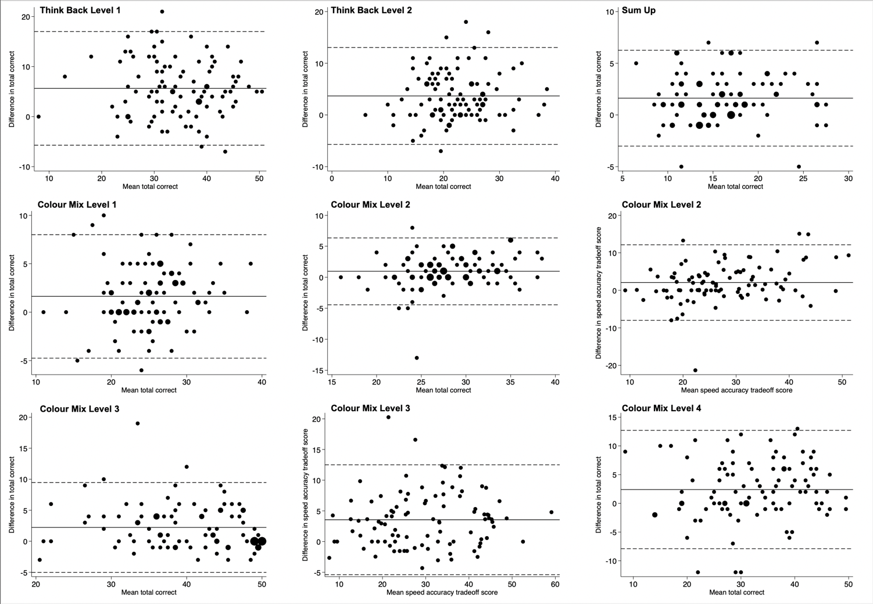
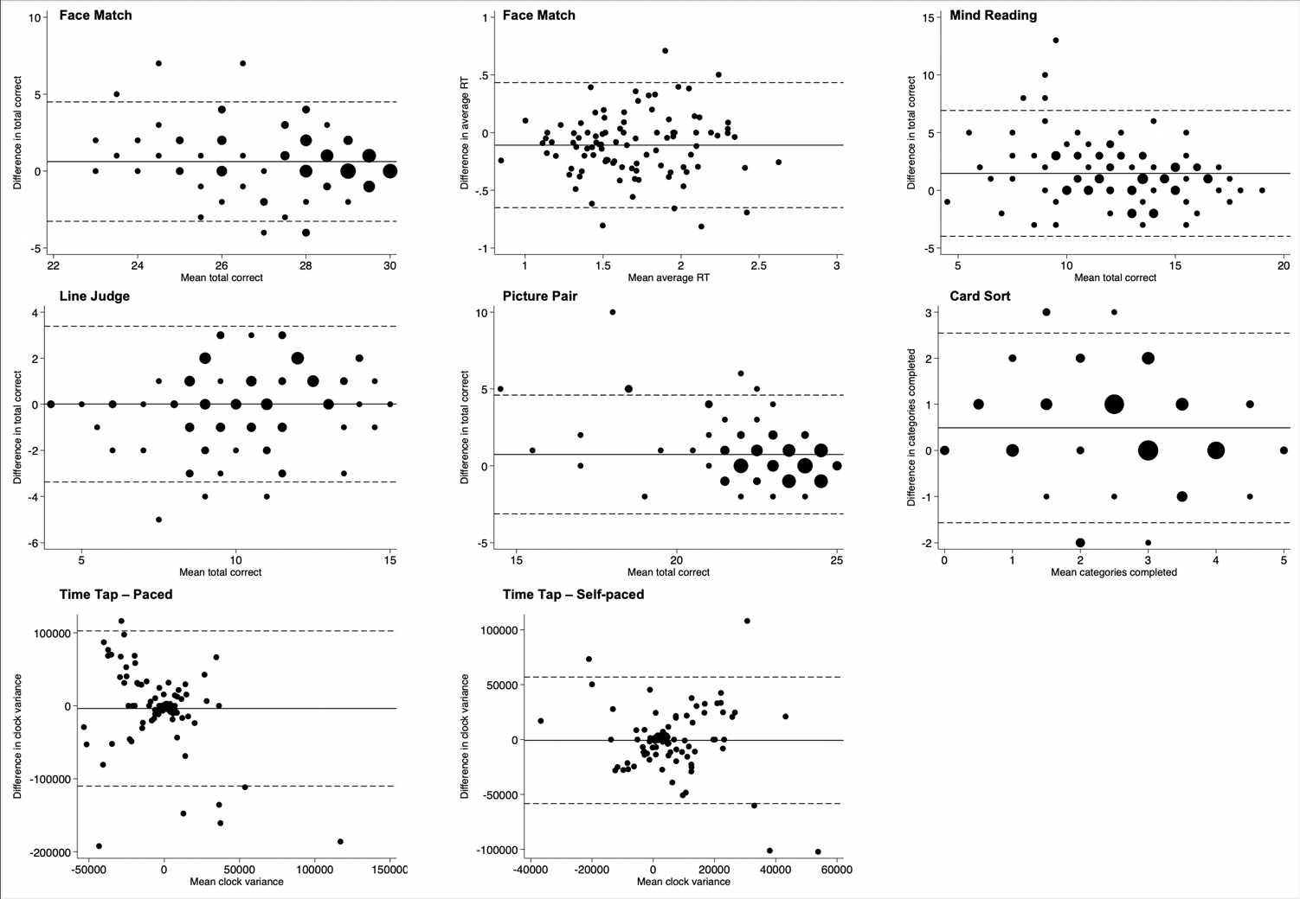

b.

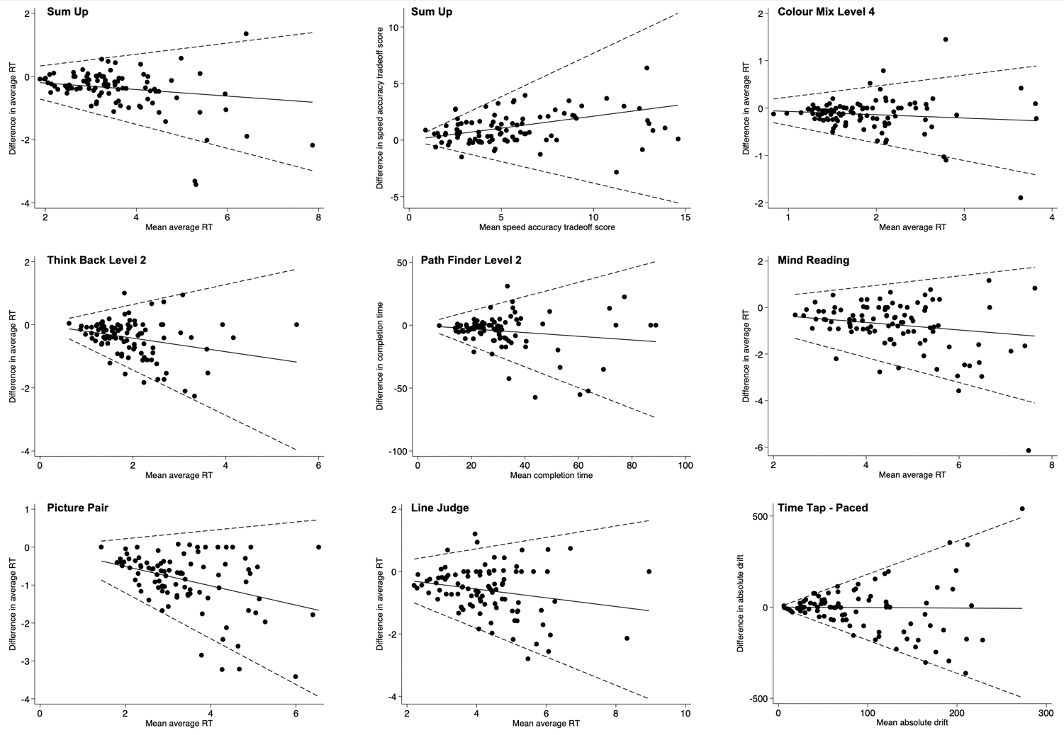

c.

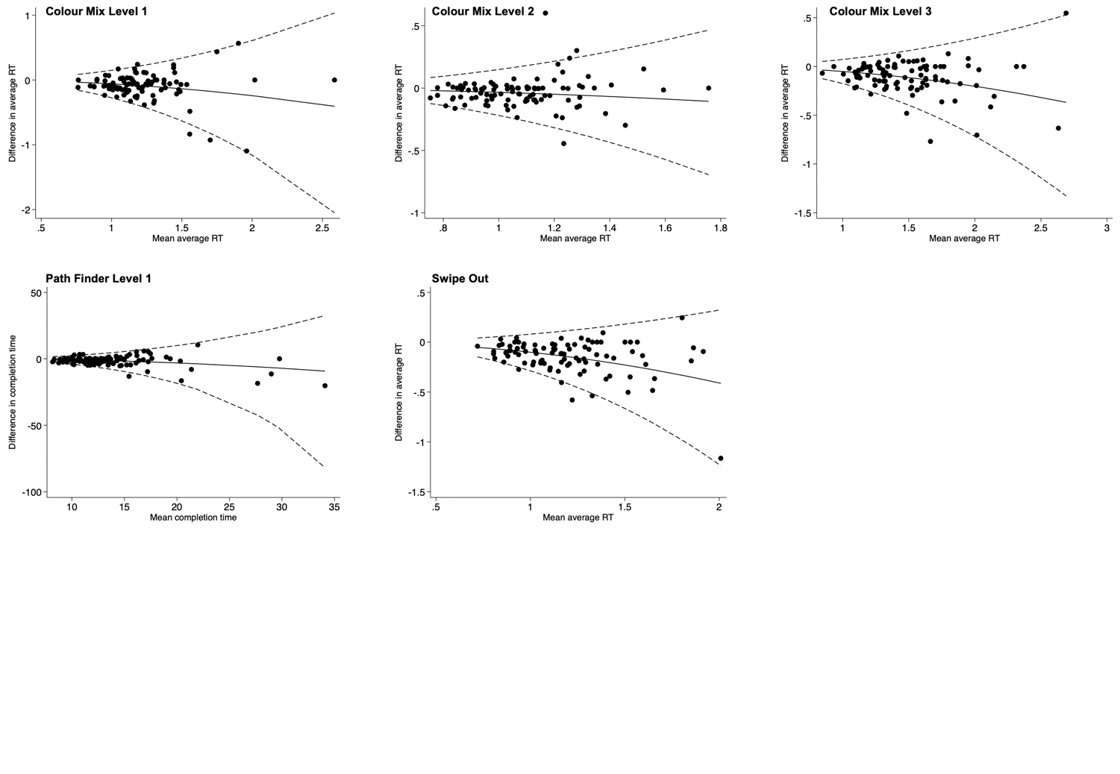

d.

