Supplemental Materials

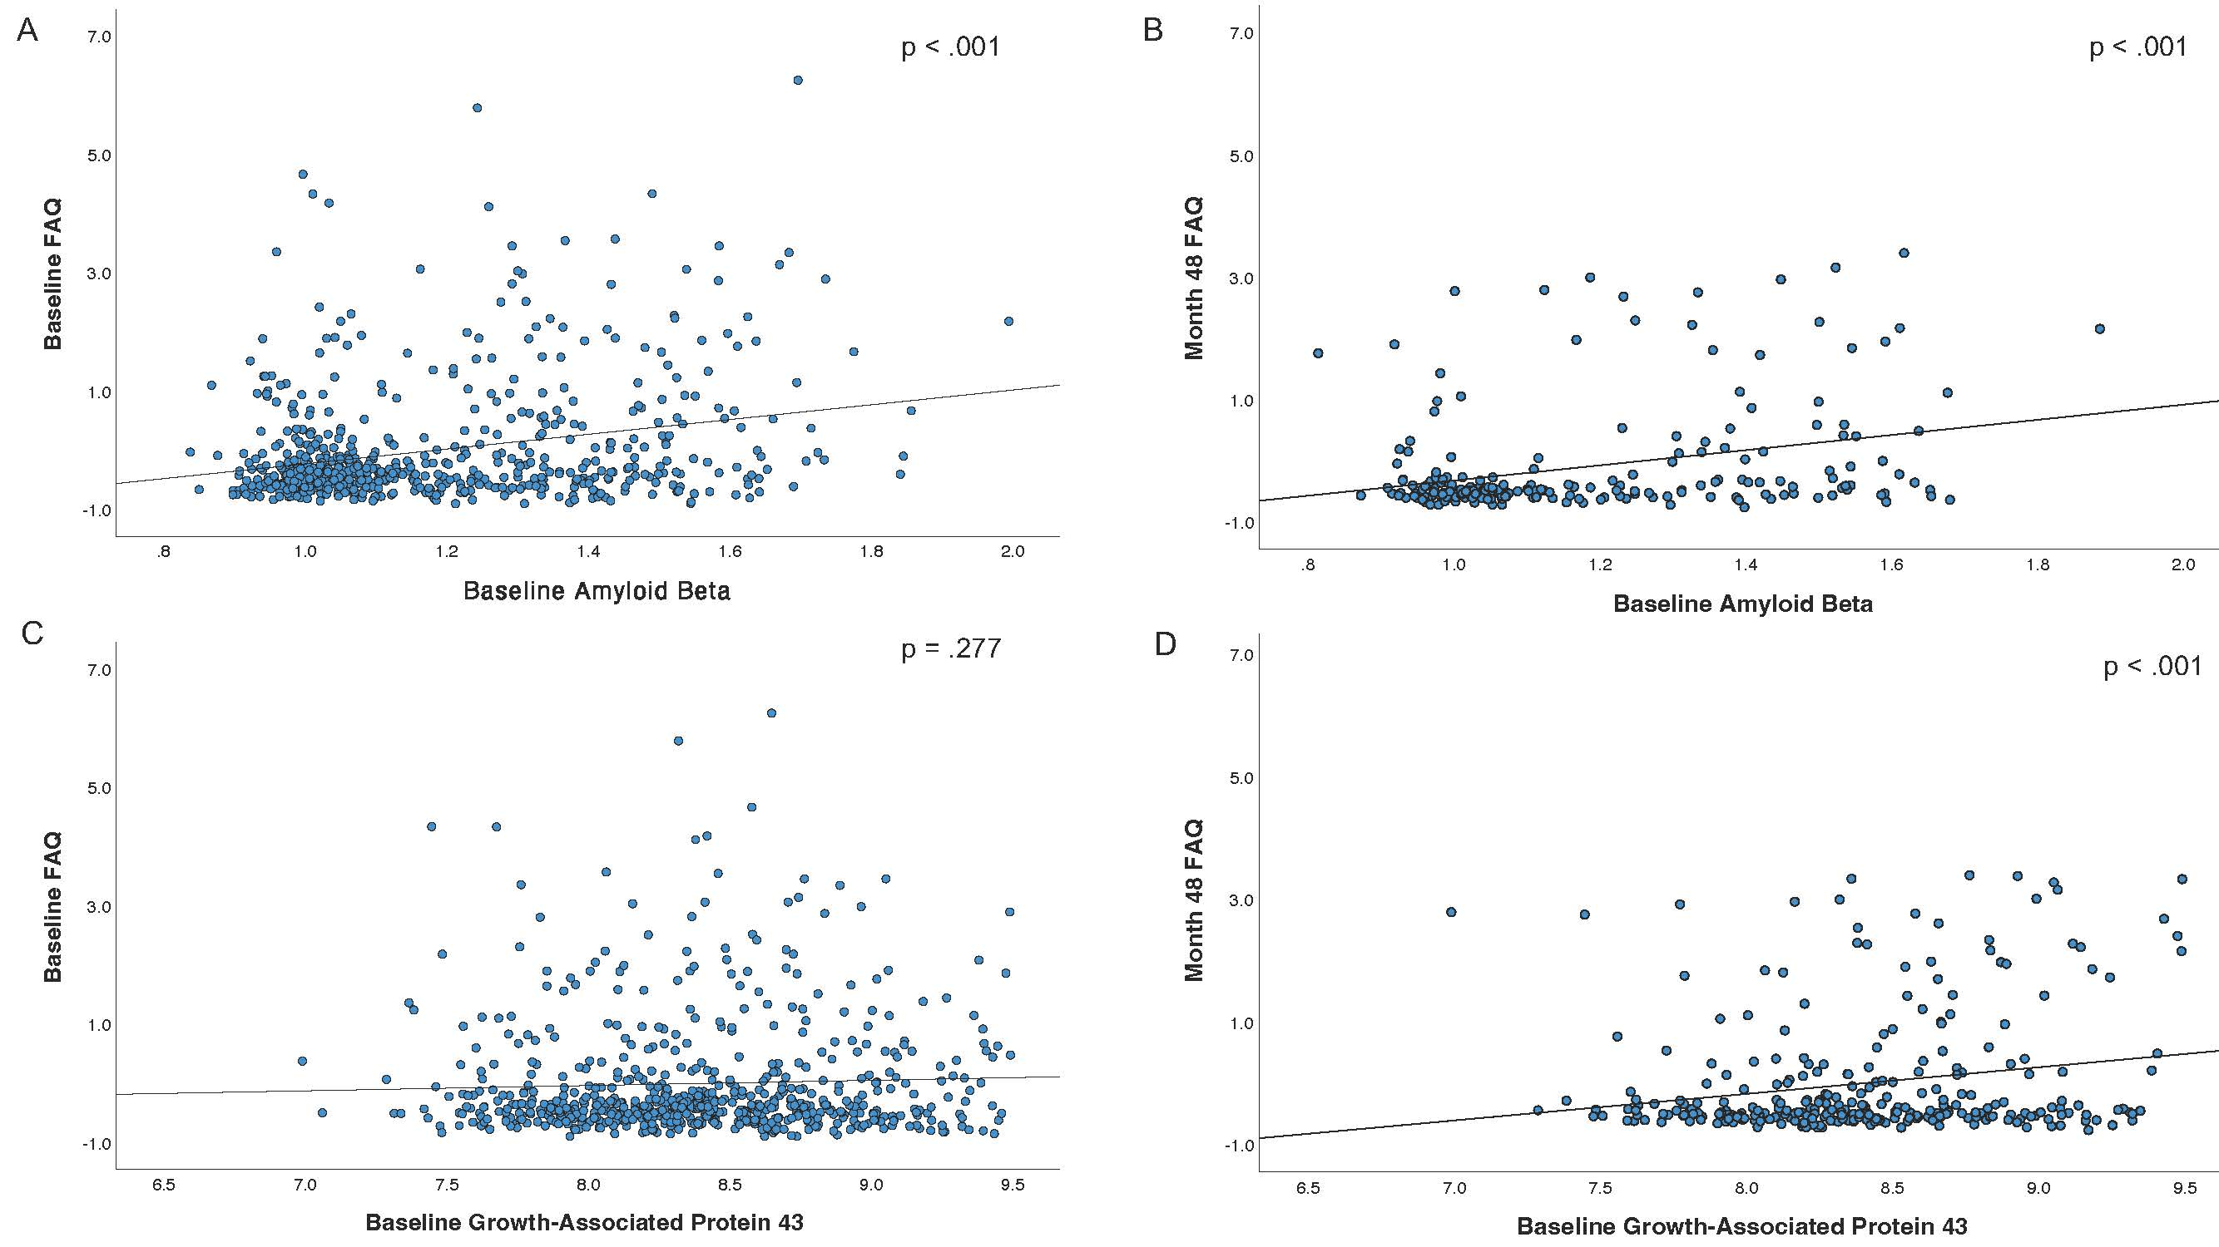

Supplementary Figure 1. Scatterplots showing associations between baseline biomarker levels and functional abilities at baseline and follow-up. The top row depicts associations between baseline amyloid beta level and functional abilities measured at baseline (A) and at 48-month follow-up (B). The bottom row displays associations between baseline growth-associated protein 43 level and functional abilities measured at baseline (C) and at 48-month follow-up (D). Functional abilities were measured with the Functional Activities Questionnaire (FAQ). FAQ scores were residualized by age, sex, and education. Higher FAQ scores indicate poorer function (i.e., greater difficulties). Amyloid beta was measured with positron emission tomography imaging. The cortical summary standardized uptake value ratio was calculated by dividing the mean florbetapir uptake across four main cortical regions by whole cerebellar florbetapir uptake. Cerebrospinal fluid growth-associated protein 43 (GAP-43) values were log transformed to improve normality of distribution prior to performing analyses. Higher baseline FAQ score was associated with greater amyloid beta burden (r = .269, p < .001) but not GAP-43 level (r = .043, p = .277). Higher FAQ score at 48-month follow-up was associated with both greater amyloid beta (r = .440, p < .001) and higher GAP-43 level (r = .202, p < .001).

Supplementary Table 1. Estimates for the model of the association of GAP-43 and longitudinal FAQ score

Parameter | Estimate | S.E. | df | t | p
Intercept | 5.992 | 0.316 | 1364.627 | 18.936 | <.001
Age | 0.263 | 0.172 | 551.579 | 1.526 | 0.128
Sex | -0.910 | 0.353 | 552.837 | -2.578 | 0.010
Education | -0.362 | 0.176 | 552.241 | -2.062 | 0.040
GAP-43 | 2.252 | 0.271 | 1729.209 | 8.299 | <.001
Time | 0.064 | 0.004 | 1252.417 | 14.352 | <.001
Time x GAP-43 | 0.037 | 0.005 | 1279.746 | 8.263 | <.001
Abbreviations: GAP-43= growth-associated protein 43; FAQ=Functional Activities Questionnaire.
Significant effects (p < 0.05) appear in bold font.

Supplementary Table 2. Estimates for the model of the association of Aβ and longitudinal FAQ score

Parameter | Estimate | S.E. | df | t | p
Intercept | 2.508 | 0.456 | 818.827 | 5.498 | <.001
Age | 0.184 | 0.124 | 636.056 | 1.480 | 0.139
Sex | -0.802 | 0.254 | 632.306 | -3.155 | 0.002
Education | -0.219 | 0.127 | 633.077 | -1.728 | 0.084
Aβ | 5.005 | 0.614 | 661.267 | 8.153 | <.001
Time | 0.013 | 0.007 | 568.556 | 1.900 | 0.058
Time x Aβ | 0.070 | 0.010 | 590.361 | 6.878 | <.001

Abbreviations: Aβ = amyloid beta; FAQ=Functional Activities Questionnaire.
Significant effects (p < 0.05) appear in bold font.

Supplementary Table 3. Estimates for the model of the association of GAP-43 and Aβ on longitudinal FAQ score

Parameter | Estimate | S.E. | df | t | p
Intercept | 2.743 | 0.461 | 810.918 | 5.951 | <.001
Age | 0.180 | 0.125 | 634.349 | 1.446 | 0.149
Sex | -0.802 | 0.254 | 631.702 | -3.154 | 0.002
Education | -0.218 | 0.127 | 632.613 | -1.715 | 0.087
Aβ | 4.496 | 0.633 | 648.962 | 7.101 | <.001
GAP-43 | 1.004 | 0.341 | 767.460 | 2.944 | 0.003
Time | 0.017 | 0.007 | 567.116 | 2.463 | 0.014
Time x Aβ | 0.061 | 0.010 | 588.993 | 5.774 | <.001
Time x GAP-43 | 0.017 | 0.005 | 590.092 | 3.115 | 0.002

Abbreviations: Aβ = amyloid beta; GAP-43= growth-associated protein 43; FAQ=Functional Activities Questionnaire.
Significant effects (p < 0.05) appear in bold font.

