Supplementary material

Supplementary tables
Supplementary Table 1. Pairwise statistical comparison of semantic fluency metrics across cohorts without adjustments
Supplementary Table 2. Correlation coefficients between total and item-level semantic fluency metrics and age, education and sex/gender

Supplementary figures
Supplementary Figure 1. Correlations between total and item-level semantic fluency metrics in SMART-MR
Supplementary Figure 2. Correlations between total and item-level semantic fluency metrics in WHICAP
Supplementary Figure 3. Correlations between total and item-level semantic fluency metrics in AAG
Supplementary Figure S4. Association of age (per 10 years) and semantic fluency metrics with the average for semantic fluency metrics calculated over the 10 words with the lowest lexical/Zipf frequency, latest age of acquisition, or longest lexical decision response time
Supplementary Figure S5. Association of level of education and semantic fluency metrics with the average for semantic fluency metrics calculated over the 10 words with the lowest lexical/Zipf frequency, latest age of acquisition, or longest lexical decision response time
Supplementary Figure S6. Association of sex and semantic fluency metrics with the average for semantic fluency metrics calculated over the 10 words with the lowest lexical/Zipf frequency, latest age of acquisition, or longest lexical decision response time
Supplementary Figure S7. Association of age (per 10 years) with semantic fluency metrics, adjusted for sex/gender and level of education
Supplementary Figure S8. Association of level of education with semantic fluency metrics, adjusted for age and sex/gender
Supplementary Figure S9. Association of sex/gender with semantic fluency metrics, adjusted for age and level of education

Supplementary methods
List of R-packages used

Supplementary tables
Supplementary Table 1. Pairwise statistical comparison of semantic fluency metrics across cohorts without adjustments
Semantic fluency metric | SMART-MR versus WHICAP |  | SMART-MR versus AAG |  | WHICAP  versus AAG
 | t-value | p-value | t-value | p-value | t-value | p-value
Total score (correct) | 36.75 | < .00001 | 47.04 | < .00001 | 0.41 | .683
Lexical frequency | -36.46 | < .00001 | -58.85 | < .00001 | -8.18 | < .00001
Lexical frequency, Ø for lowest 10 words | -47.97 | < .00001 | -62.96 | < .00001 | 0.00 | 1.000
Zipf frequency | -30.38 | < .00001 | -50.44 | < .00001 | -8.18 | < .00001
Zipf frequency, Ø for lowest 10 words | -33.42 | < .00001 | -95.35 | < .00001 | -39.76 | < .00001
Age of acquisition | 41.67 | < .00001 | 63.03 | < .00001 | 6.80 | < .00001
Age of acquisition, Ø for highest 10 words | 40.88 | < .00001 | 56.96 | < .00001 | 3.88 | 0.0001
Lexical decision response time (milliseconds) | -77.88 | < .00001 | -100.39 | < .00001 | 7.67 | < .00001
Lexical decision response time, Ø for highest 10 words | -42.09 | < .00001 | -48.75 | < .00001 | 5.79 | < .00001
Mean cluster size | 15.08 | < .00001 | 15.45 | < .00001 | -2.98 | .003
Number of switches | 19.45 | < .00001 | 15.66 | < .00001 | -6.27 | < .00001
This table shows the p-values from the pairwise statistical comparisons of differences in semantic fluency metrics across cohorts, using t-tests. Comparisons are uncorrected for age, education, sex/gender or other cohort characteristics.

Supplementary Table 2. Correlation coefficients between total and item-level semantic fluency metrics and age, education and sex/gender
 | SMART-MR |  |  | WHICAP |  |  | AAG
 | Age | Education | Sex | Age | Education | Sex* | Age | Education | Sex
totscore | -0.23 | 0.30 | X | -0.33 | 0.24 |  | -0.31 | -0.17 | -0.06
clusize | X | 0.08 | -0.10 | X | 0.08 |  | X | 0.12 | -0.08
cluswi | -0.27 | 0.16 | X | -0.26 | 0.16 |  | -0.23 | X | X
lexFQ | X | -0.20 | 0.13 | 0.24 | -0.29 |  | 0.12 | -0.14 | 0.11
lexFQ10 | 0.09 | -0.25 | 0.10 | 0.32 | -0.31 |  | 0.24 | -0.19 | 0.09
Zipf | X | -0.20 | 0.13 | 0.24 | -0.25 |  | -0.12 | -0.14 | 0.11
Zipf10 | 0.08 | -0.24 | 0.10 | 0.30 | -0.26 |  | -0.19 | X | 0.07
lexRT | X | 0.24 | -0.13 | -0.23 | 0.28 |  | -0.12 | 0.13 | -0.10
lexRT10 | -0.08 | 0.28 | -0.09 | -0.31 | 0.31 |  | -0.23 | 0.17 | -0.09
AoA | X | 0.24 | -0.17 | -0.20 | 0.29 |  | -0.12 | 0.13 | -0.14
AoA10 | -0.10 | 0.28 | -0.15 | -0.26 | 0.31 |  | -0.20 | 0.16 | -0.13
This table depicts the Pearson (age), Point-biserial (sex/gender) or Spearman rank (education) correlation coefficients between total and item-level semantic fluency metrics with an average over all named words or the 10 words with the lowest lexical frequency, lexical decision response time or Zipf frequency, or the highest age of acquisition (suffix 10) with age, education and sex/gender. The X indicates a p-value > .05 for this correlation coefficient. The column ‘Sex’ refers to sex/gender.
AoA, age of acquisition; clusize, cluster size; cluswi, cluster switches; lexFQ, lexical frequency, lexRT, lexical decision response time, totscore, total score, Zipf, Zipf frequency.
* Due to logistics, this info could not be retrieved before the submission deadline, but will be inserted before publication.

Supplementary figures
Supplementary Figure 1. Correlations between total and item-level semantic fluency metrics in SMART-MR
This figure depicts the Pearson correlation coefficients between total and item-level semantic fluency metrics with an average over all named words or the 10 words with the lowest lexical frequency, lexical decision response time or Zipf frequency, or the highest age of acquisition (suffix 10). The X indicates a p-value > .05 for this correlation coefficient.
AoA, age of acquisition; clusize, cluster size; cluswi, cluster switches; lexFQ, lexical frequency, lexRT, lexical decision response time, totscore, total score, Zipf, Zipf frequency.

Supplementary Figure 2. Correlations between total and item-level semantic fluency metrics in WHICAP
This figure depicts the Pearson correlation coefficients between total and item-level semantic fluency metrics with an average over all named words or the 10 words with the lowest lexical frequency, lexical decision response time or Zipf frequency, or the highest age of acquisition (suffix 10).
AoA, age of acquisition; clusize, cluster size; cluswi, cluster switches; lexFQ, lexical frequency, lexRT, lexical decision response time, totscore, total score, Zipf, Zipf frequency.

Supplementary Figure 3. Correlations between total and item-level semantic fluency metrics in AAG
This figure depicts the Pearson correlation coefficients between total and item-level semantic fluency metrics with an average over all named words or the 10 words with the lowest lexical frequency, lexical decision response time or Zipf frequency, or the highest age of acquisition (suffix 10). The X indicates a p-value > .05 for this correlation coefficient.
AoA, age of acquisition; clusize, cluster size; cluswi, cluster switches; lexFQ, lexical frequency, lexRT, lexical decision response time, totscore, total score, Zipf, Zipf frequency.

Supplementary Figure S4. Association of age (per 10 years) and semantic fluency metrics with the average for semantic fluency metrics calculated over the 10 words with the lowest lexical/Zipf frequency, latest age of acquisition, or longest lexical decision response time

Supplementary Figure S5. Association of level of education and semantic fluency metrics with the average for semantic fluency metrics calculated over the 10 words with the lowest lexical/Zipf frequency, latest age of acquisition, or longest lexical decision response time

Supplementary Figure S6. Association of sex and semantic fluency metrics with the average for semantic fluency metrics calculated over the 10 words with the lowest lexical/Zipf frequency, latest age of acquisition, or longest lexical decision response time

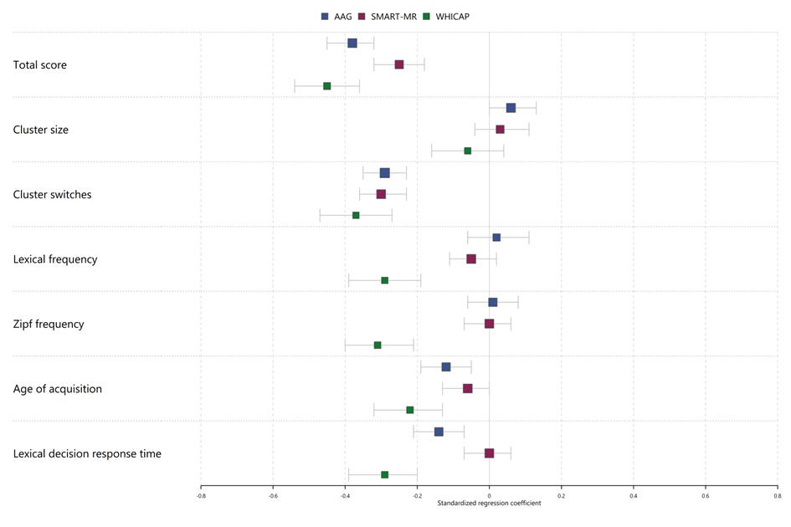
Supplementary Figure S7. Association of age (per 10 years) with semantic fluency metrics, adjusted for sex/gender and level of education

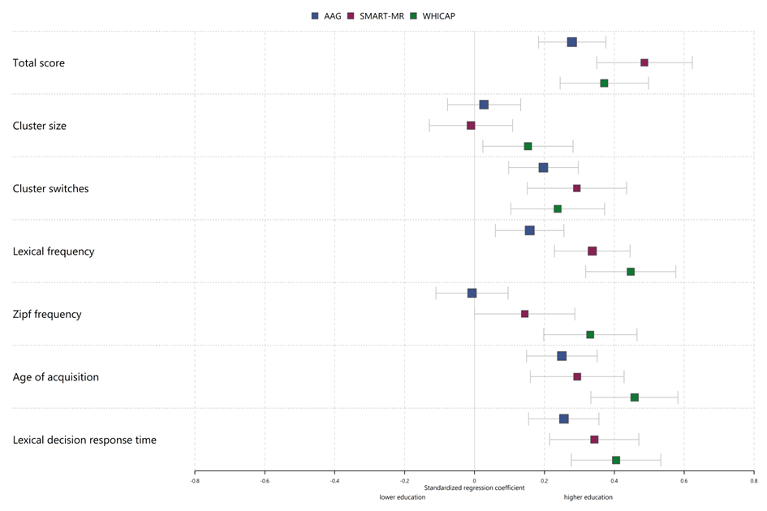
Supplementary Figure S8. Association of level of education with semantic fluency metrics, adjusted for age and sex/gender

Supplementary Figure S9. Association of sex/gender with semantic fluency metrics, adjusted for age and level of education

Supplementary methods

List of R-packages used
forestplot_2.0.1
Gordon M, Lumley T (2021). _forestplot: Advanced Forest Plot Using 'grid' Graphics_. R package version 2.0.1,<https://CRAN.R-project.org/package=forestplot>.

checkmate_2.1.0
Lang M (2017). “checkmate: Fast Argument Checks for Defensive R Programming.” _The R Journal_, *9*(1), 437-445. doi:10.32614/RJ-2017-028.

magrittr_2.0.3
Bache S, Wickham H (2022). _magrittr: A Forward-Pipe Operator for R_. R package version 2.0.3, <https://CRAN.R-project.org/package=magrittr>.

extrafont_0.18
Chang W (2022). _extrafont: Tools for Using Fonts_. R package version 0.18,<https://CRAN.R-project.org/package=extrafont>.

jtools_2.2.0
Long JA (2022). _jtools: Analysis and Presentation of Social Scientific Data_. R package version 2.2.0, <https://cran.r-project.org/package=jtools>.

flextable_0.7.2
Gohel D (2022). _flextable: Functions for Tabular Reporting_. R package version 0.7.2, <https://CRAN.R-project.org/package=flextable>.

cowplot_1.1.1
Wilke C (2020). _cowplot: Streamlined Plot Theme and Plot Annotations for 'ggplot2'_. R package version 1.1.1,<https://CRAN.R-project.org/package=cowplot>.

MplusAutomation_1.1.0
Hallquist, M. N. & Wiley, J. F. (2018). MplusAutomation: An R Package for Facilitating Large-Scale Latent Variable Analyses in Mplus Structural Equation Modeling, 25, 621-638. doi: 10.1080/10705511.2017.1402334.

plyr_1.8.7
Hadley Wickham (2011). The Split-Apply-Combine Strategy for Data Analysis. Journal of Statistical Software, 40(1), 1-29. URL https://www.jstatsoft.org/v40/i01/.

modelsummary_0.11.1
Arel-Bundock V (2022). _modelsummary: Summary Tables and Plots for Statistical Models and Data: Beautiful, Customizable, and Publication-Ready_. R package version 0.11.1, <https://CRAN.R-project.org/package=modelsummary>.

gtsummary_1.6.1
Sjoberg DD, Whiting K, Curry M, Lavery JA, Larmarange J. Reproducible summary tables with the gtsummary package. The R Journal 2021;13:570–80. https://doi.org/10.32614/RJ-2021-053.

table1_1.4.2
Rich B (2021). _table1: Tables of Descriptive Statistics in HTML_. R package version 1.4.2, <https://CRAN.R-project.org/package=table1>.

forcats_0.5.1
Wickham H (2021). _forcats: Tools for Working with Categorical Variables (Factors)_. R package version 0.5.1, <https://CRAN.R-project.org/package=forcats>.
stringr_1.4.0
Wickham H (2019). _stringr: Simple, Consistent Wrappers for Common String Operations_. R package version 1.4.0, <https://CRAN.R-project.org/package=stringr>.

dplyr_1.0.9
Wickham H, François R, Henry L, Müller K (2022). _dplyr: A Grammar of Data Manipulation_. R package version 1.0.9, <https://CRAN.R-project.org/package=dplyr>.

purrr_0.3.4
Henry L, Wickham H (2020). _purrr: Functional Programming Tools_. R package version 0.3.4, <https://CRAN.R-project.org/package=purrr>.

readr_2.1.2
Wickham H, Hester J, Bryan J (2022). _readr: Read Rectangular Text Data_. R package version 2.1.2, <https://CRAN.R-project.org/package=readr>.

tidyr_1.2.0
Wickham H, Girlich M (2022). _tidyr: Tidy Messy Data_. R package version 1.2.0, <https://CRAN.R-project.org/package=tidyr>.

tibble_3.1.7
Müller K, Wickham H (2022). _tibble: Simple Data Frames_. R package version 3.1.7, <https://CRAN.R-project.org/package=tibble>.

ggplot2_3.3.6
H. Wickham. ggplot2: Elegant Graphics for Data Analysis. Springer-Verlag New York, 2016.

tidyverse_1.3.1
Wickham et al., (2019). Welcome to the tidyverse. Journal of Open Source Software, 4(43), 1686, https://doi.org/10.21105/joss.01686)

haven_2.5.0
Wickham H, Miller E, Smith D (2022). _haven: Import and Export 'SPSS', 'Stata' and
'SAS' Files_. R package version 2.5.0, <https://CRAN.R-project.org/package=haven>.

