Supplementals

Supplemental 1. Flow-chart of studies included in the meta-analysis
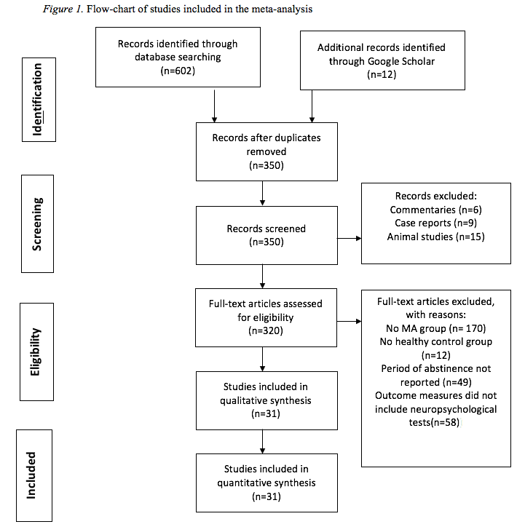

Supplemental 2. CHC test classification
Cattell-Horn Carroll factor | Definition | Test
Fluid reasoning (Gf) | The use of deliberate and controlled procedures to solve novel “on the spot” problems that cannot be solved by using previously learned habits, schemas, and scripts. | CANTAB-Intra/Extradimenisoanl shift  CANTAB -Stockings of cambridge  CogState Battery -Groton maze learning  Delay discounting task  Discrimination learning  Halstead category test  Logical problem test  Two-Choice prediction task  Two-Choice response task  Tower of London  Iowa gambling task  WCST categories completed
Short-term working memory (Gwm) | The ability to maintain and manipulate information in active attention. The mind’s central “scratchpad”. | BACS-Digit sequencing task  CalCAP-Single digit recognition (1-back cued response)  CalCAP-Sequential number (1-back)  CalCAP-Sequential number(1-increment)  CalCAP-Sequential number (2-back)  CANTAB-Spatial working memory (between and within errors)  CANTAB-Delayed matching to sample  CANTAB-Rapid visual information processing  Choice reaction time (response accuracy)  CogState Battery-Two back task  CogState Battery-Continuous paired association learning task  Missing digit span  N-Back-1 and 2 reaction time  N-Back- 1 and 2 accuracy  PASAT-total correct  Sentence span  Stop-Signal task-accuracy  WAIS-III digits backward  WAIS-III digits forward  WAIS-III letter number sequencing  WMS-III visual memory span backwards  WMS-R digits span  WMS-R logical memory  Woodcock Johnson backward digit span  WCST total errors  WCST perseveration errors
Learning efficiency (Gl) | The ability to learn, store, and consolidate new information over periods of time measured in minutes, hours, days, and years. | BACS-Verbal learning (no. of words recalled)  Babcock immediate recall  Babcock delayed recall  Benton Visual Retention Test  BVMT-R-Trial 1  BVMTR-learning  BVMT-R-learning slope  BVMT-R-delayed recall  CVLT-R-trial 1  CVLT-R-learning  CVLT-R-short delay free recall  CVLT-R-shirt delay cued recall  CVLT-R-long delay free recall  CVLT-R-long delay cued recall  CVLT-R-delayed recall  CogState Battery-one card learning test  CogState Battery-international shopping  Figure memory test-learning  Figure memory test-retention  HVLT -R-learning  HVLT -R-learning slope  HVLT -R-delayed recall  PAL-total errors  PAL-visuospatial memory procedure (mean errors to success)  PAL-visuospatial memory procedure (stages completed first trial)  Repeated memory test-word recall  Repeated memory test-picture recall  Repeated memory test-word recognition  Repeated memory test-picture recognition  RAVLT-trial 1-5  RAVLT-learning  RAVLT-delayed recall  RAVLT-immediate  Selective reminding test  Story memory test learning  Story memory test retention  WMS-III story A first recall  WMS-III story B first recall  WMS-III story A+B first recall total  WMS-III story A second recall  WMS-III story A+B second recall total  WMS-R logical memory delayed recall
Visual-spatial processing (Gv) | The ability to make use of simulated mental imagery to solve problems. Perceiving, discriminating and manipulating images in the “mind’s eye”. | RCFT copy  RCFT immediate  RCFT delayed recall  Symbol digit modalities  WAIS-III block design
Comprehension-Knowledge (Gc) | The ability to comprehend and communicate culturally-valued knowledge. | Shipley vocabulary  WAIS-III VIQ  WRAT-3 reading  NART
Retrieval fluency (Gr) | The rate and fluency at which individuals can access information stored in long-term memory. | BACS-Category instances  Category fluency  Letter fluency
Processing speed (Gs) | The ability to control attention to automatically, quickly and fluently perform relatively simple repetitive cognitive tasks. | Auditory continuous performance task  BACS-Symbol coding (no. of correct responses)  CalCAP-Degraded words with distractors  CalCAP-Response reversal/visual scanning  CalCAP-Form distraction  CogState-Detection task  CogState-Identification task  Continuous performance test  Hayling sentence completion task  Stop-signal task reaction time  Stroop Word  Stroop color  Stroop interference  Trails A and B  WAIS-III-digit symbol  WAIS-III-symbol search
Reaction and decision speed (Gt) | The speed of making very simple decisions or judgements when items are presented one at a time. | CalCAP-Simple reaction time  CalCAP -Choice reaction time  Simple reaction time 1 and 2  Choice reaction time
Psychomotor speed (Gps) | The ability to perform skilled physical body motor movements with precision, coordination, fluidity or strength. | BACS-Token motor task  Finger tapping-dominant and non-dominant hand  Grooved pegboard- dominant and non-dominant hand  Timed gait
BASC= Brief Assessment of Cognition in Schizophrenia, BVMT-R = Brief Visuospatial Memory Test-Revised, CalCAP = California Computerized Assessment Package, CVLT = California Verbal Learning Test, CANTAB = Cambridge Automated Neuropsychological Assessment Battery, HVLT-R = Hopkins Verbal Learning Test-Revised, NART= National Adult Reading Test, PASAT = Paced Auditory Serial Addition Test, PAL = Paired Associates Learning, RAVLT = Rey Auditory Verbal Learning Test, WAIS = Wechsler Adult Intelligence Test, WCST = Wisconsin Card Sorting Test, WMS = Wechsler Memory Test, WRAT= Wide Range Achievement Test

Supplemental 3. Summary of studies in the meta-analysis
Author | Year | MA group (N) | HC group  (N) | CHC factors
Boileau, Rusjan, Houle et al. | 2008 | 16 | 14 | Gf, Gwm. Gl, Gs, Gps
Chang, Ernst, Speck et al. | 2002 | 20 | 20 | Gwm, Gl, Gv, Gc, Gs, Gt, Gps
Chang, Cloak, Patterson et al. | 2005 | 50 | 50 | Gl, Gv, Gc, Gr, Gs, Gps
Cherner, Suarez, Casey et al. | 2010 | 54 | 46 | Gf, Gwm, Gl, Gr, Gs, Gps
Chen, Lin, Chen et al. | 2015 | 25 | 67 | Gf, Gwm, Gl, Gr, Gs, Gps
Farhadian, Akbarfahimi, Abharian et al. | 2017 | 60 | 60 | Gf, Gs
Fassbender, Lesh, Ursu et al. | 2015 | 30 | 27 | Gc, Gs
Henry, Minassian, and Perry | 2010 | 15 | 15 | Gf
Henry, Minassian, van Rhenen et al. | 2011 | 18 | 16 | Gf
Hoffman, Moore, Templin et al. | 2006 | 41 | 41 | Gf, Gl, Gv, Gc, Gs, Gps
Jackson | 2008 | 18 | 17 | Gwm, Gl, Gr, Gs, Gt
Johanson, Frey, Lundahl et al. | 2006 | 16 | 18 | Gf, Gwm, Gl, Gr, Gs, Gps
Kalechstein, Newton, and Green | 2003 | 27 | 18 | Gwm, Gl, Gv, Gc, Gr, Gs
Kim, Lee, Kwon et al. | 2009 | 24 | 21 | Gf
London, Berman, Voytek et al | 2005 | 17 | 16 | Gs
McCann, Kuwabara, Kumar et al. | 2007 | 22 | 17 | Gl, Gc, Gs, Gps
Monterosso, Ainslie, Xu et al. | 2007 | 12 | 17 | Gf, Gc
Moon, Soo D, Park et al. | 2009 | 19 | 18 | Gl, Gv
Morgan, Woods, Poquette et al. | 2012 | 114 | 110 | Gl
Newton, Kalechstein, Hardy et al. | 2004 | 9 | 10 | Gwm, Gt
Paulus, Hozack, Frank et al. | 2003 | 14 | 14 | Gf
Rendell, Mazur, and Henry | 2009 | 20 | 20 | Gwm, Gl, Gc, Gr, Gs
Rippeth, Heaton, Carey et al. | 2004 | 47 | 60 | Gf, Gwm, Gl, Gr, Gs, Gps
Salo, Nordahl, Galloway et al. | 2009 | 27 | 33 | Gc, Gs
Salo, Ravizza, and Fassbender | 2011 | 69 | 38 | Gc, Gs
Salo, Nordahl, Natsuaki et al. | 2006 | 36 | 16 | Gs
Salo, Nordahl, Possin et al. | 2003 | 8 | 12 | Gs
Simon, Dean, Cordova et al. | 2009 | 27 | 28 | Gf, Gwm, Gl, Gc, Gr, Gs
Salo, Ursu, Buonocore et al. | 2009 | 12 | 16 | Gc, Gs
Woods, Rippeth, Conover et al. | 2005 | 87 | 71 | Gl
Zhong, Jiang, Du et al. | 2016 | 54 | 58 | Gf, Gwm, Gl, Gs
MA=methamphetamine, N=total number of participants, HC=healthy control; Note: one study reported data on 4 groups, inclusive of an HIV infected/MA dependent group, HIV negative/MA dependent group, HIV infected/MA nondependent group, and an HIV negative/MA nondependent group (Rippeth et al., 2004). Two studies reported results for three groups: including a recently abstinent MA group, a long-term abstinent group, and a healthy control group (Salo et al., 2009; Salo, Ravizza, & Fassbender, 2011). Another study included a longitudinal design that assessed neuropsychological functioning in MA individuals in early abstinence and after one month of abstinence (Simon, Dean, Cordova, Monterosso, & London, 2009). Chen et al., (2015) reported neuropsychological functioning of MA users without psychosis, MA users with brief psychosis, MA users with persistent psychosis, as well as patients with schizophrenia and a healthy control group. Finally, one study categorized participants into three groups including a currently abusing group, an abstinent group, and a healthy control group (Farhadian, Akbarfahimi, Abharian, & Hosseini, 2017).

Supplemental 4. Forest plots

4.1 Fluid reasoning

4.2 Short-term working memory

4.3 Learning efficiency

4.4 Visual-spatial processing

4.5 Comprehension knowledge

4.6 Retrieval fluency

4.7 Processing speed

4.8 Reaction and decision speed

4.9 Psychomotor speed

Supplemental 5 Funnel Plots

5.1 Fluid reasoning

5.2 Short-term working memory

5.3 Learning efficiency

5.4 Visual-spatial processing

5.5 Comprehension knowledge

5.6 Retrieval fluency

5.7 Processing speed

5.8 Reaction and decision speed

5.9 Psychomotor speed

Supplemental 6. Risk of Bias Table

