Supplemental Materials
The Childhood Cancer Survivor Study-Neurocognitive Questionnaire (CCSS-NCQ) Revised: Item Response Analysis and Concurrent Validity
by K. M. Kenzik et al., 2014, Neuropsychology
http://dx.doi.org/10.1037/neu0000095

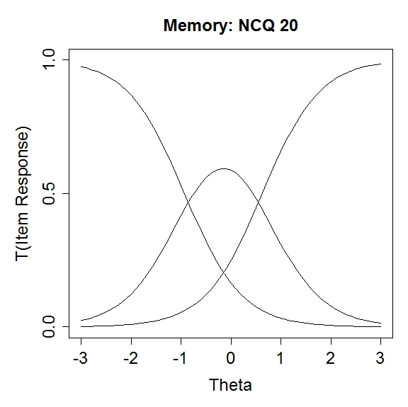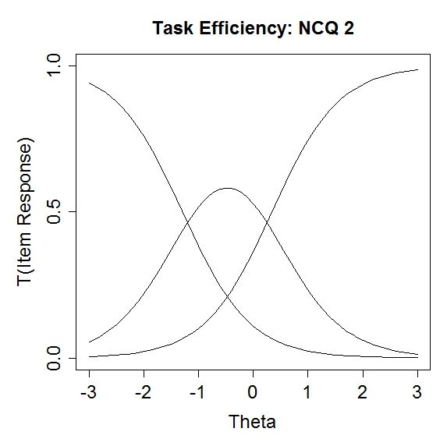
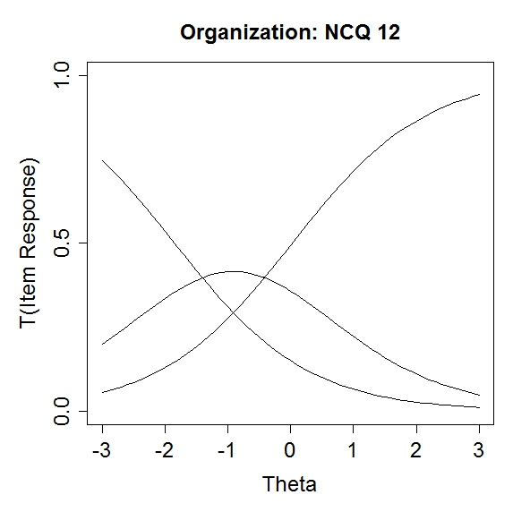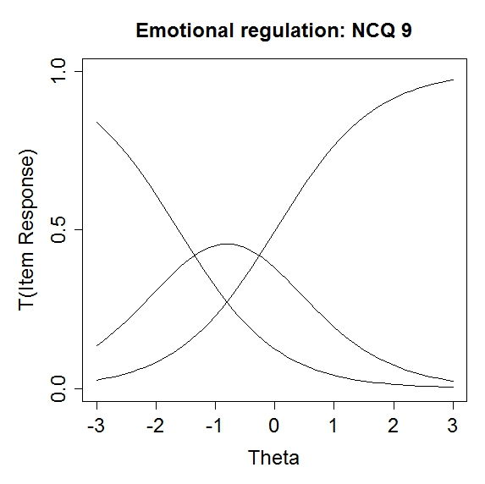
Figure S1. Graphic representation of category response curve (CRC) for an item within each domain (NCQ 20: “Trouble remembering things even for a few minutes”; NCQ 2: “Takes longer to complete work”; NCQ 12: “Trouble finding things in bedroom”; NCQ 9: “Moods changes frequently”). The CRC represents the probability of responding to a particular category given a certain underlying trait level (i.e., neurocognitive concerns). The three curves represent the response categories. Lower scores indicate more neurocognitive concerns and higher scores indicate less neurocognitive concerns. The slopes of the curves demonstrate the magnitude of the discrimination. Higher slopes indicate higher discrimination, or a stronger ability to distinguish between individuals along the underlying latent trait.

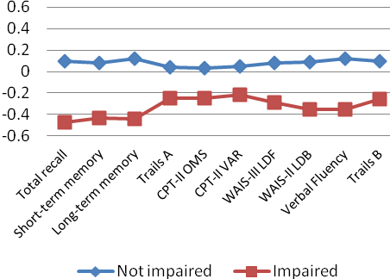

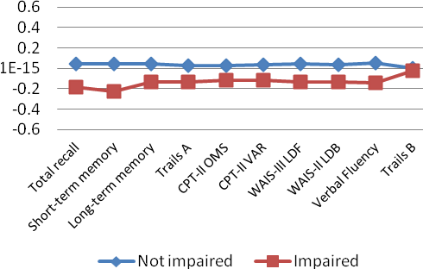
Figure S2. Mean latent scores of the revised CCSS-NCQ domains for the neurocognitive functional status determined by the direct neurocognitive assessments. *Memory direct assessments: Total recall, short-term memory and long-term memory; Attention & processing direct assessments: Trails A, CPT-II OMS, CPT-II VAR, WAIS-III LDF (longest digit forward). Executive functioning direct assessments: WAIS-LDB (longest digit backward), Verbal fluency, Trails B.

Table S1
Effect Sizes for Difference in CCSS-NCQ Scores for Impaired vs. Non-Impaired Survivors: Observed Scores of Original CCSS-NCQ and Revised CCSS-NCQ Latent Scores

 |  | Unadjustedª effect sizes^{c} |  | Adjusted^{b} effect sizes
 |  | Original CCSS-NCQ | Revised CCSS-NCQ ^{d} | Original CCSS-NCQ | Revised CCSS-NCQ
 | Memory domain
Memory assessment measures | Total recall | 0.601 | 0.639 | 0.614 | 0.656
Memory assessment measures | Short-term memory | 0.539 | 0.562 | 0.519 | 0.548
Memory assessment measures | Long-term memory | 0.633 | 0.634 | 0.622 | 0.628
Attention & processing speed assessment measures | Trails A | 0.273 | 0.316 | 0.336 | 0.380
Attention & processing speed assessment measures | CPT-II OMS | 0.231 | 0.304 | 0.146 | 0.240
Attention & processing speed assessment measures | CPT-II VAR | 0.214 | 0.293 | 0.126 | 0.220
Attention & processing speed assessment measures | WAIS-III Longest Digit Forward | 0.380 | 0.402 | 0.402 | 0.422
Executive functioning  assessments | WAIS-III Longest Digit Backward | 0.447 | 0.487 | 0.441 | 0.485
Executive functioning  assessments | Verbal Fluency | 0.448 | 0.522 | 0.441 | 0.518
Executive functioning  assessments | Trails B | 0.335 | 0.386 | 0.375 | 0.424
 | Task efficiency domain
Memory assessment measures | Total recall | 0.788 | 0.777 | 0.796 | 0.780
Memory assessment measures | Short-term memory | 0.566 | 0.563 | 0.542 | 0.533
Memory assessment measures | Long-term memory | 0.625 | 0.634 | 0.617 | 0.618
Attention & processing speed assessment measures | Trails A | 0.617 | 0.628 | 0.683 | 0.698
Attention & processing speed assessment measures | CPT-II OMS | 0.512 | 0.458 | 0.446 | 0.402
Attention & processing speed assessment measures | CPT-II VAR | 0.408 | 0.402 | 0.379 | 0.358
Attention & processing speed assessment measures | WAIS-III Longest Digit Forward | 0.556 | 0.510 | 0.561 | 0.504
Executive functioning  assessments | WAIS-III Longest Digit Backward | 0.650 | 0.595 | 0.644 | 0.599
Executive functioning  assessments | Verbal Fluency | 0.740 | 0.676 | 0.737 | 0.685
Executive functioning  assessments | Trails B | 0.538 | 0.502 | 0.568 | 0.537
 | Organization domain
Memory assessment measures | Total recall | 0.281 | 0.205 | 0.284 | 0.254
Memory assessment measures | Short-term memory | 0.295 | 0.245 | 0.282 | 0.287
Memory assessment measures | Long-term memory | 0.163 | 0.153 | 0.154 | 0.181
Attention & processing speed assessment measures | Trails A | 0.210 | 0.145 | 0.254 | 0.209
Attention & processing speed assessment measures | CPT-II OMS | 0.125 | 0.128 | 0.084 | 0.121
Attention & processing speed assessment measures | CPT-II VAR | 0.143 | 0.138 | 0.094 | 0.129
Attention & processing speed assessment measures | WAIS-III Longest Digit Forward | 0.196 | 0.192 | 0.210 | 0.196
Executive functioning  assessments | WAIS-III Longest Digit Backward | 0.191 | 0.186 | 0.189 | 0.181
Executive functioning  assessments | Verbal Fluency | 0.183 | 0.210 | 0.169 | 0.200
Executive functioning  assessments | Trails B | 0.024 | 0.022 | 0.041 | 0.034
 | Emotional regulation
Memory assessment measures | Total recall | 0.434 | 0.462 | 0.435 | 0.468
Memory assessment measures | Short-term memory | 0.401 | 0.446 | 0.373 | 0.417
Memory assessment measures | Long-term memory | 0.413 | 0.417 | 0.394 | 0.404
Attention & processing speed assessment measures | Trails A | 0.309 | 0.270 | 0.366 | 0.344
Attention & processing speed assessment measures | CPT-II OMS | 0.451 | 0.449 | 0.395 | 0.382
Attention & processing speed assessment measures | CPT-II VAR | 0.343 | 0.419 | 0.292 | 0.368
Attention & processing speed assessment measures | WAIS-III Longest Digit Forward | 0.349 | 0.377 | 0.350 | 0.380
Executive functioning  assessments | WAIS-III Longest Digit Backward | 0.416 | 0.366 | 0.410 | 0.365
Executive functioning  assessments | Verbal Fluency | 0.558 | 0.550 | 0.578 | 0.573
Executive functioning  assessments | Trails B | 0.287 | 0.258 | 0.318 | 0.301
Note: ª Unadjusted model; ^{b} Adjusted for current age, race, and gender; ^{c} Magnitude of effect size: <0.2 are classified as negligible, 0.2–0.49 as small, 0.5–0.79 as moderate, and >0.8 as large. Effect sizes ≥0.5 are considered as a clinically important difference; ^{d} Score of neurocognitive concerns estimated by IRT methods.

Table S2
Item Parameter Estimation Based on 7-Item Alternative Models

 |  |  | Alternative model 1 ª |  |  |  |  |  |  |  |  | Alternate model 2 ª
Item |  | Contents | a ^{b} |  | Thres-hold 1^{c} |  | b ^{d} |  |  | Thres-hold 2 ^{c} |  | a | Thres-hold 1 | b | Thres-hold 2
Memory
BRIEF-A 26 | Trouble staying on the same topic when talking |  | 0.592 |  |  | -2.465 |  |  | -1.457 |  | -0.449 | 0.746 | -2.474 | -1.440 | -0.406
BRIEF-A 55 | People say I am easily distracted |  | - |  |  | - |  |  | - |  | - | 0.643 | -2.081 | -1.189 | -0.297
BRIEF-A 35 | Short attention span |  | 0.588 |  |  | -1.774 |  |  | -0.724 |  | 0.326 | - | - | - | -
NCQ 13 | Forget what I am doing in the middle of things |  | 1.219 |  |  | -1.675 |  |  | -0.702 |  | 0.271 | 1.223 | -1.674 | -0.705 | 0.264
NCQ 5 | Forgets instructions easily |  | 1.641 |  |  | -1.358 |  |  | -0.493 |  | 0.372 | 1.657 | -1.355 | -0.495 | 0.365
NCQ 20 | Trouble remembering things even for a few minutes |  | 1.936 |  |  | -0.904 |  |  | -0.143 |  | 0.618 | 1.910 | -0.909 | -0.148 | 0.613
NCQ 7 | Difficulty recalling things I learned before |  | 1.482 |  |  | -1.052 |  |  | -0.028 |  | 0.996 | 1.490 | -1.053 | -0.031 | 0.991
NCQ 24 | Difficulty solving math problems in my head |  | 0.688 |  |  | -0.607 |  |  | 0.401 |  | 1.409 | 0.679 | -0.616 | 0.401 | 1.418
Task efficiency
NCQ 14 |  | Problems with self-motivation | 1.254 |  |  | -2.016 |  |  | -1.167 |  | -0.318 | 1.273 | -2.027 | -1.184 | -0.341
NCQ 6 |  | Problems completing my work | 1.643 |  |  | -2.002 |  |  | -1.149 |  | -0.296 | 1.522 | -2.072 | -1.200 | -0.328
NCQ 21 |  | Trouble prioritizing | 1.395 |  |  | -1.822 |  |  | -0.978 |  | -0.134 | 1.422 | -1.833 | -0.996 | -0.159
NCQ 16 |  | Easily overwhelmed | 1.205 |  |  | -1.596 |  |  | -0.720 |  | 0.156 | 1.190 | -1.63 | -0.749 | 0.132
NCQ 17 |  | Trouble multi-tasking | 1.468 |  |  | -1.431 |  |  | -0.682 |  | 0.067 | 1.475 | -1.455 | -0.707 | 0.041
NCQ 23 |  | Slower than others completing work | - |  |  | - |  |  | - |  | - | 1.220 | -1.435 | -0.644 | 0.147
NCQ 2 |  | Takes longer to complete work | 1.319 |  |  | -1.343 |  |  | -0.473 |  | 0.397 | - | - | - | -
NCQ 25 |  | Doesn’t work well under pressure | 1.308 |  |  | -0.986 |  |  | -0.264 |  | 0.458 | 1.370 | -0.998 | -0.286 | 0.426
Organization
BRIEF-A 40 |  | Leave the bathroom a mess |  | 0.871 |  | -2.449 |  | -1.477 |  |  | -0.465 | 0.876 | -2.447 | -1.463 | -0.479
BRIEF-A 71 |  | Trouble organizing work |  | - |  | - |  | - |  |  | - | 1.011 | -2.273 | -1.358 | -0.443
BRIEF-A 66 |  | Problems organizing activity |  | 0.856 |  | -2.170 |  | -1.273 |  |  | -0.376 | - | - | - | -
NCQ 19 |  | Desk/workspace a mess |  | 1.337 |  | -1.761 |  | -1.005 |  |  | -0.249 | 1.342 | -1.747 | -0.996 | -0.245
NCQ 12 |  | Trouble finding things in bedroom |  | 0.945 |  | -1.853 |  | -0.912 |  |  | 0.029 | 0.935 | -1.857 | -0.912 | 0.033
NCQ 4 |  | Disorganized |  | 1.316 |  | -1.565 |  | -0.661 |  |  | 0.243 | 1.343 | -1.544 | -0.651 | 0.242
BRIEF-A 60 |  | Leave my room or home a mess |  | 1.174 |  | -1.275 |  | 0.451 |  |  | 0.373 | 1.701 | -1.27 | -0.447 | 0.376
BRIEF-A 7 |  | Messy closet |  | 1.112 |  | -0.979 |  | -0.282 |  |  | 0.415 | 1.108 | -0.977 | -0.279 | 0.419
Emotional regulation
BRIEF-A 19 |  | Emotional outburst for little reason |  | 1.742 |  | -1.703 |  | -1.070 |  |  | -0.437 | 1.858 | -1.664 | -1.040 | -0.416
BRIEF-A 1 |  | Have angry outbursts |  | 1.014 |  | -2.166 |  | -0.986 |  |  | 0.194 | 1.008 | -2.159 | -0.974 | 0.211
BRIEF-A 33 |  | Overreact to small problems |  | 1.678 |  | -1.629 |  | -0.833 |  |  | -0.037 | 1.631 | -1.627 | -0.825 | -0.023
BRIEF-A 28 |  | React more emotionally to situations than my friends |  | 1.329 |  | -1.520 |  | -0.789 |  |  | -0.058 | 1.318 | -1.509 | -0.777 | -0.045
NCQ9 |  | Moods changes frequently |  | - |  | - |  | - |  |  | - | 1.042 | -1.697 | -0.826 | 0.045
BRIEF-A 12 |  | Overreact emotionally |  | 1.709 |  | -1.350 |  | -0.559 |  |  | 0.232 | 1.728 | -1.33 | -0.541 | 0.248
NCQ 1 |  | Gets upset easily |  | 1.255 |  | -1.513 |  | -0.478 |  |  | 0.557 | 1.190 | -1.533 | -0.473 | 0.587
NCQ 8 |  | Gets frustrated easily |  | 1.175 |  | -1.288 |  | -0.292 |  |  | 0.704 | - | - | - | -
Note: ªBold items are the two items with the highest correlation/modification indices within the final CFA. Analyses for the 7-item alternative models were conducted by removing the items with the highest correlation/modification indices one-by-one from the 8-item full model. ^{b} The discrimination (a) parameter describes how strongly an item is related to the latent trait. ^{c} Threshold 1 and Threshold 2 represent the first and second threshold values indicating the extent of the latent trait covered by the item. ^{d} The location (b) parameter describes how easy or difficult it is for a subject to endorse an item.

