Supplemental Materials Table of Contents
Appendix A: Post-Experiment Questionnaires in the original Dutch language – p. 2
Appendix B: The Original Dutch and English Translation of the Metacognitive Questions – p. 9
Appendix C: Full ANOVA Outputs for Each Model – p. 10
Appendix D: Results of Likelihood Ratio Testing – p. 13
Appendix E: RT as a Predictor Model – p. 15
Appendix F: Density plots of Trial Ratings by Metacognitive Question – p. 23
Appendix G: Descriptive Statistics for All Measures in Each Condition – p. 24
Appendix H: Separate ANOVA Analyses – p. 30
Appendix I: NASA-TLX Results – p. 33
Appendix J: Response Repeat Analysis – p. 34
Appendix K: Full Methods and Protocol – p. 35
Appendix L: References for Supplemental Materials – p. 44

Appendix A
Post-Experiment Questionnaires in the original Dutch language.

Figure A1
The Post-Task Trial Questionnaire
- In deze vragenlijst willen we nagaan welke informatie je gebruikt hebt om de moeilijkheid van elke individuele trial in te schatten. Duid in de onderstaande tabel voor elk item aan of je die informatie gebruikt hebt om jouw beslissingen omtrent de moeilijkheid van elke trial te maken. Duid aan met een kruisje.
 | Sterk mee oneens | Mee oneens | Noch eens, noch oneens | Mee eens | Sterk mee eens
- De snelheid waarmee ik antwoordde op de trial
- Hoe vloeiend mijn antwoord was op de trial
- Het maken van een fout op de trial
- Het gevoel dat ik een fout ging maken op de trial
- Ik voelde een conflict aan tussen de numerieke grootte van een getal en de fysieke grootte van een getal op de trial
- Onverwachtheid van de getallen op de trial
- Onzekerheid over welke toets ik moest indrukken op de trial
- Ik voelde dat er iets mis was op de trial
- Mijn antwoord op de trial was hetzelfde als op de vorige trial
- Ik voelde me moe op de trial
- Ik was afgeleid op de trial
- Geen. Ik voelde geen verschil in moeilijkheid tussen de trials

- Andere informatie of strategieën die je eventueel gebruikt hebt om de moeilijkheid van elke trial in te schatten:

Note. The original Dutch version of the post-task questionnaire assessing what cues participants used to form their judgments of difficulty for each trial.

Figure A2
The Post-Task Block Questionnaire
- In deze vragenlijst willen we nagaan welke informatie je gebruikt hebt om de moeilijkheid van elk blok met trials in te schatten. Duid in de onderstaande tabel voor elk item aan of je die informatie gebruikt hebt om jouw beslissingen omtrent de moeilijkheid van elk blok te maken. Duid aan met een kruisje.
 | Sterk mee oneens | Mee oneens | Noch eens, noch oneens | Mee eens | Sterk mee eens
- De gemiddelde snelheid waarmee ik antwoordde tijdens het blok
- Hoe vloeiend mijn antwoorden waren tijdens het blok
- Het gemiddeld aantal fouten gemaakt tijdens het blok
- Hoe vaak ik het gevoel had dat ik een fout ging maken tijdens het blok
- Hoe vaak een conflict aanvoelde tussen de numerieke grootte van een getal en de fysieke grootte van een getal tijdens het blok
- Hoe vaak ik onverwachtheid ervaarde van de getallen tijdens het blok
- Hoe vaak ik onzekerheid ervaarde over welke toets ik moest indrukken tijdens het blok
- Hoe vaak ik aanvoelde dat er iets mis was tijdens het blok
- Of mijn antwoord hetzelfde was als het vorige antwoord op trial-niveau
- Ik werd moe tijdens het blok
- Ik was afgeleid tijdens het blok
- De hoeveelheid moeilijke trials in het blok
- De hoeveelheid cognitieve bronnen (“cognitive resources”) die ik doorheen het blok moest aanspreken
- Ik gebruikte het vorige blok als referentie-punt voor mijn inschatting van de moeilijkheid van het huidige blok
- Geen. Ik gebruikte enkel informatie op het niveau van de trial (zie vraag 1), maar niet op het niveau van de blokken, om de moeilijkheid van de blokken in te schatten
- Geen. Ik voelde geen verschil in moeilijkheid tussen de blokken

- Andere informatie of strategieën die je eventueel gebruikt hebt om de moeilijkheid van elk blok in te schatten:

Note. The original Dutch version of the post-task questionnaire assessing what cues participants used to form their judgments of difficulty for each block.

Post-Experiment Questionnaires Analysis
The results of the post experiment questionnaires are displayed in Table A1 and Table A2. Participants reported that the strongest cues that they used for informing their subjective experiences of the trials were the errors they made (M = 4.54, SD = 0.78), the fluency of their response (M = 3.92, SD = 0.85), and the speed of their response (M = 3.87, SD = 1.06). Participants reported that the strongest cues that they used for informing their subjective experiences of the block were unexpected numbers (M = 4.47, SD = 1.79), the number of errors they made (M = 4.44, SD = 0.79), how often they felt like they were going to make a mistake (M = 3.93, SD = 1.19), the fluency of their responses (M = 3.82, SD = 0.99), fatigue (M = 3.75, SD = 1.11), and the speed of their responses (M = 3.63, SD = 1.12).

Table A1
Post-Experiment Trial Cue Questionnaire
Item | Mean | Standard Deviation | Kurtosis
(3) Making a mistake on the trial. | 4.54 | 0.78 | 3.89
(2) How fluent my response was on the trial. | 3.92 | 0.85 | 2.16
(1) The speed with which I responded to the trial. | 3.87 | 1.06 | 0.70
(10) I felt tired on the trial. | 3.57 | 1.18 | -0.42
(5) I felt a conflict between the numerical size of a number and the physical size of a number on the trial. | 3.56 | 1.09 | -0.25
(11) I was distracted on the trial. | 3.18 | 1.09 | -0.73
(4) The feeling that I was going to make a mistake on the trial. | 3.16 | 1.17 | -0.90
(7) Uncertainty about which key to press on the trial. | 2.53 | 1.25 | -1.08
(6) Unexpected numbers on the trial. | 2.49 | 1.06 | -0.94
(9) My answer to the trial was the same as to the previous trial. | 2.22 | 1.07 | -1.01
(12) None. I didn't feel any difference in difficulty between the trials. | 2.02 | 1.09 | 0.17
(8) I felt something was wrong on the trial. | 2.00 | 0.97 | -0.04
Note. Results from the post-experiment questionnaire exploring what cues were used for determining the subjective experiences of a trial. Items were scored on a scale of 1 (strongly disagree) to 5 (strongly agree). Items translated from Dutch. Items are rearranged from highest to lowest mean, with original item position between brackets.

Table A2
Post-Experiment Block Cue Questionnaire
Item | Mean | Standard Deviation | Kurtosis
(6) How often I experienced unexpectedness of the numbers during the block. | 4.47 | 1.79 | -0.78
(3) The average number of mistakes made during the block. | 4.44 | 0.79 | 1.49
(4) How often I felt like I was going to make a mistake during the block. | 3.93 | 1.19 | -0.93
(2) How fluent my answers were during the block. | 3.82 | 0.99 | 0.83
(10) I got tired during the block. | 3.75 | 1.11 | 0.09
(1) The average speed at which I answered during the block. | 3.63 | 1.12 | -0.08
(14) I used the previous block as a reference point for my estimation of the difficulty of the current block. | 3.53 | 1.20 | -0.30
(11) I was distracted during the block. | 3.36 | 1.11 | -0.64
(12) The amount of difficult trials in the block. | 3.28 | 1.26 | -1.00
(5) How often felt a conflict between the numerical size of a number and the physical size of a number during the block. | 3.16 | 1.23 | -1.05
(13) The amount of cognitive resources that I had to use throughout the block. | 2.80 | 1.03 | -0.67
(7) How often I experienced uncertainty about which key to press during the block. | 2.61 | 1.21 | -1.03
(9) Whether my answer was the same as the previous trial-level answer. | 2.29 | 1.15 | -1.06
(8) How many times I felt something was wrong during the block. | 2.21 | 1.07 | -0.66
(15) None. I only used information at the trial level (see question 1), but not at the block level, to estimate the difficulty of the blocks. | 2.14 | 1.01 | -0.44
(16) None. I didn't feel any difference in difficulty between the blocks. | 1.99 | 1.10 | 0.09
Note. Results from the post-experiment questionnaire exploring what cues were used for determining the subjective experiences of a block. Items were scored on a scale of 1 (strongly disagree) to 5 (strongly agree). Items translated from Dutch. Items are rearranged from highest to lowest mean, with original item position between brackets.

Appendix B
The Original Dutch and English Translation of the Metacognitive Questions

Original question for the difficulty condition: “Hoeveel moeilijkheid heb je tijdens de vorige trial ervaren bij het snel en accuraat antwoorden op het numeriek grootste getal?”
English translation for the difficulty condition: “How much difficulty did you experience during the previous trial in responding to the numerically largest number quickly and accurately?”
Original question for the effort condition: "Hoeveel inspanning investeerde je tijdens de vorige trial het snel en accuraat antwoorden op het numeriek grootste getal?"
English translation for the effort condition: "How much effort did you invest during the previous trial in responding to the numerically largest number quickly and accurately?"
Original question for the frustration condition: "Hoeveel frustratie heb je tijdens de vorige trial ervaren bij het snel en accuraat antwoorden op het numeriek grootste getal?"
English translation for the frustration condition: "How much frustration did you experience during the previous trial in responding to the numerically largest number quickly and accurately?"

Appendix C
Full ANOVA Outputs for Each Model

Table C1
Type III ANOVA Output for the Final RT Model
Fixed Effect | Sum of Squares | Mean Square | Numerator df | Denominator df |  | F | p
Trial Type | 14753967 | 14753967 | 1 | 195.81 | 1342.90 |  | < .001
PC | 103906 | 25977 | 4 | 196.32 | 2.36 |  | .054
Condition | 29308 | 14654 | 2 | 195.98 | 1.33 |  | .266
Trial Type x PC | 4840284 | 1210071 | 4 | 240.77 | 110.14 |  | < .001
Trial Type x Condition | 18033 | 9016 | 2 | 195.80 | 0.82 |  | .442
PC x Condition | 9663 | 1208 | 8 | 196.34 | 0.11 |  | .999
Trial Type x PC x Condition | 49638 | 6205 | 8 | 240.73 | 0.56 |  | .806
Note. PC = Proportion Congruency

Table C2
ANOVA Output for the Final Generalized Binomial Linear Mixed Effects Model for Error Rates
Fixed Effect | Numerator df | χ² | p
Trial Type | 1 | 505.25 | < .001
PC | 4 | 15.70 | .003
Condition | 2 | 3.60 | .165
Trial Type x PC | 4 | 688.84 | < .001
Trial Type x Condition | 2 | 0.25 | .882
PC x Condition | 8 | 9.35 | .313
Trial Type x PC x Condition | 8 | 3.74 | .879
Note. PC = Proportion Congruency

Table C3
Type III ANOVA Output for the Final Subjective Trial Rating Model
Fixed Effect | Sum of Squares | Mean Square | Numerator df | Denominator df | F | p
Trial Type | 59432 | 59432 | 1 | 195.63 | 44.68 | < .001
PC | 7682 | 1920 | 4 | 195.60 | 1.44 | .221
Condition | 10158 | 5079 | 2 | 195.98 | 3.82 | .024
Trial Type x PC | 49433 | 12358 | 4 | 185.65 | 9.29 | < .001
Trial Type x Condition | 15529 | 7764 | 2 | 195.62 | 5.83 | .003
PC x Condition | 2459 | 307 | 8 | 195.60 | 0.23 | .985
Trial Type x PC x Condition | 9403 | 1175 | 8 | 185.63 | 0.88 | .531
Note. PC = Proportion Congruency

Table C4
Type III ANOVA Output for the Final Subjective Trial Rating Model with RT as a Predictor
Fixed Effect | Sum of Squares |  | Mean Sqr. | Numerator df |  | Denominator df | F | p
Trial Type | 7627 | 7627 |  |  | 1 | 588.7 | 5.79 | .016
PC | 9683 | 2421 |  |  | 4 | 756.9 | 1.84 | .119
Condition | 2622 | 1311 |  |  | 2 | 207.7 | 1.00 | . 371
RT | 1120118 | 1120118 |  |  | 1 | 23093.8 | 850.13 | < .001
Trial Type x PC | 12840 | 3210 |  |  | 4 | 1987.0 | 2.44 | .045
Trial Type x Condition | 6140 | 3070 |  |  | 2 | 588.9 | 2.33 | .098
PC x Condition | 10909 | 1364 |  |  | 8 | 757.0 | 1.04 | .407
Trial Type x RT | 131296 | 131296 |  |  | 1 | 26118.5 | 99.65 | < .001
PC x RT | 5152 | 1288 |  |  | 4 | 9591.9 | 0.98 | .418
Condition x RT | 88632 | 44316 |  |  | 2 | 23045.5 | 33.63 | < .001
Trial Type x PC x Condition | 14569 | 1821 |  |  | 8 | 1985.2 | 1.38 | .199
Trial Type x PC x RT | 21295 | 5324 |  |  | 4 | 3042.1 | 4.04 | .003
Trial Type x Condition x RT | 1309 | 655 |  |  | 2 | 26021.2 | 0.50 | .608
PC x Condition x RT | 25744 | 3218 |  |  | 8 | 9563.7 | 2.44 | .012
Trial Type x PC x Condition x RT | 19368 | 2421 |  |  | 8 | 3032.7 | 1.84 | .066
Note. PC = Proportion Congruency

Table C5
Type III ANOVA Output for the Final Subjective Block Rating Model
Fixed Effect | Sum of Squares | Mean Square | Numerator df | Denominator df | F | p
PC | 98435 | 24608.9 | 4 | 699.62 | 10.56 | < .001
Condition | 1494 | 746.9 | 2 | 196.35 | 0.32 | .726
PC x Condition | 24708 | 3088.5 | 8 | 699.56 | 1.32 | .227
Note. PC = Proportion Congruency

Table C6
Type III ANOVA Output for the Final NASA-TLX Raw Overall Workload Model
Fixed Effect | Sum of Squares | Mean Square | Numerator df | Denominator df | F | p
PC | 533.71 | 133.43 | 4 | 196 | 3.47 | .009
Condition | 22.01 | 11.02 | 2 | 196 | 0.28 | .751
PC x Condition | 301.44 | 37.68 | 8 | 196 | 0.98 | .453
Note. PC = Proportion Congruency

Appendix D
Results of Likelihood Ratio Testing

Table D1
Likelihood Ratio Testing for RT and Error Rate Models
 | Model | Random Effect | df | AIC | Log likelihood | Test | χ² |  | p
RT | 1 | Participant (intercept) |  | 1806369 | -903152
 | 2 | Participant (intercept), Trial Type (slope) | 2 | 1804682 | -902307 | 2 vs. 1 | 1691.1 | <.001
 | 3 | Participant (intercept), PC (slope) | 14 | 1798346 | -899127 | 3 vs. 1 | 8051.3 | <.001
 | 4 | Participant (intercept), Trial Type (slope),  PC (slope) | 18 | 1797749 | -898822 | 4 vs. 2  4 vs. 3 | 6969.1  608.88 | <.001  <.001
 | 5 | Participant (intercept), Trial Type (slope),  PC (slope),  Trial Type x PC (slope) | 34 | 1797533 | -898680 | 5 vs. 4 | 284.13 | <.001
Error Rates | 1 | Participant (intercept) |  | 53741 | -26839
 | 2 | Participant (intercept), Trial Type (slope) | 2 | 53405 | -26670 | 2 vs. 1 | 340.33 | <.001
 | 3 | Participant (intercept), PC (slope) | 14 | 53482 | -26696 | 3 vs. 1 | 286.92 | <.001
 | 4 | Participant (intercept), Trial Type (slope),  PC (slope) | 18  6 | 53188  53188 | -26543  -26543 | 4 vs. 2  4 vs. 3 | 252.64  306.05 | <.001  <.001
Note. AIC = Akaike information criterion, PC = proportion congruency.

Table D2
Likelihood Ratio Testing for Trial Rating, Block Rating, and NASA-TLX Models
 | Model | Random Effect | df | AIC | Log likelihood | Test | χ² | p
Subjective Trial Rating | 1 | Participant (intercept) |  | 1523504 | -761720
 | 2 | Participant (intercept), Trial Type (slope) | 2 | 1512139 | -756036 | 2 vs. 1 | 11369 | <.001
 | 3 | Participant (intercept), PC (slope) | 14 | 1494214 | -747061 | 3 vs. 1 | 29318 | <.001
 | 4 | Participant (intercept), Trial Type (slope),  PC (slope) | 18 | 1488013 | -743955 | 4 vs. 2  4 vs. 3 | 24162 6213.1 | <.001  <.001
 | 5 | Participant (intercept), Trial Type (slope),  PC (slope),  Trial Type x PC (slope) | 34 | 1487429 | -743629 | 5 vs. 4 | 652.31 | <.001
Subjective Block Rating | 1 | Participant (intercept) |  | 10073.9 | -5019.9
NASA overall workload | 1 | Participant (intercept) |  | 7859.2 | -3912.6
 | 2 | Participant (intercept),  PC (slope) | 14 | 7745.5 | -3841.7 | 2 vs. 1 | 141.78 | <.001
Note. AIC = Akaike information criterion, PC = proportion congruency. Model 1 of Subjective Block Rating is not tested against other models as subsequent models with more random effects failed to converge.

Appendix E
The trial-level subjective ratings with RT included as a predictor in the mixed effects models.

The previous analysis suggests that the relationship between metacognitive ratings at the trial level and Proportion Congruency closely resembles the relationship between RT and Proportion Congruency (i.e., the PCE) as well as the relationship between Error Rates and Proportion Congruency. Although the interaction between Metacognitive Condition and Trial Type, which was seen for metacognitive experiences but not for RTs and Error Rates, already suggests that metacognitive experiences are not a mere readout of RTs, it remains unclear to what extent the effects seen for metacognitive experiences are driven by RTs. Indeed, previous research has found that RT is used as a cue for determining subjective difficulty (Desender et al., 2017a), so therefore we wanted to control for RT in order to examine if subjective experiences are solely a read out of RT or whether the proportion of congruent trials contributes to subjective experiences over and above RT. To achieve this, we added RT as a predictor to the mixed effects model with Subjective Trial Ratings as the dependent variable. If the effect of Proportion Congruency or the interaction of Trial Type and Proportion Congruency remained significant after RT is included as a predictor, we could infer that the proportion of congruent trials in a block has an influence on subjective experiences beyond RT.
After stepwise likelihood ratio testing the best fitting linear mixed effects model included by-subject random effects for the intercept, Trial Type, Proportion Congruency, and the interaction between Trial Type and Proportion Congruency. The main effect of RT was indeed significant F(1, 23093.8) = 850.13, p < .001, indicating that participants tended to give higher ratings when they made slower decisions. However, the main effect of Trial Type remained significant, F(1, 588.7) = 5.79, p = .016, as did the interaction of Proportion Congruency and Trial Type, F(4, 1987.0) = 2.44, p = .045. The fact that these effects remained significant after including RT as a predictor in the model suggests that although RT was a strong predictor of subjective ratings, RT was not the only cue that participants used to form subjective ratings. Rather, merely encountering a congruent versus incongruent trial as well as the relative proportions of congruent versus incongruent trials had a small but significant direct influence on subjective ratings.
There were several significant interactions found in the model that included RT as a predictor and metacognitive experiences at the trial level as the dependent variable. The interaction between RT and Trial Type reached significance, F(1, 26118.5) = 99.65, p < .001. As RT increased and responses became slower, the congruency effect for the Subjective Trial Ratings decreased (see Figure E1).

Figure E1
RT and Trial Type Interaction and RT and Metacognitive Condition Interaction
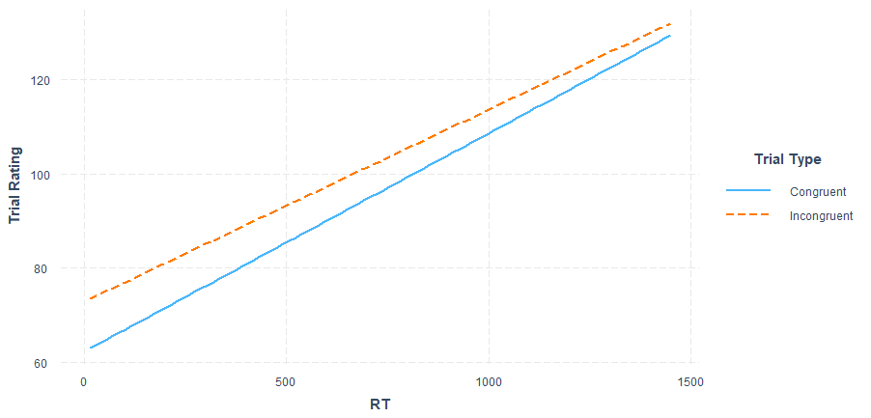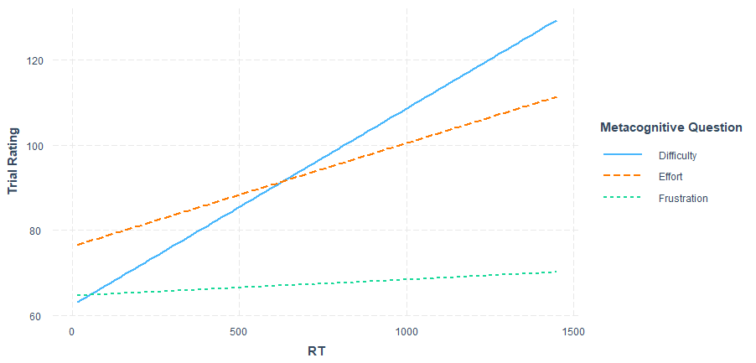
Note. The two-way interaction between RT and Trial Type and the two-way interaction of RT and Metacognitive Condition

The interaction between RT and Metacognitive Condition was also significant, F(2, 23045.5) = 33.63, p < .001. The relation between RT and Subjective Trial Ratings differed between the three Metacognitive Conditions (see Figure E1). For the difficulty and effort condition, the relation between RTs and ratings showed a steep slope, indicating that slower RTs were related to ratings of higher difficulty and effort, however this relationship was stronger for difficulty than for effort. For the frustration condition the relationship of RT and ratings was rather stable as RT increased with only a moderate increase in ratings as RT increased compared to the difficulty and effort conditions.
The three-way interaction between Trial Type, Proportion Congruency, and RT was significant F(4, 3042.1) = 4.04, p = .003. As seen in Figure E2, at 10% PC there is effectively no difference in Subjective Trial Ratings between congruent and incongruent trials given equal RT, but at every other level of PC, as responses get slower and RT increases, the difference in Subjective Trial Ratings between congruent and incongruent trials increases. This interaction indicates that for both congruent and incongruent trials as RT increased and responses were slower that Subjective Trial Ratings increased. However, as RT increased, RT had a stronger effect on Subjective Trial Ratings for incongruent trials than for congruent trials, except at 10% PC where RT had an approximately equal effect on Subjective Trial Ratings for incongruent and congruent trials.
Implications
Given that the PCE in RTs and Error Rates closely resembled the subjective PCE, we need to ask whether subjective ratings are just a mere read-out of reaction times. Indeed, in previous research it has been suggested that participants use reaction time as a cue to rate subjective difficulty (Desender et al., 2017a). In line with Desender et al. (2017a) we found that when adding RT as a predictor in our model, RT did correlate with metacognitive reports, suggesting that participants indeed used RT as a cue to form their subjective experiences. Importantly, however, we found that the influence of congruency and proportion congruency on subjective ratings remained after controlling for RT. Even after accounting for the effect of RT, we still observed small but significant effects of congruency and proportion congruency in the trial rating data. This, as well as the finding that the subjective PCE differed slightly from the RT PCE, shows that subjective experiences were not merely a read out of RT, but were also based on the conflict experience itself.

Figure E2
RT, Trial Type and Proportion Congruency Interaction
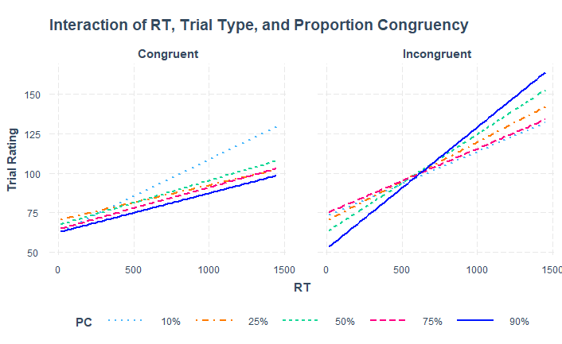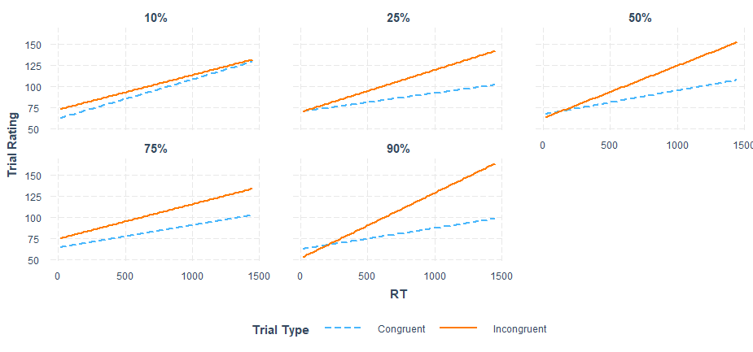
Note. The three-way interaction between RT, Trial Type and Proportion Congruency.

Finally, the three-way interaction between RT, Proportion Congruency and Metacognitive Condition was significant F(8, 9563.7) = 2.44, p = .012. Figure E2 shows the slopes for frustration condition were less steep than they were for the difficulty and effort conditions, implying that RT had less effect on subjective ratings of frustration than it had on subjective ratings of difficulty and effort. Additionally, Figure E3 shows that the slope for 10% Proportion Congruency is steeper in the difficulty condition than at the other levels influence of Proportion Congruency. This indicates that RT had a stronger influence on Subjective Trial Ratings at 10% Proportion Congruency but only for the difficulty condition, and this interaction did not occur in the effort and frustration conditions.

Figure E3
RT, Metacognitive Condition, and Proportion Congruency Interaction
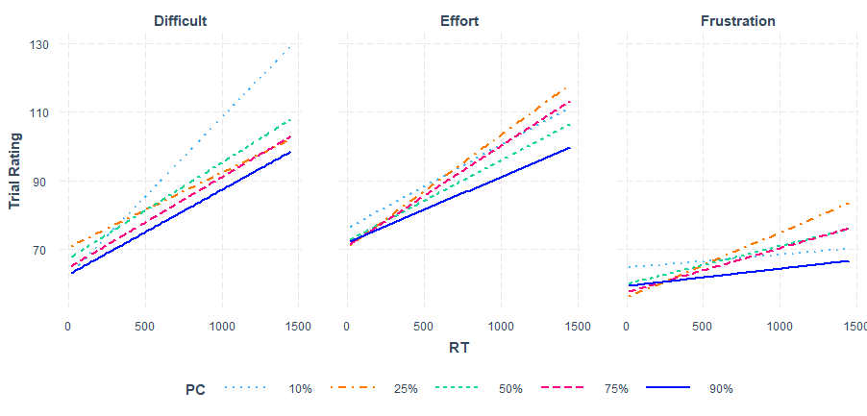
Note. The three-way interaction between RT, Metacognitive Condition, and Proportion Congruency. The plots displays the predicted Trial Rating for each condition of Proportion Congruency as RT increases from 0ms to 1500ms.

There were no other significant main effects or interactions in the model that included RT as a predictor.

Appendix F
Density plots of Trial Ratings by Metacognitive Question.

For all three conditions participants generally used the lower bounds of the scale. The shape and spread of the density plots are very similar across the three conditions, indicating that participants used the scale in a similar manner.

Figure F1
Density plots of Trial Ratings by Metacognitive Question
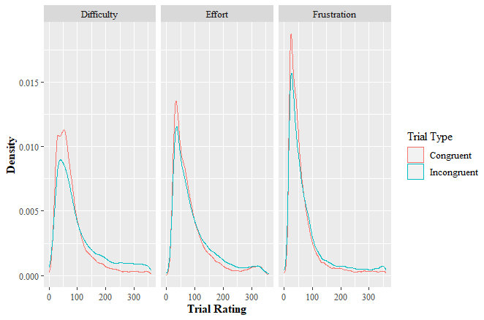
Note. The density plots display the distribution of responses for incongruent and congruent trials for the three Metacognitive Question conditions.

Appendix G
Descriptive Statistics for All Measures in Each Condition.
Table G1
Descriptive Statistics for RT by Metacognitive Question, Proportion Congruency, and Trial Type.
 |  | Metacognitive Condition
 |  | Difficulty |  | Effort |  | Frustration
 | Proportion Congruency | M | SD | M | SD | M | SD
Congruent Trials | 10% | 508.23 | 137.57 | 532.89 | 133.65 | 529.52 | 133.46
Congruent Trials | 25% | 518.70 | 141.92 | 540.67 | 141.19 | 537.64 | 138.29
Congruent Trials | 50% | 507.00 | 131.08 | 528.10 | 131.38 | 523.26 | 130.18
Congruent Trials | 75% | 486.98 | 124.72 | 509.25 | 125.01 | 501.18 | 125.69
Congruent Trials | 90% | 475.12 | 120.09 | 498.05 | 119.33 | 495.16 | 125.62
Incongruent Trials | 10% | 547.56 | 124.44 | 566.22 | 122.83 | 565.81 | 128.44
Incongruent Trials | 25% | 556.86 | 131.02 | 572.91 | 128.83 | 573.93 | 131.79
Incongruent Trials | 50% | 563.58 | 129.20 | 581.49 | 128.73 | 581.76 | 131.50
Incongruent Trials | 75% | 581.29 | 137.26 | 600.90 | 132.43 | 597.55 | 140.42
Incongruent Trials | 90% | 590.33 | 143.08 | 601.90 | 140.36 | 599.58 | 150.04
Note. RT is in milliseconds. M = Mean, SD = Standard Deviation.

Table G2
Descriptive Statistics for Error Rate by Metacognitive Question, Proportion Congruency, and Trial Type.
 |  | Metacognitive Condition
 |  | Difficulty |  | Effort |  | Frustration
 | Proportion Congruency | M | SD | M | SD | M | SD
Congruent Trials | 10% | 4.66 | 21.09 | 3.08 | 17.30 | 3.95 | 19.49
Congruent Trials | 25% | 3.49 | 18.36 | 3.03 | 17.14 | 3.58 | 18.58
Congruent Trials | 50% | 3.39 | 18.10 | 2.39 | 15.29 | 2.15 | 14.52
Congruent Trials | 75% | 1.70 | 12.95 | 1.66 | 12.80 | 2.00 | 14.00
Congruent Trials | 90% | 1.70 | 12.95 | 1.57 | 12.45 | 1.63 | 12.68
Incongruent Trials | 10% | 5.79 | 23.37 | 4.93 | 21.65 | 5.55 | 22.91
Incongruent Trials | 25% | 5.93 | 23.63 | 4.74 | 21.26 | 6.06 | 23.8
Incongruent Trials | 50% | 9.48 | 29.30 | 6.94 | 25.41 | 7.10 | 25.68
Incongruent Trials | 75% | 13.61 | 34.29 | 11.90 | 32.38 | 13.66 | 34.35
Incongruent Trials | 90% | 17.46 | 37.98 | 16.29 | 36.95 | 16.65 | 37.27
Note. Error Rate is in percentage. M = Mean, SD = Standard Deviation.

Table G3
Descriptive Statistics for Trail Level Ratings by Metacognitive Question, Proportion Congruency, and Trial Type.
 |  | Metacognitive Condition
 |  | Difficulty |  | Effort |  | Frustration
 | Proportion Congruency | M | SD | M | SD | M | SD
Congruent Trials | 10% | 85.30 | 64.31 | 88.32 | 69.43 | 66.31 | 57.70
Congruent Trials | 25% | 81.86 | 62.13 | 87.80 | 70.80 | 66.28 | 59.47
Congruent Trials | 50% | 81.03 | 60.71 | 84.54 | 67.30 | 65.32 | 60.37
Congruent Trials | 75% | 77.47 | 57.74 | 85.63 | 69.62 | 63.66 | 57.60
Congruent Trials | 90% | 74.24 | 54.73 | 81.11 | 67.30 | 61.42 | 57.15
Incongruent Trials | 10% | 94.82 | 71.82 | 92.64 | 70.28 | 66.96 | 59.04
Incongruent Trials | 25% | 96.92 | 75.54 | 92.65 | 72.98 | 70.98 | 63.69
Incongruent Trials | 50% | 94.91 | 73.18 | 88.93 | 69.19 | 70.68 | 66.78
Incongruent Trials | 75% | 97.36 | 77.75 | 93.79 | 75.03 | 69.30 | 60.86
Incongruent Trials | 90% | 95.54 | 73.30 | 86.10 | 67.37 | 67.78 | 60.90
Note. Trial Level Ratings are on a scale of 0-360. M = Mean, SD = Standard Deviation.

Table G4
Descriptive Statistics for Mini-Block Ratings by Metacognitive Question, Proportion Congruency, and Trial Type.
 | Metacognitive Condition
 | Difficulty |  | Effort |  | Frustration
Proportion Congruency | M | SD | M | SD | M | SD
10% | 129.97 | 83.21 | 125.99 | 84.23 | 104.20 | 78.65
25% | 125.38 | 82.49 | 119.13 | 82.36 | 104.63 | 77.12
50% | 122.78 | 79.35 | 113.14 | 76.60 | 99.03 | 74.48
75% | 113.46 | 76.19 | 119.68 | 83.15 | 100.43 | 76.63
90% | 103.61 | 72.35 | 105.66 | 74.66 | 87.17 | 71.069
Note. Mini-Block Ratings are on a scale of 0-360. M = Mean, SD = Standard Deviation.

Table G5
Descriptive Statistics for Block Ratings by Metacognitive Question, Proportion Congruency, and Trial Type.
 | Metacognitive Condition
 | Difficulty |  | Effort |  | Frustration
Proportion Congruency | M | SD | M | SD | M | SD
10% | 154.41 | 86.45 | 148.82 | 90.62 | 129.19 | 77.74
25% | 156.14 | 92.30 | 143.78 | 83.78 | 144.60 | 86.27
50% | 143.61 | 79.38 | 133.79 | 83.37 | 127.77 | 81.44
75% | 139.31 | 83.79 | 143.45 | 88.32 | 129.98 | 85.18
90% | 113.11 | 75.30 | 118.87 | 77.06 | 119.81 | 84.91
Note. Block Ratings are on a scale of 0-360. M = Mean, SD = Standard Deviation.

Table G6
Descriptive Statistics for NASA-TLX Ratings by Metacognitive Question, Proportion Congruency, and Trial Type.
 | Metacognitive Condition
 | Difficulty |  | Effort |  | Frustration
Proportion Congruency | M | SD | M | SD | M | SD
10% | 39.69 | 17.12 | 43.05 | 20.26 | 40.01 | 16.01
25% | 41.25 | 16.98 | 41.90 | 18.77 | 42.02 | 17.05
50% | 40.15 | 17.48 | 39.27 | 18.20 | 40.10 | 16.51
75% | 37.26 | 17.00 | 41.65 | 18.63 | 39.96 | 17.60
90% | 36.00 | 17.06 | 38.69 | 19.11 | 37.79 | 17.91
Note. M = Mean, SD = Standard Deviation.

Appendix H
Separate ANOVAs for Difficulty, Effort, and Frustration for Trial-Level Ratings and Block Ratings. At the Trial-Level there was a significant two-way interaction between Proportion Congruency and Trial type, as well as a significant main effect of Trial Type. For Block Ratings there was only a significant main effect of Proportion Congruency for Difficulty. See Tables H1 to Table H6 for ANOVA outputs.
Table H1
Output for the Subjective Difficulty Trial Rating ANOVA Model
Effect | df | SS | Mean Square | F | p
PC | 4 | 1578.26 | 394.56 | 1.08 | .366
Trial Type | 1 | 46193.29 | 46193.29 | 17.35 | <.001
Trial Type x PC | 4 | 3736.70 | 934.17 | 6.99 | < .001
Note. PC = Proportion Congruency

Table H2
Output for the Subjective Effort Trial Rating ANOVA Model
Effect | df | SS | Mean Square | F | p
PC | 4 | 2957.63 | 739.41 | 0.88 | .476
Trial Type | 1 | 9140.16 | 9140.16 | 26.43 | <.001
Trial Type x PC | 4 | 937.86 | 234.46 | 4.00 | < .001
Note. PC = Proportion Congruency

Table H3
Output for the Subjective Frustration Trial Rating ANOVA Model
Effect | df | SS | Mean Square | F | p
PC | 4 | 502.64 | 125.66 | 0.11 | .978
Trial Type | 1 | 5031.60 | 5031.60 | 14.26 | <.001
Trial Type x PC | 4 | 1461.38 | 365.34 | 4.46 | .002
Note. PC = Proportion Congruency

Table H4
Output for the Subjective Difficulty Block Rating ANOVA Model
Effect | df | SS | Mean Square | F | p
PC | 4 | 65853 | 16463.27 | 6.92 | <.001
Note. PC = Proportion Congruency

Table H5
Output for the Subjective Effort Block Rating ANOVA Model
Effect | df | SS | Mean Square | F | p
PC | 4 | 15610 | 3902.55 | 2.74 | .032
Note. PC = Proportion Congruency

Table H6
Output for the Subjective Frustration Block Rating ANOVA Model
Effect | df | SS | Mean Square | F | p
PC | 4 | 19685 | 4921.27 | 2.38 | .058
Note. PC = Proportion Congruency

Appendix I
The results of the mixed effects model analyzing the post-block NASA-TLX.
NASA-TLX
Participants completed the NASA-TLX after completing each block to assess their subjective work load of the block. The Overall Workload based on the NASA-TLX was calculated by averaging the six items. The mean Overall Workload was 39.96 (SD = 17.77). After stepwise likelihood ratio testing the best fitting linear mixed effects model included by-subject random effects for the intercept and Proportion Congruency. The fixed effect of Proportion Congruency was significant, F(4, 196) = 3.46, p = .009. Post-hoc pairwise comparisons using Holm’s correction revealed that the overall workload was only higher at 10% Proportion Congruency (M = 41.00, SD = 17.95) compared to 90% (M = 37.55, SD = 18.04), t(196) = 3.03, p = .024, and at 25% (M = 41.73, SD = 17.58) compared to 90%, t(196) = 3.55, p = .005.
No other main effects or interactions from the main model were significant.

Appendix J
The results of the mixed effects model analyzing response repeats.
An additional analysis was conducted to examine if response repetitions had an effect on subjective trial ratings. We ran a mixed effects model with Response Repeat (response repeat or response alternation) as the independent variable and Trial Ratings as the dependent variable and found that subjective trial ratings did not differ between response repeats and response alternations, F(1, 151521) = 2.42, p = .119.

Appendix K
The full methods and protocols used for this study.
Method
Participants
A total sample of 202 participants took part in the study, which consisted of three between-subject conditions. The between-subjects conditions assessed either subjective difficulty, effort, or frustration. Sixty-three participants took part in the difficulty condition (mean age = 18.78, SD = 1.44, range = 18-24, N_{female} = 55, N_{male} = 8, N_{other} = 0); 72 in the effort condition, but data from one participant were removed as the error rate exceeded 20%, leading to a total of 71 participants in this condition (mean age = 18.28, SD = 0.99, range = 17-24, N_{female} = 67, N_{male} = 3, N_{other} = 1); 67 participants took part in the frustration condition, but data from two participants were removed as the error rate exceeded 20% leading to a total of 65 participants in this condition (mean age = 18.22, SD = 0.70, range = 17-21, N_{female} = 57, N_{male} = 7, N_{other} = 1).
At least 1,600 observations per cell is recommended to achieve sufficient power using mixed effects models (Brysbaert & Stevens, 2018). Given the sample size we obtained, we achieved this number for the RT and Trial Level Subjective data; however, the Block-Level data may have been underpowered. Potential issues of power are further addressed in the discussion section.
All participants were students in the bachelor of Psychology program at KU Leuven. All participants reported normal vision or corrected to normal vision with glasses or contact lenses and spoke Dutch. Exclusion criteria for the study was participants with dyscalculia. All participants provided written informed consent or (if they were not 18 years old yet) parental consent before participating in the experiment. This study was approved by the Social and Societal Ethics Committee (SMEC) of KU Leuven (ethics approval code: G-2021-3080).
Materials and Task
Numerical Stroop Task
Participants completed the task on a Dell desktop computer. The monitor screen size was 22 inches and an AZERTY keyboard was used. The experiment was programmed in Python (version 3.6.6) using the PsychoPy package (version 2020.1.2; Peirce et al., 2019). The experiment instructions were presented to participants in Dutch. The task used was a numerical Stroop task, as this task would present an adequate challenge due to the large amount of number, location, and size features of the stimuli. This large number of stimulus features would also prevent identical stimulus presentation on consecutive trials (only 1.13% of consecutive trials were the same stimulus), as well as minimize the possibility of stimulus-response contingency learning. In this task participants first were presented with a fixation cross in the center of the screen on each trial for 500ms, followed by two simultaneously presented Arabic numbers between 1 and 9. They were asked to decide which of the two numbers was greater in numerical value as quickly and as accurately as possible. The two numbers were presented in white (RGB 255, 255, 255) on a gray (RGB 128, 128, 128) background. The left numeral was presented 2.24 visual degrees to the left of the center of the screen and the right numeral was presented 2.24 visual degrees to the right of the center, both centered vertically. The minimal difference in numerical value between the two numbers was 1 unit (e.g., 7 and 8) and the maximal difference was 3 units (e.g., 5 and 8). The two numbers also differed in their physical font size, with one of the two numerals being larger in font size than the other (e.g., 5 and 8). The smaller numeral had a font size of 1.68° in height and the larger numeral had a font size of 2.80° in height. If the numerically largest number was on the right side of the screen, participants were to press the 'F' key on the keyboard; if the numerically largest number was on the left side of the screen, they were to press the 'D' key. A congruent trial was classified as the numerically larger number also being the number with the larger font size, while an incongruent trial was a trial in which the numerically larger number was presented in the smaller font size.
After making their response, participants were presented with a metacognitive question asking either how difficult, effortful, or frustrating they found that trial to be, depending on which condition they had been assigned to (see Supplemental Material for the exact wording in Dutch and the English translation of each question). The screen that presented the metacognitive question was presented 500ms after the participants responded to the numbers or after the maximum presentation time of 2000ms had elapsed. Participants rated the metacognitive question regarding the trial they had just responded to by using the Trial Ratings Scale. They interacted with the scale by clicking the mouse on a tapered circle that started thin and progressively increased in thickness, similar to that used by Desender et al. (2021). The thickness of the circle represented the perceived difficulty, effort, or frustration (see Figure 1). The thinnest portion of the circle corresponded to the lowest rating (i.e., lowest difficulty, effort, frustration; scored as 0) and progressed into an increasingly thick line, with the thickest portion representing the highest rating (i.e., highest difficulty/effort/frustration; scored as 360). Responses were made by clicking on the portion of the circle that corresponded to the perceived difficulty, effort, or frustration. The arc degree from the thinnest point of the circle to the point of the circle that the participant clicked on was recorded as their rating for that trial. The circle was black (RGB 0, 0, 0) on a gray (RGB 128, 128, 128) background and rotated randomly every trial in order to prevent planned responses. There was no time pressure to make this response and the circle remained on the screen until participants responded. After making their response the fixation cross appeared again after 500ms, starting the next trial. Figure 1 shows an illustration of a full trial.
Additionally, participants were asked the metacognitive question after every 20 trials (“Mini-Block”) to report how difficult, effortful, or frustrating they found that Mini-Block to be as a whole. After the completion of every full block, they were asked the metacognitive question to report how difficult, effortful, or frustrating they found the full block. Mini-Blocks were incorporated into the experiment as another level of analysis. Participants would have to incorporate their experience of several trials to make a judgment of the Mini-Block, but would not have to incorporate as many trials as they did when assessing the full block.
Participants first completed a practice block containing 50 trials with an equal proportion of congruent and incongruent trials. Feedback regarding the accuracy of their response was provided after each trial. During the practice block, participants provided ratings for the metacognitive question to become familiar with the rating circle. The rating circle appeared on the screen after the feedback regarding the accuracy of their response. Feedback of the score corresponding to their click location on the rating circle was also provided (0-360). The practice block was followed by five test blocks of 160 trials each. Unlike the practice block, feedback was no longer provided for accuracy or for ratings of the metacognitive question. The five blocks differed from each other by the proportion of congruent trials within the block. The blocks contained either 10%, 25%, 50%, 75% or 90% congruent trials. Each participant completed all five blocks, and the order of the blocks were counterbalanced across participants using a Latin Square. Between each block, participants were given a self-paced break. Due to a technical failure 89 (8.81%) total block-level ratings were not recorded; 2 (0.63% of difficulty blocks) from the difficulty condition, 45 (12.68% of effort blocks) from the effort condition, and 42 (12.54% of frustration blocks) from the frustration condition.
Other material
In addition to performing the numerical Stroop task, participants had to fill in several questionnaires (see Supplemental Material). After each block of the numerical Stroop task, they filled out the Dutch translation of the NASA Task Load Index (NASA-TLX; Hart & Staveland, 1988) in order to measure the overall subjective workload of that block. The NASA-TLX is amongst the most widely used instruments to measure workload (Grier, 2015) and is a valid, reliable, and sensitive instrument for measuring workload while performing cognitive tasks (Hart & Staveland, 1988), and has been widely used to measure the aversiveness of mental effort (David et al., 2024). Participants answered six questions about workload (mental demands, physical demands, temporal demands, performance, effort, and frustration) on a 20-point Likert-like scale with 5-point increments ranging from 0 (very low) to 100 (very high), or 0 (perfect) to 100 (failure) for the item assessing performance (see Supplemental Materials for the results of the NASA-TLX).
Participants also completed two exploratory questionnaires (in Dutch) after completing the numerical Stroop task, assessing what cues they used to shape their answers on the metacognitive question. One of the questionnaires was related to their subjective experiences after each trial, and participants had to indicate to what extent they agreed with 12 different statements (e.g., To determine the difficulty of the trial, I used the speed with which I responded to the trial), using a 5-point Likert scale ranging from 1 (strongly disagree) to 5 (strongly agree). The second questionnaire was similar, but was related to their subjective experiences after each block. Here, they had to indicate to what extent they agreed with 16 statements using a 5-point Likert scale, ranging from 1 (strongly disagree) to 5 (strongly agree) (see Supplemental Material for the results of the Questionnaire).

Figure 1
Illustration of a Trial in the Numerical Stroop Task
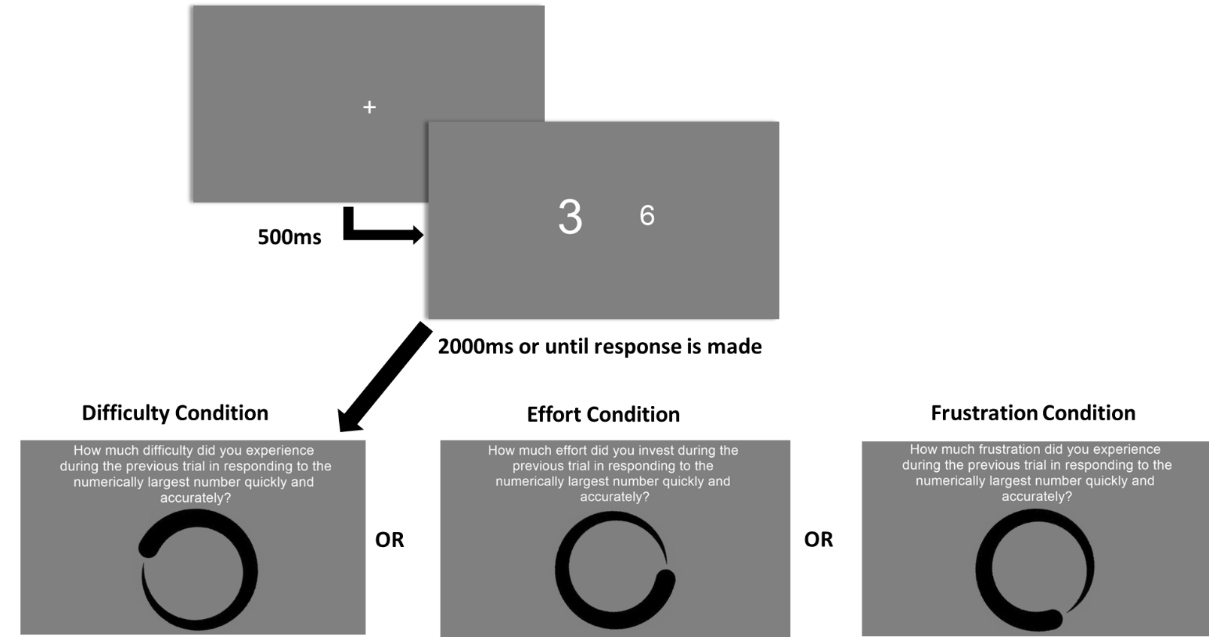
Note. After responding to the numerical Stroop trial participants were presented with one of the three metacognitive questions assessing their subjective experience of difficulty, effort, or frustration. Participants were asked the exact same question after completing a mini-block or full block with the word “trial” replaced with “20 trials” or “block” respectively.

Procedure
Before participants began the task, the experimenter gave a brief explanation of the procedure. The experiment was conducted in a computer lab where multiple participants could perform the task simultaneously. Due to COVID-19 protocols a maximum of 10 participants were allowed at one time in the computer lab and were seated at least 2 meters apart from one another and the room was constantly ventilated. Additionally, participants were required to wear mouth masks at all times throughout the experiment and were provided with hand sanitizer. After participants read and signed the informed consent or provided their signed parental consent, they began the task. After each block of 160 trials, participants completed a copy of the NASA-TLX. After completing the final block, they completed the two questionnaires.
Statistical Analysis Overview
We used a 3 (Metacognitive Condition: difficulty, effort, or frustration metacognitive question) x 2 (Trial Type: congruent or incongruent) x 5 (Proportion Congruency: 10%, 25%, 50%, 75% or 90%) mixed design, with Trial Type and Proportion Congruency as within-subject factors and Metacognitive Condition as the between-subject factor. The dependent variables collected in this study were RTs, Errors Rates, Subjective Trial Ratings of the Metacognitive Question, Subjective Mini-Block Ratings of the Metacognitive Question, the Subjective Block Ratings of the Metacognitive Question for every block, and the NASA-TLX overall workload index. The NASA-TLX overall workload was calculated by averaging the 6 items.
All analyses were performed using R Studio 4.1.1 (R Core Team, 2021). Separate analyses were performed for each dependent variable. The variables were analyzed with linear mixed effects models and a binomial generalized linear mixed effects model for the Error Rates using the lme4 package (Bates, Maechler & Bolker, 2015). The significance of the fixed effects were tested using a Type III analysis of variance (ANOVA) with Satterthwaite approximation for degrees of freedom at an alpha level of .05. The random effect structure was determined through stepwise likelihood ratio testing by adding one random effect at a time to the model and testing the significance of the fit of the model with the new random effect added to the previous iteration of the model without the effect. For the RTs, Error Rates and Subjective Trial Ratings of the Metacognitive Question models, the first iteration of the model included by-subject random intercepts only, the second iteration included random intercepts and the random effect of Trial Type, the third iteration included random intercepts and the random effect of Proportion Congruency, the fourth iteration included random intercepts and the random effects of both Trial Type and Proportion Congruency, and the fifth iteration included random intercepts, the random effects of both Trial Type and Proportion Congruency, and the interaction between Trial Type and Proportion Congruency. As Metacognitive Condition was a between-subjects variable it was excluded as a random effect.
For the models analyzing RT and Subjective Trial Ratings of the Metacognitive Question as dependent variables, we entered Trial Type, Proportion Congruency, and Metacognitive Condition as fixed main effects. The fixed effects interactions included in the models were the two-way interaction between Trial Type and Proportion Congruency, the two-way interaction between Trial Type and Metacognitive Condition, the two-way interaction between Proportion Congruency and Metacognitive Condition, and the three-way interaction between Trial Type, Proportion Congruency, and Metacognitive Condition. As the predictors for these models were all categorical, sum coding was used.
These same fixed effects were used for the model analyzing Errors Rates, but as making an error or not on each trial results in a binary response variable, a binomial generalized linear mixed effects model was used. Thus, Wald’s chi-square is reported for the Error Rates model instead of an F value.
For the models analyzing Subjective Mini-Block Ratings of the Metacognitive Question, Subjective Block Rating of the Metacognitive Question, and the NASA Overall Workload, Proportion Congruency, Metacognitive Condition, and the interaction between Proportion Congruency and Metacognitive Condition were used as fixed effects. For these models, the first iteration included by-subject random intercepts only, and the second iteration included random intercepts and the random effect of Proportion Congruency.
All models were run using bobyqa optimization. The results for the fixed effects of each model can be found in the Supplemental Material (Appendix C).
Transparency and Openness
Initially, the study was conceived to analyze subjective difficulty, effort, and frustration as separate experiments. After data collection, we decided to analyze the data of the three experiments combined together using mixed effects modeling. We chose to use mixed effects modelling because it is a powerful and flexible tool that can deal with missing data and unbalanced designs (Brown, 2021). We decided to analyze the data from the three experiments together in order to examine if any differences existed between subjective difficulty, effort, and frustration in their relation to the task demands. By merging the three experiments together we could directly examine if there was an effect of the metacognitive question asked.
All analyses were performed using R Studio 4.1.1 (R Core Team, 2021). Mixed effects models were analyzed using the lme4 package version 1.1.27.1 (Bates, Maechler & Bolker, 2015). We report all measures, manipulations, and outlier removals. Data and raw code are openly available at the project’s Open Science Framework page https://osf.io/tu6e4/. This study was not preregistered.

Appendix L

References
Bates D, Mächler M, Bolker B, Walker S (2015). “Fitting Linear Mixed-Effects Models Using lme4.” Journal of Statistical Software, 67(1), 1–48. 10.18637/jss.v067.i01.
Brown, V. A. (2021). An Introduction to Linear Mixed-Effects Modeling in R. Advances in Methods and Practices in Psychological Science, 4(1). https://doi.org/10.1177/2515245920960351
Brysbaert, M., & Stevens, M. (2018). Power Analysis and Effect Size in Mixed Effects Models: A Tutorial. Journal of Cognition, 1(1), 9. https://doi.org/10.5334/joc.10
David, L., Vassena, E., & Bijleveld, E. (2024). The unpleasantness of thinking: A meta-analytic review of the association between mental effort and negative affect. Psychological Bulletin, 150(9), 1070–1093. https://doi.org/10.1037/bul0000443
Desender, K., Teuchies, M., Gonzalez-Garcia, C., De Baene, W., Demanet, J., & Brass, M. (2021). Metacognitive Awareness of Difficulty in Action Selection: The Role of the Cingulo-opercular Network. Journal of Cognitive Neuroscience, 33(12), 2512–2522. https://doi.org/10.1162/jocn_a_01773
Desender, K., Van Opstal, F., & Van den Bussche, E. (2017a). Subjective experience of difficulty depends on multiple cues. Scientific Reports, 7(1), 44222. https://doi.org/10.1038/srep44222
Grier, R. A. (2015). How High is High? A Meta-Analysis of NASA-TLX Global Workload Scores. Proceedings of the Human Factors and Ergonomics Society Annual Meeting, 59(1), 1727–1731. https://doi.org/10.1177/1541931215591373
Hart, S. G., & Staveland, L. E. (1988). Development of NASA-TLX (Task Load Index): Results of empirical and theoretical research. In P. A. Hancock & N. Meshkati (Eds.), Advances in psychology, 52. Human mental workload (p. 139–183). North-Holland. https://doi.org/10.1016/S0166-4115(08)62386-9
Peirce, J., Gray, J. R., Simpson, S., MacAskill, M., Höchenberger, R., Sogo, H., Kastman, E., & Lindeløv, J. K. (2019). PsychoPy2: Experiments in behavior made easy. Behavior Research Methods, 51(1), 195–203. https://doi.org/10.3758/s13428-018-01193-y
R Core Team (2024). R: A Language and Environment for Statistical Computing. R Foundation for Statistical Computing, Vienna, Austria. https://www.R-project.org/
Schneider, D. W. (2019). Alertness and cognitive control: Testing the spatial grouping hypothesis. Attention, Perception, & Psychophysics, 81(6), 1913–1925. https://doi.org/10.3758/s13414-019-01764-x
Wirth, M., & Gaschler, R. (2017). Challenging Cognitive Control by Mirrored Stimuli in Working Memory Matching. Frontiers in Psychology, 8. https://doi.org/10.3389/fpsyg.2017.00653

An error rate of over 20% was chosen as an exclusion criterion as those participants were likely not fully engaged in the task. Exclusion of participants with error rates over 20% aligns with previous studies (ex. Schneider, 2019; Wirth & Gaschler, 2017). Results from all analyses were unchanged when error outliers were included.

