Content of the Interventions

Table S1
Content of the Interventions: Chapters and Tasks
Part | UV intervention (Study 1 and 2) | GM intervention (Study 1 and 2) | Control intervention (Study 1) | GM/UV intervention (Study 2)
Title | Research methods: why, what for, do I really need them? | “I can’t learn it?” That’s rubbish! Learning is a state of mind | Classroom management as a teacher competency | Research methods – don’t need them, can’t do them… or can I?
Chapter 1 | Research competence is general education | Brain training = muscle training? | What do we mean by classroom management? | Research competence is the basis for research-based action
Chapter 2 | Research competence is the basis for evidence-based teaching | What happens in the brain when we learn? | Ways of preventing and intervening in classroom disruption | Research competence helps with diagnostic tasks
Task 1 | The first part of this learning unit addressed how knowledge about research methods can be useful in everyday situations and in your role as a teacher in the future. What do you personally find most interesting about this topic - and why? This could be, for example, something you have already dealt with before this learning unit or content that reminds you of something you have experienced yourself. Please state one aspect and briefly explain why you find it important. | The first part of this learning unit dealt with the neurobiological basis of learning, in particular neuroplasticity. What did you personally find the most important in this topic and why? This could be, for example, something you have already dealt with before this learning unit or content that reminds you of something you have experienced yourself. Please state one aspect and briefly explain why you find it important. | The first part of this learning unit revolved around the different types of disruption in lessons and how teachers can deal with disturbances. What did you personally find the most important in this topic – and why? This could be, for example, something you have already dealt with before this learning unit or content that reminds you of something you have experienced yourself. Please state one aspect and briefly explain why you find it important. | The first part of this learning module dealt with the extent to which it can be useful for you as a future teacher to be able to conduct research yourself. What do you personally find most interesting about this topic - and why? This could be, for example, something you have already dealt with before this learning unit or content that reminds you of something you have experienced yourself. Please state one aspect and briefly explain why you find it important.

Part | UV intervention (Study 1 and 2) | GM intervention (Study 1 and 2) | Control intervention (Study 1) | GM/UV intervention (Study 2)
Chapter 3 | Research competence is the basis for research-based action | What helps our brain to learn: Exercise and exertion | Kounin’s principles of effective classroom management | What happens in the brain when we learn?
Chapter 4 | Research competence helps us to understand educational studies | What helps our brain to learn: Errors and challenges | Introducing and implementing rules | What helps our brain to learn
Task 2 | What experiences have you already had with research yourself? Or, if you have not conducted any research yourself yet: in what ways might you engage in research in your future school practice? Please briefly describe a situation that you have experienced or could experience yourself. | When did you last let your brain ‘grow’? For example, do you remember the last time you couldn’t do something, but then after a lot of practice and endurance you improved – or when you failed at something and learned form it? Please briefly describe a situation that you have experienced yourself. | What positive or negative experiences do you have with rules in the classroom – either from your own lessons or when observing others? Please briefly describe a situation which you have experienced yourself or observed. | When did you last let your brain ‘grow’? For example, do you remember the last time you couldn’t do something, but then after a lot of practice and endurance you improved – or when you failed at something and learned form it? Please briefly describe a situation that you have experienced yourself.
Chapter 5 | Research competence helps with diagnostic tasks | What helps our brain to learn: Good strategies and support | Operant conditioning | Research competence is the basis for evidence-based teaching
Chapter 6 | Research competence is a basis for participating in educational research | How our mindset towards learning influences our abilities | Reinforcement and punishment: recommendations for the classroom | Research competence is a basis for participating in educational research

Part | UV intervention (Study 1 and 2) | GM intervention (Study 1 and 2) | Control intervention (Study 1) | GM/UV intervention (Study 2)
Task 3 | Many teachers believe that educational research has little to do with actual practice. In fact, however, most of the questions posed by educational research come directly from practice – and practice, in turn, can benefit from the findings of this research. As a future teacher, to what extent do you see a connection between practice and research in education? Please briefly describe a situation in which you have consciously experienced – or might experience – the connection between research and practice. | Many people believe that as an adult you cannot fundamentally improve your abilities. However, brain research shows that our brain is flexible and can ‘grow’ at any time – if we give it the chance to do so. To what extent have you already experienced the way that your attitude towards learning has ultimately had an influence on how well you have learned? Please briefly describe a situation that you have experienced. | Many teachers believe that punishment and reward should not be used in the classroom - after all, learners are "not rats". Nevertheless, many work with operant conditioning, for example by telling pupils off for disruptive behavior or praising desirable behavior. Have you already used reinforcement or punishment? Or: What situations (your own school days, observations) do you remember in which the teacher used reinforcement or punishment? Please briefly describe a situation you have experienced. | Many teachers believe that educational research has little to do with actual practice. In fact, however, most of the questions posed by educational research come directly from practice – and practice, in turn, can benefit from the findings of this research. As a future teacher, to what extent do you see a connection between practice and research in education? Please briefly describe a situation in which you have consciously experienced – or might experience – the connection between research and practice.
Task 4 | At the start of the learning module, you were given the opinion of a teacher student:  “I think it is absolutely unrealistic to think that people have the time to engage with any kind of research while doing their job. I find the continual lack of time quite annoying. In general, I personally think there are other things that are far more important for my day-to-day job. I have to motivate the students in the best way possible and support their development. That has nothing to do with research or statistics. I’m a teacher, not a researcher. When I was studying, I would have gladly done without statistics. Since I’ve been teaching, I haven’t needed any of that theoretical stuff.”  What would you say to Jonas to convince him of the benefits of using methodological research skills for teachers? Make sure to refer to information from this learning unit. | At the start of the learning module, you were given the opinion of a teacher student:  "Somehow I was caught off guard when we suddenly had to deal with research methods and statistics. The explanations of statistical formulas in particular really threw me off. When I looked around the room, however, I got the impression that the others weren’t struggling at all. I asked myself - why is it so easy for them, while I have to make an effort to keep up? Are they just better than me? To be honest, math has never been my thing. In class I always just barely scraped by, and I was glad when school was over. Now, in the research methods seminar that old familiar feeling comes up again: I just can't do it!”  What would you say to Jonas to motivate him and convince him that he can improve his math and statistics skills? Make sure to refer to information from this learning unit. | At the start of the learning module, you were given the opinion of a teacher student:  "Let's face it: even the most amazing course can't prepare you for what really happens in the classroom. You just have to dive in at the deep end! We had a few pedagogical courses in our study program, but they were far too theoretical in my opinion, too far removed from reality. In the classroom, everything happens at once - someone hasn't understood the assignment over here, are people chatting over there, and you have trouble just to get through all the material. I can't stand there and consider pedagogical theories. What really helped were the discussions with experienced colleagues. And then you just have to experience it yourself and find out what works and what doesn't. I certainly could have done without the pedagogy in my studies."  What would you say to Jonas to convince him that (theoretical) pedagogical knowledge can be useful for teachers? Make sure to include information from this learning unit. | At the start of the learning module, you were given the opinion of a teacher student:  "I remember being taken aback when all of a sudden we were expected to deal with research methods and statistics in our course. Especially with the explanations of statistical formulas, I was really lost. When I looked around the room, however, I had the impression that the others had no particular difficulties. I asked myself – why do they find it so easy, but I just can't do it? Even if it had been easier for me, I would have gladly done without the statistics in my degree course. I think it is absolutely unrealistic to expect that someone has the time alongside their job to deal with research of any kind. The permanent lack of time is quite annoying. In general, other things are much more important for my day-to-day job. I have to motivate the students in the best possible way and support them in their development. That has nothing to do with research or statistics."  What would you say to Jonas to convince him of the benefits of research methodology skills for teachers and his own ability to acquire this skill? Refer to the information from this learning module.
Notes. Translated from German. GM = growth mindset, UV = utility value, GM/UV intervention = combined intervention.

Additional Analyses (Study 1)
To explore whether the interventions’ effects varied by preservice teachers’ intended (a) school type and (b) subject, we conducted subgroup analyses. We applied one-way ANOVAs to investigate whether subgroups differ in their prior growth mindset, expectancies, and utility value, and the same analyses as in the full sample (mixed ANOVAs with combined contrasts, one-way ANCOVAs, and Mann-Whitney-U-Tests) to investigate whether the intervention effects differed between subgroups.
Regarding (a) school type, we divided the sample into future primary-school teachers (n = 41) and secondary-school teachers (n = 43), which were the most common groups in our sample. There were no significant a priori subgroup differences in growth mindset, expectancies, or utility value (Table S2). Figure S1 illustrates the development of the beliefs; Table S3 shows the results of the mixed ANOVAs. The effects on growth mindset and utility value in the subgroups were similar to those in the full sample, as was indicated by significant contrasts (Table S3) and roughly similar trends (Figure S1). However, there were no significant changes in expectancies in either subgroup (effects of time: ps > .11). For willingness to engage with research, school type made a difference. Among future secondary teachers, the GM and UV interventions both increased self-reported willingness, compared to the control group, F(1,32) = 12.74, p = .001, η_{p}² = 0.29, and the UV intervention encouraged the selection of scientific articles, U = 28.00, p = .048, d = 0.89. Among future primary teachers, these effects were nonsignificant (ps > .41).
Regarding (b) the subjects, we split the preservice teachers into those with at least one STEM subject (n = 57) and those without (n = 37). There were no significant a priori differences between STEM and non-STEM students in growth mindset, expectancies, or utility value (Table S2). The GM intervention’s effect on growth mindset in the subgroups was similar to those in the full sample, as was indicated by significant contrasts (Table S4) and roughly similar trends (Figure S2). Changes in expectancies over time were, however, no longer significant (ps > .11), and descriptive scores indicated that particularly for future non-STEM teachers who worked on the UV intervention, expectancies remained unchanged over time (Figure S2). For utility value, the contrast that tested the UV intervention’s effect from pre- to posttest was only significant among STEM students, but not among non-STEM students (Table S4), and descriptive scores indicated that utility value in the non-STEM group did not increase as much through the UV intervention and decreased more between posttest and follow-up test, compared with the STEM group (Figure S2). Nevertheless, non-STEM students profited from both interventions in terms of self-reported willingness to engage with research; the effect size of the contrast that compared the GM and UV interventions to the control group was stronger for non-STEM students, F(1,26) = 5.44, p = .028, η_{p}² = 0.17, than for STEM students, F(1,46) = 3.51, p = .067, η_{p}² = 0.07. By contrast, the UV intervention encouraged the selection of scientific articles only in the STEM group, U = 90.00, p = .028, d = 0.74 but not in the non-STEM group (p = .45).

Table S2
Comparisons Between the Subgroups in Prior Beliefs, ANOVA Results
Effect |  | M (SD) | F | df | df _{error} | p
Growth mindset
 | Primary | 4.02 (0.65) | 0.14 | 1 | 82 | .709
 | Secondary | 4.08 (0.90)
 | STEM | 4.06 (0.78) | 0.75 | 1 | 92 | .390
 | Non-STEM | 3.92 (0.84)
Expectancies
 | Primary | 4.39 (1.05) | 0.00 | 1 | 82 | .975
 | Secondary | 4.38 (0.86)
 | STEM | 4.30 (1.04) | 0.63 | 1 | 92 | .428
 | Non-STEM | 4.46 (0.81)
Utility value
 | Primary | 4.24 (0.98) | 0.81 | 1 | 82 | .370
 | Secondary | 4.42 (0.79)
 | STEM | 4.33 (0.90) | 0.07 | 1 | 92 | .790
 | Non-STEM | 4.38 (0.83)
Note. Primary = Future primary teachers, Secondary = Future secondary teachers. STEM = Future STEM teachers, Non-STEM = Future non-STEM teachers.

Table S3
Effects on Research-Related Beliefs, Separated by School Type
Effect |  | Primary |  |  |  |  | Secondary
 |  | F | df | df _{error} | p | η_{p}² | F | df | df _{error} | p | η_{p}²
Growth mindset ª
 | Pre vs. Post | 11.07 | 1 | 33 | .002 | .25 | 17.03 | 1 | 35 | < .001 | .33
 | Pre vs. Follow-Up | 6.83 | 1 | 33 | .013 | .17 | 15.45 | 1 | 35 | < .001 | .31
Expectancies ª
 | Pre vs. Post | 0.29 | 1 | 33 | .596 | .01 | 3.70 | 1 | 35 | .063 | .10
 | Pre vs. Follow-Up | 0.08 | 1 | 33 | .780 | .00 | 1.91 | 1 | 35 | .175 | .05
Utility Value ^{b}
 | Pre vs. Post | 6.66 | 1 | 33 | .014 | .17 | 9.08 | 1 | 35 | .005 | .21
 | Pre vs. Follow-Up | 0.24 | 1 | 33 | .630 | .01 | 0.12 | 1 | 35 | .727 | .00
Note. Primary = Future primary teachers, Secondary = Future secondary teachers. ª based on a contrast that compared the growth mindset intervention to the utility value intervention and control intervention (GM = 2, UV = -1, control = -1). ^{b} based on a contrast that compared the utility value intervention to the growth mindset intervention and control intervention (GM = -1, UV = 2, control = -1).

Table S4
Effects on Research-Related Beliefs, Separated by Subject
Effect |  | STEM |  |  |  |  | Non-STEM
 |  | F | df | df _{error} | p | η_{p}² | F | df | df _{error} | p | η_{p}²
Growth mindset ª
 | Pre vs. Post | 19.76 | 1 | 49 | < .001 | .29 | 16.48 | 1 | 29 | < .001 | .36
 | Pre vs. Follow-Up | 23.54 | 1 | 49 | < .001 | .33 | 7.16 | 1 | 29 | .012 | .20
Expectancies ª
 | Pre vs. Post | 0.58 | 1 | 49 | .451 | .01 | 2.05 | 1 | 29 | .163 | .07
 | Pre vs. Follow-Up | 0.60 | 1 | 49 | .442 | .01 | 2.00 | 1 | 29 | .168 | .06
Utility Value ^{b}
 | Pre vs. Post | 9.66 | 1 | 49 | .003 | .17 | 1.41 | 1 | 29 | .245 | .05
 | Pre vs. Follow-Up | 0.11 | 1 | 49 | .744 | .00 | 1.00 | 1 | 29 | .325 | .03
Note. STEM = Future STEM teachers, Non-STEM = Future non-STEM teachers. ª based on a contrast that compared the growth mindset intervention to the utility value intervention and control intervention (GM = 2, UV = -1, control = -1). ^{b} based on a contrast that compared the utility value intervention to the growth mindset intervention and control intervention (GM = -1, UV = 2, control = -1).

Figure S1
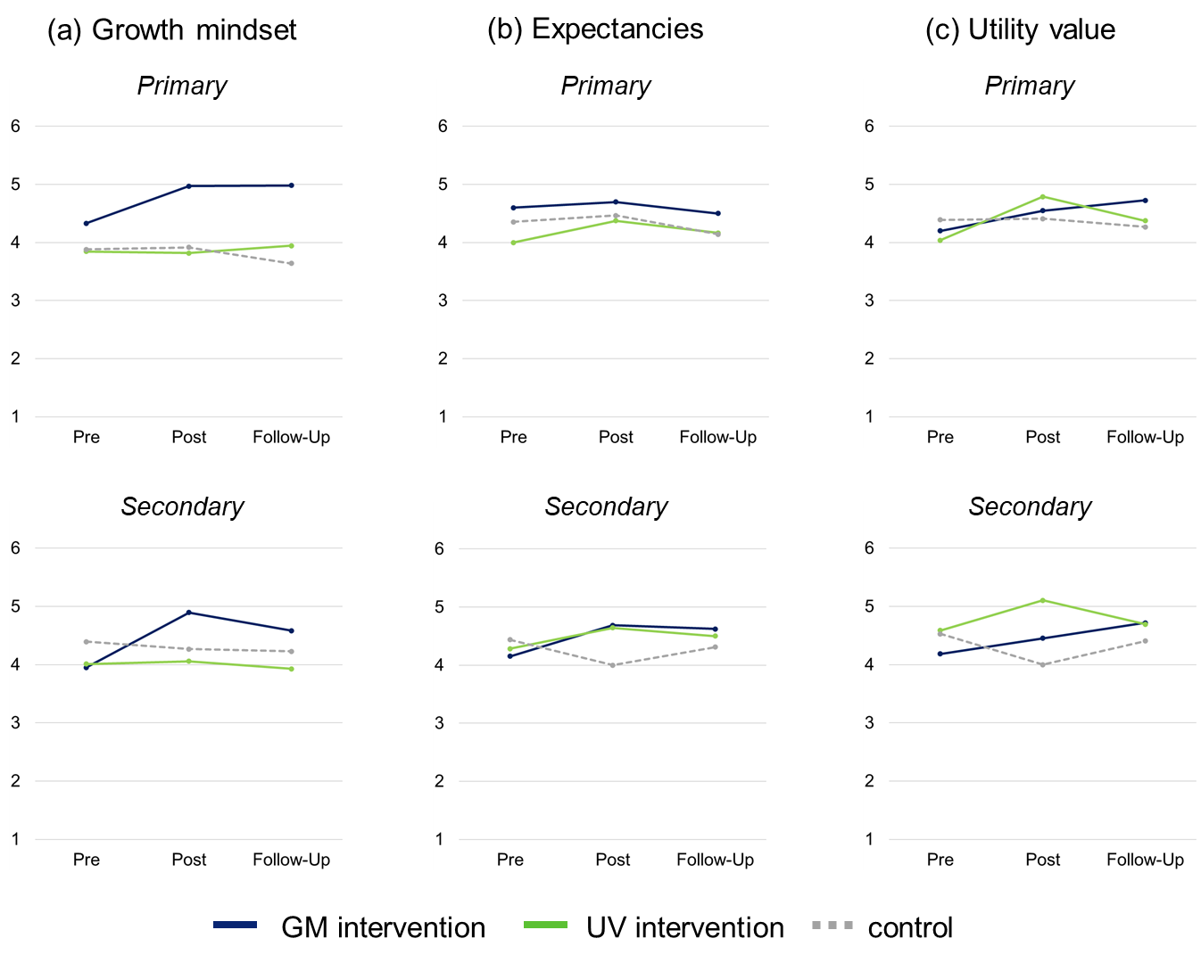
Development of Research-Related Beliefs, Separated by School Type
Note. GM = growth mindset, UV = utility value. Measurements were taken before (pretest), immediately after (posttest), and two weeks after the intervention (follow-up). Primary = Future primary teachers, Secondary = Future secondary teachers.

Figure S2
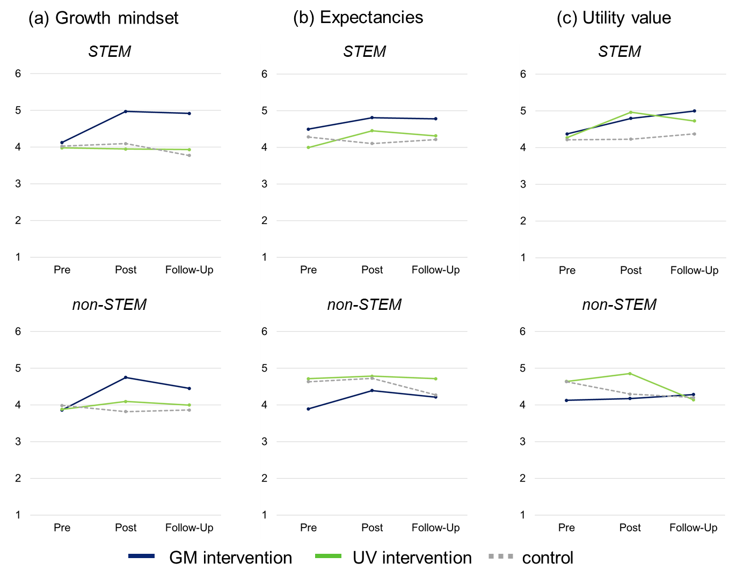
Development of Research-Related Beliefs, Separated by Subject
Note. GM = growth mindset, UV = utility value. Measurements were taken before (pretest), immediately after (posttest), and 2 weeks after the intervention (follow-up). STEM = Future STEM teachers, Non-STEM = Future non-STEM teachers.

Additional Analyses (Study 2)

(A) Moderator Analyses
To explore whether the effects of the interventions were moderated by preservice teachers’ baseline beliefs about their research competencies, we added the Time x Group x Competence Beliefs interaction to the mixed ANOVAs we used to test H1, and the Group x Competence Beliefs interaction to the one-way ANOVA we used to test H2.
Results indicated that competence beliefs did not moderate the development of growth mindset, utility value, or willingness to engage with research, but they did moderate the development of research-related expectancies (Table S5). Figure S3 shows this interaction: In the GM and GM/UV conditions, competence beliefs were negatively related to expectancy development. Hence, the lower the competence beliefs at the beginning, the stronger the increase in expectancies. In the UV condition, there was a positive relationship. Therefore, the higher the competence beliefs at the beginning, the stronger the increase in expectancies.

(B) Analyses on Long-Term Effects
To investigate whether the interventions had any long-term effects, we collected follow-up data after 8 weeks (Follow-Up I) and after 16 weeks (Follow-Up II). In contrast to the first part of the study, participation in this supplementary longitudinal survey was voluntary. Participants could win a € 30 voucher, and we donated € 5 per participant to an educational project. Out of the total sample, 36 preservice teachers completed both follow-up sessions, which took about 10 min each. These participants were evenly distributed across the GM (n = 13), UV (n = 11), and GM/UV interventions (n = 12). Dropout was unrelated to experimental condition (χ² test, p = .652), indicating that the likelihood of participating did not depend on the type of intervention. Furthermore, there was no evidence of significant differences between dropouts and nondropouts in age or gender (ps > .09) or in prior expectancies or value beliefs (ps > .30). However, preservice teachers who participated in the follow-up sessions began with a higher growth mindset than those who dropped out, F(1, 175) = 5.00, p = .027. Presumably, those with more positive attitudes toward learning and skills development were more likely to volunteer for the learning-related survey. Thus, the results must be interpreted with the limitation of self-recruitment and the very small sample size.
Internal consistencies at the follow-up sessions were good for growth mindset (α > .88), expectancies (α > .79), utility value (α > .76), and self-reported willingness to engage with research (α > .79). As in Study 1, we also administered a selection task in which participants could choose whether they wanted to receive links to websites with practical tips and tricks (Option 1), links to websites with short and easy-to-understand educational research reports (Option 2) or links to scientific articles about education (Option 3). If they had selected Options 2 or 3, we also asked whether they wanted to receive links to research reports/articles on a (a) lower or (b) higher scientific level. We weighted the options according to their science-relatedness, thus forming a sum score that ranged from 1 (Option 1) to 5 (Option 3b).
We used similar analyses as in the main analyses (ANOVAs and Mann-Whitney U tests) with the exception that we did not use any contrasts due to the exploratory nature of the analyses. Instead, we followed up significant ANOVA effects with (Bonferroni-corrected) post-hoc tests. If the sphericity assumption was violated, we applied the Greenhouse-Geisser correction to the analyses. Table S6 presents descriptive values, Table S7 presents ANOVA results for the analyses on research-related beliefs, and Figure S4 illustrates the development of the beliefs.
We first report results for (a) growth mindset, (b) expectancies, and (c) utility value. (a) Regarding growth mindset, there was no Time x Group interaction but significant effects of time and group (Table S7). We therefore explored the development of growth mindset for the groups separately. In the GM condition, growth mindset increased from pre- to post-test (diff = 0.59, 95% CI [0.09, 1.09], p = .015) and then remained on that level (ps > .53). In the GM/UV condition, growth mindset also increased from pre- to post-test (diff = 0.90, 95% CI [0.34, 1.43], p < .001), decreased again from posttest to first follow-up (diff = -0.57, 95% CI [-1.11, -0.03], p = .033), and then remained on that level (p = 1.00). In the UV condition, there was no change in growth mindset (ps = 1.00).
(b) Regarding expectancies, there was no Time x Group interaction and no overall group effect, but a significant effect of time (Table S7). Across groups, expectancies increased from pre- to post-test (diff = 0.55, 95% CI [0.35, 0.75], p < .001) and then remained on that level (ps > .37).
(c) Regarding utility value, there was no Time x Group interaction and no overall group effect, but again a significant effect of time (Table S7). Across groups, utility value increased from pre- to posttest (diff = 0.42, 95% CI [0.19, 0.66], p < .001) and then remained on that level (ps > .53). The overall increase from pretest to second follow-up was also significant (diff = 0.45, 95% CI [0.09, 0.81], p = .009).
We then analyzed the two willingness indicators, (d) self-report and (e) the selection task. (d) There was no evidence for group differences in self-reported willingness to engage with research neither at the first follow-up, F(2, 32) = 1.28, p = .292, η_{p}² = .07, nor at the second follow-up, F(2, 31) = 0.14, p = .867, η_{p}² = .01. (e) Descriptive values indicated that participants in the UV condition selected links with higher scientific demands more frequently than those in the other conditions (see Figure S5). However, differences between groups were not significant (ps > .29).
In summary, these additional analyses indicated that the positive effects of the interventions on preservice teachers’ beliefs remained largely stable for 4 months (except the effect of the combined intervention on growth mindset). Expectations and value beliefs remained above the initial level after all interventions. However, in line with the posttest results, the combined intervention did not have stronger effects on self-reported willingness to engage with research or on the selection task than the single interventions did.

Table S5
Effects on Beliefs and Willingness, Moderated by Prior Competence Beliefs
Effect |  | F | df | df _{error} | p | η_{p}²
Growth mindset
 | Time x Group x Competence Beliefs | 0.74 | 3 | 171 | .529 | 0.01
 | Time x Group | 4.76 | 2 | 171 | .010 | 0.05
 | Time | 8.78 | 1 | 171 | .003 | 0.05
 | Group | 0.01 | 2 | 171 | .989 | 0.00
Expectancies
 | Time X Group X Competence Beliefs | 2.70 | 3 | 171 | .048 | 0.05
 | Time X Group | 3.30 | 2 | 171 | .039 | 0.04
 | Time | 9.52 | 1 | 171 | .002 | 0.05
 | Group | 3.28 | 2 | 171 | .040 | 0.04
Utility Value
 | Time X Group X Competence Beliefs | 1.54 | 3 | 171 | .206 | 0.03
 | Time X Group | 3.77 | 2 | 171 | .025 | 0.04
 | Time | 6.17 | 1 | 171 | .014 | 0.04
 | Group | 1.55 | 2 | 171 | .215 | 0.02
Willingness (Self-Report)
 | Group X Competence Beliefs | 1.52 | 3 | 171 | .211 | 0.02
 | Group | 1.34 | 2 | 171 | .265 | 0.02
Note. Group = between-subjects factor with three levels (growth mindset intervention vs. utility value intervention vs. combined intervention). Time = within-subjects factor with two levels (before vs. immediately after the intervention).

Table S6
Means (and SD) of the Central Measures
Variable |  | Pretest | Posttest | Follow-Up I | Follow-Up II
Growth mindset
 | GM intervention | 4.82 (0.67) | 5.41 (0.63) | 5.13 (0.80) | 5.00 (0.93)
 | UV intervention | 4.00 (0.54) | 4.23 (0.66) | 4.00 (0.75) | 4.11 (0.97)
 | GM/UV intervention | 4.06 (0.82) | 4.96 (0.66) | 4.39 (1.04) | 4.38 (0.80)
Expectancies
 | GM intervention | 4.36 (0.76) | 4.92 (0.72) | 4.59 (0.98) | 4.46 (1.36)
 | UV intervention | 4.12 (0.82) | 4.70 (0.85) | 4.70 (0.81) | 4.42 (0.70)
 | GM/UV intervention | 4.53 (0.76) | 5.03 (1.00) | 4.61 (0.58) | 4.78 (0.74)
Utility value
 | GM intervention | 4.25 (1.17) | 4.48 (0.96) | 4.42 (0.98) | 4.50 (1.05)
 | UV intervention | 4.43 (0.46) | 5.11 (0.57) | 4.77 (0.66) | 4.86 (0.63)
 | GM/UV intervention | 4.23 (0.93) | 4.58 (1.07) | 4.52 (0.97) | 4.90 (0.63)
Willingness (self-report)
 | GM intervention | - | 3.79 (1.32) | 3.79 (1.22) | 4.13 (1.34)
 | UV intervention | - | 4.76 (0.91) | 4.55 (0.92) | 4.33 (0.89)
 | GM/UV intervention | - | 3.97 (1.40) | 4.11 (1.27) | 4.31 (0.77)

Note. GM = growth mindset, UV = utility value, GM/UV intervention = combined intervention. Measurements were taken before (pretest), immediately after (posttest), 8 weeks after (Follow-Up I), and 16 weeks after the intervention (Follow-Up II).

Table S7
Effects on Research-Related Beliefs: ANOVA Results (Study 2, longitudinal survey)
Effect |  | F | df | df _{error} | p | η_{p}²
Growth mindset
 | Time x Group | 0.80 | 4.0 | 65.6 | .529 | .05
 | Time | 6.46 | 2.0 | 65.6 | .003 | .16
 | Group | 8.30 | 2 | 33 | .001 | .34
Expectancies
 | Time x Group | 0.67 | 4.3 | 71.4 | .626 | .04
 | Time | 6.72 | 2.2 | 71.4 | .002 | .17
 | Group | 0.34 | 2 | 33 | .716 | .02
Utility value
 | Time x Group | 1.07 | 4.8 | 79.4 | .380 | .06
 | Time | 6.95 | 2.4 | 79.4 | < .001 | .17
 | Group | 0.72 | 2 | 33 | .496 | .04
Note. Group = between-subjects factor with three levels (growth mindset intervention vs. utility value intervention vs. combined intervention). Time = within-subjects factor with four levels (before vs. immediately after vs. 8 weeks after vs. 16 weeks after the intervention).

Figure S3
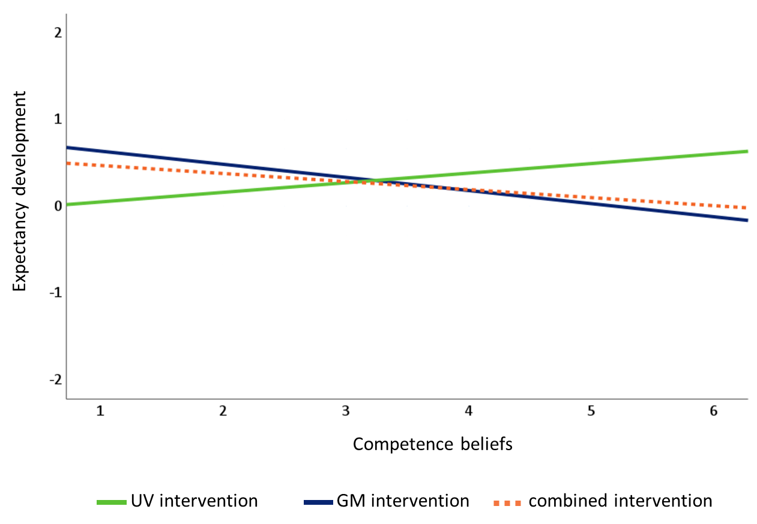
Correlation Between Expectancy Development and Prior Competence Beliefs

Note. UV = utility value, GM = growth mindset. Expectancy development represents the change in expectancies from before to after the intervention. Positive values indicate an increase in expectancies; negative values indicate a decrease.

Figure S4
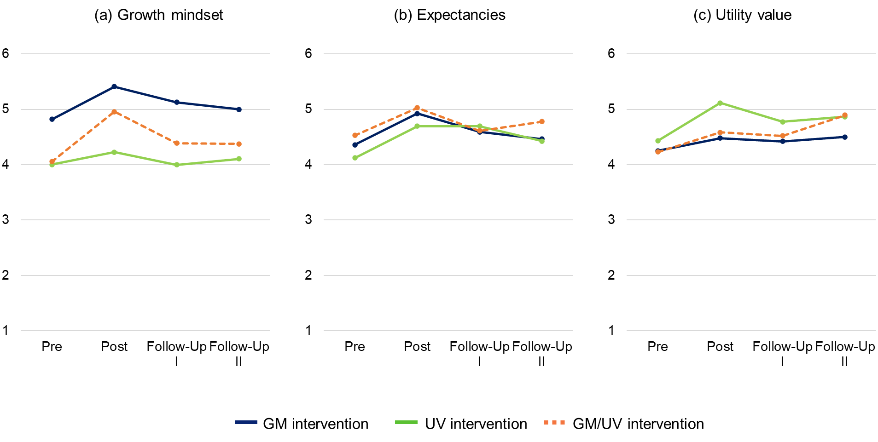
Development of Research-Related Beliefs

Note. GM = growth mindset, UV = utility value, GM/UV intervention = combined intervention. Measurements were taken before (pre), immediately after (post), 8 weeks after (Follow-Up I), and 16 weeks after the intervention (Follow-Up II).

Figure S5
Frequencies in the Selection Task

Note. GM = growth mindset, UV = utility value, GM/UV intervention = combined intervention. Categories ranged from 1 (low science-relatedness) to 5 (high science-relatedness).

