Online Supplement:
Daily leadership behavior and leader well-being: The role of team identification
Table S1
Results from Bayesian Two-Level Model.
 |  | Irritation |  |  |  | Work Engagement
Level 1: Within-leader level |  | β | P | BF |  | β | P | BF
 | Daily transformational leadership | -.00 | .51 | 1.04 |  | .10** | .93 | 12.70
 | Daily positive affect | -.07 | .81 | 4.32 |  | .48** | .99 | > 99
 | Daily negative affect | .40** | .99 | > 99 |  | -.19** | .99 | > 99
Level 2: Between-leader level
 | Transformational leadership | -.04 | .63 | 1.68 |  | .19** | .93 | 13.93
 | L-TID | -.21* | .91 | 9.75 |  | .27 | .95 | 2.28
 | F-TID | -.11 | .82 | 4.41 |  | -.01 | .54 | 1.18
 | Interaction: L-TID x F-TID | .09 | .71 | 2.46 |  | -.08 | .70 | 2.38
 | Cross level Interaction: dTF x L-TID | .14 | .70 | 2.34 |  | .05 | .60 | 1.49
 | Cross level Interaction: dTF x F-TID | -.30* | .86 | 6.04 |  | -.05 | .60 | 1.49
 | Three-way Cross level Interaction: dTF x L-TID x F-TID | .15 | .68 | 2.13 |  | .43** | .96 | 25.32
Notes. Table contains standardized coefficients. L-TID = leader team identification, F-TID = average follower team identification, dTF = daily transformational leadership.
* BF > 6, ** BF > 10.

Figure S1
Three-way cross-level interaction
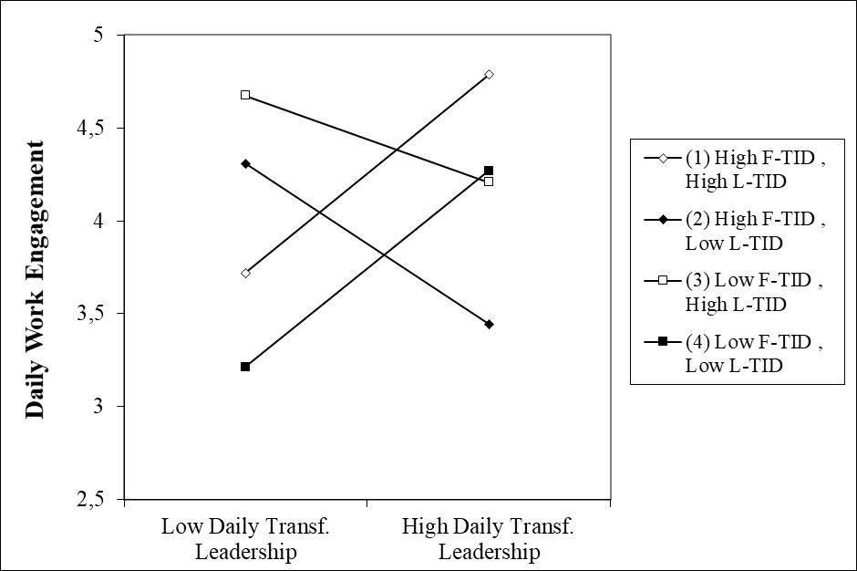
Note. The simple slopes are plotted for +/- 1 standard deviation around the mean of the moderators. L-TID = leader team identification, F-TID = average follower team identification.

