Supplementary material

Supplementary Figure 1. Comparison of Model Predictions in Foreground/Midground/Background

Supplementary Figure 1 shows confusion matrices comparing the performance of CLIP and LLaVA when only considering images where the beverage is contained in the foreground, midground, or background. These results show that LLaVA consistently outperforms CLIP in all cases. Unsurprisingly, they also show that both models perform worse as the beverage is located further away from the camera.

Supplementary Figure 1: Results comparing the performance of CLIP (left) and LLaVA (right) when evaluated in the foreground, midground, and background.
CLIP | LLaVA
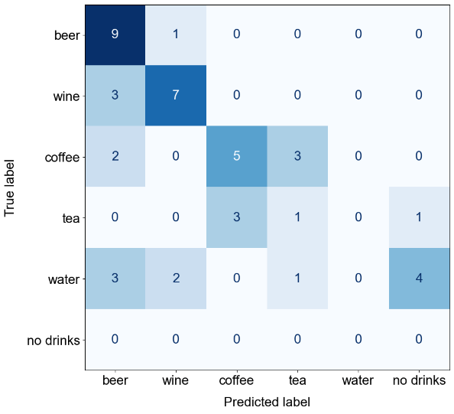  Foreground Accuracy: 48.89% | 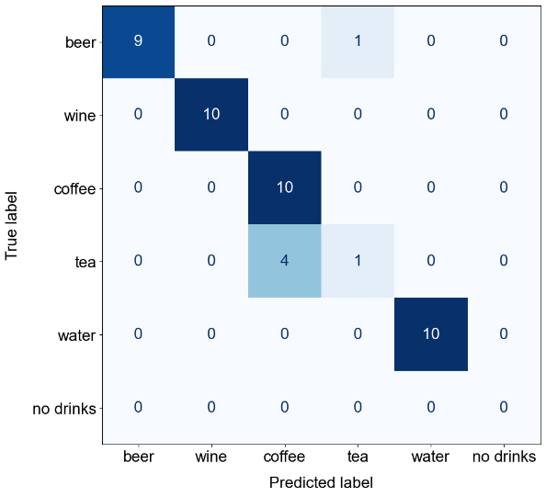  Foreground Accuracy: 88.89%
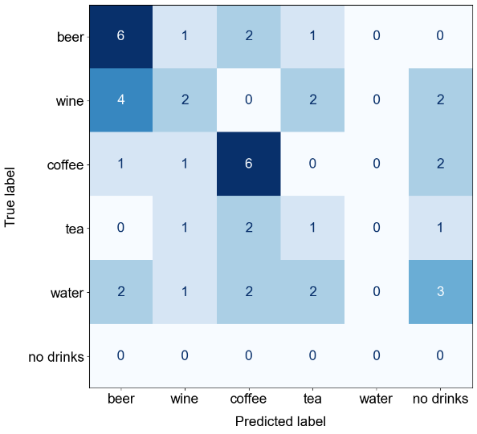  Midground Accuracy: 33.33% | 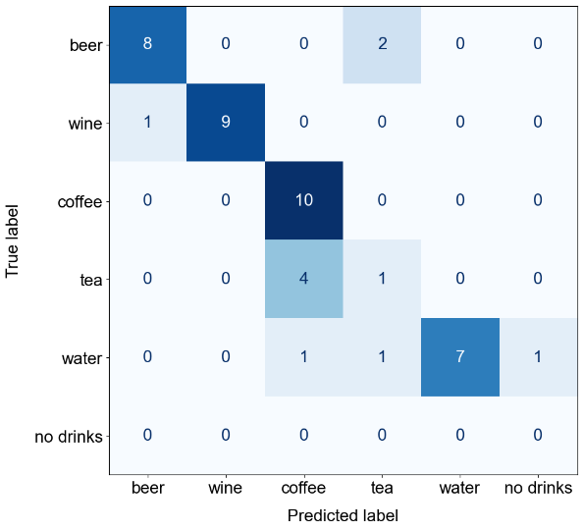  Midground Accuracy: 77.78%
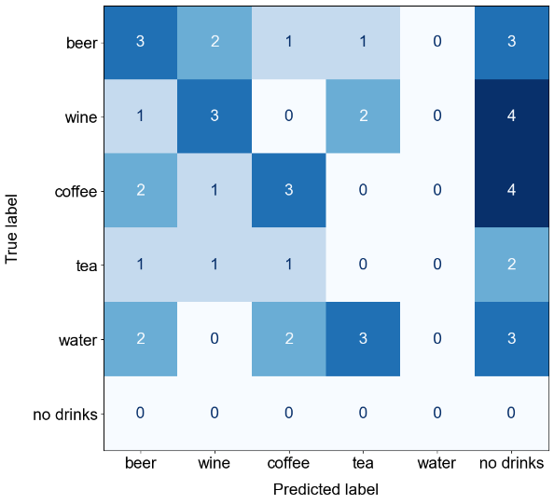  Background Accuracy: 20.00% | 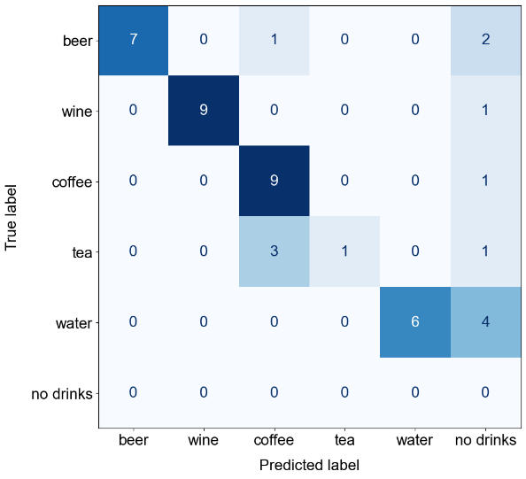  Background Accuracy: 71.11%

Supplementary Figure 2 and 3. Comparison of Model Predictions in Each Location

Supplementary Figure 2 and 3 show the confusion matrices for predictions made by CLIP and LLaVA at each of the indoor and outdoor locations respectively. Consistent with our previous observations, LLaVA consistently outperforms CLIP at each location. Interestingly, CLIP showed unexpected behaviour at specific locations, where it often predicted ‘no drinks’ at two of the indoor locations and mostly predicted ‘beer’ in all images at the location where the first author was sitting on the concrete. This may highlight a bias in CLIP, where the beverage prediction is influenced by the scene of the image.

Supplementary Figure 2: Results comparing the performance of CLIP (left) and LLaVA (right) when evaluated at each of the inside locations.
CLIP | LLaVA
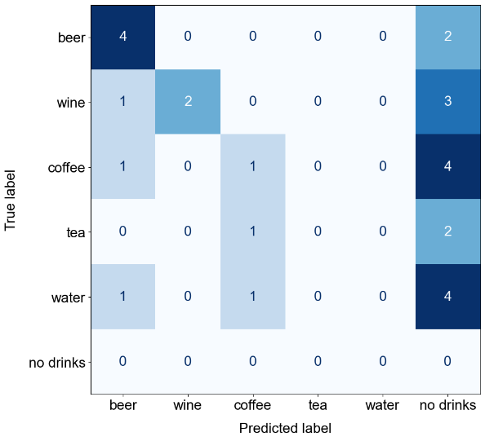  Inside – Neon Lights. Accuracy: 25.93% | 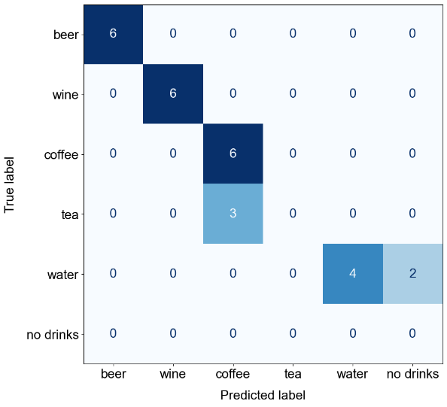  Inside – Neon Lights. Accuracy: 81.48%
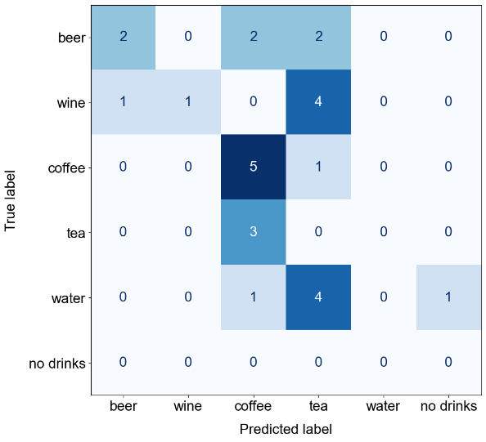  Inside – Office. Accuracy: 29.63% | 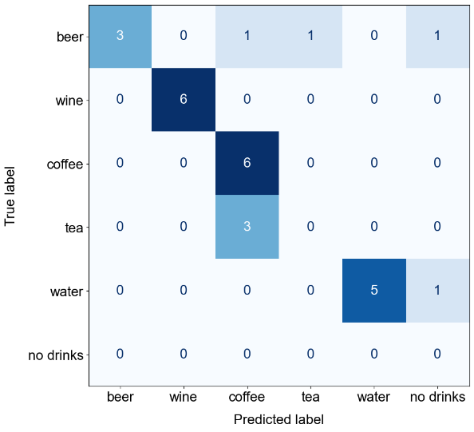  Inside – Office. Accuracy: 74.07%
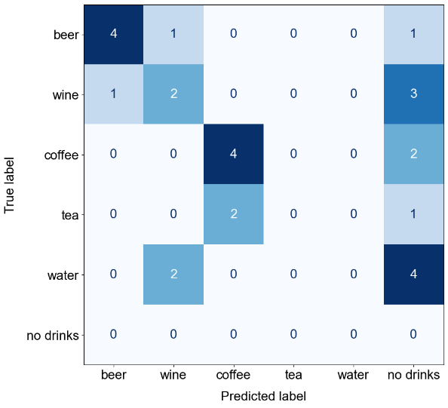  Inside – Couch. Accuracy: 37.04% | 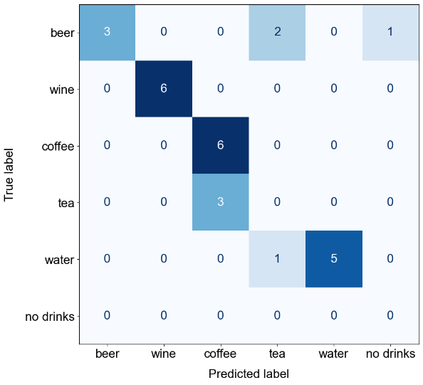  Inside – Couch. Accuracy: 74.07%

Supplementary Figure 3: Results comparing the performance of CLIP (left) and LLaVA (right) when evaluated at each of the outside locations.
CLIP | LLaVA
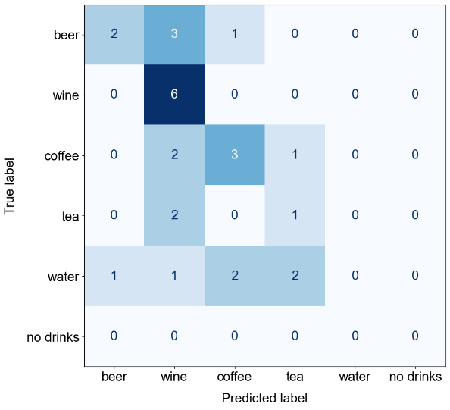  Outside – Chair. Accuracy: 44.44% | 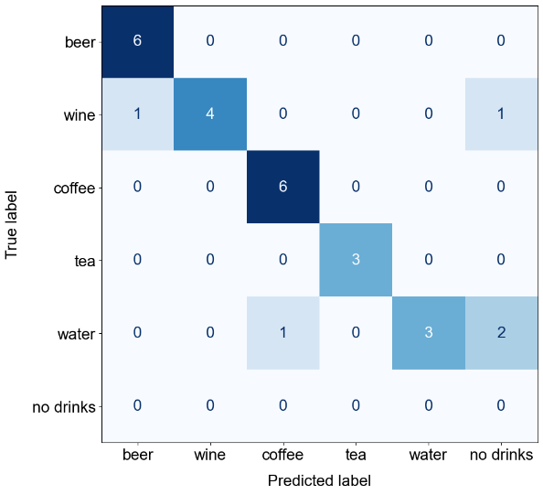  Outside – Chair. Accuracy: 81.48%
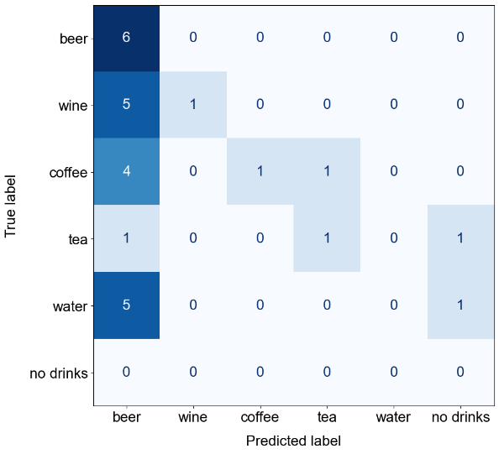  Outside – Concrete. Accuracy: 33.33% | 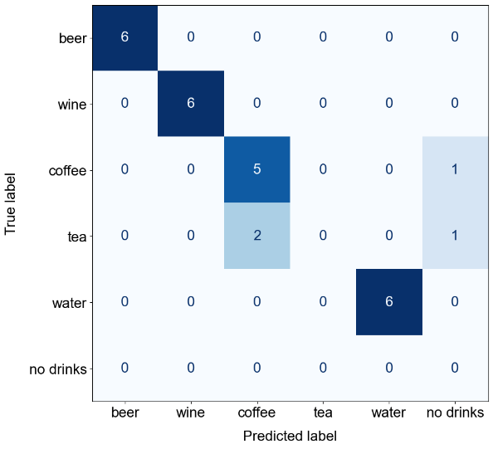  Outside – Concrete. Accuracy: 85.19%

Supplementary Figure 4. Coffee or Tea Prompt Engineering

Supplementary Figure 4 highlights our findings when trying to investigate the similarity between predictions of coffee and tea by the model. The top row shows results when the candidate label/prompt was modified before running the model, for LLaVA the prompt changed to “What type of beverage does this image contain? Pick the most relevant one from this list: beer, wine, coffee/tea, water, none. Restrict your answer to one of these options” and for CLIP we combined the candidate labels for “coffee” and “tea” to “coffee or tea”. The bottom row shows results when combining labels and predictions of coffee or tea after the model was run using the original candidate labels/prompts. In terms of overall accuracy, both approaches yielded the same result for CLIP, however we observed a small boost in accuracy for LLaVA when combining classes as a postprocessing step, rather than changing the prompt.

Supplementary Figure 4: Results comparing the performance of CLIP (left) and LLaVA (right) when either modifying the candidate label/prompt to combine the coffee and tea classes (first row), or using the original results but combining labels and predictions of coffee and tea as a postprocessing step (second row).
CLIP | LLaVA
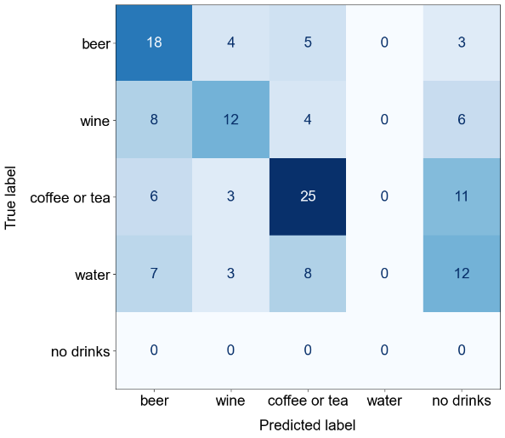  Modify Label. Accuracy: 40.74% | 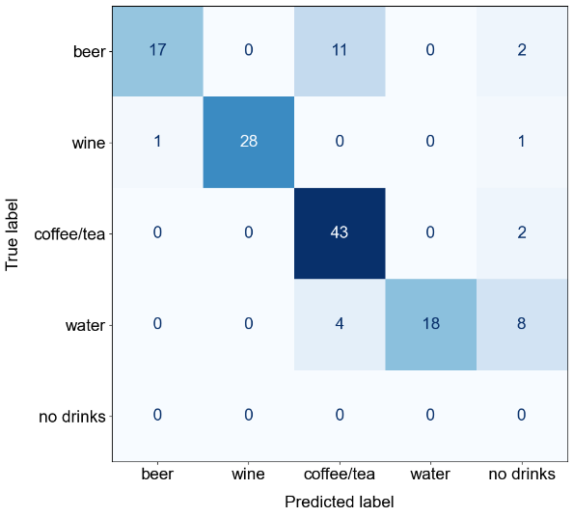  Modify Prompt. Accuracy: 78.52%
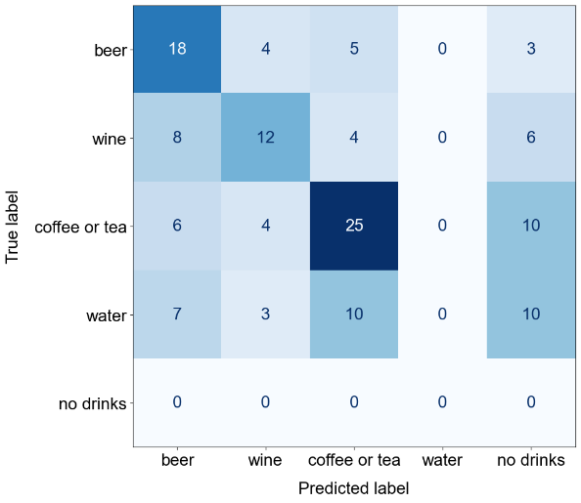  Postprocess Predictions. Accuracy: 40.74% | 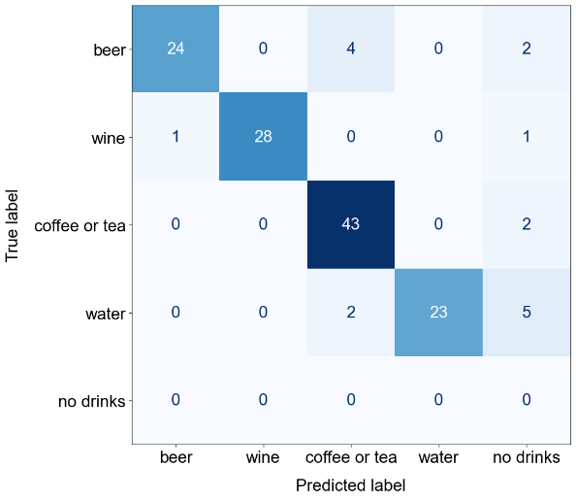  Postprocess Predictions. Accuracy: 87.41%

Supplementary Figure 5: Prompt Engineering

To further investigate the impact of different sets of candidate labels or prompts for CLIP and LLaVA, we performed prompt engineering (see the “Prompt Engineering (optional)” section of the notebook). Supplementary Figure 5 presents the results, showing that more descriptive labels led to better performance for CLIP. For LLaVA, prompting it to choose a beverage from a concise list produced better results than providing a more exhaustive list of beverage types and their receptacles.

Supplementary Figure 5: Results following prompt engineering for CLIP (top) and LLaVA (bottom).
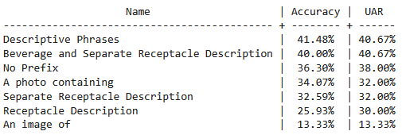
CLIP Prompt Engineering Results
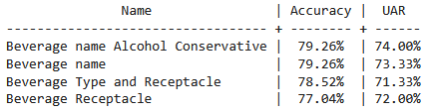
LLaVA Prompt Engineering Results

Supplementary Figure 6. CLIP Water Prompt Engineering

To further explore why CLIP did not predict the water beverage class, and investigate our hypothesis that CLIP might have been associating “a photo containing water” to an ocean or lake, we experimented with two other candidate labels to represent the water class. Namely, “a photo containing a cup of water”, and “a photo containing a bottle of water”. Code in the “Prompt Engineering (optional)” section of the notebook can be modified to reproduce this analysis. Using these different candidate labels resulted in instances where CLIP did correctly predict images containing water (Supplementary Figure 6). This finding highlights the importance of exploration and engineering of labels and prompts when using these zero-shot learning models.

Supplementary Figure 6: Results showing the performance of CLIP when experimenting with updating the water label to either “cup of water” (left), or “bottle of water” (right).
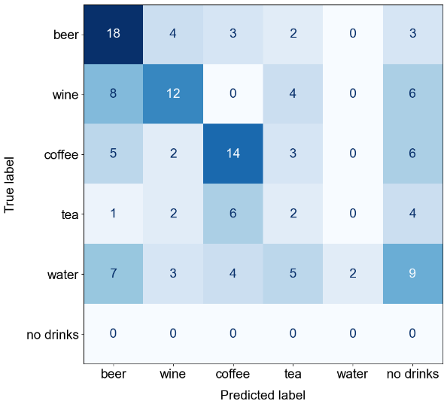  Accuracy: 35.56% | 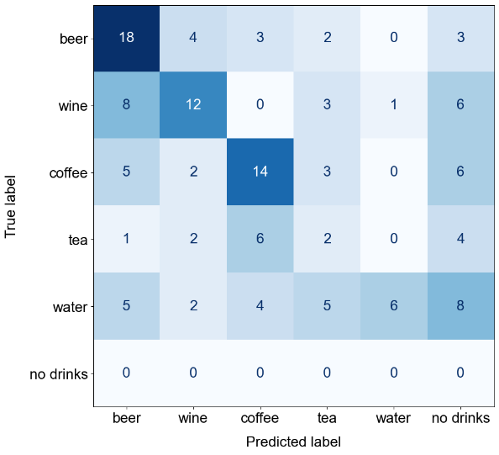  Accuracy: 38.52%

