SPSS Scripts
SPSS Script 1. Data from EXCEL (“ *.xlsx") to SPSS format (“ *.rds”) and viceversa

SPSS Script 1a. From EXCEL to SPSS

/* With SPSS syntax:
/* 1st.- Read the EXCEL file “P48.xlsx”, in:
/* 'C:\[Your file path]\P48.xlsx':
GET DATA
/TYPE=XLSX
/FILE='C:\[Your file path]\P48.xlsx'.
EXECUTE.

/* 2nd.- Save the file as “P48.sav” SPSS format:
SAVE OUTFILE='C:\[Your file path]\P48.sav'.

/* Your data is now in SPSS and you can start using it for your analysis

/* With SPSS windows:
/* 1st.- Alternatively, you can do it with the SPSS Import Wizard: SPSS has a windows user interface, for importing data from Excel files. This can be accessed through the menu: File > Open > Data..., and then selecting your Excel file:
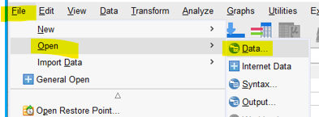

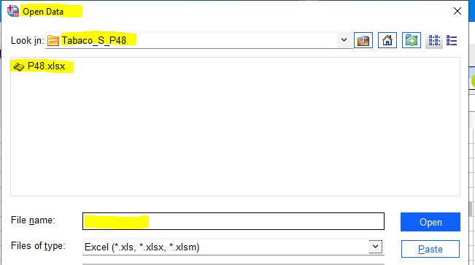

/* You will see the EXCEL file with a SPSS format, with a ‘Data View’ and another ‘Variable View’ window, in addition to the first 'Overview' window on the bottom left part of the screen:
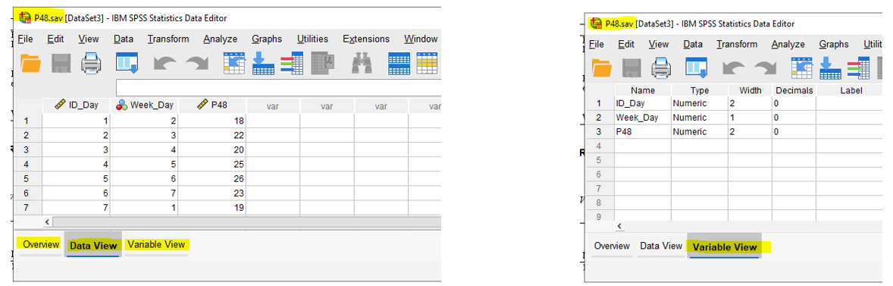

/* 2nd.- After that, you can save the file with SPSS format: File > Save As >...:
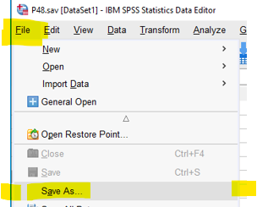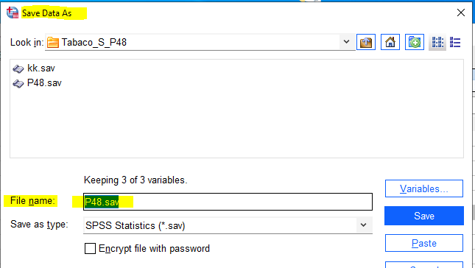

SPSS script 1b. From SPSS file to EXCEL
/* Run the instruction:
SAVE TRANSLATE /TYPE=CSV /OUTFILE='C:\[Your file path]\P48.csv'.

/* We have saved as “*.csv” file (defined by commas) because the “*xlcl” format gives some edition problems, it is easy to save the “P48.csv” file to “P48.xlcl” file.

/* Or alternatively, in Windows, having the file ‘P48.sav' opened: File > Save As >. . .
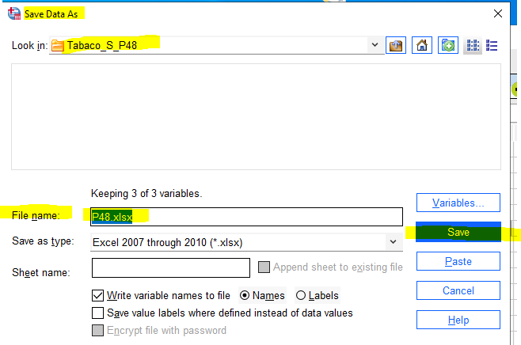

SPSS Script 2. Figures 1 and 2
SPSS Script 2a. Figure 1, ‘spaghetti’ line
/* 1st.- The basic syntax is:
GRAPH
/LINE(SIMPLE)=VALUE(P48) BY ID_Day.
/* 2nd.- After this, it is necessary to modify the figure using windows options

SPSS Script 2b. Figure 2, Mean±1.96 SD of smoked cigarettes by each day of the week
/* 1st.-
GRAPH
/ERRORBAR(STDDEV 1.96)=P48 BY Week_Day.
/* 2nd.- After this, it is necessary to modify the figure using some windows options

SPSS script 3. ACF and PACF figures of P48 raw data
/* 1st.- Check that you have in your SPSS package the module “Forecasting”, for that, navigate in your SPSS:
> Analyze > Forecasting > Autocorrelation:
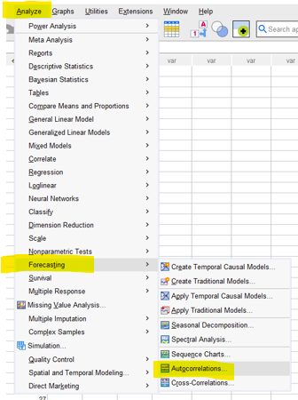
/* 2nd.- Run the syntax:
ACF VARIABLES=P48
/NOLOG /* Indicates that the data are not transformed
/MXAUTO 21 /* We recommend at least3 seasons (3*7 = 21 lags, or days)
/SERROR=IND /* It calculates the standard error.
/PACF.
/* 3th.- By default, SPSS does the ACF and PACF figures, and print the respective values, from 1 to 21, because we wrote “/MXAUTO 21”.
/* 4th.- By default, SPSS calculates the Ljung-Box values

SPSS Script 4. Ljung-Box and Augmented Dickey-Fuller tests
SPSS Script 4a. Ljung-Box test
/* By default, the Ljung-Box test is calculated with the ACF and PACF syntax, SPSS Script 3.
SPSS Script 4b. Augmented Dickey-Fuller tests
/* Note.- We do not have the SPSS “Modeler” module, but instructions for performing the ADF test are given below:
/* 1st.- Check that you have in your SPSS package the module “Modeler”, for that: > Analyze > Forecasting > Stationarity and Cointegration Tests:
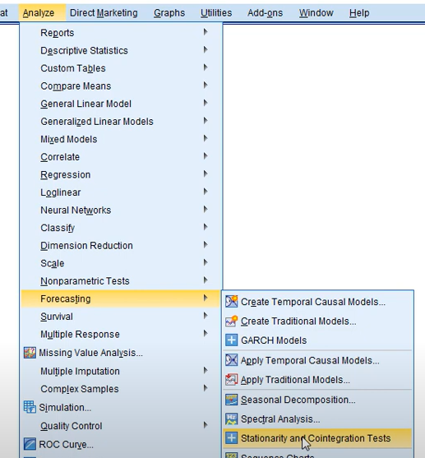

/* 2nd.- Run the syntax:
STATS TSTESTS VARIABLE = P48
/ADF ALTHYPOT = STATIONARY LAGORDER = 7. /* ¹

/* ¹ The ‘LAGORDER = 7’ is the time series seasonality, 7 days.

SPSS Script 5. Scatterplots, Figure 4
/* 1st.- Generate lagged variables:
CREATE
/P48_1=LAG(P48 1)/P48_7=LAG(P48 7)/P48_14=LAG(P48 14).

/* 2nd.- Draw scatterplots
GRAPH
/SCATTERPLOT(BIVAR)=P48_1 WITH P48 /* IV: P48_1; DV: P48
/MISSING=LISTWISE.

GRAPH
/SCATTERPLOT(BIVAR)=P48_7 WITH P48
/MISSING=LISTWISE.

GRAPH
/SCATTERPLOT(BIVAR)=P48_14 WITH P48
/MISSING=LISTWISE. /* ¹

/* ¹ Each scatter plot is in a separate frame; you can use a graphic processor for configurate the Figure 4.

SPSS Script 6. Time series regression with TSMODEL module
SPSS Script 6a. With ordinary least squares (OLS)
It is not possible to get OLS estimation with the TSMODEL module, it is necessary to do the analysis with the default option, maximum likelihood (ML.

SPSS Script 6b. ARIMA(1,0,0)(2,0,0)₇ TSs procedure with ML
/* 1st.- Open “P48.sav” data file (refer to SPSS Scripts 1a and 1b) or: File > Open > Data…
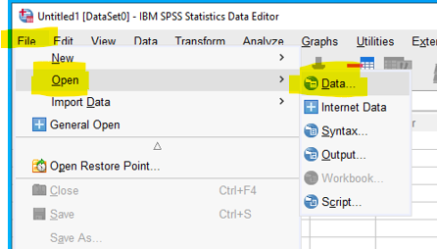

/* Next:
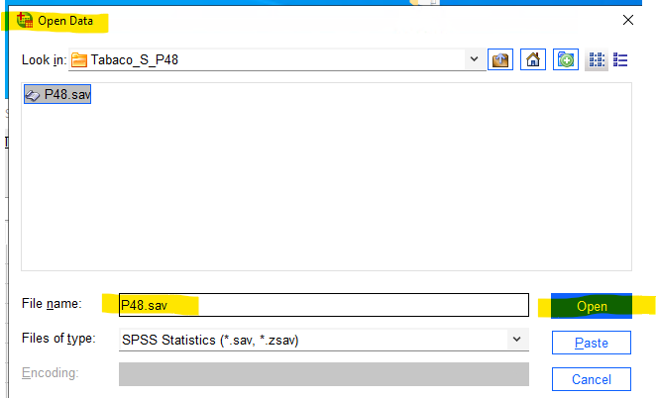

/* Now:
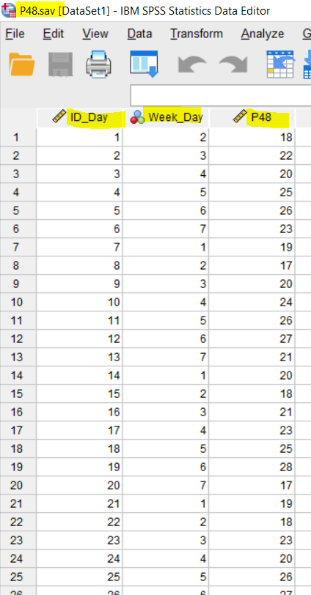

/* 2nd.- Creating Seasonality:

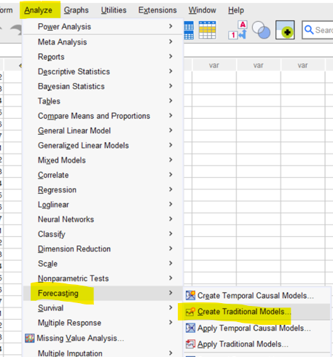

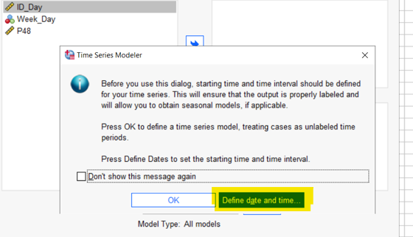

/* Since the record begins on a Tuesday, the 2nd day of the week, select ‘Day 2’.
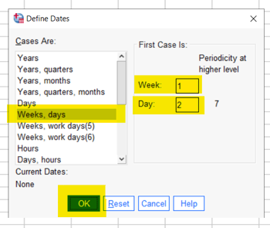

/* In the ‘Data View’, you will see:
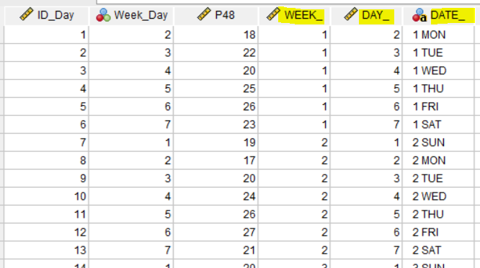

/* This indicates that SPSS has generated new variables: ‘Week_’, ‘DAY_’, and ‘DATE_’. The variables might not clearly identify the day of the week, but if you click on:
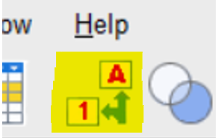
/* this action updates the numbers to display their corresponding labels.

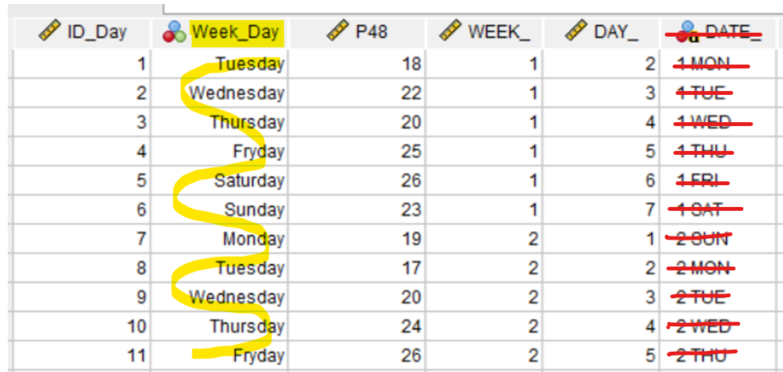
/* notice that the variable 'DATE_' generated by SPSS is wrong, the first day of registration was a Tuesday, not a Monday.

* 3rd.- Analyzing Parameters
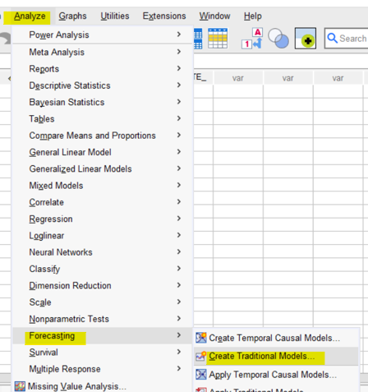

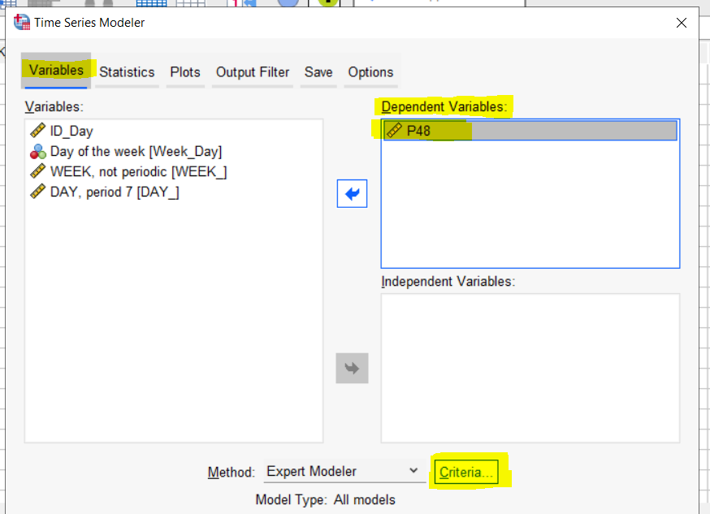
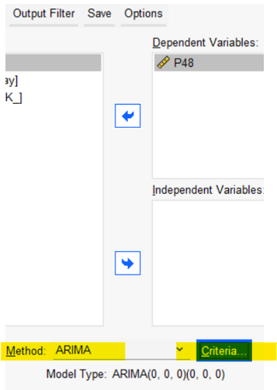

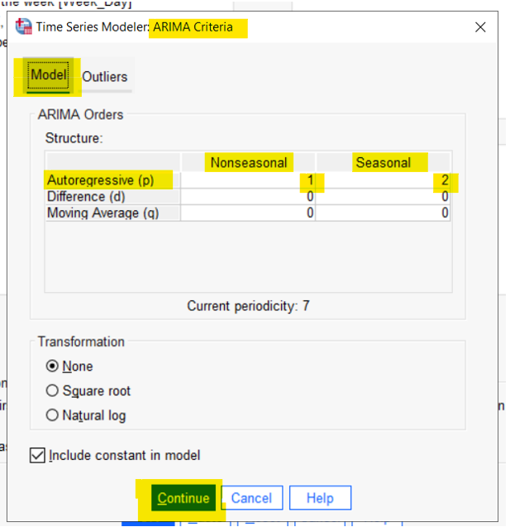

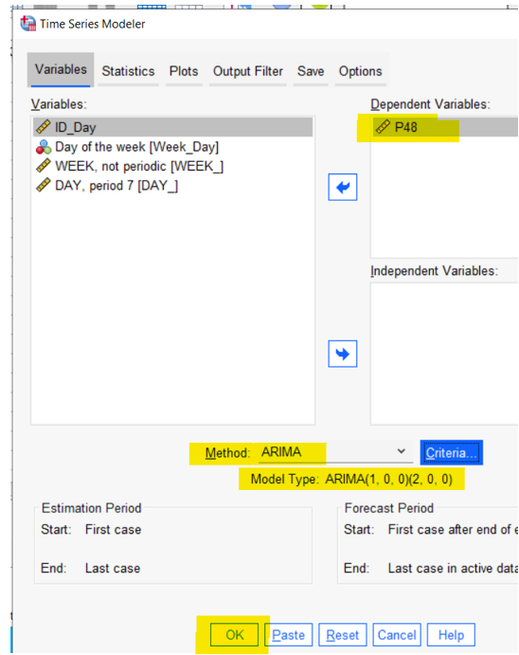

/* To obtain the syntax, click ‘Paste’ in the previous image.

/* The syntax:
TSMODEL
/MODELSUMMARY PRINT=[MODELFIT]
/MODELSTATISTICS DISPLAY=YES MODELFIT=[SRSQUARE RSQUARE]
/MODELDETAILS PRINT=[PARAMETERS]
/SERIESPLOT OBSERVED FORECAST
/AUXILIARY CILEVEL=95
/MISSING USERMISSING=EXCLUDE
/MODEL DEPENDENT=P48
PREFIX='Model'
/ARIMA AR=[1] DIFF=0 MA=[0] ARSEASONAL=[1,2] DIFFSEASONAL=0 MASEASONAL=[0]
TRANSFORM=NONE CONSTANT=YES.
/* It is very important to write ARSEASONAL=[1,2] to obtain parameters corresponding to Y_{t-7} and Y_{t-14}. If you write ARSEASONAL=[2], you will only get the parameter corresponding to Y_{t-14}.

SPSS Script 6c. AR(1, 7, 14) TSs procedure with ML
/* 1st.- Open “P48.sav” data (SPSS Scripts 1a and 1b) or:
File > Open > Data…, continue as in SPSS Script 6b.

/* 2nd.- Analysis of parameters
TSMODEL
/MODELSUMMARY PRINT=[MODELFIT] /* Model fit summary
/MODELSTATISTICS DISPLAY=YES MODELFIT=[SRSQUARE RSQUARE RMSE NORMBIC] /* Key model statistics
/MODELDETAILS PRINT=[PARAMETERS RESIDACF RESIDPACF] /* Detailed model parameters and diagnostics
/SERIESPLOT OBSERVED FORECAST /* Plot observed vs. forecasted values
/OUTPUTFILTER DISPLAY=ALLMODELS /* Display settings for model output
/SAVE PREDICTED(Pre) NRESIDUAL(Res) /* Saving Pre and Res
/AUXILIARY CILEVEL=95 MAXACFLAGS=24 /* Auxiliary settings like confidence level
/MISSING USERMISSING=EXCLUDE /* Handling of missing data
/MODEL DEPENDENT=P48 /* 3rd.- Define DV and fit the ARIMA model
PREFIX='Model' /* Define the model prefix
/ARIMA AR=[1, 7, 14] DIFF=0 MA=[0] ARSEASONAL=[0] DIFFSEASONAL=0 MASEASONAL=[0] /* AR(1, 7, 14)
TRANSFORM=NONE CONSTANT=YES /* ARIMA model specification
/AUTOOUTLIER DETECT=OFF. /* Outlier detection settings: no

SPSS Script 7. Lagging 1, 7 and 14 rows the variable P48, inside the file “P48.sav", saving the data in “P48_lagd.sav"

/* 1st.- Open “P48.sav” data (SPSS Scripts 1a and 1b)
/* 2nd.- Create lag variables P48_1, P48_7 and P48_14:
CREATE
/P48_1=LAG(P48 1)
/P48_7=LAG(P48 7)
/P48_14=LAG(P48 14).
/* you will see on “P48.sav” data the configuration of values as in Figure 5b.
/* now, save the file with the name “P48_lagd.sav".

/* or alternatively, WITH SYNTAX, you can save the file:
SAVE OUTFILE = 'C:\[Your file path]\P48_lagd.sav'. /* Important, if you want to save the same file, overwriting it, you must write only: SAVE = …; but if you want to save data in a new file, without modifying the original file (“P48.sav”), you must write: SAVE OUTFILE = …

SPSS Script 8. Forecasted and residual values from Table 2 equation
SPSS Script 8a. Forecasted values from Table 2 equation
/* 1st.- Opening file “P48.sav”,
/* you can estimate the forecasted values (Table 2):
/* Y_{t}’ = b₀ + b₁Y_{t-1} + b₂Y_{t-7} + b₃Y_{t-14}, or with the name of the variables in the datafiles:
/* P48’= 23.179 + .061·P48_1 + .465·P48_7 + .329·P48_14
/* so, if you press: > Transform > Compute Variable > …
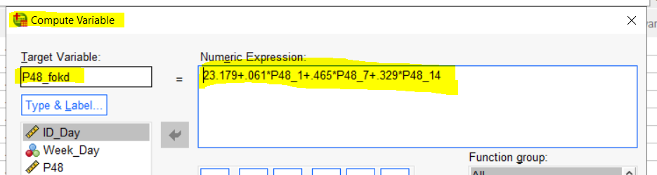

/* After that, press ‘OK’:
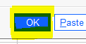
/* You will see the new variable ‘P48_fokd’ in your data file, with the forecasted values from Table 2 equation,
/* and you can check that these values are very different from the other forecasted values (TS and OLS with R, and OLS with SPSS).

/* or alternatively, you can write on the SPSS file syntax:
COMPUTE P48_fokd=23.179+.061*P48_1+.465*P48_7+.329*P48_14. /* Equation forecasted
VARIABLE LABELS P48_fokd 'P48 forecasted agree Table 2 equation'. /* Label added to the variable ‘P48_fokd’
EXECUTE.

/* Observe that we have denominated to the new variable: ‘P48_fokd’ (or: P48 forecasted), and observe the new label ('P48 forecasted agree Table 2 equation').

SPSS Script 8b. Residual values from Table 2 equation
/* once we have forecasted values in variable ‘P48_fokd’, and because Y= Y’ + e, e = Y-Y’, if our residual is named ‘P48_rsdl’:
/* P48_rsdl = P48 - P48_fokd,
/* if you press: > Transform > Compute Variable > …
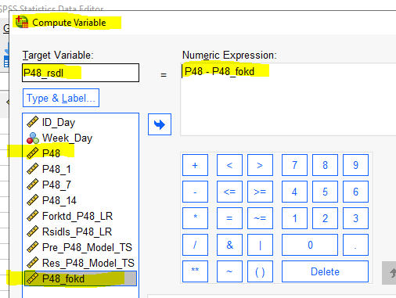
/* After that, press ‘OK’.
/* You will see on the datafile “P48_overall.sav” all the variables we are used

/* or alternatively, you can write on the SPSS file syntax:
COMPUTE P48_rsdl= P48 - P48_fokd.
EXECUTE.

/* Save the file with the P48 original data, forecasted and residual values, with name “P48_TS_Tbl2.sav”:
/* In windows: File > Save As…
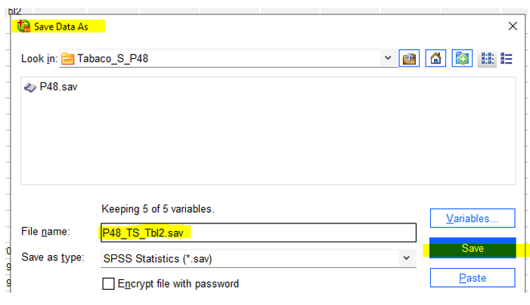

/* or alternatively, you can write on the SPSS file syntax:
SAVE OUTFILE = 'C:\[Your file path]\P48_TS_Tbl2.sav'.

SPSS Script 9. Linear regression with lagged values, plus saved forecasted and residual values

SPSS Script 9a. Linear regression
/* 1st.- Open “P48_lagd.sav” data (SPSS Scripts 1a and 1b)
/* 2nd.- Run the syntax:
REGRESSION
/MISSING LISTWISE /*deleting incomplete line of variables used
/STATISTICS COEFF OUTS R ANOVA /* overall fit indexes
/CRITERIA=PIN(.05) POUT(.10) TOLERANCE(.0001) /* technical details of estimation
/NOORIGIN /* with intercept value
/DEPENDENT P48 /* DV: P48
/METHOD=ENTER P48_1 P48_7 P48_14 /* IVs: P48_1 P48_7 P48_14
/SAVE PRED RESID. /* printing forecasted and residual values inside the file

/* By default, writing the syntax /SAVE PRED RESID , you will see 2 new variables in the file, ‘PRE_1’ and ‘RES_1’, into ‘Variable View’ window:
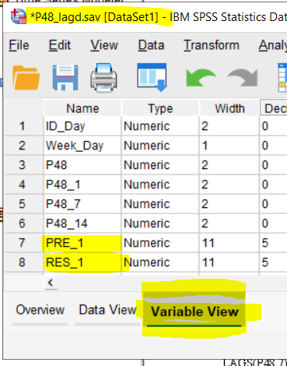

SPSS Script 9b. Renaming and saving forecasted and residual values. Saving the new file
/* 1st.- (You can rename the variables from the ‘Variable View’ window, deleting and overwriting PRE_1 ==> Forktd_P48, and RES_1 ==> Rsids_P48,
/* or write the syntax):
RENAME VARIABLES (PRE_1 = Forktd_P48) (RES_1 = Rsids_P48).
EXECUTE. /* it changes the name of the variable ‘PRE_1’ in ‘Forktd_P48’, and it renames ‘RES_1’ in ‘Rsids_P48’,

/* you will see:

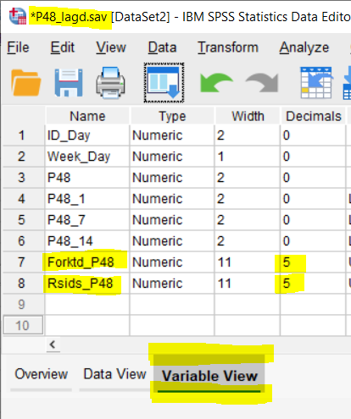

/* 2nd.- Change manually, in the ‘Variable View’ window, the number of decimals, from 5 (by default) to 3, in variables ‘Forktd_P48’ and ‘Rsids_P48’, now, you will get:

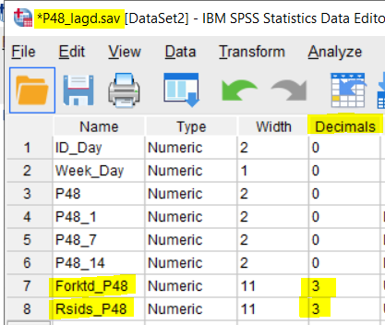

/* 3rd.- Save the updated dataset to a new file “P48_lagd_lin_reg.sav”, in windows: File > Save As > ...
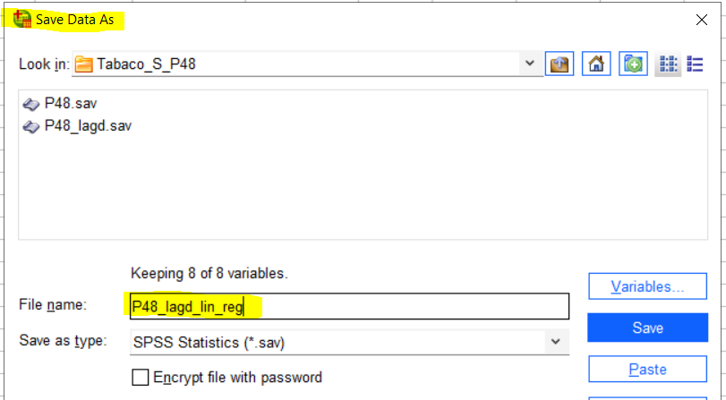

/* or write the syntax:
SAVE
OUTFILE='C:\[Your file path]\P48_lagd_lin_reg.sav'
/COMPRESSED.

/* We see on the screen:
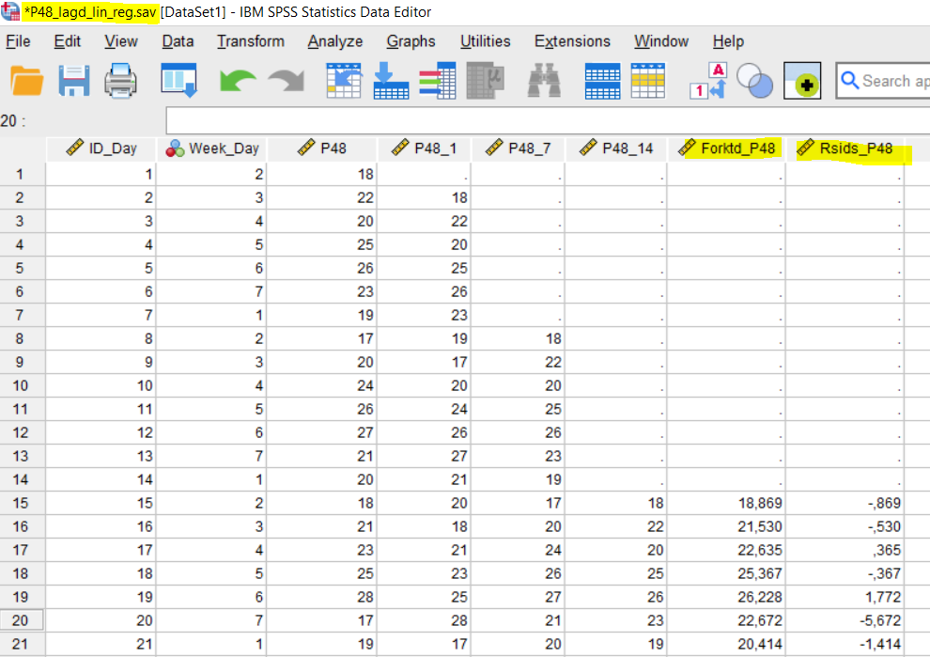
/* Observe that the forecasted and the residual values are the same as in Figure 5c.

SPSS Script 10. ACF and PACF figures of ‘Rsids_P48’ variable in “P48_lagd_lin_reg.sav”

/* 1st. – Check that you have opened the file “P48_lagd_lin_reg.sav”
/* 2nd. - Run the syntax:
ACF VARIABLES= Rsids_P48
/NOLOG /* Indicates that the data are not transformed
/MXAUTO 21 /* We recommend at least3 seasons (3*7 = 21 lags, or days)
/SERROR=IND /* It calculates the standard error.
/PACF.

/* 3th. - By default, SPSS does the ACF and PACF figures, and print the respective values, from 1 to 21, because we wrote “/MXAUTO 21”
/* 4th. - After this, it is convenient to modify the figure using windows options
/* 5th. - By default, SPSS calculates the Ljung-Box values

SPSS Script 11. Ljung-Box, Shapiro-Wilk and Breusch-Pagan tests of residuals of P48
SPSS Script 11a. Ljung-Box ACF and PACF
/* By default, the Ljung-Box test is calculated with the ACF and PACF syntax, SPSS Script 10.
SPSS Script 11b. Shapiro-Wilks test of normality
/* 1st. – Check that you have opened the file “P48_lagd_lin_reg.sav”
/* 2nd. - Run:
EXAMINE VARIABLES = Rsids_P48
/PLOT BOXPLOT STEMLEAF NPPLOT. /* Generate figures to aid with the analysis, and normality statistics
/* You get a lot of information on the variable Rsids_P48.

SPSS Script 11c. Breusch-Pagan test of homoscedasticity
/* 1st. – Check that you have opened the file “P48_lagd_lin_reg.sav”
/* 2nd. - Run:

UNIANOVA Rsids_P48 BY Week_Day /* ANOVA procedure
/METHOD=SSTYPE(3) /* Type of sums of squares
/INTERCEPT=INCLUDE
/PRINT MBP /* Modified B-P test
/MBPDESIGN=Week_Day /* The design (IV)
/CRITERIA=ALPHA(.05) /* The significance level
/DESIGN=Week_Day. /* The B-P test model (IV: Week_Day)

SPSS Script 12. Straight line regression, IV: time (ID_Day), DV: P48

SPSS Script 12a. Linear regression
/* 1st.- Open “P48_lagd.sav” data (SPSS Scripts 1a and 1b)
/* 2nd.- Run the syntax:
REGRESSION /* (1)
/MISSING LISTWISE
/STATISTICS COEFF OUTS R ANOVA
/CRITERIA=PIN(.05) POUT(.10) TOLERANCE(.0001)
/NOORIGIN
/DEPENDENT P48
/METHOD=ENTER ID_Day
/SAVE PRED RESID.
/* (1). Refer to 'SPSS Script 9a. Linear regression' for syntax explanation
/* Change the name of the residuals from the previous regression equation from 'RES_1' to 'RS_Reg_ID_Day'
/* Assign a new label to the variable 'RS_Reg_ID_Day', defining it as 'Residuals of P48 = b0 + b1·ID_Day'.
/* You will see in “Variable View”:
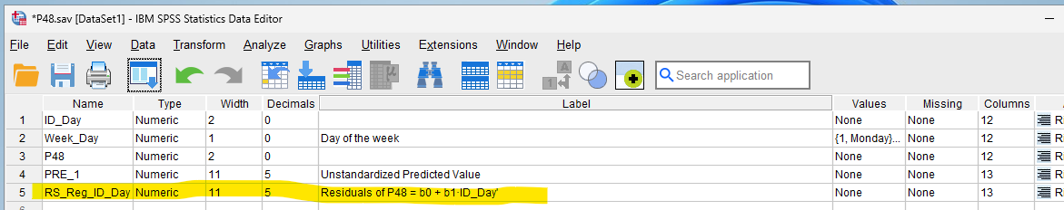

SPSS Script 12b. Residual analysis. ACF and PACF figures of 'RS_Reg_ID_Day'
/* 1st.- Run the syntax:
ACF VARIABLES=RS_Reg_ID_Day /* (2)
/NOLOG
/MXAUTO 21
/SERROR=IND
/PACF.

/* (2). Refer to 'SPSS Script 10. ACF and PACF figures’ for syntax explanation

/* You can observe than residuals are not ‘white noise’: (a) a lot of residuals are significant, and (b) The L&B test for 21 lags yields χ²= 197.458, 21df, p < .001 (not ‘white noise’)

