S6. Figures of RMSE of the estimated path coefficients, indirect effects, and pooled correlations
Figure 1. RMSE of ${\hat{β}}_{MX}$ in the 54 conditions when converting Cohen’s d with the four conversions
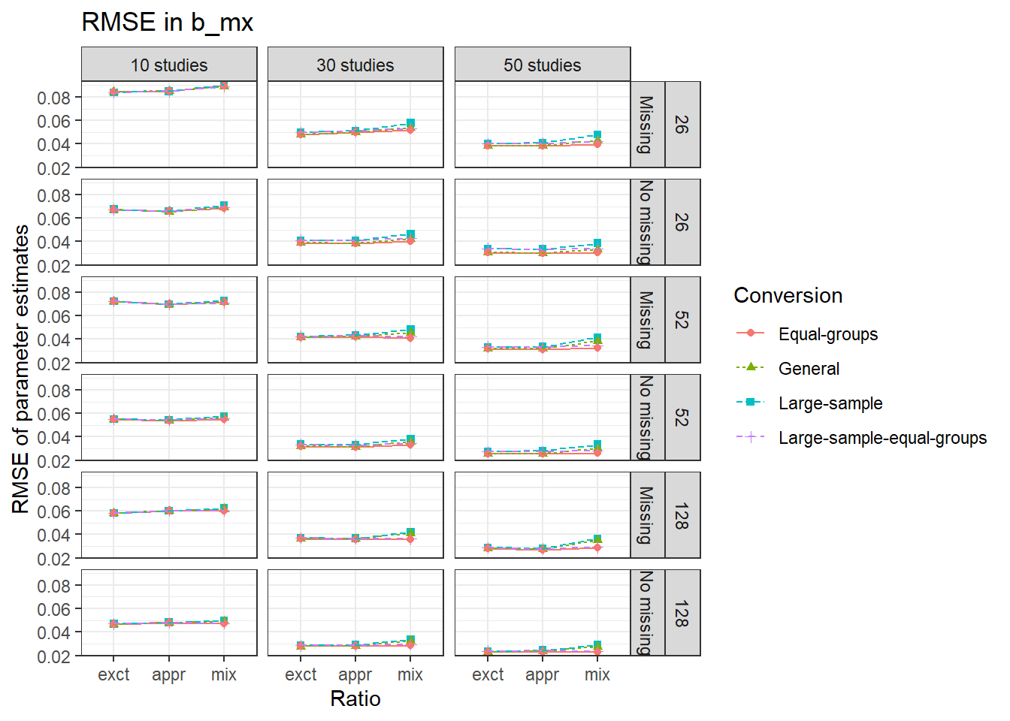
Note. Abbreviations exct, appr, mix on the x-axis represent exact, approximate, and mixed condition, respectively. The numbers 26, 52, and 128 on the right side denote the within study sample sizes.

Figure 2. RMSE of ${\hat{β}}_{YX}$ in the 54 conditions when converting Cohen’s d with the four conversions
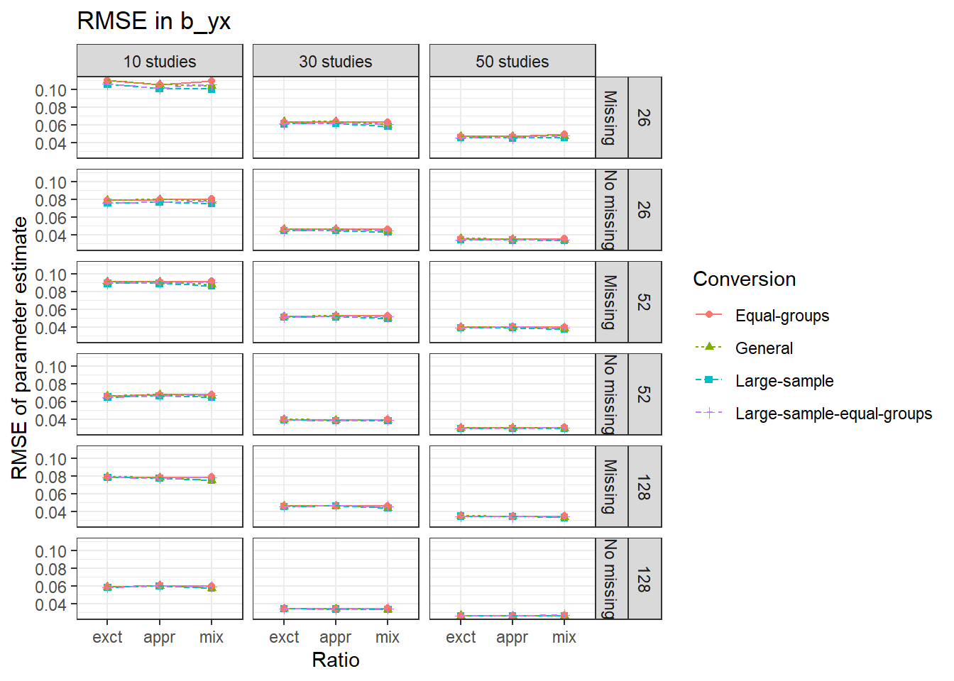
Note. Abbreviations exct, appr, mix on the x-axis represent exact, approximate, and mixed condition, respectively. The numbers 26, 52, and 128 on the right side denote the within study sample sizes.

Figure 3. RMSE of ${\hat{β}}_{YM}$ in the 54 conditions when converting Cohen’s d with the four conversions

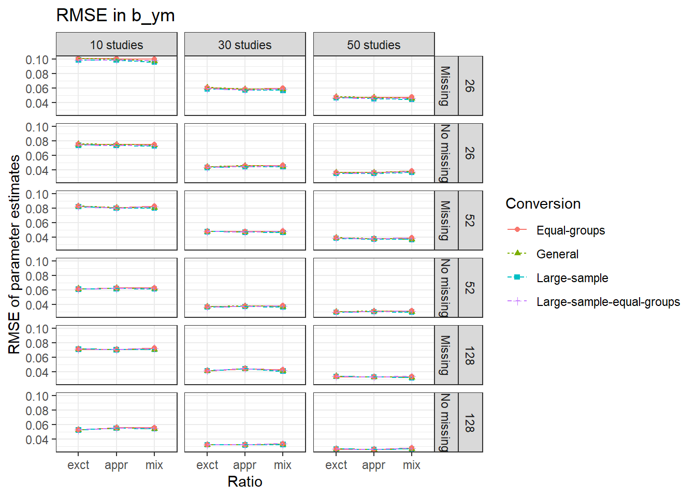
Note. Abbreviations exct, appr, mix on the x-axis represent exact, approximate, and mixed condition, respectively. The numbers 26, 52, and 128 on the right side denote the within study sample sizes.

Figure 4. RMSE of the estimate of the indirect effect in the 54 conditions when converting Cohen’s d with the four conversions
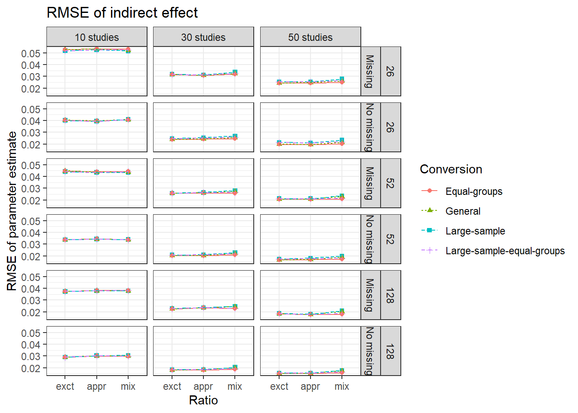
Note. Abbreviations exct, appr, mix on the x-axis represent exact, approximate, and mixed condition, respectively. The numbers 26, 52, and 128 on the right side denote the within study sample sizes.

Figure 5. RMSE of ${\hat{β}}_{MX}$ in the 54 conditions when converting Hedges’ g with the four conversions

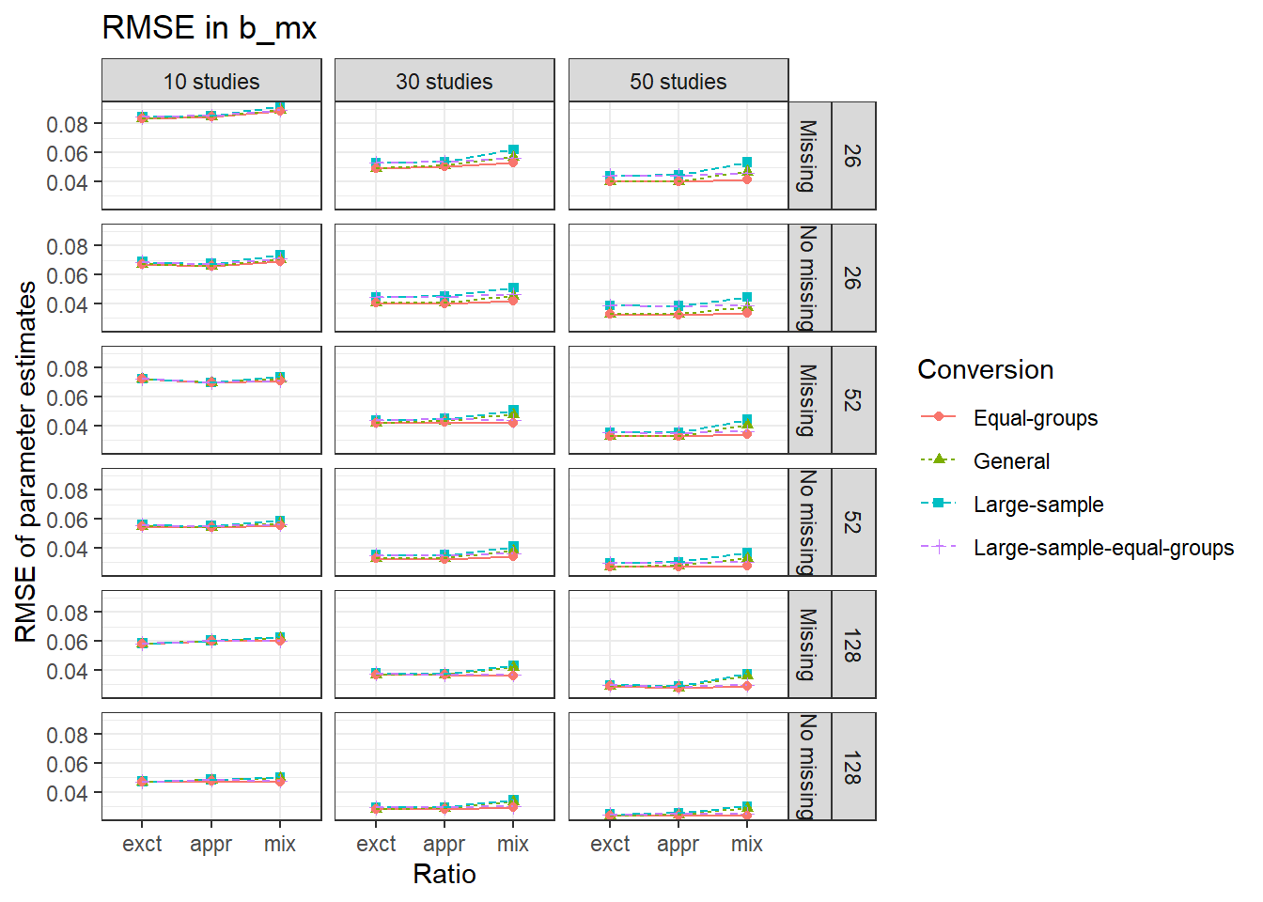
Note. Abbreviations exct, appr, mix on the x-axis represent exact, approximate, and mixed condition, respectively. The numbers 26, 52, and 128 on the right side denote the within study sample sizes.

Figure 6. RMSE of ${\hat{β}}_{YX}$ in the 54 conditions when converting Hedges’ g with the four conversions
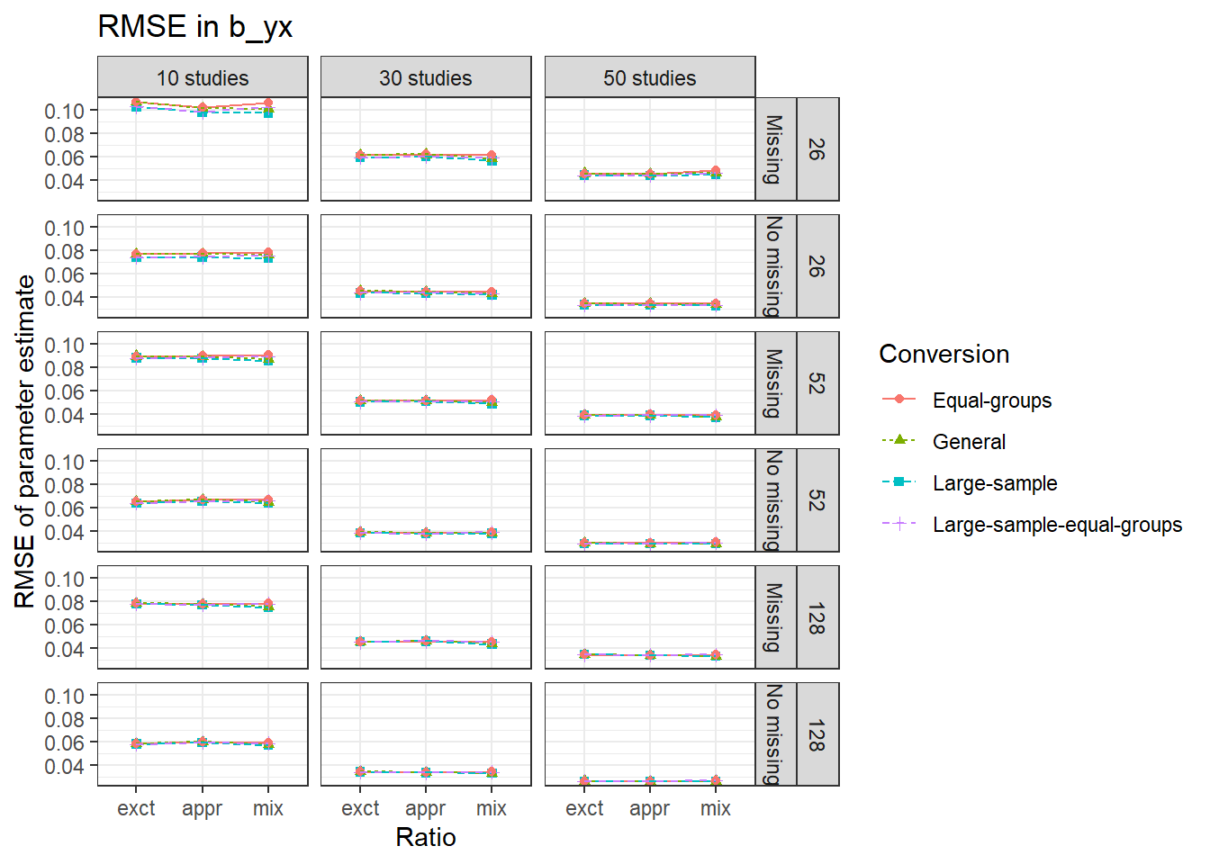
Note. Abbreviations exct, appr, mix on the x-axis represent exact, approximate, and mixed condition, respectively. The numbers 26, 52, and 128 on the right side denote the within study sample sizes.

Figure 7. RMSE of ${\hat{β}}_{YM}$ in the 54 conditions when converting Hedges’ g with the four conversions
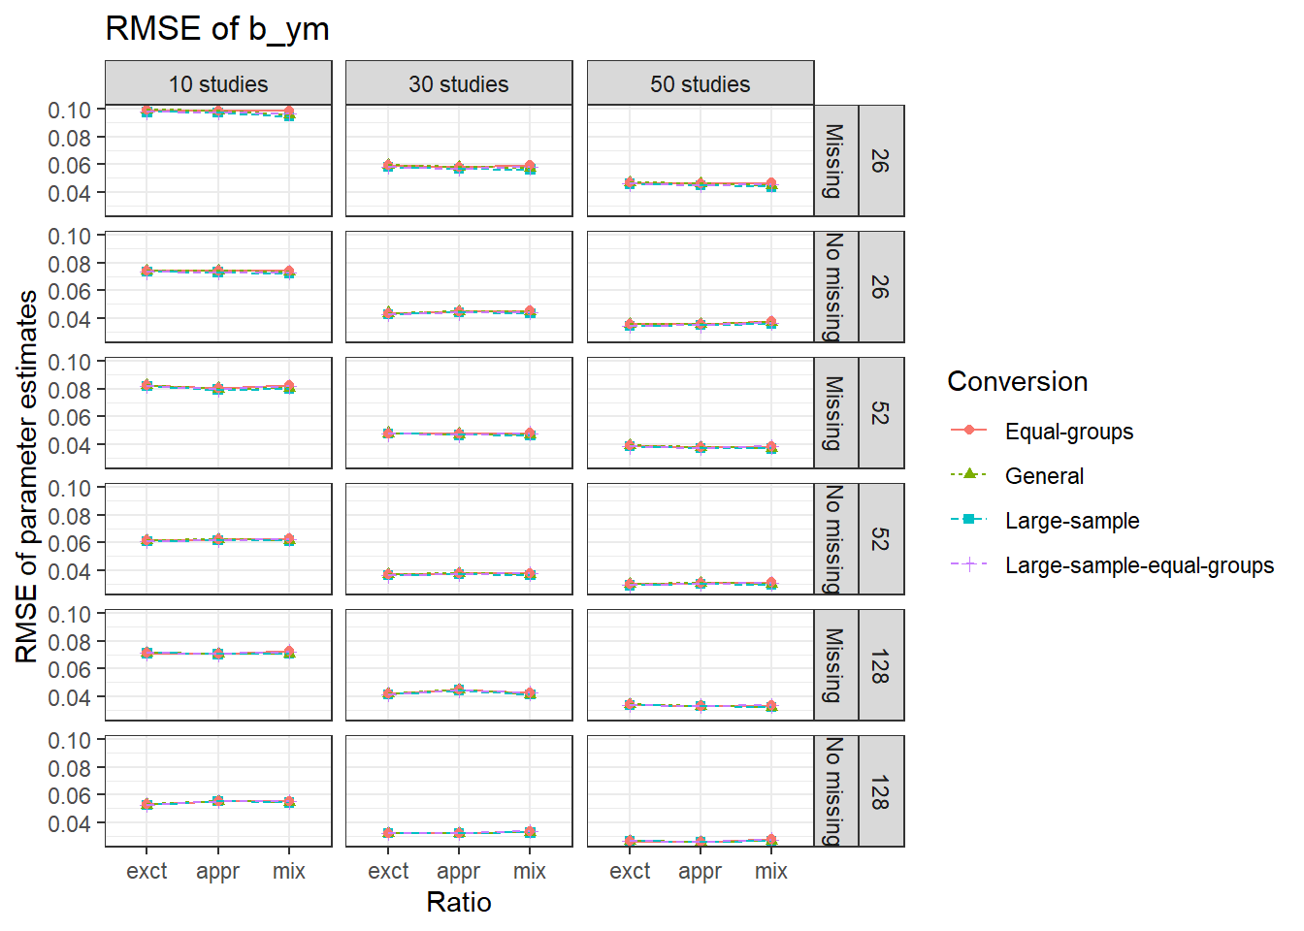
Note. Abbreviations exct, appr, mix on the x-axis represent exact, approximate, and mixed condition, respectively. The numbers 26, 52, and 128 on the right side denote the within study sample sizes.

Figure 8. RMSE of the estimate of the indirect effect in the 54 conditions when converting Hedges’ g with the four conversions

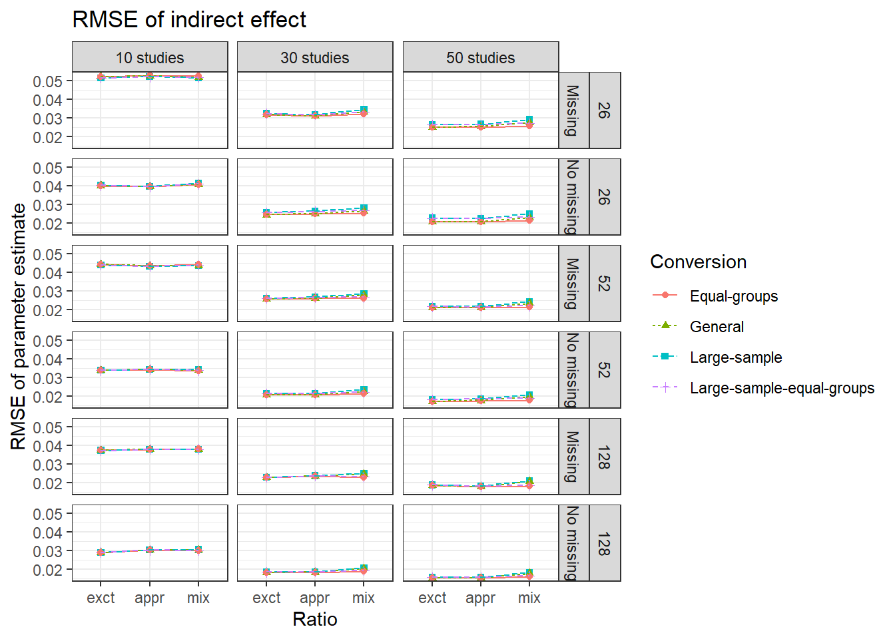
Note. Abbreviations exct, appr, mix on the x-axis represent exact, approximate, and mixed condition, respectively. The numbers 26, 52, and 128 on the right side denote the within study sample sizes.

Figure 9. RMSE of r_{pb,MX} in the 54 conditions when converting Cohen’s d with the four conversions
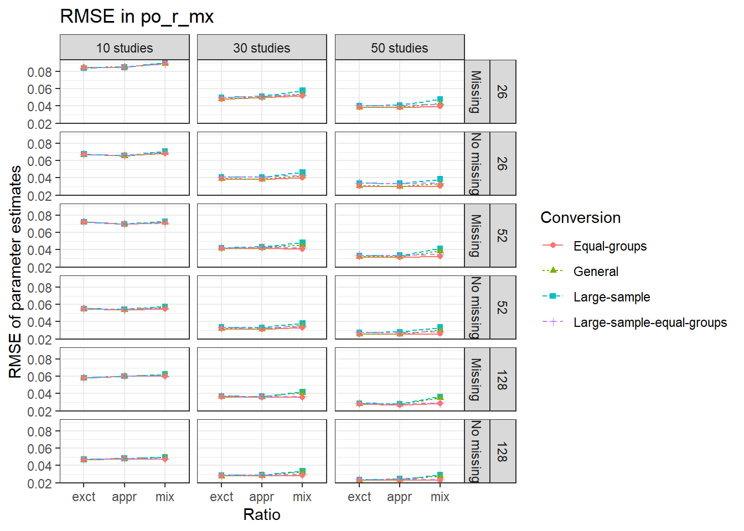
Note. Abbreviations exct, appr, mix on the x-axis represent exact, approximate, and mixed condition, respectively. The numbers 26, 52, and 128 on the right side denote the within study sample sizes.

Figure 10. RMSE of r_{pb,YX} in the 54 conditions when converting Cohen’s d with the four conversions
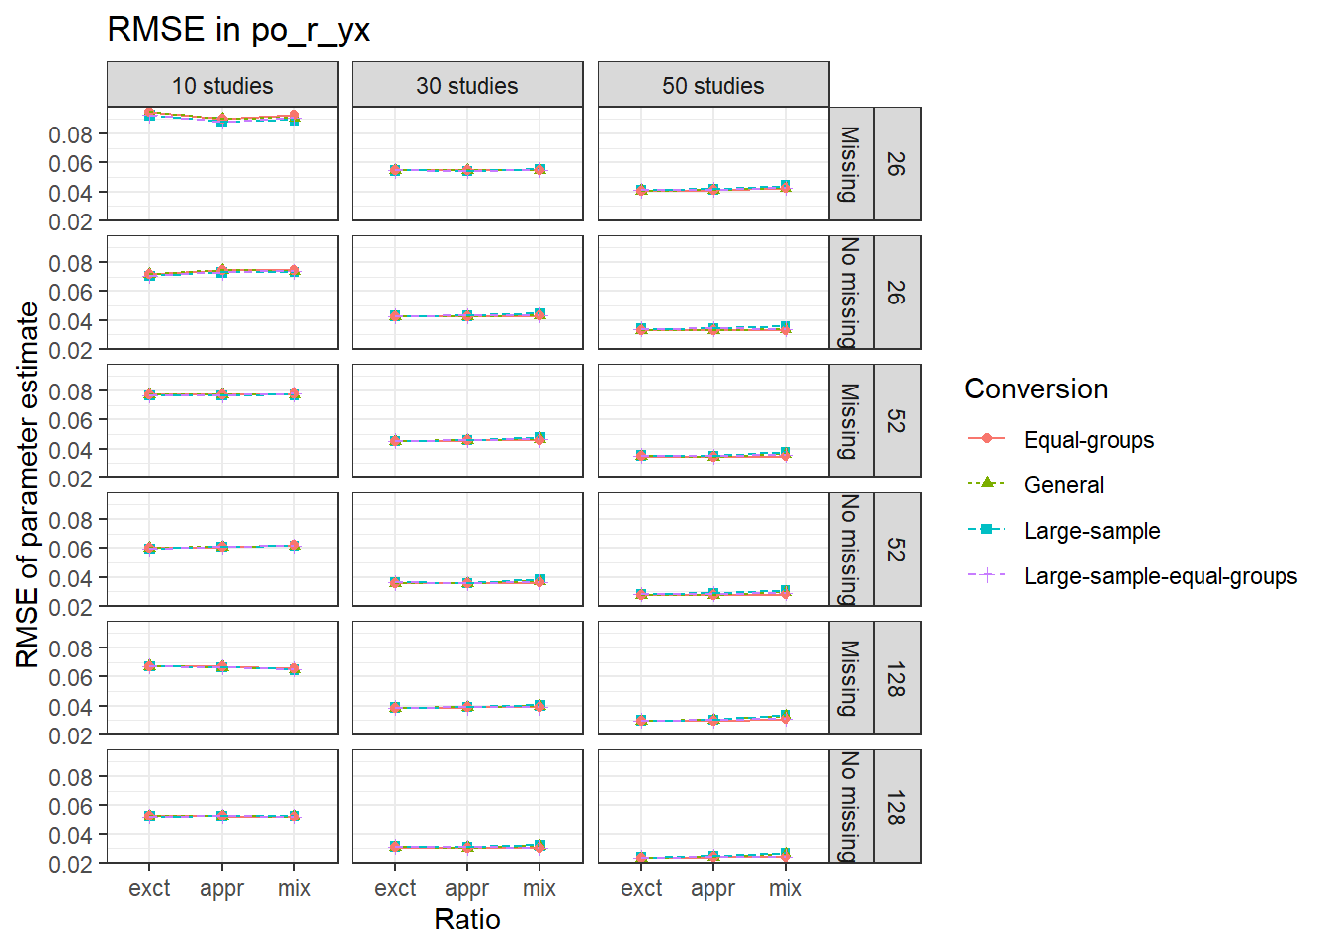
Note. Abbreviations exct, appr, mix on the x-axis represent exact, approximate, and mixed condition, respectively. The numbers 26, 52, and 128 on the right side denote the within study sample sizes.

Figure 11. RMSE of $r_{YM}$ in the 54 conditions when converting Cohen’s d with the four conversions
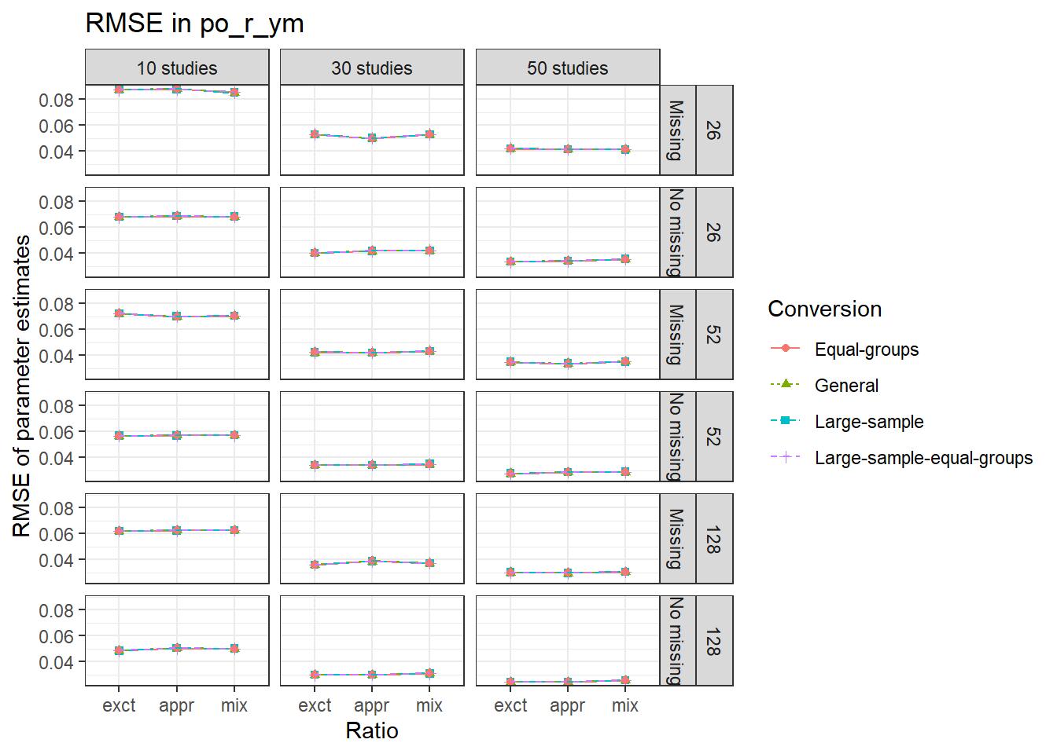
Note. Abbreviations exct, appr, mix on the x-axis represent exact, approximate, and mixed condition, respectively. The numbers 26, 52, and 128 on the right side denote the within study sample sizes.

Figure 12. RMSE of r_{pb,MX} in the 54 conditions when converting Hedges’ g with the four conversions
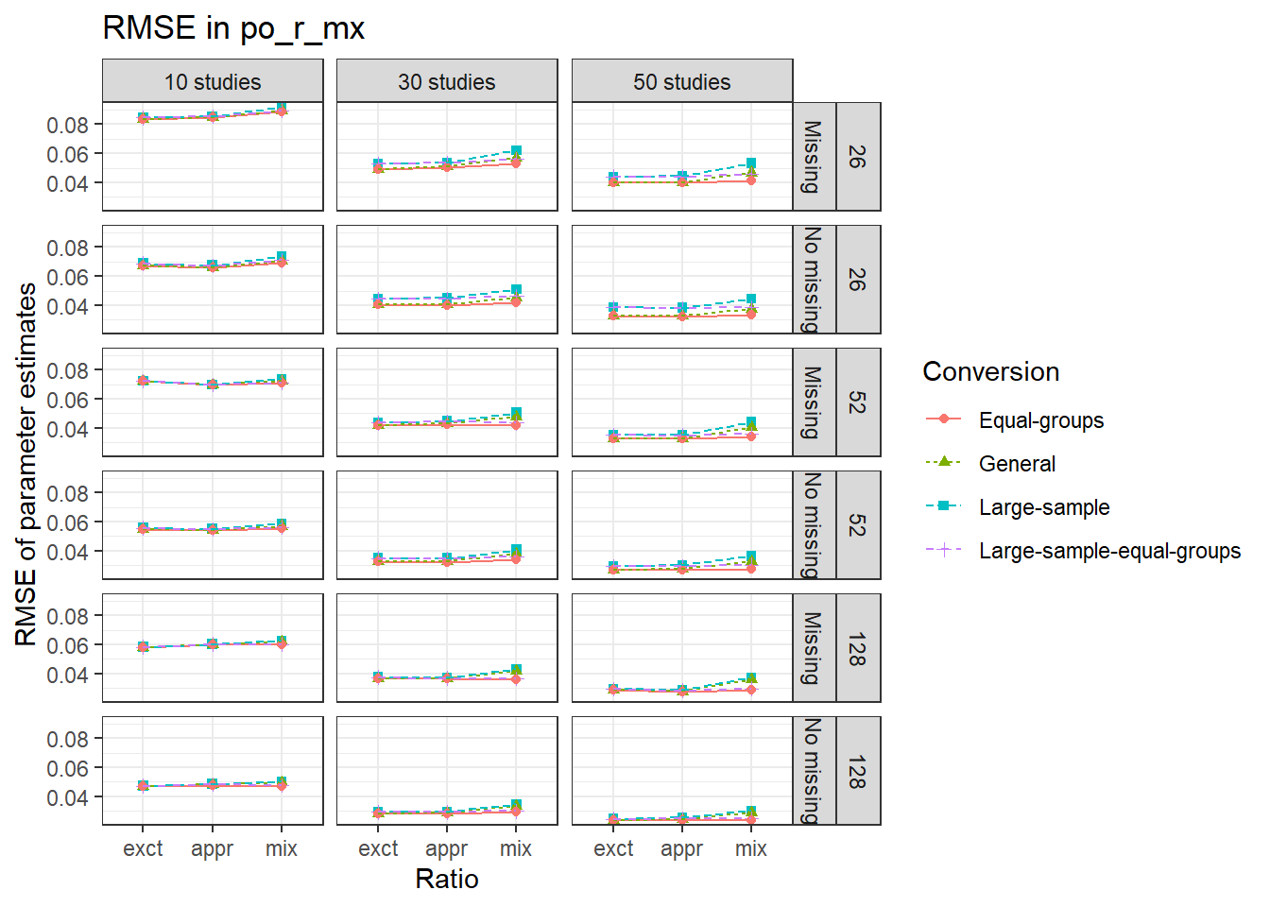
Note. Abbreviations exct, appr, mix on the x-axis represent exact, approximate, and mixed condition, respectively. The numbers 26, 52, and 128 on the right side denote the within study sample sizes.

Figure 13. RMSE of r_{pb,YX} in the 54 conditions when converting Hedges’ g with the four conversions
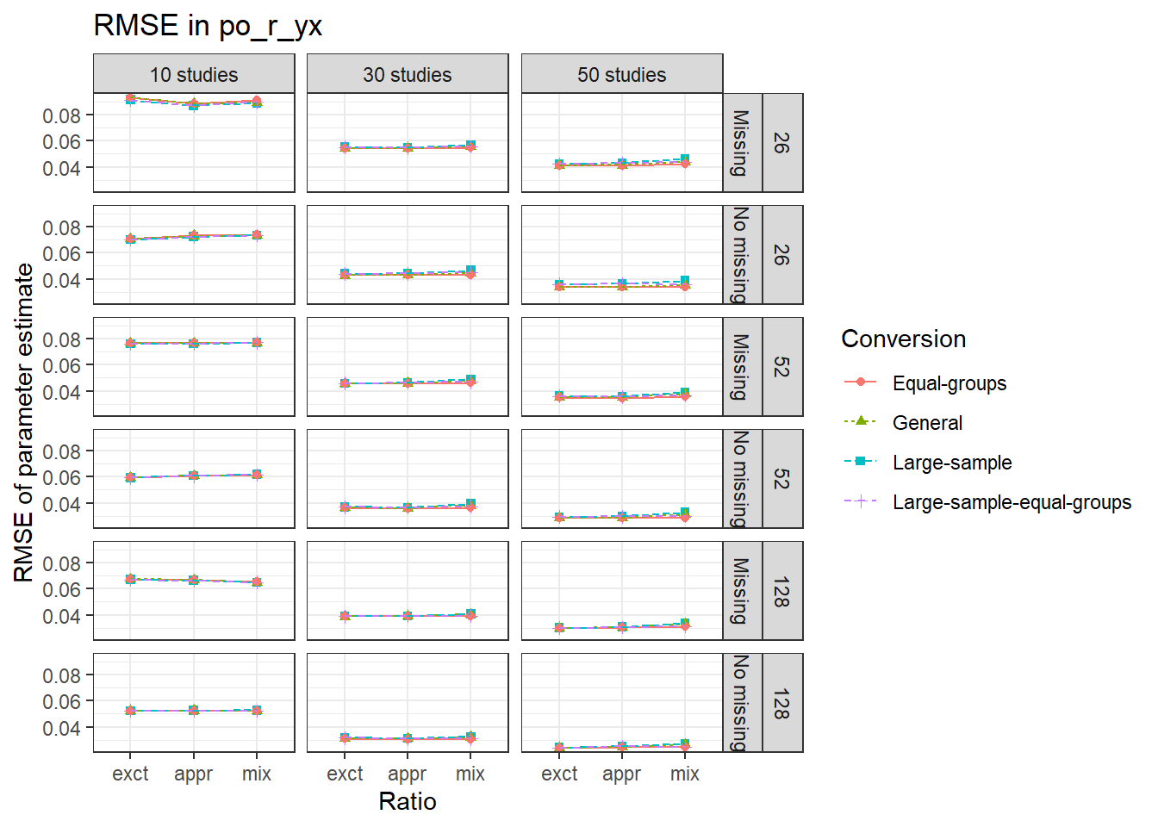
Note. Abbreviations exct, appr, mix on the x-axis represent exact, approximate, and mixed condition, respectively. The numbers 26, 52, and 128 on the right side denote the within study sample sizes.

Figure 14. RMSE of $r_{YM}$ in the 54 conditions when converting Hedges’ g with the four conversions
Note. Abbreviations exct, appr, mix on the x-axis represent exact, approximate, and mixed condition, respectively. The numbers 26, 52, and 128 on the right side denote the within study sample sizes.

