S4. Figures of relative percentage bias in the standard errors
Figure 1. Relative percentage bias in standard errors of ${\hat{β}}_{MX}$ in the 54 conditions when converting Cohen’s d with the four conversions
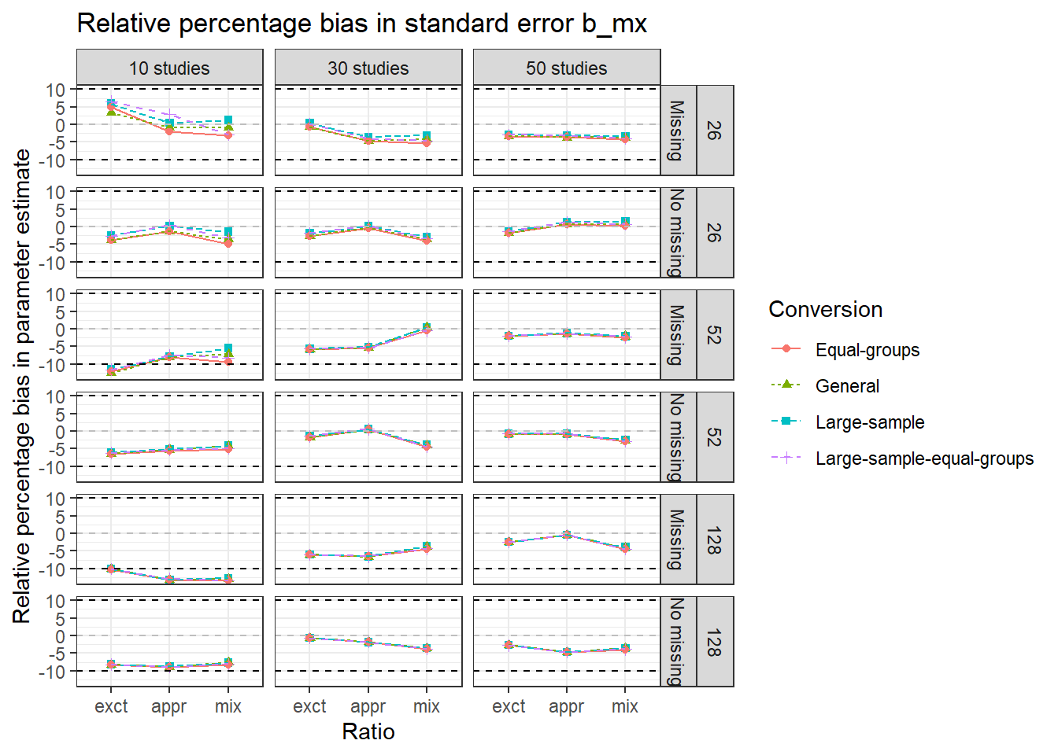
Note. Abbreviations exct, appr, mix on the x-axis represent exact, approximate, and mixed condition, respectively. The numbers 26, 52, and 128 on the right side denote the within study sample sizes. The dotted black lines indicate the margins of acceptable values of relative percentage bias.

Figure 2. Relative percentage bias in standard errors of ${\hat{β}}_{YX}$ in the 54 conditions when converting Cohen’s d with the four conversions
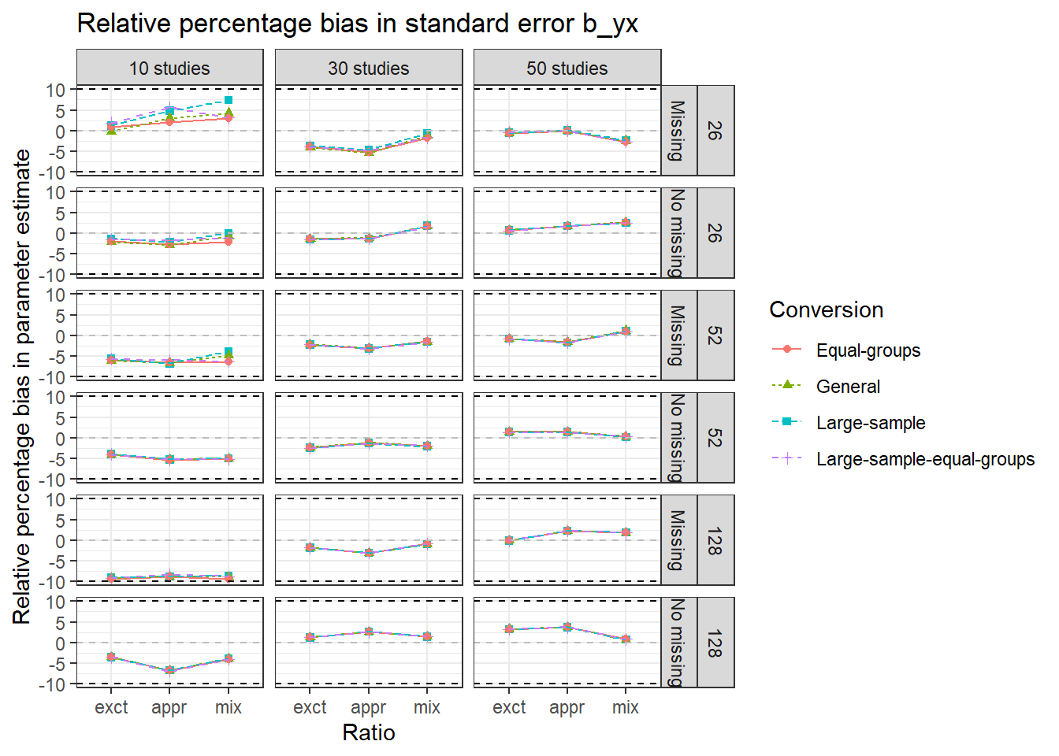
Note. Abbreviations exct, appr, mix on the x-axis represent exact, approximate, and mixed condition, respectively. The numbers 26, 52, and 128 on the right side denote the within study sample sizes. The dotted black lines indicate the margins of acceptable values of relative percentage bias.

Figure 3. Relative percentage bias in standard errors of ${\hat{β}}_{YM}$ in the 54 conditions when converting Cohen’s d with the four conversions
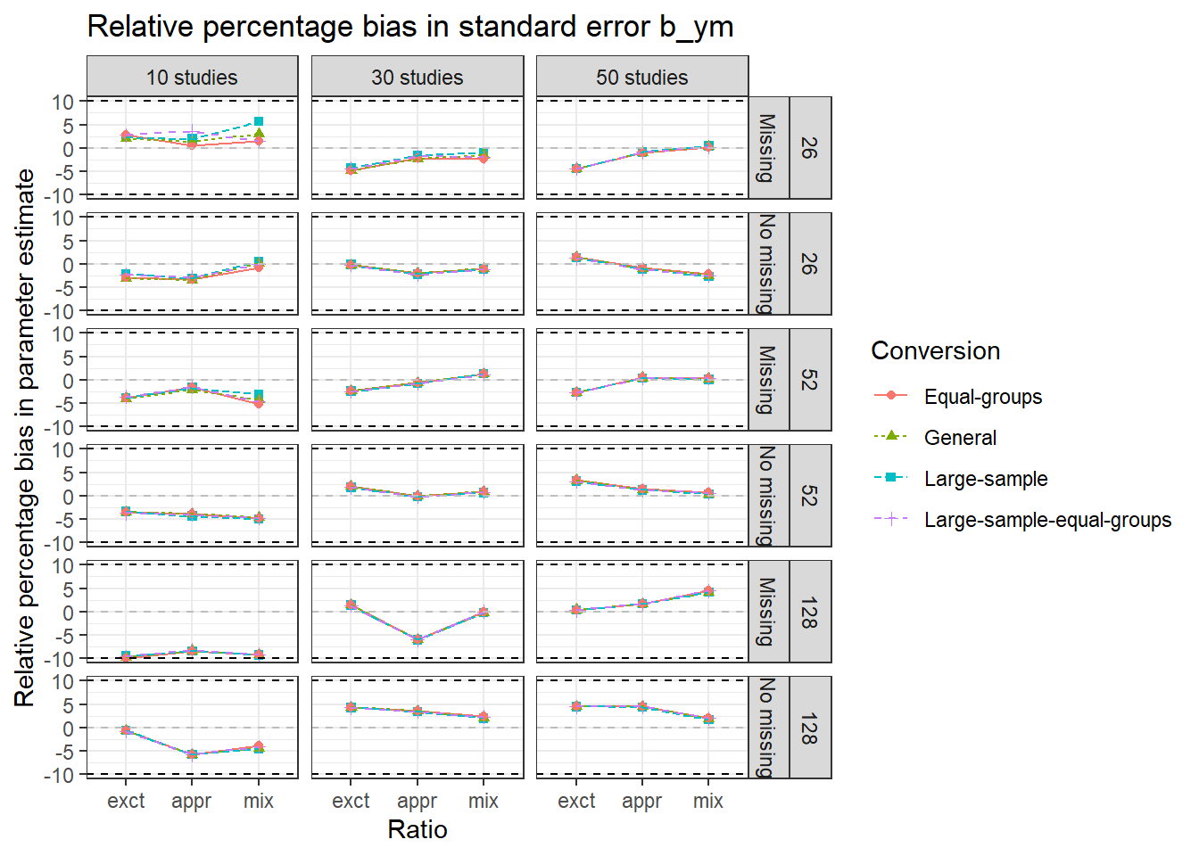
Note. Abbreviations exct, appr, mix on the x-axis represent exact, approximate, and mixed condition, respectively. The numbers 26, 52, and 128 on the right side denote the within study sample sizes. The dotted black lines indicate the margins of acceptable values of relative percentage bias.

Figure 4. Relative percentage bias in standard errors of the indirect effect in the 54 conditions when converting Cohen’s d with the four conversions
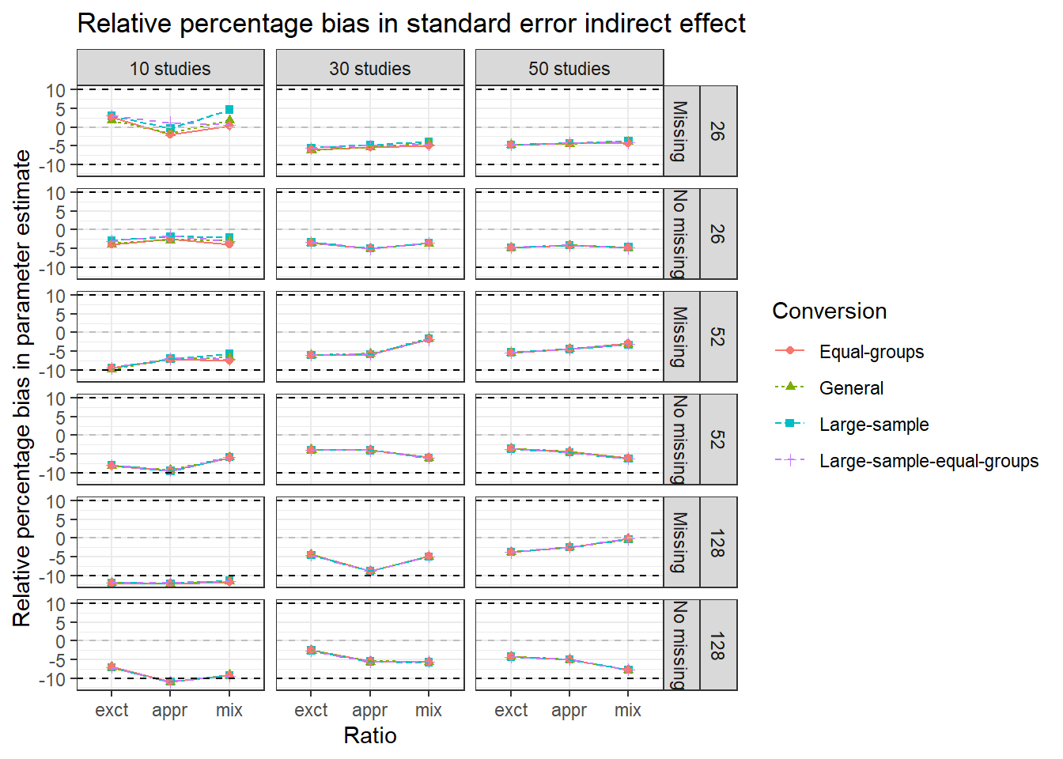
Note. Abbreviations exct, appr, mix on the x-axis represent exact, approximate, and mixed condition, respectively. The numbers 26, 52, and 128 on the right side denote the within study sample sizes. The dotted black lines indicate the margins of acceptable values of relative percentage bias.

Figure 5. Relative percentage bias in standard errors of ${\hat{β}}_{MX}$ in the 54 conditions when converting Hedges’ g with the four conversions
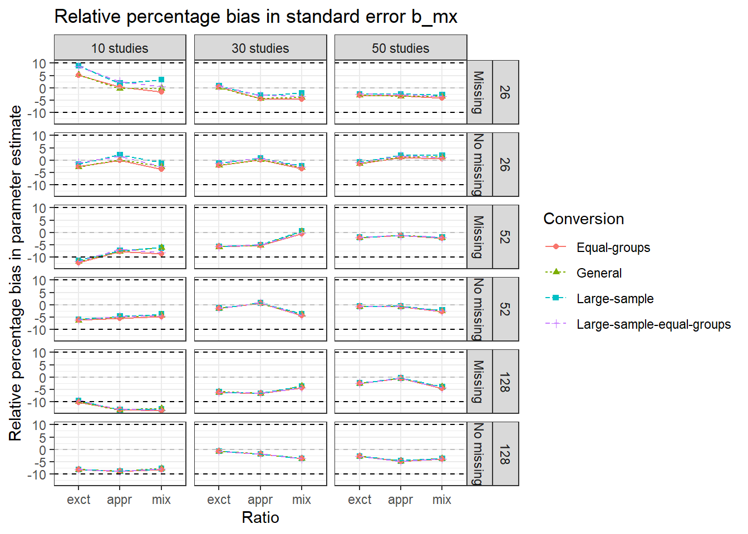
Note. Abbreviations exct, appr, mix on the x-axis represent exact, approximate, and mixed condition, respectively. The numbers 26, 52, and 128 on the right side denote the within study sample sizes. The dotted black lines indicate the margins of acceptable values of relative percentage bias.

Figure 6. Relative percentage bias in standard errors of ${\hat{β}}_{YX}$ in the 54 conditions when converting Hedges’ g with the four conversions

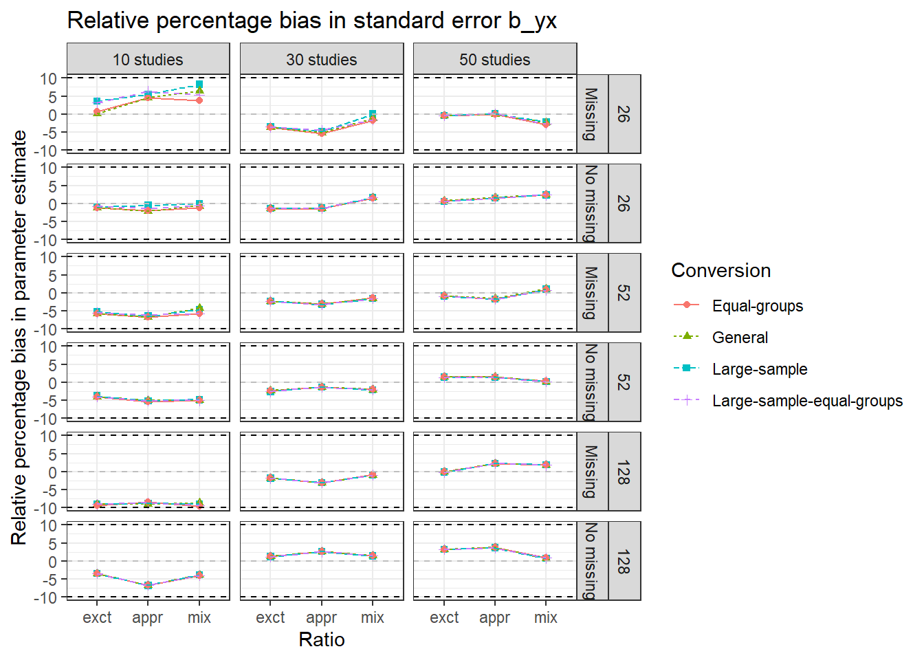
Note. Abbreviations exct, appr, mix on the x-axis represent exact, approximate, and mixed condition, respectively. The numbers 26, 52, and 128 on the right side denote the within study sample sizes. The dotted black lines indicate the margins of acceptable values of relative percentage bias.

Figure 7. Relative percentage bias in standard errors of ${\hat{β}}_{YM}$ in the 54 conditions when converting Hedges’ g with the four conversions
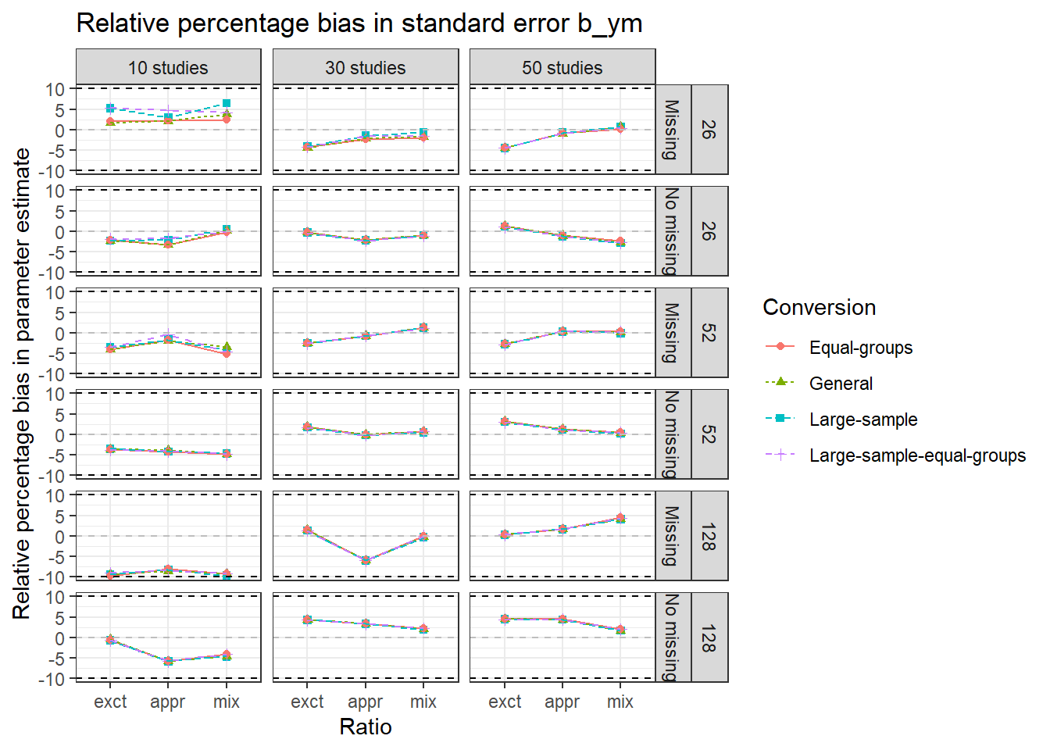
Note. Abbreviations exct, appr, mix on the x-axis represent exact, approximate, and mixed condition, respectively. The numbers 26, 52, and 128 on the right side denote the within study sample sizes. The dotted black lines indicate the margins of acceptable values of relative percentage bias.

Figure 8. Relative percentage bias in standard errors of the indirect effect in the 54 conditions when converting Hedges’ g with the four conversions
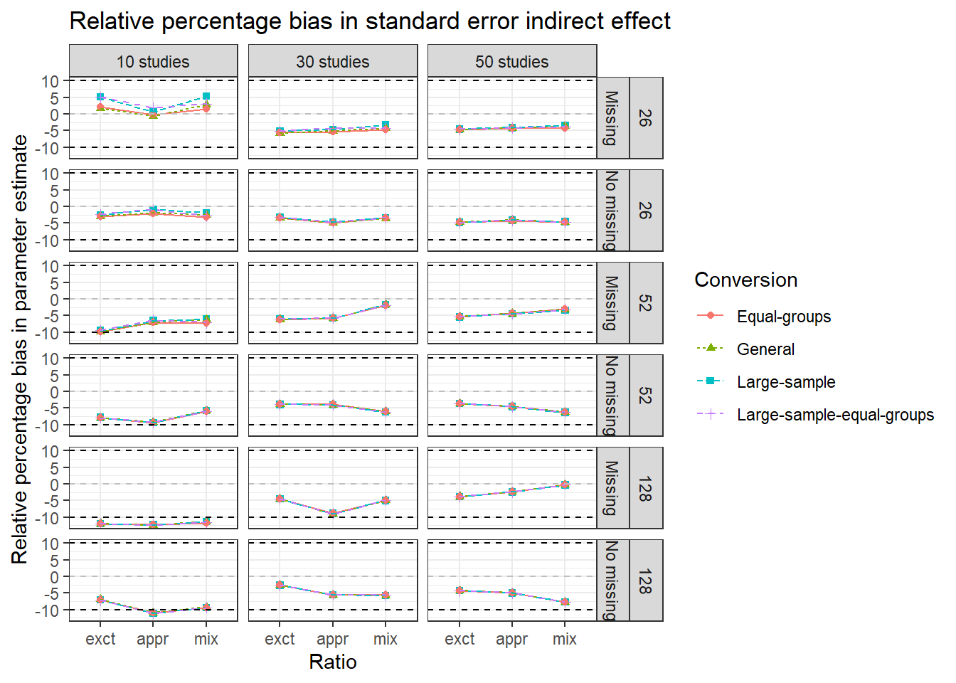
Note. Abbreviations exct, appr, mix on the x-axis represent exact, approximate, and mixed condition, respectively. The numbers 26, 52, and 128 on the right side denote the within study sample sizes. The dotted black lines indicate the margins of acceptable values of relative percentage bias.

