Supplementary Material

Methods

Participants
Twenty participants (age range: 18-48 years, 15 female) with normal or corrected-to-normal visual acuity participated in the study. All gave written informed consent. The University of Auckland Human Participants Ethics Committee approved experimental procedures. Three participants were excluded from analysis because they failed to comply with task instructions.

Stimuli
Stimuli were generated using MATLAB (MathWorks, Inc.), and the experiment was presented using the online platform Testable (https://www.testable.org). The stimuli were Gabor patterns with different orientations, sinusoidal gratings (wavelength: 1.5°) at maximum contrast convolved with a two-dimensional Gaussian (standard deviation: 1°). We used three main conditions with orientations centred on 45°, 90°, or 135°. The orientation of test patterns could differ from these main orientations by 0°, ±5°, ±10°, ±15°, or ±20°. All stimuli were presented on a uniform grey screen.

Procedure
Participants sat in front of a computer in a small testing cubicle, at a distance of 75 cm from the screen (model: Dell OptiPlex 5260 aio series, size: 26.8 cm by 47.6 cm, 21.5 inch, resolution: 1920 x 1080 pixels). There were 27 unique trial types: nine orientation offsets for each of the three main orientations. Each trial type was presented 20 times in the experiment in interleaved order. Therefore, there were 540 trials in the actual experiment. In addition, 12 trials at the beginning of the task were practice trials that were not used for analysis.

Each trial contained two stimuli. The first grating was the reference, presented for 500 ms. This could be one of the three main orientations. This was followed by a 300 ms inter-stimulus interval during which only a grey screen and the fixation cross were presented. The second grating appeared on the screen until the participant responded. It could be tilted anticlockwise, clockwise, or remain unchanged relative to the first grating (Figure S1). Participants indicated via the keyboard left or right arrow keys whether the second grating was tilted anticlockwise or clockwise, respectively. They were instructed to respond as fast and as accurately as possible. If they were unsure about the change between the two stimuli, they must nevertheless press one key to continue the task. Throughout the run, participants were asked to fixate on a small, black cross in the middle of the screen. After the participant’s response, a blank screen was presented for a 500 ms inter-trial interval.

During the 12 initial practice trials, participants could only choose the correct answer to move on to the next trial. The stimuli in the practice were easy to discriminate, including only orientation offsets of ±10° and ±20° for each of the three main orientations. Most participants could select the correct answer easily.

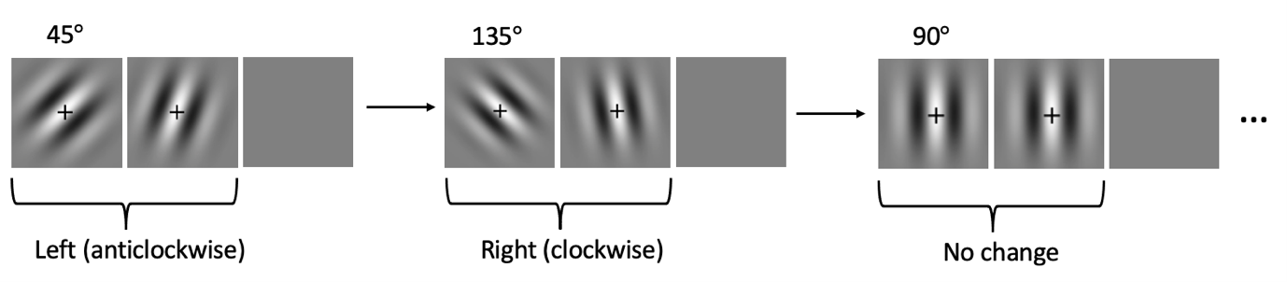
Figure S1. Experimental design. Trial sequence. The second (test) grating was either tilted anticlockwise or clockwise or was unchanged relative to the first (reference) grating. There were three main orientations around which the test grating could vary. The oblique effect is characterised by superior performance around cardinal (in this case, vertical) orientations. Note that a 500 ms inter-trial interval followed the observer’s response. There was also a 300 ms inter-stimulus interval between the two gratings in each trial, not shown here. The second grating stayed on the screen until the observer responded.

Data analysis
We then determined the participant’s orientation discrimination performance for each of the three main orientations. For each orientation offset, we calculated the proportion of trials that they chose the test stimulus as appearing more anticlockwise. Then we fit a cumulative Gaussian psychometric function to these data using a linear mean squares approach. The bandwidth (σ) of this Gaussian determines the slope of the curve. Narrower bandwidth corresponds to steeper slopes, meaning better performance (Figure S2A). We calculated two contrasts of interest. For determining the oblique effect (H₁) we subtracted the bandwidth for 90° main orientation from that for 45°. To estimate an assumed null effect (H₀), we subtracted the bandwidth for 135° from that for 45°.

We also determined the significance of these contrasts for each observer to use these results in our small-N approach. To this end, we bootstrapped the psychometric curve fits. We resampled the choices for each orientation offset with replacement, recalculated the choice proportions, and refit the psychometric curves 10,000 times. We then determined a one-tailed significance value by calculating the proportion of resamples for which the bootstrapped distribution of the two contrasts were ≤0.

Results

Psychometric curves for three representative observers are shown in Figure S2A. It is immediately apparent that the curve for 90° main orientation (red functions) has a steeper slope in all observers, that is a narrower bandwidth. We plot the contrasts between bandwidths for H₁ (45°-90°) and H₀ (45°-135°) in Figure S2B. All observers showed positive contrasts for H₁ as expected, while contrasts for H₀ ranged between positive and negative but most were in fact negative. Only one observer failed to reach significance on individual fits for H₁ and only one was significant for H₀.

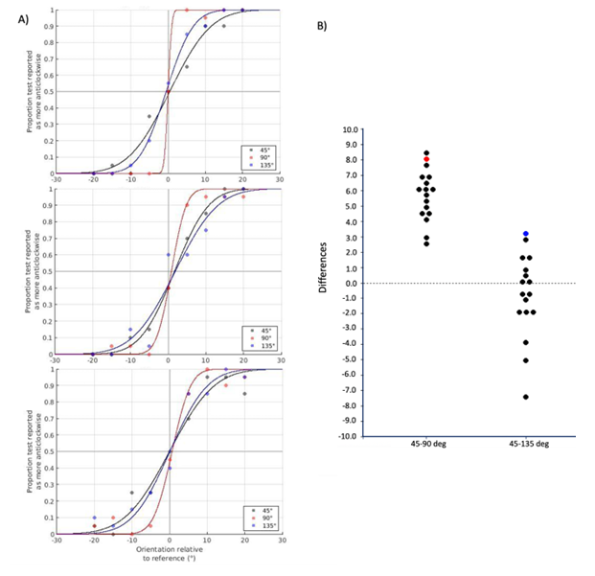

Figure S2. Oblique effect results. A). Psychometric curves from three representative observers. The proportion of trials the test grating was seen as more anticlockwise is plotted against the orientation offset, separately for the three main orientations. Black: 45°, Red: 90°, Blue: 135°. B). Contrasts across participants. Each dot denotes the difference in bandwidth between the conditions shown. The red dot indicates the observer who failed to reach significance for the contrast 45-90°. Conversely, the blue dot indicates the observer who showed a significant difference for the contrast 45-135°.

