Are Men Toxic? A Person-Centered Investigation into the Prevalence of Different Types of Masculinity in a Large Sample of New Zealand Men
Online Supplementary Materials

Table of Contents
Table of Contents 2
Table S1 Descriptive Statistics for Variables used in our Analyses 3
Table S2 Bivariate Correlations Between Variables used in our Analyses 4
Table S3 Model Fit Comparisons Using Four Distinct Types of Variance and Covariance Estimation 6
Figure S1 Profile Plots Using Four Distinct Types of Variance and Covariance Estimation 8
Table S4 Model Fit Comparisons for Solutions Using Two Random Split
Halves of the Sample 9

Table S1
Descriptive Statistics for the Variables Used in Our Analyses

Variable | N | M | SD | Min | Max
Age | 15,808 | 50.57 | 13.56 | 18 | 99
Minority status (dummy-coded) | 15,276 | .15 | .36 | 0 | 1
European (dummy-coded) | 15,808 | .89 | .31 | 0 | 1
Māori (dummy-coded) | 15,808 | .08 | .28 | 0 | 1
Pacific Nations (dummy-coded) | 15,808 | .02 | .13 | 0 | 1
Asian (dummy-coded) | 15,808 | .05 | .22 | 0 | 1
Employed (dummy-coded) | 15,804 | .83 | .38 | 0 | 1
Relationship status (dummy-coded) | 15,575 | .81 | .39 | 0 | 1
Parent (dummy-coded) | 15,808 | .74 | .44 | 0 | 1
Number Children | 15,808 | 1.87 | 1.47 | 0 | 14
Urban/rural (dummy-coded) | 15,690 | .81 | .39 | 0 | 1
Born in NZ (dummy-coded) | 15,775 | .77 | .42 | 0 | 1
Own Home (dummy-coded) | 15,422 | .76 | .43 | 0 | 1
Income | 15,129 | $124,992 | $102,773 | $1 | $3,005,000
Religious (dummy-coded) | 15,764 | .34 | .47 | 0 | 1
Deprivation | 15,717 | 4.62 | 2.71 | 1 | 10
Education | 15,494 | 5.14 | 2.73 | 0 | 10
Conservatism | 15,162 | 3.74 | 1.40 | 1 | 7
Gender Identity | 15,667 | 5.30 | 1.63 | 1 | 7
Sexual Prejudice | 15,243 | 2.59 | 1.83 | 1 | 7
Disagreeableness | 15,670 | 3.04 | .99 | 1 | 7
Narcissism | 15,667 | 2.73 | 1.29 | 1 | 7
Benevolent Sexism | 15,802 | 3.95 | 1.13 | 1 | 7
Hostile Sexism | 15,803 | 3.20 | 1.30 | 1 | 7
Opposition to domestic violence prevention | 15,689 | 2.17 | 1.19 | 1 | 7
SDO | 15,808 | 2.60 | 1.01 | 1 | 7
Hours Exercise | 15,369 | 6.70 | 9.36 | 0 | 80
Body Satisfaction | 15,622 | 4.54 | 1.59 | 1 | 7
Hours Social Media | 15,369 | 2.87 | 5.85 | 0 | 150
Hours Gaming | 15,369 | 1.90 | 6.14 | 0 | 140
Emotional Dysregulation | 15,689 | 2.65 | 1.52 | 1 | 7

Table S2
Bivariate Correlations Between the Variables Used in Our Study

 | 1 | 2 | 3 | 4 | 5 | 6 | 7 | 8 | 9 | 10 | 11 | 12 | 13 | 14 | 15
- Age | ---
- Minority | –.10 | ---
- Employed | –.24 | –.02 | ---
- Partner | .19 | –.07 | .18 | ---
- Religious | .11 | .09 | –.02 | .02 | ---
- Parent | .46 | –.03 | .05 | .39 | .09 | ---
- Deprivation | –.04 | .14 | –.11 | –.18 | .03 | –.08 | ---
- Education | –.06 | –.01^{ns} | .11 | .11 | .03 | .00^{ns} | –.18 | ---
- Conservatism | .09 | .01^{ns} | .00^{ns} | .03 | .24 | .09 | .01^{ns} | –.17 | ---
- Gender identity | .08 | .06 | .00^{ns} | .02^{ns} | .15 | .07 | .03 | –.09 | .16 | ---
- Sexual prejudice | .16 | .08 | –.10 | –.05 | .35 | .08 | .11 | –.17 | .41 | .15 | ---
- Disagreeable | –.07 | .00^{ns} | –.01^{ns} | –.02 | –.10 | –.05 | .04 | –.10 | .12 | –.02 | .10 | ---
- Narcissism | –.15 | .13 | .02 | –.09 | .01^{ns} | –.07 | .08 | –.05 | .05 | .07 | .09 | .15 | ---
- Benevolent sexism | .11 | .12 | –.06 | –.02 | .16 | .07 | .10 | –.24 | .22 | .20 | .25 | .03 | .18 | ---
- Hostile sexism | –.03 | .10 | –.06 | –.14 | .08 | –.03 | .11 | –.20 | .30 | .13 | .35 | .23 | .28 | .28 | ---
- Opposition to domestic violence prevention | .00^{ns} | –.01^{ns} | –.02 | –.03 | .02 | –.01^{ns} | –.01^{ns} | –.03 | .19 | –.05 | .23 | .19 | .08 | –.02 | .28
- SDO | .06 | .01 ^{ns} | –.03 | –.03 | .04 | .03 | .01^{ns} | –.14 | .37 | .09 | .31 | .32 | .19 | .15 | .44
- Hours exercise | .06 | –.01^{ns} | –.04 | .00^{ns} | –.01^{ns} | .00^{ns} | .04 | –.09 | .01^{ns} | .03 | .03 | –.01^{ns} | –.04 | .04 | .04
- Body satisfaction | .07 | –.02 | .01^{ns} | .06 | .03 | .07 | –.05 | .03 | .02 | .08 | .01^{ns} | –.04 | –.14 | .02 | –.08
- Hours social media | –.23 | .11 | –.02^{ns} | –.11 | –.03 | –.15 | .07 | –.02 | –.06 | –.02^{ns} | –.05 | –.02 | .11 | .02 | .04
- Hours gaming | –.28 | .05 | –.09 | –.17 | –.06 | –.21 | .07 | –.05 | –.05 | –.05 | –.05 | .07 | .07 | –.04 | .07
- Emotional dysregulation | –.12 | .07 | –.05 | –.13 | .01^{ns} | –.10 | .09 | –.09 | .01^{ns} | –.02 | .05 | .09 | .26 | .15 | .22
Note. Unless noted, correlations are significant at p < .05.
Table S2 (continued)
Bivariate Correlations Between the Variables Used in Our Study

 | 16 | 17 | 18 | 19 | 20 | 21
16. Opposition to domestic violence prevention | ---
17. SDO | 0.38 | ---
18. Hours exercise | –0.02^{ns} | 0.00^{ns} | ---
19. Body satisfaction | –0.03 | –0.03 | 0.11 | ---
20. Hours social media | –0.02 | –0.02^{ns} | 0.00^{ns} | –0.08 | ---
21. Hours gaming | 0.03 | 0.00^{ns} | –0.04 | –0.10 | 0.19 | ---
22. Emotional dysregulation | 0.04 | 0.06 | –0.03 | –0.20 | 0.09 | 0.09

Note. Unless noted, correlations are significant at p < .05.

Table S3
Fit Indices for Models with Varying Profile Solutions Under Four Different Variance-Covariance Structures

Profile(s) |  | Log-Likelihood |  | Parameters |  | AIC |  | BIC |  | aBIC |  | ∆BIC |  | Entropy
Type 1: Profile-invariant Diagonal
1 |  | −207424.34 |  | 16 |  | 414880.68 |  | 415003.37 |  | 414952.52 |  | --- |  | ---
2 |  | −201936.13 |  | 25 |  | 403922.27 |  | 404113.97 |  | 404034.53 |  | 10889.40 |  | .67
3 |  | −199529.73 |  | 34 |  | 399127.46 |  | 399388.19 |  | 399280.14 |  | 4725.78 |  | .73
4 |  | −197321.28 |  | 43 |  | 394728.56 |  | 395058.29 |  | 394921.64 |  | 4329.90 |  | .80
5 |  | −196522.92 |  | 52 |  | 393149.85 |  | 393548.60 |  | 393383.35 |  | 1509.69 |  | .82
6 |  | −195834.28 |  | 61 |  | 391790.56 |  | 392258.33 |  | 392064.47 |  | 1290.27 |  | .81
7 |  | −195144.66 |  | 70 |  | 390429.31 |  | 390966.09 |  | 390743.64 |  | 1292.24 |  | .80
8 |  | −188498.91 |  | 79 |  | 377155.83 |  | 377761.62 |  | 377510.56 |  | 13204.47 |  | .90
9 |  | −190122.24 |  | 88 |  | 380420.47 |  | 381095.28 |  | 380815.62 |  | -3333.66 |  | .86
10 |  | −186897.16 |  | 97 |  | 373988.33 |  | 374732.15 |  | 374423.89 |  | 6363.13 |  | .89
Type 2: Profile-varying Diagonal
1 |  | −207424.34 |  | 16 |  | 414880.68 |  | 415003.37 |  | 414952.52 |  | --- |  | ---
2† |  | --- |  | --- |  | --- |  | --- |  | --- |  | --- |  | ---
Type 3: Profile-invariant non-diagonal
1 |  | −199709.79 |  | 44 |  | 399507.59 |  | 399844.98 |  | 399705.16 |  | -- |  | --
2 |  | −197091.07 |  | 53 |  | 394288.13 |  | 394694.55 |  | 394526.12 |  | 5150.43 |  | 0.53
3 |  | −194620.91 |  | 62 |  | 389365.81 |  | 389841.25 |  | 389644.21 |  | 4853.30 |  | 0.92
4 |  | −193728.64 |  | 71 |  | 387599.29 |  | 388143.74 |  | 387918.10 |  | 1697.51 |  | 0.92
5 |  | −191054.18 |  | 80 |  | 382268.37 |  | 382881.83 |  | 382627.59 |  | 5261.91 |  | 0.97
6† |  | −187970.23 |  | 89 |  | 376118.47 |  | 376800.94 |  | 376518.11 |  | 6080.89 |  | 0.97
7 |  | −187510.18 |  | 98 |  | 375216.36 |  | 375967.85 |  | 375656.41 |  | 833.09 |  | 0.93
8† |  | −185276.60 |  | 107 |  | 370767.20 |  | 371587.71 |  | 371247.67 |  | 4380.14 |  | 0.93
9† |  | −184215.28 |  | 116 |  | 368662.56 |  | 369552.08 |  | 369183.44 |  | 2035.63 |  | 0.94
10† |  | −184018.30 |  | 125 |  | 368286.60 |  | 369245.14 |  | 368847.90 |  | 306.94 |  | 0.88
Type 4: Profile-varying non-diagonal
1 |  | −199709.80 |  | 44 |  | 399507.59 |  | 399844.10 |  | 399705.17 |  | -- |  | --
2 |  | −196607.78 |  | 81 |  | 393377.55 |  | 393998.68 |  | 393741.27 |  | 5845.42 |  | 0.84
3 |  | −194177.42 |  | 118 |  | 388590.84 |  | 389495.70 |  | 389120.70 |  | 4502.98 |  | 0.92
4† |  | −193581.43 |  | 155 |  | 387472.85 |  | 388661.44 |  | 388168.86 |  | 834.26 |  | 0.86
5† |  | −192940.94 |  | 192 |  | 386265.88 |  | 387738.19 |  | 387128.03 |  | 923.25 |  | 0.93
Note. Rows highlighted in bold reflect the best-fitting model under the given variance-covariance structure.
†Due to errors that emerged during the estimation procedure, results should be interpreted with caution.

Figure S1
Best-Fitting Models Under Four Different Variance-Covariance Structures

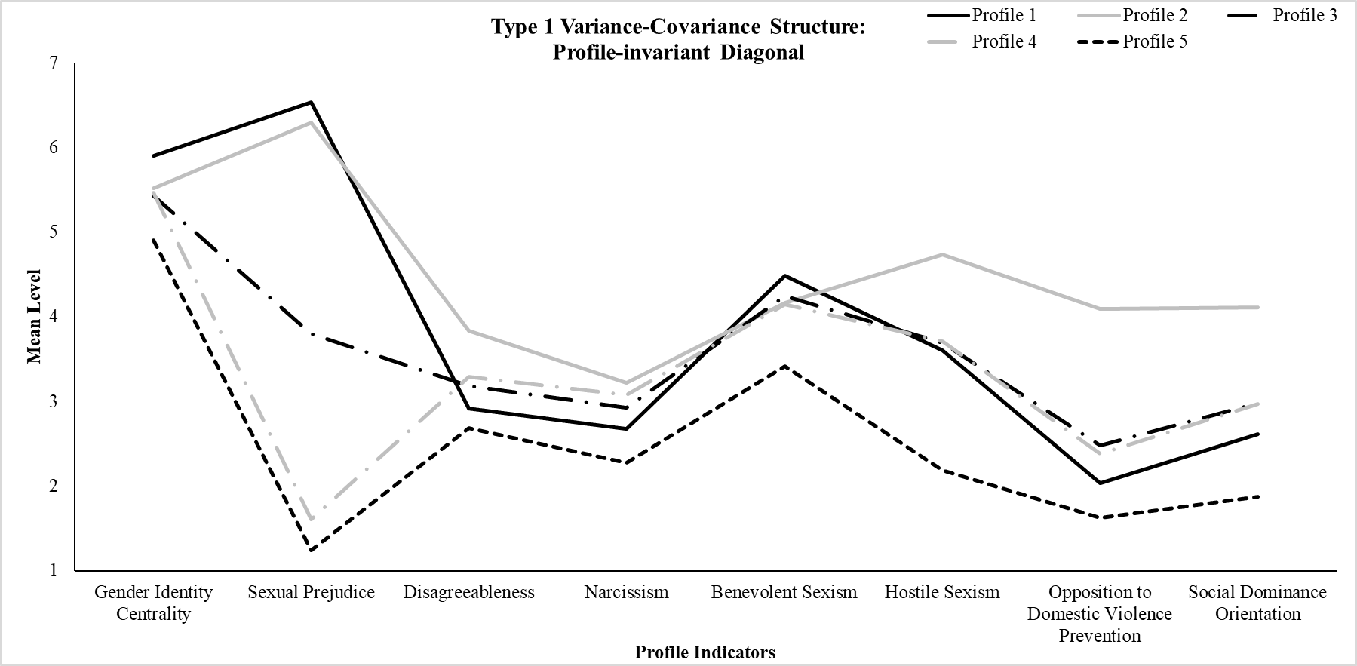 | 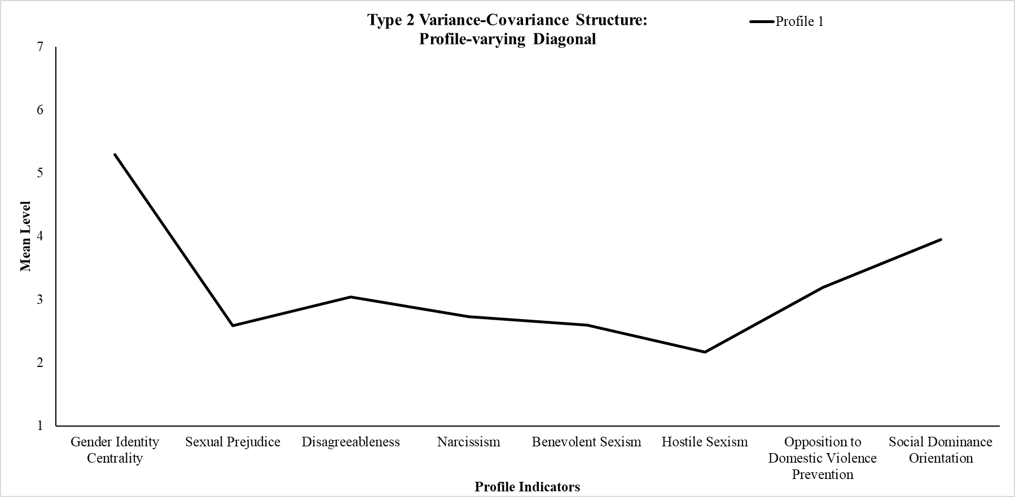
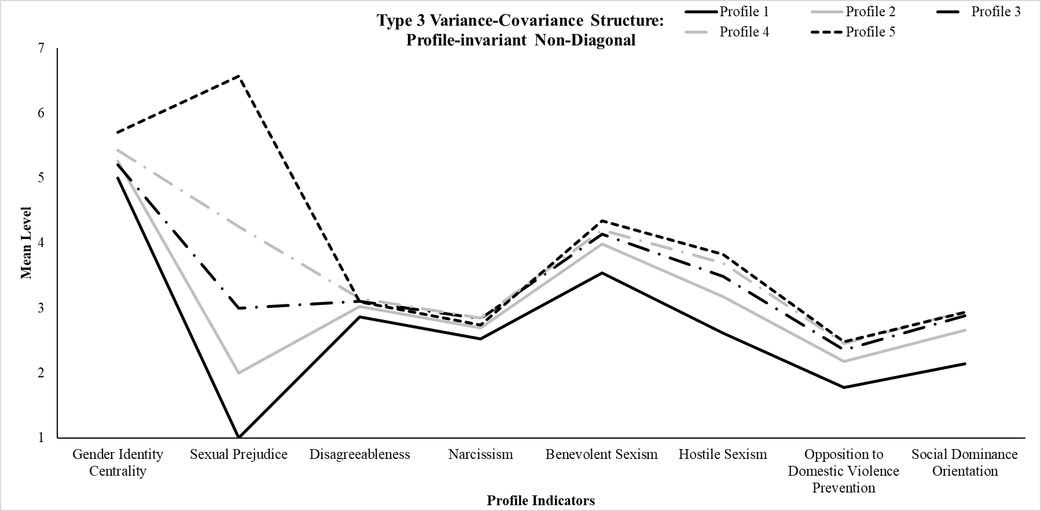 | 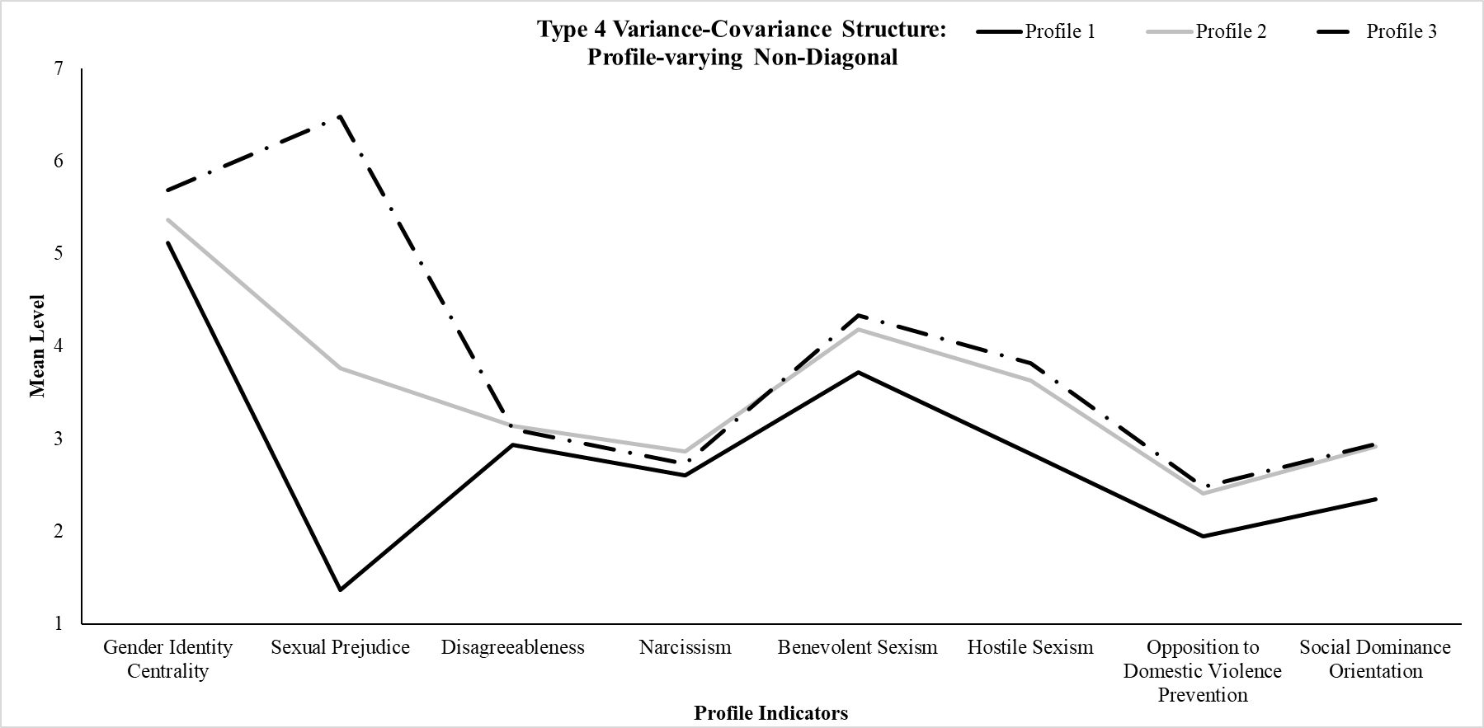

Table S4
Model Fit for Solutions Ranging Between 1 and 10 Profiles with Split-Half Samples
Profile |  | Log-Likelihood |  | AIC |  | aBIC |  | BIC |  | ∆BIC |  | LMR |  | BLRT |  | Entropy
Split Half Sample A
1 |  | −104691.82 |  | 209415.63 |  | 209476.50 |  | 209527.35 |  | --- |  | --- |  | --- |  | ---
2 |  | −101938.93 |  | 203927.85 |  | 204022.97 |  | 204102.41 |  | 5424.94 |  | 5438.50*** |  | 5505.77*** |  | 0.66
3 |  | −100704.39 |  | 201476.78 |  | 201606.14 |  | 201714.18 |  | 2388.23 |  | 2438.90*** |  | 2469.07*** |  | 0.73
4 |  | −99463.36 |  | 199012.72 |  | 199176.32 |  | 199312.96 |  | 2401.22 |  | 2207.11*** |  | ^{2234.42***} |  | 0.80
5 |  | −99049.16 |  | 198202.31 |  | 198400.14 |  | 198565.39 |  | 747.57 |  | 818.29* |  | 1596.70*** |  | 0.82
6 |  | −98706.53 |  | 197535.05 |  | 197767.13 |  | 197960.97 |  | 604.42 |  | 676.88*** |  | 648.33*** |  | 0.80
7 |  | −98381.30 |  | 196902.60 |  | 197168.92 |  | 197391.36 |  | 569.61 |  | 602.63 |  | 650.45*** |  | 0.79
8 |  | −98091.44 |  | 196340.87 |  | 196641.42 |  | 196892.47 |  | 498.89 |  | 572.65 |  | 476.29*** |  | 0.81
9† |  | −94298.05 |  | 188772.09 |  | 189106.89 |  | 189386.54 |  | 7505.93 |  | 359.50 |  | 399.46*** |  | 0.91
10† |  | −94106.02 |  | 188406.03 |  | 188775.07 |  | 189083.31 |  | 303.23 |  | 301.46 |  | 236.46*** |  | 0.86
Split Half Sample B
1 |  | −102724.13 |  | 205480.26 |  | 205540.90 |  | 205591.75 |  | --- |  | --- |  | --- |  | ---
2 |  | −99979.34 |  | 200008.68 |  | 200103.43 |  | 200182.88 |  | 5408.87 |  | 5422.40*** |  | 5489.58*** |  | 0.67
3 |  | −98800.86 |  | 197669.72 |  | 197798.58 |  | 197906.63 |  | 2276.25 |  | 2328.11*** |  | 2356.96*** |  | 0.73
4 |  | −97823.96 |  | 195733.92 |  | 195896.90 |  | 196033.54 |  | 1873.09 |  | 1929.88*** |  | 1177.05*** |  | 0.80
5 |  | −97436.54 |  | 194977.08 |  | 195174.17 |  | 195339.41 |  | 694.13 |  | 765.35*** |  | 739.97*** |  | 0.82
6 |  | −97066.06 |  | 194254.13 |  | 194485.32 |  | 194679.17 |  | 660.24 |  | 676.57** |  | 740.95*** |  | 0.80
7 |  | −96715.07 |  | 193570.14 |  | 193835.45 |  | 194057.90 |  | 621.27 |  | 693.39*** |  | 701.98*** |  | 0.79
8 |  | −96370.50 |  | 192898.99 |  | 193198.41 |  | 193449.46 |  | 608.44 |  | −5489.97 |  | 428.45*** |  | 0.83
9† |  | −93193.77 |  | 186563.54 |  | 186897.07 |  | 187176.71 |  | 6272.75 |  | −232.90 |  | 184.51*** |  | 0.89
10† |  | −88163.90 |  | 176521.79 |  | 176889.43 |  | 177197.68 |  | 9979.03 |  | 339.69*** |  | 78.55*** |  | 0.87
Note. †Due to errors that emerged during the estimation procedure, results should be interpreted with caution.

