Supplementary Material for
Balancing Spacing and Repetition for Time-Constrained Learning: Evidence from Cued Recall in Foreign Language Vocabulary Learning
Meng Cao, Veronica X. Yan, Faria Sana, Paulo F. Carvalho
Corresponding author: Meng Cao
Email: mengc2@andrew.cmu.edu

Stimuli
Table S1
Stimuli Used in the Experiments
Stimulus | Answer
Target items (Easy)
Bir | Beer
Emas | Gold
Haus | Thirsty
Polisi | Police
Sama | Same
Timur | East
Target items (Hard)
Bagaimana | How
Keberangka | Departure
Perhiasan | Jewellery
Sandiwara | Theatre
Terlambat | Late
Tinggal | Live
Filler items in Experiment 1 (Medium difficulty)
Ini | This
Sekolah | School
Jahe | Ginger
Bagasi | Luggage
Ombak | Wave
Kebudayaan | Culture
Coro | Cockroach
Bau | Stink
Debu | Dust
Asli | Authentic
Restoran | Restaurant
Tas | Bag
Rendah | Short
Dimana | Where
Dompet | Wallet
Handuk | Towel
Panas | Hot
Mungil | Cute
Tinggi | Tall
Obat | Medicine
Susu | Milk
Besar | Big
Baik | Good
Enak | Delicious
Filler items in Experiment 2
10 + 3 = | 13
10 + 4 = | 14
14 / 7 = | 2
18 / 9 = | 2
2 * 5 = | 10
3 * 6 = | 18
3 + 6 = | 9
4 * 4 = | 16
5 + 10 = | 15
7 * 2 = | 14
7 + 3 = | 10
8 * 2 = | 16
8 * 3 = | 24
8 + 7 = | 15
9 * 2 = | 18
9 + 8 = | 17
7 - 2 = | 5
10 - 8 = | 2
5 - 6 = | -1
3 - 5 = | -2
5 - 4 = | 1
9 - 9 = | 0
12 - 4 = | 8
9 - 3 = | 6
Trivia questions
In what park is “Old Faithful” located? | Yellowstone
What is the largest planet in the solar system? | Jupiter
What is the name for a cyclone that occurs over land? | Tornado
What is the name of a young sheep? | Lamb
What is the name of deer meat? | Venison
What is the name of the chapel whose ceiling was painted by Michelangelo? | Sistene
What is the name of the largest ocean on Earth? | Pacific
What is the name of the thick layer of fat on a whale? | Blubber

Analyses Regarding the Influence of Filler Items

Participants’ Accuracy on the First Two Trials During the Learning Session
In Experiment 1, spacing intervals were implemented using medium difficulty Indonesian–English word pair fillers that were similar to the target materials. In Experiments 2 and 3, these fillers were replaced with unrelated math problems. To examine whether the type of filler influenced performance during learning, we analyzed participants’ accuracy on the first two trials in the learning session in Experiments 1 and 2. All repetition/spacing conditions included data from these two trials. The first trial served as a baseline measure of initial knowledge because repetition and spacing intervals had not yet diverged across conditions. Any differences observed on the second trial would therefore reflect the effects of the manipulated spacing intervals. Mixed-effects ANOVAs showed that on Trial 1, accuracy did not differ across repetition/spacing conditions in either Experiment 1 or Experiment 2, although easy items were answered more accurately than hard items (see Table S2).

Table S2
Analysis of Variance for Repetition/Spacing Condition and Item Difficulty
Source | Effect | SS | MS | df₁ | df₂ | F | p
Experiment 1
First trial | Condition | 0.018 | 0.006 | 3 | 778 | 0.64 | .588
 | Difficulty | 9.343 | 9.343 | 1 | 778 | 978.53 | < .001
 | Condition × Difficulty | 0.016 | 0.005 | 3 | 778 | 0.57 | .638
Second Trial | Condition | 1.811 | 0.604 | 3 | 778 | 25.672 | <.001
 | Difficulty | 40.38 | 40.38 | 1 | 778 | 1710.05 | < .001
 | Condition × Difficulty | 0.244 | 0.081 | 3 | 778 | 3.44 | 0.017
Experiment 2
First trial | Condition | 0.004 | 0.001 | 3 | 786 | 0.13 | 0.942
 | Difficulty | 7.722 | 7.722 | 1 | 786 | 814.77 | <.001
 | Condition × Difficulty | 0.004 | 0.001 | 3 | 786 | 0.13 | 0.944
Second trial | Condition | 0.177 | 0.059 | 3 | 786 | 2.54 | 0.055
 | Difficulty | 47.736 | 47.736 | 1 | 786 | 2057.78 | <.001
 | Condition × Difficulty | 0.03 | 0.01 | 3 | 786 | 0.43 | 0.732

On Trial 2, the results of Experiment 1 showed that participants’ accuracy differed across repetition/spacing conditions, suggesting that spacing influenced performance (see Table S3). However, this difference was no longer significant in Experiment 2 after the language-based fillers were replaced with unrelated math problems. This pattern suggests that the Trial 2 difference observed in Experiment 1 was driven by interference from language-based fillers rather than by length of spacing intervals. These findings are consistent with interference-based accounts of forgetting, which propose that memory performance is shaped by competition from previously encountered material rather than by passive decay (Underwood, 1957).
Table S3
Sequential Comparisons of Repetition/Spacing Conditions by Item Difficulty on the Second Trial in Experiment 1
Difficulty | Contrast | Estimate | SE | df | t | p
Easy | 3 Reps − 2 Reps | 0.081 | 0.021 | 1309 | 3.94 | < .001
 | 4 Reps − 3 Reps | 0.023 | 0.021 | 1309 | 1.10 | .270
 | 6 Reps − 4 Reps | 0.046 | 0.021 | 1309 | 2.22 | .054
Hard | 3 Reps − 2 Reps | 0.021 | 0.021 | 1309 | 1.01 | .313
 | 4 Reps − 3 Reps | 0.054 | 0.021 | 1309 | 2.62 | .018
 | 6 Reps − 4 Reps | 0.075 | 0.021 | 1309 | 3.63 | < .001

Effects of Filler Type on Learning Rate
To examine whether filler items influenced learning rates, we compared trial-by-trial performance across Experiments 1 and 2. Specifically, we analyzed participants’ accuracy during the learning session using a mixed-effects logistic regression model implemented with the glmer function from lme4 (Bates et al., 2015). The model included filler type (reference: math) and trial number (centered) as fixed effects, along with their interaction. Random intercepts and random slopes for trial number were included for both participants and target words, capturing variability in baseline performance and learning rates across individuals and items. Results showed that accuracy increased with additional practice trials, b = 1.67, SE = 0.08, z = 21.61, p < .001. At a given trial, performance was lower in Experiment 1 (Indonesian–English word pairs) than in Experiment 2 (math problems), b = -0.39, SE = 0.07, z = -5.60, p < .001, suggesting that task-related filler items may have interfered with performance on target words. There was also a significant interaction between filler type and practice trials, b = -0.22, SE = 0.04, z = -5.08, p < .001, indicating that learning rates were lower with task-related filler items (M = 1.45, SE = 0.08) compared with math fillers (M = 1.67, SE = 0.08).

Exploratory Analysis Excluding High-Performing Participants
To examine whether the interaction was driven by a ceiling effect, we conducted additional analyses excluding high-performing participants. Accuracy for easy items approached ceiling in later learning trials (e.g., Trials 4–6), with many participants reaching 100%. Because Trial 4 is the last shared trial between the 4- and 6-repetition conditions, we used it as the reference point. We determined the maximum number of participants who achieved perfect accuracy at Trial 4 across the two conditions and removed that same number of top performers from all conditions. Participants were ranked based on their performance on the final trial within each condition, and the highest-performing individuals were excluded accordingly.

Experiment 1
In Experiment 1, 67 participants in the 4-repetition condition and 98 participants in the 6-repetition condition reached ceiling performance on the 4th trial. To apply a consistent exclusion criterion across conditions, we excluded the top 98 highest-performing participants within each condition. The final sample consisted of 96 participants in the 2-repetition condition, 101 in the 3-repetition condition, 101 in the 4-repetition condition, and 92 in the 6-repetition condition.
For the learning session, the mixed-effects ANOVA results were consistent with those obtained before excluding high-performing participants. There was a significant main effect of repetition/spacing condition, F(3, 491.16) = 141.06, p < .001, R² = .463, and a significant main effect of item difficulty, F(1, 2597.47) = 526.33, p < .001, R² = .168. Importantly, these effects were qualified by a significant interaction between repetition/spacing condition and item difficulty, F(3, 2597.47) = 6.73, p < .001, R² = .008 (see Figure 1S).
Figure 1S
Average Accuracy After Excluding High-Performing Participants (Experiment 1)
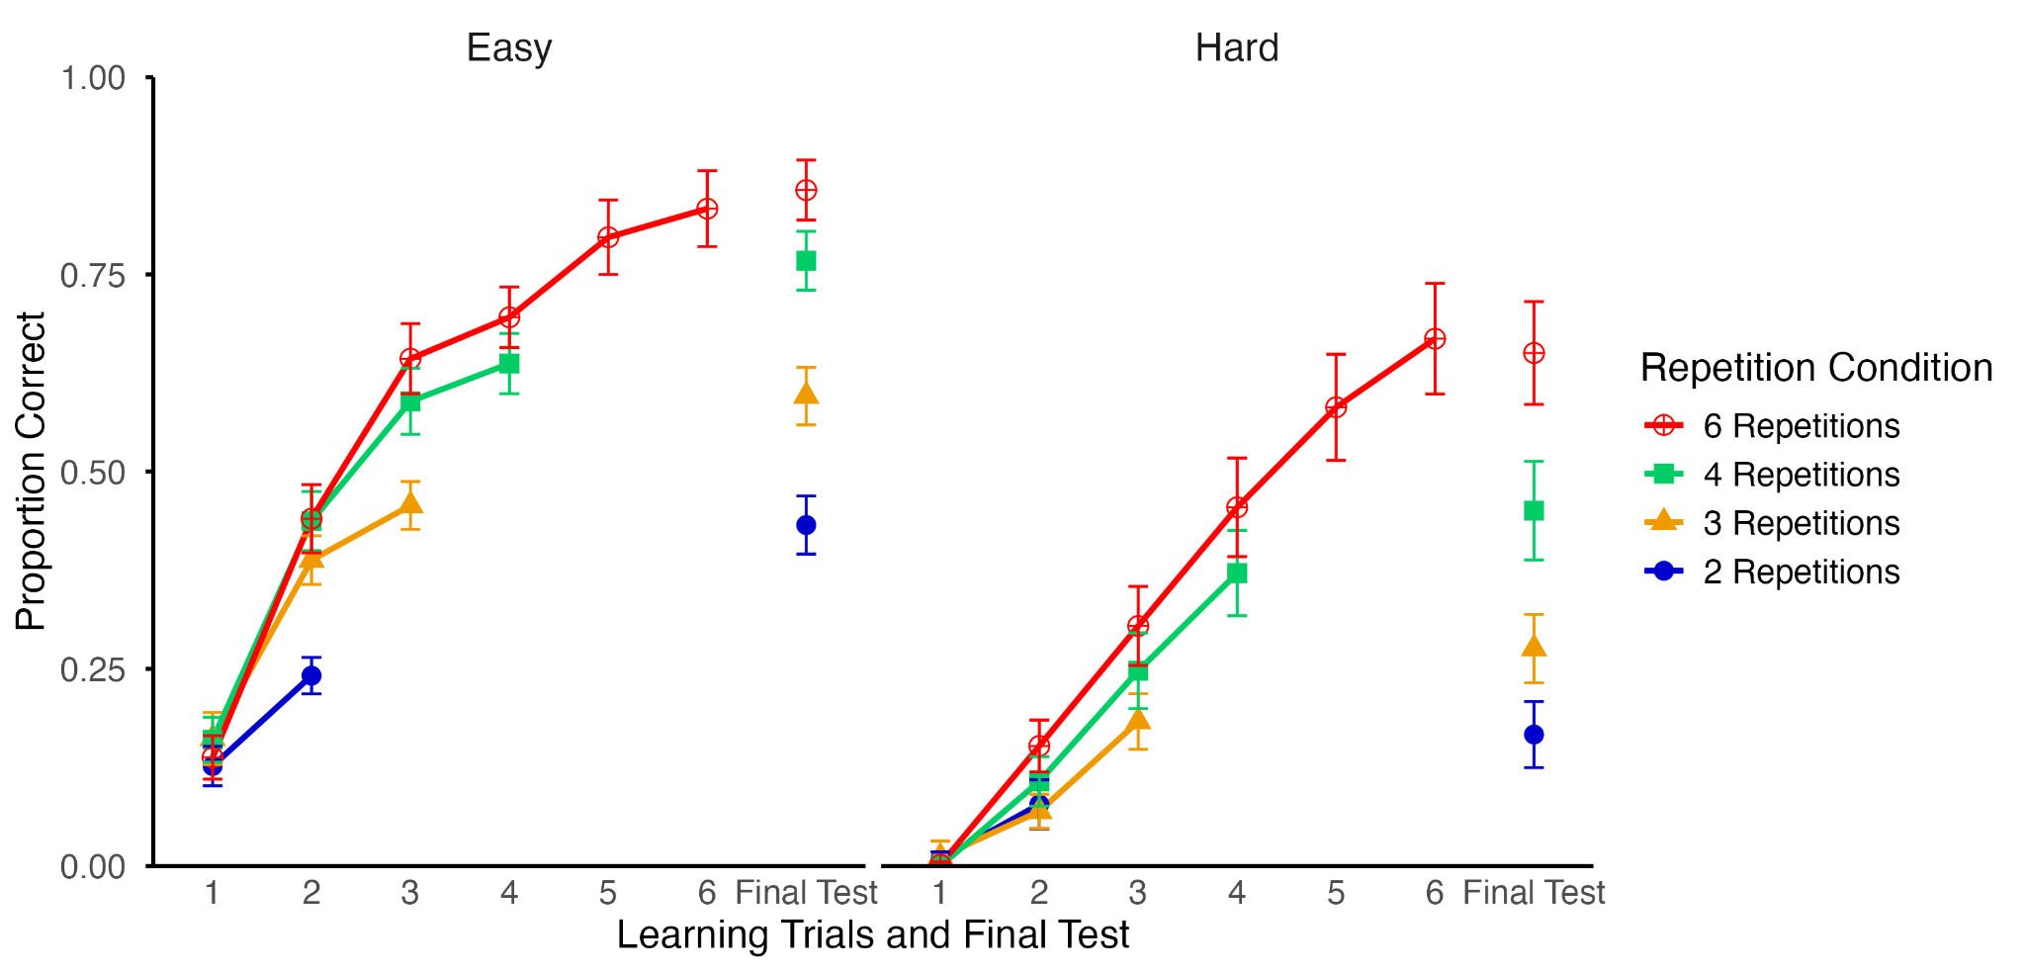

The results for the final test were also consistent with those obtained before excluding high-performing participants. The mixed-effects ANOVA revealed a significant main effect of repetition/spacing condition, F(3, 386) = 98.95, p < .001, R² = .435, a significant main effect of item difficulty, F(1, 386) = 509.67, p < .001, R² = .569, and a significant interaction between repetition/spacing condition and item difficulty, F(3, 386) = 4.63, p = .003, R² = .035.

Experiment 2
In Experiment 2, 84 participants in the 4-repetition condition and 90 participants in the 6-repetition condition reached ceiling performance on the 4th trial. Therefore, we removed 90 high-performing participants in each condition. The final sample consisted of 100 participants in the 2-repetition condition, 111 in the 3-repetition condition, 98 in the 4-repetition condition, and 111 in the 6-repetition condition.
During the learning phase, the mixed-effects ANOVA revealed a significant main effect of repetition/spacing condition, F(3, 557.86) = 138.62, p < .001, R² = .427, and a significant main effect of item difficulty, F(1, 2894.37) = 505.33, p < .001, R² = .149, replicating the pattern observed before excluding high-performing participants. In contrast, the interaction between repetition/spacing condition and item difficulty was not significant after excluding high-performing participants, F(3, 2894.37) = 1.05, p = .371, R² = .001.
However, the results for the final test were consistent with those obtained before excluding high-performing participants. There was a significant main effect of repetition/spacing condition, F(3, 426) = 67.37, p < .001, R² = .322, and a significant main effect of item difficulty, F(1, 426) = 637.06, p < .001, R² = .599. Importantly, the interaction between repetition/spacing condition and item difficulty was still significant, F(3, 426) = 16.72, p < .001, R² = .105 (see Figure 2S).
Figure 2S
Average Accuracy After Excluding High-Performing Participants (Experiment 2)
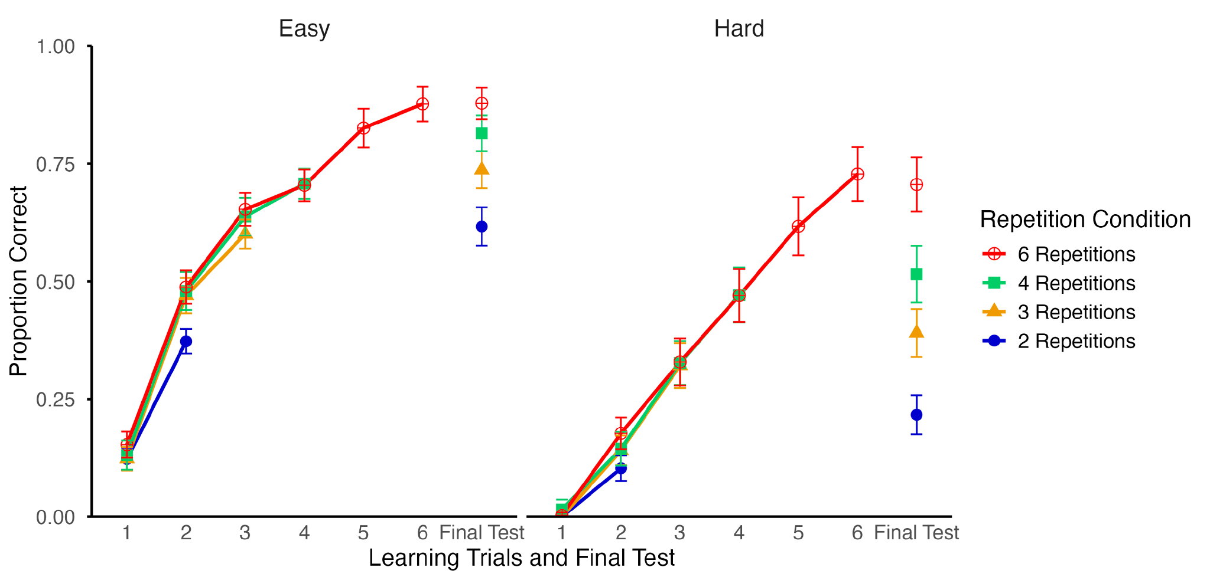

Experiment 3
Although the interaction between repetition/spacing and difficulty was not significant during the learning phase in Experiment 3, we conducted the same supplementary analyses excluding high-performing participants as in Experiments 1 and 2. There were 21 participants in the 4-repetition condition, and 31 in the 6-repetition condition, who achieved perfect accuracy on Trial 4. To maintain a consistent exclusion criterion, we removed 31 high-performing participants from each condition. The resulting sample included 23 participants in the 2-repetition condition, 33 in the 3-repetition condition, 21 in the 4-repetition condition, and 34 in the 6-repetition condition.
During the learning phase, the mixed-effects ANOVA revealed a significant main effect of repetition/spacing condition, F(3, 140.73) = 29.91, p < .001, R² = .389, and a significant main effect of item difficulty, F(1, 773.40) = 108.59, p < .001, R² = .123. In contrast, the interaction between repetition/spacing condition and item difficulty was not significant, F(3, 773.40) = 0.18, p = .909, R² = .001, replicating the results before excluding high-performing participants.
The results for the final tests were also consistent with those obtained before excluding high-performing participants. The mixed-effects ANOVA revealed a significant main effect of repetition/spacing condition, F(3, 107) = 21.00, p < .001, R² = .371, and a significant main effect of item difficulty, F(1, 551) = 405.39, p < .001, R² = .424. Importantly, the interaction between repetition/spacing condition and item difficulty was also significant, F(3, 551) = 10.01, p < .001, R² = .052 (see Figure 3S).
Figure 3S
Average Accuracy After Excluding High-Performing Participants (Experiment 3)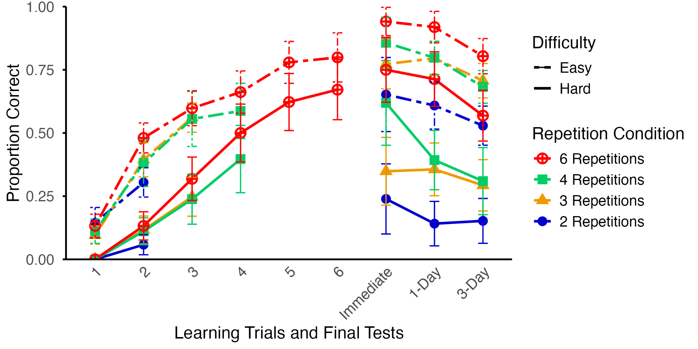

Simulated Forgetting over 20 Days
The results of the exponential decay model showed that increasing repetitions with shorter spacing intervals improved performance not only on initial recall but also at longer retention intervals, particularly for hard items. Because spacing theories emphasize long-term retention and the rate of forgetting over extended periods, we examined how participants’ performance would be expected to change beyond the three-day interval included in the study. To do so, we used the exponential function to extrapolate participants’ performance at longer retention intervals (up to 20 days). The simulated performance is shown in Figure 11. As shown in the figure, participants’ accuracy decreases with longer retention intervals, and this pattern is consistent across all item difficulty levels and repetition/spacing conditions. At no point does longer spacing with fewer repetitions result in better retention than shorter spacing with more repetitions. However, for easy items, performance differences between four and six repetitions were minimal, suggesting diminishing returns beyond four repetitions. In contrast, for hard items, additional repetitions with minimal spacing continued to yield clear benefits.
Figure 3S
Simulated Accuracy Over a 20-Day Retention Interval in Experiment 3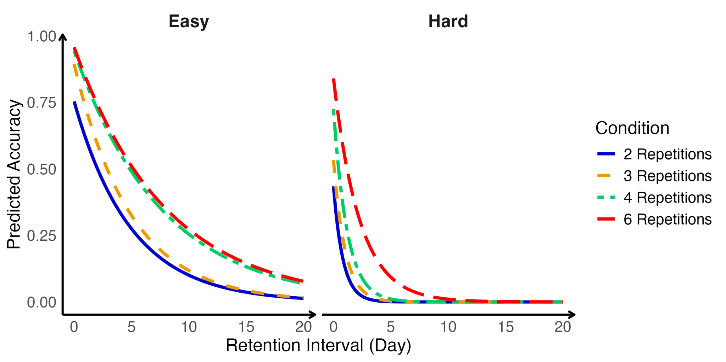

Reference
Bates, D., Mächler, M., Bolker, B., & Walker, S. (2015). Fitting linear mixed-effects models using lme4. Journal of Statistical Software, 67, 1-48. https://doi.org/10.18637/jss.v067.i01
Underwood, B. J. (1957). Interference and forgetting. Psychological review, 64(1), 49.

