Supplemental File
AI Model Information
In the present experiments, we used the composite Hit-vs-False-Alarms (HFA) classifier trained by Ayala, Smith, Ying, et al. (2025) as our AI model. The authors videorecorded eyewitnesses as they completed lineup procedures in the presence of a condition-blind research assistant. Afterwards, a team of condition-blind raters evaluated the videorecordings on theoretically informed reflector variables (see Table S1) and the authors subjected the resulting data to machine learning analyses. The purpose of this experiment was to identify the witness behaviors that demonstrated a significant capacity to predict culprit presence and the extent to which these behaviors provide added predictive value over confidence and decision speed.
To accomplish this, the authors conducted a logistic regression analysis with a LASSO (Least Absolute Shrinkage and Selection Operator) constraint (Ayala, Smith, & Wells, 2025; Dobbins & Kantner, 2019; Tibshirani, 1996). The LASSO constraint buffers against the potential that the parameter estimates in the regression models reflect patterns of noise in the dataset (overfitting; McNeish, 2015), a phenomenon that is likely in cases where a model contains numerous predictor variables. The LASSO constraint guards against overfitting by (1) shrinking inflated parameter estimates towards zero and (2) shrinking predictor variables with near-zero parameter estimates to zero and effectively removing them from the model.
The extent to which the LASSO procedure constrains the model’s parameter estimates was determined via a 10-fold cross-validation training process. The dataset was partitioned into 10 subsets (folds), and the authors trained the classifier on nine folds and validated (predicted culprit presence) on the remaining fold. They repeated this process 10 times, with each tenth of the data serving as the validation dataset. Through this iterative process, the LASSO procedure reduced coefficients derived from noise and removed predictors that did not contribute to the model’s predictive accuracy. The behaviors that the classifier deemed as predictive and accordingly retained in the model are presented in Figure S1.
Table S1.
Reflector Variables in Ayala, Smith, Ying, et al. (2025)
Variable Name |  | Variable Scoring
Visual Fluency: Facial Expressions |  | On a scale from little to no effort (1), moderate effort (2), or high effort (3)
Visual Fluency: Movements and Gestures
Uncertain
Certain
Easy
Difficult
Weak Memory
Strong Memory
Elimination
Automatic |  | Binary (Present or Absent)
Waver
Compare
Feature Match
Holistic Match
Feature Rejection
Holistic Rejection
Familiar/Similar
Nobody’s Familiar
Decision Time |  | Continuous (in seconds)
Confidence |  | Continuous (0-100%)

Figure S1.
Retained Behaviors for the Hits-False Alarms Classifier from Ayala, Smith, Ying, et al. (2025)
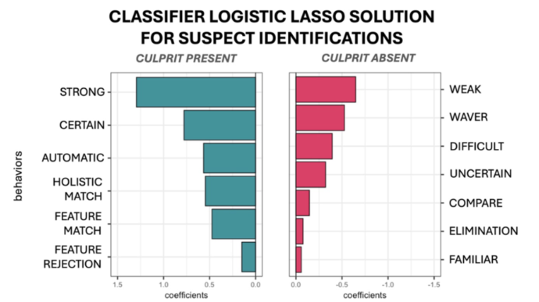
To create a composite classifier, Ayala, Smith, Ying, and colleagues (2025) fit a series of non-regularized hierarchical logistic regression models. The authors first ran three base models, in which culprit presence was regressed on one of three classes of behaviors: confidence, decision time, and the log odds estimates obtained from the behavior classifier (Figure S1). The authors saved the model-predicted log odds of culprit presence for each observation obtained from each base model in order to run a composite regression model including confidence, decision speed, and witness behaviors. In the current studies, we used this composite classifier as our AI model because it led to better classification performance than the confidence-only, speed-only, or behavior-only models (see Figure S2).
Importantly, because the authors employed a cross-validation technique for training this AI model, the receiver-operating characteristic analyses likely provide an upper-bound estimate of its likely performance in real-world contexts. The AI model was trained and tested on videos that followed the same general protocol with the same set of stimuli (Kapoor & Narayanan, 2023). The utility of behavioral cues for predicting accuracy would likely vary much more widely in practice, which would lower the AI model’s performance.
Figure S2.
Training Receiver Operating Characteristic (ROC) Curves for the Suspect-Identification Model from Ayala, Smith, Ying, et al. (2025).
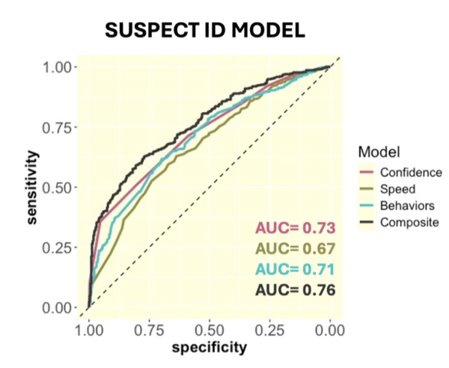
Multi-level Ordinal Regression Analyses
In the primary analyses in the main text of this paper, we conducted empirical ROC analyses to examine differences in discriminability across evaluation-approach conditions. Because participants in the control and simple-scoring conditions completed eight trials each, we conducted multi-level ordinal regression analyses with a random intercept for evaluator to compare the intuition and simple-scoring approach ROCs while controlling for potential nesting effects. We used a probit link function because it assumes that the evidence strength is normally distributed and, therefore, the regression coefficients can be interpreted in d′ units (DeCarlo, 1998). Because some confidence bins only included a small number of observations, I collapsed responses into 11 bins: Accurate 100%, Accurate 90%, Accurate 80%, Accurate 60-70%, Accurate 10-50%, Accurate/Inaccurate 0%, Inaccurate 10-50%, Inaccurate 60-70%, Inaccurate 80%, Inaccurate 90%, and Inaccurate 100%. I calculated AUCs using the following formula (Wickens, 2002):
$$A_{z}=Φ\left(\frac{μ_{s}}{\sqrt{1+ σ_{s}^{2}}}\right)$$
In Experiment 1, we found that evaluators who used the simple-scoring approach (AUC = .73) better discriminated between accurate witnesses and inaccurate witnesses than evaluators who provided intuitive judgments (AUC = .65), B = .26, SE = .08, Wald’s z = 3.37, p < .001 (see Figure S3). These findings are consistent with those from the empirical ROC analyses presented in the main text. In Experiment 2, we found no difference in discriminability between evaluators in the simple-scoring condition (AUC = .71) and those in the informed-judgment condition (AUC = .71), B = .01, SE = .08, Wald’s z = .18, p = .86 (see Figure S4). This is, again, consistent with the results from the empirical ROC comparison presented in the main text.
Figure S3.
Model-Predicted ROC Curves for Intuition Versus the Simple-Scoring Approach (Experiment 1)
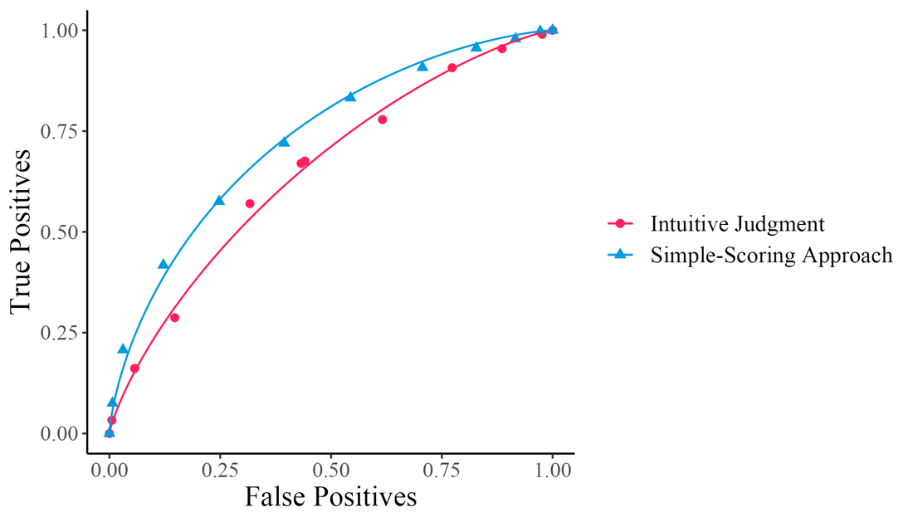
Figure S4.
Model-Predicted ROC Curves for Informed Judgments Versus the Simple-Scoring Approach (Experiment 2)
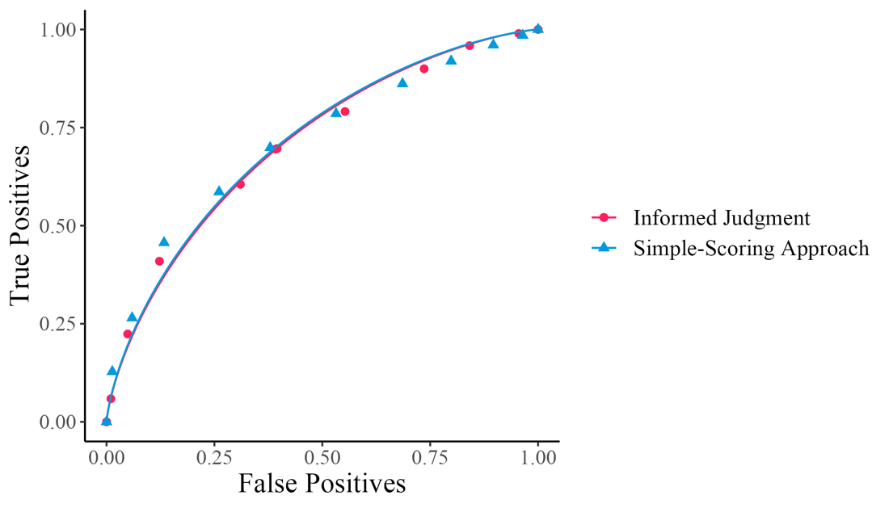
Model-Fitted Predictive Value Curves
In the primary analyses in the main text of the paper, we conducted empirical predictive value curves, which show suspect-identification accuracy (Culprit IDs / Culprit IDs + Innocent Suspect IDs) on the vertical axis against evaluator ratings on the horizontal axis (Figure 3). Here, we constructed model-fitted predictive-value curves. We fit a logistic regression model in which we regressed assessment rating on culprit presence (witness accuracy) separately for each evaluation-approach condition. We then plotted model-predicted values and calculated 95% confidence intervals for both Experiment 1 (Figure S5) and Experiment 2 (Figure S6). We found the same pattern as we do with the empirical curves: the AI model and the simple-scoring approach provide a benefit over intuition when predicting accuracy (Experiment 1), which was somewhat (but not entirely) attenuated when we informed participants on valid cues to accuracy (Experiment 2).

Figure S5.
Model-Predicted Predictive Value Curves for Experiment 1
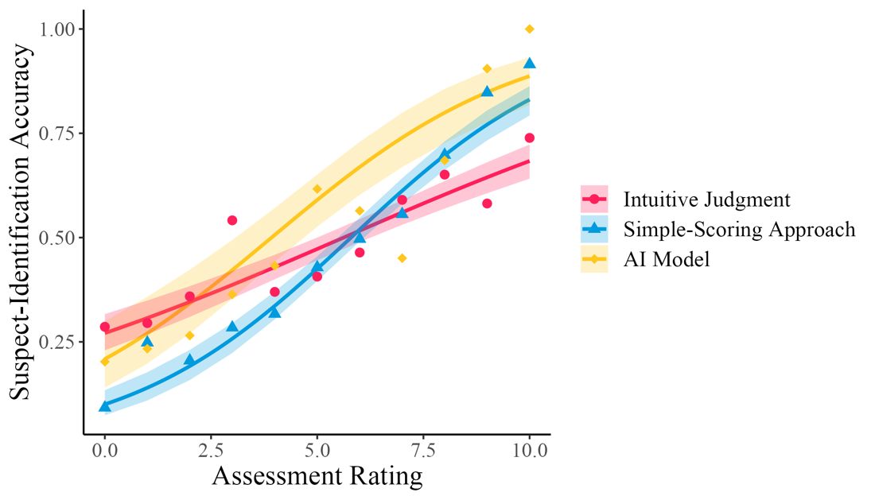
Figure S6.
Model-Predicted Predictive Value Curves for Experiment 2
