Supplemental Materials

Addis, D.R., Trikha, R., Fynes-Clinton, S., Li-Chay-Chung, A., Starrs, F., Cheng, Z.
How Depression, Age and Specificity Shapes the Content of Autobiographical Thoughts

For more information see: https://osf.io/7x9tq and https://osf.io/v7p9z/.

S1. Demographics

Table S1. Sample Broken Down by Country of Residence at S0

Country | n | Country | n
United Kingdom | 87 | Portugal | 19
Italy | 18 | Mexico* | 13
Spain | 13 | United States | 13
Canada | 10 | Chile | 7
France | 4 | Hungary | 4
New Zealand | 3 | Finland | 2
Greece | 2 | Ireland | 2
The Netherlands | 2 | Poland | 2
Belgium | 1 | Slovenia | 1
Note. *All countries are considered developed except for Mexico
(Human Development Index < .80; https://hdr.undp.org/data-center).

Figure S1. Histogram of Age Distribution of Sample
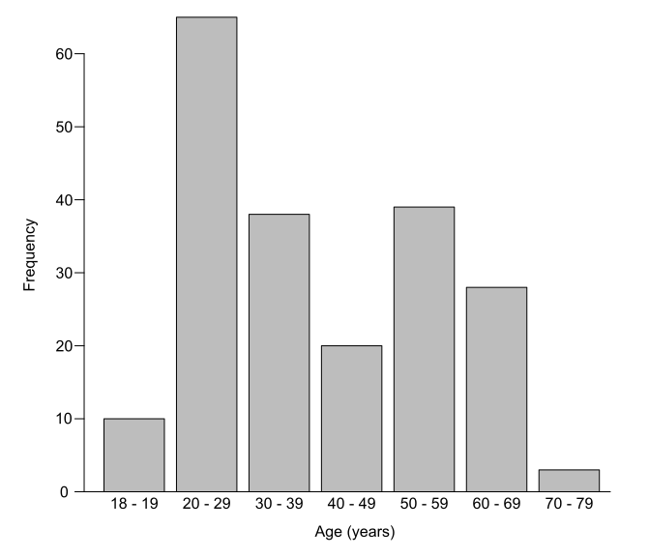
S2. Custom Pandemic Dictionary
To measure the prevalence of pandemic-related content in participants’ responses, we created a custom “pandemic” dictionary for use as a category by LIWC-22. To identify pandemic-related words in common usage during 2020, we examined government COVID-19 glossaries (e.g., Canada COVID-19 Glossary) in March 2021, and the Oxford English Corpus top 20 keywords for January to June 2020 (i.e., words with the largest significant increase between their frequency in the corpus for that month relative to their baseline frequency in the corpus over time), thus capturing words prevalent internationally. If applicable, alternate versions were created (e.g., 1st wave, 1st-wave, first wave, first-wave), and words shortened to the most appropriate root (e.g., declar* for declares, declared, declaring, declaration, etc.). The custom pandemic dictionary, provided in Table S2, comprised 271 words.

Table S2. Words Comprising the Custom Pandemic Dictionary

2020 | curb-side | herd immunity | panic-bought | skyp*
1st wave | cytokine* | herd-immunity | panicbuy* | smell
1st-wave | daily life | high temperature* | panic-buy* | spike
2 m | daily routine* | high-temperature* | person to person | spike protein*
2 meter | death | hoard* | personal protect* | spread*
2019-ncov | declar* | home school* | personal protective equipment* | stay at home
2m | departure | homeschool* | personal-protect* | stay-at-home
2-meter | detect* | home-school* | personal-protective-equipment* | strain*
2nd wave | dexameth* | hospital* | person-to-person | super spread*
2nd-wave | disease* | human to human | phase* | superspread*
3rd wave | disinfect* | human-to-human | pod | super-spread*
3rd-wave | distanc* | hydroxy* | pods | surge*
6' | droplet* | hydroxychloroquine | positive test* | swab*
6 f* | drug* | hygien* | postcovid | symptom*
6 ft | ease | icu | postpandemic | taste
6-f* | eased | immun* | ppe | temperature check
6ft | easing | in person | precaution* | test negative
Airborne | elbow bump | incubat* | precovid | test positive
anti bod* | elbow-bump | infect* | prepandemic | test*
anti vir* | emergency | inflamm* | protect* | tested negative
antibod* | epicent* | influenza | public health | tested positive
anti-bod* | epidemic* | in-person | publichealth | tests negative
antivir* | essential | intensive care | public-health | tests positive
anti-vir* | evacu* | intensive care unit | quarantin* | third wave
asymptom* | face shield | intensive-care | remdes* | third-wave
at home | face-shield | intensive-care-unit | remote* | toll
at risk | fatalit* | isolat* | reopen* | trace*
at-home | fever* | lock down* | re-open* | tracing
at-risk | fight | lockdown* | respirat* | transmiss*
border* | first wave | lock-down* | respons* | travel
bubble* | first-wave | locked down* | restrict* | two met*
capacity | fist bump | locked-down* | roll out | two-met*
case* | fist-bump | locks down* | rolled out | unidentif*
caution* | flatten the curve | locks-down* | rolled-out | vaccin*
china | flatten-the-curve | long covid | rollout | variant*
chinese | flu | long haul* | roll-out | ventilat*
clinic* | flu like | longhaul* | rolls out | viral*
closed | flu-like | long-haul* | rolls-out | virtual*
closur* | foot shake | mask* | routine* | virul*
cluster* | foot-shake | medic* | saniti* | virus*
confirmed | from home | n 95 | sars | volatil*
contact* | from-home | n95 | sars* | vulnerab*
contagio* | front line | n-95 | sars-* | wash
corona * | frontline | nasal | screen* | washed
corona* | front-line | negative test* | second wave | washes
corona-* | glove* | non essential | second-wave | washing
coronavirus | gown* | non-essential | self isolat* | wfh
cough* | hand gel* | nose | self monitor* | world health organ*
covering | hand wash* | novel | self quarantin* | world-health-organ*
covid | handgel* | origin* | self-isolat* | wuhan
covid 19 | hand-gel* | outbreak* | self-monitor* | zoom*
covid-19 | handwash* | pandemic* | self-quarantin*
crisis* | hand-wash* | panic bought | shelter in place
curb side | health care | panic buy* | shelter-in-place
curbside | health-care | panicbought | shortage*

S3. LIWC variables

Table S3. Groupings, Abbreviations and Descriptions of LIWC Variables included in PCAs

Variable number | Variable Grouping | LIWC Category | Abbreviation | Description / most frequently  used exemplars
1 | Summary | Word Count | Word Count | Total word count
2 | Summary | Words per sentence | WPS | Average words per sentence
3 | Summary | Big Words | Big Words | Percent words 7 letters or longer
4 | Linguistic | Total function words | Function Words | the, to, and, I
5 | Pronouns | Total pronouns | Pronouns | I, you, that, it
6 | Pronouns | Personal pronouns | Pers. Pronouns | I, you, my, me
7 | Pronouns | 1st person singular | I | I, me, my, myself
8 | Pronouns | 1st person plural | We | we, our, us, lets
9 | Pronouns | 2nd person | You | you, your, u, yourself
10 | Pronouns | 3rd person singular | She/He | he, she, her, his
11 | Pronouns | 3rd person plural | They | they, their, them, themsel*
12 | Pronouns | Impersonal pronouns | Impers. Pronouns | that, it, this, what
13 | Linguistic | Determiners | Determiners | the, at, that, my
14 | Linguistic | Articles | Articles | a, an, the, alot
15 | Linguistic | Numbers | Numbers | one, two, first, once
16 | Linguistic | Prepositions | Prepositions | to, of, in, for
17 | Linguistic | Auxiliary Verbs | Auxiliary Verbs | is, was, be, have
18 | Linguistic | Adverbs | Adverbs | so, just, about, there
19 | Linguistic | Conjunctions | Conjunctions | and, but, so, as
20 | Linguistic | Negations | Negations | not, no, never, nothing
21 | Linguistic | Common verbs | Verbs | is, was, be, have
22 | Linguistic | Common adjectives | Adjectives | more, very, other, new
23 | Linguistic | Quantities | Quantities | all, one, more, some
24 | Drives/Motives | Affiliation | Affiliation | we, our, us, help
25 | Drives/Motives | Achievement | Achieve | work, better, best, working
26 | Drives/Motives | Power | Power | own, order, allow, power
27 | Cognition | All-or-none | All or None | all, no, never, always
28 | Cognition | Cognitive processes | Cognitive | but, not, if, or, know
29 | Cognition | Insight | Insight | know, how, think, feel
30 | Cognition | Causation | Causation | how, because, make, why
31 | Cognition | Discrepancy | Discrepancy | would, can, want, could
32 | Cognition | Tentative | Tentative | if, or, any, something
33 | Cognition | Certitude | Certitude | really, actually, of course, real
34 | Cognition | Differentiation | Differentiation | but, not, if, or
35 | Cognition | Memory | Memory | remember, forget, remind, forgot
36 | Affect | Positive tone | Positive Tone | good, well, new, love
37 | Affect | Negative tone | Negative Tone | bad, wrong, too much, hate
38 | Affect | Emotion | Emotion | good, love, happy, hope
39 | Affect | Positive emotion | Positive Emotion | good, love, happy, hope
40 | Affect | Negative emotion | Negative Emotion | bad, hate, hurt, tired
41 | Affect | Anxiety | Anxiety | worry, fear, afraid, nervous
42 | Affect | Anger | Anger | hate, mad, angry, frustr*
43 | Affect | Sadness | Sadness | :(, sad, disappoint*, cry
44 | Affect | Swear words | Swear Words | shit, fuckin*, fuck, damn
45 | Social/Cultural | Social behavior | Social Behavior | said, love, say, care
46 | Social/Cultural | Prosocial behavior | Prosocial | care, help, thank, please
47 | Social/Cultural | Politeness | Politeness | thank, please, thanks, good morning
48 | Social/Cultural | Interpersonal conflict | Interpers. Conflict | fight, kill, killed, attack
49 | Social/Cultural | Moralization | Moralization | wrong, honor*, deserv*, judge
50 | Social/Cultural | Communication | Communication | said, say, tell, thank*
51 | Social/Cultural | Social referents | Social Referents | you, we, he, she
52 | Social/Cultural | Family | Family | parent*, mother*, father*, baby
53 | Social/Cultural | Friends | Friends | friend*, boyfriend*, girlfriend*, dude
54 | Social/Cultural | Female references | Female | she, her, girl, woman
55 | Social/Cultural | Male references | Male | he, his, him, man
56 | Social/Cultural | Politics | Politics | united states, govern*, congress*, senat*
57 | Social/Cultural | Ethnicity | Ethnicity | american, french, chinese, indian
58 | Social/Cultural | Technology | Technology | car, phone, comput*, email*
59 | Lifestyle | Leisure | Leisure | game*, fun, play, party*
60 | Lifestyle | Home | Home | home, house, room, bed
61 | Lifestyle | Work | Work | work, school, working, class
62 | Lifestyle | Money | Money | business*, pay*, price*, market*
63 | Lifestyle | Religion | Religion | god, hell, christmas*, church
64 | Physical | Health | Health | medic*, patients, physician*, health
65 | Physical | Illness | Illness | hospital*, cancer*, sick, pain
66 | Physical | Wellness | Wellness | healthy, gym*, supported, diet
67 | Physical | Mental Health | Mental Health | mental health, depressed, suicid*, trauma*
68 | Physical | Substances | Substances | beer*, wine, drunk, cigar*
69 | Physical | Food | Food | food*, drink*, eat, dinner*
70 | Physical | Death | Death | death*, dead, die, kill
71 | States | Need | Need | have to, need, had to, must
72 | States | Want | Want | want, hope, wanted, wish
73 | States | Acquire | Acquire | get, got, take, getting
74 | States | Lack | Lack | don’t have, didn’t have, *less, hungry
75 | States | Fulfilled | Fulfilled | enough, full, complete, extra
76 | States | Fatigue | Fatigue | tired, bored, don’t care, boring
77 | Drives/Motives | Reward | Reward | opportun*, win, gain*, benefit*
78 | Drives/Motives | Risk | Risk | secur*, protect*, pain, risk*
79 | Drives/Motives | Curiosity | Curiosity | scien*, look* for, research*, wonder
80 | Drives/Motives | Allure | Allure | have, like, out, know
81 | Perception | Attention | Attention | look, look* for, watch, check
82 | Perception | Motion | Motion | go, come, went, came
83 | Perception | Time | Time | when, now, then, day
84 | Perception | Space | Space | in, out, up, there
85 | Perception | Visual | Visual | see, look, eye*, saw
86 | Perception | Auditory | Auditory | sound*, heard, hear, music
87 | Perception | Feeling | Feeling | feel, hard, cool, felt
88 | Time | Past focus | Past Focus | was, had, were, been
89 | Time | Present focus | Present Focus | is, are, I’m, can
90 | Time | Future focus | Future Focus | will, going to, have to, may
91 | Conversational | Netspeak | Netspeak | :), u, lol, haha*
92 | Conversational | Assent | Assent | yeah, yes, okay, ok
93 | ¹Pandemic | ¹Pandemic | Pandemic | pandemic, covid, corona, wuhan, zoom
Note: Adapted from LIWC-22 Development Manual (retrieved on 1 December 2024, from https://www.liwc.app/static/documents/LIWC-22%20Manual%20-%20Development%20and%20Psychometrics.pdf) ¹Custom LIWC dictionary (see Section S2).

Table S4. Mean Percentages of Past and Future Responses in LIWC Categories

Grouping | LIWC Category | % of Past Responses |  |  | % of Future Responses
Grouping | LIWC Category | M | SD |  | M | SD
Linguistic | Function Words | 55.95 | 6.38 |  | 59.55 | 5.48
Linguistic | Determiners | 14.86 | 3.83 |  | 13.78 | 3.56
Linguistic | Articles | 5.99 | 2.66 |  | 5.41 | 2.55
Linguistic | Numbers | 1.41 | 1.44 |  | 0.73 | 0.94
Linguistic | Prepositions | 13.92 | 3.99 |  | 13.28 | 3.97
Linguistic | Auxiliary Verbs | 14.06 | 5.13 |  | 20.15 | 6.97
Linguistic | Adverbs | 4.68 | 2.67 |  | 4.26 | 2.52
Linguistic | Conjunctions | 5.00 | 2.83 |  | 4.69 | 2.56
Linguistic | Negations | 1.27 | 2.15 |  | 0.98 | 2.45
Linguistic | Verbs | 25.93 | 6.46 |  | 30.45 | 7.57
Linguistic | Adjectives | 6.06 | 3.05 |  | 6.01 | 2.76
Linguistic | Quantities | 4.45 | 3.03 |  | 3.47 | 2.34
Summary | Word Count | 14.62 | 10.33 |  | 14.43 | 10.02
Summary | WPS | 11.22 | 5.00 |  | 11.37 | 4.87
Summary | Big Words | 17.36 | 5.81 |  | 15.02 | 5.94
Pronoun | Pronouns | 11.84 | 4.96 |  | 11.35 | 4.56
Pronoun | Pers. Pronouns | 8.94 | 4.32 |  | 8.07 | 3.85
Pronoun | I | 7.68 | 4.22 |  | 6.98 | 3.66
Pronoun | We | 0.48 | 0.73 |  | 0.57 | 0.91
Pronoun | You | 0.13 | 0.43 |  | 0.10 | 0.38
Pronoun | She/He | 0.29 | 0.62 |  | 0.13 | 0.35
Pronoun | They | 0.24 | 0.46 |  | 0.21 | 0.43
Pronoun | Impers. Pronouns | 2.90 | 2.33 |  | 3.28 | 2.49
Time | Time | 5.84 | 3.01 |  | 5.44 | 2.87
Time | Past Focus | 14.41 | 5.71 |  | 1.64 | 1.90
Time | Present Focus | 4.53 | 2.40 |  | 6.13 | 2.42
Time | Future Focus | 0.99 | 1.33 |  | 8.52 | 3.81
Cognition | All or None | 1.17 | 2.25 |  | 1.16 | 2.51
Cognition | Cognitive | 9.17 | 4.48 |  | 8.97 | 4.23
Cognition | Insight | 2.85 | 2.45 |  | 2.22 | 1.97
Cognition | Causation | 1.45 | 1.29 |  | 1.26 | 1.29
Cognition | Discrepancy | 1.18 | 1.36 |  | 1.92 | 1.73
Cognition | Tentative | 1.24 | 1.63 |  | 1.89 | 1.88
Cognition | Certitude | 0.36 | 0.76 |  | 0.21 | 0.50
Cognition | Differentiation | 2.12 | 1.74 |  | 2.10 | 1.70
Cognition | Memory | 0.11 | 0.32 |  | 0.26 | 0.63
Drives/Motives | Affiliation | 3.03 | 2.83 |  | 2.64 | 2.60
Drives/Motives | Achieve | 2.57 | 2.84 |  | 3.07 | 2.50
Drives/Motives | Power | 0.64 | 1.28 |  | 0.67 | 0.92
Drives/Motives | Reward | 0.16 | 0.67 |  | 0.23 | 0.69
Drives/Motives | Risk | 0.31 | 0.71 |  | 0.57 | 1.20
Drives/Motives | Curiosity | 0.22 | 0.54 |  | 0.16 | 0.49
Drives/Motives | Allure | 9.09 | 4.35 |  | 13.73 | 5.01
Social/Cultural | Social Behavior | 2.93 | 2.79 |  | 2.41 | 2.11
Social/Cultural | Prosocial | 0.55 | 1.05 |  | 0.68 | 1.10
Social/Cultural | Politeness | 0.06 | 0.31 |  | 0.03 | 0.28
Social/Cultural | Interpers. Conflict | 0.04 | 0.17 |  | 0.04 | 0.15
Social/Cultural | Moralization | 0.09 | 0.30 |  | 0.08 | 0.30
Social/Cultural | Communication | 0.51 | 0.97 |  | 0.32 | 0.80
Social/Cultural | Social Referents | 5.00 | 3.68 |  | 4.21 | 3.61
Social/Cultural | Family | 1.90 | 2.88 |  | 1.78 | 2.64
Social/Cultural | Friends | 0.80 | 1.84 |  | 0.48 | 1.06
Grouping | LIWC Category | % of Past Responses |  |  | % of Future Responses
Grouping | LIWC Category | mean | sd |  | mean | sd
Social/Cultural | Female | 0.95 | 1.71 |  | 0.65 | 1.40
Social/Cultural | Male | 0.62 | 1.61 |  | 0.34 | 0.94
Social/Cultural | Politics | 0.18 | 0.73 |  | 0.11 | 0.37
Social/Cultural | Ethnicity | 0.02 | 0.20 |  | 0.03 | 0.25
Social/Cultural | Technology | 0.48 | 1.29 |  | 0.30 | 0.87
Affect | Positive Tone | 3.98 | 2.88 |  | 5.31 | 3.21
Affect | Negative Tone | 2.78 | 2.93 |  | 1.22 | 1.38
Affect | Emotion | 2.97 | 2.87 |  | 2.43 | 2.27
Affect | Positive Emotion | 1.31 | 1.87 |  | 1.99 | 2.12
Affect | Negative Emotion | 1.54 | 2.28 |  | 0.39 | 0.71
Affect | Anxiety | 0.76 | 1.62 |  | 0.22 | 0.52
Affect | Anger | 0.13 | 0.54 |  | 0.02 | 0.09
Affect | Sadness | 0.31 | 1.07 |  | 0.08 | 0.36
Affect | Swear Words | 0.01 | 0.11 |  | 0.01 | 0.19
Perception | Attention | 0.35 | 0.78 |  | 0.45 | 0.89
Perception | Motion | 2.50 | 2.07 |  | 2.37 | 2.19
Perception | Space | 5.93 | 3.44 |  | 6.47 | 3.18
Perception | Visual | 0.73 | 1.26 |  | 0.75 | 1.12
Perception | Auditory | 0.15 | 0.41 |  | 0.05 | 0.22
Perception | Feeling | 0.91 | 1.30 |  | 0.33 | 0.69
Lifestyle | Leisure | 1.23 | 3.04 |  | 0.96 | 2.62
Lifestyle | Home | 1.22 | 1.57 |  | 0.83 | 1.12
Lifestyle | Work | 3.36 | 3.63 |  | 2.91 | 3.38
Lifestyle | Money | 0.76 | 1.10 |  | 0.63 | 0.99
Lifestyle | Religion | 0.08 | 0.41 |  | 0.05 | 0.27
Physical | Health | 1.65 | 1.96 |  | 1.73 | 1.84
Physical | Illness | 1.15 | 1.41 |  | 1.15 | 1.56
Physical | Wellness | 0.10 | 0.53 |  | 0.18 | 0.73
Physical | Mental Health | 0.07 | 0.34 |  | 0.05 | 0.24
Physical | Substances | 0.02 | 0.17 |  | 0.00 | 0.04
Physical | Food | 0.83 | 1.95 |  | 0.36 | 1.15
Physical | Death | 0.16 | 0.48 |  | 0.07 | 0.34
Pandemic | ¹Pandemic | 3.32 | 3.12 |  | 2.93 | 2.70
States | Need | 0.52 | 0.99 |  | 0.55 | 0.98
States | Want | 0.31 | 0.70 |  | 0.77 | 1.04
States | Acquire | 1.19 | 1.63 |  | 1.16 | 1.52
States | Lack | 0.08 | 0.34 |  | 0.04 | 0.22
States | Fulfilled | 0.07 | 0.29 |  | 0.13 | 0.36
States | Fatigue | 0.12 | 0.67 |  | 0.02 | 0.11
Conversational | Netspeak | 0.06 | 0.31 |  | 0.04 | 0.26
Conversational | Assent | 0.04 | 0.44 |  | 0.03 | 0.24
Note. Means computed across 18 responses for 203 participants. Some words overlap between categories, therefore the percentage variables add up to more than 100. ¹Custom LIWC dictionary (see Section S2). M=Mean; SD = Standard deviation.

S4. Principal Components Analyses

Figure S2. Scree plots from the Principal Components Analyses

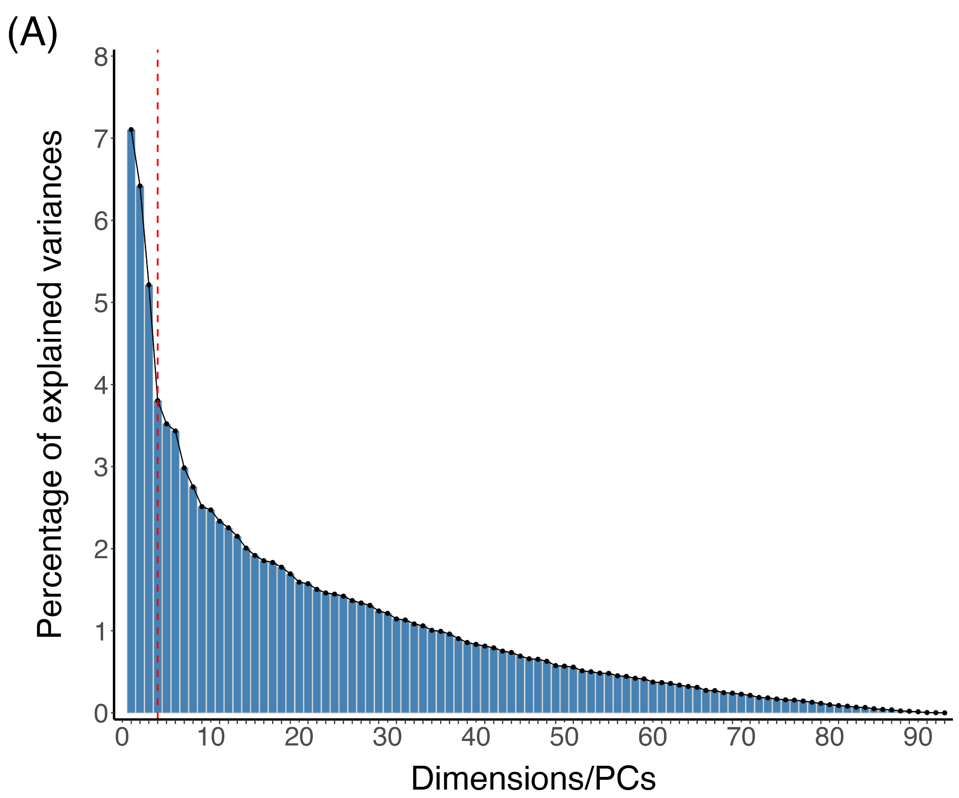
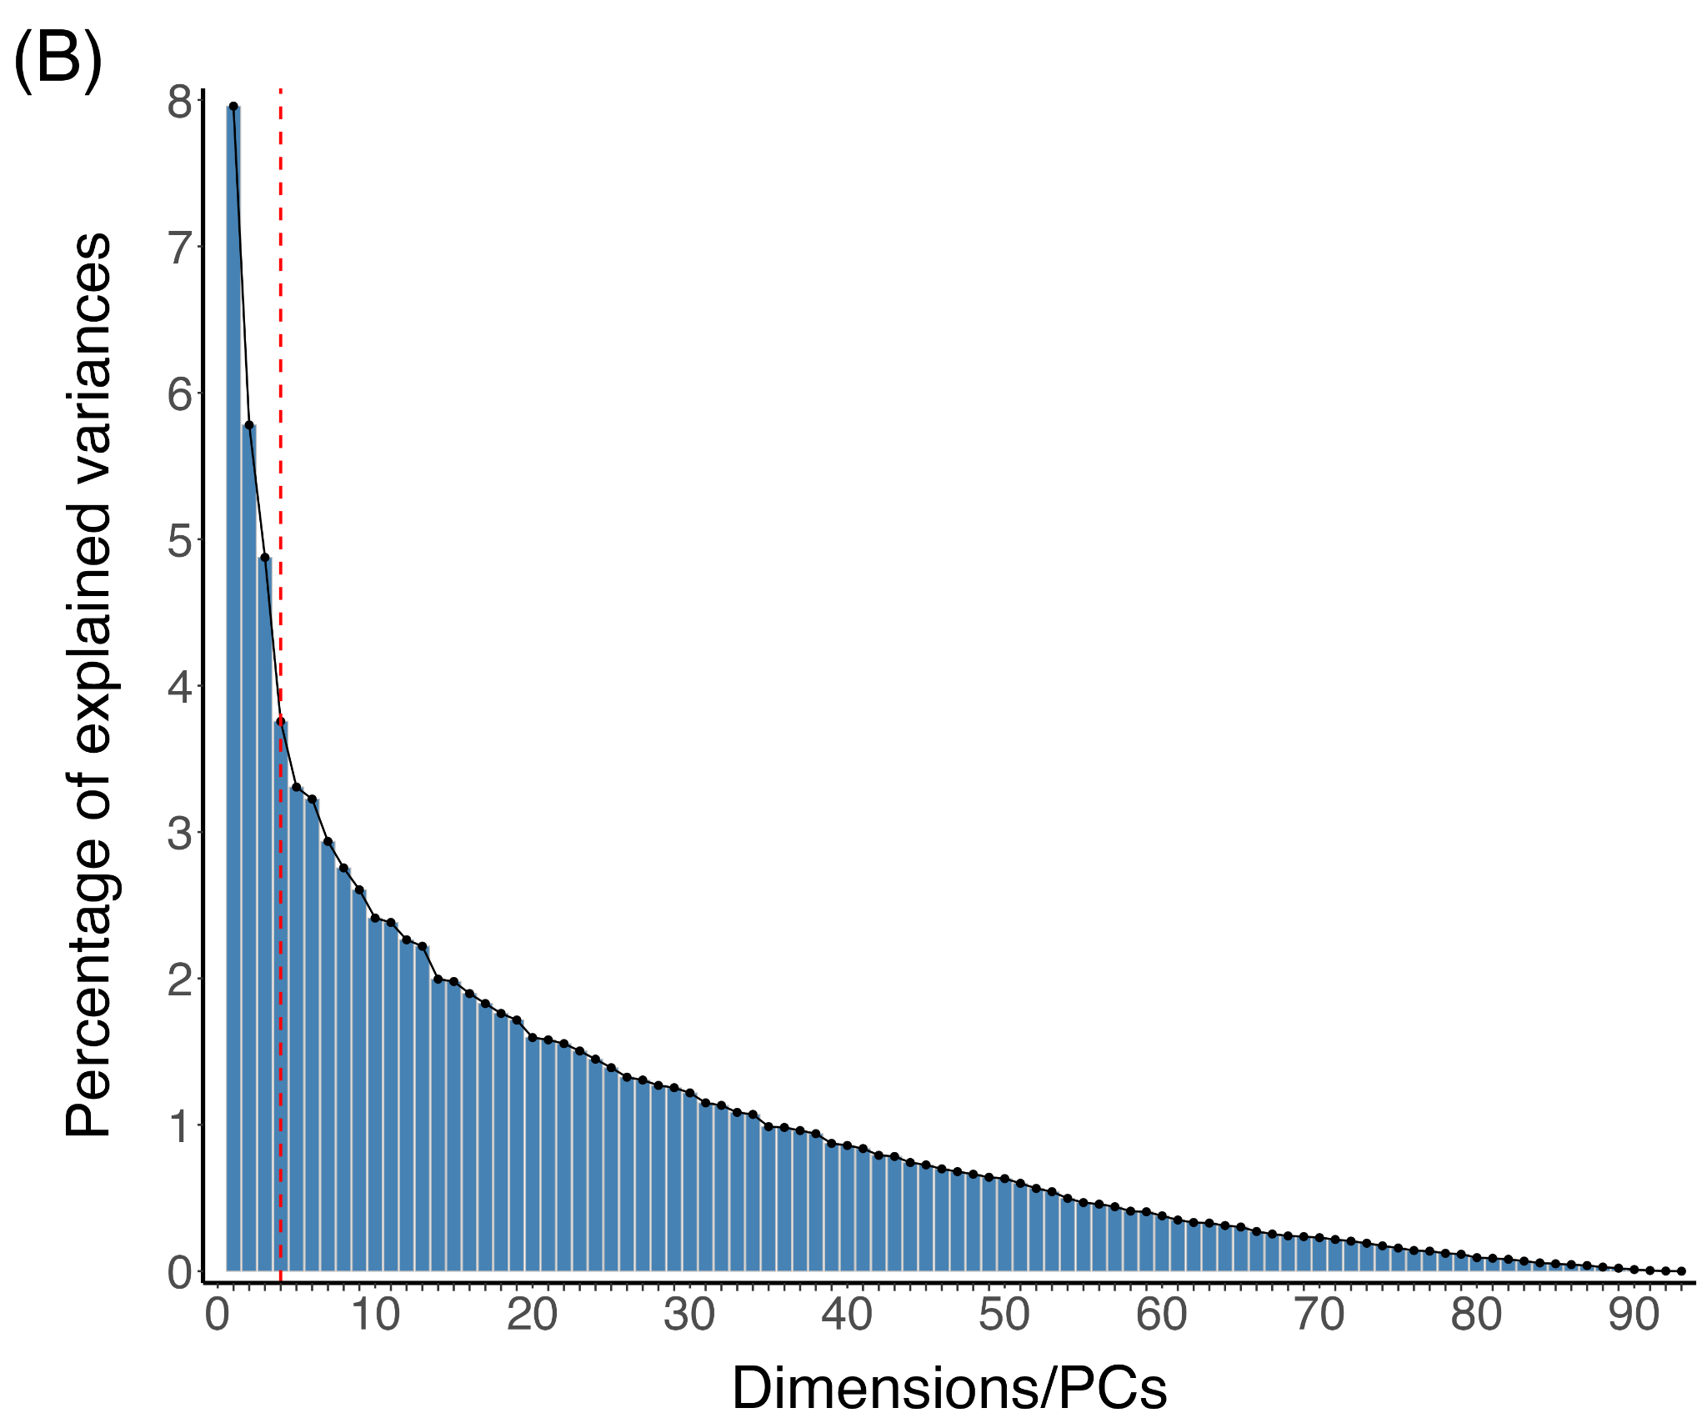

Note. Scree plots from the Principal Components Analyses run on the LIWC data for (A) Past and (B) Future SCT responses. The elbow method indicated that four PCs should be retained (dashed red line) for both PCA. LIWC = Linguistic Inquiry Word Count; PCA = Principal Components Analysis; PCs = Principal Components; SCT = Sentence Completion Task.

Table S5: Most strongly-loaded LIWC variables in each past and future PC.

PC1 (PF)  Episodic Richness |  |  |  | PC2 (PF)  Self-Focus |  |  |  | PC4 (P) / PC3 (F)  Positivity |  |  |  | PC3 (P)  Negative Past |  |  | PC4 (F)  Goal-Directed Thinking
LIWC Category | Loading |  |  | LIWC Category | Loading |  |  | LIWC Category | Loading |  |  | LIWC Category | Loading |  | LIWC Category | Loading
LIWC Category | P | F |  | LIWC Category | P | F |  | LIWC Category | P | F |  | LIWC Category | P |  | LIWC Category | F
WPS | -0.30 | -0.28 |  | Pers. Pronouns | -0.30 | -0.25 |  | Positive Emotion | -0.34 | -0.32 |  | Negative Emotion | -0.35 |  | I | -0.27
Word Count | -0.28 | -0.26 |  | I | -0.28 | -0.23 |  | Positive Tone | -0.27 | -0.27 |  | Negative Tone | -0.34 |  | Pronouns | -0.24
Conjunctions | -0.23 | -0.24 |  | Social Referents | -0.27 | -0.26 |  | Emotion | -0.18 | -0.30 |  | Emotion | -0.31 |  | Pers. Pronouns | -0.21
Cognitive | -0.23 | -0.13 |  | Affiliation | -0.26 | -0.26 |  | Allure | -0.30 | -0.07 |  | Anxiety | -0.24 |  | Work | -0.18
Adverbs | -0.19 | -0.13 |  | Female | -0.20 | -0.22 |  | Focus Present | -0.20 | -0.15 |  | Feeling | -0.19 |  | Technology | -0.15
Function Words | -0.24 | -0.10 |  | Family | -0.19 | -0.24 |  | Want | -0.09 | -0.26 |  |  |  |  | Power | -0.14
Differentiation | -0.23 | -0.12 |  | Pronouns | -0.24 | -0.16 |  | Social Behavior | -0.15 | -0.23 |  |  |  |  | Determiners | -0.14
Impers. Pronouns | -0.21 | -0.12 |  | Determiners | -0.22 | -0.16
Tentative | -0.17 | -0.11 |  | Male | -0.21 | -0.15
Pronouns | -0.15 | -0.19
Prepositions | -0.12 | -0.14
Determiners | -0.05 | -0.17
Pers. Pronouns | -0.06 | -0.15
Quantities | -0.05 | -0.14
Verbs | 0.23 | 0.30 |  | Cognitive | 0.20 | 0.25 |  | Illness | 0.26 | 0.18 |  | Space | 0.14 |  | Health | 0.27
Auxiliary Verbs | 0.16 | 0.29 |  | Emotion | 0.13 | 0.19 |  | Pandemic | 0.24 | 0.17 |  | Motion | 0.14 |  | Illness | 0.25
Work | 0.14 | 0.15 |  | Tentative | 0.13 | 0.19 |  | Health | 0.23 | 0.18 |  | Prepositions | 0.14 |  | Pandemic | 0.25
Past Focus | 0.24 | -0.08 |  | Discrepancy | 0.13 | 0.17 |  | Big Words | 0.18 | 0.09 |  | Food | 0.13 |  | Prepositions | 0.22
Food | 0.15 | 0.02 |  | Want | 0.13 | 0.14 |  | Numbers | 0.14 | 0.05 |  | Articles | 0.12 |  | Motion | 0.21
Future Focus | -0.05 | 0.27 |  | Negative Tone | 0.17 | 0.07 |  | Articles | 0.12 | 0.18 |  | Work | 0.11 |  | Space | 0.20
Allure | 0.05 | 0.17 |  | Verbs | 0.15 | -0.04 |  | Negative Tone | 0.09 | 0.14 |  | Fulfilled | 0.10 |  | Affiliation | 0.17
 |  |  |  | Negative Emotion | 0.14 | 0.10 |  | Time | 0.06 | 0.14 |  | Politics | 0.10 |  | Social Referents | 0.16
 |  |  |  | Negations | 0.14 | 0.10 |  |  |  |  |  | Allure | 0.10 |  | Family | 0.16
 |  |  |  | Adverbs | 0.12 | 0.10
 |  |  |  | Auxiliary Verbs | 0.12 | -0.06
 |  |  |  | Past Focus | 0.12 | 0.05
 |  |  |  | Positive Emotion | 0.03 | 0.17
 |  |  |  | Insight | 0.10 | 0.17
 |  |  |  | Adjectives | 0.09 | 0.16
 |  |  |  | Positive Tone | -0.01 | 0.15
Note. Shown in bold with red/blue fill are loadings ≥ 1 SD higher or lower than the mean of the positive or negative loadings, respectively. PCs from the past and future analyses that are significantly correlated are presented together. LIWC Category abbreviations are provided in Table S2. F=Future; LIWC = Linguistic Inquiry Word Count; P=Past; PC = Principal Component.

Table S6.Thought Content Profiles: Themes and Representative Responses

PC1 (P/F)
Episodic Richness
Negatively-loaded Content | Positively-loaded Content
- Linguistic indicators of verbosity, cognition | - Temporality, actions, activities
(P) I still recall how/that I used to have huge amounts of energy when I was a child. I used to run all day. I also had plenty of creativity. As of now I only have the latter: it's focused rather than chaotic though. That energy got lost somewhere, as I'm super laid down  (P) The most important thing that I have ever breathed is air, - who knows and who is judging the importance - it does not matter to me what is 'important' other than to me and I don't want to think about it - comparisons are odious, I believe someone famous once said, but I don't know who  (F) In the future, I imagine how/that I will be okay with any choice I make. I'm sometimes fearful that in the future I'll regret not taking opportunities now, but I never realize how well I can adapt to situations. I imagine I can handle it, whatever life throws at me  (F) Next week I will continue writing my series of children's books in the hope that soon I will get the opportunity to see my granddaughter and read the books with her. It is my dearest wish to see her soon but I don't this will be possible so in the meantime I busy myself writing for her | (P) Last week I was working in the garden  (P) I still recall how/that I wrote a 100 chapter novel  (P) Last week I learned web development  (F) Next week I will finish unpacking my new apartment  (F) The most important thing that I have/will ever do is graduate  (F) In the future I imagine how/that I will pass this exam
PC2 (P/F)
Self-Focus
Negatively-loaded Content | Positively-loaded Content
- Social, pronouns | - Cognitive-affective
(P) I still recall how/that I could hang out with my friends at any time  (P) Last week I visited my family  (P) I still recall how/that I fell in love with my husband in high school.  (F) Next week I will go out with my friends  (F) In the future, I imagine how/that I will be able to see my son again  (F) In the future I imagine how/that I will see my daughter grow | (P) I still recall how/that I have made many mistakes, but have made a lot of progress too  (P) I still recall how/that I felt guilty when I was unable to save a dog’s life  (F) The most important thing that I will ever remember is this pandemic period, people start behaving differently these days.  (F) In the future, I imagine how/that I COVID-pandemic is over and everything working just like after that. I can travel and shopping without fear that I get COVID

PC4 (P) / PC3 (F)
Positivity
Negatively-loaded Content | Positively-loaded Content
- Positive affect, social | - Pandemic, health/illness
(P) Last week I enjoyed some time outside home  (P) Last week I got to see my friends for prosecco in a garden!  (P) I still recall how/that I visited my best friend. We ate fish and chips and watched a comedy show. I felt relaxed and happy  (F) In the future, I imagine how/that I will look back on this year as the greatest learning experience of my life so far  (F) In the future, I imagine how/that I will once again be able to relax in company, go to the cinema, hug a friend. I hope so  (F) Next week I will be looking forward to my son’s birthday | (P) I still recall how/that I was so stressed and worried at the start of the pandemic  (P) I still recall how/that I felt as it became apparent how serious this pandemic was  (P) Last week I got mad about people not following social distancing  (F) In the future I imagine how/that I will have difficulty integrating back into "normal" social society  (F) In the future I imagine how/that I will look back and wonder how this happened, how things would change so much, how it was allowed to happen.  (F) Next week I will be studying as normal during pandemic
PC3 (P)
Negative Past
Negatively-loaded Content | Positively-loaded Content
- Negative affect, emotion | - Movement, motivators, activities
(P) I still recall how/that I was worried sick about covid-19  (P) I still recall how/that I felt when the number of deaths in the UK surpassed 30000  (P) I still recall how/that I felt when I was stuck at home during the first lockdown with a baby and toddler, it was very difficult | (P) I still recall how/that I was the last time I ate in a restaurant  (P) The most important thing that I have ever ate is delicious food  (P) I still recall how/that I used to go to the baseball games
PC4 (F)
Goal-Directed Thinking
Negatively-loaded Content | Positively-loaded Content
- Work, technology, power, “I” | - Pandemic, social, movement
(F) In the future I imagine how/that I can study face-to-face  (F) Next week I start to make a personal blog, and maybe a [video blog], about my profession and some other things  (F) In the future I imagine how/that I find a job that makes me feel fulfilled. | (F) In the future, I imagine how/that I go into stores and walk without a mask  (F) The most important thing that I will ever hear is that there is a reliable vaccine for COVID 19  (F) Next week I want to roam freely, go out etc.
Note. For each PC, themes are identified and 2-3 example past and future responses from the 5 participants with the highest and lowest PC scores are presented. Sentence stems are provided (underlined) for context but were not included in LIWC analyses. F = Future; P = Past; PC = Principal Component.

S5. Simple Slopes Analyses

Table S7. Simple slopes for Age x PHQ-9 x Specificity on Future Episodic Richness

Age Trend at: | b | SE | t | p | 95% CI
Low PHQ-9, Low Future Specificity | 0.02 | 0.04 | 0.41 | .685 | -0.06, 0.09
Low PHQ-9, High Future Specificity | -0.20 | 0.05 | -3.76 | < .001 | -0.30, -0.09
High PHQ-9, Low Future Specificity | -0.28 | 0.07 | -3.80 | < .001 | -0.43, -0.13
High PHQ-9, High Future Specificity | 0.26 | 0.13 | 2.04 | .043 | 0.01, 0.51
Differences in Age Trends at:
Low vs. High Future Specificity at Low PHQ-9 | 0.21 | 0.09 | 2.51 | .061 | -0.01, 0.44
Low vs. High Future Specificity at High PHQ-9 | -0.54 | 0.19 | -2.92 | .020 | -1.02, -0.06
Low vs. High PHQ-9 at Low Future Specificity | 0.30 | 0.10 | 2.95 | 0.018 | 0.04, 0.55
Low vs. High PHQ-9 at High Future Specificity | -0.46 | 0.16 | -2.79 | 0.029 | -0.89, -0.03
Low Future specificity and High PHQ-9 vs.  High Future specificity and Low PHQ-9 | -0.08 | 0.07 | -1.19 | 0.634 | -0.26, 0.10
Low Future specificity and Low PHQ-9 vs.  High Future specificity and High PHQ-9 | -0.24 | 0.12 | -2.08 | 0.164 | -0.55, 0.06
Note. Future specificity: low = 0.00, high = 0.78; PHQ-9: low = 0.00, high = 21.33; CI = confidence intervals; PHQ = Patient Health Questionnaire; SE = standard error.

Table S8. Simple slopes analysis for Specificity x Age on Past Positivity

Age Trend at: | b | SE | t | p | 95% CI
Low Past Specificity | 0.05 | 0.02 | 2.25 | 0.03 | 0.01, 0.09
High Past Specificity | -0.06 | 0.02 | -2.79 | 0.01 | -0.11, -0.02
Note. Past specificity: low = 0.00, high = 1.00; CI = confidence intervals; SE = standard error.

Table S9. Simple slopes analysis for Specificity x PHQ-9 on Future Positivity

PHQ-9 Trend at: | b | SE | t | p | 95% CI
Low Future Specificity | -0.16 | 0.07 | -2.28 | 0.02 | -0.29, -0.02
High Future Specificity | 0.20 | 0.10 | 2.05 | 0.04 | 0.01, 0.39
Note. Past specificity: low = 0.00, high = 0.78; CI = confidence intervals; PHQ = Patient Health Questionnaire; SE = standard error.

