Supplemental Materials – Memory Test in Experiment 1
Critical items:
- The perpetrator sees a man when she exits the elevator downstairs. What was the man holding?
- Frying pan
- Sieve
- The perpetrator sees a woman coming towards her downstairs. What colour is this woman’s jumper?
- Blue
- Black
- What does the perpetrator see on the floor when she stops to tie her shoelace?
- Glove
- Watch
- What time is shown on the screen when the perpetrator looks at her phone?
- 08:30
- 11:45
- What does the perpetrator take from the table after she first enters the building?
- Tablet
- Laptop
- How many coat buttons can be seen when the perpetrator places her coat on the table in the office?
- 1
- 3
- What item does the perpetrator see on the table upstairs whilst stealing the mobile phone?
- Bowl
- Mug
- What letters were spray painted inside the elevator?
- SDL
- ERS
- What colour are the lockers that the perpetrator tries to break into?
  - Blue
  - Purple
- What warning sign does the perpetrator see on the wall by the drinks fountain?
  - No smoking
  - No mobile phones
- What item of cutlery does the perpetrator see on the draining board in the kitchen?
  - Plastic fork
  - Metal spoon
- At the top of the stairs, what sign does the perpetrator see?
  - Café
  - Toiles
- What colour is the screen above the elevator button?
  - Red
  - Blue
- When the perpetrator looks into the hall downstairs, what letter is seen on a sign on the door?
  - K
  - T
- What is drawn on the flip chart the perpetrator sees in the office?
  - House
  - Tree
- What does the perpetrator see on the TV screen in the office?
  - Abstract pattern
  - Car advert
- What image appears on the laptop screen on the desk in the office?
  - Beach
  - Mountains
- What does the perpetrator take from the desk in the office?
  - Credit card
  - Cash
Filler items:
- What number waiting room does the perpetrator look into?
- 1
- 2
- What colour is the perpetrator's t-shirt?
  - Blue
  - White
- What colour is the water bottle that the perpetrator takes from the table downstairs?
  - Pink
  - Green
- What colour is the perpetrator’s coat?
  - White
  - Black
- What type of bag does the perpetrator carry with her?
  - Backpack
  - Shopping bag
- What animal is seen on the noticeboard in the final office?
  - Elephant
  - Tiger

Supplemental Materials – Counterbalancing Scheme in Experiment 1
Item | Item Type
 | Narrative 1 | Narrative 2 | Narrative 3
Time | Misled | Control | Consistent
Lockers | Control | Consistent | Misled
Computer | Control | Consistent | Misled
Letter | Consistent | Misled | Control
Sign | Control | Consistent | Misled
Item on table | Control | Consistent | Misled
Screen | Consistent | Misled | Control
Graffiti | Misled | Control | Consistent
Utensil | Consistent | Misled | Control
Jumper | Consistent | Misled | Control
Accessory | Misled | Control | Consistent
Warning | Misled | Control | Consistent
Cutlery | Control | Consistent | Misled
Drawing | Control | Consistent | Misled
Buttons | Misled | Control | Consistent
Screensaver | Consistent | Misled | Control
Television | Misled | Control | Consistent
Money | Consistent | Misled | Control

Supplemental Materials – Misleading Narratives in Experiment 1
Narrative 1

A young woman is standing outside an academic department on campus, talking on her mobile phone. She looks down at the mobile phone screen, which shows the time to be 08:30. She places it in her coat pocket before entering the building. She snoops around in the foyer and then enters the downstairs hall. The woman continues snooping and stops at a door that has a sign with the letter ‘T’ pinned to it.
She stops to look inside the room but finds that it is occupied. She then walks upstairs, turns left at the top of the stairs and snoops around a set of tables. Afterwards, she goes to the elevator and calls it by pressing the button below the blue screen. The initials ’SDL’ are graffitied inside of the elevator.
After returning to ground level, the woman exits the elevator and notices a man holding a sieve. Heading through the downstairs hall, she sees a young woman wearing a blue jumper walking towards her. To avoid being caught snooping, she stops to tie her shoelace and notices a watch on the ground near her shoe. When the coast is clear, she takes a water bottle from a nearby table. She fills it with water at the drinks fountain next to ’no smoking’ sign.
She then walks down a corridor, turning right at the end of it and looks inside a waiting room. Next, she enters the kitchen and spends some time searching the cupboards. After turning off the light and leaving, the young woman finds an office that has been left unattended. She enters the office to have a look around. She removes her bag and her coat, which has one button, and places them on the table.
There is a laptop on the desk, which has a screensaver picture of some mountains. The TV on the wall shows an abstract pattern. The woman snoops around and takes some cash from the desk before she gathers her things to leave. She takes one last look around the office before turning the corner and making her escape.
Narrative 2
A young woman is standing outside an academic department on campus, talking on her mobile phone. She looks down at the mobile phone screen. She places it in her coat pocket before entering the building. She snoops around the blue lockers in the foyer and then enters the downstairs hall, where she spots an unattended laptop and puts it into her bag. The woman continues snooping and stops at a door that has a sign with the letter ’K’ pinned to it.
She stops to look inside the room but finds that it is occupied. She then walks upstairs, turns left at the top of the stairs, and walks past a sign pointing to the café. She snoops around a set of tables, spotting a mug on one of them. Afterwards, she goes to the elevator and calls it by pressing the button below the red screen.
After returning to ground level, the woman exits the elevator and notices a man holding a frying pan. Heading through the downstairs hall, she sees a young woman wearing a black jumper walking towards her. To avoid being caught snooping, she stops to tie her shoelace. When the coast is clear, she takes a water bottle from a nearby table. She fills it with water at the drinks fountain.
She then walks down a corridor, turning right at the end of it and looks inside a waiting room. Next, she enters the kitchen and spends some time searching the cupboards and sees a metal spoon on the draining board. After turning off the light and leaving, the young woman finds an office that has been left unattended. She enters the office to have a look around and sees a drawing of a house on a large flip chart. She removes her bag and her coat and places them on the table.
There is a laptop on the desk, which has a screensaver picture of a beach. The woman snoops around and takes a credit card from the desk before she gathers her things to leave. She takes one last look around the office before turning the corner and making her escape.
Narrative 3
A young woman is standing outside an academic department on campus, talking on her mobile phone. She looks down at the mobile phone screen, which shows the time to be 11:45. She places it in her coat pocket before entering the building. She snoops around the purple lockers in the foyer and then enters the downstairs hall, where she spots an unattended tablet and puts it into her bag. The woman continues snooping.
She stops to look inside the room but finds that it is occupied. She then walks upstairs, turns left at the top of the stairs, and walks past a sign pointing to the toilets. She snoops around a set of tables, spotting a bowl on one of them. Afterwards, she goes to the elevator and calls it by pressing the button. The initials ‘ERS’ are graffitied inside of the elevator.
After returning to ground level, the woman exits the elevator and notices a man. Heading through the downstairs hall, she sees a young woman walking towards her. To avoid being caught snooping, she stops to tie her shoelace and notices a glove on the ground near her shoe. When the coast is clear, she takes a water bottle from a nearby table. She fills it with water at the drinks fountain next to a ‘no mobile phones’ sign.
She then walks down a corridor, turning right at the end of it and looks inside a waiting room. Next, she enters the kitchen and spends some time searching the cupboards and sees a plastic fork on the draining board. After turning off the light and leaving, the young woman finds an office that has been left unattended. She enters the office to have a look around and sees a drawing of a tree on a large flip chart. She removes her bag and her coat, which has three buttons, and places them on the table.
There is a laptop on the desk. The TV on the wall shows a car advert. The woman snoops around before she gathers her things to leave. She takes one last look around the office before turning the corner and making her escape.

Supplemental Materials – Descriptive Statistics for Experiment 1
Table S1
Means, Standard Deviations and 95% Confidence Intervals for Accuracy and Confidence by Condition and Item Type
 | Accuracy |  |  | Confidence
 | M | SD | CI | M | SD | CI
Sensitised
Consistent | 90.33 | 13.01 | 87.78, 92.88 | 84.80 | 9.16 | 83.00, 86.60
Control | 80.17 | 17.84 | 76.67, 83.66 | 79.28 | 10.28 | 77.27, 81.30
Misled | 64.17 | 24.66 | 59.33, 69.00 | 81.25 | 9.00 | 79.49, 83.01
Non-Sensitised
Consistent | 92.22 | 12.02 | 89.92, 94.52 | 86.79 | 8.83 | 85.10, 88.48
Control | 79.05 | 19.06 | 75.40, 82.69 | 78.32 | 11.23 | 76.17, 80.47
Misled | 58.89 | 27.35 | 53.66, 64.12 | 84.52 | 9.57 | 82.69, 86.35

Table S2
Count Data for Each Confidence Bin by Condition and Item Type
 | Sensitised |  |  | Non-Sensitised
 | 50-60 | 70-80 | 90-100 | 50-60 | 70-80 | 90-100
Consistent | 132 | 97 | 371 | 109 | 114 | 407
Control | 198 | 102 | 300 | 231 | 102 | 297
Misled | 161 | 134 | 305 | 132 | 125 | 373

Supplemental Materials – Memory Test in Experiment 2
  - How many cash-in-transit security guards were in the video?
  - What colour was the cash-in-transit security guards' vehicle?
  - How many police officers were in the video?
  - What colour were the coats worn by the police officers?
  - What did one of the police officers put on while standing outside the bank?
  - After the cash-in-transit security guards left the bank, what beverage did the police officers talk about getting?
  - What colour was the robber's vehicle?
  - What item of jewellery did the robber look at while sitting in his car?
  - What type of barriers were in place to keep the queues orderly?
  - What colour were the robber's overalls?
  - What colour were the robber's shoes?
  - What type of bag was the robber carrying?
  - What colour were the walls inside the bank?
  - Upon entering the bank, what did the robber do to the man stood near the doors?
  - What type of gun was the robber carrying?
  - After speaking to the tellers at the counter, what did the robber tell everyone to do?
  - What type of accessory did the bank manager wear over his shirt?
  - What did the robber call the man in the red chequered shirt?

Supplemental Materials – Counterbalancing Scheme in Experiment 2
Item (Centrality) | Item Type
 | Narrative 1 | Narrative 2 | Narrative 3
SecurityGuards (I) | Consistent | Misled | Control
GuardsVehicle (P) | Misled | Control | Consistent
PoliceOfficers (I) | Control | Consistent | Misled
PoliceJackets (P) | Consistent | Misled | Control
OfficersAccessory (P) | Control | Consistent | Misled
OfficerChat (I) | Misled | Control | Consistent
RobberCar (I) | Consistent | Misled | Control
RobberItem (C) | Control | Consistent | Misled
QueueSystem (P) | Consistent | Misled | Control
RobberOveralls (C) | Misled | Control | Consistent
RobberShoes (I) | Control | Consistent | Misled
RobberBag (C) | Consistent | Misled | Control
Walls (P) | Misled | Control | Consistent
FirstMan (C) | Control | Consistent | Misled
Gun (C) | Misled | Control | Consistent
Instructions (C) | Consistent | Misled | Control
ManagersAccessory (P) | Control | Consistent | Misled
RedShirtMan (I) | Misled | Control | Consistent
* (C) = central item, (P) = peripheral item, (I) = intermediate item

Supplemental Materials - Misleading Narratives in Experiment 2
Narrative 1
Two cash-in-transit security guards get out of a large blue vehicle and approach the bank. They are wearing dark clothing with black caps. The security guards enter the bank, and the bank manager takes them into a room where they place the bags filled with money. There are police officers standing outside the bank wearing green coats. After delivering the money, the security guards leave the bank and drive off. The officers then talk briefly about getting a beer and walk away from the bank.
A male robber is seated inside his blue car. After a utility pole sparks nearby, the robber puts on a clown mask which has frizzy red hair on it, then begins driving towards the bank. Meanwhile, the lights suddenly go off in the bank and the bank manager tells someone called Sally to call the power company. There are several people waiting at the counters and there are rope and posts to keep the queues orderly.
The robber enters the bank through the glass doors at the front of the building which have flags on either side. He is wearing black overalls and carrying a duffle bag. The robber glances around the building which has blue walls inside and notices a man standing near the doors. He approaches the man. The robber then walks over and talks to the bank tellers while pointing his pistol at them.
After talking to the bank tellers, the robber issues instructions to the other people in the bank and tells them to get on the ground. He then grabs the bank manager and tells him to open the vault. The bank manager has grey hair and is wearing a beige jacket. While bank manager goes to open the vault, the robber talks to other the people in the bank. He tells them that he will not hurt them if they do not move. He then shouts at a man wearing a red checkered shirt and calls him a cowboy, before throwing his bag to the bank manager. While the bank manager fills the bag with money, the robber keeps watch over the other people in the bank. The robber then takes the bag, walks towards the doors, and leaves the bank.
Narrative 2
Three cash-in-transit security guards get out of a large vehicle and approach the bank. They are wearing dark clothing with black caps. The security guards enter the bank, and the bank manager takes them into a room where they place the bags filled with money. There are two police officers standing outside the bank wearing blue coats. After delivering the money, the security guards leave the bank and drive off. One of the police officers standing outside the bank puts on a glove. The officers walk away from the bank.
A male robber is seated inside his white car and looking at a watch that he is holding. After a utility pole sparks nearby, the robber puts on a clown mask which has frizzy red hair on it, then begins driving towards the bank. Meanwhile, the lights suddenly go off in the bank and the bank manager tells someone called Sally to call the power company. There are several people waiting at the counters and there are glass dividers to keep the queues orderly.
The robber enters the bank through the glass doors at the front of the building which have flags on either side. He is wearing overalls with black shoes and carrying a backpack. The robber glances around the building and notices a man standing near the doors. He approaches the man and pulls him to the ground. The robber then walks over and talks to the bank tellers.
After talking to the bank tellers, the robber issues instructions to the other people in the bank and tells them to get in the corner. He then grabs the bank manager and tells him to open the vault. The bank manager has grey hair and is wearing a beige jacket with a tie over his shirt. While bank manager goes to open the vault, the robber talks to other the people in the bank. He tells them that he will not hurt them if they do not move. He then shouts at a man wearing a red checkered shirt, before throwing his bag to the bank manager. While the bank manager fills the bag with money, the robber keeps watch over the other people in the bank. The robber then takes the bag, walks towards the doors, and leaves the bank.
Narrative 3
Cash-in-transit security guards get out of a large black vehicle and approach the bank. They are wearing dark clothing with black caps. The security guards enter the bank, and the bank manager takes them into a room where they place the bags filled with money. There are three police officers standing outside the bank. After delivering the money, the security guards leave the bank and drive off. One of the police officers standing outside the bank puts on a hat. The officers then talk briefly about getting a coffee and walk away from the bank.
A male robber is seated inside his car and looking at some rings that he is holding. After a utility pole sparks nearby, the robber puts on a clown mask which has frizzy red hair on it, then begins driving towards the bank. Meanwhile, the lights suddenly go off in the bank and the bank manager tells someone called Sally to call the power company. There are several people waiting at the counters.
The robber enters the bank through the glass doors at the front of the building which have flags on either side. He is wearing beige overalls with brown shoes. The robber glances around the building which has cream walls inside and notices a man standing near the doors. He approaches the man and trips him over. The robber then walks over and talks to the bank tellers while pointing his shotgun at them.
After talking to the bank tellers, the robber issues instructions to the other people in the bank. He then grabs the bank manager and tells him to open the vault. The bank manager has grey hair and is wearing a beige jacket with braces over his shirt. While bank manager goes to open the vault, the robber talks to other the people in the bank. He tells them that he will not hurt them if they do not move. He then shouts at a man wearing a red checkered shirt and calls him a lumberjack, before throwing his bag to the bank manager. While the bank manager fills the bag with money, the robber keeps watch over the other people in the bank. The robber then takes the bag, walks towards the doors, and leaves the bank.

Supplemental Materials – Descriptive Statistics for Experiment 2
Table S3
Means, Standard Deviations and 95% Confidence Intervals for Accuracy and Confidence by Condition and Item Type
 | Accuracy |  |  | Confidence
 | M | SD | CI | M | SD | CI
Non-Sensitised
Consistent | 77.58 | 19.61 | 73.90, 81.26 | 65.37 | 20.41 | 61.54, 69.20
Control | 63.32 | 22.72 | 59.06, 67.58 | 54.45 | 20.11 | 50.67, 58.23
Misled | 49.11 | 26.47 | 44.14, 54.08 | 62.37 | 19.20 | 58.77, 65.97
Sensitised
Consistent | 75.45 | 21.83 | 71.33, 79.57 | 63.64 | 17.20 | 60.40, 66.89
Control | 60.71 | 23.35 | 56.31, 65.11 | 54.68 | 18.47 | 51.19, 58.16
Misled | 54.12 | 22.84 | 49.81, 58.43 | 60.49 | 18.78 | 56.95, 64.04

Table S4
Count Data for Each Confidence Bin by Condition and Item Type
 | Sensitised |  |  |  | Non-Sensitised
 | 0 - 20 | 30 - 50 | 60 - 80 | 90 - 100 | 0 - 20 | 30 - 50 | 60 - 80 | 90 - 100
Consistent | 96 | 88 | 197 | 233 | 109 | 100 | 164 | 266
Control | 148 | 113 | 166 | 182 | 167 | 113 | 156 | 193
Misled | 110 | 124 | 182 | 206 | 122 | 104 | 189 | 224

Supplemental Materials – Item Centrality Analysis for Experiment 2
The logistic regression models revealed that item centrality significantly predicted memory accuracy, χ² (2) = 11.67, p = .003, but not misinformation endorsement, χ² (2) = 4.62, p = .100. The odds of a correct response were 4.52 times higher for intermediate items (M = 72.49) than peripheral items (M = 45.13), but there was no significant difference between central (M = 71.66) and intermediate items (OR = 0.97). These findings suggest that although participants were better at remembering central and intermediate items than peripheral items, they were equally likely to report misinformation regardless of item centrality.
It is worth noting, however, that the logistic regression analysis relied on a crude classification of item centrality based on the results of pilot testing, which neglects variance within each category and may not perfectly replicate in this study. Therefore, as an alternative approach, we retrospectively estimated item centrality on a continuum using control accuracy in the non-sensitised condition as a proxy, ranging from 0% (maximally peripheral) to 100% (maximally central) control accuracy. To examine how item centrality was linked to the standard misinformation effect, we then conducted correlational analyses on item centrality and the size of the misinformation effect (the difference between control and misled performance) in the non-sensitised condition separately for both operationalisations of the misinformation effect (memory accuracy and misinformation endorsement).
Figure S1 shows that there was a significant positive correlation between item centrality and the size of the misinformation effect for memory accuracy (R = 0.58, p = .01), but there was no significant correlation between item centrality and the size of the misinformation effect for misinformation endorsement (R = 0.19, p = .44). These findings suggest that although misinformation produced a larger decrease in memory accuracy for more central items, this was not explained by participants reporting more misinformation on those items than on relatively peripheral items.
Figure S1.
The Size of the Misinformation Effect in Experiment 2 by Item Centrality
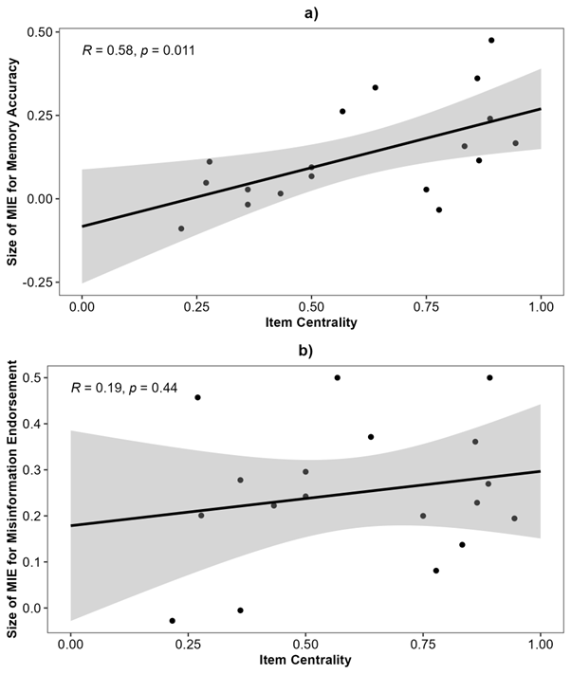
Note. The shaded area around the line denotes the standard error. Larger values indicate a larger misinformation effect (MIE).
Next, we explored whether sensitisation instructions produced a larger reduction in the misinformation effect for intermediate items than central and peripheral items. To this end, we conducted quadratic regression analyses on the reduction in the misinformation effect separately for memory accuracy and misinformation endorsement. The predictor variables were control accuracy and the square of centred control accuracy (the quadratic term). The reduction in the misinformation effect was calculated as the size of the misinformation effect in the non-sensitised condition minus the difference in the sensitised condition, with higher values denoting a larger reduction in the size of the misinformation effect.
For memory accuracy (Figure S2a), neither item centrality (F[1, 15] = 2.59, p = .13) nor the quadratic term (F[1, 15] = 0.17, p = .68) significantly predicted the reduction of the misinformation effect in the sensitised condition relative to the non-sensitised condition. These results were mirrored in the misinformation endorsement, such that the reduction in the misinformation effect was not significantly predicted by item centrality (F[1, 15] = 0.24, p = .63) or the quadratic term (F[1, 15] = 0.31, p = .59). Put simply, our results suggest that the sensitisation instructions were effective at reducing the misinformation effect regardless of item centrality.
Figure S2.
The Reduction of the Misinformation Effect in the Sensitised Condition in Experiment 2 by Item Centrality
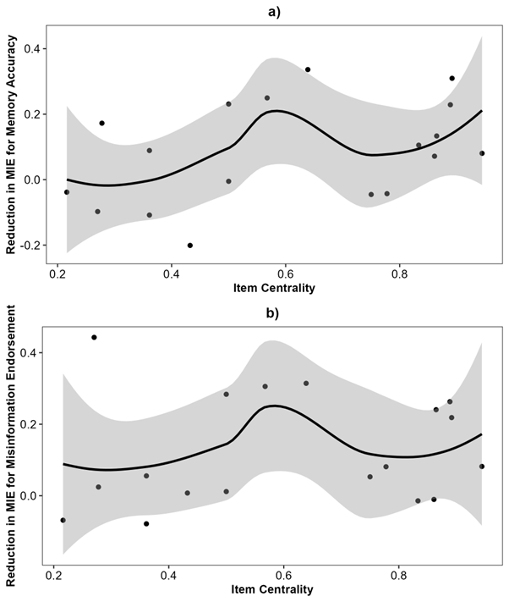
Note. The shaded area around the line denotes the standard error. Larger values indicate a larger reduction in the misinformation effect (MIE).

