Supplemental Tables and Figures

Supplement 1. Table S1. Deviation from Pre-registration pp. 2-6

Supplement 2. Reanalysis of Zottoli, Helm et al., 2023, Study 3. pp. 7 -9
Table S2. Parameter estimates pg. 7
Table S3. Posterior Predicted Plea Rates Across Conditions pg. 8
Table S4. Posterior Predicted Change in Plea Rate Between pg. 8
Discount Conditions, broken out by PTS
Table S5. Posterior Predicted Change in Plea Rate Between pg. 9
Discount Conditions, broken out by PTS and POC

Supplement 3. Table S6. Current Study, Model Fit Indices, Primary Analysis pg. 9

Supplement 4. Comparison of Current Study and Zottoli, Helm et al., 2023 pp. 10-11
(Model 1: accept ~ PTS + Discount)
Table S7. Parameter Estimates for Model 1 pg. 10
Table S8. Posterior Predicted Changes in Plea Rate, pg. 11
by Discount and PTS, for Model 1 (accept ~ PTS + Discount)
Supplement 5. Current Study. Exploratory Analysis, POC X Discount Interaction pp. 11-13
Table S9. Model Fit Indices, Exploratory Analysis pg. 11
Figure S1A (Guilty) & S1B (Innocent). Posterior Predicted Plea Rate, pp. 12-13
across experimental conditions and POC
(Model: accept~pts+disc+poc+poc:disc)
Supplement 6. Prior Sensitivity pg. 14
Table S11. Parameter Estimates under two different prior pg. 14
specifications for regression coefficients
Table S12. Posterior Predicted marginal plea rates for main effects pg. 14
models, for selected conditions, under four different
prior specifications for regression coefficients.

Supplement 1. Deviation from Pre-registration

Table S1. Deviation from Pre-registration
Deviations
# | Details |  | Original Wording | Deviation Description | Reader Impact
1 | Type | Inferential Criteria | To test for jump discontinuities:  “A Region of Approximate Equivalence (ROPE) in the range of -0.2 to 0.2 will be used for all parameters. The existence of effects will be quantified by the Probability of Direction index (Makowski, Ben-Shachar, Chen, et al., 2019) and the practical significance of the effect will be established if no portion of the 89%HDI falls inside the ROPE (Kruschke, 2018).” | We instead generated posterior predictions for differences in plea-rates between discount conditions and calculated Bayes Factors to quantify support for/against predicted jump-discontinuities (i.e., changes above/below threshold).  Given that our hypotheses were with respect to the absolute change in plea rates between discount conditions (not the relative change), the logic of using the HDI+Rope test for the parameter values (which indicate the change in odds) was flawed. I.e., the rope for each parameter estimate would need to be different and the choice as to the rope would be largely subjective (e.g., based on plea rates in the observed data in each condition). | This change should improve the ability of readers to understand the results. A Bayes factor computed from posterior predictions directly compares the posterior probability of two competing hypotheses and are directly interpretable (e.g., can answer the question “What is the probability that the difference in acceptance rate is greater than 5 percentage points?")
1 | Reason | Logical Flaw
1 | Timing | After data access
2 | Type | Analysis | “Weakly-informative priors ( β~t(ν=5,μ=0,σ=2) will be used for all parameters (i.e., intercept; main and interaction effects) to regularize the posterior (Gelman, 2019).” | To be fully transparent, when we wrote the pre-registration we had not given appropriate thought to prior specifications and assumed we would just use a common default prior for logistic regression parameters. Our level of knowledge increased in the ensuing time period and we are now better able to make well-reasoned decisions that do not simply rely on rules of thumb.  1. In the actual study analyses, the priors on the intercepts (αs) were different from the priors for the regression coefficients (βs) and different for guilty and innocent models. We assigned priors of N(0,1) to regression weights and priors of N(-4.6, 0) and N(-2.9, 0) to the intercepts for innocent and guilty models, respectively.  Reason: Given that we coded for repeated contrasts and that it is empirically well-established that the reference categories of 10% discount and Low POC would have very low plea rates for guilty and innocent mock defendants, we were able to specify a more reasonable prior for intercepts (e.g., 1% innocent; 5% guilty).  2. Instead of using t-distributions (as in the pre-reg) we used normal distributions for all priors.  Reason: Normal distributions were more computationally efficient. Although t-distribution priors allow for more robustness to outliers, our decisions to assign broad priors and use autoscaling made them unnecessary. | Neither of these changes will have affect on the reader’s understanding of results.  1. The priors on the intercepts permitted a very wide range of possible values (e.g., even an extremely unlikely plea rate of 99% for innocent participants was possible) and served mainly to regularize sampling.  2. Given the broadness, the exact shape of the prior (whether t-distribution or normal) has little influence on the results.  3. We ran a prior sensitivity analysis for a main effects model and differences between default priors and our choice for priors were negligible (e.g., rounding error at the 4th decimal place).  In sum, these changes served to improve the computational efficiency of the sampling and the overall stability of the model estimates, but did not change the strength of the priors’ influence on the posterior.
2 | Reason | New knowledge
2 | Timing | After data access
3 | Type | Analysis | “Bayes factors will be used to compare and select between models using a 9-group discount variable versus a 3-group discount variable to predict plea decisions” | We did not conduct these analyses. After completing our primary analyses, we concluded that no new insight or knowledge would be gained by doing this additional testing. Specifically, the current reporting shows clearly where/when discount groups emerge & clarifies how POC and PTS affect the presence and location of the groups. | No discernible impact. The overall report will be shorter, and uncluttered by superfluous analyses.
3 | Reason | Analysis deemed superfluous
3 | Timing | After results known
4 | Type | Analysis | “Bayes factors will be used […] to compare the fit of a different discount grouping for the 2-year PTS compared to model fit for the data collapsed across PTS (Hypothesis 3). | Resource constraints restricted us to replicating only two of the three PTS conditions from the Zottoli, Helm et al., (2023) study. The PTS = 2 condition was eliminated from the design, but some language referring to it was inadvertently left in the analysis section of the pre-registration report. | N/A
4 | Reason | Typo/Error |  |  | N/A
4 | Timing | Before data collection |  |  | N/A
5 | Type | Research Questions | “Whereas, for guilty participants, higher perceived POC is expected to be associated with higher plea rates across offer condition, we expect the plea rates of innocent participants are to be relatively unaffected by differences in perceived POC, until the meaningful distinction between plea and PTS is perceived to be large[…] . At that point, innocent participants are expected to respond to perceived POC in the same way as guilty participants[…]” | The language in the pre-reg refers to the way innocent mock-defendants should be affected by manipulations of numerically presented probabilities, which was the methodology we used in prior work (Bartlett & Zottoli, 2021; Zottoli, Helm et al., 2023; Study 1). The methodology of this study is not suitable to examine the effect of numerical changes in POC, and doing so was never the intent of this study.  This study was designed to examine the effect of changes in plea rates across a range of plea discounts, and to examine how perceived POC (measured categorically) might affect the relationship between discount and plea decision.  As we have explained in the manuscript, we expected innocent mock-defendants to be relatively insensitive to changes in plea offers until that offer creates a sufficiently large distinction between plea sentence and trial sentence to compete with the highly-valued consideration of factual guilt or innocence. And, when perceived probability of conviction is so high as to effectively boil the decision down to certain vs. virtually certain conviction, discounts, will compete with factual guilt or innocence, making it more likely that at least some defendants will be willing to plead in lower discount categories. | N/A
5 | Reason | Miscommunication |  |  | N/A
5 | Timing | Before data access |  |  | N/A
6 | Type | Terminology | In the pre-reg, generally, we referred to hypotheses and exploratory analyses. | We wanted to use more precise language that acknowledges the reality that there is a continuum between purely exploratory and purely confirmatory research. We also wanted to differentiate between the formal hypotheses we tested and foundational assumptions (i.e., well- established findings, such as people plead more when they are guilty"). | We anticipate that these changes (which had no impact on study design or on data analytic choices) will be useful to readers by helping them home on the key aims of the research and make decisions as to the weight to place on any individual set of findings.
6 | Reason | New Knowledge
6 | Timing | Before data access
7 | Type | Exploratory analysis | “[…] we will apply the parameters explicitly identified in the model for the guilty participants to the innocent participants […] to compare predictive model accuracies regarding innocent participants versus guilty participants.” | To avoid scope creep as well as an overly lengthy report, we did not engage in the exploratory work on the cross-validation of models built on guilty-mock defendant with data from innocent-mock defendant data. There are also some conceptual problems with the approach we have in the pre-reg that we can address in future work. | N/A
7 | Reason | Scope creep; manuscript length; conceptual issue |  |  | N/A
7 | Timing | Before data access |  |  | N/A

Supplement 2. Reanalysis of Zottoli, Helm et al., 2023, Study 3.

Table S2. Parameter estimates (model: accept ~ pts + disc + poc + pts:disc)
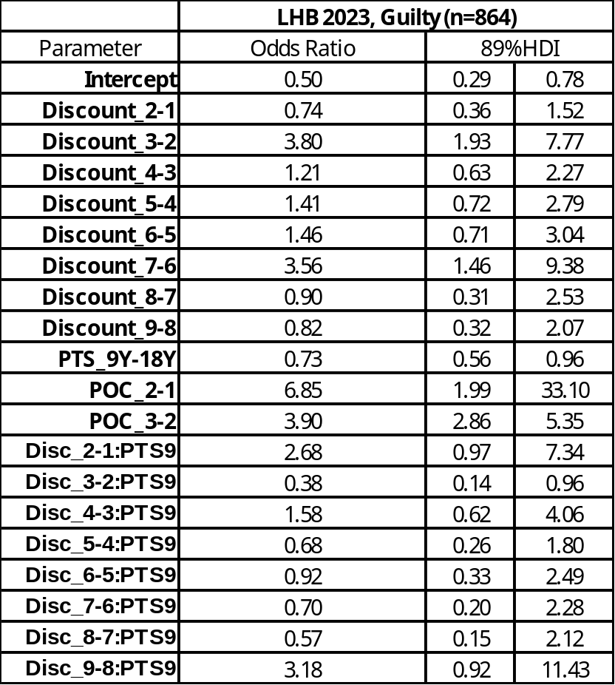

Table S3. Reanalysis of Zottoli, Helm et al., 2023, Study 3.
Posterior Predicted Plea Rates Across Conditions (Model 3: accept ~ pts + disc + poc + pts:disc)
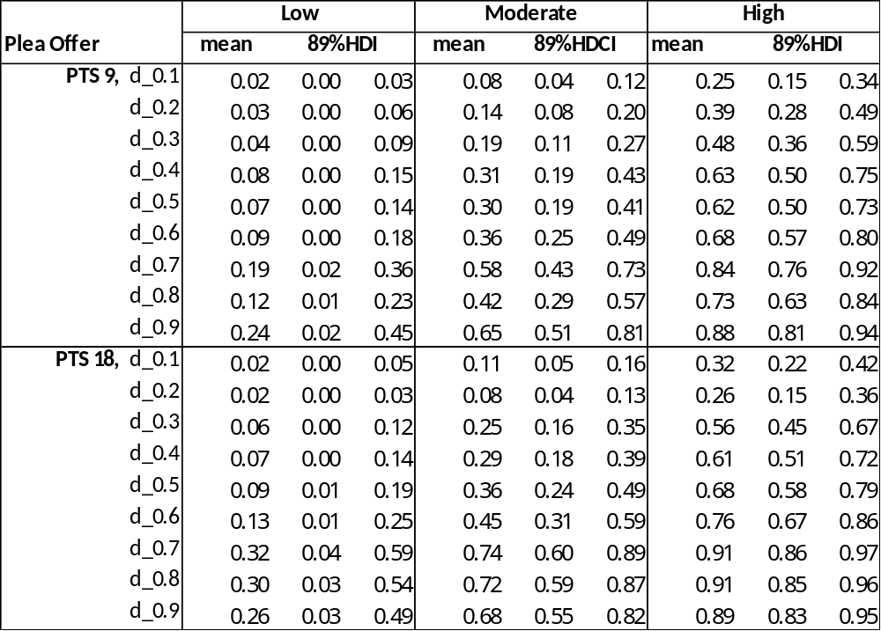

Table S4. Reanalysis of Zottoli, Helm et al., 2023, Study 3.
Posterior Predicted Change in Plea Rate Between Discount Conditions, broken out by PTS (Model 3: accept ~ pts + disc + poc + pts:disc)
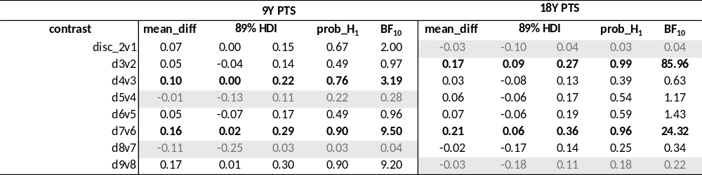

Table S5. Reanalysis of Zottoli, Helm et al., 2023, Study 3.
Posterior Predicted Change in Plea Rate Between Discount Conditions, broken out by PTS and POC (Model 3: accept ~ pts + disc + poc + pts:disc)
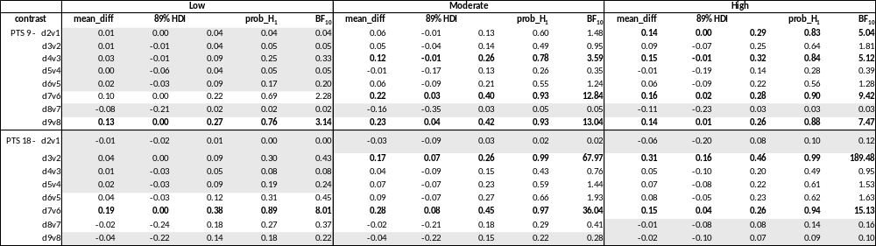

Supplement 3. Current Study, Model Fit Indices, Primary Analysis
Table S6. Model Fit Indices
 |  | Classification |  |  | Cross Validation
Sample | Model | SENS | SPEC | OVERALL | ELPD_diff | se_diff | WAIC
GUILTY | pts + disc | 0.75 | 0.62 | 0.7 | -174.96 | 18.3 | 2163
 | pts + disc + poc | 0.76 | 0.76 | 0.76 | 0 | 0 | 1813.06
 | pts + disc + poc + pts:disc | 0.77 | 0.75 | 0.76 | -0.36 | 3.83 | 1813.77
INNOCENT | pts + disc | 0 | 1 | 0.94 | 33.52 | 9.76 | 726.55
 | pts + disc + poc | 0.21 | 0.99 | 0.94 | -3.05 | 3.22 | 665.62
 | pts + disc + poc + pts:disc | 0.32 | 0.97 | 0.93 | 0.00 | 0.00 | 659.36
Note. SENS: Sensitivity, SPEC: Specificity, ELPD-diff: difference in expected log-predictive density across models, approximated using Pareto smoothed importance sampling; WAIC: Watanabe-Akaike Information Criterion. Classification cut offs were .6 for guilty participant sampes and .3 for innocent.

Supplement 4. Comparison of Current Study and Zottoli, Helm et al., 2023, Model 1 (accept ~ PTS + Discount)

Table S7. Parameter Estimates for Model 1
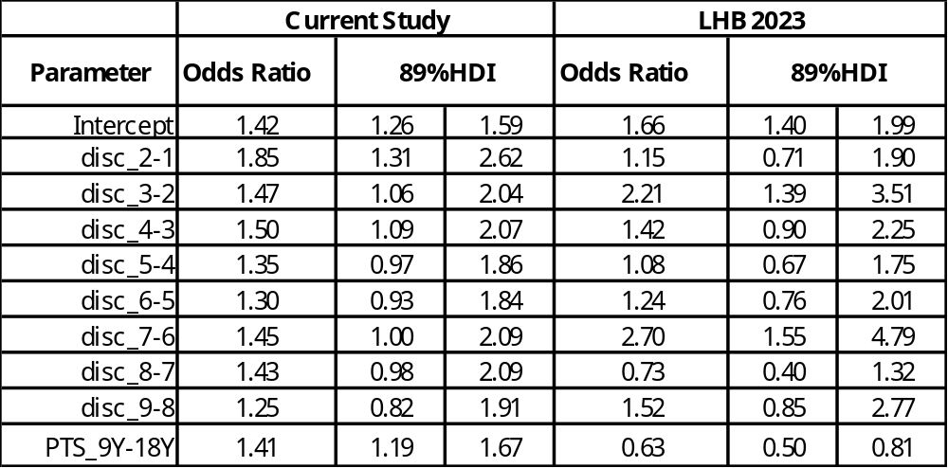

Table S8. Posterior Predicted Changes in Plea Rate, by Discount and PTS, for Model 1 (accept ~ PTS + Discount)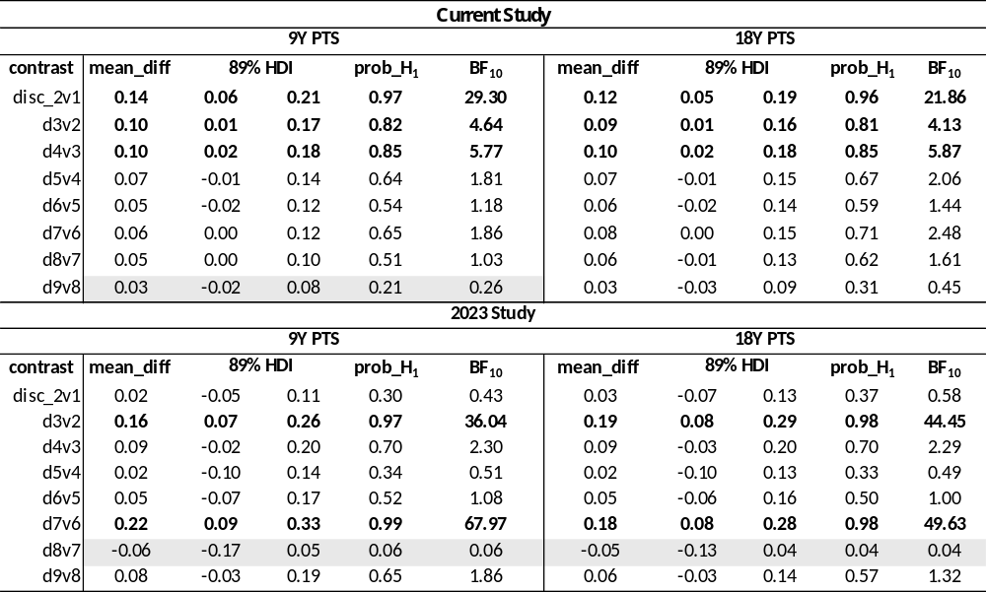

Supplement 5. Current Study. Exploratory Analysis, POC X Discount Interaction
Table S9. Model Fit Indices. Exploratory Analysis, POC X Discount Interaction
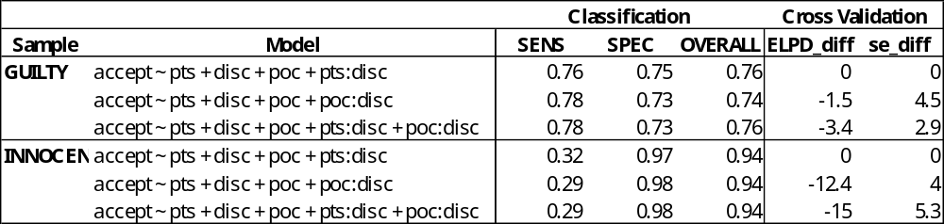

Figure S1A and S1B. Current Study. Exploratory Analysis, POC X Discount Interaction
Posterior Predicted Plea Rate, across experimental conditions and POC; Model: accept~pts+disc+poc+poc:disc

Figure S1A. GUILTY MODEL
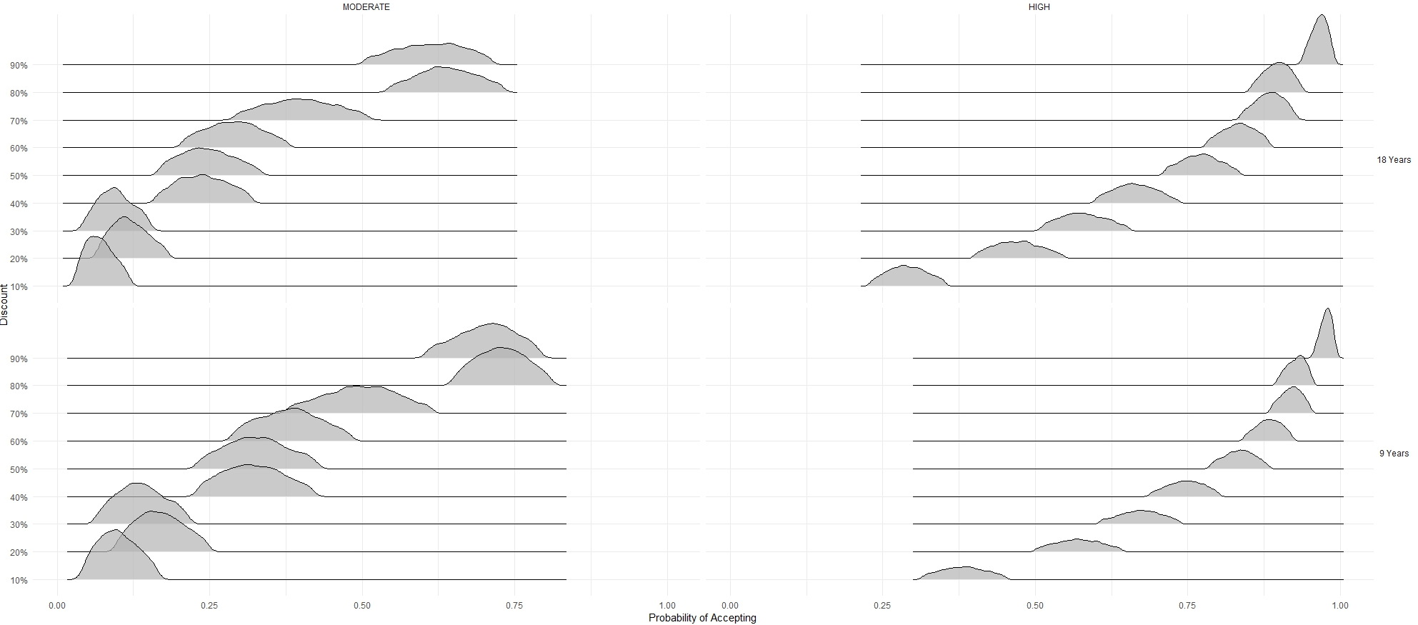

Figure S1B. INNOCENT MODEL

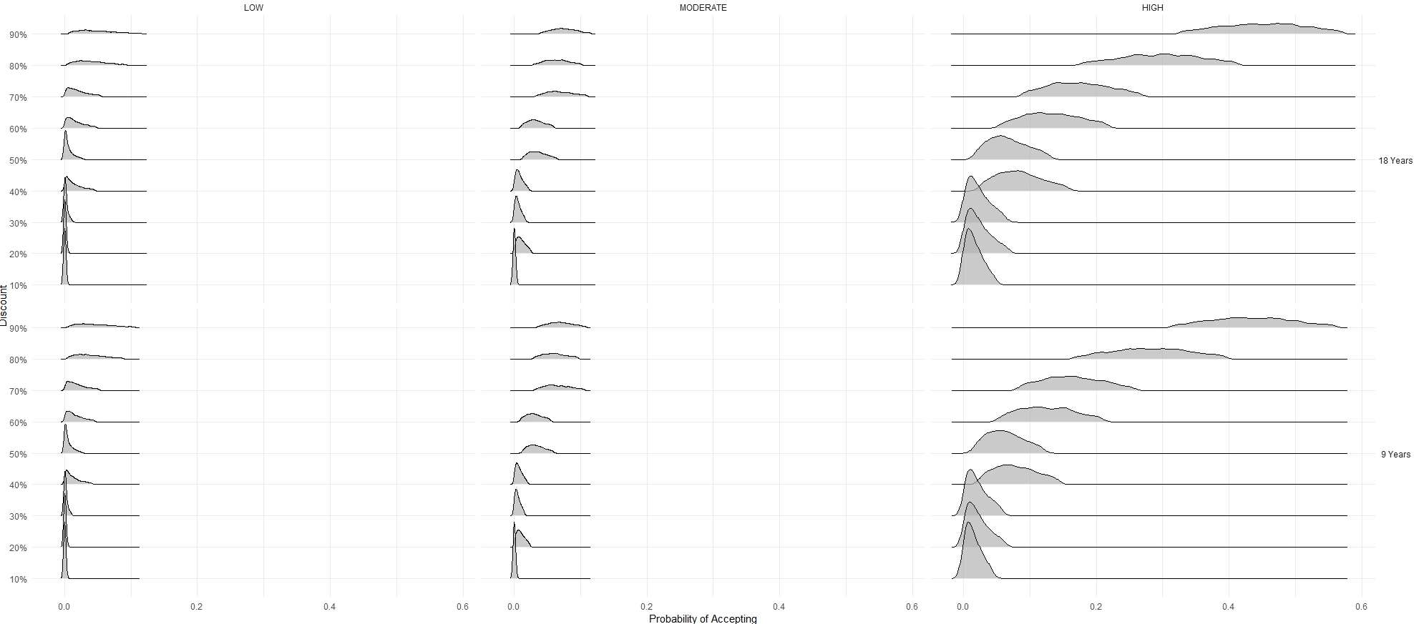

Supplement 6. Prior Sensitivity

Table S11. Current Study, Parameter Estimates under two different prior specifications for regression coefficients
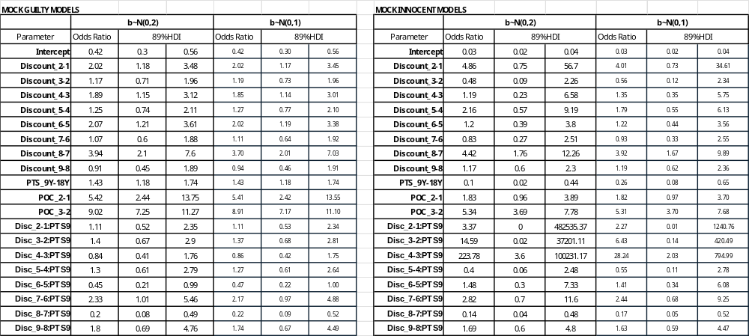

Table S12. Current Study, Prior Sensitivity
Posterior Predicted marginal plea rates for main effects models, for selected conditions, under four different prior specifications for regression coefficients.
