Online Supplemental Material
This document contains supplemental materials for the study. Below is a brief Table of Contents:
- Supplement A: Subgroup Analysis by Policy Domain
- Supplement B: Marginal Means Analysis
- Supplement C: Additional Outcomes – Efficiency and Fairness
- Supplement D: Statistical Power Analysis
- Supplement E: Pilot Study

Supplement A: Subgroup Analysis by Policy Domain
This supplement contains AMCE estimates for each policy domain. While the general trends and directions of the effects are mostly consistent across domains, several notable differences emerge. Notably, accuracy matters more in the “morally neutral” policy domains (“permit” and “city”); the Public engagement attribute only affects the “parole” policy domain; and the explanation of the decision matters most for the “unemployment”
policy.

Figure 5
AMCE Estimates by Policy Domain: Parole
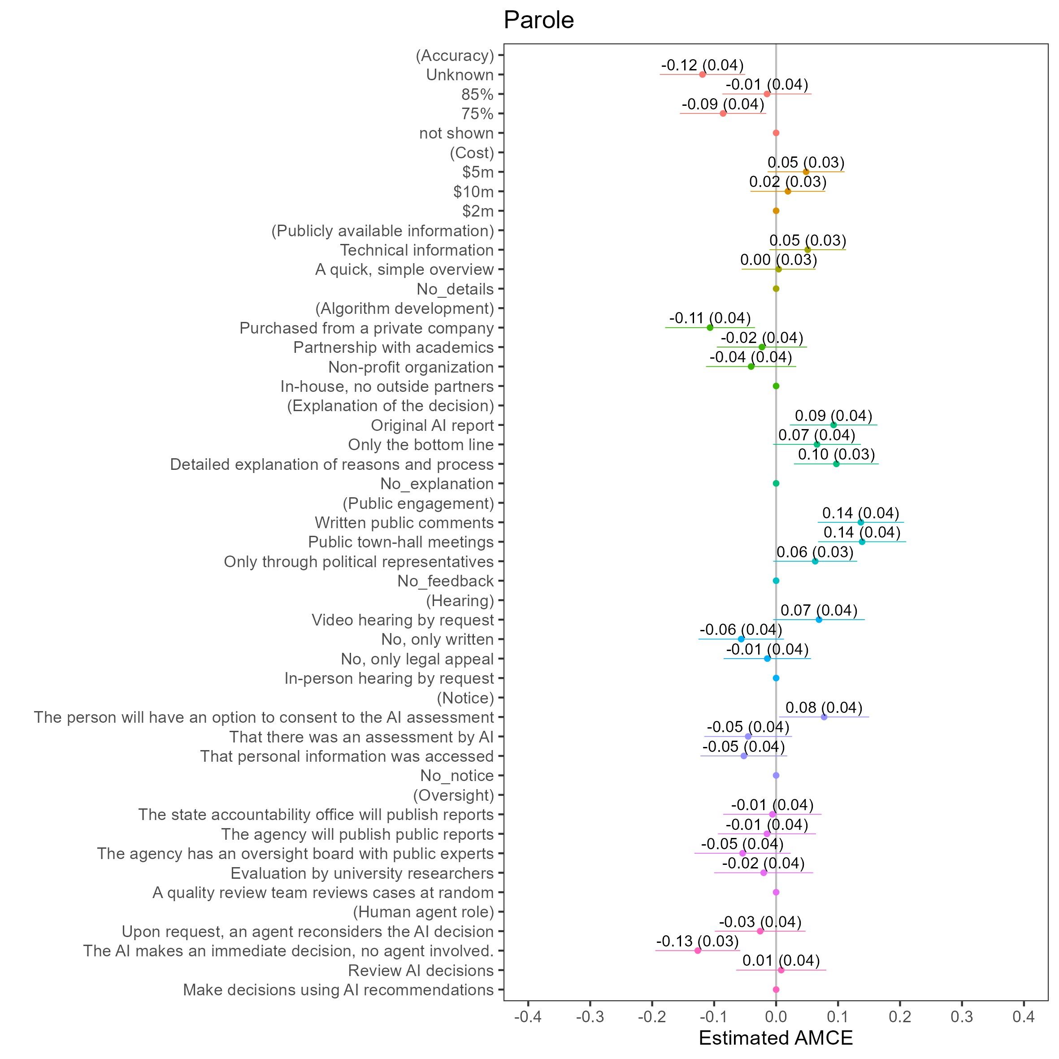

Figure 6
AMCE Estimates by Policy Domain: Unemployment
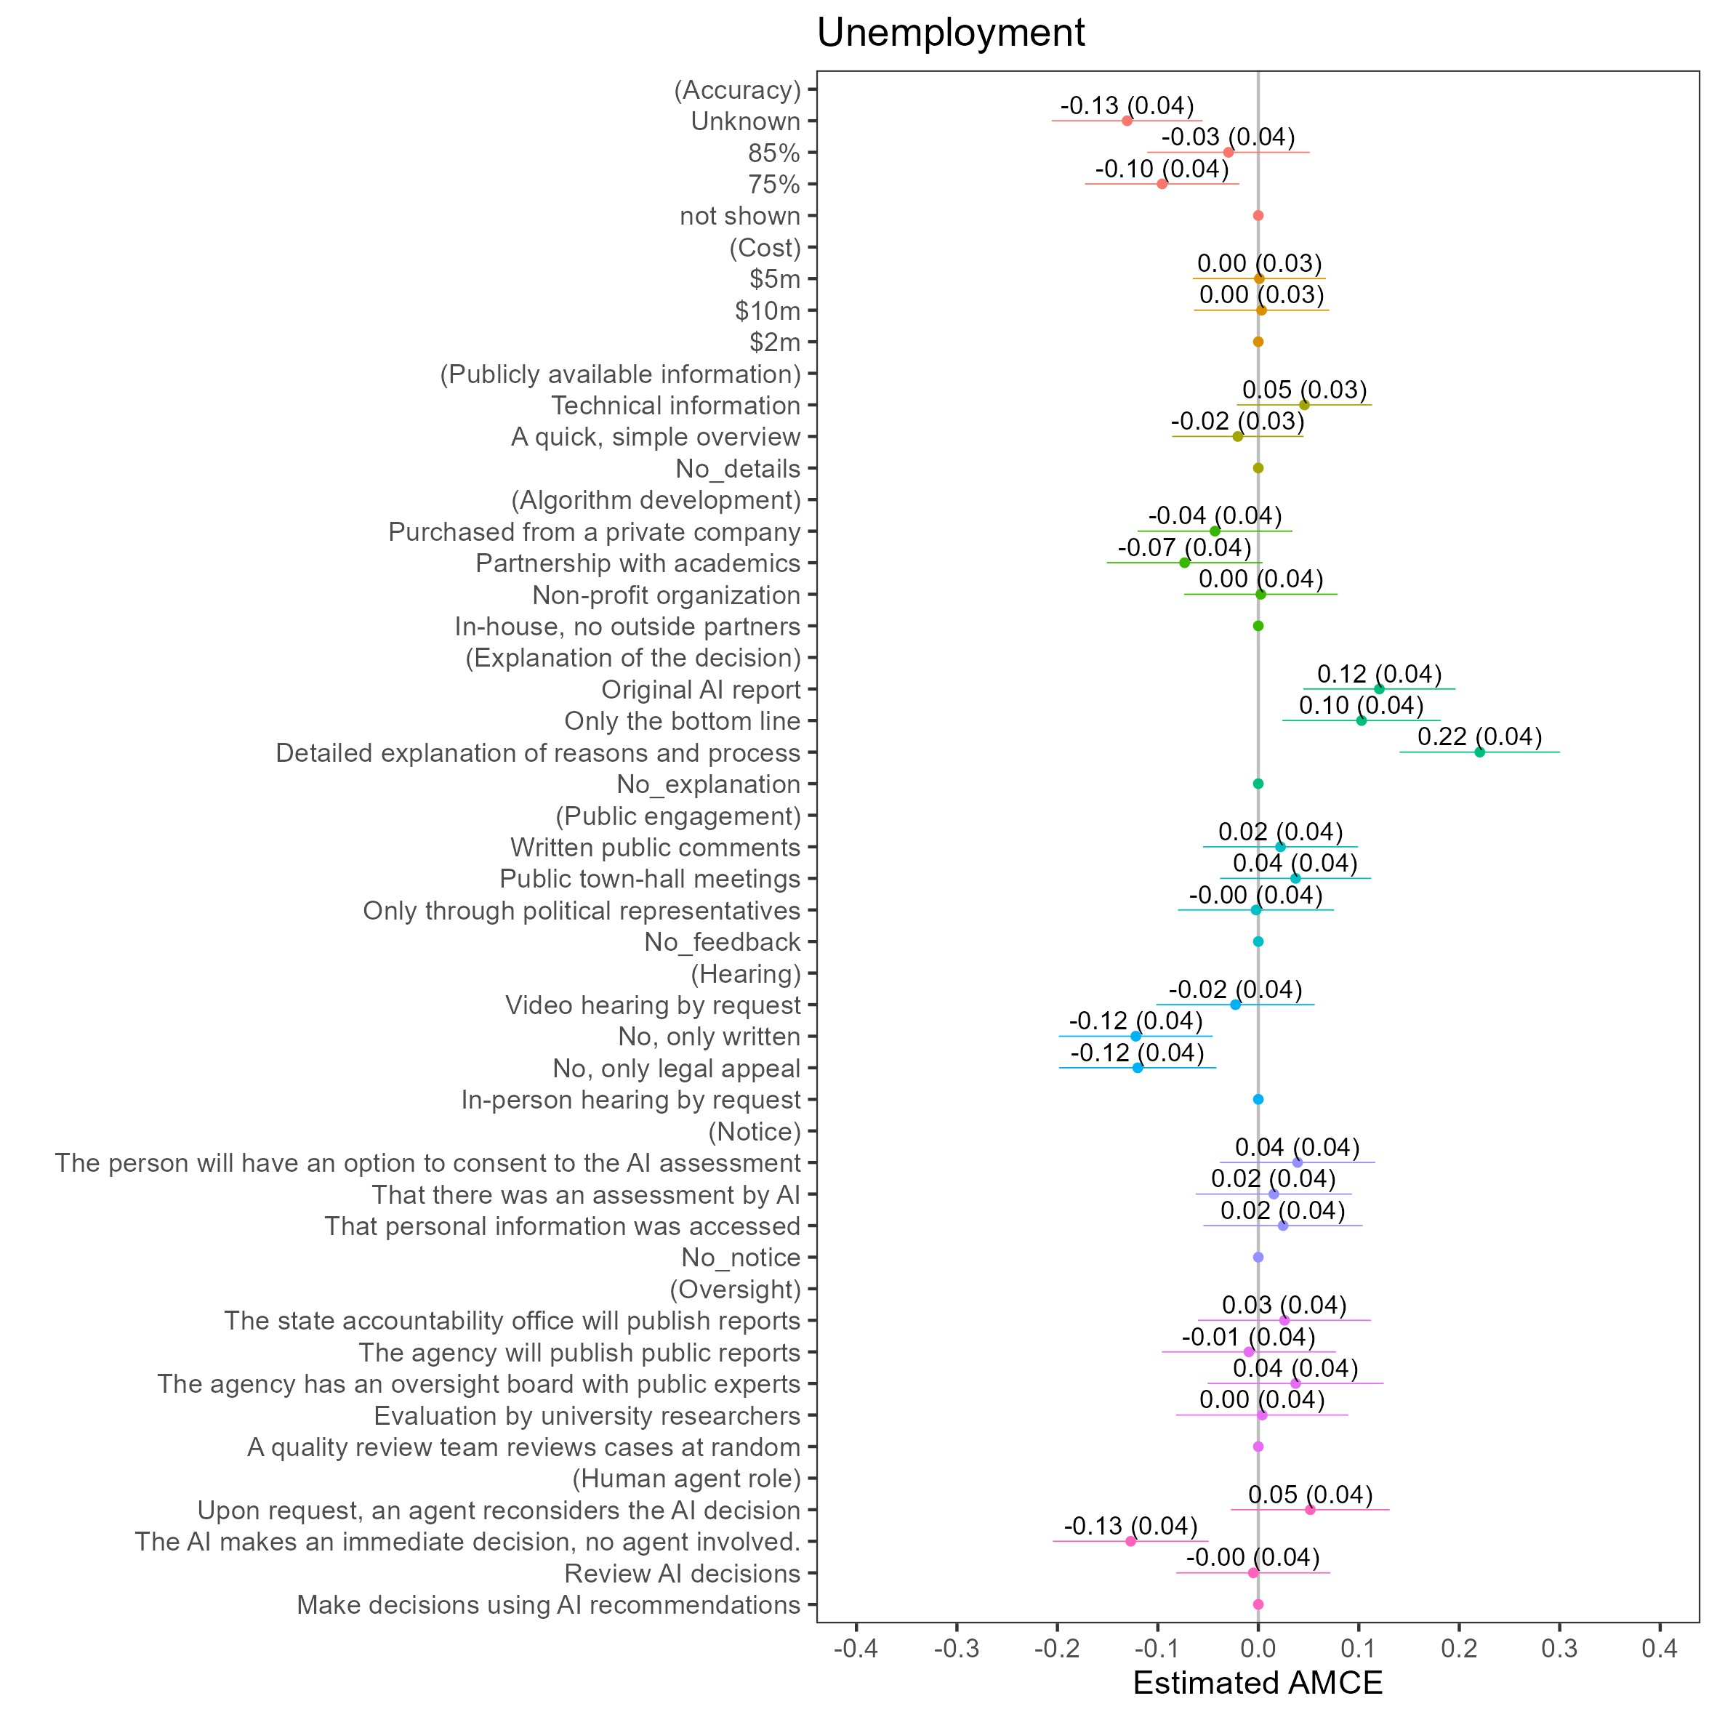

Figure 7
AMCE Estimates by Policy Domain: Refugee Resettlement
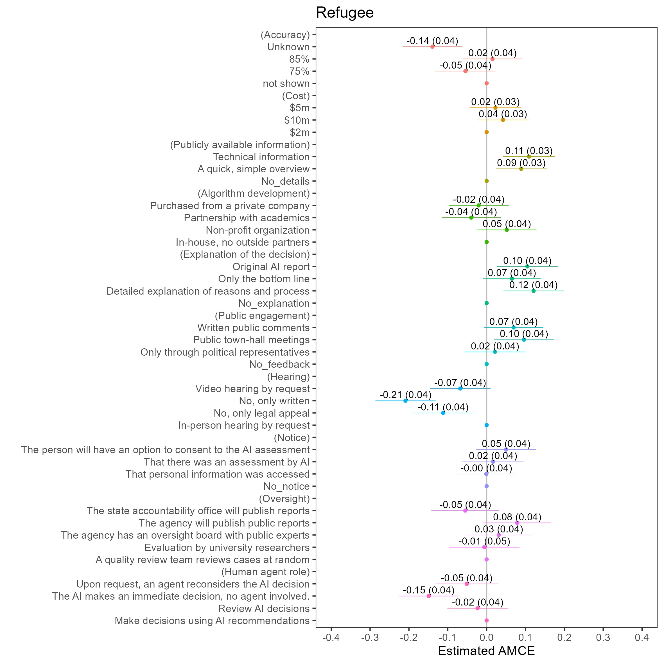

Figure 8
AMCE Estimates by Policy Domain: Permit
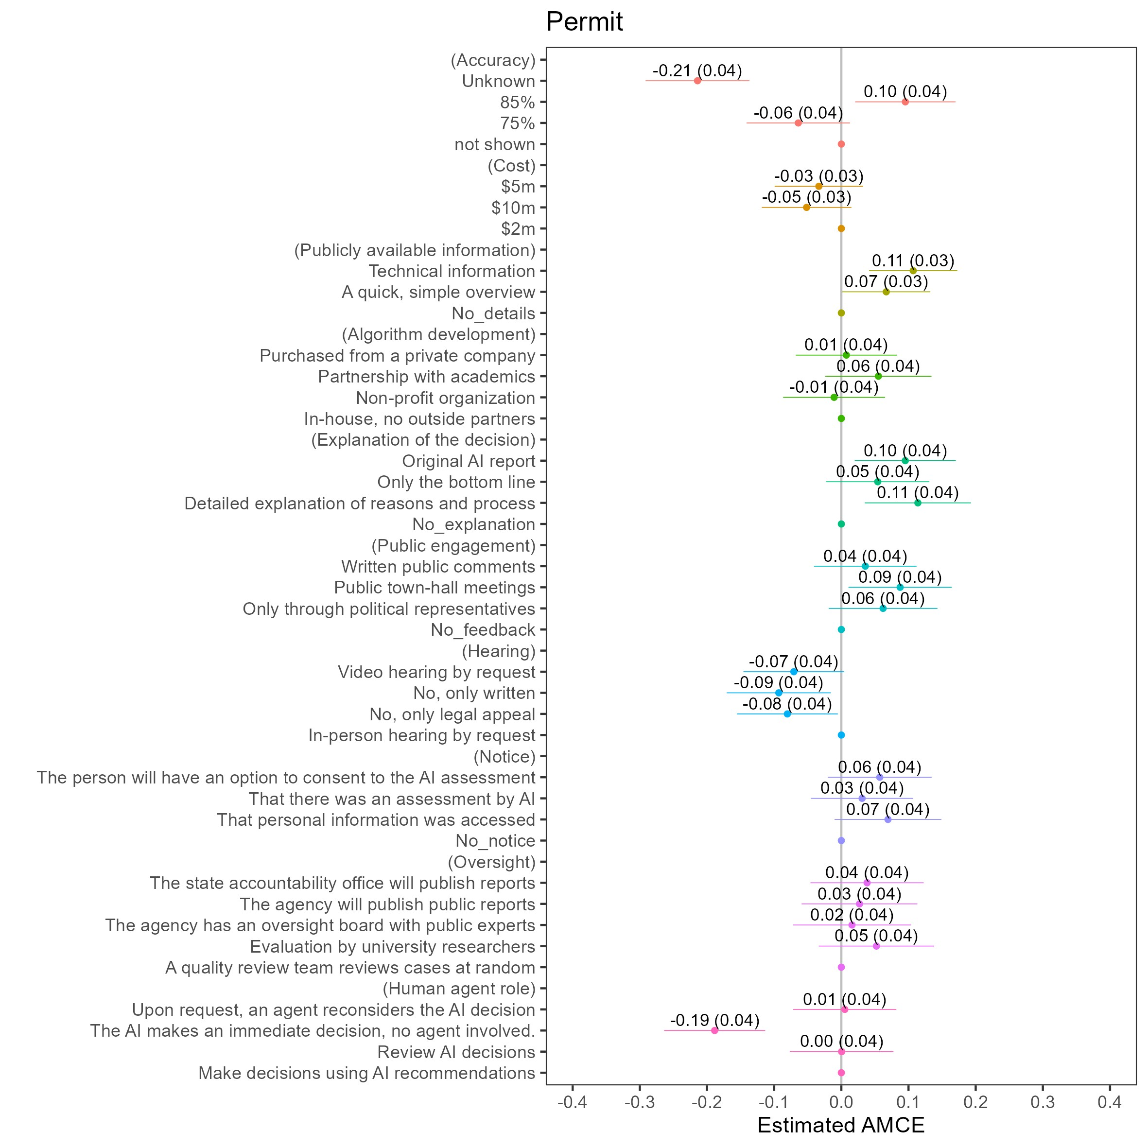

Figure 9
AMCE Estimates by Policy Domain: City

Supplement B: Marginal Means Analysis
Figure 10 presents the Marginal Means framework, allowing for a closer examination of the most notable levels across attributes.

Figure 10
Marginal Means of Main Outcome (Acceptability)
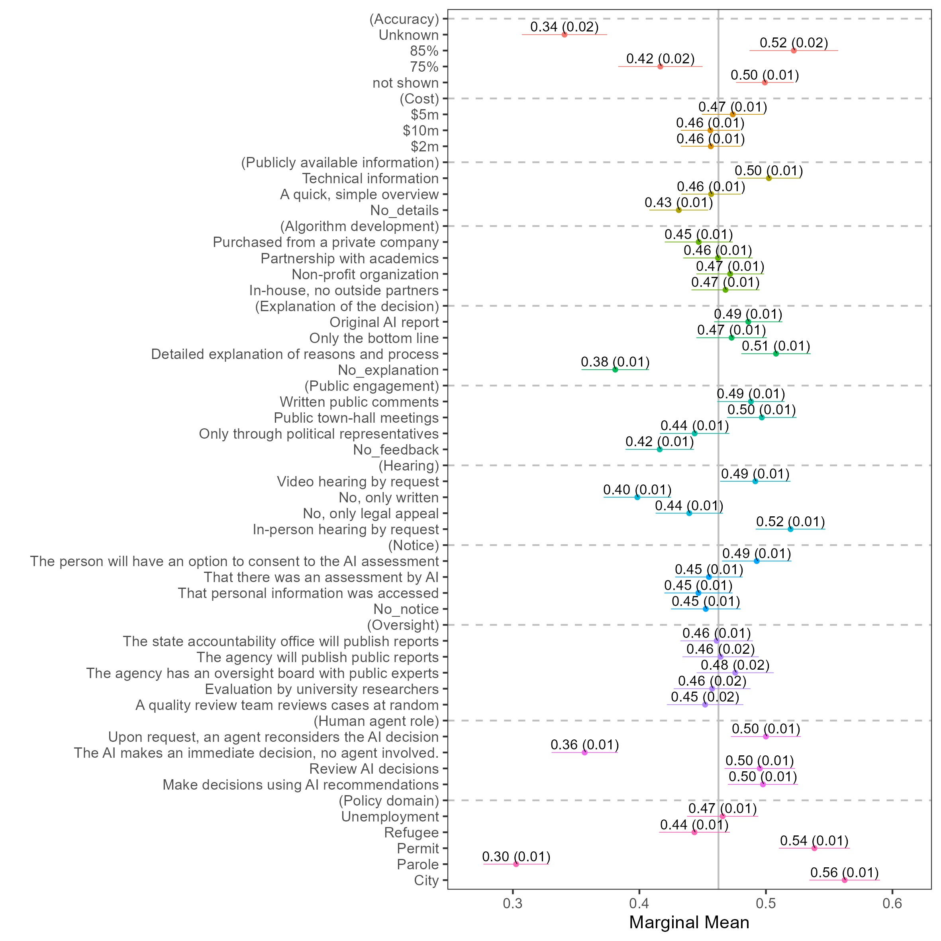
Note: This figure displays the Marginal Means (MM) for acceptability across different attribute levels. Analysis was conducted using a Gaussian Generalized Linear Model (GLM). Points represent estimated marginal means, and bars represent 95% confidence intervals.
Supplement C: Additional Outcomes – Efficiency and Fairness

Efficiency
64.3% of programs were perceived as “efficient” compared to 46.2% for acceptability and 49.7% for fairness, t = -20.391, df = 12108, p<.001.

Figure 11
AMCE of Secondary Outcome: Efficiency
Fairness
49.7% of policies were seen as “fair."

Figure 12
AMCE of Secondary Outcome: Fairness

Supplement D: Statistical Power Analysis
To calculate the statistical power of our conjoint experiment, we followed established methodologies for analyzing forced-choice conjoint designs. With N = 1,213 participants each completing 5 choice tasks, we have a total of 6,065 observations.

Key Parameters
- Number of participants (N): 1,213
- Tasks per respondent: 5
- Total observations: 6,065
- Significance level (α): .05
- Desired power threshold: 80%

Calculation Process
For conjoint experiments, the standard error (SE) of the average marginal component effect (AMCE) can be approximated as:
s
1
SE =(2)
N × T
where N is the number of participants and T is the number of tasks per respondent.
For our study:
s
1
SE 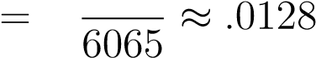 (3)
The minimum detectable effect size (MDES) at 80% power can be calculated using:
MDES = (z_{1−α/2} + z_{1−β}) × SE (4)
where:
- z_{1−α/2} is the critical value for a two-sided test at α = .05 (1.96)
- z_{1−β} is the critical value for power of 0.80 (0.84)
- SE is the standard error calculated above
This yields an MDES of .036 standard deviations at 80% power. For larger effect
sizes:
- .05 SD: 97.3% power
- 0.10 SD: >99.9% power
- 0.15 SD: >99.9% power
These calculations account for the clustered nature of the data where observations from the same respondent may be correlated. The high statistical power is achieved by combining a substantial sample size and the efficiency gained from multiple observations per respondent in the conjoint design.

Consideration of Attribute Structure
Our design includes 10 attributes with varying numbers of levels:
- Public information (3 levels)
- Accuracy (4 levels)
- Algorithm development (4 levels)
- Human-agent role (4 levels)
- Explanation (4 levels)
- Notice (4 levels)
- Hearing (4 levels)
- Oversight (5 levels)
- Public engagement (4 levels)
- Cost (3 levels)
While the number of levels and attributes affects the frequency with which each specific level appears in the experiment, the fundamental power calculations for detecting average marginal component effects (AMCEs) depend primarily on the total number of observations (Hainmueller et al., 2014). Our randomized design ensures that each level appears with equal probability within its attribute, maintaining balanced statistical power across all comparisons.

Supplement E: Pilot Study
We conducted a pilot study with a smaller sample and four policy domains in May and June 2022. The results of the pilot study were reproduced in the main article, granting it additional robustness.

Sample
We sample 499 participants from the U.S. adult population, recruited through the Prolific online platform. Participants were paid according to a $10 hourly rate. The survey included a manipulation check, but no participants were disqualified on this or any other
basis.
The sample contained about 42% male participants and 57% female participants, with the rest identifying non-binary or other sex categories. The mean age of the sample was 38.6 years (median 36). As per race and ethnicity, participants that identified as White comprised 79.6% of the sample, 10.4% Asian, 6.2% African-American, 5% as Latino (and 4.8% Hispanic; other categories were less than 1% of the sample; participants could choose multiple categories).
As per the extra randomization step, 51% of the sample was shown the attribute of accuracy, while 49% did not have the attribute included in the experiment table.

Results
Overall, 43.7% of the programs were deemed “acceptable,” and 44.7% were seen as “fair” (the difference is not significant). Both outcomes exhibit almost identical AMCE estimates across all attributes and levels.
Correlation between outcomes is presented in Table 8.
We present the results of our conjoint task asking participants to indicate whether they think the government program is acceptable or not in Figure 13. The figure displays the marginal effect each attribute had on the probability a respondent classified the Table 7
Sample Descriptive Statistics
Statistic | Mean | SD | Min | Max
Age | 38.65 | 13.76 | 19 | 83
Female | 0.57 | 0.50 | 0 | 1
Liberal | 0.54 | 0.50 | 0 | 1
Democrat | 0.49 | 0.50 | 0 | 1
Education High School or less | 0.15 | 0.35 | 0 | 1
High AI familiarity | 0.41 | 0.49 | 0 | 1
No CS formal training | 0.61 | 0.49 | 0 | 1
No programming experience | 0.60 | 0.49 | 0 | 1
AI is beneficiary | 0.58 | 0.23 | .00 | 1.00
Pro AI Regulation | 0.71 | 0.18 | .00 | 1.00
Favorable of Technology | 0.55 | 0.18 | .00 | 0.95
program as “acceptable,” relative to the omitted level of each experimental factor. Within each, the omitted variable is displayed first (without a 95% confidence interval). Estimated effects are interpreted relative to the omitted categories. If we omit a different level for each category, the direction and appearance of the plot can change, but the relative distance between levels will not.
The pilot study’s results were reproduced in the main aticle.

Table 8
Correlation between Outcomes: Acceptability, Fairness and Efficiency
 | Acceptability | Fairness | Efficiency
Acceptability | 1 | 0.94 | 0.61
Fairness | 0.94 | 1 | 0.60
Efficiency | 0.61 | 0.60 | 1

Figure 13
AMCE of Main Outcome (Acceptability)
