Figure S1 Flowchart of Sample Selection

Figure S2
The Path Diagram of the Dyadic Cross-Lagged Panel APIM
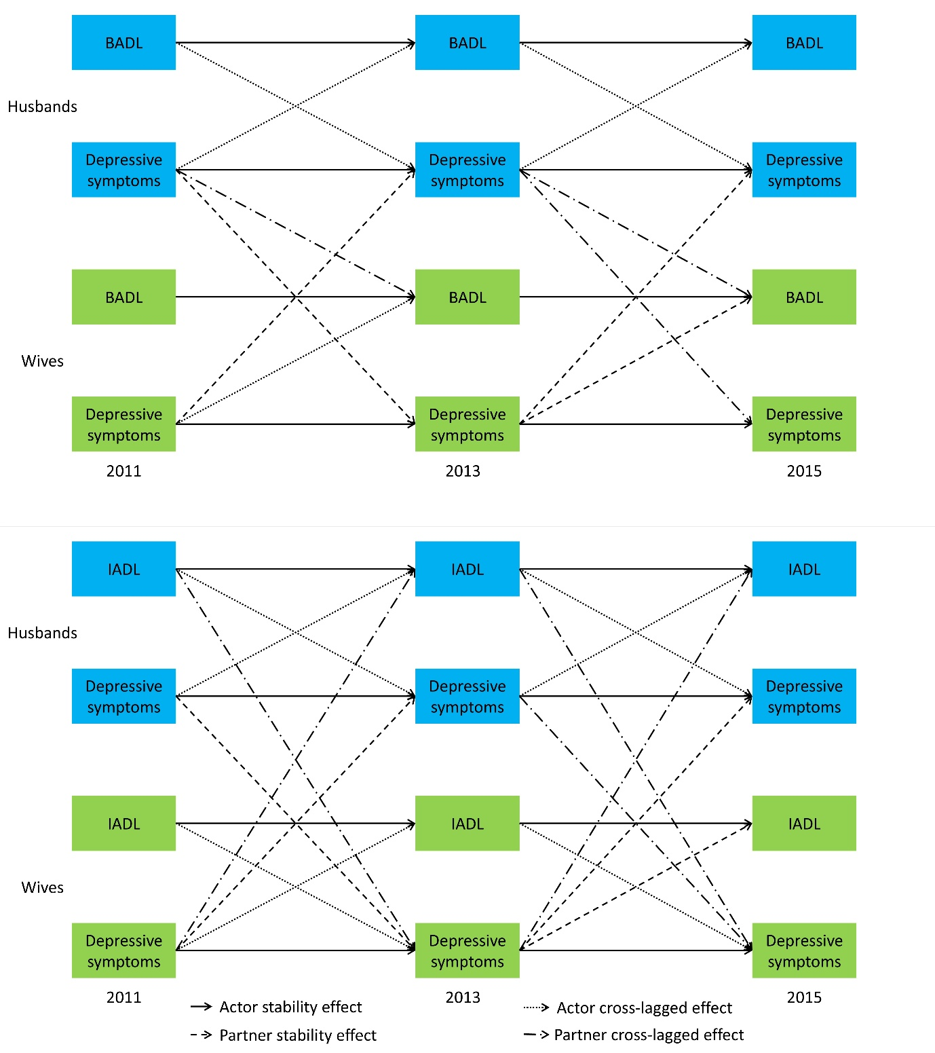
Note. Only significant paths were shown in this figure. Control variables, covariance and non-significant paths were omitted. Blue refers to husbands while green refers to wives. BADL = Basic Activities of Daily Living; IADL = Instrumental Activities of Daily Living

Table S1 Spearman Correlations Between the ADL and IADL
Variable | 1 | 2 | 3 | 4 | 5 | 6 | 7 | 8 | 9 | 10 | 11
1. rBADLW1 | —
2. rBADLW2 | .36** | —
3. rBADLW3 | .35** | .47** | —
4. sBADLW1 | .26** | .08** | .07** | —
5. sBADLW2 | .08** | .18** | .11** | .36** | —
6. sBADLW3 | .07** | .11** | .16** | .35** | .47** | —
7. rIADLW1 | .55** | .30** | .28** | .19** | .06** | .06** | —
8. rIADLW2 | .31** | .57** | .36** | .09** | .15** | .11** | .40** | —
9. rIADLW3 | .31** | .38** | .59** | .08** | .09** | .12** | .36** | .44** | —
10. sIADLW1 | .19** | .06** | .06** | .55** | .30** | .28** | .19** | .07** | .08** | —
11. sIADLW2 | .09** | .15** | .11** | .31** | .57** | .36** | .07** | .16** | .11** | .40** | —
12. sIADLW3 | .08** | .09** | .12** | .31** | .38** | .59** | .08** | .11** | .11** | .36** | .44**
Note: rBADLW1- rBADLW3 refers to husbands’ BADL from Wave 1- Wave 3; rIADLW1- rIADLW3 refers to wives’ IADL from Wave 1- Wave 3; sBADLW1- sBADLW3 refers to wives’ BADL from Wave 1- Wave 3; sIADLW1- sIADLW3 refers to wives’ IADL from Wave 1- Wave 3; Spearman correlations were calculated based on the original data without imputation.
Table S2
Characteristics of Sample
Variables | BADL model |  |  |  | IADL model
Variables | Husbands | Wives | t or χ² | p | Husbands | Wives | t or χ² | p
Individual-level characteristic
Age, mean (SD) | 67.69 (5.59) | 67.56 (5.59) | 1.026 | .305 | 66.97 (5.36) | 66.91 (5.30) | 0.613 | .540
Hukou status ª, n (%) |  |  | 0.124 | .725 |  |  | 0.825 | .364
Agriculture or no hukou | 927 (80.0%) | 921 (79.5%) |  |  | 1332 (77.4%) | 1311 (76.1%)
Non-agriculture or unified hukou | 231 (20.0%) | 238 (20.5) |  |  | 390 (22.6%) | 413 (23.9)
Education, n (%) |  |  | 0.385 | .825 |  |  | 1.667 | .435
No formal education | 430 (37.1%) | 418 (36.1%) |  |  | 573 (33.2%) | 579 (33.6%)
Below high school | 663 (57.2%) | 677 (58.5%) |  |  | 1036 (60.1%) | 1010 (58.7%)
High school or above | 66 (5.7%) | 63 (5.4%) |  |  | 115 (6.7%) | 133 (7.7%)
Couple-level characteristic
Relationship length, mean (SD) | 45.64 (7.48) |  |  |  | 44.83 (7.35)
Number of persons in the household, mean (SD) | 3.39 (1.87) |  |  |  | 3.41 (1.84)
Household income, mean (SD) | 20,194 (30,886) |  |  |  | 22,830 (32,678)
Focal variables
BADL_{W1}, mean (SD) | 0.88 (1.88) | 0.97 (2.09) | 1.122 | .262 | 0.84 (1.84) | 0.91 (2.02) | 0.918 | .359
BADL_{W2}, mean (SD) | 0.99 (2.07) | 0.95 (2.13) | 0.450 | .653 | 0.93 (2.01) | 0.87 (2.05) | 0.682 | .495
BADL_{W3}, mean (SD) | 1.29 (2.45) | 1.34 (2.71) | 0.428 | .669 | 1.24 (2.42) | 1.27 (2.63) | 0.294 | .769
IADL_{W1}, mean (SD) | 1.30 (2.63) | 1.32 (2.73) | 0.215 | .830 | 1.04 (2.39) | 1.05 (2.51) | 0.236 | .813
IADL_{W2}, mean (SD) | 1.51 (3.04) | 1.54 (3.05) | 0.297 | .767 | 1.20 (2.76) | 1.24 (2.80) | 0.380 | .704
IADL_{W3}, mean (SD) | 1.78 (3.31) | 1.98 (3.47) | 1.324 | .186 | 1.42 (3.00) | 1.60 (3.20) | 1.642 | .101
Depression_{W1}, mean (SD) | 9.64 (6.42) | 9.68 (6.33) | 0.158 | .874 | 8.61 (6.26) | 8.60 (6.27) | 0.066 | .947
Depression_{W2}, mean (SD) | 8.44 (5.66) | 8.70 (5.74) | 1.324 | .186 | 7.76 (5.59) | 7.85 (5.68) | 0.567 | .571
Depression_{W3}, mean (SD) | 8.86 (6.50) | 9.04 (6.53) | 0.721 | .471 | 8.07 (6.41) | 8.12 (6.43) | 0.232 | .816
Note. BADL = Basic Activities of Daily Living; IADL = Instrumental Activities of Daily Living.
ª The Chinese hukou (household registration) system is a government administrative tool that ties citizens to a specific birthplace or legally designated residence. Functioning as an internal passport, it has historically determined access to public education, healthcare, and social housing based on one’s assigned geographical category. In our analysis, this grouping captures meaningful disparities in access to welfare and public services while reducing sparse categories and improving statistical stability. Specifically, unified resident hukou, a product of recent reforms aimed at narrowing the agricultural–non-agricultural divide, was grouped with non-agricultural hukou. Conversely, participants with no hukou were grouped with agricultural hukou, given their potentially limited access to public services and social protection.

Table S3
Model Comparisons Across Dyadic Cross-Lagged Panel APIMs
Models | CFI | TLI | RMSEA | SRMR | χ2 | df | Δχ2 | Δdf | p(Δχ2)
BADL
Indistinguishable | 0.89 | 0.88 | 0.06 | 0.07 | 470.664 | 62
Partially distinguishable | 0.89 | 0.87 | 0.06 | 0.06 | 381.866 | 46 | 88.798 | 16 | <.001
Fully distinguishable | 0.90 | 0.87 | 0.06 | 0.06 | 361.458 | 38 | 25.408 | 8 | .009
IADL
Indistinguishable | 0.90 | 0.89 | 0.06 | 0.06 | 621.659 | 62
Partially distinguishable | 0.90 | 0.86 | 0.07 | 0.06 | 557.718 | 46 | 63.941 | 16 | <.001
Fully distinguishable | 0.91 | 0.85 | 0.08 | 0.06 | 541.958 | 38 | 15.760 | 8 | .046
Note.
Indistinguishable model equates all parameters across gender. Partially distinguishable model equates the directional parameters (paths) across gender while allowing each spouse their own baseline parameters (variances, covariances, means). Fully distinguishable model free the directional parameters (paths) across gender as well as their baseline parameters (variance, covariance, means).
χ2, chi-square; df, degrees of freedom; RMSEA, root mean square error of approximation; CFI, comparative fit index; TLI, Tucker-Lewis Index; Δχ2, chi-square difference; p(Δχ2), p-value for the chi-square difference. BADL = Basic Activities of Daily Living; IADL = Instrumental Activities of Daily Living;
Table S4 Sensitivity Analysis for BADL with Complete Dataset (N =456 dyads)
 | Stability Effects |  |  |  |  |  | Cross-lagged Effects
 | BADL→BADL |  |  | DEP→DEP |  |  | BADL→DEP |  |  | DEP→BADL
 | b | 95%CI | p | b | 95%CI | p | b | 95%CI | p | b | 95%CI | p
actor effects
H→H | 0.456 | [0.311, 0.602] | <.001 | 0.463 | [0.389, 0.538] | <.001 | 0.137 | [−0.056, 0.327] | .164 | 0.038 | [0.015, 0.060] | <.001
W→W | 0.491 | [0.338, 0.644] | <.001 | 0.506 | [0.429, 0.583] | <.001 | 0.199 | [−0.054, 0.452] | .123 | 0.040 | [0.017, 0.063] | .001
partner effects
W→H | −0.034 | [−0.095, 0.016] | .267 | 0.134 | [0.068, 0.200] | .001 | −0.026 | [−0.215, 0.164] | .790 | 0.007 | [−0.013, 0.026] | .522
H→W | −0.022 | [−0.082, 0.038] | .472 | 0.083 | [0.021, 0.144] | .009 | −0.045 | [−0.233, 0.142] | .635 | 0.006 | [−0.015, 0.028] | .570

Table S5 Sensitivity Analysis for IADL with Complete Dataset (N =1080 dyads)
 | Stability Effects |  |  |  |  |  | Cross-lagged Effects
 | IADL→IADL |  |  | DEP→DEP |  |  | IADL→DEP |  |  | DEP→IADL
 | b | 95%CI | p | b | 95%CI | p | b | 95%CI | p | b | 95%CI | p
actor effects
H→H | 0.562 | [0.468, 0.655] | <.001 | 0.467 | [0.417, 0.518] | <.001 | 0.199 | [0.083, 0.316] | .001 | 0.017 | [−0.000, 0.035] | .053
W→W | 0.540 | [0.458, 0.623] | <.001 | 0.506 | [0.457, 0.555] | <.001 | 0.144 | [0.024, 0.264] | .018 | 0.033 | [0.012, 0.053] | .002
partner effects
W→H | −0.058 | [−0.119, 0.003] | .195 | 0.087 | [0.044, 0.130] | <.001 | −0.025 | [−0.121, 0.071] | .609 | 0.021 | [0.002, 0.041] | .027
H→W | −0.019 | [−0.068, 0.030] | .448 | 0.020 | [0.011, 0.090] | .012 | 0.106 | [−0.008, 0.220] | .069 | 0.002 | [−0.015, 0.019] | .842

