Supplemental Material

Sample Characteristics
Table S1
Sample Characteristics of Participants in Wave 1 (N = 700) and Wave 2 (N = 700)
Characteristic | Wave 1 |  | Wave 2
Characteristic | n (%)  unweighted Sample | n (%)  weighted Sample | n (%)  unweighted Sample | n (%)  weighted Sample
Age | (M = 71.04, SD = 7.60; age range 60-93, weighted data) |  | (M = 71.53, SD = 8.15; age range 60-97, weighted data)
60-69 | 463 (66.1%) | 356 (50.9%) | 367 (52.4%) | 353 (50.4%)
70-79 | 171 (24.4%) | 230 (32.8%) | 216 (30.9%) | 199 (28.4%)
80+ | 66 (9.4%) | 114 (16.3%) | 117 (16.7%) | 149 (21.2%)
Gender
male | 276 (39.4%) | 308 (44%) | 266 (38.0%) | 308 (44%)
female | 424 (60.6%) | 392 (56%) | 434 (62.0%) | 392 (56%)
Educational qualification (ISCED 97)
low | 410 (58.6%) | 580 (82.9%) | 328 (46.9%) | 580 (82.9%)
intermediate | 114 (16.3%) | 40 (5.6%) | 118 (16.9%) | 31 (4.4%)
high | 149 (21.3%) | 54 (7.8%) | 218 (31.1%) | 63 (9.1%)
No data | 27 (3.9%) | 26 (3.7%) | 36 (5.1%) | 26 (3.7%)
Job status
yes | 92 (13.1%) | 60 (8.6%) | 122 (17.4%) | 104 (14.8%)
no | 600 (85.7%) | 634 (90.6%) | 570 (81.4%) | 590 (84.4%)
No data | 8 (1.1%) | 6 (0.8%) | 8 (1.1%) | 6 (0.8%)
Recent influenza vaccination behavior
yes | 432 (61.7%) | 457 (65.2%) | 455 (65.0%) | 460 (65.7%)
no | 267 (38.1%) | 242 (34.6%) | 225 (32.1%) | 217 (31.0%)
No data | 1 (0.1%) | 1 (0.1%) | 20 (2.9%) | 23 (3.4%)
Recent pneumococcal vaccination behavior (and unvaccinated in the past 10 years)
yes | 32 (4.6%) | 23 (3.2%) | 79 (11.3%) | 91 (13.0%)
no | 479 (68.4%) | 479 (68.4%) | 517 (73.9%) | 507 (72.5%)
No data | 189 (27.0%) | 199 (28.4%) | 104 (14.9%) | 102 (14.6%)
How often vaccinated against influenza in the past 10 years
No vaccination | 115 (16.4%) | 100 (14.2%) | 126 (18.0%) | 111 (15.9%)
1-3 | 74 (10.6%) | 71 (10.1%) | 91 (13.0%) | 91 (13.0%)
4-6 | 58 (8.3%) | 58 (8.4%) | 57 (8.1%) | 51 (7.3%)
7-9 | 50 (7.1%) | 43 (6.2%) | 50 (7.1%) | 41 (5.8%)
10 or always | 387 (55.3%) | 411 (58.7%) | 368 (52.6%) | 398 (56.8%)
No data | 16 (2.3%) | 16 (2.4%) | 8 (1.1%) | 8 (1.1%)
Vaccinated against pneumococci in the past 10 years
yes | 189 (27.0%) | 199 (28.4%) | 73 (10.4%) | 63 (9.0%)
no | 477 (68.1%) | 468 (66.8%) | 434 (62.0%) | 438 (62.6%)
No data | 34 (4.9%) | 34 (4.8%) | 193 (27.6%) | 199 (28.4%)
Doctors recommendation to vaccination
Influenza
Yes | 557 (79.6%) | 550 (78.5%) | 486 (69.4%) | 478 (68.3%)
No | 130 (18.6%) | 133 (19.0%) | 196 (28.0%) | 197 (28.2%)
No data | 13 (1.9%) | 18 (2.5%) | 18 (2.6%) | 25 (3.5%)
Pneumococci
yes | 231 (33.0%) | 227 (32.5%) | 238 (34.0%) | 232 (33.1%)
no | 433 (61.9%) | 434 (62.0%) | 417 (59.6%) | 426 (60.9%)
No data | 36 (5.1%) | 38 (5.5%) | 45 (6.4%) | 42 (6.0%)
Note. We coded educational qualification as low, medium, high, using the International Standard Classification of Education 97 (ISCED-97) (Schneider, 2008). Data was weight according to (Betlehem, 2008) to represent the distribution of the Thuringian population. The “No data”-category refers to the answers provided as “don’t know or “no response (n/a)”.
Table S2
Socio-demographic Distributions Between Experimental Groups and Waves
 |  | Wave 1 (2017) |  | Wave 2 (2018)
Variable | Level | Control Group | Exposure | Control Group | Exposure | χ² | p
Age Categories | 60-69 | 234 (66.9%) | 229 (65.4%) | 201 (51.5%) | 166 (53.5%) | 30.55 | <.001
Age Categories | 70-79 | 83 (23.7%) | 88 (25.1%) | 111 (28.5%) | 105 (33.9%) | 30.55 | <.001
Age Categories | 80+ | 33 (9.4%) | 33 (9.4%) | 78 (20.0%) | 39 (12.6%) | 30.55 | <.001
Gender | Female | 198 (56.6%) | 226 (64.6%) | 232 (59.5%) | 202 (65.2%) | 0.24 | .621
Gender | Male | 152 (43.4%) | 124 (35.4%) | 158 (40.5%) | 108 (34.8%) | 0.24 | .621
Education | high | 135 (38.6%) | 128 (36.6%) | 213 (54.6%) | 123 (39.7%) | 21.70 | <.001
Education | middle | 168 (48.0%) | 179 (51.1%) | 123 (31.5%) | 136 (43.9%) | 21.70 | <.001
Education | low | 37 (10.6%) | 29 (8.3%) | 39 (10.0%) | 31 (10.0%) | 21.70 | <.001
Education | Missing | 10 (2.9%) | 14 (4.0%) | 15 (3.8%) | 20 (6.5%) | 21.70 | <.001
Past behavior – Influenza vaccination | 1/10 | 19 (5.4%) | 14 (4.0%) | 21 (5.4%) | 17 (5.5%) | 5.65 | .774
Past behavior – Influenza vaccination | 2/10 | 13 (3.7%) | 6 (1.7%) | 8 (2.1%) | 15 (4.8%) | 5.65 | .774
Past behavior – Influenza vaccination | 3/10 | 13 (3.7%) | 9 (2.6%) | 19 (4.9%) | 11 (3.5%) | 5.65 | .774
Past behavior – Influenza vaccination | 4/10 | 9 (2.6%) | 7 (2.0%) | 6 (1.5%) | 6 (1.9%) | 5.65 | .774
Past behavior – Influenza vaccination | 5/10 | 10 (2.9%) | 18 (5.1%) | 18 (4.6%) | 13 (4.2%) | 5.65 | .774
Past behavior – Influenza vaccination | 6/10 | 7 (2.0%) | 7 (2.0%) | 7 (1.8%) | 7 (2.3%) | 5.65 | .774
Past behavior – Influenza vaccination | 7/10 | 5 (1.4%) | 7 (2.0%) | 3 (0.8%) | 3 (1.0%) | 5.65 | .774
Past behavior – Influenza vaccination | 8/10 | 12 (3.4%) | 6 (1.7%) | 14 (3.6%) | 8 (2.6%) | 5.65 | .774
Past behavior – Influenza vaccination | 9/10 | 6 (1.7%) | 14 (4.0%) | 13 (3.3%) | 9 (2.9%) | 5.65 | .774
Past behavior – Influenza vaccination | 10/10 | 182 (52.0%) | 205 (58.6%) | 203 (52.1%) | 165 (53.2%) | 5.65 | .774
Past behavior – Influenza vaccination | Missing | 74 (21.1%) | 57 (16.3%) | 78 (20.0%) | 56 (18.1%) | 5.65 | .774
Past Behavior – Pneumococcal vaccine | Not vaccinated | 256 (73.1%) | 221 (63.1%) | 266 (68.2%) | 168 (54.2%) | 48.822 | <.001
Past Behavior – Pneumococcal vaccine | Vaccinated | 75 (21.4%) | 114 (32.6%) | 90 (23.1%) | 103 (33.2%) | 48.822 | <.001
Past Behavior – Pneumococcal vaccine | Missing | 19 (5.4%) | 15 (4.3%) | 34 (8.7%) | 39 (12.6%) | 48.822 | <.001
Population | rural | 213 (60.9%) | 211 (60.3%) | 233 (59.7%) | 177 (57.1%) | 0.50 | .479
Population | urban | 137 (39.1%) | 139 (39.7%) | 157 (40.3%) | 133 (42.9%) | 0.50 | .479
Jobstatus | Employed | 47 (13.4%) | 45 (12.9%) | 73 (18.7%) | 49 (15.8%) | 4.65 | .031
Jobstatus | Unemployed/Retired | 299 (85.4%) | 301 (86.0%) | 314 (80.5%) | 256 (82.6%) | 4.65 | .031
Jobstatus | Missing | 4 (1.1%) | 4 (1.1%) | 3 (0.8%) | 5 (1.6%) | 4.65 | .031

Note. df = degrees of freedom. F = F-statistic. η²ρ = partial eta-squared effect size. p = p-value. Wave 1 = 2017; Wave 2 = 2018. Exposure = intervention exposure group; Age categories, gender, education, past behavior, population, and job status were included as socio-demographic variables in further analyses. Education was coded as low, intermediate, and high according to the International Standard Classification of Education 97 (ISCED-97; Schneider, 2008). Missing values reflect responses of "don't know" or "no response (n/a)".
Figure S1
Flow Diagram of Recruitment Procedure in Wave 1
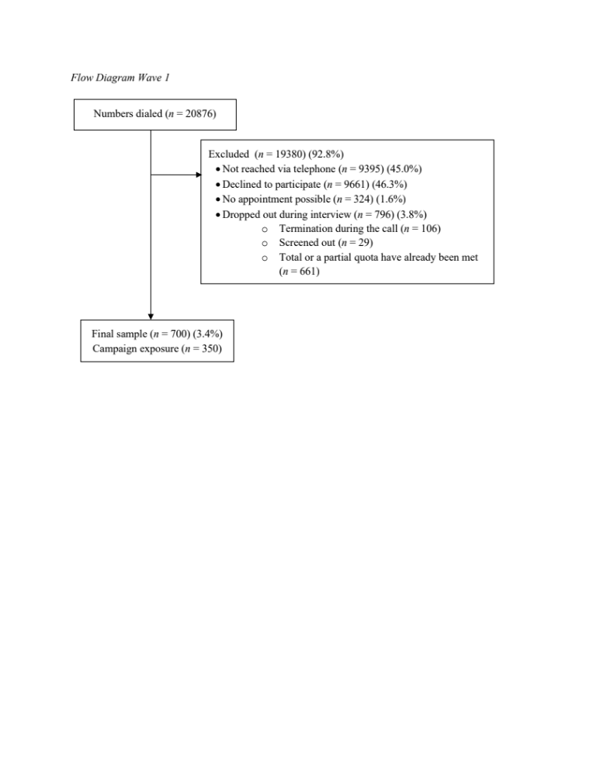
Figure S2
Flow Diagram of Recruitment Procedure in Wave 2
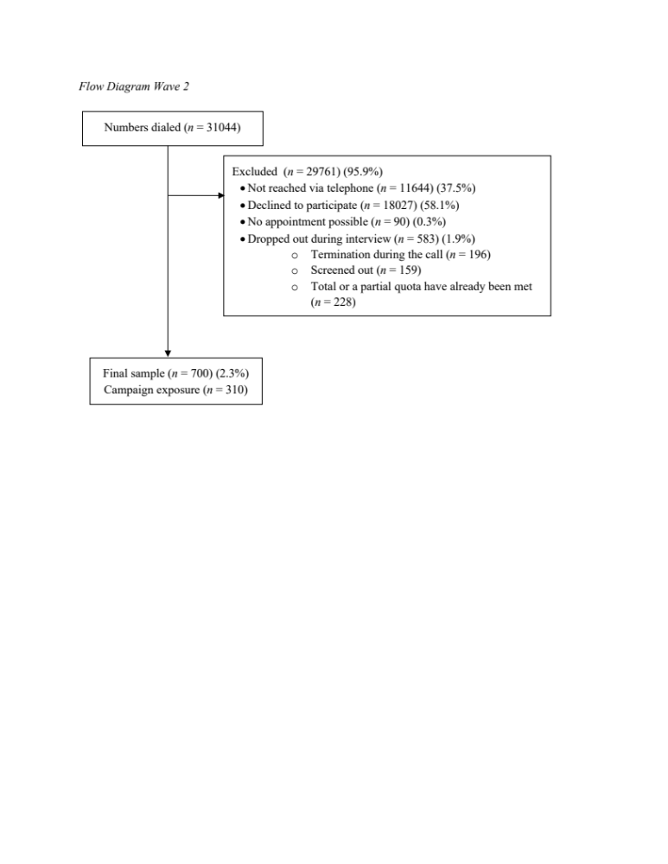

Analyses with vs. without control variables (CVs)
Knowledge
Knowledge about Influenza
Table S3
AN(C)OVA Results for Influenza Knowledge by Intervention Year (Wave 1 vs. Wave 2) and Intervention Exposure vs. Control Group
 | With Control Variables |  |  |  | Without Control Variables
Variables | df | F | $$ρ$$ | $η$² | df | F | $$ρ$$ | $η$²
Model | 7 | 6.297 | .000 | .033 | 3 | 3.923 | .008 | .009
(Intercept) | 1 | 97.433 | .000 | .070 | 1 | 15814.843 | .000 | .920
Intervention exposure | 1 | 11.834 | .001 | .009 | 1 | 10.266 | .001 | .007
Year of participation | 1 | .118 | .731 | .000 | 1 | .186 | .666 | .000
Interaction Year of participation * Exposure | 1 | .735 | .391 | .001 | 1 | 1.420 | .234 | .001
Age | 1 | .040 | .842 | .000
Gender | 1 | .057 | .811 | .000
Education | 1 | 30.780 | .000 | .023
Job status | 1 | 1.175 | .279 | .001
Error | 1303 |  |  |  | 1368
Total | 1311 |  |  |  | 1372
Corrected Total | 1310 |  |  |  | 1371
Note. df = degrees of freedom. F = F-statistic. η² = eta-squared effect size. p = p-Value. Education was coded as low, intermediate, and high according to the International Standard Classification of Education 97 (ISCED-97; Schneider, 2008). Wave 1 = 2017; Wave 2 = 2018. Exposure = intervention exposure group.

Knowledge about Pneumococci
Table S4
AN(C)OVA Results for Pneumococcal Knowledge by Intervention Year (Wave 1 vs. Wave 2) and Intervention Exposure vs. Control Group
 | With Control Variables |  |  |  |  | Without Control Variables
Variables | df | F | $$ρ$$ | $η$² | df |  | F | $$ρ$$ | $η$²
Model | 7 | 5.055 | .000 | .032 | 3 |  | 3.140 | .025 | .008
(Intercept) | 1 | 21.423 | .000 | .019 | 1 |  | 2803.117 | .000 | .712
Intervention exposure | 1 | 12.789 | .000 | .012 | 1 |  | 9.103 | .003 | .008
Year of participation | 1 | .430 | .512 | .000 | 1 |  | .527 | .468 | .000
Interaction Year of participation * Exposure | 1 | .270 | .604 | .000 | 1 |  | .027 | .868 | .000
Age | 1 | 1.974 | .160 | .002
Gender | 1 | .012 | .912 | .000
Education | 1 | 22.169 | .000 | .020
Job status | 1 | 2.305 | .129 | .002
Error | 1085 |  |  |  | 1134
Total | 1093 |  |  |  | 1138
Corrected Total | 1092 |  |  |  | 1137
Note. df = degrees of freedom. F = F-statistic. η² = eta-squared effect size. p = p-Value. Education was coded as low, intermediate, and high according to the International Standard Classification of Education 97 (ISCED-97; Schneider, 2008). Wave 1 = 2017; Wave 2 = 2018. Exposure = intervention exposure group.

Knowledge about Sepsis
Table S5
AN(C)OVA Results for Sepsis Knowledge by Intervention Year (Wave 1 vs. Wave 2) and Intervention Exposure vs. Control Group
 | With Control Variables |  |  |  | Without Control Variables
Variables | df | F | $$ρ$$ | $η$² | df | F | $$ρ$$ | $η$²
Model | 7 | 8.699 | .000 | .045 | 3 | 2.808 | .038 | .006
(Intercept) | 1 | 106.133 | .000 | .076 | 1 | 6307.552 | .000 | .823
Intervention exposure | 1 | 5.223 | .022 | .004 | 1 | 5.480 | .019 | .004
Year of participation | 1 | .837 | .360 | .001 | 1 | 1.109 | .292 | .001
Interaction Year of participation * Exposure | 1 | .515 | .473 | .000 | 1 | 1.695 | .193 | .001
Age | 1 | 24.543 | .000 | .019
Gender | 1 | 5.237 | .022 | .004
Education | 1 | 30.256 | .000 | .023
Job status | 1 | .418 | .518 | .000
Error | 1298 |  |  |  | 1360
Total | 1306 |  |  |  | 1364
Corrected Total | 1305 |  |  |  | 1363
Note. df = degrees of freedom. F = F-statistic. η² = eta-squared effect size. p = p-Value. Education was coded as low, intermediate, and high according to the International Standard Classification of Education 97 (ISCED-97; Schneider, 2008). Wave 1 = 2017; Wave 2 = 2018. Exposure = intervention exposure group.

5C Psychological Antecedents of Vaccination
Influenza Vaccination Confidence
Table S6
AN(C)OVA Results for Confidence by Intervention Year (Wave 1 vs. Wave 2) and Intervention Exposure vs. Control Group
 | Without Control Variables |  |  |  | With Control Variables
Variables | df | F | $$ρ$$ | $η$² | df | F | $$ρ$$ | $η$²
Corrected Model | 3 | .785 | .502 | .002 | 7 | 4.478 | .000 | .023
(Intercept) | 1 | 9752.429 | .000 | .877 | 1 | 20.650 | .000 | .016
Year of participation | 1 | .437 | .509 | .000 | 1 | 1.536 | .215 | .001
Intervention exposure | 1 | 1.074 | .300 | .001 | 1 | 1.781 | .182 | .001
Year of participation * Intervention Exposure | 1 | .808 | .369 | .001 | 1 | 1.183 | .277 | .001
Age |  |  |  |  | 1 | 22.164 | .000 | .017
Gender |  |  |  |  | 1 | .058 | .809 | .000
Education |  |  |  |  | 1 | 1.049 | .306 | .001
Job status |  |  |  |  | 1 | .181 | .670 | .000
Error | 1372 |  |  |  | 1304
Total | 1376 |  |  |  | 1312
Corrected total | 1375 |  |  |  | 1311
Note. df = degrees of freedom. F = F-statistic. η² = eta-squared effect size. p = p-Value. Education was coded as low, intermediate, and high according to the International Standard Classification of Education 97 (ISCED-97; Schneider, 2008). Wave 1 = 2017; Wave 2 = 2018. Exposure = intervention exposure group.

Influenza Vaccination Complacency
Table S7
AN(C)OVA Results for Complacency by Intervention Year (Wave 1 vs. Wave 2) and Intervention Exposure vs. Control Group
 | Without Control Variables |  |  |  | With Control Variables
Variables | df | F | $$ρ$$ | $η$² | df | F | $$ρ$$ | $η$²
Corrected Model | 3 | 1.066 | .362 | .002 | 7 | 1.950 | .059 | .010
(Intercept) | 1 | 8756.844 | .000 | .864 | 1 | 54.073 | .000 | .040
Year of participation | 1 | .028 | .866 | .000 | 1 | .305 | .581 | .000
Intervention exposure | 1 | 2.799 | .095 | .002 | 1 | 2.603 | .107 | .002
Year of participation * Intervention Exposure | 1 | .412 | .521 | .000 | 1 | .311 | .577 | .000
Age |  |  |  |  | 1 | .156 | .693 | .000
Gender |  |  |  |  | 1 | 9.456 | .002 | .007
Education |  |  |  |  | 1 | .750 | .387 | .001
Job status |  |  |  |  | 1 | 1.106 | .293 | .001
Error | 1380 |  |  |  | 1314
Total | 1384 |  |  |  | 1322
Corrected total | 1383 |  |  |  | 1321
Note. df = degrees of freedom. F = F-statistic. η² = eta-squared effect size. p = p-Value. Education was coded as low, intermediate, and high according to the International Standard Classification of Education 97 (ISCED-97; Schneider, 2008). Wave 1 = 2017; Wave 2 = 2018. Exposure = intervention exposure group.

Influenza Vaccination Collective Responsibility
Table S8
AN(C)OVA Results for Collective Responsibility by Intervention Year (Wave 1 vs. Wave 2) and Intervention Exposure vs. Control Group
 | Without Control Variables |  |  |  | With Control Variables
Variables | df | F | $$ρ$$ | $η$² | df | F | $$ρ$$ | $η$²
Corrected Model | 3 | 2.337 | .072 | .005 | 7 | 1.379 | .210 | .007
(Intercept) | 1 | 21631.231 | .000 | .655 | 1 | 197.490 | .000 | .015
Year of participation | 1 | 2.038 | .154 | .001 | 1 | 1.409 | .235 | .001
Intervention exposure | 1 | 5.222 | .022 | .004 | 1 | 3.615 | .057 | .003
Year of participation * Intervention Exposure | 1 | .094 | .759 | .000 | 1 | .486 | .486 | .000
Age |  |  |  |  | 1 | .088 | .767 | .000
Gender |  |  |  |  | 1 | .637 | .425 | .000
Education |  |  |  |  | 1 | 2.508 | .114 | .002
Job status |  |  |  |  | 1 | 1.159 | .282 | .001
Error | 1364 |  |  |  | 1301
Total | 1368 |  |  |  | 1309
Corrected total | 1367 |  |  |  | 1308
Note. df = degrees of freedom. F = F-statistic. η² = eta-squared effect size. p = p-Value. Education was coded as low, intermediate, and high according to the International Standard Classification of Education 97 (ISCED-97; Schneider, 2008). Wave 1 = 2017; Wave 2 = 2018. Exposure = intervention exposure group.

Influenza Vaccination Constraints
Table S9
AN(C)OVA Results for Constraints by Intervention Year (Wave 1 vs. Wave 2) and Intervention Exposure vs. Control Group
 | Without Control Variables |  |  |  | With Control Variables
Variables | df | F | $$ρ$$ | $η$² | df | F | $$ρ$$ | $η$²
Corrected Model | 3 | 1.237 | .295 | .003 | 7 | 1.207 | .295 | .006
(Intercept) | 1 | 3137.529 | .000 | .694 | 1 | 44.547 | .000 | .033
Year of participation | 1 | 3.440 | .064 | .002 | 1 | 4.357 | .037 | .003
Intervention exposure | 1 | .384 | .535 | .000 | 1 | .632 | .427 | .000
Year of participation * Intervention Exposure | 1 | .014 | .906 | .000 | 1 | .014 | .906 | .000
Age |  |  |  |  | 1 | .649 | .420 | .000
Gender |  |  |  |  | 1 | .007 | .934 | .000
Education |  |  |  |  | 1 | 1.543 | .214 | .001
Job status |  |  |  |  | 1 | .966 | .326 | .001
Error | 1386 |  |  |  | 1318
Total | 1390 |  |  |  | 1326
Corrected total | 1389 |  |  |  | 1325
Note. df = degrees of freedom. F = F-statistic. η² = eta-squared effect size. p = p-Value. Education was coded as low, intermediate, and high according to the International Standard Classification of Education 97 (ISCED-97; Schneider, 2008). Wave 1 = 2017; Wave 2 = 2018. Exposure = intervention exposure group.

Influenza Vaccination Calculation
Table S10
AN(C)OVA Results for Calculation by Intervention Year (Wave 1 vs. Wave 2) and Intervention Exposure vs. Control Group
 | Without Control Variables |  |  |  | With Control Variables
Variables | df | F | $$ρ$$ | $η$² | df | F | $$ρ$$ | $η$²
Corrected Model | 3 | 1.695 | .166 | .004 | 7 | 2.052 | .046 | .011
(Intercept) | 1 | 5903.644 | .000 | .813 | 1 | 76.754 | .000 | .056
Year of participation | 1 | .186 | .667 | .000 | 1 | .035 | .852 | .000
Intervention exposure | 1 | 4.758 | .029 | .004 | 1 | 4.338 | .037 | .003
Year of participation * Intervention Exposure | 1 | .014 | .905 | .000 | 1 | .108 | .742 | .000
Age |  |  |  |  | 1 | 5.891 | .015 | .005
Gender |  |  |  |  | 1 | 2.579 | .109 | .002
Education |  |  |  |  | 1 | .471 | .493 | .000
Job status |  |  |  |  | 1 | .036 | .850 | .000
Error | 1354 |  |  |  | 1287
Total | 1358 |  |  |  | 1295
Corrected total | 1357 |  |  |  | 1294
Note. df = degrees of freedom. F = F-statistic. η² = eta-squared effect size. p = p-Value. Education was coded as low, intermediate, and high according to the International Standard Classification of Education 97 (ISCED-97; Schneider, 2008). Wave 1 = 2017; Wave 2 = 2018. Exposure = intervention exposure group.

Pneumococcal Vaccination Confidence
Table S11
AN(C)OVA Results for Confidence by Intervention Year (Wave 1 vs. Wave 2 and Intervention Exposure vs. Control Group
 | Without Control Variables |  |  |  | With Control Variables
Variables | df | F | $$ρ$$ | $η$² | df | F | $$ρ$$ | $η$²
Corrected Model | 3 | 3.165 | .024 | .017 | 7 | 3.176 | .003 | .040
(Intercept) | 1 | 6346.998 | .000 | .919 | 1 | 14.194 | .000 | .026
Year of participation | 1 | .015 | .903 | .000 | 1 | .003 | .960 | .000
Intervention exposure | 1 | 8.982 | .003 | .016 | 1 | 10.620 | .001 | .020
Year of participation * Intervention Exposure | 1 | .371 | .542 | .001 | 1 | .636 | .425 | .001
Age |  |  |  |  | 1 | 6.623 | .010 | .012
Gender |  |  |  |  | 1 | .484 | .487 | .001
Education |  |  |  |  | 1 | .530 | .467 | .001
Job status |  |  |  |  | 1 | .621 | .431 | .001
Error | 557 |  |  |  | 530
Total | 561 |  |  |  | 538
Corrected total | 560 |  |  |  | 537
Note. df = degrees of freedom. F = F-statistic. η² = eta-squared effect size. p = p-Value. Education was coded as low, intermediate, and high according to the International Standard Classification of Education 97 (ISCED-97; Schneider, 2008). Wave 1 = 2017; Wave 2 = 2018. Exposure = intervention exposure group.

Pneumococcal Vaccination Complacency
Table S12
AN(C)OVA Results for Complacency by Intervention Year (Wave 1 vs. Wave 2) and Intervention Exposure vs. Control Group
 | Without Control Variables |  |  |  | With Control Variables
Variables | df | F | $$ρ$$ | $η$² | df | F | $$ρ$$ | $η$²
Corrected Model | 3 | 4.577 | .004 | .023 | 7 | 2.527 | .014 | .031
(Intercept) | 1 | 2215.400 | .000 | .795 | 1 | 9.867 | .002 | .018
Year of participation | 1 | 11.124 | .001 | .019 | 1 | 11.925 | .001 | .021
Intervention exposure | 1 | 1.935 | .165 | .003 | 1 | 2.328 | .128 | .004
Year of participation * Intervention Exposure | 1 | 1.925 | .166 | .003 | 1 | 2.270 | .132 | .004
Age |  |  |  |  | 1 | 1.734 | .188 | .003
Gender |  |  |  |  | 1 | 1.253 | .263 | .002
Education |  |  |  |  | 1 | .132 | .717 | .000
Job status |  |  |  |  | 1 | 1.530 | .217 | .003
Error | 572 |  |  |  | 544
Total | 576 |  |  |  | 552
Corrected total | 575 |  |  |  | 551
Note. df = degrees of freedom. F = F-statistic. η² = eta-squared effect size. p = p-Value. Education was coded as low, intermediate, and high according to the International Standard Classification of Education 97 (ISCED-97; Schneider, 2008). Wave 1 = 2017; Wave 2 = 2018. Exposure = intervention exposure group.

Pneumococcal Vaccination Collective Responsibility
Table S13
AN(C)OVA Results for Collective Responsibility by Intervention Year (Wave 1 vs. Wave 2) and Intervention Exposure vs. Control Group
 | Without Control Variables |  |  |  | With Control Variables
Variables | df | F | $$ρ$$ | $η$² | df | F | $$ρ$$ | $η$²
Corrected Model | 3 | 1.064 | .364 | .006 | 7 | 1.609 | .130 | .020
(Intercept) | 1 | 8925.855 | .000 | .940 | 1 | 45.825 | .000 | .077
Year of participation | 1 | 2.762 | .097 | .005 | 1 | 2.961 | .086 | .005
Intervention exposure | 1 | .528 | .468 | .001 | 1 | .208 | .648 | .000
Year of participation * Intervention Exposure | 1 | .032 | .859 | .000 | 1 | .298 | .585 | .001
Age |  |  |  |  | 1 | 3.831 | .051 | .007
Gender |  |  |  |  | 1 | 1.628 | .202 | .003
Education |  |  |  |  | 1 | 1.952 | .163 | .004
Job status |  |  |  |  | 1 | 3.773 | .053 | .007
Error | 572 |  |  |  | 546
Total | 576 |  |  |  | 554
Corrected total | 575 |  |  |  | 553
Note. df = degrees of freedom. F = F-statistic. η² = eta-squared effect size. p = p-Value. Education was coded as low, intermediate, and high according to the International Standard Classification of Education 97 (ISCED-97; Schneider, 2008). Wave 1 = 2017; Wave 2 = 2018. Exposure = intervention exposure group.

Pneumococcal Vaccination Constraints
Table S14
AN(C)OVA Results for Constraints by Intervention Year (2017 vs. 2018) and Intervention Exposure (vs. Control Group)
 | Without Control Variables |  |  |  | With Control Variables
Variables | df | F | $$ρ$$ | $η$² | df | F | $$ρ$$ | $η$²
Corrected Model | 3 | 1.517 | .209 | .008 | 7 | 1.099 | .362 | .014
(Intercept) | 1 | 1223.475 | .000 | .688 | 1 | 15.335 | .000 | .028
Year of participation | 1 | 4.418 | .036 | .008 | 1 | 2.339 | .127 | .004
Intervention exposure | 1 | .050 | .823 | .000 | 1 | .006 | .938 | .000
Year of participation * Intervention Exposure | 1 | .056 | .812 | .000 | 1 | .002 | .961 | .000
Age |  |  |  |  | 1 | .023 | .879 | .000
Gender |  |  |  |  | 1 | .189 | .664 | .000
Education |  |  |  |  | 1 | .533 | .466 | .001
Job status |  |  |  |  | 1 | 3.966 | .047 | .007
Error | 556 |  |  |  | 531
Total | 560 |  |  |  | 539
Corrected total | 559 |  |  |  | 538
Note. df = degrees of freedom. F = F-statistic. η² = eta-squared effect size. p = p-Value. Education was coded as low, intermediate, and high according to the International Standard Classification of Education 97 (ISCED-97; Schneider, 2008). Wave 1 = 2017; Wave 2 = 2018. Exposure = intervention exposure group.

Pneumococcal Vaccination Calculation
Table S15
Calculation as a Function of Intervention Year (2017 vs. 2018) and Intervention Exposure (vs. Control Group) (ANOVA)
 | Without Control Variables |  |  |  | With Control Variables
Variables | df | F | $$ρ$$ | $η$² | df | F | $$ρ$$ | $η$²
Corrected Model | 3 | 2.195 | .088 | .011 | 7 | 3.107 | .003 | .037
(Intercept) | 1 | 7657.848 | .000 | .928 | 1 | 84.958 | .000 | .130
Year of participation | 1 | 3.116 | .078 | .005 | 1 | 3.646 | .057 | .006
Intervention exposure | 1 | 2.224 | .136 | .004 | 1 | 2.079 | .150 | .004
Year of participation * Intervention Exposure | 1 | 1.953 | .163 | .003 | 1 | 1.715 | .191 | .003
Age |  |  |  |  | 1 | 7.352 | .007 | .013
Gender |  |  |  |  | 1 | 6.798 | .009 | .012
Education |  |  |  |  | 1 | .233 | .629 | .000
Job status |  |  |  |  | 1 | .043 | .836 | .000
Error | 596 |  |  |  | 570
Total | 600 |  |  |  | 578
Corrected total | 599 |  |  |  | 577
Note. df = degrees of freedom. F = F-statistic. η² = eta-squared effect size. p = p-Value. Education was coded as low, intermediate, and high according to the International Standard Classification of Education 97 (ISCED-97; Schneider, 2008). Wave 1 = 2017; Wave 2 = 2018. Exposure = intervention exposure group.

Intention
Vaccination Intention
Table S16
Influenza and Pneumococcal Vaccination Intention (Self-Report) as a Function of Campaign Exposure (Campaign vs. Control Group)and Year of Participation (Wave 1 vs. Wave 2) (AN(C)OVA)
 | Influenza Vaccination Intention |  |  |  | Pneumococcal Vaccination Intention
Variables | df | F | $$ρ$$ | $η$² |  | df | F | $$ρ$$ | $η$²
Model | 3 | .419 | .740 | .002 |  | 3 | 1.011 | .387 | .003
(Intercept) | 1 | 1098.604 | .000 | .686 |  | 1 | 2912.063 | .000 | .745
Year of participation | 1 | .197 | .658 | .000 |  | 1 | 1.552 | .213 | .002
Campaign exposure | 1 | .584 | .445 | .001 |  | 1 | .152 | .697 | .000
Interaction Year of participation * Exposure | 1 | .434 | .511 | .001 |  | 1 | .908 | .341 | .001
Error | 504 |  |  |  |  | 997
Total | 508 |  |  |  |  | 1001
Corrected Total | 507 |  |  |  |  | 1000
Model | 7 | .237 | .976 | .003 |  | 7 | 1.554 | .146 | .011
(Intercept) | 1 | 7.683 | .006 | .016 |  | 1 | 10.231 | .001 | .011
Year of participation | 1 | .335 | .563 | .001 |  | 1 | .578 | .447 | .001
Campaign exposure | 1 | .271 | .603 | .001 |  | 1 | .486 | .486 | .001
Interaction Year of participation * Exposure | 1 | .233 | .630 | .000 |  | 1 | .269 | .604 | .000
Age | 1 | .199 | .656 | .000 |  | 1 | 1.091 | .296 | .001
Gender | 1 | .051 | .822 | .000 |  | 1 | 6.067 | .014 | .006
Education | 1 | .239 | .625 | .001 |  | 1 | 2.094 | .148 | .002
Jobstatus | 1 | .329 | .566 | .001 |  | 1 | .152 | .696 | .000
Error | 477 |  |  |  |  | 946
Total | 485 |  |  |  |  | 954
Corrected Total | 484 |  |  |  |  | 953

Note. df = degrees of freedom. F = F-statistic. η² = eta-squared effect size. p = p-Value. Education was coded as low, intermediate, and high according to the International Standard Classification of Education 97 (ISCED-97; Schneider, 2008). Wave 1 = 2017; Wave 2 = 2018. Exposure = intervention exposure group.

