Supplementary Document
Preliminary Analysis
Preliminary analyses were conducted in R program (R Core Team, 2024). A series of independent-sample t-tests and analysis of variance (ANOVA) tests were conducted to compare group-level mean differences on key variables across sociodemographic characteristics (i.e., biological sex, first-generation college student, Pell-grant recipient, commuting status, and race/ethnicity).
Supplementary Table 1 shows person-level means, standard deviations, ranges, and bivariate correlations between study variables. Supplementary Table 2 shows that female participants (Mean = 6.02, SD = 4.64) reported highest levels of everyday discrimination at W1L than male participants (Mean = 4.76, SD = 3.97). Female participants (Mean = 6.76, SD = 4.46) also reported the higher levels of sleep disturbance at W2L than male participants (Mean = 5.41, SD = 3.52). Female participants reported higher levels of daytime dysfunction at W2L (Mean = 2.30, SD = 1.52) than male participants (Mean = 1.89, SD = 1.51).
Black participants reported more everyday discrimination at W1L (F (5,606) = 4.57, p < .001; Mean = 7.54, SD = 4.50) than Asian (Mean = 4.87, SD = 4.18) and White participants (Mean = 5.19, SD = 4.32). Multiracial and other race participants had higher levels of variability in daily sleep quality at W1D (F (5,615) = 3.41, p < .001; Mean = .65, SD = .22) than Asian (Mean = .57, SD = .22) and Black participants (Mean = .53, SD = .28).

Supplementary Table 1
Means, standard deviations, ranges, and correlations of study variables
 | N | M | SD | Range | 1 | 2 | 3 | 4 | 5
1. Everyday discrimination (W1L) | 614 | 5.79 | 4.54 | 0-20
2. Sleep quality: average (W1D) | 628 | 2.01 | .40 | .31-3 | -.13**
3. Sleep quality: variability (W1D) | 628 | .47 | .15 | 0-0.85 | .08* | -.31**
4. Sleep disturbance (W2L) | 493 | 6.49 | 4.31 | 0-22 | .29** | -.23** | .19**
5. Daytime dysfunction (W2L) | 493 | 2.23 | 1.54 | 0-6 | .28** | -.28** | .06 | .34**
Covariates:
Male (W1L) | 626 | .25 | .43 | 0-1 | -.13** | .05 | -.02 | -.14** | -.12**
Cohort 2 (W1L)ª | 628 | .60 | .49 | 0-1 | -.03 | .16** | .06 | .01 | .06
Cohort 3 (W1L)ª | 628 | .16 | .37 | 0-1 | .06 | -.05 | .01 | .03 | -.10*
Asian (W1L)^{b} | 626 | .24 | .43 | 0-1 | -.05 | .00 | -.06 | -.03 | .03
Black (W1L)^{b} | 626 | .15 | .35 | 0-1 | .18** | .04 | -.07 | .00 | .04
Latinx (W1L)^{b} | 626 | .31 | .46 | 0-1 | .01 | -.02 | .02 | -.02 | -.02
Multi-racial and Others (W1L)^{b} | 626 | .02 | .14 | 0-1 | -.05 | .05 | .02 | -.02 | -.08
Somatic symptoms (W1L) | 604 | 1.17 | .66 | 0-3 | .40** | -.26** | .11** | .49** | .41**
Depressive symptoms (W1L) | 615 | 6.42 | 5.36 | 0-25 | .30** | -.31** | .13** | .40** | .45**
Sleep disturbance (W1L) | 615 | 7.06 | 4.10 | 0-25 | .26** | -.22** | .17** | .59** | .23**
Daytime dysfunction (W1L) | 615 | 2.80 | 1.53 | 0-6 | .20** | -.30** | .05 | .28** | .50**
Sleep duration: average (W1D) | 628 | 6.08 | .89 | 2.79-9.80 | -.09* | .27** | -.05 | .01 | -.21**
Note. N, M, and SD are used to represent sample size, mean, and standard deviation, respectively. W1L = wave 1 longitudinal survey. W1D = wave 1 daily diary survey. W2L = wave 2 longitudinal survey. Superscriptª indicates cohort 1 was the referent group. Superscript^{b} indicates White college students were the referent group. * indicates p < .05. ** indicates p < .01.
Supplementary Table 2
Mean difference tests across demographic characteristics
 | Everyday discrimination (W1L) |  | Sleep quality: average (W1D) |  | Sleep quality: variability (W1D) |  | Sleep disturbance (W2L) |  | Daytime dysfunction (W2L)
 | t(df)/  F(df1,df2) | p | t(df)/  F(df1,df2) | p | t(df)/  F(df1,df2) | p | t(df)/  F(df1,df2) | p | t(df)/  F(df1,df2) | p
Sexª | 10.36 (611) | .001 | -2.98 (612) | .15 | .50 (612) | .66 | 8.65 (482) | <.001 | 4.48 (482) | .01
First generation collegeª | -1.88 (606) | .06 | .84 (617) | .40 | .55 (617) | .58 | -.46 (486) | .65 | -.75 (486) | .45
Pell recipientª | -2.58 (606) | .01 | .82 (617) | .41 | .50 (617) | .62 | -.78 (486) | .43 | -1.42 (486) | .16
Commuterª | .79 (606) | .43 | .04 (617) | .97 | 2.68 (617) | .01 | 1.18 (486) | .24 | -1.15 (486) | .25
Race^{b} | 4.57 (5,606) | <.001 | 1.01 (5,613) | .69 | 3.41 (5,615) | <.001 | .55 (3,484) | .65 | .34 (3,484) | .80
Note. W1D = wave 1 daily diary survey. W1L = wave 1 longitudinal survey. W2L = wave 2 longitudinal survey. Superscriptª indicates independent-sample t-test was conducted. Superscript^{b} indicates one-way analysis of variance (ANOVA) was conducted.
Supplementary Table 3
Associations of key predictors and covariates at W1L with sleep outcomes at W2L
Predictor | Sleep disturbance (W2L) |  |  |  | Daytime dysfunction (W2L)
Predictor | b | 95% CI [LL,UL] | β |  | b | 95% CI [LL,UL] | β
Everyday discrimination (W1L) | .05 | [-.03, .13] | .05 |  | .05 | [.02, .08] | .13
Sleep quality: average (W1D) | -.83 | [-1.70, .05] | -.08 |  | -.46 | [-.79, -.13] | -.12
Sleep quality: variability (W1D) | .92 | [-1.25, 3.08] | .03 |  | -.26 | [-1.05, .54] | -.03
Covariates:
Male (W1L) | -.36 | [-1.03, .32] | -.04 |  | .01 | [-.28, .29] | .002
Age | .39 | [-.32, 1.08] | .04 |  | -.08 | [-.18, -.35] | .02
Asian (W1L) | .24 | [-.66, 1.15] | .02 |  | .11 | [-.21, .44] | .03
Black (W1L) | .18 | [-1.13, 1.48] | .01 |  | -.22 | [-.68, .24] | -.05
Latinx (W1L) | -.86 | [-1.73, .02] | -.08 |  | -.24 | [-.57, .10] | -.06
Others (W1L) | -.18 | [-1.04, .67] | -.02 |  | .14 | [-.29, .47] | .04
Somatic symptoms (W1L) | 1.28 | [.52, 1.11] | .19 |  | .27 | [.01, .53] | .11
Depressive symptoms (W1L) | .09 | [.002, .19] | .12 |  | .04 | [.01, .07] | .15
Sleep disturbance (W1L) | .44 | [.35, .52] | .41 |  | -.01 | [-.04, .03] | -.02
Daytime dysfunction (W1L) | .04 | [-.22, .29] | .01 |  | .31 | [.21, .40] | .30
Sleep duration: average (W1D) | .57 | [.20, .94] | .12 |  | -.10 | [-.25, .04] | -.06
Note. W1D = wave 1 daily diary survey. W1L = wave 1 longitudinal survey. W2L = wave 2 longitudinal survey. b = unstandardized coefficients. 95% CI[LL,UL] = lower level (LL) and upper level (UL) of unstandardized coefficient 95% confidence intervals. β = standardized coefficients. Bold numbers indicate parameters with significant p values.
Supplementary Table 4
Sleep quality at W1D mediating associations between everyday discrimination at W1L and health outcomes at W2L
Outcome | Mediator | A path |  |  |  | B path |  |  |  | Direct Effect |  |  |  | Indirect Effect
Outcome | Mediator | b | 95% CI [LL,UL] | β |  | b | 95% CI [LL,UL] | β |  | b | 95% CI [LL,UL] | β |  | b | 95% CI [LL,UL] | β
Sleep disturbance | Sleep quality (A) | -.01 | [-.02, -.004] | -.13 |  | -.83 | [-1.79, .002] | -.08 |  | .05 | [-.05, .14] | .05 |  | .009 | [-.003, .02] | .01
Sleep disturbance | Sleep quality (V) | .003 | [.001, .01] | .09 |  | .92 | [-1.64, 2.56] | .03 |  | .05 | [-.05, .14] | .05 |  | .003 | [-.01, .01] | .004
Daytime dysfunction | Sleep quality (A) | -.01 | [-.02, -.004] | -.13 |  | -.46 | [-.81, -.15] | -.12 |  | .05 | [.01, .08] | .13 |  | .005 | [.001, .01] | .02
Daytime dysfunction | Sleep quality (V) | .003 | [.001, .01] | .09 |  | -.26 | [-1.36, .24] | -.03 |  | .05 | [.01, .08] | .13 |  | -.001 | [-.004, .001] | -.003
Note. W1D = wave 1 daily diary survey. W1L = wave 1 longitudinal survey. W2L = wave 2 longitudinal survey. b = unstandardized coefficients. 95% CI[LL,UL] = lower level (LL) and upper level (UL) of unstandardized coefficient 95% confidence intervals. β = standardized coefficients. (A) indicates average sleep quality across two weeks. (V) indicates variability in sleep quality across two weeks. A path indicates the association between predictor and mediator variables. B path indicates the association between mediator and outcome variables. Direct path indicates the association between predictor and outcome variables while controlling for the mediator variables. Indirect path indicates the association between predictor and outcome variables through the mediator variables. Bold numbers indicate significant paths.
Supplementary Table 5
Sleep duration at W1D mediating associations between everyday discrimination at W1L and health outcomes at W2L
Outcome | Mediator | A path |  |  |  | B path |  |  |  | Direct Effect |  |  |  | Indirect Effect
Outcome | Mediator | b | 95% CI [LL,UL] | β |  | b | 95% CI [LL,UL] | β |  | b | 95% CI [LL,UL] | β |  | b | 95% CI [LL,UL] | β
Sleep disturbance | Sleep duration (A) | -.01 | [-.03, .003] | -.97 |  | .58 | [.21, .95] | .12 |  | .05 | [-.03, .13] | .05 |  | -.007 | [-.03, .01] | -.01
Sleep disturbance | Sleep duration (V) | .003 | [-.001, .007] | .07 |  | .46 | [-.91, 1.83] | .02 |  | .05 | [-.03, .13] | .05 |  | .002 | [-.005, .01] | .002
Daytime dysfunction | Sleep duration (A) | -.01 | [-.03, .003] | -.97 |  | .10 | [-.25, .05] | -.06 |  | .05 | [.01, .08] | .13 |  | .001 | [-.002, .006] | .005
Daytime dysfunction | Sleep duration (V) | .003 | [-.001, .007] | .07 |  | .23 | [-.28, .74] | .03 |  | .05 | [.01, .08] | .13 |  | .001 | [-.001, .003] | .003
Note. W1D = wave 1 daily diary survey. W1L = wave 1 longitudinal survey. W2L = wave 2 longitudinal survey. b = unstandardized coefficients. 95% CI[LL,UL] = lower level (LL) and upper level (UL) of unstandardized coefficient 95% confidence intervals. β = standardized coefficients. (A) indicates average sleep duration across two weeks. (V) indicates variability in sleep duration across two weeks. Bold numbers indicate significant paths. A path indicates the association between predictor and mediator variables. B path indicates the association between mediator and outcome variables. Direct path indicates the association between predictor and outcome variables while controlling for the mediator variables. Indirect path indicates the association between predictor and outcome variables through the mediator variables.

Sample Selection Criterion
The initial sample consisted of 810 1st-year college participants (C1 = 213 students, C2 = 485 students, C3 = 112 students). After ineligible students (i.e., international, medically documented sleep disorder) were excluded from the data (Total = 161 students, C1 = 58 students, C2 = 100 students, C3 = 3 students), a total of 649 students completed the initial survey (W1L; C1 = 155 students, C2 = 385 students, C3 = 109 students). Then, we screened data quality in the daily diaries. Previous self-reported daily diary studies of sleep have documented an association between missing attention check questions with higher levels of daytime sleepiness, signaling unreliable responses in sleep-related questions (Authors’ citation). Consistent with best practices and maximizing data quality, we removed daily diary reports for days when participants failed to answer both attention check questions correctly (C1 = 132 reports, C2 = 460 reports, C3 = 178 reports) and when participants failed to complete daily diary reports before 12:00 PM in the next day (C1 = 4 reports, C2 = 21 reports, C3 = 5 reports), which in total is equivalent to excluding 5 participants failing meeting sleep protocol in all reported days (C1 = 0 students, C2 = 3 students, C3 = 2 students). Lastly, to calculate robust and reliable means and variability in daily reports of sleep across the 14-day daily diary reports, participants who had less than five days of valid daily diary reports (Total = 16 students, C1 = 3 students, C2 = 8 students, C3 = 5 students) were excluded from this analysis (Lau et al., 2022), which resulted in a final analytic sample of 626 students (W1D; C1 = 152 students, C2 = 372 students, C3 = 102 students; Supplementary Figure 1). Of note, among the final analytic sample, 607 students continued participating in the follow-up survey (W2L; C1 = 152 students, C2 = 372 students, C3 = 102 students).

Supplementary Figure 1
Sample selection flow chart
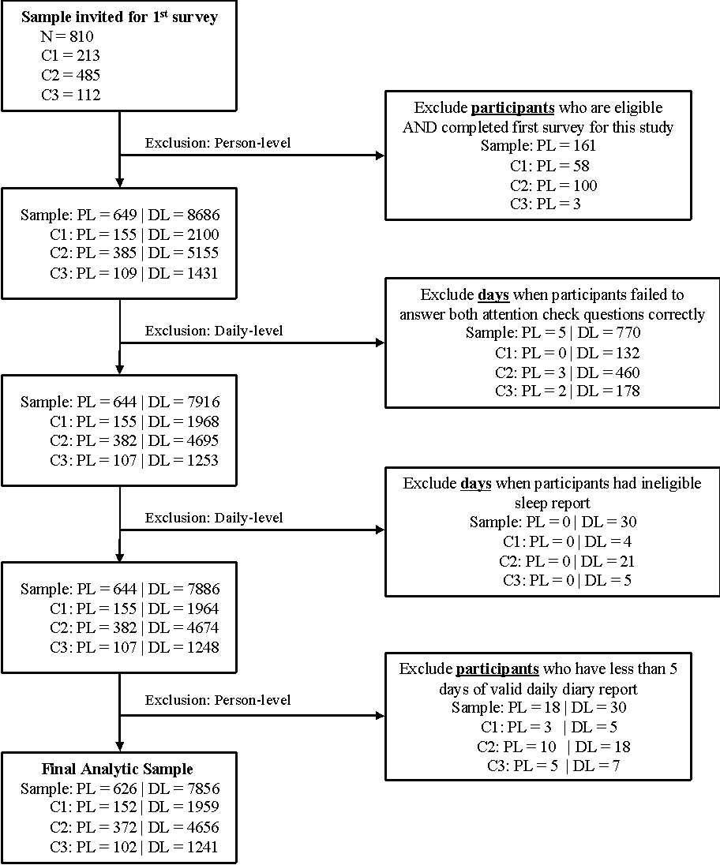
Note. PL = sample size in person-level, DL = sample size in daily level, C1 = Cohort 1, C2 = Cohort 2, C3 = Cohort 3.

Supplementary Figure 2
Daily sleep quality mean and variability (W1D) across weekdays as a mediator of the association between fall everyday discrimination (W1L) and spring sleep outcomes (W2L) in the first year of college
Note. W1L = wave 1 longitudinal survey. W1D = wave 1 daily diary survey. W2L = wave 2 longitudinal survey. Standardized coefficients are shown. Dashed lines indicate non-significant paths. Covariates were included in the analysis but omitted from the figure. * indicates p < .05. ** indicates p < .01. *** indicates p < .001.
Supplementary Figure 3
Daily sleep quality mean and variability (W1D) across weekends as a mediator of the association between fall everyday discrimination (W1L) and spring sleep outcomes (W2L) in the first year of college
Note. W1L = wave 1 longitudinal survey. W1D = wave 1 daily diary survey. W2L = wave 2 longitudinal survey. Standardized coefficients are shown. Dashed lines indicate non-significant paths. Covariates were included in the analysis but omitted from the figure. * indicates p < .05. ** indicates p < .01. *** indicates p < .001.

