Supplemental Material
Section A: Risk of Bias analysis.

This project assessed risk of bias across 8 domains, adapted from the Johanna Briggs Institute Critical Appraisal Tool for Analytical Cross-Sectional Studies (Munn et al., 2023) and (b) the Cochrane Risk of Bias Tool (Higgins et al., 2011). This approach of integrating across multiple tools (following Donald et al., 2021) was taken because no existing tool was found to be suitable for comparing across multiple study types. In each domain, the risk of bias was assessed as low, high, or some concerns, with the latter category used for both minor issues that were identified or when the risk of bias was unclear from the manuscript.
(1) The eligibility criteria were clearly specified. Studies which clearly described their sample and recruitment methodology were scored as low risk in this domain if the inclusion criteria could be inferred from this contextual information.

(2) The exposure (social identity) was assessed or manipulated in a way that was valid and reliable. For example, the use of a widely verified paradigm for manipulating social identity salience (e.g., Häusser et al., 2012), or a measure of social identification that had previously undergone formal verification.
(3) Confounds were identified and managed appropriately. Experimental studies were scored as low risk because an experiment in the most effective way to deal with confounds. A non-experimental study could also be classified as low risk if they either (a) include appropriate covariates in their analysis, or (b) had a non-experimental matched control group (e.g., Stevens & Cruwys 2020).
(4) Randomisation occurred and was conducted adequately. Experimental studies were scored as low risk unless there were concerns about bias in the randomisation strategy or strategic drop-out.
(5) Participants were blinded. This criterion assessed the transparency of the researchers’ hypotheses and the risk of this influencing their responses (e.g., demand characteristics from participants). Experiments with a plausible cover story were most likely to be scored a slow risk.
(6) The outcome assessment was protected from assessor bias. If the DV is measured in a way that is not open to assessor interpretation (e.g. heart rate), studies were likely to be assessed as low risk. If assessors’ interpretation could play a role in the scoring of the outcome and they were not blind to allocation, then the study would likely be scored high risk.
(7) Any missing data was disclosed and unlikely to be systematic. This criterion assessed the degree of dropout/missing data, and whether it was patterned in any way that may have affected the results. For example, if people were more likely to drop out in one experimental condition than the other, that would likely receive a score of high risk.
(8) The outcomes (objective health indicators) were assessed using valid, reliable measures. This criterion assessed whether the dependent variable was an appropriate operationalisation of the construct of interest. For example, if an indicator was widely used, calculated using established methods, and interpreted in the standard way it would be evaluated as low risk. If the authors interpreted a cardiovascular measure differently to other papers, or were the first to use a particular indicator without presenting validation evidence, it would be assessed as high risk.
Table S1. Risk of bias assessment for each study included in the review.
Study | 1. Eligibility criteria | 2. IV valid and reliable | 3. Confound management | 4. Randomisation | 5. Participant blinding | 6. Assessor bias | 7. Missing data | 8. DV valid and reliable | Overall score
Banas et al. (2016) [Study 2] | Low | Low | Low | Low | Low | Low | Low | Low | 16
Beauchamp et al 2021 | Low | Some concerns | Low | Low | Some concerns | High | Low | Low | 12
Beckwith et al. (2015) | Low | Low | Low | High | High | Low | Some concerns | Low | 11
Berger & Rand (2008) [Study 3] | High | Some concerns | Low | Low | Low | Low | Low | Low | 13
Blanton et al. (2012) | Low | Some concerns | Low | Low | Low | Low | Low | Low | 15
Branscombe & Wann (1992) | Low | High | Low | Some concerns | Low | Low | Low | Low | 13
Brown, Bradley & Lang (2006) | Low | Low | Low | Low | Low | Low | Some concerns | Low | 15
Choi et al. (2022) | Low | Low | Low | HIgh | High | Low | Low | Low | 12
Cleveland et al. (2012) | Low | High | Low | Low | Low | Low | Low | Low | 14
Cruwys et al. (2012) | Low | Low | Low | Low | Low | Low | Low | Low | 16
Cruwys et al. (2018) [Study 1] | Low | Low | Low | Low | High | Low | Low | Low | 14
Cruwys et al. (2023) [Study 1] | Low | Low | High | High | Some concerns | Low | Some concerns | Low | 10
Cruwys et al. (2023) [Study 2] | Low | Low | High | High | Some concerns | Low | Some concerns | Low | 10
Dariusz (2022) | Low | Low | Low | Low | Low | Low | Low | Low | 16
De Silva & Harpham (2007) | Low | Low | Low | High | Low | Low | Some concerns | Low | 13
Derks et al. (2011) | Low | High | Low | Low | Low | Low | Low | Low | 14
Doherty et al. (2023) | Low | Low | High | High | Low | Low | Some concerns | Low | 11
Domen et al. (2022) [Study 2] | Low | Some concerns | Low | Low | Some concerns | Low | Low | Low | 14
Dover et al. (2015) | Low | High | Low | Low | Low | Low | Low | Low | 14
Dreisoerner et al. (2021) | Low | Low | Low | Low | Low | High | Some concerns | Low | 15
Eliezer et al. (2010) | Low | Low | Low | Low | Low | Low | Some concerns | Low | 15
Erkens et al. (2019) | Low | Low | Low | Low | Low | Low | Low | High | 14
Franco et al. (2021) | Low | Some concerns | Low | High | Low | Low | Low | Low | 13
Frisch et al. (2014) | Low | Low | Low | Low | Low | High | Low | Low | 14
Galinha et al. (2022) | Low | High | Low | Low | High | Low | Low | Low | 12
Gallagher et al. (2014) | Low | Some concerns | Low | Low | Low | Low | Low | Low | 15
Gallagher et al. (2021) | Low | Some concerns | Low | Low | Low | Low | Low | Low | 15
Giesebrecht et al. (2024) | Low | Some concerns | Low | High | Low | Low | Low | Low | 13
Gleibs et al. (2011) | Low | Low | Low | Low | Some concerns | Low | Low | Low | 15
Gregson et al. (2011) | Some concerns | High | Low | High | Low | Some concerns | Some concerns | High | 7
Griffin et al. (2025) | Low | Low | Low | High | Low | Low | Some concerns | Some concerns | 12
Grunseit et al. (2024a) | Low | Low | High | High | Low | Low | Low | Low | 12
Grunseit et al. (2024b) | Low | Low | High | High | Low | Low | Low | Low | 12
Guendelman et al.(2011) [Study 2] | Low | Some concerns | Low | Low | Low | Low | Low | Low | 15
Halbeisen et al. (2023) | Low | Low | Low | Low | Low | Low | Low | Low | 16
Harpham et al. (2006) | Low | Low | Low | High | Low | Low | Low | Low | 14
Haslam & Reicher (2006) | Low | Low | Low | High | High | Low | Low | Low | 12
Häusser et al. (2012) | Low | Low | Low | Low | Low | Low | Low | Low | 16
Hunger et al. (2018) | Low | High | Low | Low | Low | Low | Low | Low | 14
Inoue et al. (2024) | Low | Low | High | High | High | Low | Low | Low | 10
Jones & Jetten (2011) [Study 1] | Low | Some concerns | Low | High | High | Low | Low | Low | 11
Jones & Jetten (2011) [Study 2] | Low | Low | Low | Low | Low | High | Low | Low | 14
Ketturat et al. (2016) | Low | Low | Low | High | High | Low | Low | Low | 12
Khan et al. (2020) | Low | Low | Some concerns | High | High | Low | Low | Some concerns | 10
Liu & Higgs (2019) [Study 1] | Low | Low | Low | Low | Low | Low | Low | Low | 16
Liu & Higgs (2019) [Study 2] | Low | Low | Low | Low | Low | Low | Low | Low | 16
Liu, Thomas & Higgs (2019) [Study 3] | Low | Low | Low | Low | Low | Low | Low | Low | 16
Ma, Chen & Wang (2024) | Low | High | Low | High | Low | Some concerns | Low | Some concerns | 10
Matheson & Cole (2004) | Some concerns | Some concerns | Some concerns | Low | Low | Low | Some concerns | Low | 12
McCleary-Gaddy et al.(2019) | Low | Some concerns | Low | Low | Low | Low | Low | Low | 15
McCree et al. (2023) | Low | Some concerns | High | High | Low | Low | Some concerns | Low | 10
McLamore et al. (2021) | Low | Low | Low | Low | Low | Low | Low | Low | 16
McMahon et al (unpublished) | Low | Some concerns | Low | High | Low | Low | Low | Low | 13
McMahon et al. (2024a) | Low | Low | Low | Some concerns | Low | Low | Low | Low | 15
McMahon et al. (2024b) | Low | Some concerns | Low | High | Low | Low | Low | Some concerns | 12
Mendes et al. (2007) | Low | Some concerns | Low | Low | Low | Low | Low | Low | 15
Miller et al. (2021a) | Low | Low | Low | High | Some concerns | Low | Low | Low | 13
Miller et al. (2021b) [Study 1] | Low | Some concerns | Low | Low | Some concerns | Low | Low | Low | 14
Miller et al. (2021b) [Study 2] | Low | Some concerns | Low | Some concerns | Low | Low | Low | Low | 14
Minagawa & Saito (2015) | Low | High | Low | High | Low | Low | Some concerns | Low | 11
Murata et al. (2005) | Low | High | Low | High | Low | Low | Low | Low | 12
Murphy et al. (2007) | Low | High | Low | Low | Low | Low | Low | Low | 14
Newson et al. (2020) | Low | Low | Low | High | Some concerns | Low | Low | Low | 13
Page-Gould et al. (2010) | Low | Some concerns | Low | Low | Low | Low | Low | Low | 15
Platow et al. (2007) | Low | Low | Low | Low | Low | Low | Low | Low | 16
Reeves et al. (2024) | Low | Low | Low | High | Low | Low | Low | Low | 14
Reis et al. (2023) | Low | Low | Low | Low | Low | Low | Low | Low | 16
Sampasivam et al. (2016) | Low | Low | Low | Low | Low | Low | Low | Low | 16
Sampasivam et al. (2018) | Low | Some concerns | Low | Low | Low | Low | Low | Low | 15
Sani et al. (2015) | Low | Low | Low | Low | High | Low | Some concerns | Low | 13
Scheepers (2009) | Low | Some concerns | Low | Low | Low | Low | Low | Low | 15
Scheepers (2017) | Low | Some concerns | Low | Low | Low | Low | Low | Low | 15
Scheepers (unpublished) [Study 1] | Low | Low | Low | Low | Low | Low | Some concerns | Low | 15
Scheepers (unpublished) [Study 2] | Low | Low | Low | Low | Low | Low | Some concerns | Low | 15
Scheepers (unpublished) [Study 3] | Low | Low | Low | Low | Low | Low | Some concerns | Low | 15
Scheepers (unpublished) [Study 4] | Low | Low | Low | Low | Low | Low | Some concerns | Low | 15
Scheepers (unpublished) [Study 5] | Low | Low | Low | Low | Low | Low | Some concerns | Low | 15
Scheepers (unpublished) [Study 6] | Low | Low | Low | Low | Low | Low | Some concerns | Low | 15
Scheepers & Ellemers (2005) | Low | Some concerns | Low | Low | Low | Low | Low | Low | 15
Scheepers et al. (2009) [Study 1] | High | Low | Low | Low | Low | Low | Low | Low | 14
Scheepers et al. (2009) [Study 2] | High | High | Low | Low | Low | Low | Low | Low | 12
Scheepers et al. (2014) [Study 1] | Low | Low | Low | Low | Low | Low | Low | Low | 16
Scheepers et al. (2014) [Study 2] | Low | Some concerns | Low | Low | Low | Low | Low | Low | 15
Schury et al. (2020) | Low | Low | Low | Low | Low | Low | Low | Low | 16
Seaton & Zeiders (2021) | Low | Low | Low | High | High | Low | Low | Low | 12
Siedlik et al. (2016) | Some concerns | High | Some concerns | High | Low | Low | Low | Some concerns | 9
Skelton et al. (2024) | Low | Low | Low | Low | Low | Low | Low | Low | 16
Skilton et al (unpublished) | Low | Low | Low | Low | Low | Low | Low | Low | 16
Slater et al. (2018) [Study 3] | Low | Low | Low | Low | Low | Low | Low | Low | 16
Steffens et al. (2016) | Low | Some concerns | Low | Some concerns | Low | Low | Low | Low | 14
Stevens and Cruwys (2020) | Low | Some concerns | Low | Some concerns | Low | Low | High | Low | 14
Stevens et al. (2021) | Low | Some concerns | Low | High | Low | Some concerns | Low | Low | 12
Stevens, Fitzpatrick, et al. (2022) | Low | Low | Low | Low | Low | High | Low | Some concerns | 13
Stevens, White, et al. (2022) | Some concerns | Low | Low | High | High | Low | Low | Low | 11
Stevens et al. (2023) | Low | Low | Low | Low | Low | High | Low | Low | 14
Stevens, Rees & Polman (2019) | Low | Low | High | High | High | Low | Low | Low | 10
Su et al. (2022) | Low | High | Some concerns | Some concerns | Some concerns | Low | Low | Low | 11
Thomas et al. (2006) | Low | Some concerns | Low | High | High | Some concerns | Low | Low | 10
Townsend et al. (2011) [Study 1] | Low | Some concerns | Low | Low | Low | Low | Low | Low | 15
Townsend et al. (2011) [Study 2] | Low | Some concerns | Low | Low | Low | Low | Low | Low | 15
Tucker et al. (1999) | Low | High | Some concerns | High | Low | Low | Low | Low | 11
van Rossum (unpublished) | Low | Low | Low | Low | Low | Low | Low | Low | 16
Wegge et al. (2012) | Low | Low | Low | High | Low | Low | Some concerns | Low | 13
Wierts et al. (2023) | Low | Low | High | High | High | Low | Some concerns | Low | 9
Wilson et al. (2021) | Low | Some concerns | Low | High | High | Low | Low | Low | 11
Wingard (1982) | Low | High | Low | High | Low | Low | Low | Low | 12
Wisse & Sleebos (2016) [Study 1] | Low | Low | Low | Low | Low | Low | Low | Some concerns | 15
Ysseldyk et al. (2018) [Study 2] | Some concerns | Some concerns | High | High | Low | Low | Low | Low | 10

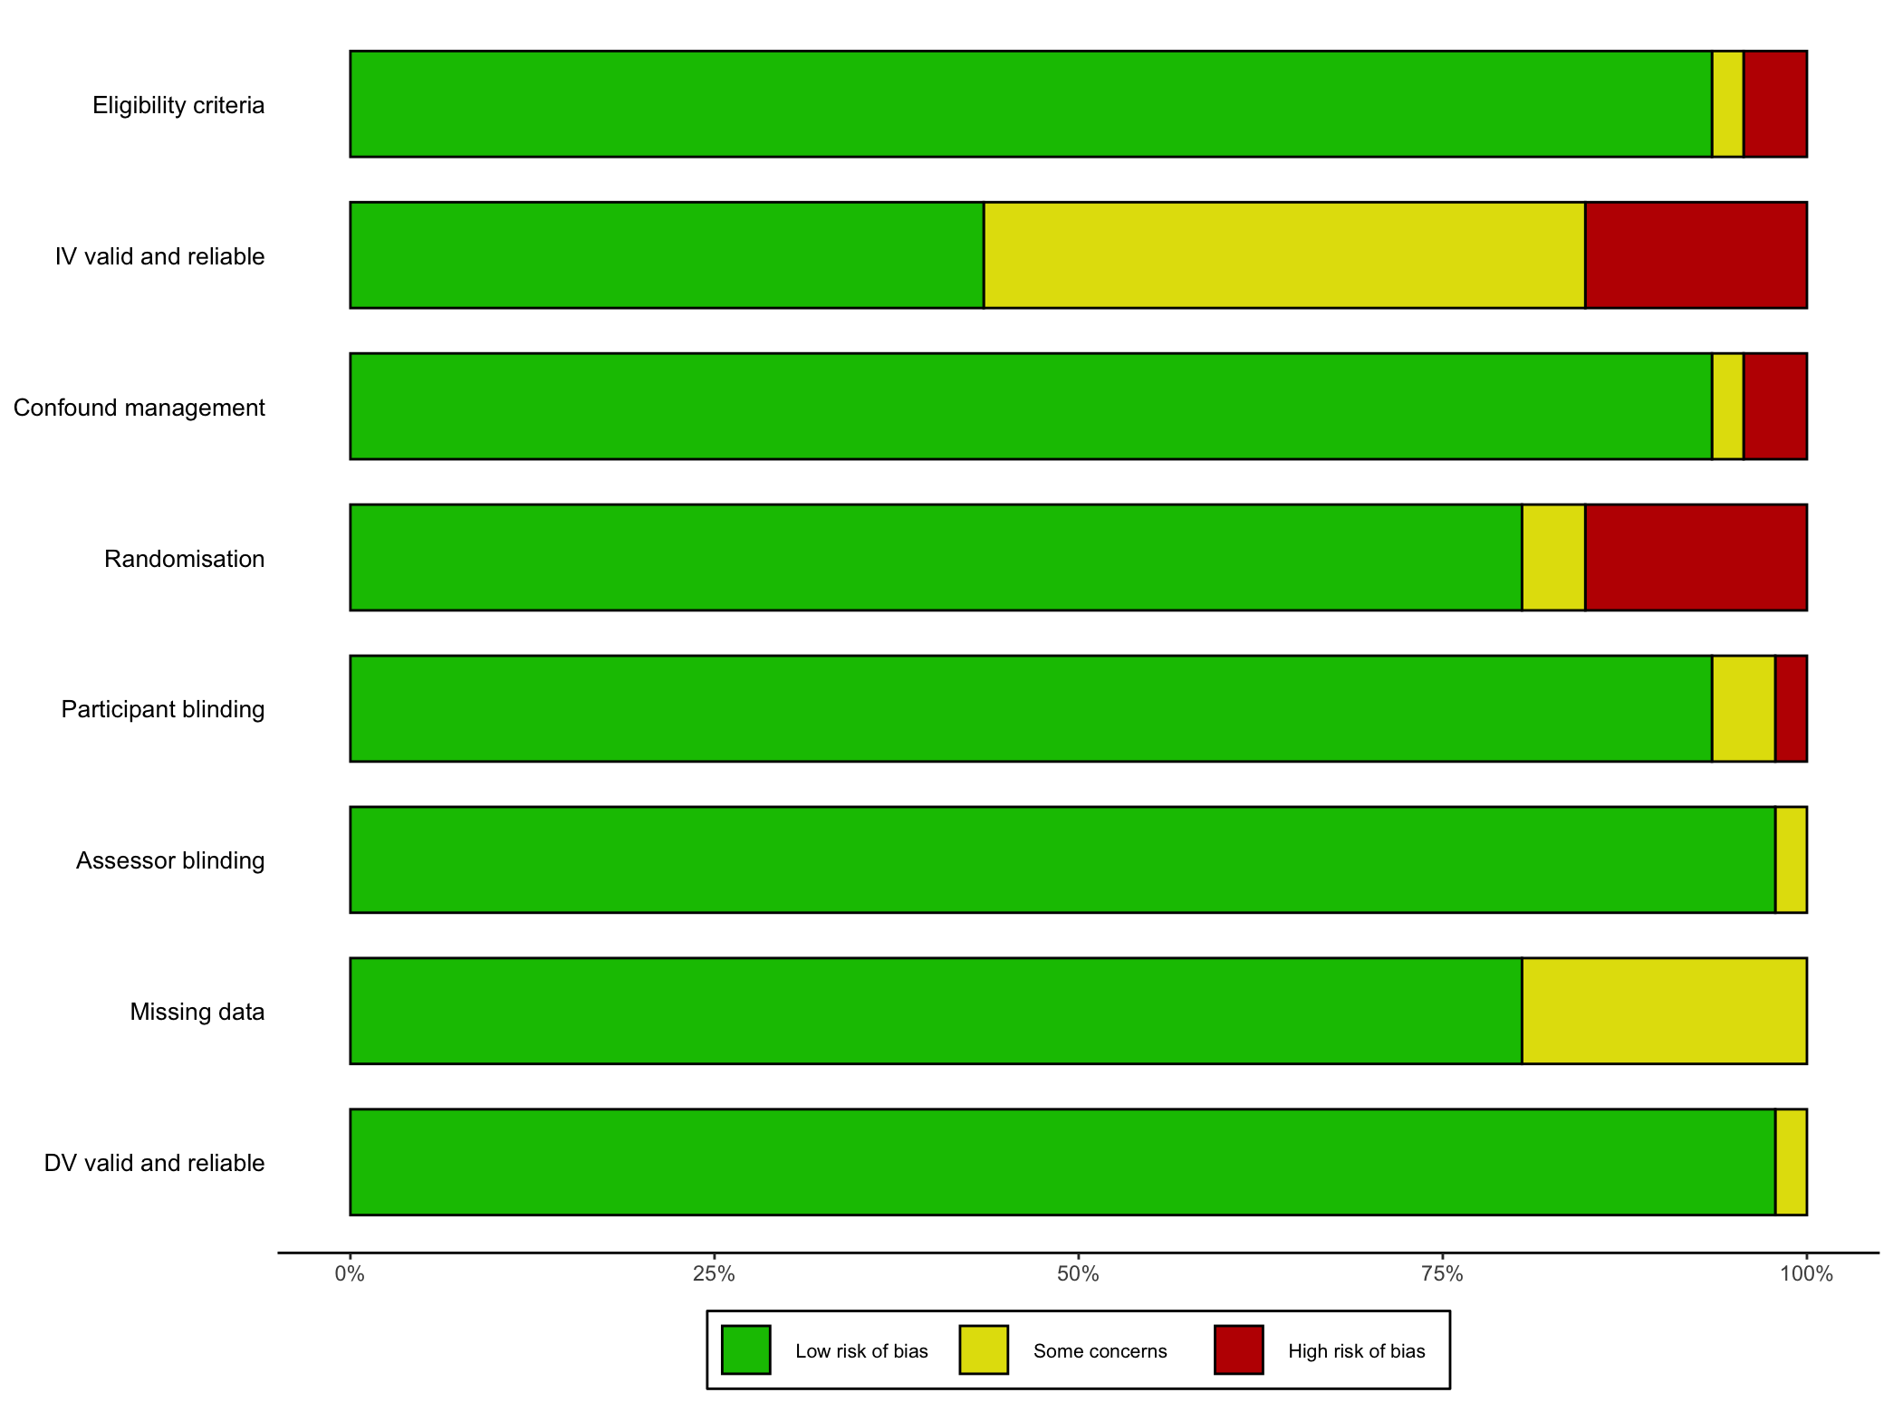
Figure S1. Cluster 1 Risk of bias
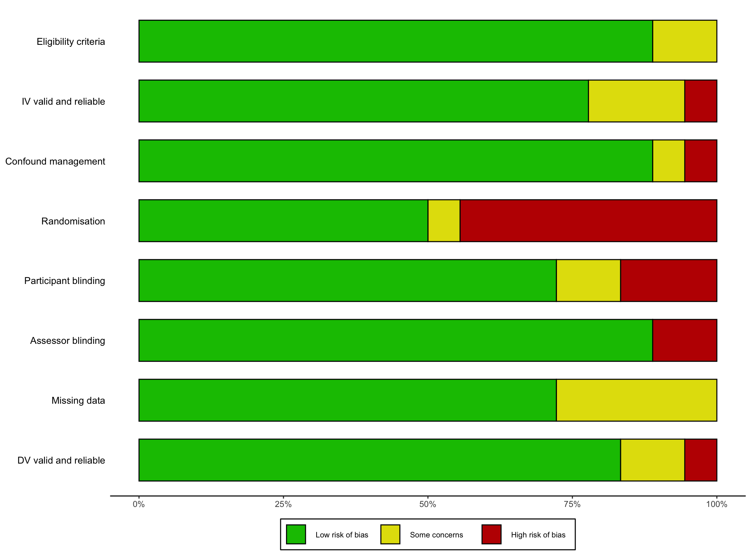
Figure S2. Cluster 2 Risk of bias
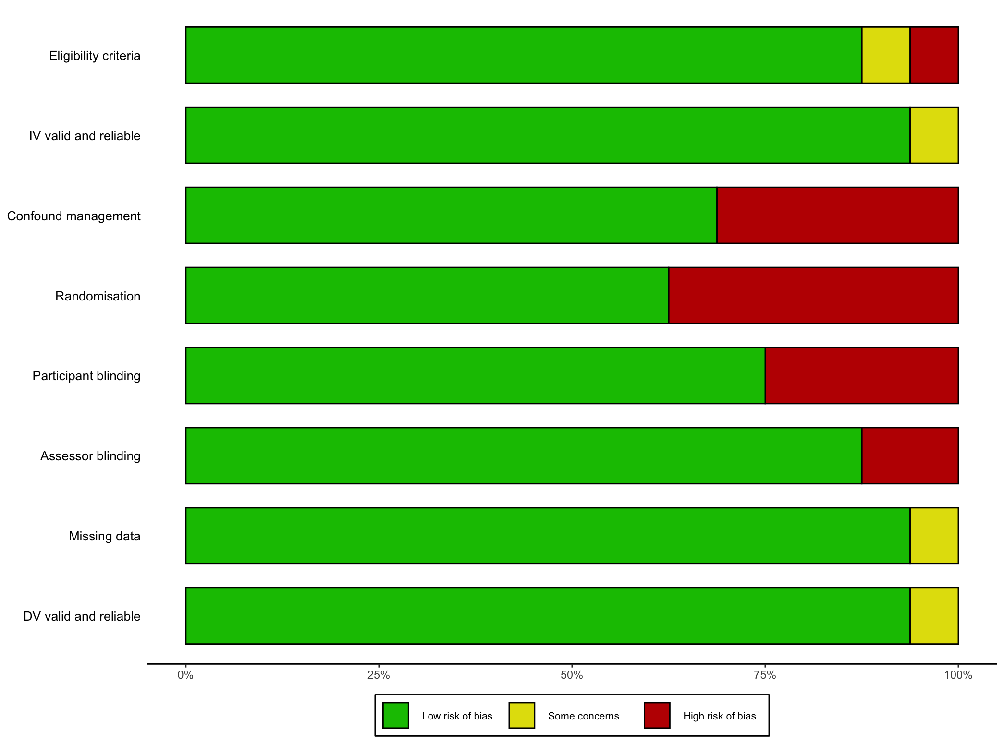
Figure S3. Cluster 3 Risk of bias
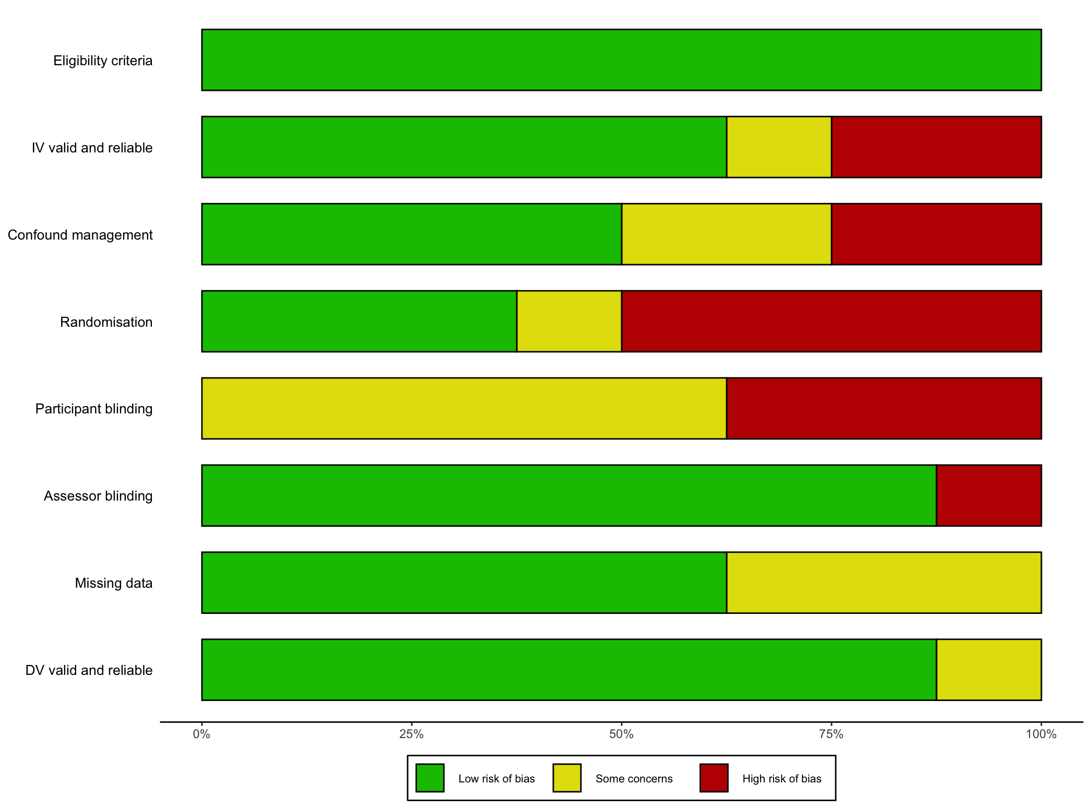
Figure S4. Cluster 4 Risk of bias

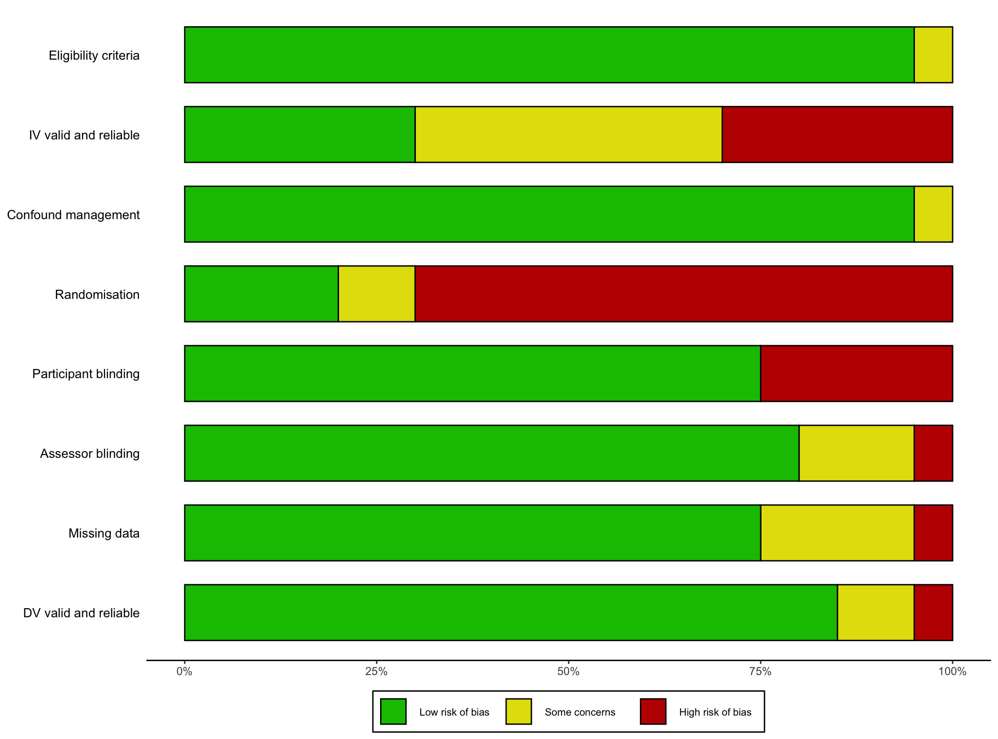
Figure S5. Cluster 5 Risk of bias
Section B: Supplementary Tables and Figures

Table S2. The hypotheses associated with the social identity approach to health (reproduced from Haslam et al., 2018).

H1 (the social identity hypothesis): Because it is the basis for meaningful group life, social identity is central to both good and ill health.
H2 (the identification hypothesis): A person will generally experience the health-related benefits or costs of a given group membership only to the extent that they identify with that group.
H3 (the group circumstance hypothesis): When and to the extent that a person defines themselves in terms of a given social identity, their well-being will be affected by the state and circum- stances of the group with which that identity is associated.
H3a. When the group that defines a person’s social identity is enhanced in some way (e.g., by success, high status, or advancement), social identity becomes a beneficial psychological resource and tends to have positive consequences for their well-being.
H3b. When the group that defines a person’s social identity is compromised in some way (e.g., by stigma, low status, or failure), the capacity for social identity to function as a beneficial psychological resource is reduced, and this will tend to have negative consequences for their well-being.
H4 (the identity restoration hypothesis): People will be motivated to restore positive identity when this is compromised by events that threaten or undermine their social identities (e.g., group failure, stigma, low status, or loss of group membership).
H5 (the mobility hypothesis): When circumstances threaten, undermine, or preclude positive social identity, if people perceive group boundaries to be permeable, they are likely to respond to the threat to positive identity through strategies of personal mobility.
H6 (the creativity hypothesis): When circumstances threaten, undermine, or preclude positive social identity, if people perceive group boundaries to be impermeable but group relations to be secure, they are likely to respond to the threat to positive identity through strategies of social creativity.
H7 (the competition hypothesis): When circumstances threaten, undermine, or preclude positive social identity, if people perceive group boundaries to be impermeable and group relations to be insecure, they are likely to respond to the threat to positive identity through strategies of social competition.
H8 (the norm enactment hypothesis): When and to the extent that a person defines themselves in terms of a given social identity, they will enact – or at least strive to enact – the norms and values associated with that identity.
H9 (the influence hypothesis): When and to the extent that people define themselves in terms of shared social identity, they will be more likely to influence each other.
H10 (the prototypicality hypothesis): People will have more influence in defining the meaning of a given social identity to the extent that they are seen to be representative of that identity.
H11 (the multiple identities hypothesis): Providing they are compatible with each other, important to them, and positive, the more social identities a person has access to, the more psychological resources they can draw upon and the more beneficial this will be for their health.
H12 (the connection hypothesis): When and to the extent that people define themselves in terms of shared social identity, they will be more likely to perceive themselves as similar and connected and to be positively oriented towards (e.g., trusting of) each other. H13 (the meaning hypothesis): When and to the extent that people define themselves in terms of shared social identity, that identity will focus their energies and imbue them with a sense of meaning, purpose, and worth.
H14 (the support hypothesis): When and to the extent that people define themselves in terms of shared social identity, they will (1) expect to give each other support, (2) actually give each other support, and (3) construe the support they receive more positively.
H15 (the agency hypothesis):When and to the extent that people define themselves in terms of shared social identity, they will develop a sense of efficacy, agency, and power.
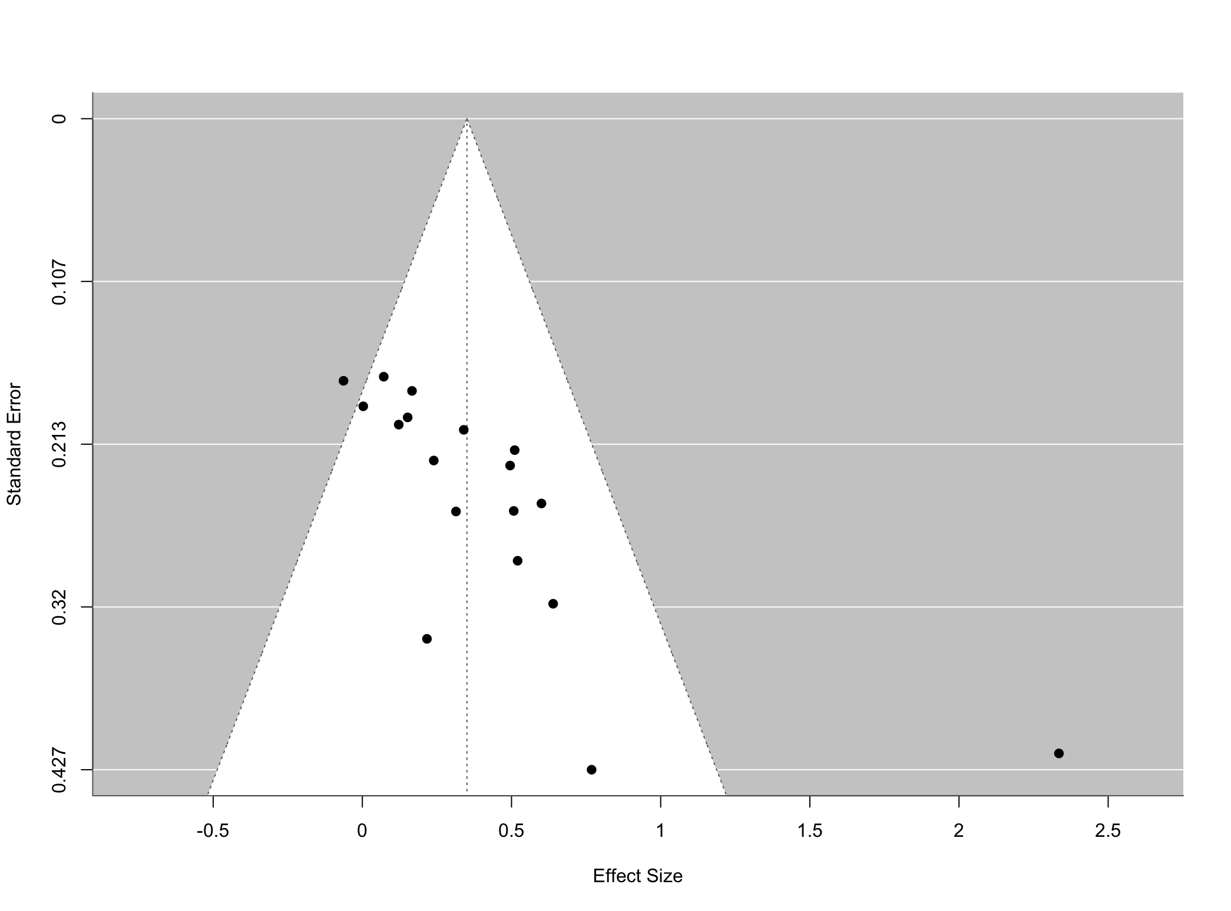
Figure S6. Funnel plot for Cluster 1 studies indicated asymmetry, such that studies with smaller standard errors (which tend to be larger studies) tended to have effect sizes closer to 0.

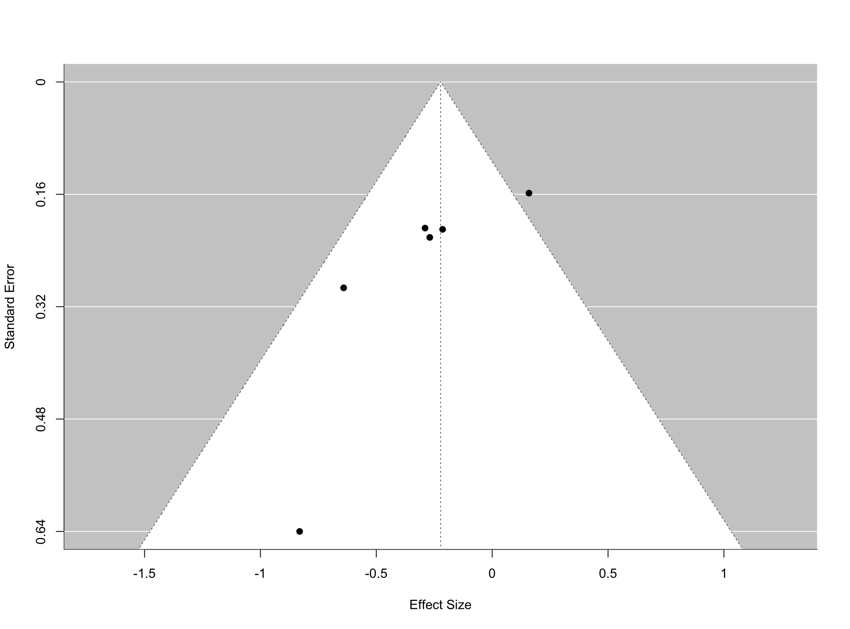
Figure S7. Funnel plot for Cluster 2 studies indicated asymmetry, such that studies with smaller standard errors (which tend to be larger studies) tended to have effect sizes closer to 0.

