Supplement 5
Model estimates for subgroup analysis “Women with severe menstrual pain” (PLS-SEM, 10,000 bootstrap samples)
Path | Conversational context
Path | Friends |  |  | Physicians |  |  |  | Co-workers
Path | b | SD | 95% CI |  | b | SD | 95% CI |  | b | SD | 95% CI
Knowledge →
Pub Stigma | 0.050 | 0.112 | -0.17, 0.27 |  | -0.030 | 0.100 | -0.22, 0.17 |  | -0.043 | 0.095 | -0.15,  0.23
Attitude | 0.073 | 0.099 | -0.12, 0.28 |  | 0.018 | 0.090 | -0.15, 0.20 |  | -0.103 | 0.099 | -0.30, 0.09
PBC | 0.155* | 0.092 | -0.03, 0.33 |  | -0.029 | 0.073 | -0.17, 0.12 |  | -0.038 | 0.100 | -0.24, 0.16
Pub Stigma →
Attitude | -0.432*** | 0.087 | -0.60, -0.26 |  | -0.403*** | 0.083 | -0.56,  -0.24 |  | -0.312*** | 0.087 | -0.48, -0.14
Norm | -0.372*** | 0.097 | -0.56, -0.18 |  | -0.219* | 0.094 | -0.41.  -0.04 |  | -0.329*** | 0.089 | -0.51,  -0.16
PBC | -0.321*** | 0.099 | -0.52, -0.13 |  | -0.199** | 0.082 | -0.36,  -0.04 |  | -0.341*** | 0.084 | -0.51,  -0.18
Self-stigma | 0.606*** | 0.073 | 0.46, 0.74 |  | 0.671*** | 0.046 | 0.58, 0.76 |  | 0.662*** | 0.056 | 0.56, 0.77
Att → Int | 0.427*** | 0.126 | 0.18, 0.67 |  | 0.450*** | 0.091 | 0.29, 0.64 |  | 0.451*** | 0.090 | 0.27, 0.62
Norm → Int | 0.146 | 0.143 | -0.14, 0.42 |  | 0.127 | 0.088 | -0.06, 0.29 |  | 0.155* | 0.074 | 0.01, 0.30
PBC → Int | -0.138 | 0.141 | -0.42, 0.13 |  | 0.085 | 0.095 | -0.10, 0.27 |  | 0.359*** | 0.090 | 0.17, 0.53
Self-stigma → Int | -0.002 | 0.111 | -0.22, 0.22 |  | 0.302*** | 0.073 | 0.16, 0.44 |  | 0.156* | 0.083 | -0.00, 0.32
Note. N_{overall} = 368, N_{friends} = 119, N_{physicians} = 135, N_{co-workers} = 114; displayed are the bootstrapped estimates, SDs, and 95% Cis for each model relationship; conversational context: social setting of TPB constructs (either referring to conversations about menstrual symptoms with friends, doctors, or co-workers); subsample includes only participants who have to use painkillers during menstruation at least occasionally; *** p < .001, ** p < .01, * p < 05.

Supplement 6
Significant path relationships in all assessed conversational contexts for subgroup “women with severe menstrual pain”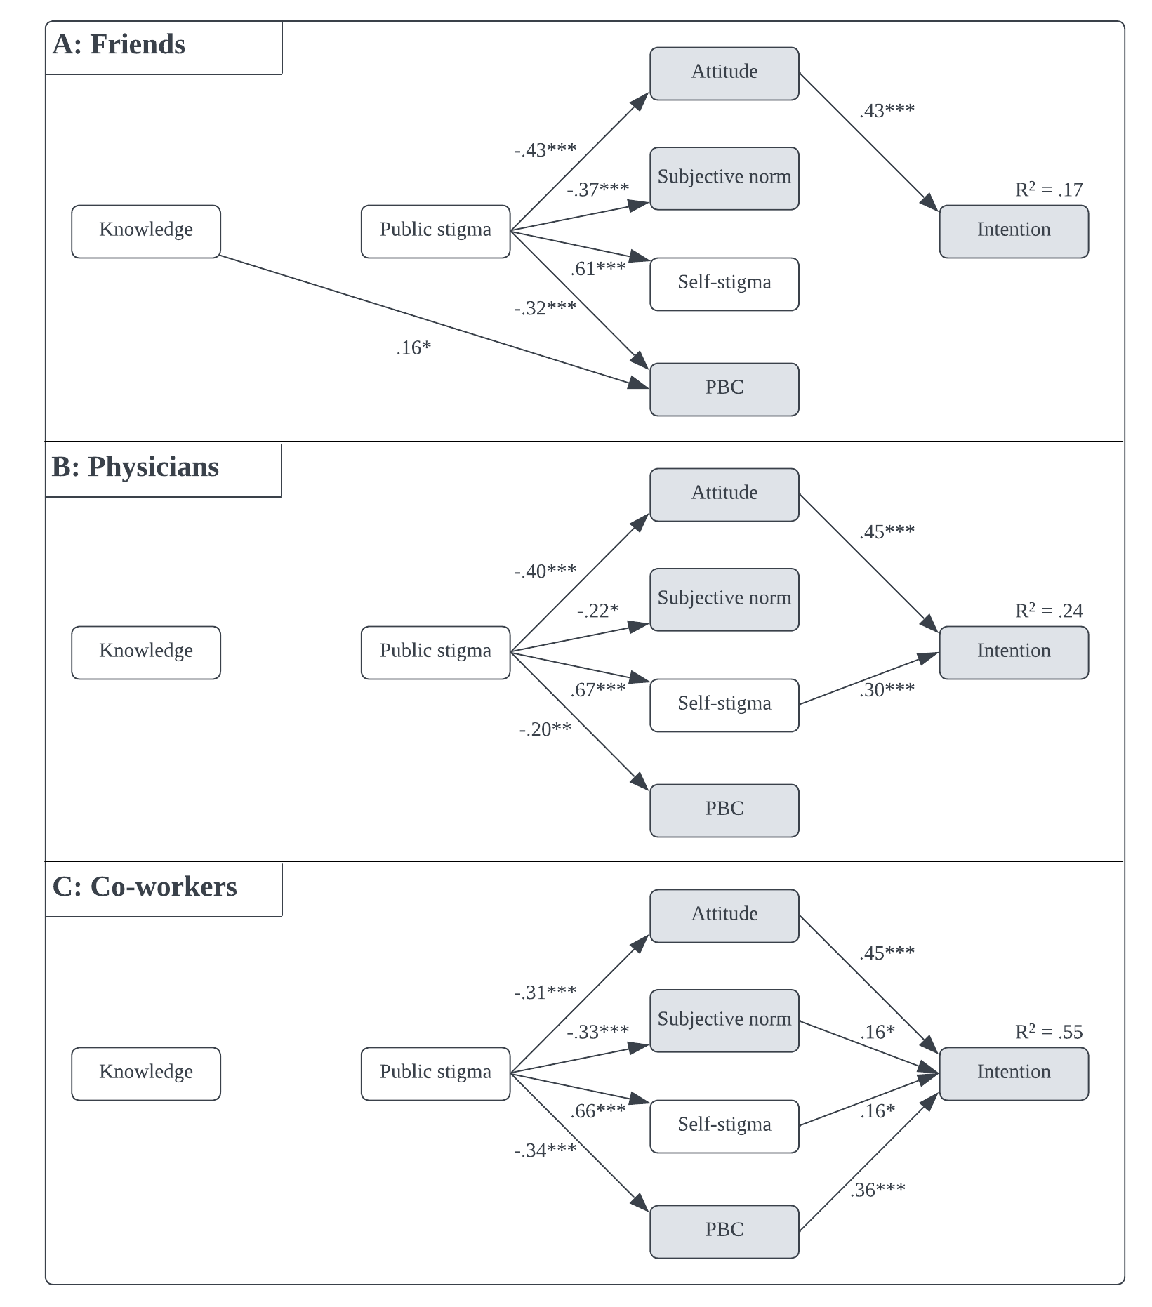
Note. Constructs in the shaded shapes were measured for the respective conversational context (friends, physicians, co-workers), whereas knowledge, public stigma and self-stigma were measured as global constructs. ); subsample analysis includes only participants who have to use painkillers during menstruation at least occasionally.

