Supplement 2: Symptom-Self test and Endometriosis Diagnosis
Endometriosis is a debilitating gynecological condition affecting millions of women worldwide, characterized by the presence of endometrial-like tissue outside the uterine cavity, often leading to pelvic pain and infertility. Despite its prevalence, endometriosis remains underdiagnosed and undertreated, necessitating the development of accessible and reliable screening tools. In this supplement, we present a self-test questionnaire aimed at assessing symptoms commonly associated with endometriosis. The questionnaire includes items querying the presence and severity of pelvic pain, the need for pain relief medication, gastrointestinal symptoms during menstruation, chronic pelvic pain unrelated to menstruation, and pain during sexual intercourse. Utilizing this self-test, individuals can self-assess their symptoms and potential risk of endometriosis, facilitating early detection and intervention.
Study Sample
In the pre-registered online study, we included n = 768 participants based on their self-test results. We included those participants that reported at least one of the symptoms to occur at least sometimes. Out of these 768 participants, 701 (91.28%) indicated high values on at least one of the menstrual pain related symptoms (pain during menstruation, pain despite pain killers, pain during bowel movements while menstruating). Figure A1 shows percentages for the self-test items in the study sample.
Figure A1. Distribution of Symptom-Self test answers.
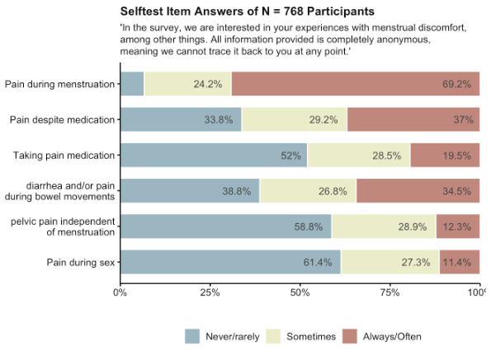

Figure A2. Density plot for the Mean Score of the Six Items.
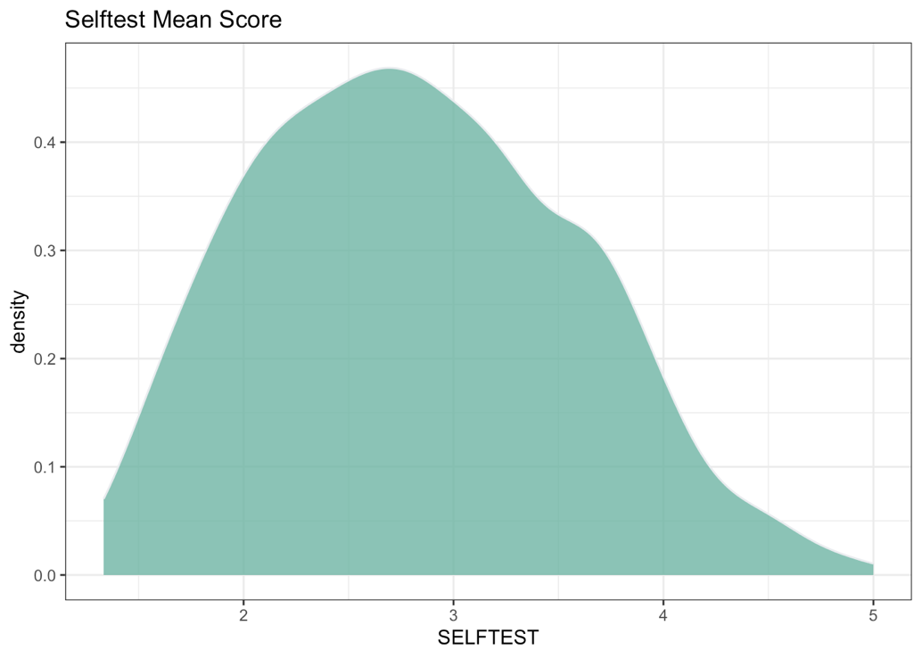
The mean of the total scale is M(SD) = 2.82 (.75). If mean scores of 3.5 or higher are defined as extreme values, n = 169 participants fall into this extreme value range.

Sample before Screen-In
As we used the self-test values as screen-in criteria (among other factors such as completion time and having colleagues in the respective reference condition), we can use the self-test values from the sample before screen-out to look at the representative distribution of symptoms. N = 1313 participants gave consent to participate in the study and answered the questions regarding the self-test items.

Figure B1. Distribution of Symptom-Self test answers.
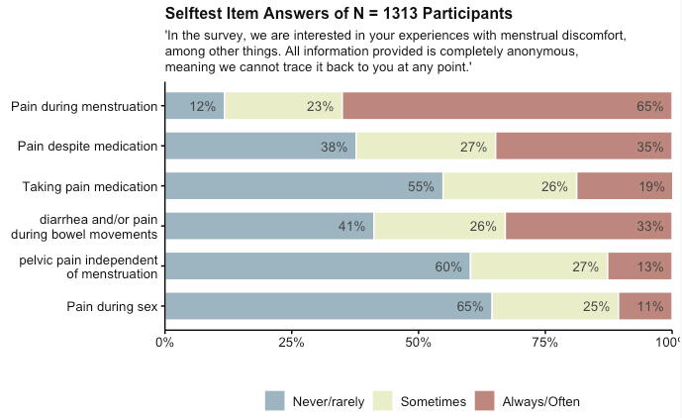
65% of the whole sample experiences menstrual pain on a regular basis. In 35% of all participants, their pain medication strategy is not sufficient, so that the participants experience significant pain despite the use of medication. 33% experience co-occurring symptoms like diarrhea or pain during bowel movements.

Figure B2. Density plot for the Mean Score of the Six Items.
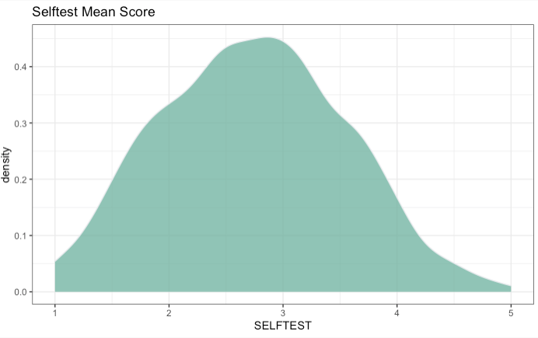
The mean of the total scale is M(SD) = 2.74 (.80). If mean scores of 3.5 or higher are defined as extreme values, n = 277 participants fall into this extreme value range. To assess whether more participants report extreme values when also reporting an endometriosis diagnosis, a chi-square test was conducted. This test indicating significant differences in the cells, 𝛘²(1) = 56.00, p < .001. The cross-tabulation below demonstrates an association between self-test results and self-reported diagnosis.
Table B3. Cross-Table for Self-reported Endometriosis and Mean Score.
 | Self-reported Diagnosis | No Self-reported Diagnosis
Self-test <4 (symptoms low) | 27 | 955
Self-test >4 (symptoms high) | 37 | 214

The mean difference between the respective groups of diagnosed (M(SD)= 3.52) vs. undiagnosed (M(SD)=2.68) is statistically significant, t(1231) = 8.44, p <.001, 95% Confidence Interval of the SMD [1.04;.65].
In conclusion, it can be claimed that the test, in its current form, is capable of distinguishing between diagnosed and undiagnosed individuals. However, the false negative rate among diagnosed individuals remains higher than the true positive rate. Future studies should investigate whether self-tests provide better explanatory power when examining specific subgroups within the affected population, or whether additional screening questions are needed to make self-tests more reliable.

There are n= 49 women who report that menstrual occurring pain is not their primary symptom.
