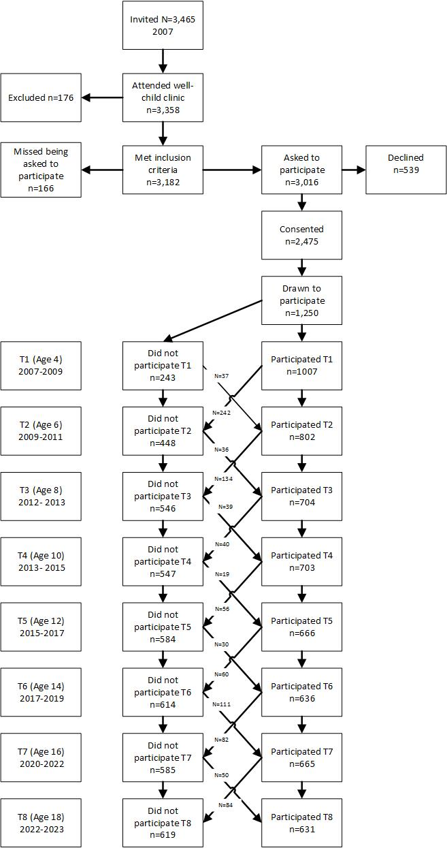
Supplementary figure 1. The cohort study design and flow of participants

Supplementary table 1. Bivariate correlations between all study variables at ages 6-18.
Variable | 2. | 3. | 4. | 5. | 6. | 7. | 8. | 9. | 10. | 11. | 12. | 13. | 14. | 15. | 16. | 17. | 18. | 19. | 20. | 21. | 22. | 23. | 24. | 25. | 26. | 27. | 28. | 29. | 30. | 31. | 32. | 33. | 34. | 35. | 36. | 37. | 38. | 39. | 40. | 41. | 42.
1. CPM⁶ | .23*** | .24*** | .13** | .07 | .10* | .03 | .89*** | .29*** | .28*** | -.09* | -.02 | -.03 | -.05 | -.54*** | -.11* | -.14** | -.10* | -.10* | -.10 | -.08 | .08* | .11* | .07 | .03 | .06 | .02 | .01 | -.05 | N.A. | -.09* | -.05 | -.04 | .01 | .02 | .17*** | .06 | .09* | .05 | .05 | .10* | .12*
2. CPM⁸ |  | .30*** | .27*** | .24*** | .24*** | .19** | .28*** | .87*** | .05*** | .24*** | .18** | .19** | .14* | .19*** | -.54*** | -.15** | -.13** | -.20** | -.23*** | -.13** | -.06 | -.14* | -.02 | .00 | -.02 | -.04 | -.01 | -.06 | N.A. | .00 | .00 | .02 | .01 | .00 | .10* | .18*** | .16*** | .18*** | .25*** | .20*** | .19***
3. CPM¹⁰ |  |  | .48*** | .40*** | .25** | .29*** | .27*** | .40*** | .89*** | .44*** | .34*** | .20** | .23** | -.13*** | -.16* | -.62*** | -.29*** | -.25*** | -.24*** | -.17** | .00 | .02 | .09 | .05 | .11* | .01 | -.04 | -.09* | N.A. | -.01 | .02 | .01 | -.01 | .07 | .15*** | .15*** | .17** | .15* | .21*** | .28*** | .27***
4. CPM¹² |  |  |  | .53*** | .32*** | .27*** | .22*** | .34*** | .50*** | .92*** | .45*** | .27*** | .20*** | -.10* | -.21*** | -.31*** | -.60*** | -.37*** | -.27*** | -.15** | -.12** | -.04 | -.03 | -.09 | -.02 | -.08 | -.07 | -.04 | N.A. | .02 | .12** | .11* | .09 | .13** | .18*** | .24*** | .29*** | .31*** | .35*** | .36*** | .40***
5. CPM¹⁴ |  |  |  |  | .30*** | .36*** | .16** | .32*** | .41*** | .52*** | .91*** | .26*** | .29*** | -.04 | -.18** | -.24*** | -.29*** | -.52*** | -.22*** | -.21*** | -.04 | .00 | .04 | .02 | .03 | -.14** | -.01 | .00 | N.A. | .04 | .12** | .07 | .08 | .10* | .10* | .14** | .14* | .23*** | .34*** | .34*** | .37***
6. CPM¹⁶ |  |  |  |  |  | .49*** | .19*** | .26*** | .23*** | .31*** | .26*** | .90*** | .44*** | -.10* | -.18** | -.21** | -.21*** | -.30*** | -.54*** | -.25*** | -.10** | -.11* | -.04 | -.07 | -.07 | -.07 | .00 | -.10* | N.A. | .05 | .11* | .14** | .10 | .10 | .07 | .09 | .16** | .25*** | .29*** | .28*** | .35***
7. CPM;¹⁸ |  |  |  |  |  |  | .13* | .23** | .27*** | .26*** | .33*** | .45*** | .91*** | -.03 | -.16** | -.19** | -.22*** | -.30*** | -.30*** | -.48*** | .10 | .10 | .10 | .04 | -.05 | -.03 | -.04 | -.06 | N.A. | .02 | .06 | .03 | .05 | .11* | .09 | .05 | .16 | .19*** | .22*** | .31*** | .25***
8. MVPA⁶ |  |  |  |  |  |  |  | .40*** | .37*** | .18*** | .10* | .12* | .05 | -.40*** | -.10* | -.16** | -.15** | -.16** | -.16** | -.12* | .11* | .15** | .09 | .04 | .08 | .08 | .02 | -.07 | N.A. | -.08 | -.09* | -.04 | -.01 | -.03 | .19*** | .10* | .14** | .11* | .14** | .18*** | .23***
9. MVPA⁸ |  |  |  |  |  |  |  |  | .47*** | .34*** | .27*** | .24*** | .17* | -.18*** | -.42*** | -.17** | -.13* | -.20*** | -.17** | -.10 | .08 | .18* | .04 | .04 | .03 | -.02 | .05 | -.08 | N.A. | .02 | -.02 | .02 | -.02 | -.01 | .19*** | .23*** | .26*** | .24*** | .31*** | .31*** | .34***
10. MVPA¹⁰ |  |  |  |  |  |  |  |  |  | .50*** | .36*** | .20** | .23*** | -.12** | -.15** | -.48*** | -.25*** | -.23*** | -.19*** | -.11* | -.02 | .02 | .05 | .04 | .06 | -.04 | -.02 | -.10** | N.A. | .00 | .06 | .04 | .01 | .08 | .20*** | .21*** | .26*** | .25*** | .29*** | .36*** | .36***
11. MVPA¹² |  |  |  |  |  |  |  |  |  |  | .47*** | .28*** | .22*** | -.06 | -.16** | -.23*** | -.44*** | -.30*** | -.21*** | -.09 | -.16*** | -.09 | -.07 | -.13** | -.05 | -.11* | -.10 | -.02 | N.A. | .12** | .17*** | .15** | .10 | .12* | .18*** | .23*** | .30*** | .34*** | .37*** | .35*** | .42***
12. MVPA¹⁴ |  |  |  |  |  |  |  |  |  |  |  | .23*** | .29*** | -.01 | -.15** | -.16** | -21*** | -.34*** | -.16** | -.14** | -.02 | -.01 | .01 | .01 | .02 | -.16*** | -.02 | .02 | N.A. | .06 | .11* | .08 | .07 | .08 | .08 | .13** | .13* | .23*** | .32*** | .32*** | .33***
13. MVPA¹⁶ |  |  |  |  |  |  |  |  |  |  |  |  | .46*** | -.04 | -.11* | -.11 | -.14** | -.20*** | -.26*** | -.10* | -.11 | -.13* | -.06 | -.09 | -.14* | -.08 | -.03 | -.10* | N.A. | .04 | .12* | .14** | .06 | .07 | .07 | .06 | .15** | .19*** | .25*** | .21*** | .30***
14. MVPA¹⁸ |  |  |  |  |  |  |  |  |  |  |  |  |  | .02 | -.07 | -.09 | -.15** | -.17** | -.16** | -.19*** | .13* | .11 | .09 | .02 | -.09 | -.04 | -.05 | -.06 | N.A. | .00 | .04 | .01 | .03 | .08 | .06 | .01 | .12** | .12* | .16** | .24*** | .22***
15. ST⁶ |  |  |  |  |  |  |  |  |  |  |  |  |  |  | .31*** | .17*** | .15** | .11* | .15** | .13* | -.15 *** | -16** | -.09* | -.04 | -.10 | -.04 | -19** | .05 | N.A. | .02 | .01 | .00 | -.02 | .00 | -.10* | -.02 | -.06 | .01 | -.01 | -.03 | -.04
16. ST⁸ |  |  |  |  |  |  |  |  |  |  |  |  |  |  |  | .29*** | .24*** | .18** | .25*** | .20*** | -.04 | -.14* | -.07 | -.05 | -.04 | -.02 | -.08 | .03 | N.A. | -.07 | -.08 | -.06 | -.02 | -.01 | -.11* | -.14** | -.11 | -.16** | -.19*** | -.15** | -.08
17. ST¹⁰ |  |  |  |  |  |  |  |  |  |  |  |  |  |  |  |  | .39*** | .32*** | .34*** | .27*** | -.03 | -.03 | -.06 | -.03 | -.11 | -.08 | -.04 | .06 | N.A. | .03 | .00 | .00 | .00 | -.09 | -.04 | -.05 | -.05 | -.10 | -.11* | -.15** | -.19***
18. ST¹² |  |  |  |  |  |  |  |  |  |  |  |  |  |  |  |  |  | .46*** | .33*** | .25*** | -.02 | -.05 | -.08 | -.02 | -.05 | -.04 | -.04 | .08 | N.A. | -.01 | .03 | .01 | .00 | -.02 | -.10* | -.14** | -.13** | -.13** | -.18*** | -.14** | -.16**
19. ST¹⁴ |  |  |  |  |  |  |  |  |  |  |  |  |  |  |  |  |  |  | .44*** | .40*** | .00 | .00 | -.03 | -.03 | -.11 | -.01 | -.12 | .00 | N.A. | -.04 | -.05 | .01 | -.04 | -.06 | -.06 | -.14** | -.13** | -.18*** | -.25*** | -.26*** | -.24***
20. ST¹⁶ |  |  |  |  |  |  |  |  |  |  |  |  |  |  |  |  |  |  |  | .51*** | -.01 | -.06 | -.09 | -.08 | -.11 | -.05 | -.09 | .11* | N.A. | -.02 | .06 | .04 | .00 | -.04 | -.07 | -.16*** | -.13* | -.23*** | -.24*** | -.25*** | -.25***
21. ST¹⁸ |  |  |  |  |  |  |  |  |  |  |  |  |  |  |  |  |  |  |  |  | -.02 | -.04 | -.08 | -.08 | -.10 | -.07 | -.06 | .10* | N.A. | -.04 | .03 | .07 | .01 | -.04 | -.06 | -.10* | -.10* | -.20*** | -.17** | -.22*** | -.18***
22. EF⁶ |  |  |  |  |  |  |  |  |  |  |  |  |  |  |  |  |  |  |  |  |  | .70*** | .57*** | .49*** | .37*** | .36*** | .22** | -.24*** | N.A. | -.16** | -.17*** | -.18*** | -.17** | -.16** | .02 | -.01 | -.05 | -.09* | -.02 | -.04 | -.06
23. EF⁸ |  |  |  |  |  |  |  |  |  |  |  |  |  |  |  |  |  |  |  |  |  |  | .74*** | .62*** | .46*** | .50*** | .33** | -.22*** | N.A. | -.24*** | -.23*** | -.23*** | -.17** | -.18*** | -.03 | .04 | -.04 | -.08 | .03 | .02 | .03
24. EF¹⁰ |  |  |  |  |  |  |  |  |  |  |  |  |  |  |  |  |  |  |  |  |  |  |  | .71*** | .56*** | .52*** | .32** | -.22*** | N.A. | -.22*** | -.20*** | -.26*** | -.22*** | -.23*** | .06 | .01 | -.05 | -.07 | .00 | .05 | .02
25. EF¹² |  |  |  |  |  |  |  |  |  |  |  |  |  |  |  |  |  |  |  |  |  |  |  |  | .58*** | .52*** | .47*** | -.15** | N.A. | -.24** | -.24*** | -.31*** | -.28*** | -.29*** | .01 | -.02 | -.03 | -.09* | .07 | .06 | .04
26. EF¹⁴ |  |  |  |  |  |  |  |  |  |  |  |  |  |  |  |  |  |  |  |  |  |  |  |  |  | .43*** | .42*** | -.19*** | N.A. | -.15*** | -.24*** | -.33*** | -.24*** | -.24*** | .07 | -.01 | -.01 | -.12* | -.05 | .00 | -.05
27. EF¹⁶ |  |  |  |  |  |  |  |  |  |  |  |  |  |  |  |  |  |  |  |  |  |  |  |  |  |  | .53*** | -.16** | N.A. | -.17*** | -.15** | -.32*** | -.36*** | -.32*** | .01 | -.08 | -.02 | -.10* | -.10 | -.10 | -.05
28. EF¹⁸ |  |  |  |  |  |  |  |  |  |  |  |  |  |  |  |  |  |  |  |  |  |  |  |  |  |  |  | -.13** | N.A. | -.21** | -.22*** | -.20*** | -.28*** | -.26*** | -.03 | -.07 | -.05 | -.12* | -.02 | -.02 | -.05
29. C⁶ |  |  |  |  |  |  |  |  |  |  |  |  |  |  |  |  |  |  |  |  |  |  |  |  |  |  |  |  | N.A. | .08 | .14** | .12** | .13** | .11** | -.04 | .02 | -.07 | -.05 | -.08* | -.09* | -.08
30. C⁸ |  |  |  |  |  |  |  |  |  |  |  |  |  |  |  |  |  |  |  |  |  |  |  |  |  |  |  |  |  | N.A. | N.A. | N.A. | N.A. | N.A. | N.A. | N.A. | N.A. | N.A. | N.A. | N.A. | N.A.
31. C¹⁰ |  |  |  |  |  |  |  |  |  |  |  |  |  |  |  |  |  |  |  |  |  |  |  |  |  |  |  |  |  |  | .49*** | .40*** | .31*** | .28*** | .19*** | .27*** | .35*** | .26*** | .25*** | .17** | .15**
32. C¹² |  |  |  |  |  |  |  |  |  |  |  |  |  |  |  |  |  |  |  |  |  |  |  |  |  |  |  |  |  |  |  | .65*** | .50*** | .43*** | .14** | .22*** | .19*** | .37*** | .27*** | .20*** | .17**
33. C¹⁴ |  |  |  |  |  |  |  |  |  |  |  |  |  |  |  |  |  |  |  |  |  |  |  |  |  |  |  |  |  |  |  |  | .63*** | .52*** | .11* | .19*** | .17** | .28*** | .34*** | .24*** | .18***
34. C¹⁶ |  |  |  |  |  |  |  |  |  |  |  |  |  |  |  |  |  |  |  |  |  |  |  |  |  |  |  |  |  |  |  |  |  | .76*** | .09 | .16** | .12** | .21*** | .23*** | .23*** | .18***
35. C¹⁸ |  |  |  |  |  |  |  |  |  |  |  |  |  |  |  |  |  |  |  |  |  |  |  |  |  |  |  |  |  |  |  |  |  |  | .10* | .22*** | .18*** | .19*** | .26*** | .25*** | .23***
36. PAC⁶ |  |  |  |  |  |  |  |  |  |  |  |  |  |  |  |  |  |  |  |  |  |  |  |  |  |  |  |  |  |  |  |  |  |  |  | .33*** | .31*** | .18*** | .20*** | .21*** | .24***
37. PAC⁸ |  |  |  |  |  |  |  |  |  |  |  |  |  |  |  |  |  |  |  |  |  |  |  |  |  |  |  |  |  |  |  |  |  |  |  |  | .54*** | .41*** | .33*** | .36*** | .35***
38. PAC¹⁰ |  |  |  |  |  |  |  |  |  |  |  |  |  |  |  |  |  |  |  |  |  |  |  |  |  |  |  |  |  |  |  |  |  |  |  |  |  | .50*** | .45*** | .45*** | .46***
38. PAC¹² |  |  |  |  |  |  |  |  |  |  |  |  |  |  |  |  |  |  |  |  |  |  |  |  |  |  |  |  |  |  |  |  |  |  |  |  |  |  | .64*** | .57*** | .53***
40. PAC¹⁴ |  |  |  |  |  |  |  |  |  |  |  |  |  |  |  |  |  |  |  |  |  |  |  |  |  |  |  |  |  |  |  |  |  |  |  |  |  |  |  | .77*** | .70***
41. PAC¹⁶ |  |  |  |  |  |  |  |  |  |  |  |  |  |  |  |  |  |  |  |  |  |  |  |  |  |  |  |  |  |  |  |  |  |  |  |  |  |  |  |  | .81***
42. PAC¹⁸
Note: *=p<.05 **=p<.01 ***=p<.001; CPM=Counts per minute; MVPA=Moderate-to-vigorous physical activity; ST=Sedentary time; EF = Executive Functions; C = Conscientiousness; PAC = Perceived Athletic Competence ^{6, 8, 10, 12, 14, 16, 18}=Participants age at time of assessment.

Supplementary table 2. Summary of Model Fit Statistics for the RI-CLPM Analyses.
Model | χ² (df) | CFI | TLI | RMSEA (90% CI) | SRMR | Comp. | Δχ^{2 (Δdf)} | p
Counts
M1: Baseline model – cross-lagged paths freely estimated across time | 352.643(214) | .971 | .752 | .027 (.022, .033) | .057
M2: Predictors constrained to be of equal strength across time | 367.996(228) | .970 | .955 | .027 (.022, .032) | .060 | M2 vs M1 | 15.468(14) | .347
M3: Predictors unconstrained by sex | 745.412((396) | .928 | .872 | .045 (.040, .0.50) | .104
M4: Predictors constrained to be of equal strength for both sexes | 757.622(410) | .928 | .877 | .044 (.039, .049) | .104 | M4 vs M3 | 13.122(14) | .517
MVPA
M1: Baseline model – cross-lagged paths freely estimated across time | 383.571(214) | .966 | .943 | .030 (.025, .035) | .061
M2: Predictors constrained to be of equal strength across time | 400.485(228) | .965 | .946 | .030 (.025, .034) | .064 | M6 vs M5 | 17.231(14) | .244
M3: Predictors unconstrained by sex | 741.114(396) | .930 | .876 | .045 (.040, .050) | .104
M4: Predictors constrained to be of equal strength for both sexes | 755.179(410) | .930 | .880 | .044 (.039, .049) | .105 | M8 vs M7 | 14.065(14) | .445
Sedentary time
M1: Baseline model – cross-lagged paths freely estimated across time | 335.677(214) | .974 | .957 | .026 (.020, .031) | .060
M2: Predictors constrained to be of equal strength across time | 353.520(228) | .973 | .956 | .025 (.020, .030) | .063 | M10 vs M9 | 17.863(14) | .213
M3: Predictors unconstrained by sex | 729.098(396) | .930 | .876 | .044 (.039, .049) | .107
M4: Predictors constrained to be of equal strength for both sexes | 751.663(410) | .928 | .877 | .044 (.039, .049) | .108 | M12 vs M11 | 22.502(14) | .069
Note. χ2 = Chi-square; CFI = comparative fit index; TLI = Tucker-Lewis index; RMSEA = root mean square error of approximation; SRMR = standardized root mean square residual; Comp. = model comparison; Δχ^{2 (Δdf)} = Satorra-Bentler scaled Chi-square difference test. Preferred models in bold text, discarded models in roman font.

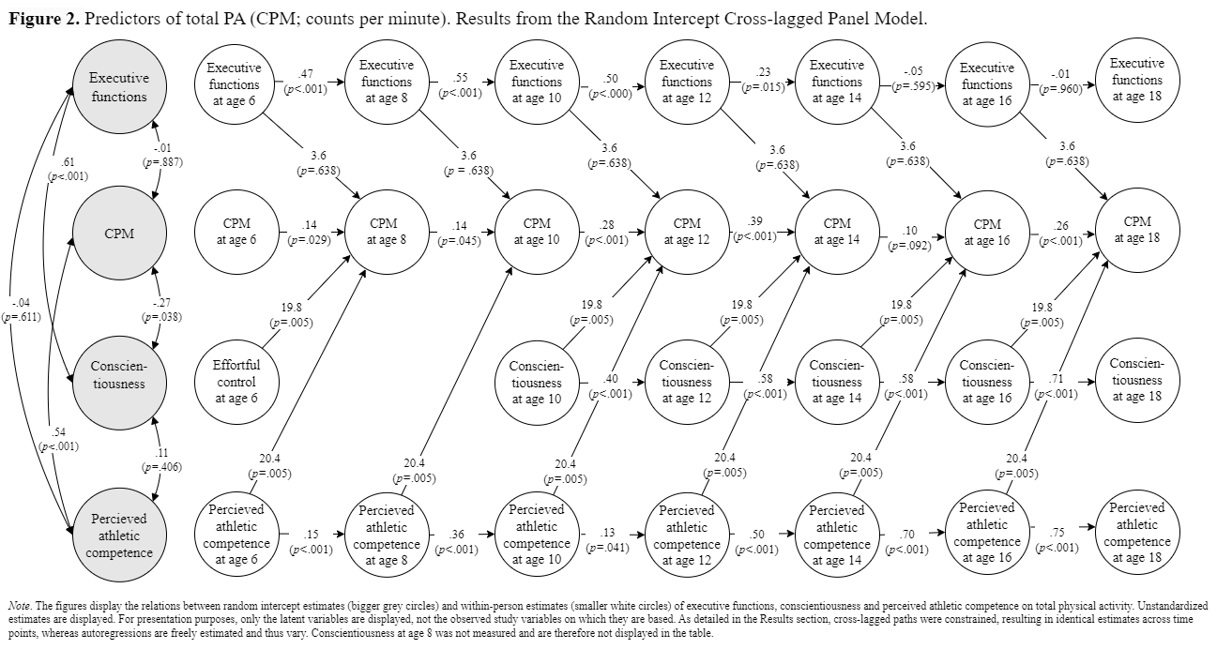

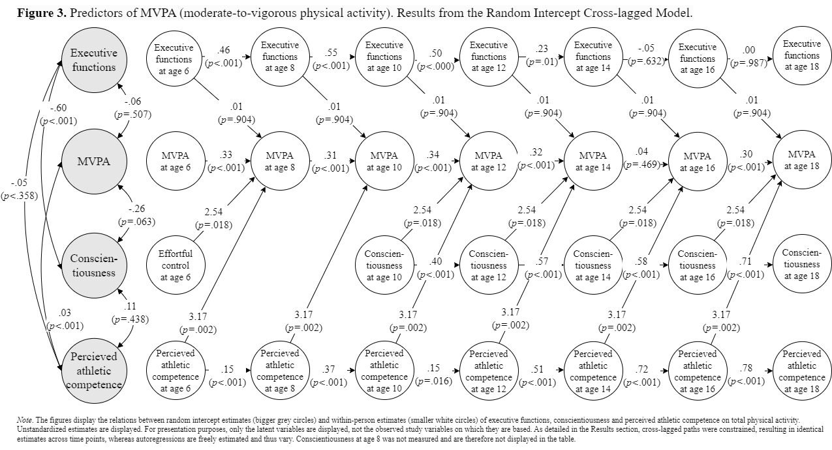

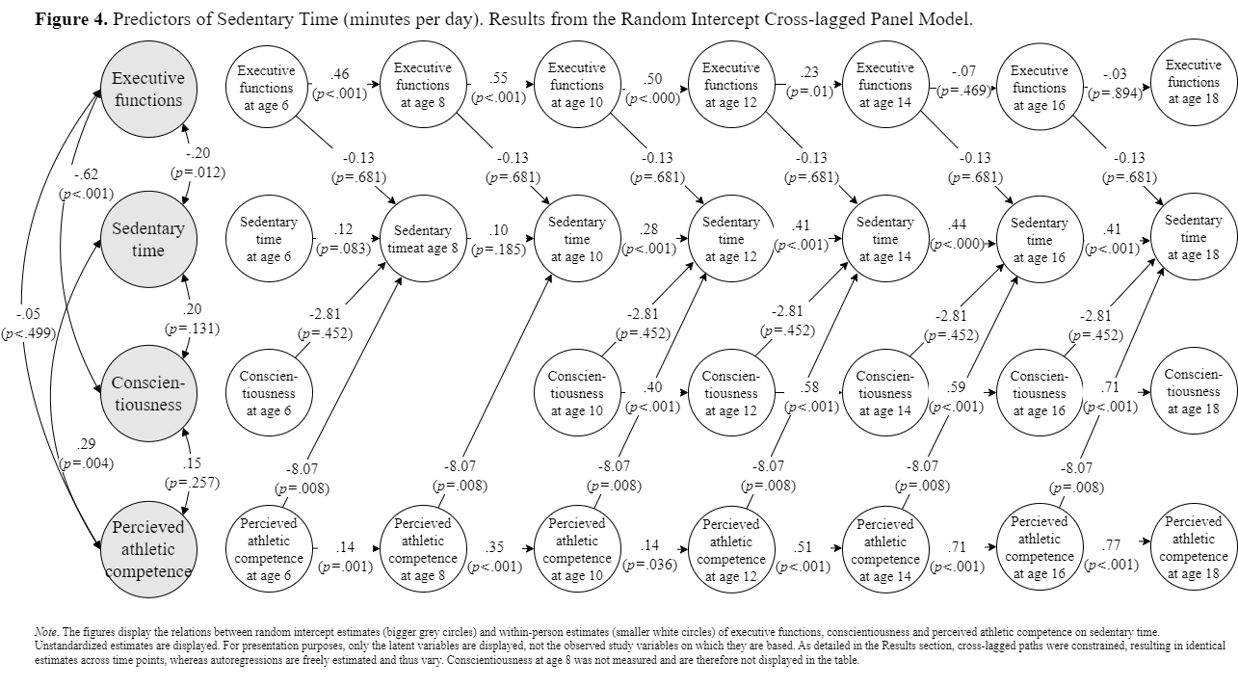

Mplus syntax analysis 1
Title:
RI-CLPM total physical activity (counts) on PAC, EF and C unconstrained model.
Data:
File is psychpred.dat ;
Variable:
Names are
w cpm2 cpm3 cpm4 cpm5 cpm6 cpm7 cpm8
abi2 abi3 abi4 abi5 abi6 abi7 abi8
brieft2 brieft3 brieft4 brieft5 brieft6 brieft7 brieft8
cbqec2 bfic4 bfic5 bfic6 bfic7 bfic8;
Missing are all (-9999) ;
weight is w;
usevariables are
w cpm2 cpm3 cpm4 cpm5 cpm6 cpm7 cpm8
abi2 abi3 abi4 abi5 abi6 abi7 abi8
brieft2 brieft3 brieft4 brieft5 brieft6 brieft7 brieft8
cbqec2 bfic4 bfic5 bfic6 bfic7 bfic8;
Analysis:
ESTIMATOR = MLR;
ITERATIONS = 1000000;
PROCESS = 4;
MODEL:
! Create between components (random intercepts)
PA BY cpm2@1 cpm3@1 cpm4@1 cpm5@1 cpm6@1 cpm7@1 cpm8@1;
ASE BY abi2@1 abi3@1 abi4@1 abi5@1 abi6@1 abi7@1 abi8@1;
EF BY brieft2@1 brieft3@1 brieft4@1 brieft5@1 brieft6@1 brieft7@1 brieft8@1;
C BY cbqec2@1 bfic4@1 bfic5@1 bfic6@1 bfic7@1 bfic8@1;

! Create within-person centered variables
PA2 by cpm2@1;
PA3 by cpm3@1;
PA4 by cpm4@1;
PA5 by cpm5@1;
PA6 by cpm6@1;
PA7 by cpm7@1;
PA8 by cpm8@1;

ASE2 by abi2@1;
ASE3 by abi3@1;
ASE4 by abi4@1;
ASE5 by abi5@1;
ASE6 by abi6@1;
ASE7 by abi7@1;
ASE8 by abi8@1;

EF2 by brieft2@1;
EF3 by brieft3@1;
EF4 by brieft4@1;
EF5 by brieft5@1;
EF6 by brieft6@1;
EF7 by brieft7@1;
EF8 by brieft8@1;

C2 by cbqec2@1;
C4 by bfic4@1;
C5 by bfic5@1;
C6 by bfic6@1;
C7 by bfic7@1;
C8 by bfic8@1;

! Cstrain measurement error variances to 0
cpm2-cpm8@0;
abi2-abi8@0;
brieft2-brieft8@0;
cbqec2@0;
bfic4-bfic8@0;

! Estimate lagged effects between within-person centered variables
PA8 ASE8 EF8 C8 ON PA7 ASE7 EF7 C7 ;
PA7 ASE7 EF7 C7 ON PA6 ASE6 EF6 C6;
PA6 ASE6 EF6 C6 ON PA5 ASE5 EF5 C5;
PA5 ASE5 EF5 C5 ON PA4 ASE4 EF4 C4;
PA4 ASE4 EF4 C4 ON PA3 ASE3 EF3 ;
PA3 ASE3 EF3 ON PA2 ASE2 EF2 C2;

! Estimate covariance between random intercepts
PA WITH ASE EF C;

! overruling the defaults of mplus to correlate Latent factors;
PA ASE EF C WITH PA2@0 ASE2@0 EF2@0 C2@0;

! Estimate covariances between residuals of within-person components
PA8 ASE8 EF8 C8 with PA8 ASE8 EF8 C8;
PA7 ASE7 EF7 C7 with PA7 ASE7 EF7 C7;
PA6 ASE6 EF6 C6 with PA6 ASE6 EF6 C6;
PA5 ASE5 EF5 C5 with PA5 ASE5 EF5 C5;
PA4 ASE4 EF4 C4 with PA4 ASE4 EF4 C4;
PA3 ASE3 EF3 with PA3 ASE3 EF3 ;
PA2 ASE2 EF2 C2 with PA2 ASE2 EF2 C2;

OUTPUT: SAMP STAND CINTERVAL MODINDICES MOD tech4;

Mplus syntax analysis 2
Title:
RI-CLMP total physical activity (counts) on PAC, EF and C constrained model.
Data:
File is psychpred.dat ;
Variable:
Names are
w cpm2 cpm3 cpm4 cpm5 cpm6 cpm7 cpm8
abi2 abi3 abi4 abi5 abi6 abi7 abi8
brieft2 brieft3 brieft4 brieft5 brieft6 brieft7 brieft8
cbqec2 bfic4 bfic5 bfic6 bfic7 bfic8;
Missing are all (-9999);
weight is w;
usevariables are
w cpm2 cpm3 cpm4 cpm5 cpm6 cpm7 cpm8
abi2 abi3 abi4 abi5 abi6 abi7 abi8
brieft2 brieft3 brieft4 brieft5 brieft6 brieft7 brieft8
cbqec2 bfic4 bfic5 bfic6 bfic7 bfic8;
Analysis:
ESTIMATOR = MLR;
ITERATIONS = 1000000;
PROCESS = 4;

MODEL:
! Create between components (random intercepts)
PA BY cpm2@1 cpm3@1 cpm4@1 cpm5@1 cpm6@1 cpm7@1 cpm8@1;
ASE BY abi2@1 abi3@1 abi4@1 abi5@1 abi6@1 abi7@1 abi8@1;
EF BY brieft2@1 brieft3@1 brieft4@1 brieft5@1 brieft6@1 brieft7@1 brieft8@1;
C BY cbqec2@1 bfic4@1 bfic5@1 bfic6@1 bfic7@1 bfic8@1;

! Create within-person centered variables
PA2 by cpm2@1;
PA3 by cpm3@1;
PA4 by cpm4@1;
PA5 by cpm5@1;
PA6 by cpm6@1;
PA7 by cpm7@1;
PA8 by cpm8@1;

ASE2 by abi2@1;
ASE3 by abi3@1;
ASE4 by abi4@1;
ASE5 by abi5@1;
ASE6 by abi6@1;
ASE7 by abi7@1;
ASE8 by abi8@1;

EF2 by brieft2@1;
EF3 by brieft3@1;
EF4 by brieft4@1;
EF5 by brieft5@1;
EF6 by brieft6@1;
EF7 by brieft7@1;
EF8 by brieft8@1;

C2 by cbqec2@1;
C4 by bfic4@1;
C5 by bfic5@1;
C6 by bfic6@1;
C7 by bfic7@1;
C8 by bfic8@1;

! Constrain measurement error variances to 0
cpm2-cpm8@0;
abi2-abi8@0;
brieft2-brieft8@0;
cbqec2@0;
bfic4-bfic8@0;

! Estimate lagged effects between within-person centered variables
PA8 ON
PA7
ASE7 (1)
EF7 (2)
C7 (3)
;
ASE8 EF8 C8 ON PA7 ASE7 EF7 C7;

PA7 ON
PA6
ASE6 (1)
EF6 (2)
C6 (3)
;
ASE7 EF7 C7 ON PA6 ASE6 EF6 C6;

PA6 ON
PA5
ASE5 (1)
EF5 (2)
C5 (3)
;
ASE6 EF6 C6 ON PA5 ASE5 EF5 C5;

PA5 ON
PA4
ASE4 (1)
EF4 (2)
C4 (3)
;
ASE5 EF5 C5 ON PA4 ASE4 EF4 C4;

PA4 ON
PA3
ASE3 (1)
EF3 (2)
;
ASE4 EF4 C4 ON PA3 ASE3 EF3 ;

PA3 ON
PA2
ASE2 (1)
EF2 (2)
C2 (3)
;
ASE3 EF3 ON PA2 ASE2 EF2 C2;

! Estimate covariance between random intercepts
PA WITH ASE EF C;

! overruling the defaults of mplus to correlate Latent factors;
PA ASE EF C WITH PA2@0 ASE2@0 EF2@0 C2@0;

! Estimate covariances between residuals of within-person components
PA8 ASE8 EF8 C8 with PA8 ASE8 EF8 C8;
PA7 ASE7 EF7 C7 with PA7 ASE7 EF7 C7;
PA6 ASE6 EF6 C6 with PA6 ASE6 EF6 C6;
PA5 ASE5 EF5 C5 with PA5 ASE5 EF5 C5;
PA4 ASE4 EF4 C4 with PA4 ASE4 EF4 C4;
PA3 ASE3 EF3 with PA3 ASE3 EF3 ;
PA2 ASE2 EF2 C2 with PA2 ASE2 EF2 C2;

OUTPUT: SAMP STAND CINTERVAL MODINDICES MOD tech4;

Mplus syntax analysis 3
Title:
RI-CLPM MVPA on PAC, EF and C unconstrained model.
Data:
File is psychpred.dat ;
Variable:
Names are
w mvpa2 mvpa3 mvpa4 mvpa5 mvpa6 mvpa7 mvpa8
abi2 abi3 abi4 abi5 abi6 abi7 abi8
brieft2 brieft3 brieft4 brieft5 brieft6 brieft7 brieft8
cbqec2 bfic4 bfic5 bfic6 bfic7 bfic8;
Missing are all (-9999) ;
weight is w;
usevariables are
w mvpa2 mvpa3 mvpa4 mvpa5 mvpa6 mvpa7 mvpa8
abi2 abi3 abi4 abi5 abi6 abi7 abi8
brieft2 brieft3 brieft4 brieft5 brieft6 brieft7 brieft8
cbqec2 bfic4 bfic5 bfic6 bfic7 bfic8;
Analysis:
ESTIMATOR = MLR;
ITERATIONS = 1000000;
PROCESS = 4;

MODEL:
! Create between components (random intercepts)
PA BY mvpa2@1 mvpa3@1 mvpa4@1 mvpa5@1 mvpa6@1 mvpa7@1 mvpa8@1;
ASE BY abi2@1 abi3@1 abi4@1 abi5@1 abi6@1 abi7@1 abi8@1;
EF BY brieft2@1 brieft3@1 brieft4@1 brieft5@1 brieft6@1 brieft7@1 brieft8@1;
C BY cbqec2@1 bfic4@1 bfic5@1 bfic6@1 bfic7@1 bfic8@1;

! Create within-person centered variables
PA2 by mvpa2@1;
PA3 by mvpa3@1;
PA4 by mvpa4@1;
PA5 by mvpa5@1;
PA6 by mvpa6@1;
PA7 by mvpa7@1;
PA8 by mvpa8@1;

ASE2 by abi2@1;
ASE3 by abi3@1;
ASE4 by abi4@1;
ASE5 by abi5@1;
ASE6 by abi6@1;
ASE7 by abi7@1;
ASE8 by abi8@1;

EF2 by brieft2@1;
EF3 by brieft3@1;
EF4 by brieft4@1;
EF5 by brieft5@1;
EF6 by brieft6@1;
EF7 by brieft7@1;
EF8 by brieft8@1;

C2 by cbqec2@1;
C4 by bfic4@1;
C5 by bfic5@1;
C6 by bfic6@1;
C7 by bfic7@1;
C8 by bfic8@1;

! Cstrain measurement error variances to 0
mvpa2-mvpa8@0;
abi2-abi8@0;
brieft2-brieft8@0;
cbqec2@0;
bfic4-bfic8@0;

! Estimate lagged effects between within-person centered variables
PA8 ASE8 EF8 C8 ON PA7 ASE7 EF7 C7;
PA7 ASE7 EF7 C7 ON PA6 ASE6 EF6 C6;
PA6 ASE6 EF6 C6 ON PA5 ASE5 EF5 C5;
PA5 ASE5 EF5 C5 ON PA4 ASE4 EF4 C4;
PA4 ASE4 EF4 C4 ON PA3 ASE3 EF3 ;
PA3 ASE3 EF3 ON PA2 ASE2 EF2 C2;

! Estimate covariance between random intercepts
PA WITH ASE EF C;

! overruling the defaults of mplus to correlate Latent factors;
PA ASE EF C WITH PA2@0 ASE2@0 EF2@0 C2@0;

! Estimate covariances between residuals of within-person components
PA8 ASE8 EF8 C8 with PA8 ASE8 EF8 C8;
PA7 ASE7 EF7 C7 with PA7 ASE7 EF7 C7;
PA6 ASE6 EF6 C6 with PA6 ASE6 EF6 C6;
PA5 ASE5 EF5 C5 with PA5 ASE5 EF5 C5;
PA4 ASE4 EF4 C4 with PA4 ASE4 EF4 C4;
PA3 ASE3 EF3 with PA3 ASE3 EF3 ;
PA2 ASE2 EF2 C2 with PA2 ASE2 EF2 C2;
OUTPUT: SAMP STAND CINTERVAL MODINDICES MOD tech4 ;
Mplus syntax analysis 4
Title:
RI-CLPM MVPA on PAC, EF and C constrained model.
Data:
File is psychpred.dat ;
Variable:
Names are
w mvpa2 mvpa3 mvpa4 mvpa5 mvpa6 mvpa7 mvpa8
abi2 abi3 abi4 abi5 abi6 abi7 abi8
brieft2 brieft3 brieft4 brieft5 brieft6 brieft7 brieft8
cbqec2 bfic4 bfic5 bfic6 bfic7 bfic8;
Missing are all (-9999) ;
weight is w;
usevariables are
w mvpa2 mvpa3 mvpa4 mvpa5 mvpa6 mvpa7 mvpa8
abi2 abi3 abi4 abi5 abi6 abi7 abi8
brieft2 brieft3 brieft4 brieft5 brieft6 brieft7 brieft8
cbqec2 bfic4 bfic5 bfic6 bfic7 bfic8;
Analysis:
ESTIMATOR = MLR;
ITERATIONS = 1000000;
PROCESS = 4;

MODEL:
! Create between components (random intercepts)
PA BY mvpa2@1 mvpa3@1 mvpa4@1 mvpa5@1 mvpa6@1 mvpa7@1 mvpa8@1;
ASE BY abi2@1 abi3@1 abi4@1 abi5@1 abi6@1 abi7@1 abi8@1;
EF BY brieft2@1 brieft3@1 brieft4@1 brieft5@1 brieft6@1 brieft7@1 brieft8@1;
C BY cbqec2@1 bfic4@1 bfic5@1 bfic6@1 bfic7@1 bfic8@1;

! Create within-person centered variables
PA2 by mvpa2@1;
PA3 by mvpa3@1;
PA4 by mvpa4@1;
PA5 by mvpa5@1;
PA6 by mvpa6@1;
PA7 by mvpa7@1;
PA8 by mvpa8@1;

ASE2 by abi2@1;
ASE3 by abi3@1;
ASE4 by abi4@1;
ASE5 by abi5@1;
ASE6 by abi6@1;
ASE7 by abi7@1;
ASE8 by abi8@1;

EF2 by brieft2@1;
EF3 by brieft3@1;
EF4 by brieft4@1;
EF5 by brieft5@1;
EF6 by brieft6@1;
EF7 by brieft7@1;
EF8 by brieft8@1;

C2 by cbqec2@1;
C4 by bfic4@1;
C5 by bfic5@1;
C6 by bfic6@1;
C7 by bfic7@1;
C8 by bfic8@1;

! Constrain measurement error variances to 0
mvpa2-mvpa8@0;
abi2-abi8@0;
brieft2-brieft8@0;
cbqec2@0;
bfic4-bfic8@0;

! Estimate lagged effects between within-person centered variables
PA8 ON
PA7
ASE7 (1)
EF7 (2)
C7 (3)
;
ASE8 EF8 C8 ON PA7 ASE7 EF7 C7;

PA7 ON
PA6
ASE6 (1)
EF6 (2)
C6 (3)
;
ASE7 EF7 C7 ON PA6 ASE6 EF6 C6;

PA6 ON
PA5
ASE5 (1)
EF5 (2)
C5 (3)
;
ASE6 EF6 C6 ON PA5 ASE5 EF5 C5;

PA5 ON
PA4
ASE4 (1)
EF4 (2)
C4 (3)
;
ASE5 EF5 C5 ON PA4 ASE4 EF4 C4;

PA4 ON
PA3
ASE3 (1)
EF3 (2)
;
ASE4 EF4 C4 ON PA3 ASE3 EF3 ;

PA3 ON
PA2
ASE2 (1)
EF2 (2)
C2 (3)
;
ASE3 EF3 ON PA2 ASE2 EF2 C2;

! Estimate covariance between random intercepts
PA WITH ASE EF C;

! overruling the defaults of mplus to correlate Latent factors;
PA ASE EF C WITH PA2@0 ASE2@0 EF2@0 C2@0;

! Estimate covariances between residuals of within-person components
PA8 ASE8 EF8 C8 with PA8 ASE8 EF8 C8;
PA7 ASE7 EF7 C7 with PA7 ASE7 EF7 C7;
PA6 ASE6 EF6 C6 with PA6 ASE6 EF6 C6;
PA5 ASE5 EF5 C5 with PA5 ASE5 EF5 C5;
PA4 ASE4 EF4 C4 with PA4 ASE4 EF4 C4;
PA3 ASE3 EF3 with PA3 ASE3 EF3 ;
PA2 ASE2 EF2 C2 with PA2 ASE2 EF2 C2;

OUTPUT: SAMP STAND CINTERVAL MODINDICES MOD tech4;

Mplus syntax analysis 5
Title:
RI-CLPM sedentary time on PAC, EF and C unconstrained model.
Data:
File is psychpred.dat ;
Variable:
Names are
w sed2 sed3 sed4 sed5 sed6 sed7 sed8
abi2 abi3 abi4 abi5 abi6 abi7 abi8
brieft2 brieft3 brieft4 brieft5 brieft6 brieft7 brieft8
cbqec2 bfic4 bfic5 bfic6 bfic7 bfic8;
Missing are all (-9999) ;
weight is w;
usevariables are
w sed2 sed3 sed4 sed5 sed6 sed7 sed8
abi2 abi3 abi4 abi5 abi6 abi7 abi8
brieft2 brieft3 brieft4 brieft5 brieft6 brieft7 brieft8
cbqec2 bfic4 bfic5 bfic6 bfic7 bfic8;
Analysis:
ESTIMATOR = MLR;
ITERATIONS = 1000000;
PROCESS = 4;

MODEL:
! Create between components (random intercepts)
PA BY sed2@1 sed3@1 sed4@1 sed5@1 sed6@1 sed7@1 sed8@1;
ASE BY abi2@1 abi3@1 abi4@1 abi5@1 abi6@1 abi7@1 abi8@1;
EF BY brieft2@1 brieft3@1 brieft4@1 brieft5@1 brieft6@1 brieft7@1 brieft8@1;
C BY cbqec2@1 bfic4@1 bfic5@1 bfic6@1 bfic7@1 bfic8@1;

! Create within-person centered variables
PA2 by sed2@1;
PA3 by sed3@1;
PA4 by sed4@1;
PA5 by sed5@1;
PA6 by sed6@1;
PA7 by sed7@1;
PA8 by sed8@1;

ASE2 by abi2@1;
ASE3 by abi3@1;
ASE4 by abi4@1;
ASE5 by abi5@1;
ASE6 by abi6@1;
ASE7 by abi7@1;
ASE8 by abi8@1;

EF2 by brieft2@1;
EF3 by brieft3@1;
EF4 by brieft4@1;
EF5 by brieft5@1;
EF6 by brieft6@1;
EF7 by brieft7@1;
EF8 by brieft8@1;

C2 by cbqec2@1;
C4 by bfic4@1;
C5 by bfic5@1;
C6 by bfic6@1;
C7 by bfic7@1;
C8 by bfic8@1;

! Constrain measurement error variances to 0
sed2-sed8@0;
abi2-abi8@0;
brieft2-brieft8@0;
cbqec2@0;
bfic4-bfic8@0;

! Estimate lagged effects between within-person centered variables
PA8 ASE8 EF8 C8 ON PA7 ASE7 EF7 C7;
PA7 ASE7 EF7 C7 ON PA6 ASE6 EF6 C6;
PA6 ASE6 EF6 C6 ON PA5 ASE5 EF5 C5;
PA5 ASE5 EF5 C5 ON PA4 ASE4 EF4 C4;
PA4 ASE4 EF4 C4 ON PA3 ASE3 EF3 ;
PA3 ASE3 EF3 ON PA2 ASE2 EF2 C2;

! Estimate covariance between random intercepts
PA WITH ASE EF C;

! overruling the defaults of mplus to correlate Latent factors;
PA ASE EF C WITH PA2@0 ASE2@0 EF2@0 C2@0;

! Estimate covariances between residuals of within-person components
PA8 ASE8 EF8 C8 with PA8 ASE8 EF8 C8;
PA7 ASE7 EF7 C7 with PA7 ASE7 EF7 C7;
PA6 ASE6 EF6 C6 with PA6 ASE6 EF6 C6;
PA5 ASE5 EF5 C5 with PA5 ASE5 EF5 C5;
PA4 ASE4 EF4 C4 with PA4 ASE4 EF4 C4;
PA3 ASE3 EF3 with PA3 ASE3 EF3 ;
PA2 ASE2 EF2 C2 with PA2 ASE2 EF2 C2;
OUTPUT: SAMP STAND CINTERVAL MODINDICES MOD tech4 ;
Mplus syntax analysis 6
Title:
RI-CLPM sedentary time on PAC, EF and C constrained model.
Data:
File is psychpred.dat ;
Variable:
Names are
w sed2 sed3 sed4 sed5 sed6 sed7 sed8
abi2 abi3 abi4 abi5 abi6 abi7 abi8
brieft2 brieft3 brieft4 brieft5 brieft6 brieft7 brieft8
cbqec2 bfic4 bfic5 bfic6 bfic7 bfic8;
Missing are all (-9999) ;
weight is w;
usevariables are
w sed2 sed3 sed4 sed5 sed6 sed7 sed8
abi2 abi3 abi4 abi5 abi6 abi7 abi8
brieft2 brieft3 brieft4 brieft5 brieft6 brieft7 brieft8
cbqec2 bfic4 bfic5 bfic6 bfic7 bfic8;
Analysis:
ESTIMATOR = MLR;
ITERATIONS = 1000000;
PROCESS = 4;

MODEL:
! Create between components (random intercepts)
PA BY sed2@1 sed3@1 sed4@1 sed5@1 sed6@1 sed7@1 sed8@1;
ASE BY abi2@1 abi3@1 abi4@1 abi5@1 abi6@1 abi7@1 abi8@1;
EF BY brieft2@1 brieft3@1 brieft4@1 brieft5@1 brieft6@1 brieft7@1 brieft8@1;
C BY cbqec2@1 bfic4@1 bfic5@1 bfic6@1 bfic7@1 bfic8@1;

! Create within-person centered variables
PA2 by sed2@1;
PA3 by sed3@1;
PA4 by sed4@1;
PA5 by sed5@1;
PA6 by sed6@1;
PA7 by sed7@1;
PA8 by sed8@1;

ASE2 by abi2@1;
ASE3 by abi3@1;
ASE4 by abi4@1;
ASE5 by abi5@1;
ASE6 by abi6@1;
ASE7 by abi7@1;
ASE8 by abi8@1;

EF2 by brieft2@1;
EF3 by brieft3@1;
EF4 by brieft4@1;
EF5 by brieft5@1;
EF6 by brieft6@1;
EF7 by brieft7@1;
EF8 by brieft8@1;

C2 by cbqec2@1;
C4 by bfic4@1;
C5 by bfic5@1;
C6 by bfic6@1;
C7 by bfic7@1;
C8 by bfic8@1;

! Constrain measurement error variances to 0
sed2-sed8@0;
abi2-abi8@0;
brieft2-brieft8@0;
cbqec2@0;
bfic4-bfic8@0;

! Estimate lagged effects between within-person centered variables
PA8 ON
PA7
ASE7 (1)
EF7 (2)
C7 (3)
;
ASE8 EF8 C8 ON PA7 ASE7 EF7 C7;

PA7 ON
PA6
ASE6 (1)
EF6 (2)
C6 (3)
;
ASE7 EF7 C7 ON PA6 ASE6 EF6 C6;

PA6 ON
PA5
ASE5 (1)
EF5 (2)
C5 (3)
;
ASE6 EF6 C6 ON PA5 ASE5 EF5 C5;

PA5 ON
PA4
ASE4 (1)
EF4 (2)
C4 (3)
;
ASE5 EF5 C5 ON PA4 ASE4 EF4 C4;

PA4 ON
PA3
ASE3 (1)
EF3 (3)
;
ASE4 EF4 C4 ON PA3 ASE3 EF3 ;

PA3 ON
PA2
ASE2 (1)
EF2 (2)
C2 (3)
;
ASE3 EF3 ON PA2 ASE2 EF2 C2;

! Estimate covariance between random intercepts
PA WITH ASE EF C;

! overruling the defaults of mplus to correlate Latent factors;
PA ASE EF C WITH PA2@0 ASE2@0 EF2@0 C2@0;

! Estimate covariances between residuals of within-person components
PA8 ASE8 EF8 C8 with PA8 ASE8 EF8 C8;
PA7 ASE7 EF7 C7 with PA7 ASE7 EF7 C7;
PA6 ASE6 EF6 C6 with PA6 ASE6 EF6 C6;
PA5 ASE5 EF5 C5 with PA5 ASE5 EF5 C5;
PA4 ASE4 EF4 C4 with PA4 ASE4 EF4 C4;
PA3 ASE3 EF3 with PA3 ASE3 EF3 ;
PA2 ASE2 EF2 C2 with PA2 ASE2 EF2 C2;

OUTPUT: SAMP STAND CINTERVAL MODINDICES MOD tech4 ;

