SUPPLEMENTARY MATERIALS
Intimate partner relationship strain and general health for prospective mothers and their child: A Target Trial Emulation study

Table S1
Target trial specification and emulation for research question 1.
Protocol component | Target trial | Emulation
Eligibility criteria | Australian young adult (age 19−20 years) females in a romantic relationship. | ATP young adult (age 19−20 years) females, with their first born G3 child, and reporting that they are in a romantic relationship during young adulthood (at age 19−20 or 23−24) and the perinatal period (at 32 weeks’ gestation or 12 months postpartum).  Exclusion criteria: females who did not participate in ATPG3.
Treatment strategy | Intervention arm: intervention that induces elevated relationship strain in early young adulthood (age 19−20).  Comparator arm: no intervention | Intervention arm: elevated relationship strain in early young adulthood (age 19−20).  Comparator arm: no-low relationship strain
Assignment procedures | Participants will be randomly assigned to either strategy at baseline and will be aware of the strategy to which they have been assigned. | Randomisation is emulated via adjustment for pre-exposure confounders (refer to the measures section in the manuscript for the included confounders).  Approach to confounder adjustment: G-computation
Follow-up | Starts: treatment assignment  Ends: 32 weeks’ gestation | Same
Outcome | General health at later young adulthood (age 23−28) and pregnancy (32 weeks’ gestation) | Same
Causal contrast | Per-protocol analysis: comparison of general health between groups receiving each treatment strategy. | Same
Notes: Table was adapted from Hernan and Robins (2016).

Table S2

Target trial specification and emulation for research question 2.
Protocol component | Target trial
Eligibility criteria | Australian young adult (age 19−20 years) females in a romantic relationship. | ATP young adult (age 19−20 years) females reporting that they are in a romantic relationship during young adulthood (at age 19−20 or 23−24) and the perinatal period (at 32 weeks’ gestation or 12 months postpartum).  Exclusion criteria: females who did not participate in ATPG3.
Treatment strategy | Exposure 1:  Intervention arm: intervention that induces elevated relationship strain in early young adulthood (age 19−20).  Comparator arm: no intervention  Exposure 2:  Intervention arm: intervention that induces elevated relationship strain in pregnancy (32 weeks’ gestation).  Comparator arm: no intervention | Exposure 1:  Intervention arm: elevated relationship strain in early young adulthood (age 19−20).  Comparator arm: no-low relationship strain  Exposure 2:  Intervention arm: elevated relationship strain in pregnancy (32 weeks’ gestation).  Comparator arm: no-low relationship strain
Assignment procedures | Participants will be randomly assigned to either strategy at baseline and will be aware of the strategy to which they have been assigned. | Randomisation is emulated via adjustment for pre-exposure confounders (refer to the measures section in the manuscript for the included confounders).  Approach to confounder adjustment: G-computation
Follow-up | Starts: treatment assignment  Ends: 12 months postpartum | Same, except ends at 12 months postpartum for each ATPG3 offspring in the study.
Outcome | Offspring (G3) general health at 12 months postpartum | Same
Causal contrast | Per-protocol analysis: comparison of general health between groups receiving each treatment strategy. | Same
Notes: Table was adapted from Hernan and Robins (2016).

Table S3

Target trial specification and emulation for research question 3
Protocol component | Target trial
Eligibility criteria | Australian young adult (age 19−20 years) females in a romantic relationship. | ATP young adult (age 19−20 years) females reporting that they are in a romantic relationship during young adulthood (at age 19−20 or 23−24) and the perinatal period (at 32 weeks’ gestation or 12 months postpartum).  Exclusion criteria: females who did not participate in ATPG3.
Treatment strategy | Intervention arm 1: intervention that induces elevated relationship strain in early young adulthood (age 19−20) only.  Intervention arm 2: intervention that induces elevated relationship strain in pregnancy (32 weeks’ gestation) only.  Intervention arm 3: intervention that induces elevated relationship strain in early young adulthood (age 19−20) and pregnancy (32 weeks’ gestation).  Comparator arm: no intervention | Intervention arm 1: elevated relationship strain in early young adulthood (age 19−20) only.  Intervention arm 2: elevated relationship strain in pregnancy (32 weeks’ gestation) only.  Intervention arm 3: elevated relationship strain in early young adulthood (age 19−20) and pregnancy (32 weeks’ gestation).  Comparator arm: no-low relationship strain
Assignment procedures | Participants will be randomly assigned to either strategy at baseline and will be aware of the strategy to which they have been assigned. | Randomisation is emulated via adjustment for pre-exposure confounders (refer to the measures section in the manuscript for the included confounders).  Approach to confounder adjustment: G-computation
Follow-up | Starts: treatment assignment  Ends: 12 months postpartum | Same, except ends at 12 months postpartum for each ATPG3 offspring in the study.
Outcome | Offspring (G3) general health at 12 months postpartum | Same
Causal contrast | Per-protocol analysis: comparison of general health between groups receiving each treatment strategy. | Same
Notes: Table was adapted from Hernan and Robins (2016).

Table S4
Baseline characteristics of participants with complete and incomplete data in the full sample (N=521).
 | Complete cases (N=108) | Incomplete cases (N=413)
 | mean | mean
G1 father age | 30.31 | 30.10
G1 mother age | 27.94 | 27.99
G1 SEP during G2 adolescence | 0.19 | 0.06
G1-G2 parental warmth | 4.13 | 4.19
G2 extraversion | 4.95 | 5.11
G2 agreeableness | 5.29 | 5.40
G2 conscientiousness | 5.28 | 5.53
G2 neuroticism | 3.29 | 3.48
G2 openness | 5.05 | 5.18
G2 BMI | 21.18 | 21.26
 | % | %
G1 separation | 15.7% | 25.9%
G1 non-Australian born | 25.0% | 29.5%
G2 very ill-health | 8.3% | 6.7%
G2 delinquency | 38.9% | 36.6%
G2 mental health difficulties | 41.7% | 48.7%
G2 substance use | 60.2% | 59.2%
G2 menarche <12 years | 13.9% | 20.2%
G2 sexual intercourse <16 years | 13.0% | 10.2%
Notes: Descriptive statistics are based on those with observed data. Mean units are unstandardised units / scale scores. SEP = socio-economic position. Complete cases refer to participants with no missing data on confounders, exposures, and outcomes. Incomplete cases refer to participants with missing data on at least one variable. G1 = Grandparent, G2 = women, and G3 = offspring.

Table S5.
Sensitivity analysis for the estimated average estimate using continuous relationship strain.
 | Unadjusted |  |  | Adjusted
 | β | 95%CI | p-value | β | 95%CI | p-value
Research question 1: The effect of relationship strain in early young adulthood on maternal general health in young adulthood and pregnancy (N=300)
Women’s general health in young adulthood | -0.04 | -0.16, 0.09 | 0.549 | 0.01 | -0.11, 0.14 | 0.826
Women’s general health in pregnancy | -0.02 | -0.16, 0.13 | 0.821 | -0.01 | -0.16, 0.15 | 0.948
Research question 2: The effect of relationship strain in early young adulthood and pregnancy on offspring general health (N=521)
Relationship strain in young adulthood | 0.00 | -0.11, 0.11 | 0.991 | 0.01 | -0.10, 0.13 | 0.835
Relationship strain in pregnancy | -0.08 | -0.20, 0.04 | 0.180 | -0.09 | -0.21, 0.03 | 0.121
Research question 3: The effect of persistent relationship strain on offspring general health (N=521) ª
No-low strain | REF | - | - | REF | - | -
Elevated relationship strain in early young adulthood only | 0.01 | -0.11, 0.12 | 0.915 | 0.01 | -0.10, 0.13 | 0.812
Elevated relationship strain in pregnancy only | -0.08 | -0.20, 0.04 | 0.177 | -0.10 | -0.22, 0.03 | 0.137
Elevated relationship strain in both young adulthood and pregnancy | -0.08 | -0.28, 0.12 | 0.453 | -0.07 | -0.29, 0.14 | 0.501
Notes. CI = confidence interval. Estimates are based on 60 imputed datasets. Adjusted models included all pre-exposure confounders and interactions between relationship strain and G1 non-Australian born, SEP, and G2 mental health.
^{a.} No-low strain = estimated outcome when relationship strain in early young adulthood and pregnancy are at mean levels; elevated strain in early young adulthood only = estimated outcome when relationship strain in early young adulthood is set at 1-SD above the mean and relationship strain in pregnancy is at the mean level; elevated strain in pregnancy only = estimated outcome when relationship strain in early young adulthood is at the mean level and relationship strain in pregnancy is set at 1-SD above the mean; elevated relationship strain at both time points = estimated outcome when both variables are set at 1-SD above the mean.

Table S6
Sensitivity analysis for the estimated average estimate in the restricted sample.
 | Unadjusted |  |  | Adjusted
 | β | 95%CI | p-value | β | 95%CI | p-value
Research question 1: The effect of relationship strain in early young adulthood on maternal general health in young adulthood and pregnancy (N=211) ª
Women’s general health in young adulthood
No-low strain | REF | - | - | REF | - | -
Elevated strain | -0.02 | -0.32, 0.28 | 0.891 | 0.03 | -0.27, 0.34 | 0.827
Women’s general health in pregnancy
No-low strain | REF | - | - | REF | - | -
Elevated strain | -0.10 | -0.48, 0.27 | 0.589 | -0.10 | -0.48, 0.28 | 0.606
Research question 2: The effect of relationship strain in early young adulthood and pregnancy on offspring general health (N=248) ^{b}
Relationship strain in young adulthood
No-low strain | REF | - | - | REF | - | -
Elevated strain | 0.04 | -0.28, 0.37 | 0.802 | 0.03 | -0.30, 0.35 | 0.874
Relationship strain in pregnancy
No-low strain | REF | - | - | REF | - | -
Elevated strain | -0.36 | -0.66, -0.06 | 0.018 | -0.39 | -0.71, -0.08 | 0.015
Research question 3: The effect of persistent relationship strain on offspring general health (N=248) ^{b}
No-low strain | REF | - | - | REF | - | -
Elevated relationship strain in early  young adulthood only | 0.01 | -0.11, 0.12 | 0.915 | 0.01 | -0.10, 0.13 | 0.812
Elevated relationship strain in  pregnancy only | -0.08 | -0.20, 0.04 | 0.177 | -0.10 | -0.22, 0.03 | 0.137
Elevated relationship strain in both  young adulthood and pregnancy | -0.08 | -0.28, 0.12 | 0.453 | -0.07 | -0.29, 0.14 | 0.501
Notes. CI = confidence interval. Estimates are based on 60 imputed datasets. Adjusted models included all pre-exposure confounders and interactions between relationship strain and G1 non-Australian born, SEP, and G2 mental health.
ª Restricted to G2 in a relationship at early young adulthood (age 19-20)
^{b} Restricted to G2 in a relationship at early young adulthood (age 19-20) and in pregnancy (32 weeks’ gestation)

Table S7
Sensitivity analysis for the estimated average estimate using available case data.
 | Unadjusted |  |  | Adjusted
 | β | 95%CI | p-value | β | 95%CI | p-value
Research question 1: The effect of relationship strain in early young adulthood on maternal general health in young adulthood and pregnancy (N=300)
Women’s general health in young adulthood
No-low strain | REF | - | - | REF | - | -
Elevated strain | -0.02 | -0.32, 0.29 | 0.914 | 0.17 | -0.23, 0.57 | 0.394
Women’s general health in pregnancy
No-low strain | REF | - | - | REF | - | -
Elevated strain | -0.25 | -0.6, 0.09 | 0.148 | -0.08 | -0.58, 0.41 | 0.736
Research question 2: The effect of relationship strain in early young adulthood and pregnancy on offspring general health (N=521)
Relationship strain in young adulthood
No-low strain | REF | - | - | REF | - | -
Elevated strain | 0.03 | -0.22, 0.28 | 0.808 | 0.01 | -0.32, 0.33 | 0.960
Relationship strain in pregnancy
No-low strain | REF | - | - | REF | - | -
Elevated strain | -0.28 | -0.52, -0.03 | 0.030 | -0.29 | -0.68, 0.10 | 0.138
Research question 3: The effect of persistent relationship strain on offspring general health (N=521)
No-low strain | REF | - | - | REF | - | -
Elevated relationship strain in early  young adulthood only | -0.03 | -0.57, 0.51 | 0.911 | -0.56 | -1.45, 0.33 | 0.216
Elevated relationship strain in  pregnancy only | -0.39 | -0.93, 0.14 | 0.148 | -0.75 | -1.48, -0.02 | 0.044
Elevated relationship strain in both  young adulthood and pregnancy | -0.36 | -0.86, 0.13 | 0.147 | -0.70 | -1.38, -0.01 | 0.046
Notes. = confidence interval. Estimates are based on available case data (N will vary). Adjusted models included all pre-exposure confounders and interactions between relationship strain and G1 non-Australian born, SEP, and G2 mental health.

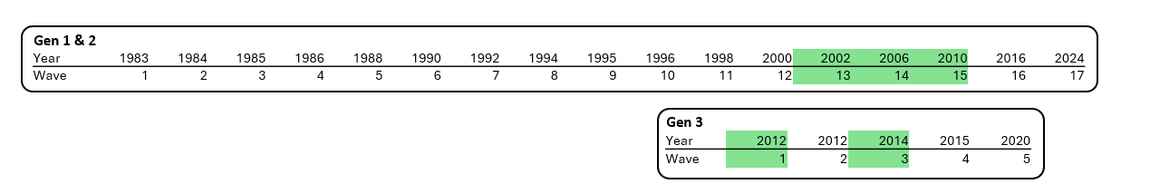

Figure S1
This diagram, which was adapted from Olsson et al. (2022), provides an overview of the Australian Temperament Project (ATP). The waves utilised for the primary exposure (intimate partner relationship strain) and outcomes (general health) are highlighted in green. The confounders were obtained from Gen 1 and 2 during waves 1 – 12.
Olsson, C. A., Letcher, P., Greenwood, C. J., McIntosh, J. E., Barker, S., Olsson, C. M., Macdonald, J. A., Spry, E. A., Hutchinson, D., Ryan, J., Edwards, B., McGee, R., Patton, G. C., & Sanson, A. V. (2022). The Australian Temperament Project Generation 3 study: a population-based multigenerational prospective cohort study of socioemotional health and development. BMJ Open, 12(9), e061854. https://doi.org/10.1136/bmjopen-2022-061854

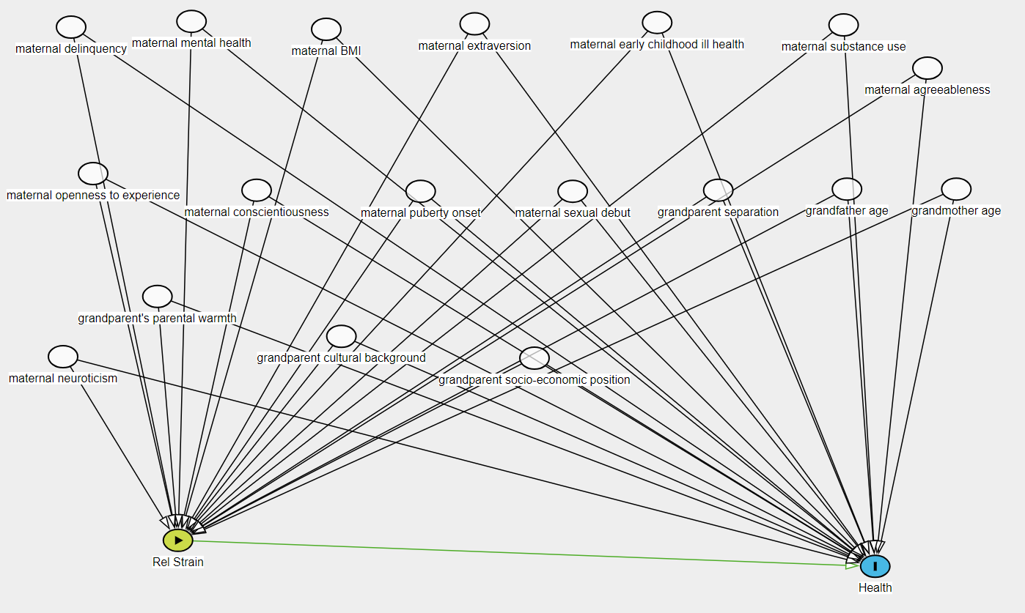

Figure S2
Directed acyclic graph (DAG) portraying the assumed causal structure of the research questions
Note. This DAG was created by https://www.dagitty.net/dags.html

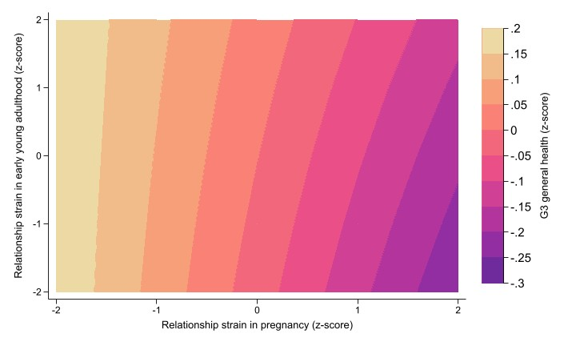
Figure S3
Interaction between relationship strain in early young adulthood and relationship strain in pregnancy on G3 general health, from research question 3 sensitivity analysis using continuous exposures.
Note: Figure suggests that the lowest levels of G3 general health were when relationship strain low in young adulthood but high in pregnancy, as observed in Table 3.

