Supplemental Material

Supplemental Table 1.
Bivariate correlations and simple descriptive statistics for substantive variables across time in a sample of N = 495 Mexican American parents
Mothers (n = 321)
 | Mean(SD) | 1 |  | 2 | 3 | 4 | 5 | 6 | 7 | 8 | 9 | 10 | 11 | 12 | 13 | 14 | 15 | 16 | 17 | 18 | 19 | 20
1. Age | 37.23(6.20) | 1.00
2. Acculturation Spanish | 4.23(1.10) | 0.07 |  | 1.00
3. Acculturation English | 2.64(1.27) | -0.18 |  | -0.76 | 1.00
4. Mother BMI | 30.28(6.70) | 0.03 |  | -0.04 | 0.04 | 1.00
5. Tangible Support (T1) | 2.99(0.65) | -0.18 |  | -0.27 | 0.35 | 0.03 | 1.00
6. Positive Involvement (T1) | 3.35(0.69) | -0.10 |  | 0.10 | 0.02 | -0.05 | 0.11 | 1.00
7. Pressure to Eat (T1) | 2.30(0.86) | -0.08 |  | 0.10 | -0.09 | -0.21 | -0.07 | 0.29 | 1.00
8. Control Behavior with Food (T1) | 1.50(0.44) | -0.04 |  | -0.03 | 0.04 | -0.12 | -0.05 | 0.06 | 0.45 | 1.00
9. Restrict Food (T1) | 2.28(0.44) | -0.05 |  | 0.11 | 0.00 | 0.10 | 0.03 | 0.32 | -0.07 | -0.06 | 1.00
10. Perceived Stress (T1) | 2.12(0.76) | 0.02 |  | -0.07 | -0.02 | 0.05 | -0.20 | -0.23 | 0.01 | 0.18 | -0.02 | 1.00
11. Positive Involvement (T2) | 3.23(0.70) | -0.09 |  | 0.09 | 0.07 | -0.09 | 0.09 | 0.64 | 0.19 | 0.13 | 0.26 | -0.17 | 1.00
12. Pressure to Eat (T2) | 2.14(0.83) | -0.12 |  | 0.09 | -0.03 | -0.28 | -0.06 | 0.16 | 0.71 | 0.43 | -0.10 | 0.07 | 0.27 | 1.00
13. Control Behavior with Food (T2) | 1.47(0.40) | -0.10 |  | 0.01 | 0.02 | -0.15 | 0.02 | 0.03 | 0.24 | 0.56 | 0.03 | 0.17 | 0.08 | 0.47 | 1.00
14. Restrict Food (T2) | 2.23(0.47) | -0.01 |  | 0.08 | 0.00 | 0.12 | 0.02 | 0.24 | -0.06 | -0.03 | 0.57 | -0.01 | 0.40 | -0.04 | 0.00 | 1.00
15. Perceived Stress (T2) | 2.19(0.76) | 0.06 |  | 0.01 | -0.06 | 0.11 | -0.18 | -0.10 | -0.07 | 0.07 | 0.04 | 0.39 | -0.10 | -0.01 | 0.10 | -0.03 | 1.00
16. Positive Involvement (T3) | 3.09(0.67) | -0.15 |  | 0.05 | 0.10 | -0.08 | 0.03 | 0.59 | 0.23 | 0.06 | 0.28 | -0.18 | 0.70 | 0.22 | 0.06 | 0.30 | -0.03 | 1.00
17. Pressure to Eat (T3) | 2.05(0.84) | -0.16 |  | 0.04 | 0.00 | -0.21 | -0.01 | 0.19 | 0.68 | 0.37 | -0.10 | 0.05 | 0.20 | 0.75 | 0.36 | -0.12 | 0.04 | 0.36 | 1.00
18. Control Behavior with Food (T3) | 1.41(0.38) | -0.13 |  | -0.04 | 0.07 | -0.15 | 0.04 | 0.04 | 0.26 | 0.48 | -0.07 | 0.14 | 0.14 | 0.43 | 0.52 | -0.04 | 0.08 | 0.12 | 0.44 | 1.00
19. Restrict Food (T3) | 2.22(0.47) | -0.08 |  | -0.02 | 0.13 | 0.10 | -0.04 | 0.22 | -0.03 | -0.06 | 0.50 | -0.04 | 0.30 | 0.01 | 0.01 | 0.52 | -0.03 | 0.46 | 0.07 | -0.03 | 1.00
20. Perceived Stress (T3) | 2.11(0.77) | 0.07 |  | 0.00 | 0.01 | 0.09 | -0.15 | -0.11 | -0.01 | 0.13 | 0.08 | 0.38 | -0.14 | -0.06 | 0.05 | -0.02 | 0.56 | -0.20 | -0.07 | 0.08 | -0.04 | 1.00
Fathers (n = 174)
 | Mean(SD) | 1 |  | 2 | 3 | 4 | 5 | 6 | 7 | 8 | 9 | 10 | 11 | 12 | 13 | 14 | 15 | 16 | 17 | 18 | 19 | 20
1. Age | 39.75(6.83) |  | 1.00
2. Acculturation Spanish | 4.01(1.10) |  | 0.00 | 1.00
3. Acculturation English | 2.95(1.12) |  | 0.04 | -0.68 | 1.00
4. Father BMI | 29.87(4.31) |  | -0.19 | -0.02 | 0.06 | 1.00
5. Tangible Support (T1) | 2.99(0.55) |  | -0.10 | -0.23 | 0.27 | 0.16 | 1.00
6. Positive Involvement (T1) | 3.12(0.70) |  | -0.09 | 0.12 | 0.07 | -0.04 | -0.02 | 1.00
7. Pressure to Eat (T1) | 2.43(0.86) |  | -0.01 | -0.03 | -0.03 | -0.08 | 0.10 | 0.35 | 1.00
8. Control Behavior with Food (T1) | 1.61(0.50) |  | -0.02 | -0.02 | -0.11 | 0.03 | 0.11 | 0.15 | 0.50 | 1.00
9. Restrict Food (T1) | 2.29(0.47) |  | -0.08 | 0.23 | -0.13 | 0.05 | -0.06 | 0.42 | 0.01 | 0.15 | 1.00
10. Perceived Stress (T1) | 1.88(0.71) |  | -0.11 | -0.20 | 0.05 | 0.08 | -0.05 | -0.24 | 0.06 | 0.13 | -0.04 | 1.00
11. Positive Involvement (T2) | 3.07(0.78) |  | -0.09 | 0.10 | 0.11 | -0.05 | -0.08 | 0.77 | 0.33 | 0.01 | 0.37 | -0.17 | 1.00
12. Pressure to Eat (T2) | 2.28(0.82) |  | -0.04 | -0.11 | 0.02 | -0.18 | 0.02 | 0.35 | 0.77 | 0.29 | 0.05 | -0.01 | 0.40 | 1.00
13. Control Behavior with Food (T2) | 1.52(0.42) |  | -0.19 | -0.15 | -0.03 | -0.05 | 0.03 | 0.17 | 0.34 | 0.55 | 0.09 | 0.17 | 0.16 | 0.43 | 1.00
14. Restrict Food (T2) | 2.21(0.42) |  | -0.01 | 0.20 | -0.09 | 0.03 | 0.00 | 0.37 | 0.11 | -0.08 | 0.47 | -0.20 | 0.48 | 0.19 | 0.08 | 1.00
15. Perceived Stress (T2) | 1.90(0.75) |  | -0.14 | -0.21 | 0.04 | 0.05 | 0.11 | -0.13 | 0.01 | 0.23 | -0.08 | 0.34 | -0.19 | 0.00 | 0.18 | -0.13 | 1.00
16. Positive Involvement (T3) | 2.95(0.78) |  | -0.05 | 0.14 | 0.09 | 0.00 | -0.08 | 0.69 | 0.17 | -0.03 | 0.16 | -0.36 | 0.79 | 0.20 | 0.04 | 0.36 | -0.20 | 1.00
17. Pressure to Eat (T3) | 2.16(0.81) |  | -0.04 | -0.12 | 0.13 | -0.15 | 0.18 | 0.29 | 0.74 | 0.36 | -0.02 | -0.13 | 0.31 | 0.70 | 0.30 | 0.02 | 0.03 | 0.32 | 1.00
18. Control Behavior with Food (T3) | 1.47(0.41) |  | -0.11 | 0.06 | -0.06 | -0.09 | 0.04 | 0.14 | 0.41 | 0.64 | 0.22 | 0.17 | 0.10 | 0.42 | 0.55 | 0.09 | 0.21 | -0.01 | 0.42 | 1.00
19. Restrict Food (T3) | 2.25(0.43) |  | 0.02 | 0.10 | 0.02 | -0.13 | 0.08 | 0.35 | 0.08 | -0.02 | 0.40 | -0.21 | 0.32 | 0.10 | 0.01 | 0.62 | 0.02 | 0.36 | 0.02 | 0.00 | 1.00
20. Perceived Stress (T3) | 2.04(0.69) |  | 0.12 | -0.15 | 0.02 | -0.10 | -0.09 | -0.24 | -0.02 | 0.15 | -0.06 | 0.37 | -0.35 | -0.02 | 0.07 | -0.13 | 0.37 | -0.32 | -0.06 | 0.21 | -0.06 | 1.00
Note. T1 = baseline; T2 = one year after baseline; T3 = two years after baseline; M = mean; SD = standard deviation; * = p < 0.05; ** = p < 0.01; *** = p < 0.001.

Supplemental Table 2.
Within-family dyad and within-person intraclass correlations for four parental feeding practices
 | Within-Family Dyad |  |  | Within-Person
 | Time 1 | Time 2 | Time 3 | Mothers | Fathers
Positive Feeding | 0.193 | 0.049 | 0.027 | 0.607 | 0.713
Pressure to Eat | 0.520 | 0.382 | 0.604 | 0.679 | 0.713
Control with Food | 0.176 | 0.194 | 0.311 | 0.539 | 0.619
Restrict Food | 0.322 | 0.364 | 0.210 | 0.578 | 0.496
Note. Within-person intraclass correlations are calculated across time.

Supplemental Figure 1.
Conceptual figure of models estimating the associations between perceived stress, tangible social support, and gender on parental feeding practices

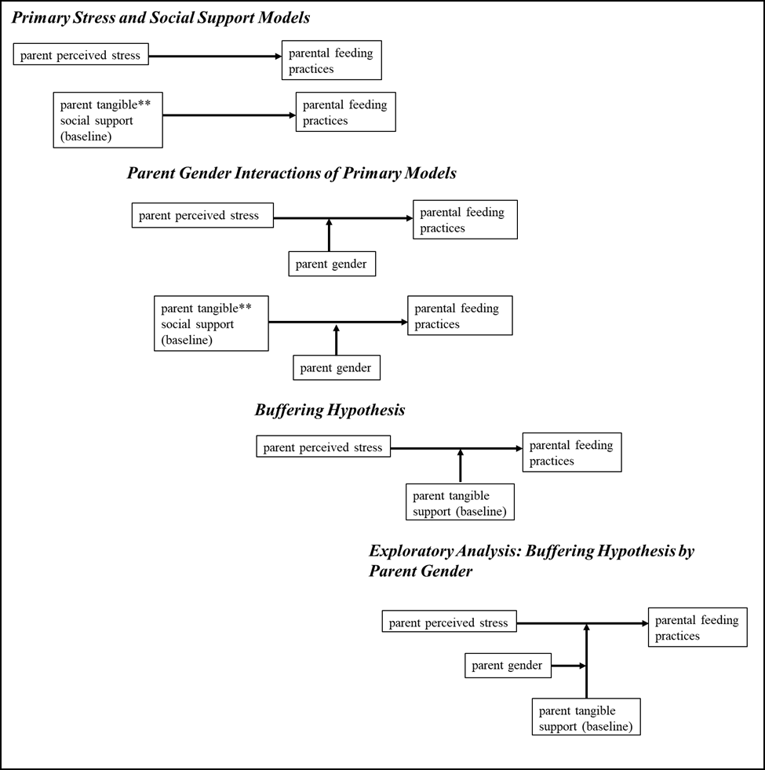
Note. Parental feeding practices include positive involvement in child eating, pressuring a child to eat, controlling behavior with food, and restricting food. Parental perceived stress was measured at baseline and each follow-up. Parental tangible social support was measured at baseline only and thus to address this limitation, a tangible support by time interaction was estimated in the Primary Stress and Social Support Model phase to understand whether tangible support at baseline was associated with changes in parental feeding across time. This relationship was also examined across parent gender at the Parent Gender Interactions of Primary Models phase.

Supplemental Figure 2.
Parent gender moderates the interaction between baseline tangible social support and time on controlling behavior with food in an unadjusted model.

Note. Parent gender moderates a tangible social support by time interaction on controlling behavior with food in the unadjusted model, F(1, 886) = 4.11, p = 0.043 such that for mothers with high (versus low) tangible support, their control with food behavior decreased significantly from baseline to follow-up visit 2, b = -0.10, 95% CI (-0.16, -0.04). However, for fathers with low (versus high) social support, their control with food feeding behavior decreased significantly from baseline to follow-up visit 2, b = -0.08, 95% CI (-0.13, -0.03). Parent gender was not a moderator of this interaction in a model adjusted parent demographic and health covariates.

