Finding benefits during collective stress: A study of health behaviors in a longitudinal representative U.S. sample during the COVID-19 era
Supplemental File 2

Figure & Tables

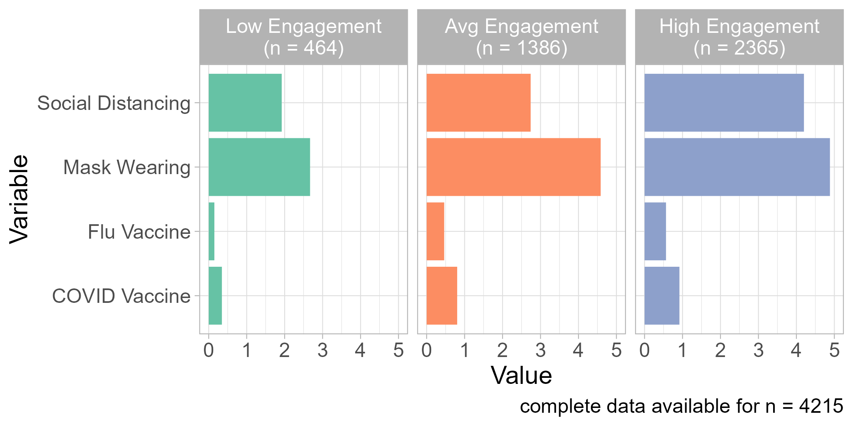
Figure S1
Clusters of health protective behaviors at Waves 2 and 3

Table S1
Descriptive statistics for key variables
 | n | weighted n | M | SD | Min | Max
Wave 1
Pre-pandemic mental health | 6,513 | 6450.91 | 0.18 | 0.38 | 0 | 1
Secondary stressors | 6,456 | 6377.63 | 1.36 | 1.21 | 0 | 7
Community exposures | 6,491 | 6418.27 | 4.88 | 1.54 | 0 | 6
Wave 2
Benefit finding | 5,634 | 5619.59 | 2.83 | 0.97 | 1 | 5
Emotional exhaustion | 5,657 | 5658.22 | 2.70 | 0.85 | 1 | 5
Functional impairment | 5,638 | 5640.84 | 1.77 | 0.91 | 1 | 5
Global distress | 5,661 | 5661.00 | 0.68 | 0.72 | 0 | 4
Posttraumatic stress related to COVID-19 | 5,657 | 5657.94 | 1.79 | 0.83 | 1 | 5
Social distancing | 5,651 | 5642.82 | 3.43 | 1.04 | 1 | 5
Mask wearing | 5,633 | 5623.37 | 4.51 | 0.85 | 1 | 5
Financial stressors | 5,659 | 5659.23 | 0.65 | 1.05 | 0 | 6
Secondary stressors | 5,659 | 5659.81 | 1.37 | 1.34 | 0 | 9
Ever been sick with COVID-19 (yes=1; no=0) | 5,647 | 5640.04 | 0.05 | 0.22 | 0 | 1
Total (cumulative) lifetime individual-level adverse events | 5,660 | 5,657 | 2.65 | 1.95 | 0 | 8
Wave 3
Benefit finding | 4,856 | 4844.86 | 2.72 | 0.94 | 1 | 5
Emotional exhaustion | 4,877 | 4873.04 | 2.75 | 0.80 | 1 | 5
Functional impairment | 4,878 | 4874.55 | 1.83 | 0.94 | 1 | 5
Global distress | 4,881 | 4881.00 | 0.63 | 0.73 | 0 | 4
Posttraumatic stress related to COVID-19 | 4,873 | 4868.49 | 1.65 | 0.78 | 1 | 5
Vaccine behavior (yes=1; no=0) | 4,851 | 4841.98 | 0.78 | 0.42 | 0 | 1
Financial stressors | 4,877 | 4873.76 | 0.88 | 1.31 | 0 | 8
Secondary stressors | 4,880 | 4880.42 | 0.57 | 0.98 | 0 | 8
Ever been sick with COVID-19 (yes=1; no=0) | 4,860 | 4859.30 | 0.21 | 0.41 | 0 | 1
Total (cumulative) lifetime individual-level adverse events | 4,878 | 4879.16 | 3.34 | 2.49 | 0 | 16
Wave 4
Benefit finding | 4,841 | 4837.91 | 2.93 | 0.96 | 1 | 5
Emotional exhaustion | 4,858 | 4858.01 | 2.64 | 0.80 | 1 | 5
Functional impairment | 4,858 | 4858.01 | 1.72 | 0.87 | 1 | 5
Global distress | 4,855 | 4855.63 | 0.64 | 0.69 | 0 | 4
Posttraumatic stress related to war in Ukraine | 4,847 | 4847.70 | 1.49 | 0.67 | 1 | 5
Total (cumulative) lifetime individual-level adverse events | 4,858 | 4857.78 | 3.89 | 2.86 | 0 | 21
Indirect exposure to the war in Ukraine | 4,846 | 4844.45 | 0.13 | 0.34 | 0 | 1

Table S2

Wave 2 correlations between key study variables, N=5,661ª
Variables | (1) | (2) | (3) | (4) | (5) | (6) | (7) | (8) | (9) | (10) | (11)
(1) Finding benefits | 1.000
(2) Emotional  exhaustion | 0.059*** | 1.000
(3) Functional  impairment | 0.077*** | 0.556*** | 1.000
(4) Global distress | 0.074*** | 0.704*** | 0.688*** | 1.000
(5) COVID-19 PTS^{b} | 0.204*** | 0.602*** | 0.574*** | 0.709*** | 1.000
(6) Social distancing^{c} | 0.293*** | 0.229*** | 0.182*** | 0.211*** | 0.288*** | 1.000
(7) Mask wearing^{c} | 0.253*** | 0.129*** | 0.052*** | 0.096*** | 0.127*** | 0.536*** | 1.000
(8) Financial stressors | 0.065*** | 0.297*** | 0.264*** | 0.316*** | 0.303*** | 0.065*** | -0.001 | 1.000
(9) Secondary  stressors | 0.097*** | 0.346*** | 0.278*** | 0.309*** | 0.338*** | 0.135*** | 0.074*** | 0.251*** | 1.000
(10) Personal  COVID-19 illness | 0.019 | 0.071*** | 0.099*** | 0.102*** | 0.094*** | -0.042*** | -0.061*** | 0.099*** | 0.107*** | 1.000
(11) Lifetime  individual-level  adversity | 0.034** | 0.182*** | 0.219*** | 0.214*** | 0.188*** | 0.070*** | 0.017 | 0.148*** | 0.231*** | 0.029** | 1.000
*** p<0.01, ** p<0.05, * p<0.1
ªNs may vary due to missing data; ^{b}PTS=posttraumatic stress; ^{c}Frequency from 1=never to 5=all the time

Table S3

Wave 3 correlations between key study variables, N=4,859ª

Variables | (1) | (2) | (3) | (4) | (5) | (6) | (7) | (8) | (9) | (10) | (11)
(1) Finding benefits | 1.000
(2) Emotional  exhaustion | 0.022 | 1.000
(3) Functional  impairment | 0.075*** | 0.536*** | 1.000
(4) Global distress | 0.070*** | 0.669*** | 0.661*** | 1.000
(5) COVID-19 PTS^{b} | 0.198*** | 0.551*** | 0.540*** | 0.684*** | 1.000
(6) Vaccine behavior^{c} | 0.115*** | -0.036** | -0.058*** | -0.035** | 0.005 | 1.000
(7) Flu vaccine | 0.100*** | -0.089*** | -0.033** | -0.068*** | -0.003 | 0.390*** | 1.000
(8) Financial stressors | 0.066*** | 0.333*** | 0.303*** | 0.362*** | 0.342*** | -0.141*** | -0.158*** | 1.000
(9) Secondary  stressors | 0.124*** | 0.313*** | 0.286*** | 0.334*** | 0.371*** | -0.074*** | -0.082*** | 0.433*** | 1.000
(10) Personal COVID-19  illness | 0.012 | 0.055*** | 0.056*** | 0.063*** | 0.040*** | -0.238*** | -0.142*** | 0.093*** | 0.122*** | 1.000
(11) Lifetime  individual-level  adversity | 0.084*** | 0.217*** | 0.254*** | 0.242*** | 0.211*** | -0.065*** | -0.035** | 0.272*** | 0.271*** | 0.026* | 1.000
*** p<0.01, ** p<0.05, * p<0.1
ªNs may vary due to missing data; ^{b}PTS=posttraumatic stress; ^{c}Vaccinated =1, not vaccinated =0

Table S4
Wave 4 correlations between key study variables, N=4,881ª

Variables | (1) | (2) | (3) | (4) | (5) | (6)
(1) Finding benefits | 1.000
(2) Emotional  exhaustion | 0.010 | 1.000
(3) Functional  impairment | 0.087*** | 0.598*** | 1.000
(4) Global distress | 0.064*** | 0.698*** | 0.748*** | 1.000
(5) Ukraine-war related  PTS^{b} | 0.194*** | 0.438*** | 0.465*** | 0.569*** | 1.000
(6) Lifetime  individual-level  adversity | 0.126*** | 0.231*** | 0.285*** | 0.275*** | 0.185*** | 1.000
*** p<0.01, ** p<0.05, * p<0.1
ªNs may vary due to missing data; ^{b}PTS=posttraumatic stress; ^{c}Frequency from 1=never to 5=all the time

Table S5
Multinomial logistic regression results examining Wave 1 and pre-pandemic predictors of trajectory of benefit finding membership (Always Low is the reference group), N=4,216
 | Always High |  |  |  |  | Always Middle |  |  |  |  | Decreasing |  |  |  |  | Increasing
Variable | RRR | SE | p | Lower | Upper | RRR | SE | p | Lower | Upper | RRR | SE | p | Lower | Upper | RRR | SE | p | Lower | Upper
Age | 1.02 | 0.01 | 0.00 | 1.01 | 1.03 | 1.01 | 0.00 | 0.10 | 1.00 | 1.02 | 1.01 | 0.00 | 0.02 | 1.00 | 1.02 | 0.99 | 0.00 | 0.02 | 0.98 | 1.00
Woman  (Man = 0) | 5.05 | 0.82 | 0.00 | 3.68 | 6.94 | 3.34 | 0.45 | 0.00 | 2.57 | 4.35 | 2.55 | 0.37 | 0.00 | 1.92 | 3.38 | 2.63 | 0.37 | 0.00 | 2.00 | 3.45
College education (No degree=0) | 0.69 | 0.15 | 0.08 | 0.45 | 1.04 | 0.79 | 0.14 | 0.18 | 0.56 | 1.11 | 1.00 | 0.19 | 0.99 | 0.69 | 1.45 | 0.91 | 0.17 | 0.63 | 0.64 | 1.31
Ethnicity (White=0)
Black, Non-Hispanic | 10.11 | 4.45 | 0.00 | 4.27 | 23.96 | 3.42 | 1.46 | 0.00 | 1.47 | 7.92 | 2.93 | 1.32 | 0.02 | 1.21 | 7.09 | 1.38 | 0.66 | 0.51 | 0.54 | 3.55
Other/2+races, Non-Hispanic | 2.60 | 0.70 | 0.00 | 1.54 | 4.39 | 1.33 | 0.31 | 0.22 | 0.85 | 2.10 | 1.14 | 0.29 | 0.61 | 0.69 | 1.87 | 1.06 | 0.27 | 0.81 | 0.65 | 1.74
Hispanic | 4.74 | 1.38 | 0.00 | 2.68 | 8.38 | 2.07 | 0.60 | 0.01 | 1.17 | 3.66 | 2.31 | 0.68 | 0.00 | 1.30 | 4.10 | 1.53 | 0.49 | 0.18 | 0.82 | 2.86
Income | 0.92 | 0.05 | 0.10 | 0.84 | 1.02 | 0.91 | 0.04 | 0.02 | 0.84 | 0.98 | 0.96 | 0.04 | 0.32 | 0.88 | 1.04 | 1.00 | 0.04 | 0.95 | 0.93 | 1.08
Pre-COVID mental health | 1.05 | 0.25 | 0.83 | 0.66 | 1.67 | 0.74 | 0.16 | 0.16 | 0.48 | 1.12 | 0.91 | 0.19 | 0.66 | 0.60 | 1.38 | 0.81 | 0.16 | 0.28 | 0.54 | 1.20
Secondary stressors W1 | 1.44 | 0.12 | 0.00 | 1.23 | 1.69 | 1.34 | 0.10 | 0.00 | 1.17 | 1.54 | 1.33 | 0.10 | 0.00 | 1.15 | 1.54 | 1.16 | 0.08 | 0.04 | 1.00 | 1.34
Community exposures W1 | 0.98 | 0.07 | 0.77 | 0.85 | 1.13 | 0.97 | 0.06 | 0.61 | 0.85 | 1.10 | 0.87 | 0.06 | 0.06 | 0.76 | 1.00 | 0.99 | 0.08 | 0.94 | 0.86 | 1.15
Financial exposures W2 | 0.96 | 0.09 | 0.65 | 0.80 | 1.15 | 1.12 | 0.10 | 0.19 | 0.95 | 1.33 | 0.97 | 0.09 | 0.77 | 0.82 | 1.16 | 1.06 | 0.10 | 0.54 | 0.88 | 1.26
Secondary stressors W2 | 1.24 | 0.08 | 0.00 | 1.09 | 1.41 | 1.18 | 0.07 | 0.01 | 1.05 | 1.33 | 1.22 | 0.08 | 0.00 | 1.07 | 1.39 | 1.05 | 0.06 | 0.46 | 0.93 | 1.18
Ever infected with COVID-19 W2 | 1.30 | 0.57 | 0.55 | 0.55 | 3.08 | 1.13 | 0.46 | 0.76 | 0.51 | 2.52 | 1.49 | 0.64 | 0.35 | 0.64 | 3.44 | 0.96 | 0.37 | 0.91 | 0.45 | 2.03
Total negative life stressors W2 | 0.98 | 0.04 | 0.53 | 0.90 | 1.05 | 0.99 | 0.03 | 0.79 | 0.93 | 1.06 | 0.99 | 0.04 | 0.80 | 0.92 | 1.07 | 1.03 | 0.04 | 0.40 | 0.96 | 1.11

