Vaccination invitations sent by warm and competent medical professionals disclosing risks and benefits increase trust and booking intention and reduce inequalities between ethnic groups.

Marie Juanchich, Claire M. Oakley, Hazel Sayer, Dawn Liu Holford, Wändi Bruine de Bruin, Cara Booker, Tim Chadborn, Gaëlle Vallee-Tourangeau, Reed M. Wood, & Miroslav Sirota

Supplementary materials

Table of Contents
A. Pilot data showing beliefs about “who is at higher risk” from COVID? 2
B. Full description of the sample 3
C. Text message wording of the risk-benefit and source manipulations 12
D. Vaccination uptake across countries and ethnic/racial groups 17
E. Effect of vaccine risk-benefit information across ethnic/racial groups in the UK and the US 19
F. Visual display showcasing the interaction risk/benefits information x source 26
G. Further analyses on the effect of the source 27
a. Effect of the source manipulation tested separately for the White ethnic majority and minorities from the UK and the US 27
b. Effect of signing with an ethnic minority name across ethnic/racial groups in the UK and the US 32
H. Effect of describing ethnic minority groups as “at higher risk” from COVID and of signing the message for people from the White majority and people from ethnic minority groups 33
I. Effects of vaccine risk-benefit information and source with covariates age, gender, and education 37
J. Effect of vaccine risk-benefit information and source of the first message only on perceived trust and vaccination booking intention 39

Pilot data showing beliefs about “who is at higher risk” from COVID?

In a survey conducted before the main study, we asked participants who they believed were at higher risk from COVID. The question was included in a survey on vaccination attitude distributed in the UK and the US via the Prolific online platform. Participants were asked whether four groups were at higher risk from COVID: older adults, pregnant women, children, and people from ethnic minority groups. In the sample, 61% believed that pregnant women were at higher risk from COVID, and 15% believed that children were at higher risk from it. Importantly, a large majority of people recognise that older adults were at higher risk from COVID. However, only half believed that to be the case for people from ethnic minority groups. This percentage was similar among people who identified as belonging to the White majority and those who belong to ethnic minority groups.

Table SM1
Results from a pre-test study testing people’s beliefs about who is at higher risk from COVID. Most people believed older adults were at higher risk, whereas they were split about whether people from ethnic minority groups were at higher risk.
 | White majority respondents  (n = 890) |  |  |  | Ethnic minority respondents  (n = 253)
 | Yes | No | Not sure |  | Yes | No | Not sure
Ethnic minority | 51% (453) | 25% (221) | 24% (215) |  | 49% (124) | 23% (58) | 28% (71)
Elderly | 98% (876) | 0.3% (3) | 1% (11) |  | 98% (248) | 0.4% (1) | 2% (4)

Full description of the sample

Table SM2
Sociodemographic characteristics of the sample (including age, gender, ethnicity, household size, education, religion, employment, social media, political orientation, income, and place of living).

 | UK (N = 2,018) |  | US (N = 2,020)
 | n | % | n | %
Age group (years)
18-24 | 232 | 12% | 261 | 13%
25-34 | 393 | 20% | 381 | 19%
35-44 | 360 | 18% | 362 | 18%
45-54 | 391 | 19% | 380 | 19%
55-64 | 322 | 16% | 219 | 11%
65-99 | 319 | 16% | 414 | 21%
Gender
Man | 990 | 49% | 953 | 47%
Woman | 1,025 | 51% | 1,038 | 51%
Non-binary | 2 | 0.1% | 24 | 1%
Other | 1 | <0.1% | 5 | 0.2%
Household size
Household of 1 | 384 | 19% | 385 | 19%
Household of 2-3 | 1,041 | 52% | 1,072 | 53%
Household of 4-5 | 492 | 24% | 453 | 22%
Household of 6+ | 101 | 5% | 110 | 5%
Born in the UK/US | 1,642 | 82% | 1,845 | 91%
Ethnicity minority | 961 | 47% | 1028 | 51%
Native English speaker = Yes | 1,796 | 89% | 1,813 | 90%
English proficiency in non-native
Beginner | 0 | 0% | 8 | 4%
Intermediate | 50 | 23% | 33 | 16%
Advanced | 101 | 46% | 73 | 35%
Expert | 71 | 32% | 93 | 45%
Level of education
No formal education | 17 | 1% | 14 | 1%
UK Primary/US Elementary school | 23 | 1% | 10 | 1%
UK GCSE/US High school | 490 | 24% | 0 | 0%
UK A/AS Levels/US High School diploma/GED or equivalent | 506 | 25% | 1,197 | 59%
Bachelor’s degree or equivalent | 665 | 33% | 513 | 25%
Master’s, Doctorate or equivalent | 287 | 14% | 267 | 13%
Other | 30 | 2% | 19 | 1%
Religion
No religion | 642 | 32% | 283 | 14%
Christian# | 684 | 34% | 649 | 32%
Protestant | 74 | 4% | 214 | 11%
Roman Catholic | 149 | 7% | 409 | 20%
Muslim | 232 | 12% | 46 | 2%
Buddhist | 23 | 1% | 44 | 2%
Sikh | 25 | 1% | 1 | <0.1%
Hindu | 74 | 4% | 25 | 1%
Jewish | 7 | 0.3% | 45 | 2%
Agnostic | 57 | 3% | 120 | 6%
Other | 51 | 3% | 184 | 9%
Work Status
Working full time (30 or more hours per week) | 860 | 43% | 778 | 39%
Working part-time (1-30 hours a week) | 343 | 17% | 237 | 12%
Full-time student | 101 | 5% | 74 | 4%
Retired | 337 | 17% | 426 | 21%
Unemployed | 161 | 8% | 240 | 12%
Not working/homemaker | 173 | 9% | 184 | 9%
Other | 43 | 2% | 81 | 4%
Financial hardship during the pandemic
Yes, most of the time | 147 | 7% | 358 | 18%
Yes, on a few/some occasions | 641 | 20% | 746 | 37%
No | 1,194 | 59% | 885 | 44%
Social media used on a regular basis
YouTube | 1,168 | 58% | 1,306 | 65%
Facebook | 1,279 | 63% | 1,362 | 67%
WhatsApp | 1,279 | 63% | 349 | 17%
Twitter | 584 | 29% | 539 | 27%
TikTok | 448 | 22% | 566 | 28%
Snapchat | 386 | 19% | 478 | 24%
Instagram | 966 | 48% | 886 | 44%
Reddit | 149 | 7% | 232 | 12%
Another platform | 32 | 2% | 56 | 3%
None of the above | 162 | 8% | 195 | 10%
Subjective social status
Around the 0-30 percentiles | 350 | 17% | 348 | 17%
Around the 40-60 percentiles | 1011 | 50% | 894 | 44%
Around the 70+ percentiles | 657 | 33% | 778 | 39%
Conservatism tendency
Liberal | 606 | 30% | 646 | 32%
Moderate | 1,068 | 53% | 833 | 41%
Conservative | 344 | 17% | 541 | 27%
Political party (UK)
Conservative | 548 | 27% | -- | --
Labour | 783 | 39% | -- | --
Liberal Democrat | 151 | 8% | -- | --
Scottish National Party (SNP) | 44 | 2% | -- | --
Plaid Cymru | 6 | 0.3% | -- | --
Reform Party, formerly Brexit Party/Independence party | 50 | 3% | -- | --
Green Party | 94 | 8% | -- | --
Other | 94 | 8% | -- | --
Prefer not to say | 248 | 12% | -- | --
Political party (US)
Republican | -- | -- | 486 | 24%
Democrat | -- | -- | 807 | 40%
Independent | -- | -- | 527 | 26%
Other | -- | -- | 117 | 6%
Prefer not to say | -- | -- | 83 | 4%
Overall household income (after tax)
<£ / $ 25,000 per year | 648 | 32% | 432 | 21%
£/ $ 25,000 - £49,999 per year | 752 | 37% | 561 | 28%
£/ $ 50,000 - £74,999 per year | 282 | 14% | 390 | 19%
£/ $ 75,000 - £124.999 per year | 138 | 7% | 299 | 15%
£/ $ 125,000 – 149,999 per year | 21 | 1% | 84 | 4%
£/ $ 150,000 or more per year | 22 | 1% | 154 | 8%
Prefer not to say | 155 | 7% | 100 | 5%
Urban/Rural
Urban | 915 | 45% | 994 | 49%
Suburban | 813 | 40% | 644 | 32%
Rural | 290 | 14% | 382 | 19%
Region (UK)
North East | 78 | 4% | -- | --
North West | 224 | 11% | -- | --
Yorkshire & Humber | 174 | 9% | -- | --
East Midlands | 151 | 8% | -- | --
West Midlands | 216 | 11% | -- | --
East of England | 147 | 7% | -- | --
London | 400 | 20% | -- | --
Scotland | 121 | 6% | -- | --
Northern Ireland | 27 | 1% | -- | --
# participants could select Christian, Protestant or Roman Catholic and selections rates for these three categories are reported here although we could have added the % of protestant and roman catholic respondents to the % of Christian respondents.

Table SM3
Health Characteristics of participants

 | UK (N = 1973) |  | US (N=1966)
 | n | % | n | %
Clinically vulnerable
Yes | 428 | 21% | 500 | 25%
No | 1,545 | 77% | 1,466 | 73%
Official COVID diagnosis
Yes | 451 | 22% | 478 | 24%
No | 1,531 | 76% | 1,489 | 74%
Possibility of COVID infection
Yes, definitely | 78 | 5% | 96 | 5%
Yes, probably | 293 | 19% | 253 | 17%
No, probably not | 589 | 38% | 521 | 34%
No, definitely not | 602 | 39% | 664 | 43%
Needle fear
Yes | 268 | 13% | 369 | 18%
No | 1,744 | 86% | 1,632 | 81%
COVID vaccine Side effects
No, not at all | 594 | 33% | 536 | 35%
Minor side effects | 946 | 52% | 722 | 47%
Yes, some more intense side effects | 235 | 13% | 232 | 15%
Yes, serious side effects | 34 | 2% | 57 | 4%
Pregnancy/Trying to become pregnant (% for women only)
Yes | 65 | 6% | 65 | 6%
No | 953 | 94% | 968 | 94%
Diet
Vegan | 27 | 2% | 60 | 3%
Vegetarian | 123 | 6% | 79 | 4%
Mixed diet including meat | 1,799 | 89% | 1,817 | 90%
Pescetarian | 60 | 3% | 64 | 3%
COVID first vaccination status
Yes, fully (i.e., two doses of two-dose vaccines such as Pfizer or Moderna vaccine) | 946 | 47% | 1348 | 68%
Yes, fully with two doses of the Oxford/AstraZeneca vaccine | 772 | 38% | 26 | 1%
Yes, fully, with one dose of the Johnson & Johnson vaccine | 17 | 1% | 118 | 6%
Yes, partly (e.g., one dose out of two) | 74 | 4% | 55 | 3%
No | 201 | 10% | 451 | 23%
Booster vaccine status (only for eligible respondents)
Yes | 1,347 | 79% | 932 | 66%
No, but I have plans to attend a walk-in vaccination site in the next 7 days | 77 | 5% | 130 | 9%
No, but I have booked my appointment | 82 | 5% | 126 | 9%
No | 187 | 11% | 216 | 15%
For those who haven’t had their booster yet: Are you planning to have it?
Yes, definitely, as soon as I can | 30 | 16% | 36 | 17%
I will likely get it | 41 | 22% | 52 | 24%
I will wait a little before deciding if I want it | 61 | 32% | 55 | 25%
I will likely not get it | 30 | 16% | 40 | 18%
I will definitely not get it | 26 | 14% | 32 | 15%

Table SM4
Ethnicity of participants in the UK and US subsamples.
UK subsample, N = 1693 | n | %
White | 959 | 57%
White British | 927 | 55%
Irish | 10 | 1%
Any other white background | 22 | 1%
Mixed or multiple ethnic groups | 133 | 8%
White & Black Caribbean | 39 | 2%
White & Black African | 12 | 1%
White & Asian | 46 | 3%
Any other mixed or multiple ethnic background | 36 | 2%
Asian or Asian British | 389 | 23%
Indian | 133 | 8%
Pakistani | 82 | 5%
Bangladeshi | 24 | 1%
Chinese | 72 | 4%
Any other Asian background | 78 | 5%
Black, African, Caribbean or Black British | 175 | 10%
Black African | 123 | 7%
Black Caribbean | 42 | 3%
Any other Black background | 10 | 1%
Other ethnic group | 37 | 2%
Arab | 10 | 1%
Any other ethnic group | 36 | 2%
Participants from ethnic majority | 959 | 57%
Participants from an ethnic minority | 734 | 43%
US subsample, N = 1,693
Race
White | 838 | 60%
American Indian or Alaska Native | 44 | 3%
Asian | 175 | 13%
Black or African American | 110 | 8%
Multiracial | 87 | 6%
Native Hawaiian or Pacific Islander | 8 | 1%
other | 142 | 10%
Ethnicity
Hispanic or Latino/a | 1023 | 73%
Non-Hispanic or Latino/a | 381 | 27%
Total participants from ethnic majority | 694 | 49%
Total participants from ethnic minority groups | 710 | 51%

Text message wording of the risk-benefit and source manipulations

The vaccination invitation messages were devised on a website, to look like mobile phone text messages (https://ifaketextmessage.com).
Note about material development: We engaged with a Patient and Public Engagement Group while developing the materials. Three users provided in-depth comments on the materials (e.g., informed consent, questions, and answer options). We also conducted an online pilot study where participants could provide extensive qualitative feedback before launching the survey. The design of the text messages did not change based on the feedback, but the input was instrumental in improving the study description before participants consented to participate. The feedback also suggested we should provide more options “not to answer” (e.g., about vaccination status) and more open text options for self-description (e.g., ethnicity), and those changes were implemented. The wording of the vaccine risk and benefit manipulation and that of the source is shown in Table SM5.
Figure SM1
Example of vaccination invitation text messages used for British and American respondents, which was based on the NHS text messages.
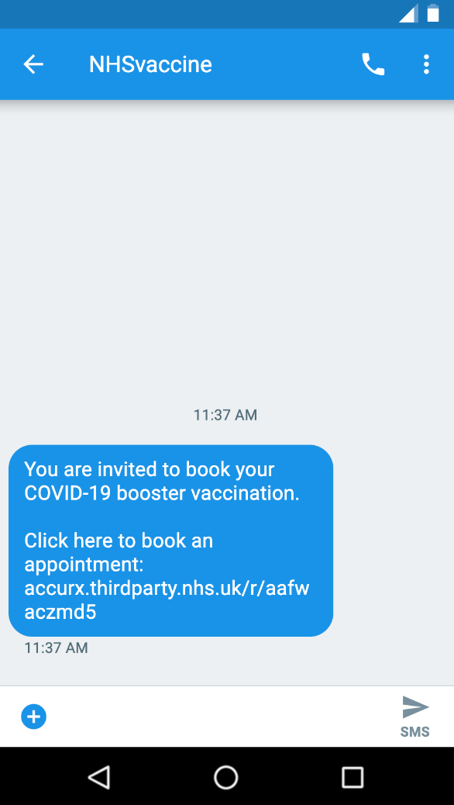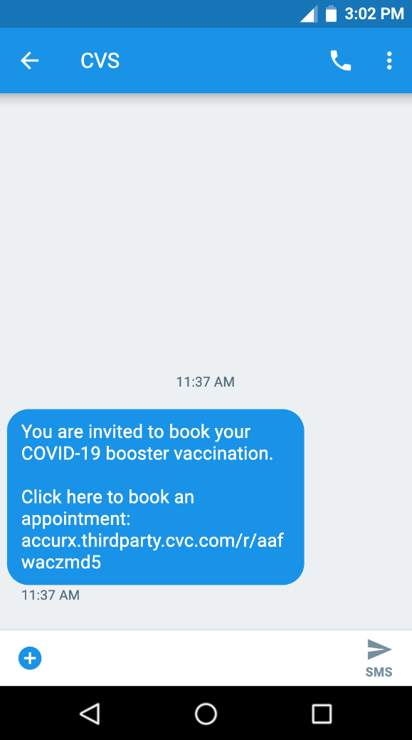

For the condition where the source was named, we chose an “Asian name” for the UK version of the study and a “Black name” for the US one. We did not choose to focus on an Asian for both because Asian US minority members showed only slight vaccination hesitancy (Nguyen et al., 2022) relative to the White majority. We did not choose to use a Black name for both because while both groups demonstrate higher levels of vaccination hesitation than the White majority, the UK Black minority group is more than twice smaller than the Asian group (ONS, 2022). So, to maximise the potential impact of naming the source, in the UK sample, we used the name ‘Sanjay Kumar’, which is common in the British Indian community and rare in the British White community (Zwysen, Di Stasio, & Heath, 2020). In the US sample, we used the name ‘Lamar Washington’, which is more prevalent in the Black American community and rare in the White American population (Bertrand & Mullainathan, 2004; Gaddis, 2017).

Table SM5
Exact wording of the different message content tested in the study shown with a control sender information for the UK sample (US sample variations shown between square brackets).
 | CONDITION | SOURCE | MESSAGE
1 | Control message  Invitation | NHSvaccine [CVS] | You are invited to book your COVID-19 booster vaccination.  Click here to book an appointment: accurx.thirdparty.nhs.uk/r/aafwaczmd5  [accurx.thirdparty.cvs.com/r/aafwaczmd5]
2 | … + vaccine benefits | NHSvaccine [CVS] | You are invited to book your COVID-19 booster vaccination.  The vaccine reduces your chance of becoming infected and protects you against severe forms of the illness. It also protects your loved ones by reducing the risk that you infect others. COVID can be severe, don't risk it.  Click here to book an appointment: accurx.thirdparty.nhs.uk/r/aafwaczmd5  [accurx.thirdparty.cvs.com/r/aafwaczmd5]
3 | … + vaccine risks | NHSvaccine [CVS] | You are invited to book your COVID-19 booster vaccination.  The vaccine reduces your chance of becoming infected and protects you against severe forms of the illness. It also protects your loved ones by reducing the risk that you infect others. COVID can be severe, don't risk it.  Vaccines may cause side effects, but the benefits outweigh the risks. The most common side effects are very mild (e.g., sore arm, fever) and severe side effects are very rare (e.g., allergic reaction).  Click here to book an appointment: accurx.thirdparty.nhs.uk/r/aafwaczmd5  [accurx.thirdparty.cvs.com/r/aafwaczmd5]
4 | … + at higher risk groups (including ethnic minority groups) | NHSvaccine [CVS] | You are invited to book your COVID-19 booster vaccination.  The vaccine reduces your chance of becoming infected and protects you against severe forms of the illness. It also protects your loved ones by reducing the risk that you infect others. COVID can be severe, don't risk it.  This vaccination is especially important for people who are at higher risk from COVID such as older individuals or those from ethnic minorities.  Vaccines may cause side effects, but the benefits outweigh the risks. The most common side effects are very mild (e.g., sore arm, a fever) and severe side effects are very rare (e.g., allergic reaction).  Click here to book an appointment: accurx.thirdparty.nhs.uk/r/aafwaczmd5  [accurx.thirdparty.cvs.com/r/aafwaczmd5]

Table SM6
Exact wording of the different sources tested in the study shown with a control content message for the UK sample (US sample variations shown between square brackets).
 | CONDITION | SOURCE | MESSAGE
1 | Control source: Health institution | NHSvaccine [CVS] | You are invited to book your COVID-19 booster vaccination.  Click here to book an appointment: accurx.thirdparty.nhs.uk/r/aafwaczmd5  [accurx.thirdparty.cvs.com/r/aafwaczmd5]
2 | Medical professional | Your local GP [physician] | As your local GP [family physician], I would like to invite you to book your COVID-19 booster vaccination.  Click here to book an appointment: accurx.thirdparty.nhs.uk/r/aafwaczmd5  [accurx.thirdparty.cvs.com/r/aafwaczmd5]
3 | Competent and warm medical professional | Your local GP [physician] | As your local GP [family physician], and a health expert who cares for the local community, I would like to invite you to book your COVID-19 booster vaccination.  Click here to book an appointment: accurx.thirdparty.nhs.uk/r/aafwaczmd5  [accurx.thirdparty.cvs.com/r/aafwaczmd5]
4 | Named competent and warm medical professional | Your local GP [physician] | As your local GP and a health expert who cares for the local community, I would like to invite you to book your COVID-19 booster vaccination.  Click here to book an appointment: accurx.thirdparty.nhs.uk/r/aafwaczmd5  [accurx.thirdparty.cvs.com/r/aafwaczmd5]  Dr Sanjay Kumar [Dr Lamar J. Washington, MD]

Vaccination uptake across countries and ethnic/racial groups

Participants from ethnic minority groups were 7 percentage points less likely to have received the COVID first vaccination and 13 percentage points less likely to have received the booster dose or to have firm plans to do it within a week. However, these differences were larger in the UK than in the US: -24 vs. -14 percentage points for the first vaccination and -11 percentage points in the UK vs. -2 in the US for the booster.

Table SM7
Ethnic and racial composition of the sample, along with COVID-19 vaccination uptake.
 |  | First COVID vaccination | Booster✭
Ethnic/racial group | n | % (n)
UK |  | n = 2018 | n = 1697
White | 1057 | 91.4% (966) | 89.6% (860)
Asian | 470 | 84.9% (399) | 71.2% (277)
Mixed | 176 | 77.8% (137) | 67.9% (91)
Black | 265 | 72.5% (192) | 53.4% (95)
Other ethnic group | 51 | 80.4% (41) | 64.9% (24)
Ethnic minority groups total | 962 | 80.0% (769) | 65.9% (487)
UK total | 2018 | 85.9 (1734) | 79.3% (1346)
US |  | n = 2020 | n = 1409 ✭
By ethnicity
Hispanic or Latino/a | 557 | 71.8% (400) | 56.4% (215)
Non-Hispanic or Latino/a | 1463 | 74.6% (1092) | 69.7% (717)
By race
Asian | 200 | 90.0% (180) | 69.9% (123)
Multiracial | 134 | 66.4% (89) | 53.4% (47)
White | 1195 | 74.6% (892) | 73.0% (511)
Black or African American | 181 | 65.2% (118) | 56.4% (62)
Other | 217 | 71.9% (156) | 53.8% (77)
American Indian or Alaska Native | 80 | 61.3% (49) | 43.2% (19)
Native Hawaiian / Pacific Islander | 13 | 61.5% (8) | 75.0% (6)
Ethnic minority total (incl. ned) | 1028 | 72.9% (749) | 59.0% (421)
US total | 2020 | 73.9% (1492) | 66.1% (932)
Overall total | 4038 | 79.9% (3226) | 73.3% (2278)
Note. ned: Not enough data. Indicated where n < 11 for a group. US data are analysed separately by race and ethnicity. ✭ the sample considered for the booster only includes people who were eligible to get the booster. It does not include people who had not received their first round of the COVID vaccine as they were not eligible.

Effect of vaccine risk-benefit information across ethnic/racial groups in the UK and the US
Participants’ trust in the vaccination invitation text message and intention to book their vaccination are depicted in Figure SM 2 per ethnic/racial group in the UK (Panels A and B) and the US (Panels C-F). We formally tested the effect of our two independent variables, Vaccine risk-benefit information and Source, in a variance analysis for each ethnic/racial group in the UK and the US (where n > 100).
The analysis can be summarised in three main findings. First, based on the control message containing no benefit-risk information sent by the NHS/CVC, participants across ethnic groups trusted the message less and intended to book their appointment less than the White majority (See Figure SM 2). Second, the variance analysis showed that vaccine risk-benefit information had a statistically significant effect within each group taken separately, in the UK and the US (See Table SM 8 and SM 9). Third, the effect of the source and its interaction with the risk-benefit information within each ethnic/racial group was equal to or greater than the effect sizes observed in the main analyses but were not statistically significant when tested in separate ethnic/racial groups.
In the control no-risk-benefit information condition, participants from all ethnic minority groups in the UK and the US reported less trust in the text message and lower intention to book their vaccination appointment than participants of the White majority group (shown at the bottom of the panels). As shown in Figure SM2 (Panels A and B), the provision of vaccine information consistently had a positive effect on trust across ethnic groups in the UK (Asian, Black, Mixed or Other). Vaccine risk-benefit information contributed to closing the gap between White British respondents and individuals from ethnic minority groups. The effects are similar, albeit the slope is flatter for intention to book the vaccination appointment. The results are similar in the US sample (Figure SM2, Panels C-F): trust increased for all the ethnic/racial groups with the addition of information about the benefits and risks of vaccines, and booking intention showed a similar trend, albeit with a less steep increase.
The results of the MANOVA shown in Table SM8 for the UK and Table SM9 for the US samples showed that the vaccine information manipulation had a statistically significant effect on trust in the text message and vaccination booking intention within all the ethnic/racial groups in the UK and the US. Consistently with findings reported in the manuscript, the source did not have a main effect within the ethnic/racial groups. Finally, the interaction effect between vaccine risk-benefit information and the source was not statistically significant for each ethnic minority groups.
Figure SM2.
Effect of the risk-benefit information on mean trust in the vaccination invitation across ethnic groups in the UK and racial and ethnic groups in the US (error bars show 95% CI). The Figure shows that providing more information about vaccines was beneficial across ethnic groups in the UK and the US, as shown by the consistent increase in average trust perception (orange) and booking intention (blue) with extra vaccine information.
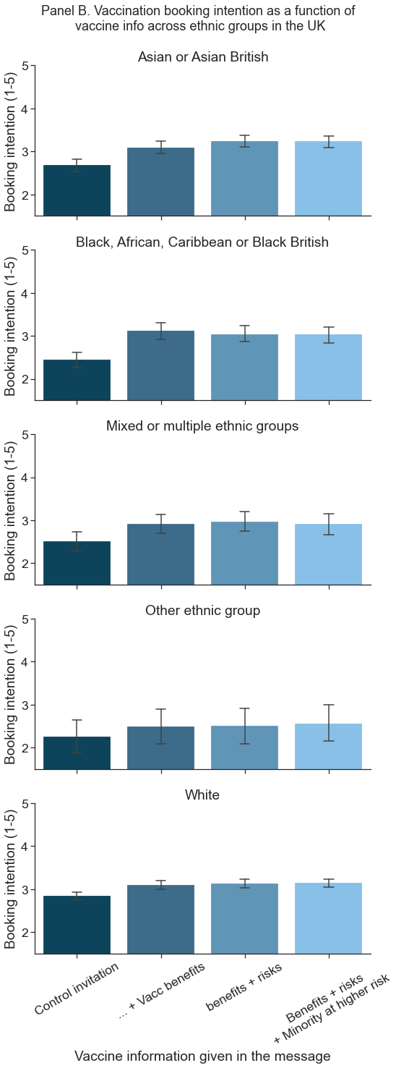
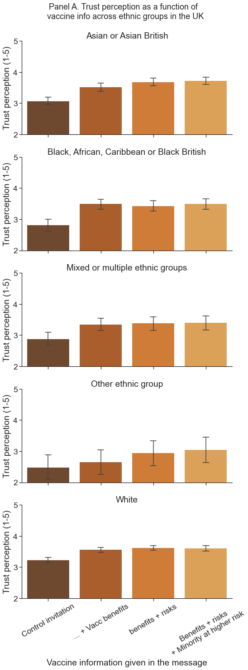
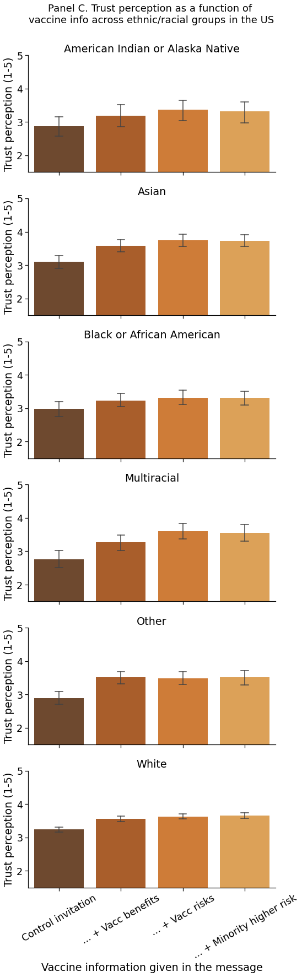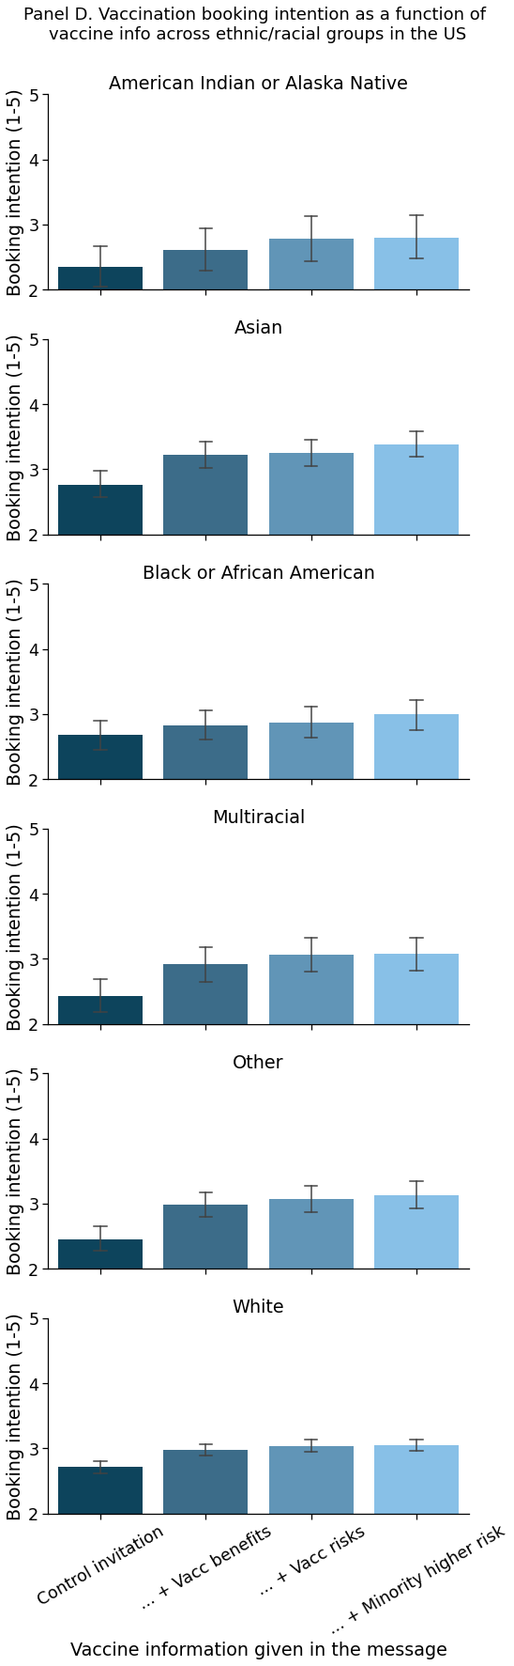
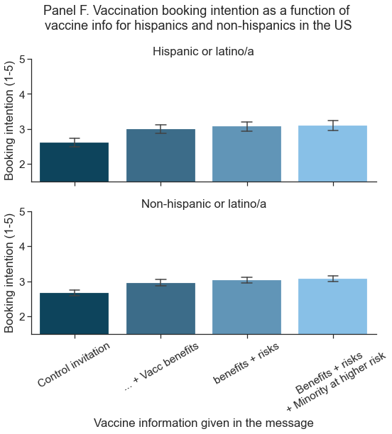
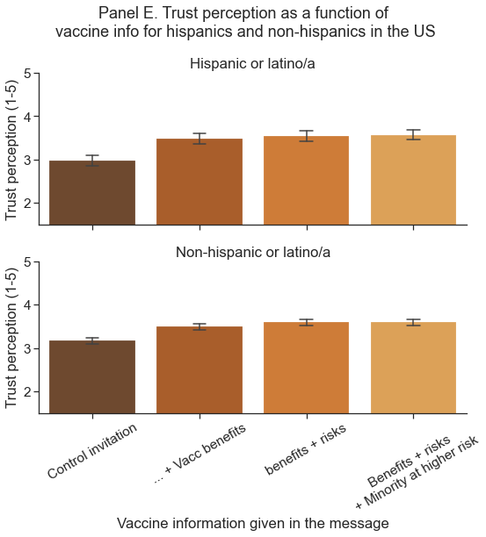
Table SM8.
Effect of risk-benefits information and source on participants’ trust in the vaccine invitation text message and vaccination booking intention within each ethnic group (n > 100) in the UK sample.
 | Trust |  |  |  | Booking
 | F | p | ηp² |  | F | p | ηp²
UK Asian (n = 470)
Risk-benefit | (2.6, 1225.5) = 60.19 | < .001 | .11 |  | (2.6, 1230.0) = 46.29 | < .001 | .09
Source | (3, 466) = 0.52 | .667 | .003 |  | (3, 466) = 0.77 | .510 | .005
Risk-benefit * Source | (7.9, 1225.5) = 0.44 | .912 | .003 |  | (7.9, 1230) = 0.63 | .753 | .004
UK Black (n = 264) | F | p | ηp² |  | F | p | ηp²
Risk-benefit | (2.7, 806.3) = 28.19 | < .001 | .10 |  | (2.8, 810.7) = 24.68 | < .001 | .09
Source | (3, 260) = 0.41 | .749 | .005 |  | (3, 260) = 0.75 | .523 | .005
Risk-benefit * Source | (8.1, 806.3) = 0.66 | .729 | .008 |  | (8.5, 810.7) = 0.26 | .981 | .009
UK Mixed (n = 176) | F | p | ηp² |  | F | p | ηp²
Risk-benefit | (2.4, 408.6) = 10.79 | < .001 | .06 |  | (2.6, 453.0) = 9.35 | < .001 | .05
Source | (3, 172) = 0.40 | .755 | .007 |  | (3, 172) = 0.16 | .926 | .003
Risk-benefit * Source | (7.1, 408.6) = 1.13 | .347 | .02 |  | (7.9, 453.0) = 0.69 | .696 | .01
Note: the analyses used the Huynh-Feldt adjustment for univariate tests.
The UK ethnic minority group “Other” (n = 51) was not included in the analyses because the number of respondents within that group was less than 100, with 7-16 participants only per between-subjects condition.

Table SM 9.
Effect of message risk-benefit information and source on participants’ trust in the vaccine invitation text message and vaccination booking intention within each racial/ethnic group (n > 100) in the US sample.
 | Trust |  |  |  | Booking
 | F | p | ηp² |  | F | p | ηp²
US Asian (n = 200)
Risk-benefit | (2.6, 507.9) = 29.13 | < .001 | .13 |  | (2.6, 509.7) = 21.95 | < .001 | .10
Source | (3, 196) = 0.53 | .666 | .01 |  | (3, 196) = 1.13 | .337 | .002
Risk-benefit * Source | (7.8, 507.9) = 2.01 | .046 | .03 |  | (7.8, 509.7) = 2.44 | < .014 | .04
US Black (n = 181) | F | p | ηp² |  | F | p | ηp²
Risk/benefits | (2.8, 489.8) = 6.41 | < .001 | .04 |  | (2.6, 494.8) = 4.98 | .003 | .03
Source | (3, 177) = 1.72 | .165 | .03 |  | (3, 177) = 1.52 | .211 | .03
Risk-benefit * Source | (8.3, 489.8) = 0.85 | .562 | .01 |  | (8.4, 494.8) = 0.87 | .545 | .02
US Multiracial (n = 134) | F | p | ηp² |  | F | p | ηp²
Risk-benefit | (2.7, 352.9) = 21.76 | < .001 | .14 |  | (2.8, 369.8) = 16.41 | < .001 | .11
Source | (3, 130) = 2.04 | .111 | .05 |  | (3, 130) = 1.34 | .265 | .03
Risk-benefit * Source | (8.1, 352.9) = 0.18 | .994 | .004 |  | (8.5, 369.8) = 0.19 | .994 | .004
US Other (n = 217) | F | p | ηp² |  | F | p | ηp²
Risk-benefit (4 levels) | (2.4, 502.6) = 24.25 | < .001 | .10 |  | (2.6, 553.3) = 28.39 | < .001 | .12
Source (4 levels) | (3, 213) = 1.11 | .347 | .02 |  | (3, 213) = 1.43 | .235 | .02
Risk-benefit * Source | (7.1, 502.6) = 0.38 | .916 | .005 |  | (7.8, 553.3) = 0.84 | .569 | .01
US Hispanics (n = 557) | F | p | ηp² |  | F | p | ηp²
Risk-benefit (4 levels) | (2.5, 1382.8) = 59.45 | < .001 | .10 |  | (2.6, 1433.9) = 40.02 | < .001 | .07
Source (4 levels) | (3, 553) = 1.08 | .358 | .01 |  | (3, 553) = 0.45 | .720 | .002
Risk-benefit * Source | (7.5, 1382.8) = 0.60 | .771 | .003 |  | (7.5, 1433.9) = 0.81 | .588 | .004
The US participants who reported being “American Indian or Alaska Native” (n = 80) and Native Hawaiian or other Pacific Islander (n = 13), were not included in the analyses due to the number of respondents being fewer than 100, with some between-subjects condition < 20 participants.

Visual display showcasing the interaction risk/benefits information x source

The differences across source conditions are larger on the left-hand side of Figure SM3, in the control no risk-benefit condition and grow smaller on the right-hand side, for the more detailed messages.
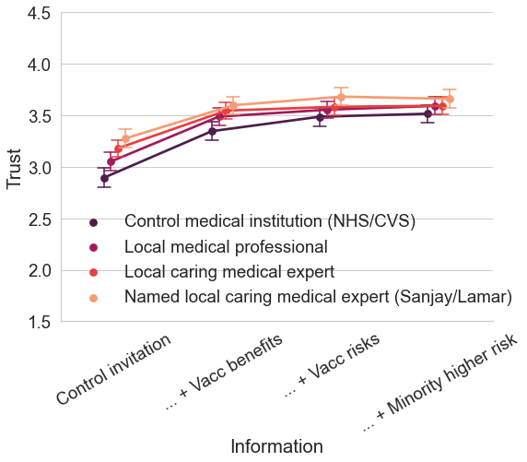
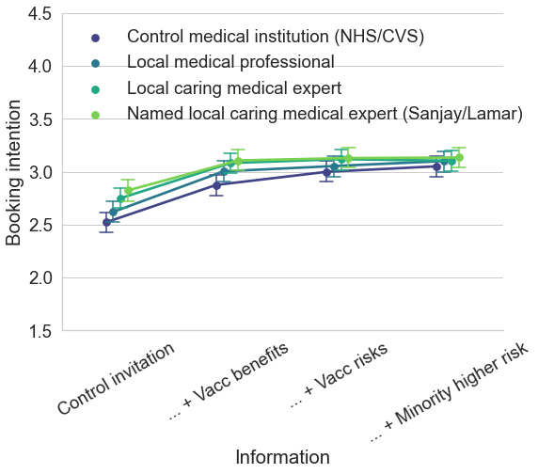
Figure SM3. Effect of the source on trust and booking intention as a function of the risks and benefits information provided in the text message showing an interaction pattern where the effect of the source was larger for the control message.

Further analyses on the effect of the source

Effect of the source manipulation tested separately for the White ethnic majority and minorities from the UK and the US

We show the mean trust and booking intention for each ethnic group in the UK and the US in Figure SM4. The Figure shows that for ethnic minority group members in the UK and the US (see dotted lines), having a doctor who belonged to an ethnic minority (Indian/Black) slightly increased trust perception and booking intention. For the White majority group, the pattern was the same in the US, having a black doctor signing the message did slightly increased trust and booking, but for the White majority in the UK, having an Indian doctor sign the message led to a slight decrement in trust and booking intention. However, these trends were not statistically significant. The country of residence did not have a main effect on trust and booking intention, nor did it interact with the message content and message source to predict trust and booking intention.
Figure SM4
Effect of the message source manipulation on mean trust and booking intention per ethnicity in the UK and race and ethnicity in the US (error bars show 95% CI).

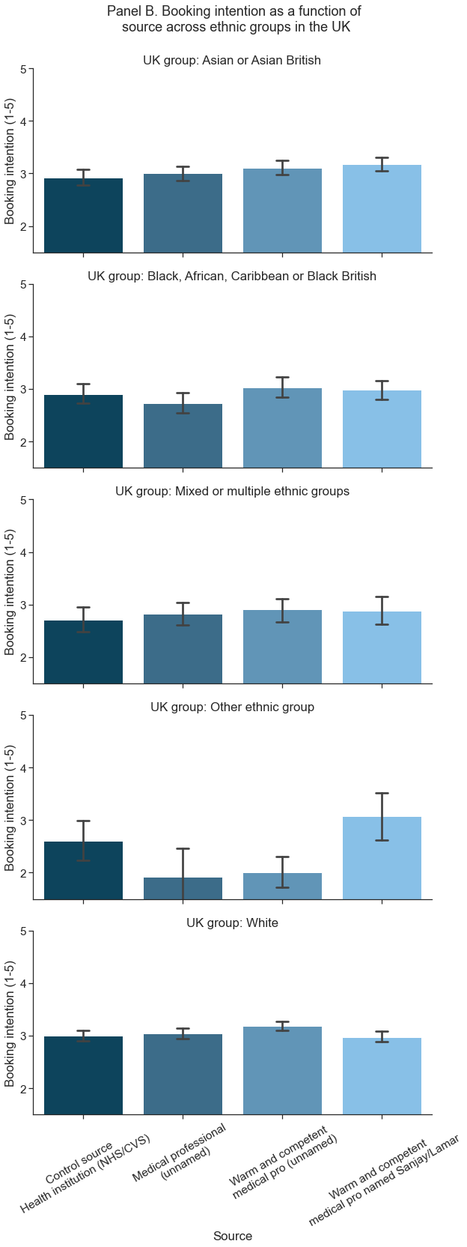
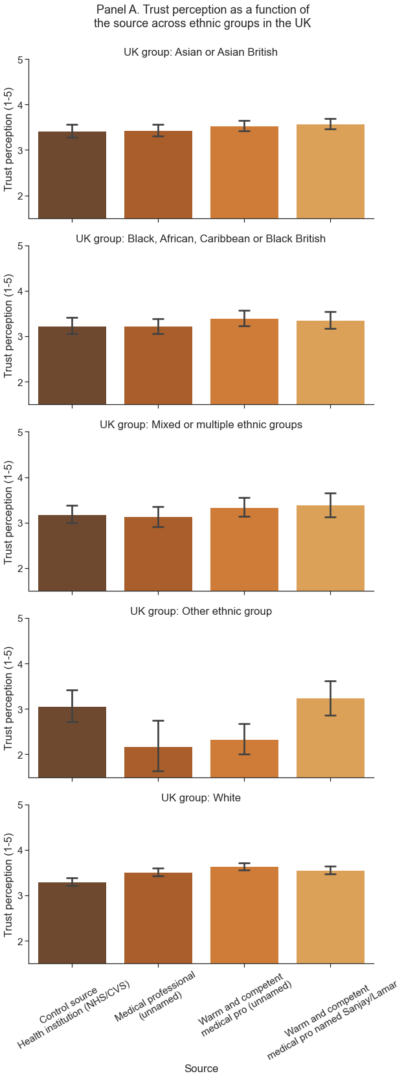
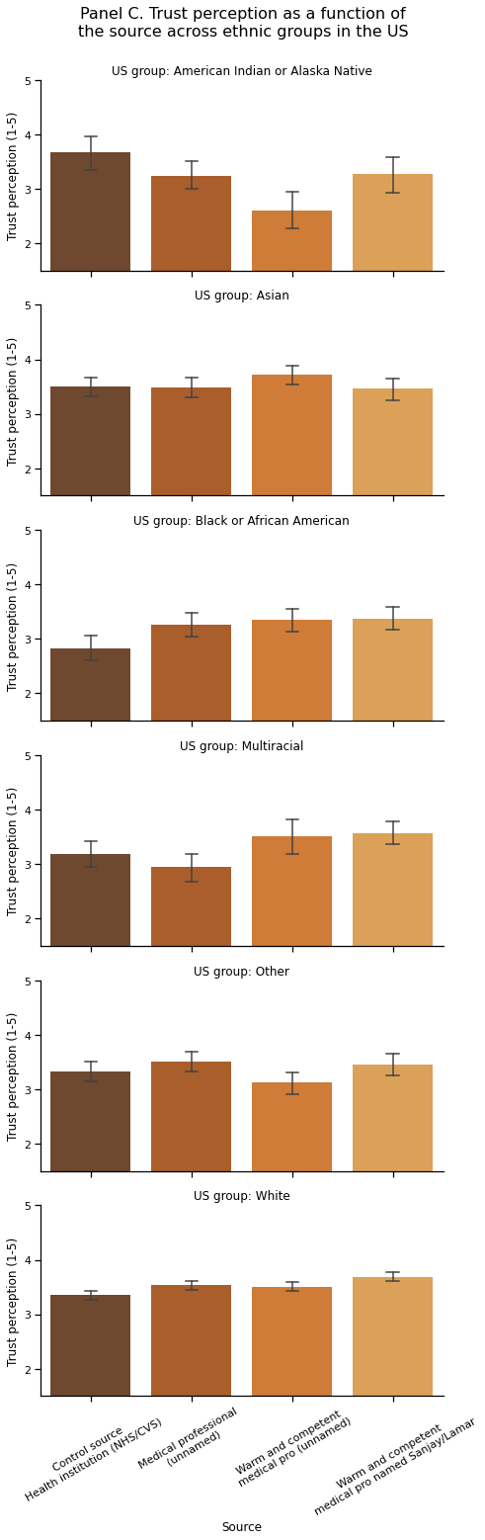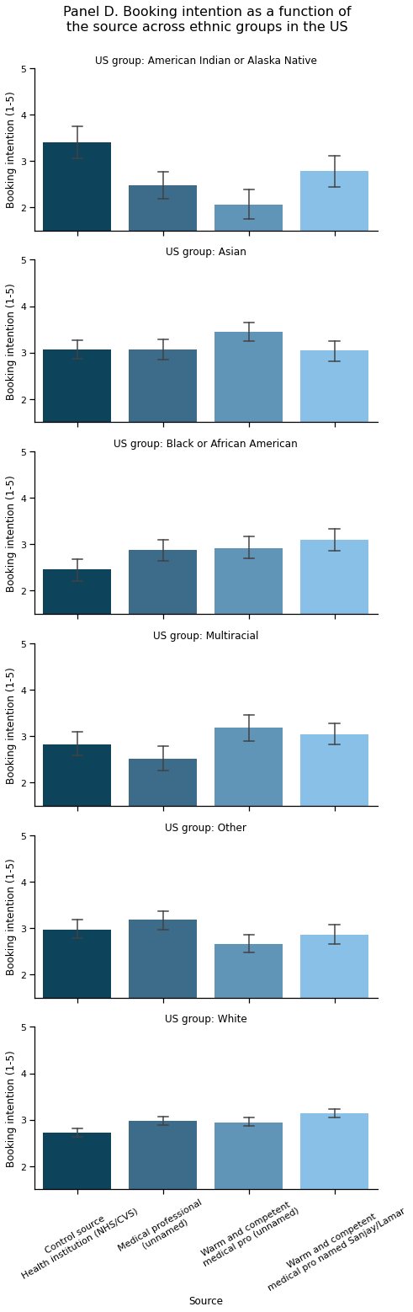
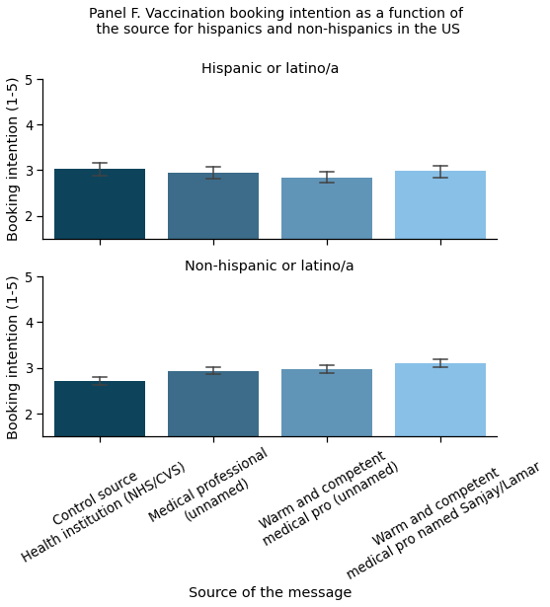
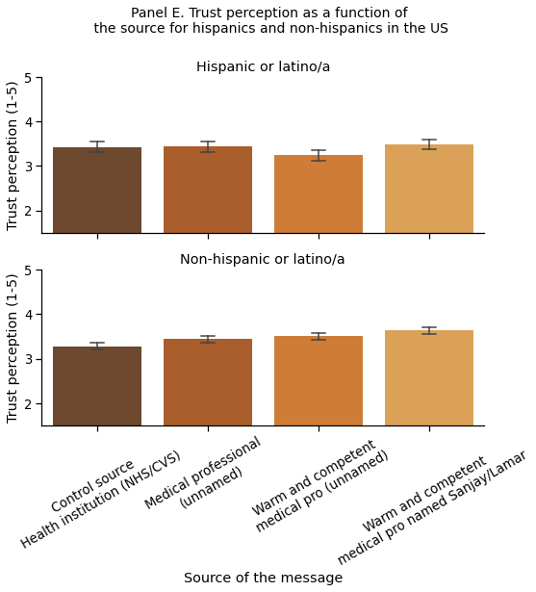

To further assert the effect of the source, we tested it within the control message only, where the mean differences were largest (see table SM11 for the overall sample and Table 12 for a breakdown of the analyses within the White majority and within ethnic minority groups). The analysis indicates that in the UK the effect of the source was more prominent in the White majority than in ethnic minority groups. In UK ethnic minority groups, none of the changes in the source led to a statistically significant increment in trust or booking intention. In the US subsample, the personal physician who signed their text message (with a Black American prototypical name) provided an increment in trust and booking intention relative to the control source, in the overall sample, in the White majority subsample, but not in the ethnic minority subsample.
Table SM10
Effect of the source in the control message condition only, in the control no information condition - when the invitation message was kept to its minimum (mean difference and p value).
 | Trust |  | Booking
Given control text
UK
Control vs. medical pro | 0.14 | .739 | 0.03 | >.990
Control vs. Warm and competent medical pro | 0.35* | <.001 | 0.28 | .025
Control vs. Named warm and competent medical pro | 0.40* | <.001 | .26 | .055
Medical professional vs. Warm and competent medical pro | 0.21 | .101 | .25 | .053
Warm and competent medical pro vs. Named warm and competent medical pro | 0.05 | >.990 | -.02 | >.990
US | Trust |  | Booking
Control vs. Medical pro | 0.18 | .285 | .17 | .455
Control vs. Warm and competent medical pro | 0.22 | .081 | .17 | .427
Control vs. Named warm and competent medical pro | 0.36 | <.001 | .35* | .002
Medical professional vs. Warm and competent medical pro | 0.04 | >.990 | .00 | >.990
Warm and competent medical pro vs. Named warm and competent medical pro | 0.14 | .720 | .17 | .465

Table SM11
Effect of the source in the control message condition only, in the control no information condition - when the invitation message was kept to its minimum (mean difference and p value within the White majority and ethnic minority groups.
 | Ethnic minority groups |  |  |  | White majority group
 | Trust |  | Booking |  | Trust |  | Booking
Given control text
UK
Control vs. medical pro | -0.02 | > .990 | 0.001 | > .990 | 0.21 | .271 | 0.04 | > .990
Control vs. Warm and competent medical pro | 0.09 | > .990 | 0.13 | > .990 | 0.34* | .009 | 0.18 | .862
Control vs. Named warm and competent medical pro | 0.18 | .552 | 0.23 | .371 | 0.26 | .109 | -0.02 | > .990
Medical professional vs. Warm and competent medical pro | 0.11 | > .990 | 0.13 | > .990 | 0.12 | > .99 | 0.14 | > .990
Warm and competent medical pro vs. Named warm and competent medical pro | 0.09 | .347 | 0.10 | > .990 | 0.08 | > .99 | -0.21 | .619
US | Trust |  | Booking |  | Trust |  | Booking
Control vs. Medical pro | 0.07 | > .990 | 0.01 | > .990 | 0.17 | .739 | 0.26 | .273
Control vs. Warm and competent medical pro | 0.06 | > .990 | 0.08 | > .990 | 0.16 | .919 | 0.20 | .844
Control vs. Named warm and competent medical pro | 0.16 | > .990 | 0.10 | > .990 | 0.38* | .004 | 0.45* | .005
Medical professional vs. Warm and competent medical pro | 0.01 | > .990 | 0.07 | > .990 | 0.01 | > .990 | 0.07 | > .990
Warm and competent medical pro vs. Named warm and competent medical pro | 0.10 | > .990 | 0.03 | > .990 | 0.22 | .291 | 0.25 | .382

Effect of signing with an ethnic minority name across ethnic/racial groups in the UK and the US

The third experimental condition of the source included a name suggesting the source belonged to an ethnic minority group (Indian group with Dr Sanjay Kumar in the UK and Black group with Dr Lamar Washington in the US). Including a named source did not significantly increase trust and booking intention relative to an unnamed source in the overall sample (as reported in the manuscript) nor in ethnic minority groups (Table SM11). Here we consider if the effect might vary across ethnic minority groups.
One could expect the UK Asian respondents to answer more positively to the Indian doctor than UK Black respondents or people from the UK White majority, and Black American respondents to answer more positively to the Black American named doctor in the US sample than Asian or White American respondents. However, this was not the case as shown in Figure SM4. Across ethnic groups, there was no clear effect of naming the source Dr Sanjay Kumar in the UK and Dr Lamar Washington in the US.

Effect of describing ethnic minority groups as “at higher risk” from COVID and of signing the message for people from the White majority and people from ethnic minority groups

In our study, the optimal vaccine information condition was the one describing risks and benefits and highlighting that some groups, like ethnic minority groups, are at higher risk from COVID. When we named the source of the message, we also chose a name that would be more likely to raise trust in people from ethnic minority groups by selecting a more typical Indian name (i.e., Sanjay Kumar) for the UK and a more typical Black name (i.e., Lamar Washington) for the US. Here, we zoom on these specific conditions to highlight the pattern of results within the White majority and in ethnic minority groups. Figure SM5 shows the levels of trust and booking intention (orange and blue, respectively) for people belonging to minority groups (dotted line) and people belonging to the White majority (plain line) in the UK (top panel) and in the US (lower panel). The effect of adding information about ethnic minorities being at higher risk is shown across panels shown in columns. Figure SM5 shows only minimal differences between the two messages and no pattern variation between the White majority (plain line) and ethnic minority groups (dotted line). The analyses shown in Table SM12 confirm this trend. The analysis that compares the message that includes risks and benefits with the message that contains additional information about ethnic minorities being at higher risk from COVID showed a null effect for both people from the White majority and those from ethnic minority groups.
Naming the doctor was also expected to raise trust and booking intention especially ethnic minority groups but did not do so statistically significantly. Here, we observe that the trend of signing with a name more typical of a person from an ethnic minority group (Indian in the UK and Black in the US) did not increase trust and booking intention more in people from ethnic minority groups. The analyses shown in Table SM12 confirms this trend. The analysis that compares the message sent by the warm and competent medical professional with the message sent by a named warm and competent medical professional showed a null effect for both people from the White majority and those from ethnic minority groups.
Figure SM5
Effect of adding information about ethnic minorities being at higher risk from COVID and signing the text message with an ethnic name on mean trust and vaccination booking intention for people from ethnic minority groups and those for the White majority (error bars show 95% CI)
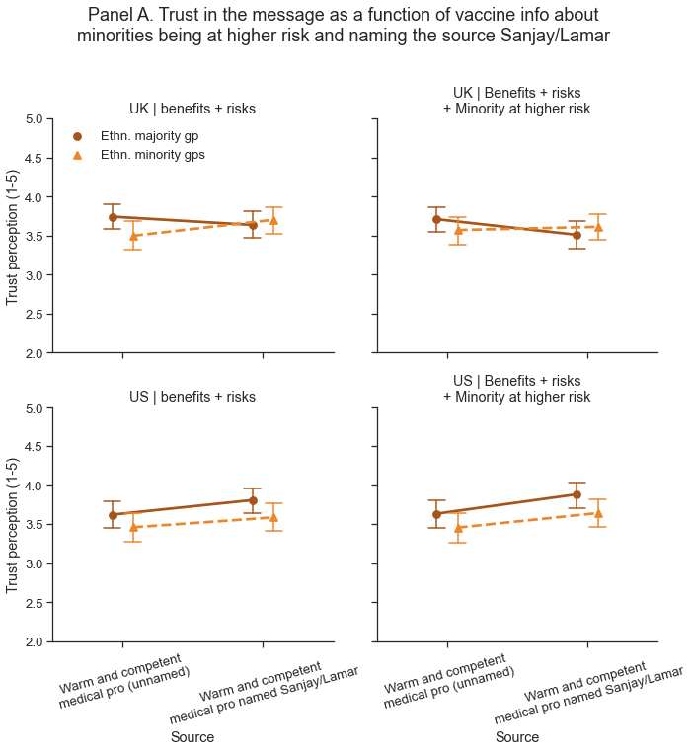
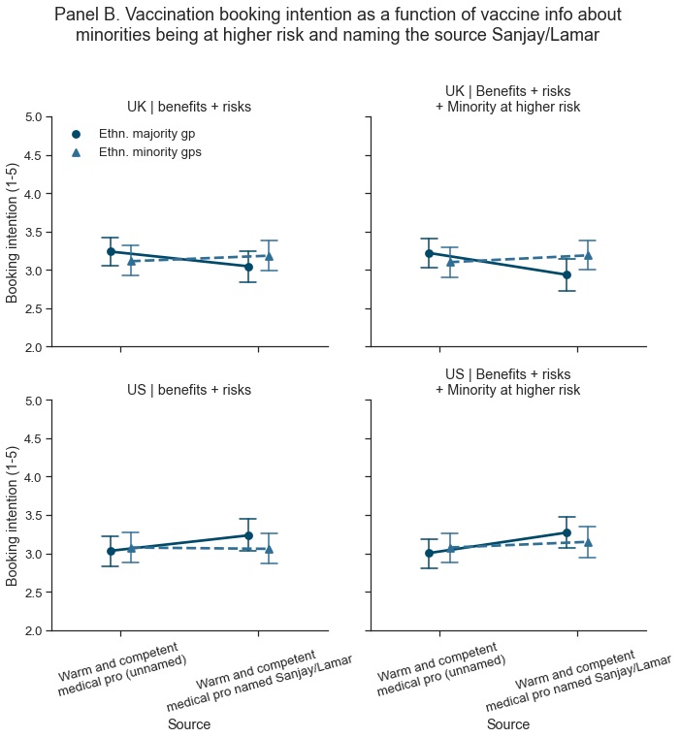
Table SM12
Comparison of the effect of different text message risk-benefit information and source on trustworthiness perception and booking intention of people from the White majority and from ethnic minority groups in the UK and the US.
 | Ethnic minority groups |  |  |  | White majority
 | Trust |  | Booking |  | Trust |  | Booking
 | MD | p | MD | p | MD | p | MD | p
Effect of risk-benefit information
Control no info vs. Benefits | .48*** | <.001 | .42*** | <.001 | .31*** | <.001 | .26* | .021
Control no info vs. Benefits & risks | .58*** | <.001 | .50*** | <.001 | .37*** | <.001 | .30*** | <.001
Control no info vs. Benefits & risks & ethnic min grps at higher risk | .61*** | <.001 | .52*** | <.001 | .38*** | <.001 | .32*** | <.001
Benefits vs. Benefits & risks | .11*** | <.001 | .08** | .008 | .06** | .007 | .04 | .161
Benefits & risks vs. Benefits & risks & ethnic min grps at higher risk | .03 | >.99 | .02 | >.99 | <.01 | >.99 | .02 | >.99
Effect of the source
Control (Health institution) vs. Warm medical pro | .03 | >.99 | .01 | >.99 | 0.19 | .073 | .16 | .577
Control (Health institution) vs. Warm and competent medical pro | .08 | >.99 | .10 | >.99 | .25 | .006 | .20 | .200
Control (Health institution) vs. Named warm and competent medical pro (Sanjay/Lamar) | .17 | .175 | .16 | .386 | .32 | <.001 | .21 | .149
Local medical professional vs. Warm and competent medical pro | .05 | >.99 | .10 | >.99 | .06 | >.99 | .04 | >.99
Warm and competent medical pro vs. Named warm and competent medical pro (Sanjay/Lamar) | .09 | >.99 | .06 | >.99 | .06 | >.99 | .01 | >.99
Note: The pattern of the effect of the message manipulation is the same for the UK and the US so we did not split the pairwise comparison analyses for each country.

Effects of vaccine risk-benefit information and source with covariates age, gender, and education

The effect of the message content on trust and booking intention remained statistically significant after we controlled for the age, gender and education levels of participants. The interaction effect between message content and message source also remained, along with the interaction effect between message content and ethnicity. The effects are reported in Table SM13, with Huynh-Feldt corrections (degrees of freedom were rounded to the nearest integer). The analyses also showed an effect of age, gender and education on trust perception and booking intention.
Table SM13
Effects of message content and source with country of residence and ethnicity as extra factors and three sociodemographic covariates: age, gender and education (N = 4,038)
 | Trust |  |  | Booking
 | F | p | η_{p}² | F | p | η_{p}²
Within-subject effects
Risk-benefit information | (2, 7352) = 7.73 | <.001 | .002 | (3, 6707) = 5.18 | .002 | .002
Risk-benefit information * Source | (7, 7352) = 4.09 | <.001 | .003 | (8, 6707) = 3.99 | <.001 | .003
Risk-benefit information * Ethnic group | (3, 7352) = 4.37 | .007 | .001 | (3, 6707) = 8.46 | < 001 | .002
Risk-benefit information * Country | (3, 7352) = 0.51 | .641 | <.001 | (3, 6707) = 0.96 | .489 | <.001
Risk-benefit information * Source * Ethnic min group | (8, 7352) = 1.04 | .401 | .001 | (8, 6707) = 1.14 | .334 | .001
Risk-benefit information * Gender | (2, 7352) = 5.17 | .003 | .001 | (3, 6707) = 1.07 | .383 | .001
Risk-benefit information * Age | (3, 7352) = 3.57 | .020 | .001 | (3, 6707) = 0.38 | .742 | <.001
Risk-benefit information * Education | (3, 7352) = 2.66 | .057 | .001 | (3, 6707) = 1.05 | .363 | <.001
Between-subject effects
Source | (3, 3945) = 7.03 | <.001 | .01 | (3, 3945) = 3.36 | .018 | .003
Ethnic group (Min = 1, Maj = 0) | (1, 3945) = 0.03 | .870 | <.001 | (1, 3945) = 3.23 | .073 | .001
Country of residence | (1, 3945) = 0.07 | .790 | <.000 | (1, 3945) = 3.44 | .064 | .001
Age | (1, 3945) = 75.08 | <.001 | .02 | (3, 3945) = 31.46 | <.001 | .01
Gender (Women = 1, Men = 0) | (1, 3945) = 4.23 | .040 | .001 | (1, 3945) = 20.09 | <.001 | .01
Education | (1, 3945) = 49.81 | <.001 | .01 | (1, 3945) = 49.65 | <.001 | .01
Source * Ethnic group | (3, 3945) = 1.39 | .244 | .001 | (3, 3945) = 0.44 | .725 | <.001
Note: The degrees of freedom of the univariate tests are rounded values of Huynh-Feldt adjusted values.

Effect of vaccine risk-benefit information and source of the first message only on perceived trust and vaccination booking intention

To evaluate the extent to which the comparison processes between information given in the text messages were responsible for the effect of vaccine information, we compared participants’ trust perception and vaccination booking intention for the first message they saw only (instead of for the four messages they saw within-subjects). Because the order of presentation of the message was randomised for each participant, the first message was between-subjects. Participants saw either the control message, a message including benefits, a message including benefits and risks, or a message including benefits, risks, and focusing on higher risk groups.
As shown in Figure SM6, the pattern of results is consistent with the results of the within-subject manipulation of risk-benefit information. Participants trusted the control message the least and the message including benefits, risks, and groups at higher risk from COVID the most. For booking intention, the trend was similar, except that the highest booking intention was in the risk and benefits condition, with a slight dip when at-risk groups were mentioned.
We conducted an ANOVA with risk-benefit information, source, and ethnicity (majority/minorities) as between-subject factors and trust and booking intention as dependent variables. The results are consistent with the findings from the within-subjects design. The risk-benefit information had a main effect on both trust in the message and booking intention, F(3, 4037) = 41.05, p < .001, η_{p}² = .03 and F(3, 4037) = 19.94, p < .001, η_{p}² = .02. The source had an effect on trust perception but not booking intention, F(3, 4037) = 3.48, p = .015, η_{p}² = .003 and F(3, 4037) = 1.24, p = .295, η_{p}² = .001. The analysis also showed that people from ethnic minority groups trusted the message less and intended less to book a vaccination appointment, F(1, 4037) = 22.72, p < .001, η_{p}² = .01 and F(1, 4037) = 6.13, p < .013, η_{p}² = .002. The effect of vaccine risk-benefit information and message source did not depend on ethnicity, as the interactions with ethnicity were not statistically significant, respectively, for trust, F(3, 4037) = 0.08, p = 970, η_{p}² < .001 and F(3, 4037) = 0.54, p = .656, η_{p}² < .001 and for booking intention, F(3, 4037) = 0.10, p = .962, η_{p}² < .001 and F(3, 4037) = 1.03, p = .378, η_{p}² = .001.
Figure SM6
Mean trust perception and booking intention reported based on the first message shown in the study, hence reflecting between-subjects differences of the risk-benefit information manipulation without comparison possibility between messages.
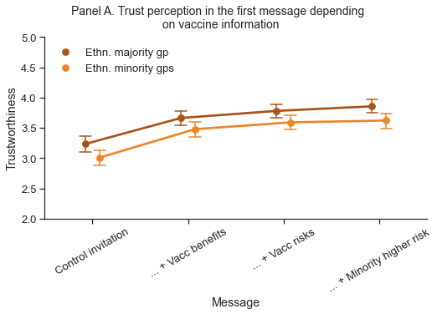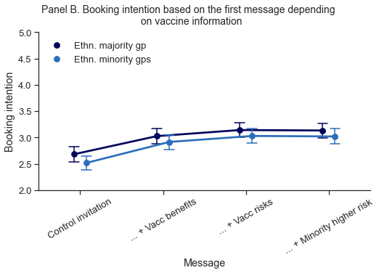

Note: Mean responses with error bars representing 95% confidence intervals.

References

Bertrand, M., & Mullainathan, S. (2004). Are Emily and Greg More Employable than Lakisha and Jamal? A Field Experiment on Labor Market Discrimination. The American Economic Review, 94(4), 991-1013. Retrieved from http://www.jstor.org/stable/3592802
Gaddis, S. M. (2017). How black are Lakisha and Jamal? Racial perceptions from names used in correspondence audit studies. Sociological Science, 4, 469-489.
Nguyen, L. H., Joshi, A. D., Drew, D. A., Merino, J., Ma, W., Lo, C.-H., . . . Consortium, C. (2022). Self-reported COVID-19 vaccine hesitancy and uptake among participants from different racial and ethnic groups in the United States and United Kingdom. Nature Communications, 13(1), 636. doi:10.1038/s41467-022-28200-3
ONS. (2022). Ethnic group, England and Wales: Census 2021. Retrieved from https://www.ons.gov.uk/peoplepopulationandcommunity/culturalidentity/ethnicity/bulletins/ethnicgroupenglandandwales/census2021
Zwysen, W., Di Stasio, V., & Heath, A. (2020). Ethnic Penalties and Hiring Discrimination: Comparing Results from Observational Studies with Field Experiments in the UK. Sociology, 55(2), 263-282. doi:10.1177/0038038520966947

