Appendix A
Details of Participant Recruitment and Data Collection Procedures and Institutional Review Board Approvals for the Samples in Each Dataset Included in the Meta-Analysis

Dataset 1 (Caudwell & Hagger, 2015; Student alcohol pre-drinking)
Participants were undergraduate students recruited via social media and posters placed on noticeboards and prominent locations around university campus locations in Western Australia. Participation was incentivized through entry into a prize draw or by offering course credit. Participants were eligible for inclusion in the study if they were aged 18 years or older and enrolled in a full-time course at a Western Australian university. Participants (N = 508) completed a baseline online questionnaire comprising theory of planned behavior (TPB) measures and past behavior at an initial data collection occasion (Time 1). Four weeks later, at a second data collection occasion (Time 2) participants (N = 341 (retention rate = 67.1%) completed a follow-up measure of behavior. Of these participants, 55 reported not engaging in pre-drinking in the previous four weeks and a further 6 participants’ data had a high proportion of missing data, resulting in a final sample of 280 (M age = 21.41 years SD = 4.21 years; 90 men, 190 women). The majority (79.2%) self-identified as Caucasian in ethnicity. Data on education level and income were not collected. Ethical approval was secured from the Curtin University Human Research Ethics Committee in advance of data collection. These data were previously published (Caudwell & Hagger, 2015).
Datasets 2 and 3 (Hagger & Chatzisarantis, 2005; University student and staff dieting and exercise)
Participants were undergraduate university students and university employees. Participants were required to completed self-report measures of TPB constructs referring to either dieting behavior or leisure-time exercise behavior at an initial data collection occasion. Participants in the dieting behavior sample (N = 523; 322 women, 201 men; M age = 21.13, SD = 3.72) were provided with instructions that they were participating in a ‘survey’ on behaviours relating to ‘watching your diet’. A standardized set of instructions defined the target behaviour of ‘watching your diet’ as “cutting down on sugary foods (e.g. sweets, soft drinks, chocolate), cutting down on fatty foods (e.g. butter, bacon, potato chips), avoiding snacks between meals, decreasing food intake in general by eating lighter meals, not having seconds and not overeating, taking diet pills or liquid diet formula to control weight, eating diet foods (e.g. reduced calorie salad dressing, diet soft drinks), and fasting i.e. purposefully skipping one or more meals. It does not necessarily imply being on a specific diet or dietary programme”. For the exercise sample (N = 596; 344 women, 252 men; M age = 26.81, SD = 10.71), the target behavior was defined as “vigorous physical activities such as sports and active pastimes that raise your heart rate/pulse and make you breathe deeply for 20 minutes at a time”. Two weeks after the initial occasion, participants were completed a follow-up self-report measure of their dieting behavior or vigorous physical activity over the previous fortnight. Data on education level, income, ethnicity, and race were not collected. The study was approved by the research ethics committee of the University of Essex. These data were previously published (Hagger & Chatzisarantis, 2005).
Dataset 4 (Hagger et al., 2017; Student consumption of high-sugar foods and beverages)
Participants were undergraduate students studying at two universities in Australia. Students were recruited via online psychology participant pools of research study participants. Participants received either course credit or an opportunity to enter a prize draw to win department store vouchers in return for their participation. The study received approval from the institutional review boards of each university (Curtin University and Griffith University). A prospective correlational design was used with participants (N = 111, 77 women, 34 men; M age = 22.86, SD = 7.92) completing self-report measures of the TPB variables at an initial laboratory visit (T1). Participants (N = 90, 61 women, 29 men; M age = 23.12, SD = 7.87; attrition rate = 18.92%, ) completed a follow-up survey containing behavioral measures at a second point in time (T2), two weeks later. Participants in the final sample were highly educated, all were studying for an undergraduate or postgraduate degree. The majority of participants identified as White Caucasian (85.55%) with small minorities identifying as Asian (12.22%), African (3.33%), and Indigenous/Torres-Strait Islander (1.11%) and Middle Eastern or Arabic (2.22%). Data on income were not collected. These data have been previously published (Hagger et al., 2017).
Dataset 5 (Hagger & Armitage, 2004; Primary/elementary school students’ physical activity)
The participants were school students recruited from 10 schools in the East Midlands region of the United Kingdom. Consent was obtained from the schoolteachers and the parents of the participants prior to data collection. The sample comprised 1198 adolescents (girls n = 580, M age = 13.45, SD = 0.78; boys n = 618, M age = 13.47, SD = 0.82). Data on the ethnicity and race of the students, and on the education level and income of their caregivers, were not collected. Department of Education reports on the demographic characteristics of the school catchment areas indicated that the schools were in low-to-middle income regions of the East Midlands region. Consent from parents, teachers and the children was obtained prior to data collection. Studies were reviewed and approved by the school headteachers prior to data collection. The children were told they were participating in a survey on their opinions about their physical activities outside of school. Prior to administration and at frequent intervals during administration, the participants were reminded that the target behavior was leisure-time physical activities and not activity in school-time physical education. Physical activities were defined as vigorous pastimes that “make your heart beat faster” or “make you out of breath” for at least 20 minutes at a time. Study measures were collected at a single time point only with no follow up measures. Findings from this study have been previously published (Hagger, Chatzisarantis, & Biddle, 2002).
Dataset 6 (Hagger et al., 2012; Company employees binge drinking)
Participants (N = 661, men = 296, women = 365; M age = 30.99, SD = 8.89, range = 46) were employees from seven companies in Estonia (n = 189, men = 121, women = 68; M age = 29.97, SD = 5.88, range = 27), 14 companies in Finland (n = 184, men = 63, women = 121; M age = 28.46, SD = 3.58, range = 27), 10 companies in Sweden (n = 73, men = 25, women = 48; M age = 25.46, SD = 3.83, range = 16), and three companies in the UK (n =215, men = 87, women = 128; M age= 35.95, SD =12.51, range = 46) who agreed to participate in a ‘health survey’. Participants completed TPB measures and past behavior with respect to binge drinking (heavy episodic drinking) at an initial data collection point, and then completed a follow-up measure of binge drinking behavior at a second time point one month later. Attrition across the time points due to absences, inaccessibility, and missing data resulted in a final sample size of 486 participants (men = 225, women = 261; M age = 30.41, SD = 8.31; range = 46; attrition rate = 25.87%). This was made up of 131 participants in the UK sample (men = 54, women = 77; M age = 35.56, SD = 12.56, range = 46; attrition rate = 39.10%), 154 participants in the Estonian sample (men = 94, women = 60; M age = 29.76, SD = 5.63, range = 26; attrition rate = 16.90%; missing cases, n = 3), 136 participants in the Finnish sample (men = 55, women = 81; M age = 28.38, SD = 3.60, range = 17; attrition rate = 26.10%), and 65 participants in the Swedish sample (men = 22, women = 43; M age = 25.80, SD = 3.67, range = 16; attrition rate = 9.6%, missing cases, n = 1).
The companies that consented to participate in the study were largely based in the managerial, caring profession, and clerical work sectors with employees mainly engaged in office work. Contact with employees was made through senior members of staff such as company directors or managers who advertised the opportunity to participate in the study to their employees. Companies were sourced from these national groups because survey data has shown elevated levels of heavy alcohol drinking patterns in these nations relative to other European nations, particularly among young people. The companies were selected as they were large employers in the region providing the opportunity to recruit a substantive sample of employees from middle-income backgrounds. Data from employer records indicated that participants ranged in job status from senior management to entry-level office worker (e.g., secretary, clerical worker). This indicates that the majority of employees could be classified as white collar workers and of a middle socio-economic background based on figures from the relevant governmental agencies in the participating countries. Specific data on ethnicity and race were not collected. These data were previously published (Hagger et al., 2012).
Dataset 7 (Hagger et al., 2003; High school students’ physical activity)
Participants were high school students (N = 295; boys = 132, girls = 163; M age = 14.50 years, SD = 1.35) recruited from three state high schools. School principals and students’ parents granted consent for data to be collected in their schools, and participating students signed informed consent forms. The students were recruited at the schools’ convenience during lessons with their homeroom teacher and during study periods. Students from three classes in the 8th, 9th, or 10th grades in each school were recruited to the study. Students were informed that they were taking part in a survey on young people. Students completed TPB and past behavior measures at an initial data collection occasion. Five weeks later, students self-reported their physical activity participation. Data on the ethnicity and race of the students, and on the education level and income of their caregivers, were not collected. Attrition across the three waves of data collection due to absences and inaccessibility resulted in final sample sizes of 222 participants in the British sample (118 girls, 104 boys; M age = 14.68 years, SD = 1.47). Two researchers conducted the data collection in quiet classroom conditions. Children were separated such that they could not copy or discuss responses. All of measures were completed anonymously to preserve confidentiality. Prospective responses were matched with baseline responses by using birth date and gender. These data were previously published (Hagger, Chatzisarantis, Culverhouse, & Biddle, 2003).
Datasets 8-10 (Hagger et al., 2007; High school students’ physical activity)
Participants were high school students recruited from schools in Great Britain, Estonia, and Hungary. British participants (N = 699) were recruited from two government-run high schools in southeastern England. School statistics indicated that the majority of the pupils in each school were of white European ethnicity, with less than 10% from other ethnic minority groups. Students from the catchment areas of the schools were matched the socioeconomic status (SES) distribution of British schools according to data from the National Office for Standards in Education based the child’s eligibility for free school meals. Participants in the Estonian sample (N = 361) were recruited from three state-run high schools. Details on the SES of the participants were given by the school principal. Students were from districts characterized as middle class, and the school population matched the distribution of SES levels among urban-dwelling school children in Estonia. The majority of the pupils were Estonian nationals, although a significant minority were children of Estonian-born Russian immigrants. Hungarian participants (N = 286) were recruited from three state-run secondary schools in a Hungarian city. The local government register indicated that the catchment area of the school encompassed communities of low and middle SES, but no data on ethnicity were available.
Participants completed standard measures of TPB constructs and past physical activity participants at an initial time point, and completed follow-up measures of physical activity participation five weeks later. Measures were translated into participants’ native language using standard back-translation techniques. Consent for the school pupils’ participation in the study was obtained from students’ parents and the school principals prior to data collection. Pupils were informed that they were participating in a survey on young people and signed an informed consent form. Students completed measures in quiet classroom conditions and were isolated from each other so that they could not copy or discuss responses. All the questionnaires were completed anonymously to preserve confidentiality, and questionnaires across the two waves were matched using birth date and gender to preserve anonymity.
Attrition across the two waves of data collection due to missing data, absences, and inaccessibility resulted in final sample sizes of 432 participants in the British sample (boys = 198, girls = 234; M age = 13.96, SD = 1.51), 268 participants in the Estonian sample (boys = 117, girls = 151; M age = 15.04, SD = .91), and 235 participants in the Hungarian sample (boys = 114, girls = 121; M age = 14.01, SD = .99). We did not directly collect data on the ethnicity and race of the students, or on the education level and income of their caregivers. These data were previously published (Hagger et al., 2007).
Dataset 11 (Hagger, Chatzisarantis, & Biddle, 2001; High school students’ physical activity)
Participants were high school students (N = 1238, boys = 607, girls = 630, M age = 13.50, SD = 0.70) were recruited from twenty government-run schools. Schools were contacted by telephone from the local education authority lists covering the counties of Cheshire, Leicestershire, Nottinghamshire and Staffordshire. School principals from eleven schools agreed to participate and provided written consent. The principals and class teachers reviewed and approved the study protocol and measures. Children’s parents gave consent for their children to participate in the study and students signed an informed consent form prior to participating. Students completed measures of the TPB constructs and past behavior in small groups (maximum 100 participants per group) in a quiet classroom conditions. The questionnaires were completed together as a class with the researcher reading each item aloud and then providing adequate time for the class to ask questions and provide their responses. Study measures were collected at a single time point only with no follow up measures. Data on the ethnicity and race of the students, and on the education level and income of their caregivers, were not collected. These data were previously published (Hagger, Chatzisarantis, & Biddle, 2001).
Dataset 12 (Hagger, Chatzisarantis, & Biddle, 1998, unpublished; High school students’ physical activity)
Participants were high school students (N = 497, boys = 211, girls = 286) aged 12 to 14 years recruited from high schools in the midlands of the United Kingdom. Consent from the school principals and lesson teachers whose classes were nominated to participate in the study. We also obtained parental consent for children in these classes and participating children also signed consent forms. Participants completed measures of TPB constructs and past behavior under quiet classroom conditions and in the presence of the class teacher. Participants were informed they were participating in a study on activities they did in their free time. The target behaviour, physical activity, was defined for the participants as “activities which make you out of breath or huff and puff for at least 20 minutes at a time”. The children were reminded throughout the administration period of the type, intensity and duration of the physical activity behaviour under scrutiny and that free-time physical activity was the behavior of interest. All the items were read aloud and then time was given for the participants to ask any questions and make their responses. Data on the ethnicity and race of the students, and on the education level and income of their caregivers, were not collected. These data have not been previously published, but used methods similar to a published study (Hagger, Chatzisarantis, Biddle, & Orbell, 2001).
Dataset 13 (Hagger et al., 2009, Finnish high school students’ physical activity)
Participants were high school students (N = 158) recruited from three co-educational high schools in the Jyväskylä region of central Finland. Participants were of lower-middle class socio-economic status according to the national school registry. Details on ethnicity were not available. Participants completed TPB and past behavior measures at an initial time point, and then completed follow up measures of behavior at a follow-up time point five weeks later. Permission from school principals and parental consent was obtained prior to data collection. Pupils were told that they were participating in a survey on young people’s physical activity. Data were collected in quiet classroom conditions and pupils were isolated so that they could not discuss responses. Questionnaires were completed anonymously to preserve confidentiality and were matched using birth date and gender. Attrition across the data collection occasions due to absences and inaccessibility resulted in final sample size of 127 participants (boys = 55, girls = 72; M age = 14.30, SD = 0.49; attrition rate = 19.62%). These data were previously published as part of a multi-national study (Hagger et al., 2009), with the remaining datasets published elsewhere (Hagger et al., 2007).
Datasets 14 and 15 (Hagger, Chatzisarantis, & Harris, 2006; University students’ physical activity and dieting)
Participants were university undergraduate and graduate students (total N = 511) recruited from classes across undergraduate and graduate programs of study. Participants were assigned to receive measures referring to leisure-time exercise or dieting as the target behavior on an arbitrary basis. Participants in the exercise behavior sample (N = 261; women = 166, men 95 men; M age = 25.43, SD = 10.26) were informed they were taking part in a survey on exercise habits. Participants in the dieting behavior sample (N = 250; women = 141, men = 109; M age = 24.64, SD = 6.39) were notified they were participating in a survey on watching your diet. Participants were required to complete measures of TPB and past behavior on an initial data collection occasion, and two weeks later reported their leisure time physical activity or dieting behaviors using self-report measures. Data were collected by three research assistants in quiet class conditions. Questionnaires were completed anonymously to preserve confidentiality and prospective responses were matched with baseline responses by using birth date and gender. The research was reviewed and passed by the University of Essex research ethics committee. Data on the income and ethnicity/race of the students were not collected, although their level of education was assumed to be high as they were all enrolled on an undergraduate or postgraduate University degree program. These data were previously published (Hagger, Chatzisarantis, & Harris, 2006).
Dataset 16 (Hagger & Chatzisarantis, 2006, unpublished; University students’ multiple health behaviors)
Participants were undergraduate and graduate students (N = 263; men = 99; women = 164; M age = 22.40, SD = 4.33) enrolled in a UK university. In the first wave of data collection, participants were presented with standardized two-item measures of the TPB variables for 20 health-related behaviors salient to the student sample: regular exercise, eating a portion of vegetables twice every day, taking multi-vitamin tablets, brushing and flossing twice per day, sleeping 7 hours per night, eating five portions of fresh fruit and vegetables regularly, avoiding smoking, drinking 4 pints of water every day, going to the pub, using a condom when having sex, avoiding eating 'junk' food, avoiding taking caffeine and other legal stimulants, hand washing after visiting the toilet, wearing a seatbelt when in a car, avoiding getting drunk, avoiding taking illegal drugs, sitting with the correct posture when using a computer, seeking medical care when ill, studying in good light, and avoiding making long calls on a mobile phone (>10 minutes). Measures were taken in quiet class conditions, with participants given an enforced 60-second break every ten minutes to allay fatigue and non-attentive responding. Participants completed single-item measures of their participation in each of the target behaviors at a second wave of data collection two weeks later. Participants completing questionnaires on the first data collection occasion but did not complete follow-up measures at the allotted class time on the second data collection occasion were contacted by telephone, resulting in no attrition across data collection occasions. Questionnaires were de-anonymized by the researchers that collected the data and the questionnaires matched across time points by a unique code comprising their date of birth, gender, and mother’s maiden name that they specified on the first data occasion. Ethical clearance for the study protocol was secured from the university research ethics committee. Data on the income and ethnicity and race of the students were not collected, although their level of education was assumed to be high as they were all enrolled on an undergraduate University degree program. These data have not been previously published, but the methods used are similar to a previously published study (Hagger & Chatzisarantis, 2006).
Dataset 17 (McLachlan & Hagger, 2010; University students and staff and company employees’ physical activity)
Participants (N = 259) were staff and students recruited from a UK University and staff from several private companies in South East UK. Participants completed standardized measures of the TPB constructs and past behavior at an initial data collection occasion, and then completed a follow-up self-report measure of physical activity behavior three weeks later. Participants were informed that they were participating in a survey on physical activity. The participants were presented with a definition of leisure-time active sports and/or vigorous physical activities prior to completing the measures. Attrition between the first and second of data collection occasions resulted in a final sample of 185 adults (men = 56, women = 129; M age = 30.83, SD = 13.21; attrition rate = 33.59%). Data on the income and ethnicity and race of the participants were not collected. These data were previously published (McLachlan & Hagger, 2010).
Dataset 18 (Hagger, Anderson, Kyriakaki, & Darkings, 2007; University students’ health behaviors)
Participants were undergraduate students from two Universities in the United Kingdom (N = 525; women = 325, men = 200; M age = 22.84, SD = 6.50). Participants completed TPB and past behavior measures for two health-related behaviors: dieting and binge drinking and a sub-sample (N = 202; women = 99 women, men = 103 men; M age = 21.49, SD = 2.14) completed measures for exercise behavior. Participants were informed they were taking part in a survey on ‘health habits’ prior to completing the study measures. For each set of measures, the target behavior was defined for the participants and given a standardized set of instructions. Two weeks after completing the initial measures, participants self-reported their dieting, binge drinking behavior, and exercise behavior. Data on the income and ethnicity and race of the students were not collected, although their level of education was assumed to be high as they were all studying for an undergraduate or postgraduate degree. These data have been previously published (Hagger, Anderson, Kyriakaki, & Darkings, 2007).
Datasets 19-21 (Hagger et al., 2005; School students’ physical activity)
Participants were high school students recruited from government schools in Greece, Poland, and Singapore. Participants in the Greek sample (N = 183) were recruited from a single suburban school in Thessaloniki, Greece. Only 121 participants provided usable data. The school draws its students from a catchment area characterized as ‘middle-class’ and the school’s principal indicated that school population matched the demographic profile of school children in mainland Greece. The majority of the pupils were Greek nationals with a small minority of children from Greek-born immigrants with Greek as their native language. Participants in the Polish sample (N = 120) were recruited from three government-run high schools in Bytom, a town close to Katowice, Poland. Two of the schools are based around suburban housing projects and one was close to the town centre. Details on ethnicity were not available, but the local government regional data suggested that the population of the catchment area of the schools were of lower socio-economic status. Participants in the Singaporean sample (N = 217) were recruited from one junior college in the Nanyang district of Singapore, with 170 useable cases. The majority of the participants were of Chinese ethnicity (78%), while the remainder were of Malay (15%) and Indian (7%) ethnicity. According to the college principal, the student body was highly representative of the national average in terms of socioeconomic status. Data on the ethnicity and race of the students, or on the education level and income of their caregivers, were not collected directly. School principals granted consent for data to be collected in their schools and received and approved the study measures and protocol. The students were recruited from lessons in which there was no specific syllabus content to be fulfilled. Parental consent for the students’ participation was obtained prior to data collection and students completed informed consent forms.
Participants completed standard measures of TPB constructs and a self-report measure of past behavior at an initial data collection occasion, with a follow-up measure of behavior taken on a second occasion five weeks later. Researchers conducted the data collection in quiet classroom conditions. Participants were informed that they would be taking part in a survey on young people. Participants were separated so that they could not copy or discuss responses. All of the questionnaires were completed anonymously to preserve confidentiality. Measures across time-points were matched using birth date and gender.
Attrition across the three waves of data collection due to missing data, absences, and inaccessibility resulted in final sample sizes of 93 participants in the Greek sample (girls = 57, boys = 36 boys; M age = 13.99, SD = .80; attrition rate = 49.18%), 103 participants in the Polish sample (girls = 56, boys = 47; M age = 16.32, SD = 1.12; attrition rate = 14.17%), and 133 participants in the Singaporean sample (girls = 67, boys = 66; M age = 13.32, SD = .47; attrition rate = 38.71%). These data have been published previously (Hagger, Chatzisarantis, Barkoukis, Wang, & Baranowski, 2005).
Dataset 22 (Hamilton & White, 2008; High school students’ physical activity)
Participants were 423 grade nine students, 251 (59%) girls and 172 (41%) boys, ranging in age from 12 to 16 years (M = 13.47, SD = 0.56), with 97.4% aged between 13 and 14 years. A majority of the participants reported coming from an English speaking background (87%) and not having a disability that interferes with them doing physical activity (91%). Participants were recruited from 10 schools across South East Queensland, Australia. School participation was determined by convenience and availability although attempts were made to provide a representation of students from a range of socio-demographic backgrounds. Data on the ethnicity and race of the students, or on the education level and income of their caregivers, were not collected. Of the participants who completed the main questionnaire, 395 completed the follow-up questionnaire 1 week later.
The study used a prospective design with two waves of data collection 1 week apart. The main questionnaire assessed the standard theory of planned behavior predictors (i.e., attitude, subjective norm, perceived behavioral control, and intention), along with past behavior and other additional measures. The second wave of data collection assessed participants’ self-reported physical activity during the previous week. Both parental and child written consent were required for participation. Following the return of signed consent forms, questionnaire distribution commenced. In all cases, participants completed the questionnaires at their own pace and in selected class times. A code identifier was used to enable matching of the questionnaires, and to maintain confidentiality and anonymity of participants. All participants received a water bottle or pen as a thank you gift for participating. The university ethics committee and relevant school educational authorities approved the study. Full details of participant characteristics and procedures are provided elsewhere (Hamilton & White, 2008).
Dataset 23 (Hamilton et al., 2018, unpublished; High school students’ physical activity)
Participants included a total of 230 students (102 boys and 127 girls) recruited from one co-educational non-government school in Brisbane, Queensland, Australia. The age of participants ranged between 11 and 15 years, with an average age of 12.88 years. The school grade levels included middle school grades composed of grades seven, eight, and nine. General demographic information was obtained from the My School website (http://www.myschool.edu.au/). Majority of students were born in Australia and 63% of students’ parents earn an income in the top quarter. A scale of socio-educational advantage that is computed for schools across Australia, the index of community socio-educational advantage (ICSEA), showed that this school had an ICSEA value above the National Average at the time of data collection. Data on the ethnicity and race of the students, or on the education level and income of their caregivers, were not collected. Of the participants who completed the main questionnaire, 185 completed the final follow-up 4 weeks later.
The study used a prospective design with two waves of data collection 4 weeks apart. The main questionnaire assessed the standard theory of planned behavior predictors (i.e., attitude, subjective norm, perceived behavioral control, and intention), along with past behavior and other additional measures. The second wave of data collection assessed participants’ self-reported physical activity during the previous 4 weeks. Both parental and child written consent were required for participation. Following the return of signed consent forms, questionnaire distribution commenced. In all cases, participants completed the questionnaires at their own pace and in selected class times. A code identifier was used to enable matching of the questionnaires, and to maintain confidentiality and anonymity of participants. Verbal and written instructions were given to participants for both waves of data collection. The university ethics committee and relevant school educational authorities approved the study. No previous manuscripts have been published using these data.
Dataset 24 (Hamilton et al., 2017, unpublished; University students’ dental flossing)
Participants were university students recruited from a major university in Queensland, Australia. Participants were recruited via three methods: face-to-face at the university, online through email and social media (i.e., Facebook), and posters advertising the study displayed in common areas at the university. A prospective design was used. Participants (N = 629) completed a baseline paper-based questionnaire at an initial point in time. Three participants were removed due to incomplete data on all theory of planned behavior measures, making a final sample at Time 1 of N = 626 in the current study. At the follow-up, participants (N = 254; 79.4% women; M age = 22.23, SD = 6.40) completed a behavioral follow-up survey over the phone. An information sheet outlining the details of the study was provided to all participants and informed consent was assumed by completion of the survey. As an incentive to participate, individuals were offered the opportunity to enter a prize draw to win one of four AU$25 gift voucher or receive course credit if they were eligible. Participants in the final sample were highly educated, all were studying for an undergraduate degree. The majority of participants identified as White Caucasian (79.1%). Data on family income varied: AU$0-18,200 (27%), AU$18,201-$37,000 (20%), AU$37,001-80,000 (23%), $80,001-$180,000 (20%), AU$>180,000 (10%). The study was approved by the Griffith University Human Research Ethics Committees prior to participant recruitment and data collection. No previous manuscripts have been published using these data. These data are unpublished, but methods used are similar to a previously published study (Hamilton, Bonham, Bishara, Kroon, & Schwarzer, 2017).
Dataset 25 (Arnautovska et al., 2019; Older adults’ physical activity)
Participants were older adults aged 65 years and older, who resided independently in a community-dwelling, and were able to engage in physical activity of at least moderate intensity. Participants were recruited through a variety of methods including advertisements in local community newsletters, face-to-face presentations at community events, and word of mouth. Participants (N = 213) completed an online or paper-based questionnaire at Time 1. Two weeks later, at Time 2, participants (N = 163, 64.8% women; M age = 73.8, SD = 7.0, range = 65–95) completed a behavioral follow-up survey over the phone. Participants in the final sample were majority lower education status (university educated = 35.4%, non-university education = 64.6%), of middle-income socio-economic status, as determined by the average gross weekly income (up to $1,000 = 68%, over $1,000 = 32%), and predominantly Australian in nationality (Australian-born = 63.4%). About half of the participants were married or in a de-facto relationship (49.7%) and most were retired (87.3%). An information sheet outlining the details of the study was provided to all participants and informed consent was assumed by completion of the survey. As an incentive to participate, individuals were offered the opportunity to enter a prize draw to win one of five AU$20 gift vouchers. The study was approved by the Griffith University Human Research Ethics Committees prior to participant recruitment and data collection. Full details of participant recruitment and study procedures are provided elsewhere (Arnautovska, Fleig, O’Callaghan, & Hamilton, 2019).
Dataset 26 (Hamilton et al., 2017; Parent-for-child sun safety behaviors)
Participants were residents of Queensland, Australia and comprised parents who had at least one child aged between 2 and 5 years who usually resided in the same household as the parent. Parents were independent, with only one partner from each couple completing the questionnaire. Participants were recruited via online advertising (e.g., online parenting forums such as “BubHub” and “Raising Children Network”, social media such as “Facebook”), face-to-face (e.g., dance schools, shopping centres), and through schools and childcare facilities. Participants (N = 373) completed an online questionnaire at Time 1. Two weeks later, at Time 2, participants (N = 273; 87.1% women; M age = 34.83, SD = 5.19) completed a behavioral follow-up survey online. An information sheet outlining the details of the study was provided to all participants and informed consent was assumed by completion of the survey. As an incentive to participate, individuals were offered the opportunity to enter a prize draw to win one of three double pass movie vouchers. In the final sample, participants were highly educated, with the majority reporting having obtained a university degree (59.23%) and a substantive minority obtaining a high school certificate or a vocational qualification (37.36%). The majority of participants identified as White Caucasian (92.67%) with small minorities identifying as Asian (0.73%), African (2.56%), and Indigenous/Torres-Strait Islander/Pacific Islander (2.93%). A large majority of the participants were full-time or part-time employed (76.19%), and participants were from middle-to-high income backgrounds, with a large majority reporting an annual income over AU$80,001 (72.16%). The study was approved by the Griffith University Human Research Ethics Committees prior to participant recruitment and data collection. Full details of participant characteristics and procedures are provided elsewhere (Hamilton, Kirkpatrick, Rebar, & Hagger, 2017).
Dataset 27 (Hamilton et al., 2017, unpublished; Parent-for-child tooth brushing)
Participants were parents with at least one child aged between 2 and 5 years who usually resided in the same household as the parent. Parents were independent, with only one partner from each couple completing the questionnaire. Participants were recruited face-to-face at locations in the Greater Brisbane, Australia area where parents congregate (e.g., swim schools, sporting clubs). A prospective design was used. Participants (N = 281) completed a paper-based questionnaire at an initial point in time. At the follow-up, participants (N = 219; 72.8% women; M age = 37.15, SD = 4.81) completed a behavioral follow-up survey online or over the phone. In the final sample, participants were highly educated, with the majority reporting having obtained a university degree (76.3%). The majority of participants identified as White Caucasian (78.1%) and married (85.8%). A large majority of the participants were full-time or part-time employed (79.5%), and participants were from middle-to-high income backgrounds, with a large majority reporting an annual income over AU$80,001 (85.2%). An information sheet outlining the details of the study was provided to all participants and informed consent was assumed by completion of the survey. As an incentive to participate, individuals were given a thank you package that included a children’s toothbrush, sample toothpaste, and information on child tooth brushing procedures. The study was approved by the Griffith University Human Research Ethics Committees prior to participant recruitment and data collection. No previous manuscripts have been published using these data. These data are unpublished, but methods used are similar to a previously published study (Hamilton, Cornish, Kirkpatrick, Kroon, & Schwarzer, 2018).
Dataset 28 (Hamilton, Cox, & White, 2012; Parents’ physical activity)
Participants were parents of at least one child younger than 5 years of age who usually resided in the same household as the parent. Parents were independent, with only one partner from each couple completing the questionnaire. Parents were recruited via various networks (e.g., parenting groups, swim schools, child play centres, playgroup and day care associations, online parenting forums, and the University Alumni association). At Time 1, parents (N = 580) completed the main questionnaire either on-line or paper-based. At Time 2, 1 week later, parents (N = 458, 55.0% women; M age = 35.54, SD = 5.40; range = 21–53 years), via telephone follow-up, self-reported their PA behavior in the previous week. A large majority of the parents were in a partnered relationship (96%) and indicated they were Australian in nationality (76%). A majority of participants were university educated (53%) and engaged in full-time (49%) or part-time (23%) work. Half of the sample reported having one child, while the remainder reported having one (25%) or three or more children (25%). An information sheet outlining the details of the study was provided to all participants and informed consent was assumed by completion of the survey. A prize draw of a chance to win one of five AU$150 sporting store gift vouchers was offered as an incentive for participation. The study was approved by the Griffith University Human Research Ethics Committees prior to participant recruitment and data collection. Full details of participant recruitment and characteristics are provided elsewhere (Hamilton, Cox, & White, 2012).
Dataset 29 (Hamilton et al., 2021; University student sleep hygiene, Australia sample)
Participants were Australian undergraduate university students. The study used a prospective-correlational design with a four-week behavioral follow-up. At Time 1, students (N = 329) completed an online survey assessing social psychological constructs of attitude, subjective norm, perceived behavioral control, intention, and past behavior regarding their sleep hygiene behavior. Demographic variables were also collected. At Time 2, four weeks later, 201 students (M age = 22.82, SD = 8.89; men = 36, women = 165) completed an online behavioral follow-up regarding their sleep hygiene behavior over the previous 4 weeks. Participants were highly educated, each was enrolled in a full-time or part-time university degree program, and the vast majority were never married (85%). Data on ethnicity and race and income were not collected. Consent was gained through the completion of the Time 1 questionnaire, and consent to contact participants for the Time 2 follow-up was given through the provision of contact details. On completion of the study, eligible students were awarded course credit, no other incentives were offered. The study was approved by the Griffith University Human Research Ethics Committees prior to participant recruitment and data collection. Full details of participant characteristics and procedures are provided elsewhere (Hamilton, Ng, Zhang, Phipps, & Zhang, 2020).
Dataset 30 (Hamilton et al., 2020; University students’ heavy episodic drinking)
Participants were university students aged between 18 and 25 years recruited from a major university in Queensland, Australia using a combination of face-to-face and online methods. Face-to-face recruitment involved direct approach by a member of the research team, with the potential participant being given a flyer containing the study URL. Online recruitment included notices sent in broadcast emails to all students at the university, notices posted on Facebook, and a notice posted on the school subject/participant pool. Participants (N = 204) completed a baseline online questionnaire in the lab at Time 1. Four weeks later, at Time 2, participants (N = 161, M age = 20.03, SD = 2.15; men = 53, women = 108) completed a behavioral follow-up survey online or over the phone. Participants were educated, with the majority reporting having completed high school (67.7%) and a small minority reported having already obtained a university degree (17.4%) or a vocational qualification (14.3%). The majority of participants identified as White Caucasian (81.4%) with small minorities identifying as Asian (9.3%), African (0.6%), and Indigenous/Torres-Strait Islander/Pacific Islander (2.4%). The majority of participants reported that their family was in the middle (average annual income between AU$37,001 and AU%80,000; 26.1%) and high (average annual income above AU$80,000; 35.4%) income categories. The majority of participants reported being never married (96.9%). An information sheet outlining the details of the study was provided to all participants and informed consent was assumed by completion of the survey. As an incentive to participate, individuals were offered the opportunity to enter a prize draw to win one of four AU$25 gift voucher or receive course credit if they were eligible. The study was approved by the Griffith University Human Research Ethics Committees prior to participant recruitment and data collection. Full details of participant recruitment and characteristics are provided elsewhere (Hamilton, Gibbs, Keech, & Hagger, 2020). The final sample in the latter published study (N = 121) was smaller than the final sample used in the present analysis because the research included an implicit association test for which there were fewer cases available for analysis.
Dataset 31 (Hamilton et al., 2020; University student sleep hygiene, Hong Kong sample)
Participants were Hong Kong undergraduate university students. The study used a prospective-correlational design with a four-week behavioral follow-up. At Time 1, students (N = 285) completed a paper-based survey assessing social psychological constructs of attitude, subjective norm, perceived behavioral control, intention, and past behavior regarding their sleep hygiene behavior. Demographic variables were also collected. At Time 2, four weeks later, 161 students (M age = 20.47, SD = 7.80; men = 77, women = 84) completed a paper-based behavioral follow-up regarding their sleep hygiene behavior over the previous 4 weeks. Participants were highly educated, each was enrolled in a full-time university degree program, and all reported never being married. Data on ethnicity and race and income were not collected. Consent was gained through the completion of the Time 1 questionnaire, and consent to contact participants for the Time 2 follow-up was given through the provision of contact details. The study was approved by the Hong Kong Baptist University Human Research Ethics Committees prior to participant recruitment and data collection. Full details of participant characteristics and procedures are provided elsewhere (Hamilton, Ng, Zhang, Phipps, & Zhang, 2020).
Dataset 32 (Allom et al., 2016; University student physical activity)
Participants were 188 first generation college students, ranging in age from 17 to 54 years, M age = 19.60; SD = 4.88, from a public university in a metropolitan area of South East Queensland, Australia, of which 45% of the total commencing students in the year of data collection were first-generation. Inclusion criteria included: 1) commencing a university degree for the first time that semester; 2) aged 17 years and older, and 3) first generation within their family to attend college. Students were excluded from participation if they identified having a physical disability perceived to interfere with doing regular physical activity. The study used a prospective design with two stages of data collection occurring one week apart. The study was conducted within the first semester of enrolment within the degree, across a 2-month time period, which did not span an examination period in order to ensure that the physical activity of participants reflected their typical behavior. Participants were recruited using convenience sampling, the university’s participant pool, advertisement on social media, and in lectures. At Time 1, participants (N = 188) completed an online questionnaire, and one week later, at Time 2 (N = 101; 82.2% women; M age = 20.12, SD = 5.79) participants completed a follow-up survey assessing their physical activity behavior during the previous week. A large majority of participants were full time students (94.1%) and had completed high school within 3 years of commencing their university studies (85.6%). Most participants reported coming from an English-speaking background (80.3%), and were currently engaged in employment (70.2%). No data on race/ethnicity or income were collected. A code identifier was used to match the results of the questionnaires, and to maintain confidentiality and anonymity. Participants enrolled in the relevant psychology course received credit for participation (51%), while all other participants did not receive incentives for participation. The study was approved by the University Human Research Ethics Committees prior to participant recruitment and data collection. Full details of participant characteristics and procedures are provided elsewhere (Allom, Mullan, Cowie, & Hamilton, 2016).
Dataset 33 (Phipps et al., 2020; Limiting sugar consumption)
The study adopted a two-occasion prospective survey design. Participants (N = 233) completed an online survey assessing self-report measures of social psychological constructs regarding free sugar limiting behavior, and demographic variables at an initial data collection occasion (Time 1). Two weeks later, at Time 2, participants (N = 205, 46 men, 159 women; M age = 22.20, SD = 7.92) completed a follow-up measure of free sugar limiting behavior. Participants were highly educated, each was enrolled in a full-time or part-time university degree program, and the vast majority were born in Australia (78.04%). Data on income were not collected. Participants were eligible for inclusion in the study if they were part of the targeted undergraduate cohort, and completed a consent form agreeing to participate in the study and stating availability to be contacted at a later time for follow-up data collection. Eligible participants were granted course credit in return for their participation. The study was approved by the University Human Research Ethics Committees prior to participant recruitment and data collection. Full details of participant characteristics and procedures are provided elsewhere (Phipps, Hagger, & Hamilton, 2020).
Dataset 34 (Hamilton et al., 2018, unpublished; High school students’ restricting sugary drinks and eating fruits and vegetables)
Participants were Year 7 and Year 8 students between 11 and 14 years of age. Participants were recruited from two co-educational schools in South East Queensland, Australia of which one was a public school and the other was a private school. General characteristics of the schools were obtained from each school’s profile on the My School website (http://www.myschool.edu.au). The index of community and socio-educational advantage (ICSEA), a scale calculated for each school across Australia using data such as parent occupation and education, indicated that the private school was above the national average, while the public school was slightly below the national average. Data on the ethnicity and race of the students, or on the education level and income of their caregivers, were not collected. No incentives were offered to the schools or students for participation in the study.
A prospective survey design was adopted whereby participants (N = 266) completed measures of the target psychological variables at Time 1 and measures of the target behavioural variables at Time 2 (N = 198, 46.4% women; M age = 12.60, SD = 0.61) one week later. Schools were recruited via an email which provided information about the research and an invitation to participate. Following approval from school principals, study procedures and resources were organised with the relevant school staff. Both child and parent/guardian consent was required to participate. A combination of online and paper-based surveys, with identical content, were used in the study. Participants completed the surveys in class time for both time points. Data was matched using a unique code identifier provided by participants. Consent forms were also matched to each participant in the data set to confirm each had received parent/guardian consent to participate in the study. The study was approved by the Griffith University Human Research Ethics Committee as well as the relevant school authority as stated in the ethical guidelines from Education Queensland. No previous manuscripts have been published using these data.
Dataset 35 (Spinks & Hamilton, 2016; Parent-for-child limiting discretionary choices and healthy eating)
Participants were comprised of 197 Australian mothers ranging in age from 18 to 46 years, with at least one child aged 2 or 3 years. Of the mothers who completed the main questionnaire, 161 completed the follow-up questionnaire one-week later. The study adopted a prospective design with two phases of data collection. In phase one, paper-based and online versions were utilised for the main questionnaire. In the second phase, a follow-up phone call was conducted one-week later to assess behaviour from the previous week. Participants were recruited face-to-face via convenience sampling methods, access to childcare facilities, and one swim school; and on-line via social networking sites (e.g., Facebook; Australia’s Mothers Group). Mothers completed the main questionnaire in either paper-based (N = 151, 76.6%) or online formats (N = 46, 23.4%). Participants were educated, with the majority reporting having gained an undergraduate or postgraduate degree (57.4%) or a technical or vocational qualification (26.4%). Nearly half of the participants were in part-time or full-time work (47.7%) with a substantive minority on leave or care duties (35.5%). Nearly all were in partnered relationships (95.4%). No data were collected on ethnicity/race or income were collected. As an incentive to participate, individuals were provided the opportunity to go into a prize draw to win one of three double-pass movie vouchers (valued at AU$36 each). The study was approved by the Griffith University Human Research Ethics Committees prior to participant recruitment and data collection. Full details of participant characteristics and procedures are provided elsewhere (Spinks & Hamilton, 2016).
Dataset 36 (Hamilton et al., 2016; Parent-for-child screen time and physical activity)
The sample comprised 207 Australian parents, 138 mothers (M = 36.43 years; SD = 5.04, 66.7%) and 69 fathers (M = 36.33 years; SD = 6.5) who had at least one child aged between 2 and 5 years who usually resided in the same household as the parent. When responding to questionnaire items, parents were instructed to consider the oldest child aged between 2 and 5 years. Parents were independent, with only one partner from each couple completing the questionnaire. Almost all parents were married (96%), and just over half were employed full-time (52.4%). Data on parent ethnicity/race and income were not collected. One week later, 152 parents (64.5% mothers, M age = 36.34 years; SD = 5.40) responded to the follow-up questionnaire (attrition rate = 73.4%). Participants were recruited via online sources (e.g., parenting websites), face-to-face (e.g., swim schools), and through their child’s day care facility (long day care, kindergarten). A prize draw was offered (to win one of three AU$150 supermarket gift cards) upon completion of both questionnaires. The study adopted a prospective correlational design with a 1-week follow-up. Parents completed the main questionnaire either online or paper-based, and 1 week later completed the behavioral follow-up via telephone. The study was approved by the Griffith University Human Research Ethics Committees prior to participant recruitment and data collection. Full details of participant characteristics and procedures are provided elsewhere (Hamilton, Spinks, White, Kavanagh, & Walsh, 2016).
Dataset 37 (Hamilton et al., 2019; Pregnant women physical activity and dieting)
Participants were pregnant women aged 18 years and older and recruited in Australia, with the majority residing in the states of Queensland and New South Wales (N = 171, 66%). Women were eligible to participate if they had not been diagnosed with a medical condition preventing them from engaging in physical activity in the antenatal period. Participants were recruited via face-to-face contact at mother/baby groups and general practice surgeries, along with advertisements at antenatal classes, childcare centers, and on social media. Participants (N = 207) completed an online or paper-based questionnaire at Time 1. One week later, at Time 2, participants (N = 117; M age = 30,53, SD = 4.42) completed a behavioral follow-up survey online or over the phone. The majority of participants were highly educated, with a large majority reporting having gained an undergraduate or postgraduate degree (61.6%) or a technical or vocational qualification (23.9%). The majority of participants were in part-time or full-time work (75.2%) with a substantive minority on leave or care duties (24.8%). The majority of participants identified as White Caucasian (96.5%) with small minorities identifying as Indigenous/Torres-Strait Islander (0.9%) or other ethnicities (2.6%). The majority of participants reported that their family was in the middle (average annual income between AU$37,001 and AU%80,000; 27.3%) and high (average annual income above AU$80,000; 65.0%) income categories. An information sheet outlining the details of the study was provided to all participants and informed consent was assumed by completion of the survey. As an incentive to participant, individuals were offered the opportunity to enter a prize draw to win one of three double pass movie vouchers (each valued at AU$50). The study was approved by the Griffith University Human Research Ethics Committees prior to participant recruitment and data collection. Full details of participant characteristics and procedures are provided elsewhere (Hamilton, Fleig, Henderson, & Hagger, 2019).
Dataset 38 (Hamilton et al., 2018, unpublished; Long-haul heavy goods vehicle drivers’ fruit and vegetable consumption and limiting discretionary choices)
Participants were male, long-haul heavy HGV drivers, who drove a ≥ 12-tonne HGV, travelled at least 200km in one work period, and spent most of their work time driving (weekly driving hours, M = 67.20, SD = 15.08). Drivers were recruited face-to-face at HGV events/locations (e.g., HGV stops, HGV charity events) and through social media (e.g., Facebook groups) and offered the opportunity to enter into a draw to win one of three AU$100 gift vouchers as an incentive to participate. The study received approval from the Institution Human Research Ethics Committee. A prospective-correlational design was used. At Time 1, participants (N = 148) completed a survey either face-to-face or online. One week later, at Time 2, participants (N = 84; M age = 45.94, SD = 12.07) completed a behavioural follow-up survey. Participants in the final sample were majority lower education status (university educated = 5.95%, vocational training = 34.52%, high school or less = 59.53). The majority of participants identified as White Caucasian (89.295%) with small minorities identifying as Indigenous/Torres-Strait Islander (3.57%), Māori (1.19%), Indian (1.19%), or other ethnicities (7.14%). Data on income were not collected. Participant data across the time points was anonymized and matched using a unique code identifier created by the participant. The study was approved by the Griffith University Human Research Ethics Committees prior to participant recruitment and data collection. No previous manuscripts have been published using these data. These data are unpublished, but methods used are similar to a previously published study (Brown, Hagger, Morrissey, & Hamilton, K., 2018).
Dataset 39 (Hamilton et al., 2018, unpublished; Student alcohol consumption safe limits and physical activity)
Participants were university students recruited from a major university in Queensland, Australia using a combination of face-to-face and online methods. Participants (N = 267) completed a baseline paper-based or online questionnaire at Time 1. Four weeks later, participants (N = 166, 71.7% women; M age = 20.73, SD = 3.99) completed a behavioral follow-up survey online or over the phone. Participants were highly educated, each was enrolled in a full-time or part-time university degree program, and the vast majority identified as White Caucasian (79.40%) with small minorities identifying as Indigenous/Torres-Strait Islander (2.4%), Asian (7.9%), Pacific Islander (1.2%), African (1.8%), or other ethnicities (7.3%). Data on family income varied: AU$0-18,200 (18.1%), AU$18,201-$37,000 (17.5%), AU$37,001-80,000 (31.9%), $80,001-$180,000 (24.7%), AU$>180,000 (7.8%). An information sheet outlining the details of the study was provided to all participants and informed consent was assumed by completion of the survey. As an incentive to participate, individuals were offered the opportunity to enter a prize draw to win one of four AU$25 gift voucher or receive course credit if they were eligible. The study was approved by the Griffith University Human Research Ethics Committees prior to participant recruitment and data collection. No previous manuscripts have been published using these data.
References
Allom, V., Mullan, B., Cowie, E., & Hamilton, K. (2016). Physical activity and transitioning to college: The importance of intentions and habits. American Journal of Health Behavior, 40, 280-290. https://doi.org/10.5993/AJHB.40.2.13
Arnautovska, U., Fleig, L., O’Callaghan, F., & Hamilton, K. (2019). Older adults’ physical activity: The integration of autonomous motivation and theory of planned behaviour constructs. Australian Psychologist, 54, 46-54. doi:10.1111/ap.12346.
Brown, D., Hagger, M. S., Morrissey, S., & Hamilton, K. (2018). Predicting fruit and vegetable consumption in long-haul heavy goods vehicle drivers: Application of a multi-theory, dual-phase model and the contribution of past behavior. Appetite, 121, 326-336. https://doi.org/10.1016/j.appet.2017.11.106.
Caudwell, K. M., & Hagger, M. S. (2015). Predicting alcohol pre-drinking in Australian undergraduate students using an integrated theoretical model. Applied Psychology: Health and Well-Being, 7, 188–213. https://doi.org/10.1111/aphw.12044
Hagger, M. S., Anderson, M., Kyriakaki, M., & Darkings, S. (2007). Aspects of identity and their influence on intentional behaviour: Comparing effects for three health behaviours. Personality and Individual Differences, 42, 355-367. https://doi.org/10.1016/j.paid.2006.07.017
Hagger, M. S., & Chatzisarantis, N. L. D. (2005). First- and higher-order models of attitudes, normative influence, and perceived behavioural control in the Theory of Planned Behaviour. British Journal of Social Psychology, 44, 513-535. https://doi.org/10.1348/014466604X16219
Hagger, M. S., & Chatzisarantis, N. L. D. (2006). Self-identity and the theory of planned behaviour: Between- and within-participants analyses. British Journal of Social Psychology, 45, 731-757. https://doi.org/10.1348/014466605X85654
Hagger, M. S., Chatzisarantis, N. L. D., Barkoukis, V., Wang, C. K. J., Hein, V., Pihu, M., . . . Karsai, I. (2007). Cross-cultural generalizability of the Theory of Planned Behavior among young people in a physical activity context. Journal of Sport and Exercise Psychology, 29, 2-20. https://doi.org/10.1123/jsep.29.1.2
Hagger, M. S., Chatzisarantis, N. L. D., Barkoukis, V., Wang, C. K. J., & Baranowski, J. (2005). Perceived autonomy support in physical education and leisure-time physical activity: A cross-cultural evaluation of the trans-contextual model. Journal of Educational Psychology, 97, 376-390. https://doi.org/10.1037/0022-0663.97.3.376
Hagger, M. S., Chatzisarantis, N. L. D., & Biddle, S. J. H. (2001). The influence of self-efficacy and past behaviour on the physical activity intentions of young people. Journal of Sports Sciences, 19, 711-725. https://doi.org/10.1080/02640410152475847
Hagger, M. S., Chatzisarantis, N. L. D., Biddle, S. J. H., & Orbell, S. (2001). Antecedents of children's physical activity intentions and behaviour: Predictive validity and longitudinal effects. Psychology and Health, 16, 391-407. https://doi.org/10.1080/08870440108405515
Hagger, M. S., Chatzisarantis, N. L. D., Culverhouse, T., & Biddle, S. J. H. (2003). The processes by which perceived autonomy support in physical education promotes leisure-time physical activity intentions and behavior: A trans-contextual model. Journal of Educational Psychology, 95, 784–795. https://doi.org/10.1037/0022-0663.95.4.784
Hagger, M. S., Chatzisarantis, N. L. D., & Harris, J. (2006). From psychological need satisfaction to intentional behavior: Testing a motivational sequence in two behavioral contexts. Personality and Social Psychology Bulletin, 32, 131-138. https://doi.org/10.1177/0146167205279905
Hagger, M. S., Chatzisarantis, N. L. D., Hein, V., Pihu, M., Soós, I., Karsai, I., . . . Leemans, S. (2009). Teacher, peer, and parent autonomy support in physical education and leisure-time physical activity: A trans-contextual model of motivation in four cultures. Psychology and Health, 24, 689-711. https://doi.org/10.1080/08870440801956192
Hagger, M. S., Lonsdale, A., Hein, V., Koka, A., Lintunen, T., Pasi, H. J., . . . Chatzisarantis, N. L. D. (2012). Predicting alcohol consumption and binge drinking in company employees: An application of planned behaviour and self-determination theories. British Journal of Health Psychology, 17, 379-407. https://doi.org/10.1111/j.2044-8287.2011.02043.x
Hagger, M. S., Trost, N., Keech, J., Chan, D. K. C., & Hamilton, K. (2017). Predicting sugar consumption: Application of an integrated dual-process, dual-phase model. Appetite, 116, 147-156. https://doi.org/10.1016/j.appet.2017.04.032
Hamilton, K., Bonham, M., Bishara, J., Kroon, J., & Schwarzer, R. (2017). Translating dental flossing intentions into behavior: A longitudinal investigation of the mediating effect of planning and self-efficacy on young adults. International Journal of Behavioral Medicine, 24, 420-427. https://doi.org/10.1007/s12529-016-9605-4
Hamilton, K., Cornish, S., Kirkpatrick, A., Kroon, J., & Schwarzer, R. (2018). Parental supervision for their children’s toothbrushing: Mediating effects of planning, self-efficacy, and action control. British Journal of Health Psychology, 23, 387-406. https://doi.org/10.1111/bjhp.12294
Hamilton, K., Cox, S., & White, K. M. (2012). Testing a model of physical activity among mothers and fathers of young children: Integrating self-determined motivation, planning, and theory of planned behavior. Journal of Sport and Exercise Psychology, 34, 124-145. https://doi.org/https://doi.org/10.1123/jsep.34.1.124
Hamilton, K., Fleig, L., Henderson, J., & Hagger, M. S. (2019). Being active in pregnancy: theory-based predictors of physical activity among pregnant women. Women & Health, 9, 213-228. http://doi.org/10.1080/03630242.2018.1452835
Hamilton, K., Gibbs, I., Keech, J. J., & Hagger, M. S. (2020). Reasoned and implicit processes in heavy episodic drinking: An integrated dual process model. British Journal of Health Psychology, 25, 189-209. https://doi.org/10.1111/BJHP.12401
Hamilton, K., Kirkpatrick, A., Rebar, A., & Hagger, M.S. (2017). Child sun safety: Application of an integrated behavior change model. Health Psychology, 36, 916-926. https://doi.org/10.1037/hea0000533.
Hamilton, K., Ng, H., Zhang, C-Q., Phipps, D., & Zhang, R. (2021). Social psychological predictors of sleep hygiene behaviors in Australian and Hong Kong university students. International Journal of Behavioral Medicine. https://doi.org/10.1007/s12529-020-09859-8
Hamilton, K., Spinks, T., White, K.M., Kavanagh, D.J., & Walsh, A.M. (2016). A psychosocial analysis of parents’ decisions for limiting their young child’s screen time: an examination of attitudes, social norms and roles, and control perceptions. British Journal of Health Psychology, 21, 285-301. https://doi.org/10.1111/bjhp.12168.
Hamilton, K., & White, K. M. (2008). Extending the theory of planned behavior: The role of self and social influences in predicting adolescent regular moderate-to-vigorous physical activity. Journal of Sport & Exercise Psychology, 30, 56-74. https://doi.org/10.1123/jsep.30.1.56
McLachlan, S., & Hagger, M. S. (2011). The influence of chronically-accessible autonomous and controlling motives on physical activity within an extended theory of planned behaviour. Journal of Applied Social Psychology, 41, 445-470. https://doi.org/10.1111/j.1559-1816.2010.00721.x
Phipps, D., Hagger, M. S., & Hamilton K. (2020). Predicting limiting ‘free sugar’ consumption using an integrated model of behavior. Appetite. https://doi.org/10.1016/j.appet.2020.104668
Spinks, T., & Hamilton, K. (2016). Investigating mothers’ decisions to give their 2-3 year old a nutritionally balanced diet. Journal of Nutrition Education and Behavior, 48, 250-257. https://doi.org/10.1016/j.jneb.2016.02.002

Appendix B
Characteristics of Datasets Used in the Current Meta-Analysis and Moderator Coding

Dataset | Sample | N | Behavior | Design | Publication status | Behavior type moderator |  |  | Scale score coverage moderator |  |  | Age¹ | Previous studies using dataset
 |  |  |  |  |  | Mod. 1 | Mod. 2 |  | Attitude/PBC | SN/  PBC | Intention/  PBC
1 | University students | 280 | Alcohol pre-drinking | PRO | PUB | HR | OTH |  | 1 | 1 | 1 | 0 | Caudwell, K. M., & Hagger, M. S. (2015). Predicting alcohol pre-drinking in Australian undergraduate students using an integrated theoretical model. Applied Psychology: Health and Well-Being, 7, 188–213. https://doi.org/10.1111/aphw.12044
2 | University students and staff | 523 | Dieting | PRO | PUB | HP | DB |  | 1 | 0 | 1 | 0 | Hagger, M. S., & Chatzisarantis, N. L. D. (2005). First- and higher-order models of attitudes, normative influence, and perceived behavioural control in the Theory of Planned Behaviour. British Journal of Social Psychology, 44, 513-535. https://doi.org/10.1348/014466604X16219
3 | University students and staff | 596 | Physical activity | PRO | PUB | HP | PA |  | 1 | 1 | 1 | 0 | Hagger, M. S., & Chatzisarantis, N. L. D. (2005). First- and higher-order models of attitudes, normative influence, and perceived behavioural control in the Theory of Planned Behaviour. British Journal of Social Psychology, 44, 513-535. https://doi.org/10.1348/014466604X16219
4 | University students | 90 | Consumption of high-sugar foods and beverages | PRO | PUB | HR | DB |  | 0 | 0 | 0 | 0 | Hagger, M. S., Trost, N., Keech, J., Chan, D. K. C., & Hamilton, K. (2017). Predicting sugar consumption: Application of an integrated dual-process, dual-phase model. Appetite, 116, 147-156. https://doi.org/10.1016/j.appet.2017.04.032
5 | Primary/  elementary school students | 1198 | Physical activity | CS | PUB | HP | PA |  | 0 | 0 | 0 | 1 | Hagger, M. S., & Armitage, C. (2004). The influence of perceived loci of control and causality in the theory of planned behavior in a leisure-time exercise context. Journal of Applied Biobehavioral Research, 9, 45-64. https://doi.org/10.1111/j.1751-9861.2004.tb00091.x
6 | Company employees | 661 | Binge drinking | PRO | PUB | HR | OTH |  | 1 | 1 | 1 | 0 | Hagger, M. S., Lonsdale, A., Hein, V., Koka, A., Lintunen, T., Pasi, H. J., . . . Chatzisarantis, N. L. D. (2012). Predicting alcohol consumption and binge drinking in company employees: An application of planned behaviour and self-determination theories. British Journal of Health Psychology, 17, 379-407. https://doi.org/10.1111/j.2044-8287.2011.02043.x
7 | High school students | 222 | Physical activity | PRO | PUB | HP | PA |  | 1 | 1 | 1 | 1 | Hagger, M. S., Chatzisarantis, N. L. D., Culverhouse, T., & Biddle, S. J. H. (2003). The processes by which perceived autonomy support in physical education promotes leisure-time physical activity intentions and behavior: A trans-contextual model. Journal of Educational Psychology, 95, 784–795. https://doi.org/10.1037/0022-0663.95.4.784
8 | High school students – British | 432 | Physical activity | PRO | PUB | HP | PA |  | 1 | 1 | 0 | 1 | Hagger, M. S., Chatzisarantis, N. L. D., Barkoukis, V., Wang, C. K. J., Hein, V., Pihu, M., . . . Karsai, I. (2007). Cross-cultural generalizability of the Theory of Planned Behavior among young people in a physical activity context. Journal of Sport and Exercise Psychology, 29, 2-20. https://doi.org/10.1123/jsep.29.1.2
9 | High school students – Estonia | 268 | Physical activity | PRO | PUB | HP | PA |  | 1 | 1 | 1 | 1 | Hagger, M. S., Chatzisarantis, N. L. D., Barkoukis, V., Wang, C. K. J., Hein, V., Pihu, M., . . . Karsai, I. (2007). Cross-cultural generalizability of the Theory of Planned Behavior among young people in a physical activity context. Journal of Sport and Exercise Psychology, 29, 2-20. https://doi.org/10.1123/jsep.29.1.2
10 | High school students - Hungary | 235 | Physical activity | PRO | PUB | HP | PA |  | 1 | 1 | 0 | 1 | Hagger, M. S., Chatzisarantis, N. L. D., Barkoukis, V., Wang, C. K. J., Hein, V., Pihu, M., . . . Karsai, I. (2007). Cross-cultural generalizability of the Theory of Planned Behavior among young people in a physical activity context. Journal of Sport and Exercise Psychology, 29, 2-20. https://doi.org/10.1123/jsep.29.1.2
11 | High school students | 1238 | Physical activity | CS | PUB | HP | PA |  | 1 | 1 | 1 | 1 | Hagger, M. S., Chatzisarantis, N. L. D., & Biddle, S. J. H. (2001). The influence of self-efficacy and past behaviour on the physical activity intentions of young people. Journal of Sports Sciences, 19, 711-725. https://doi.org/10.1080/02640410152475847
12 | High school students | 497 | Physical activity | CS | UPUB | HP | PA |  | 1 | 1 | 1 | 1 | No previous manuscripts have been published using these data.
13 | High school students | 127 | Physical activity | PRO | PUB | HP | PA |  | 1 | 1 | 1 | 1 | Hagger, M. S., Chatzisarantis, N. L. D., Hein, V., Pihu, M., Soós, I., Karsai, I., . . . Leemans, S. (2009). Teacher, peer, and parent autonomy support in physical education and leisure-time physical activity: A trans-contextual model of motivation in four cultures. Psychology and Health, 24, 689-711. https://doi.org/10.1080/08870440801956192
14 | University students | 250 | Dieting | PRO | PUB | HP | DB |  | 0 | 0 | 0 | 0 | Hagger, M. S., Chatzisarantis, N. L. D., & Harris, J. (2006). From psychological need satisfaction to intentional behavior: Testing a motivational sequence in two behavioral contexts. Personality and Social Psychology Bulletin, 32, 131-138. https://doi.org/10.1177/0146167205279905
15 | University students | 261 | Physical activity | PRO | PUB | HP | PA |  | 1 | 1 | 1 | 0 | Hagger, M. S., Chatzisarantis, N. L. D., & Harris, J. (2006). From psychological need satisfaction to intentional behavior: Testing a motivational sequence in two behavioral contexts. Personality and Social Psychology Bulletin, 32, 131-138. https://doi.org/10.1177/0146167205279905
16 | University students | 263 | Multiple health behaviorsª | PRO | UPUB | MIX | OTH |  | - | - | - | 0 | No previous manuscripts have been published using these data.
17 | University students and staff and company employees | 185 | Physical activity | PRO | PUB | HP | PA |  | 1 | 0 | 0 | 0 | McLachlan, S., & Hagger, M. S. (2011). The influence of chronically-accessible autonomous and controlling motives on physical activity within an extended theory of planned behaviour. Journal of Applied Social Psychology, 41, 445-470. https://doi.org/10.1111/j.1559-1816.2010.00721.x
18 | University students | 525 | Dieting, alcohol consumption, physical activity | PRO | PUB | MIX | OTH |  | - | - | - | 0 | Hagger, M. S., Anderson, M., Kyriakaki, M., & Darkings, S. (2007). Aspects of identity and their influence on intentional behaviour: Comparing effects for three health behaviours. Personality and Individual Differences, 42, 355-367. https://doi.org/10.1016/j.paid.2006.07.017
19 | High school students – Greece | 93 | Physical activity | PRO | PUB | HP | PA |  | 1 | 0 | 0 | 1 | Hagger, M. S., Chatzisarantis, N. L. D., Barkoukis, V., Wang, C. K. J., & Baranowski, J. (2005). Perceived autonomy support in physical education and leisure-time physical activity: A cross-cultural evaluation of the trans-contextual model. Journal of Educational Psychology, 97, 376-390. https://doi.org/10.1037/0022-0663.97.3.376
20 | High school students – Poland | 103 | Physical activity | PRO | PUB | HP | PA |  | 1 | 0 | 1 | 1 | Hagger, M. S., Chatzisarantis, N. L. D., Barkoukis, V., Wang, C. K. J., & Baranowski, J. (2005). Perceived autonomy support in physical education and leisure-time physical activity: A cross-cultural evaluation of the trans-contextual model. Journal of Educational Psychology, 97, 376-390. https://doi.org/10.1037/0022-0663.97.3.376
21 | High school students - Singapore | 133 | Physical activity | PRO | PUB | HP | PA |  | 0 | 0 | 0 | 1 | Hagger, M. S., Chatzisarantis, N. L. D., Barkoukis, V., Wang, C. K. J., & Baranowski, J. (2005). Perceived autonomy support in physical education and leisure-time physical activity: A cross-cultural evaluation of the trans-contextual model. Journal of Educational Psychology, 97, 376-390. https://doi.org/10.1037/0022-0663.97.3.376
22 | High school students | 423 | Physical activity | PRO | PUB | HP | PA |  | 1 | 1 | 1 | 1 | Hamilton, K., & White, K.M. (2008). Extending the Theory of Planned Behavior: The role of self and social influences in predicting adolescent regular moderate-to-vigorous physical activity. Journal of Sport & Exercise Psychology, 30, 56-74.
23 | High school students | 230 | Physical activity | PRO | UPUB | HP | PA |  | 1 | 0 | 1 | 1 | No previous manuscripts have been published using these data.
24 | University Students | 626 | Dental flossing | PRO | UPUB | HP | OTH |  | 1 | 0 | 0 | 0 | No previous manuscripts have been published using these data.
25 | Older adults | 213 | Physical activity | PRO | PUB | HP | PA |  | 1 | 1 | 1 | 0 | Arnautovska, U., Fleig, L., O’Callaghan, F., & Hamilton, K. (2019). Older adults’ physical activity: The integration of autonomous motivation and theory of planned behaviour constructs. Australian Psychologist, 54, 46-54. https://doi.org/10.1111/ap.12346.
26 | Parents | 373 | Parent-for-child sun safety behaviors | PRO | PUB | HP | OTH |  | 1 | 1 | 1 | 0 | Hamilton, K., Kirkpatrick, A., Rebar, A., & Hagger, M.S. (2017). Child sun safety: Application of an integrated behavior change model. Health Psychology, 36, 916-926. https://doi.org/10.1037/hea0000533.
27 | Parents | 281 | Parent-for-child tooth brushing | PRO | UPUB | HP | OTH |  | 1 | 1 | 1 | 0 | No previous manuscripts have been published using these data.
28 | Parents | 580 | Physical activity | PRO | PUB | HP | PA |  | 1 | 1 | 1 | 0 | Hamilton, K., Cox, S. & White, K.M., (2012). Testing a model of physical activity among mothers and fathers of young children: integrating self-determined motivation, planning, and theory of planned behavior. Journal of Sport & Exercise Psychology, 34, 124-145.
29 | University students | 201 | Sleep hygiene | PRO | PUB | HP | OTH |  | 1 | 1 | 1 | 0 | Hamilton, K., Ng, H. T. H., Zhang, C.-Q., Phipps, D. J., & Zhang, R. (2021). Social psychological predictors of sleep hygiene behaviors in Australian and Hong Kong university students. International Journal of Behavioral Medicine, 28(2), 214-226. https://doi.org/10.1007/s12529-020-09859-8
30 | University students | 204 | Heavy episodic drinking | PRO | PUB | HR | OTH |  | 0 | 0 | 0 | 0 | Hamilton, K., Gibbs, I., Keech, J. J., & Hagger, M. S. (2020). Reasoned and implicit processes in heavy episodic drinking: An integrated dual process model. British Journal of Health Psychology, 25, 189-209. https://doi.org/10.1111/BJHP.12401
31 | University students | 161 | Sleep hygiene | PRO | PUB | HP | OTH |  | 0 | 0 | 0 | 0 | Hamilton, K., Ng, H. T. H., Zhang, C.-Q., Phipps, D. J., & Zhang, R. (2021). Social psychological predictors of sleep hygiene behaviors in Australian and Hong Kong university students. International Journal of Behavioral Medicine, 28(2), 214-226. https://doi.org/10.1007/s12529-020-09859-8
32 | University students | 188 | Physical activity | PRO | PUB | HP | PA |  | 1 | 1 | 1 | 0 | Allom, V., Mullan, B., Cowie, E., & Hamilton, K. (2016). Physical activity and transitioning to college: The importance of intentions and habits. American Journal of Health Behavior, 40, 280-290. https://doi.org/10.5993/AJHB.40.2.13.
33 | University students | 233 | Limiting free sugar | PRO | PUB | HP | DB |  | 1 | 1 | 1 | 0 | Phipps, D., Hagger, M. S., & Hamilton K. (2020). Predicting limiting ‘free sugar’ consumption using an integrated model of behavior. Appetite. https://doi.org/10.1016/j.appet.2020.104668
34 | High school students | 266 | Restricting sugary drinks and eating fruits and vegetables | PRO | UPUB | HP | DB |  | - | - | - | 1 | No previous manuscripts have been published using these data
35 | Parents | 196 | Parent-for-child limiting discretionary choices and healthy eating | PRO | PUB | HP | DB |  | - | - | - | 0 | Spinks, T., & Hamilton, K. (2016). Investigating mothers’ decisions to give their 2-3 year old a nutritionally balanced diet. Journal of Nutrition Education and Behavior, 48, 250-257. https://doi.org/10.1016/j.jneb.2016.02.002
36 | Parents | 208 | Parent-for-child screen time and physical activity | PRO | PUB | HP | OTH |  | - | - | - | 0 | Hamilton, K., Spinks, T., White, K.M., Kavanagh, D.J., & Walsh, A.M. (2016). A psychosocial analysis of parents’ decisions for limiting their young child’s screen time: An examination of attitudes, social norms and roles, and control perceptions. British Journal of Health Psychology,21(2), 285-301. https://doi.org/10.1111/bjhp.12168.
37 | Pregnant women | 207 | Physical activity and fruit and vegetable consumption | PRO | PUB | HP | OTH |  | - | - | - | 0 | Hamilton, K., Fleig, L., Henderson, J., & Hagger, M. S. (2019). Being active in pregnancy: Theory-based predictors of physical activity among pregnant women. Women & Health, 9, 213-228. https://doi.org/10.1080/03630242.2018.1452835
38 | Long-haul heavy goods vehicle drivers | 84 | Fruit and vegetable consumption and limiting discretionary choices | PRO | UPUB | HP | DB |  | - | - | - | 0 | No previous manuscripts have been published using these data.
39 | University students | 267 | Drinking alcohol within safe limits and physical activity | PRO | UPUB | HP | OTH |  | - | - | - | 0 | No previous manuscripts have been published using these data.
Note. ¹Sample age moderator variable coded as 1 = older samples comprising adult samples and 0 = younger samples comprising lower- and high-school students. Mod. 1 = Moderator 1 – Studies classified as targeting a behavior that is health risk (e.g., alcohol consumption, consumption of high-sugar beverages), health protective (e.g., physical activity, eating fruit and vegetables), or a mix of both health protective and health risk behaviors; Mod. 2 = Moderator 2 – Studies classified as targeting physical activity, dietary behaviors, or other (e.g., parent-for-child toothbrushing; alcohol consumption); SN = Subjective norm; PBC = Perceived behavioral control; Attitude/PBC = Studies in which both the attitude and PBC variables were classified as having a high percentage of scores (>60%) above the scale midpoint (low coverage, coded 1), or studies in which one or both variables had a low percentage of scores (≤60%) above the scale midpoint (high coverage, coded 0); SN/PBC = Studies in which both the subjective norm and PBC variables were classified as having a high percentage of scores (>60%) above the scale midpoint (low coverage, coded 1), or studies in which one or both variables had a low percentage of scores (≤60%) above the scale midpoint (high coverage, coded 0); Intention/PBC = Studies in which both the intention and PBC variables were classified as having a high percentage of scores (>60%) above the scale midpoint (low coverage, coded 1), or studies in which one or both variables had a low percentage of scores (≤60%) above the scale midpoint (high coverage, coded 0); HP = Health promoting behavior; HR = Health risk behavior; PA = Physical activity behavior; DB = Dietary behavior (e.g., eating sufficient fruit and vegetables, restricting consumption of sugar-sweetened beverages; dieting); OTH = Health behaviors other than physical activity and dietary behaviors; PRO = Prospective design studies; CS = Cross-sectional design studies. ªMultiple behaviors were: regular exercise, eating a portion of vegetables twice every day, taking multi-vitamin tablets, brushing and flossing twice per day, sleeping 7 hours per night, eating five portions of fresh fruit and vegetables regularly, avoiding smoking, drinking 4 pints of water every day, going to the pub, using a condom when having sex, avoiding eating junk food, avoiding taking caffeine and other legal stimulants, hand washing after visiting the toilet, wearing a seatbelt when in a car, avoiding getting drunk, avoiding taking illegal drugs, sitting with the correct posture when using a computer, seeking medical care when ill, studying in good light, and avoiding making long calls on a mobile phone (>10 minutes).

Appendix C
Items and Response Scales for Measures Used in Studies Included in the Meta-Analysis
Dataset | Sample | Behavior | Variable | Item(s)/measure | Scale
1 | University students | Alcohol pre-drinking | Attitude | For me, pre-drinking over the next four weeks is... | 1 = unimportant, 6 = important  1 = not worthwhile, 6 = worthwhile  1 = unenjoyable, 6 = enjoyable  1 = harmful, 6 = beneficial  1 = bad, 6 = good
 |  |  | Subjective norm | People who are important to me would approve of my decision to pre-drink over the next four weeks  Most people who are important to me would want me to pre-drink sessions over the next four weeks  Most people whose opinions I value would approve of me pre-drinking over the next four weeks | 1 = strongly disagree, 6 = strongly agree
 |  |  | Perceived behavioral control | How much personal control do you have over pre-drinking over the next four weeks?  It is mostly up to me whether or not I pre-drink over the next four weeks  If I wanted to, I could pre-drink over the next four weeks | 1 = no control at all, 6 = complete control  1 = strongly disagree, 6 = strongly agree
 |  |  | Intention | I intend to pre-drink over the next four weeks  I plan to pre-drink over the next four weeks  I will try to pre-drink over the next four weeks. | 1 = extremely unlikely, 6 = extremely likely
 |  |  | Past behavior/  behavior | I consumed alcoholic beverages at my home or someone else’s house before I went out on each individual occasion over the past four weeks with the following regularity.  How many drinking sessions would you have had in total over the past four weeks? | 1 = never, 7 = everyday
2 | University students and staff | Dieting | Attitude | For me, watching my diet in the next fortnight is… | 1 = of no use, 6 = useful  1 = unimportant, 6 = important  1 = not worthwhile, 6 = worthwhile  1 = worthless, 6 = valuable  1 = sad, 6 = happy  1 = unsatisfying, 6 = satisfying  1 = unenjoyable, 6 = enjoyable  1 = unpleasant, 6 = pleasant
 |  |  | Subjective norm | Most people who are important to me would want me to watch my diet in the next fortnight.  Most people I know would approve of me watching my diet in the next fortnight  People who are important to me would…[approve/disapprove]…of me watching my diet in the next fortnight.  Most people close to me expect me to watch my diet in the next fortnight. | 1 = disagree very strongly, 6 = agree very strongly  1 = disagree very strongly, 6 = agree very strongly  1 = very strongly disapprove, 6 = very strongly approve  1 = extremely unlikely, 6 = extremely likely
 |  |  | Perceived behavioral control | For me to watching my diet in the next fortnight would be…  How much personal control do you have over watching your diet in the next fortnight?  There is a lot I can do to make sure I watch my diet in the next fortnight.  I am in complete control over watching my diet in the next fortnight.  Overall, how much control do you have over watching your diet in the next fortnight? | 1 = extremely difficult, 6 = extremely easy  1 = no control at all, 6 = complete control  1 = disagree very strongly, 6 = agree very strongly  1 = disagree very strongly, 6 = agree very strongly  1 =low control, 6 = high control
 |  |  | Intention | I intend to watch my diet in the next two weeks.  I plan to watch my diet in the next two weeks.  I will watch my diet in the next two weeks.  I want to watch my diet in the next two weeks.  I expect to watch my diet in the next two weeks. | 1 = disagree very strongly, 6 = agree very strongly
 |  |  | Past behavior/  behavior | In the course of the past two weeks, how often have you watched your diet?  I watched my diet over the past two weeks with the following regularity. | 1 = almost never, 6 = every day  1 = never, 6 = every day
3 | University students and staff | Physical activity | Attitude | For me, doing vigorous physical activities for 20 minutes at a time at least three times per week in the next fortnight is… | 1 = of no use, 6 = useful  1 = unimportant, 6 = important  1 = not worthwhile, 6 = worthwhile  1 = worthless, 6 = valuable  1 = sad, 6 = happy  1 = unsatisfying, 6 = satisfying  1 = unenjoyable, 6 = enjoyable  1 = unpleasant, 6 = pleasant
 |  |  | Subjective norm | Most people who are important to me would want me to do vigorous physical activities for 20 minutes per day at least three times per week in the next fortnight.  Most people I know would approve of me doing vigorous physical activities for 20 minutes per day at least three times per week in the next fortnight.  People who are important to me would…[approve/disapprove]…of me doing in vigorous physical activities for 20 minutes per day at least three times per week in the next fortnight.  Most people close to me expect me to do vigorous physical activities for 20 minutes per day at least three times per week in the next fortnight. | 1 = disagree very strongly, 6 = agree very strongly  1 = disagree very strongly, 6 = agree very strongly  1 = very strongly disapprove, 6 = very strongly approve  1 = extremely unlikely, 6 = extremely likely
 |  |  | Perceived behavioral control | For me to do vigorous physical activities for 20 minutes at a time at least three times per week in the next fortnight would be…  How much personal control do you have in doing vigorous physical activities for 20 minutes at a time at least three times per week in the next fortnight?  There is a lot I can do to make sure I do vigorous physical activities for 20 minutes at a time at least three times per week in the next fortnight.  I am in complete control over my doing vigorous physical activities for 20 minutes at a time at least three times per week in the next fortnight.  Overall, how much control do you have over doing vigorous physical activities for 20 minutes at a time at least three times per week in the next fortnight? | 1 = extremely difficult, 6 = extremely easy  1 = no control at all, 6 = complete control  1 = disagree very strongly, 6 = agree very strongly  1 = disagree very strongly, 6 = agree very strongly  1 =low control, 6 = high control
 |  |  | Intention | I intend to participate in vigorous physical activities for 20 minutes at a time at least three times per week in the next fortnight  I plan to do vigorous physical activities for 20 minutes at a time at least three times per week in the next fortnight  I will do vigorous physical activities for 20 minutes at a time at least three times per week in the next fortnight  I want to do vigorous physical activities for 20 minutes at a time at least three times per week in the next fortnight | 1 = disagree very strongly, 6 = agree very strongly
 |  |  | Past behavior/  behavior | In the course of the past two weeks, how often have you participated in vigorous physical activity for 20 minutes at a time?  I engaged in vigorous physical activity for 20 minutes at a time the following number of times per week in the past two weeks. | 1 = almost never, 6 = every day  1 = never, 6 = every day
4 | University students | Consuming high-sugar foods and beverages | Attitude | For me, avoiding consuming foods and beverages that are high in sugar in the next week is… | 1 = of no use, 7 = useful  1 = unimportant, 7 = important  1= unenjoyable, 7 = enjoyable  1 = unpleasant, 7 = pleasant
 |  |  | Subjective norm | Most people who are important to me would want me to avoid consuming foods and beverages that are high in sugar.  Most people I know would approve of me avoiding consuming foods and beverages that are high in sugar.  People who are important to me would…[approve/disapprove]….of me avoiding consuming foods and beverages that are high in sugar.  Most people close to me expect me to avoid consuming foods and beverages that are high in sugar. | 1 = strongly disagree, 7 = strongly agree  1 = strongly disagree, 7 = strongly agree  1 = disapprove very strongly, 7 = approve very strongly  1 = extremely unlikely, 7 = extremely likely
 |  |  | Perceived behavioral control | How much personal control do you have in avoiding consuming foods and beverages that are high in sugar?  I am confident I can completely avoid consuming foods and beverages that are high in sugar.  I am in complete control over avoiding consuming foods and beverages that are high in sugar.  I believe I have the ability to avoid consuming foods and beverages that are high in sugar. | 1 = no control, 7 = complete control  1 = extremely unconfident, 7 = extremely confident  1 = strongly disagree, 7 = strongly agree  1 = strongly disagree, 7 = strongly agree
 |  |  | Intention | I try hard to avoid consuming foods and beverages that are high in sugar. | 1 = completely disagree, 4 = completely agree.
 |  |  | Past behavior/  behavior | In the course of the past two weeks, how often have you consumed foods or beverages that are high in sugar?  I consumed foods and beverages that are high in sugar the following number of times in the past two weeks. | 1 = “almost never, 7 = “every day”  1 = “0-5 times”, 6 = “21+ times”
5 | Primary/ elementary school children | Physical activity | Attitude | My doing physical activities at least three times in my own time in the next week is... | 1 = unpleasant, 6 = fun  1 = boring, 6 = exciting  1 = bad, 6 = good
 |  |  | Subjective norm | Most people important to me think I should do physical activities at least three times in my own time in the next week. | 1 = unlikely, 7 = likely
 |  |  | Perceived behavioral control | Do you think it would be easy or difficult to do physical activities which make you out of breath at least three times in your own time in the next week?  How much control do you have over your ability to participate in physical activities which make you out of breath at least three times in your own time in the next week?  Whether or not I participate in physical activities that will make  me out of breath at least three or more times in your own time in the next  week is entirely up to me.  It is mostly up to me whether I do physical activities that make me out of  breath at least three or more times in my own time in the next week,  measured with true± false scale end-points  How much personal control do you feel you have over participating  in physical activities that will make you out of breath at least three or more times in your own time in the next week? | 1 = difficult, 7 = easy  1 = very little control, 7 = complete control  1 = strongly disagree, 7 = strongly agree  1 = true, 7 = false  1 = very little control, 7 = complete control
 |  |  | Intention | I plan to do physical activities that make my heart beat faster or make me out of breath at least three times in my own time during the next week.  I intend to do physical activities that make my heart beat faster or make me out of breath at least three times in my own time during the next week.  I will do physical activities that make my heart beat faster or make me out of breath at least three times in my own time during the next week. | 1 = unlikely, 7 = likely
 |  |  | Past behavior | How often have you performed physical activities which make you out of breath at least three times per week in the past six months? | 1 = never, 6 = every day
6 | Company employees | Binge drinking | Attitude | For me, keeping my alcohol drinking to within safe limits on each individual occasion or session over the next three months is... | 1 = of no use, 6 = useful  1 = unimportant, 6 = important  1 = not worthwhile, 6 = worthwhile  1 = bad, 6 = good  1 = unenjoyable, 6 = enjoyable
 |  |  | Subjective norm | Most people who are important to me (e.g., friends, family, etc.) would want me to keep my alcohol drinking to within safe limits on each individual occasion or session over the next three months.  Most people I know would approve of me keeping my alcohol drinking to within safe limits on each individual occasion or session over the next three months.  People who are important to me would…[approve/disapprove]…of me keeping my alcohol drinking to within safe limits on each individual occasion or session over the next three months. | 1 = disagree very strongly, 6 = agree very strongly  1 = disagree very strongly, 6 = agree very strongly  1 = very strongly disapprove, 7 = very strongly approve
 |  |  | Perceived behavioral control | How much personal control do you have over keeping your alcohol drinking to within safe limits on each individual occasion or session over the next three months?  How confident are you that you can keep your alcohol drinking to within safe limits on each individual occasion or session over the next three months?  Overall, how much control do you think you have over keeping your alcohol drinking to within safe limits on each individual occasion or session over the next three months? | 1 = no control at all, 6 = complete control  1 = extremely unconfident, 6 = extremely confident  1 = low control, 6 = high control
 |  |  | Intention | I intend to keep my alcohol drinking to within safe limits on each individual occasion or session over the next three months.  I plan to keep my alcohol drinking to within safe limits on each individual occasion or session over the next three months  I will keep my alcohol drinking to within safe limits on each individual occasion or session over the next three months | 1 = extremely unlikely, 6 = extremely likely  1 = extremely unlikely, 6 = extremely likely  1 = disagree very strongly, 6 = agree very strongly
 |  |  | Past behavior/  behavior | Frequency of binge-drinking occasions in the previous 4 weeks. Participants were required to write down how many occasions they exceeded 10 [alcohol] ‘units’ for men or seven ‘units’ for women each week over the previous 4 weeks. Separate response boxes were provided for each week and responses were summed to give the total number of binge-drinking occasions for the previous 4 weeks. | –
7 | High school students | Physical activity | Attitude | Participating in active sports and/or vigorous physical activities during my  leisure-time in the next 5 weeks is… | 1 = useless, 7 = useful  1 = harmful, 7 = beneficial  1 = bad, 7 = good  1 = unenjoyable, 7 = enjoyable  1 = unimportant, 7 = important
 |  |  | Subjective norms | Most people who are important to me think that I should do active sports and/or vigorous physical activities for at least 30 minutes, 3 days per week during my leisure time over the next 5 weeks.  Most people who are important to me pressure me to do active sports and/or vigorous physical activities for at least 30 minutes, 3 days per week during my leisure time over the next 5 weeks. | 1 = strongly disagree, 7 = strongly agree
 |  |  | Perceived behavioral control | How much control do you have over doing active sports and/or vigorous physical activities for at least 30 minutes, 3 days per week during your leisure time over the next 5 weeks.  If I wanted to I could do active sports and/or vigorous physical activities for at least 30 minutes, 3 days per week during your leisure time over the next 5 weeks.  I feel in complete control over whether I will do active sports and/or vigorous physical activities for at least 30 minutes, 3 days per week during your leisure time over the next 5 weeks. | 1 = very little control, 7 = complete control  1 = strongly disagree, 7 = strongly agree  1 = completely false, 7 = completely true
 |  |  | Intention | I intend to do active sports and/or vigorous physical activities for at least 30 minutes, 3 days per week during my leisure time, over the next 5 weeks.  I intend to do active sports and/or vigorous physical activities for at least 30 minutes, 3 days per week during my leisure time, over the next 5 weeks with the following regularity.  I intend to do active sports and/or vigorous physical activities for at least 30 minutes, _______days per week, during my leisure time over the next 5 weeks. | 1 = unlikely, 7 = likely  1 = not at all, 7 = every day
 |  |  | Past behavior | During the last six months, I have been doing active sports, and/or vigorous physical activities…. | 1 = not at all, 6 = most days of the week
 |  |  | Behavior | How many times per week have you participated in active sports/vigorous physical activities for at least 30 minutes at a time in the last 5 weeks? | 0 = not at all, 8 = most days of the week
8-10 | High school students | Physical activity | Attitude | For me, doing vigorous physical activities for 20 minutes at a time at least three times per week in the next five weeks is… | 1 = of no use, 6 = useful  1 = unimportant, 6 = important  1 = unpleasant, 6 = pleasant  1 = unsatisfying, 6 = satisfying  1 = unenjoyable, 6 = enjoyable
 |  |  | Subjective norms | Most people who are important to me would want me to do vigorous physical activities for at least 20 minutes at a time at least three times per week in the next five weeks.  People who are important to me would approve of me doing vigorous physical activities for at least 20 minutes at a time at least three times per week in the next five weeks.  Most people who are important to me pressure me to do vigorous physical activities for at least 20 minutes at a time at least three times per week in the next five weeks.ª  Most people who are important to me would want me to do vigorous physical activities for at least 20 minutes at a time at least three times per week in the next five weeks.ª | 1 = disagree, 6 = agree
 |  |  | Perceived behavioral control | For me doing vigorous physical activities for 20 minutes at a time at least three times per week in the next five weeks would be . . .  How much personal control do you think you have in doing vigorous physical activities for 20 minutes at a time at least three times per week in the next five weeks?  How much do you feel doing vigorous physical activities for 20 minutes at a time at least three times per week in the next five weeks is beyond your control? | 1 = very difficult, 6 = very easy  1 = no control at all, 6 = complete control  1 = not at all, 6 = very much so
 |  |  | Intention | I intend to participate in vigorous physical activities for 20 minutes at a time at least three times per week in the next five weeks.  I plan to participate in vigorous physical activities for 20 minutes at a time at least three times per week in the next five weeks.  How often do you expect to be able to participate in vigorous physical activities for 20 minutes at a time at least three times per week in the next five weeks? | 1 = disagree very strongly, 6 = agree very strongly  1 = disagree very strongly, 6 = agree very strongly  1 = very unlikely, 6 = very likely
 |  |  | Past behavior | How often have you participated in vigorous physical activities for 20 minutes at a time in the past six months? | 1 = never, 6 = every day
 |  |  | Behavior | In the course of the past five weeks, how often have you participated  in vigorous physical activities for 20 minutes at a time?  I engaged in vigorous physical activity for 20 minutes at a time with the following regularity… | 1 = almost never, 6 = every day  1 = never, 6 = every day
11 | High school students | Physical activity | Attitude | My doing physical activities that make me out of breath at least three or more times in the next week is... | 1 = unpleasant, 6 = fun  1 = boring, 6 = exciting  1 = bad, 6 = good
 |  |  | Subjective norm | Most people important to me think I should do physical activities that make me out of breath at least three or more times in the next week. | 1 = unlikely, 7 = likely
 |  |  | Perceived behavioral control | Whether or not I participate in physical activities that will make me out of breath at least three or more times in the next week is entirely up to me.  It is mostly up to me whether I do physical activities that make me out of breath at least three or more times in the next week.  How much personal control do you have over participating in physical activities which make you out of breath at least three or more times in the next week?  Do you think it would be easy or difficult to do physical activities which make you out of breath at least three or more times in the next week? | 1 = disagree very strongly, 7 = agree very strongly  1 = false, 7 = true  1 = very little control, 7 = complete control  1 = difficult, 7 = easy
 |  |  | Intention | I plan to do physical activities that make me out of breath at least three or more times during my free time the next week.  I intend to do physical activities that make me out of breath at least three or more times during my free time the next week.  I will do physical activities that make me out of breath at least three or more times during my free time the next week. | 1 = unlikely, 7 = likely
 |  |  | Past behavior | How often have you performed physical activities which make you out of breath in the past six months? | 1 = hardly ever, 7 = very often
12 | High school students | Physical activity | Attitude | My doing physical activities at least three or more times in the next week  is... | 1 = unpleasant, 7 = fun  1 = boring, 7 = exciting  1 = bad, 7 = good
 |  |  | Subjective norm | Most people important to me think I should do physical activities at least three or more times in the next week. | 1 = unlikely, 7 = likely
 |  |  | Perceived behavioral control | Do you think it will be easy or difficult for you to participate in physical activities which make you out of breath three or more times in the next week?  It is mostly up to me whether I do physical activities that make me out of breath at least three or more times in the next week.  If I wanted to I could do physical activities three or more times in the next week.  There is very little I can do to make sure I do three or more physical activities in the next week. | 1 = difficult, 7 = easy  1 = false, 7 = true  1 = false, 7 = true  1 = disagree, 7 = agree
 |  |  | Intention | I plan to do physical activities at least three or more times during my free time in the next week.  I intend to do physical activities at least three or more times during my free time in the next week.  I will do physical activities at least three or more times during my free time in the next week. | 1 = unlikely, 7 = likely
 |  |  | Past behavior | How often have you performed physical activities that make you out  of breath in the past six months? | 1 = never, 7 = at least seven times per week
13 | High school students | Physical activity | Attitude | Participating in active sports and/or vigorous physical activities during my leisure time in the next 5 weeks is… | 1 = useless, 7 = useful  1 = bad, 7 = good  1 = harmful, 7 = beneficial  1 = boring, 7 = interesting  1 = unenjoyable, 7 = enjoyable
 |  |  | Subjective norms | People important to me think that I should do active sports and/or vigorous physical activities during my leisure time in the next 5 weeks.  People who are important to me would approve of me doing active sports and/or vigorous physical activities during my leisure time in the next 5 weeks.  Most people who are important to me pressure me to do active sports and/or vigorous physical activities during my leisure time in the next 5 weeks.  Most people who are important to me would want me to do active sports and/or vigorous physical activities during my leisure time in the next 5 weeks. | 1 = disagree, 7 = agree
 |  |  | Perceived behavioral control | I feel in complete control over whether I do active sports and/or vigorous physical activities in my leisure time in the next 5 weeks.  How much control do you have over doing active sports and/or vigorous physical activities for at least 30 minutes, 3 days per week during your leisure time over the next 5 weeks.  If I wanted to I could do active sports and/or vigorous physical activities for at least 30 minutes, 3 days per week during your leisure time over the next 5 weeks. | 1 = no control, 7 = complete control  1 = strongly disagree, 7 = strongly agree  1 = completely false, 7 = completely true
 |  |  | Intention | I intend to do active sports and/or vigorous physical activities during my leisure time in the next 5 weeks.  I plan to do active sports and/or vigorous physical activities during my leisure time in the next 5 weeks.  I will do active sports and/or vigorous physical activities during my leisure time in the next 5 weeks. | 1 = strongly disagree, 7 = strongly agree
 |  |  | Past behavior | In the course of the past 6 months, how often, on average, have you participated in vigorous physical activities for 20 min at a time? | 1 = not at all, 6 = most days per week
 |  |  | Behavior | In the course of the past five weeks, how often have you participated  in vigorous physical activities for 20 minutes at a time?  I engaged in vigorous physical activity for 20 minutes at a time with the following regularity… | 1 = almost never, 6 = every day  1 = never, 6 = every day
14 | University students | Dieting | Attitude | For me, watching my diet in the next fortnight is… | 1 = of no use, 6 = useful  1 = unimportant, 6 = important  1 = not worthwhile, 6 = worthwhile  1 = worthless, 6 = valuable  1 = unfavorable, 6 = favorable  1 = unsatisfying, 6 = satisfying  1 = unenjoyable, 6 = enjoyable  1 = unpleasant, 6 = pleasant
 |  |  | Subjective norms | Most people who are important to me would want me to watch my diet in the next fortnight.  Most people I know would approve of me watching my diet in the next fortnight.  People who are important to me would… [approve/disapprove] …of me watching my diet in the next fortnight.  Most people close to me expect me to watch my diet in the next fortnight. | 1 = disagree very strongly, 6 = agree very strongly  1 = disagree very strongly, 6 = agree very strongly  1 = very strongly disapprove, 6 = very strongly approve  1 = extremely unlikely, 6 = extremely likely
 |  |  | Perceived behavioral control | For me to watch my diet in the next fortnight would be…  How much personal control do you have over watching your diet in the next fortnight?  If I wanted to I could watch my diet in the next fortnight.  I am confident I could watch my diet in the next fortnight.  There is a lot I can do to make sure I watch my diet in the next fortnight.  I am in complete control over my watching my diet in the next fortnight.  I believe I have the ability to watch my diet in the next fortnight.  Overall, how much control do you have over watching your diet in the next fortnight?  There are likely to be plenty of opportunities for me to watch my diet in the next fortnight.  What is the likelihood that if you tried you could watch your diet in the next fortnight?  For me to watch my diet in the next fortnight would be… | 1 = extremely difficult, 6 = extremely easy  1 = no control at all, 6 = complete control  1 = disagree very strongly, 6 = agree very strongly  1 = extremely unconfident, 6 = extremely confident  1 = disagree very strongly, 6 = agree very strongly  1 = disagree very strongly, 6 = agree very strongly  1 = disagree very strongly, 6 = agree very strongly  1 = extremely low control, 6 = extremely high control  1 = disagree very strongly, 6 = agree very strongly  1 = extremely unlikely, 6 = extremely likely  1 = extremely difficult, 6 = extremely easy
 |  |  | Intention | I intend to watch my diet in the next fortnight.  My will to watch my diet in the next fortnight is…  I will watch my diet in the next fortnight.  I want to watch my diet in the next fortnight.  I will try to watch my diet in the next fortnight | 1 = extremely unlikely, 6 = extremely likely  1 = no will, 6 = very strong will  1 = disagree very strongly, 6 = agree very strongly  1 = extremely unlikely, 6 = extremely likely  1 = extremely unlikely, 6 = extremely likely
 |  |  | Past behavior | In the course of the past four weeks, how often have you to watched your diet?  I engaged in watching my diet the following number of times in the past four weeks. | 1 = almost never, 6 = every day  1 = never, 6 = every day
 |  |  | Behavior | In the course of the past fortnight, how often have you watched your diet?  I engaged in watching my diet the following number of times in the past fortnight. | 1 = almost never, 6 = every day  1 = never, 6 = every day
15 | University students | Physical activity | Attitude | For me, doing vigorous physical activities for 20 minutes at a time at least three times per week in the next fortnight is… | 1 = of no use, 6 = useful  1 = unimportant, 6 = important  1 = not worthwhile, 6 = worthwhile  1 = worthless, 6 = valuable  1 = unfavorable, 6 = favorable  1 = unsatisfying, 6 = satisfying  1 = unenjoyable, 6 = enjoyable  1 = unpleasant, 6 = pleasant
 |  |  | Subjective norms | Most people who are important to me would want me to do vigorous physical activities for 20 minutes per day at least three times per week in the next fortnight.  Most people I know would approve of me doing vigorous physical activities for 20 minutes per day at least three times per week in the next fortnight.  People who are important to me would… [approve/disapprove] …of me doing in vigorous physical activities for 20 minutes per day at least three times per week in the next fortnight.  Most people close to me expect me to do vigorous physical activities for 20 minutes per day at least three times per week in the next fortnight. | 1 = disagree very strongly, 6 = agree very strongly  1 = disagree very strongly, 6 = agree very strongly  1 = very strongly disapprove, 6 = very strongly approve  1 = extremely unlikely, 6 = extremely likely
 |  |  | Perceived behavioral control | For me to do vigorous physical activities for 20 minutes at a time at least three times per week in the next fortnight would be…  How much personal control do you have over doing vigorous physical activities for 20 minutes at a time at least three times per week in the next fortnight?  For me to do vigorous physical activities for 20 minutes at a time at least three times per week in the next fortnight would be…  How much personal control do you have over doing vigorous physical activities for 20 minutes at a time at least three times per week in the next fortnight?  If I wanted to I could do vigorous physical activities for 20 minutes at a time at least three times per week in the next fortnight.  I am confident I could do vigorous physical activities for 20 minutes at a time at least three times per week in the next fortnight.  There is a lot I can do to make sure I do vigorous physical activities for 20 minutes at a time at least three times per week in the next fortnight.  I am in complete control over my doing vigorous physical activities for 20 minutes at a time at least three times per week in the next fortnight.  I believe I have the ability to do vigorous physical activities for 20 minutes at a time at least three times per week in the next fortnight.  Overall, how much control do you have over doing vigorous physical activities for 20 minutes at a time at least three times per week in the next fortnight?  There are likely to be plenty of opportunities for me to do vigorous physical activities for 20 minutes at a time at least three times per week in the next fortnight.  What is the likelihood that if you tried you could do vigorous physical activities for 20 minutes at a time at least three times per week in the next fortnight?  For me to do vigorous physical activities for 20 minutes at a time at least three times per week in the next fortnight would be… | 1 = extremely difficult, 6 = extremely easy  1 = no control at all, 6 = complete control  1 = disagree very strongly, 6 = agree very strongly  1 = extremely unconfident, 6 = extremely confident  1 = disagree very strongly, 6 = agree very strongly  1 = disagree very strongly, 6 = agree very strongly  1 = disagree very strongly, 6 = agree very strongly  1 = extremely low control, 6 = extremely high control  1 = disagree very strongly, 6 = agree very strongly  1 = extremely unlikely, 6 = extremely likely  1 = extremely difficult, 6 = extremely easy
 |  |  | Intention | I intend to participate in vigorous physical activities for 20 minutes at a time at least three times per week in the next fortnight.  My will to participate in vigorous physical activities for 20 minutes at a time at least three times per week in the next fortnight is…  I will do vigorous physical activities for 20 minutes at a time at least three times per week in the next fortnight  I want to do vigorous physical activities for 20 minutes at a time at least three times per week in the next fortnight.  I will try to do vigorous physical activities for 20 minutes at a time at least three times per week in the next fortnight. | 1 = extremely unlikely, 6 = extremely likely  1 = no will, 6 = very strong will  1 = disagree very strongly, 6 = agree very strongly  1 = extremely unlikely, 6 = extremely likely  1 = extremely unlikely, 6 = extremely likely
 |  |  | Past behavior | In the course of the past four weeks, how often have you participated  in vigorous physical activities for 20 minutes at a time?  I engaged in vigorous physical activity for 20 minutes at a time the following number of times per week in the past four weeks. | 1 = almost never, 6 = every day  1 = never, 6 = every day
 |  |  | Behavior | In the course of the past fortnight, how often have you participated in vigorous physical activity for 20 minutes at a time?  I engaged in vigorous physical activity for 20 minutes at a time the following number of times per week in the past fortnight. | 1 = almost never, 6 = every day  1 = never, 6 = every day
16 | University students | Multiple health behaviors^{b} | Attitude | For me, to do [health behavior] in the next fortnight is… | 1 = useless, 6 = useless  1 = unsatisfying, 6 = satisfying
 |  |  | Subjective norm | Most people who are important to me would want me to [health behavior] in the next fortnight.  Most people I know would approve of me [health behavior] in the next fortnight. | 1 = disagree very strongly, 6 = agree very strongly
 |  |  | Perceived behavioral control | For me to [health behavior] in the next fortnight would be…  If I wanted to I could do [health behavior] in the next fortnight. | 1 = extremely difficult, 6 = extremely easy  1 = disagree very strongly, 6 = agree very strongly
 |  |  | Intention | I intend to [health behavior] in the next fortnight…  I want to [health behavior] in the next fortnight | 1 = extremely unlikely, 6 = extremely likely
 |  |  | Behavior | In the course of the past two weeks, how often have you [health behavior]? | 1 = never, 6 = almost everyday
17 | University staff and students and company employees | Physical activity | Attitude | For me, doing active sports and/or vigorous physical activities for at least 40 minutes, 4 days per week during my leisure-time, over the next 3 weeks is… | 1 = useless, 7 = useless  1 = unsatisfying, 7 = satisfying  1 = unimportant, 7 = important
 |  |  | Subjective norms | Most people who are important to me would want me to do active sports and/or vigorous physical activities, for at least 40 minutes, 4 days per week during my leisure-time, over the next 3 weeks.  People important to me think that I should do active sports and/or vigorous physical activities, for at least 40 minutes, 4 days per week during my leisure-time, over the next 3 weeks.  People who are important to me would approve of me doing active sports and/or vigorous physical activities, for at least 40 minutes, 4 days per week during my leisure-time, over the next 3 weeks.  Most people who are important to me pressure me to do active sports and/or vigorous physical activities, for at least 40 minutes, 4 days per week during my leisure-time, over the next 3 weeks. | 1 = strongly disagree, 7 = strongly agree
 |  |  | Perceived behavioral control | I am confident I can do active sports and/or vigorous physical activities, for at least 40 minutes, 4 days per week during my leisure-time, over the next 3 weeks.  How much control do you have over doing active sports and/or vigorous physical activities, for at least 40 minutes, 4 days per week during my leisure-time, over the next 3 weeks.  If I wanted to I could do active sports and/or vigorous physical activities, for at least 40 minutes, 4 days per week during my leisure-time, over the next 3 weeks. | 1 = very unlikely, 7 = very likely  1 = strongly disagree, 7 = strongly agree  1 = strongly disagree, 7 = strongly agree
 |  |  | Intention | I intend to do active sports and/or vigorous physical activities for at least 40 minutes, 4 days per week during my leisure-time, over the next 3 weeks.  I plan to do active sports and/or vigorous physical activities for at least 40 minutes, 4 days per week during my leisure-time, over the next 3 weeks.  I will do active sports and/or vigorous physical activities for at least 40 minutes, 4 days per week during my leisure-time, over the next 3 weeks. | 1 = strongly disagree, 7 = strongly agree
 |  |  | Past behavior/ behavior | In the last 3 weeks, I participated in active sports and/or vigorous physical activities for at least 40 minutes during my leisure time…  In the course of the past three weeks, how often have you participated  in active sports and/or vigorous physical activities for at least 40 minutes during my leisure time? | 1 = not at all, 7 = most days of the week  1 = never, 7 = very often
18 | University students | Dieting, alcohol consumption, physical activity | Attitude | For me, [watching my diet/participating in binge drinking sessions/doing in vigorous physical activities for 20 minutes at a time at least three times per week] in the next fortnight is… | 1 = of no use, 6 = useful  1 = unimportant, 6 = important  1 = not worthwhile, 6 = worthwhile  1 = worthless, 6 = valuable  1 = unfavorable, 6 = favorable  1 = unsatisfying, 6 = satisfying  1 = unenjoyable, 6 = enjoyable  1 = unpleasant, 6 = pleasant  1 = bad, 6 = good
 |  |  | Subjective norm | Most people who are important to me would want me to [watch my diet/participate in binge drinking sessions/participate in vigorous physical activities for 20 minutes at a time at least three times per week] in the next fortnight.  Most people I know would approve of me [watching my diet/participating in binge drinking sessions/participating in vigorous physical activities for 20 minutes at a time at least three times per week] in the next fortnight.  People who are important to me would… [approve/disapprove]…of me [watching my diet/participating in binge drinking sessions/participating in vigorous physical activities for 20 minutes at a time at least three times per week] in the next fortnight/.  Most people close to me expect me to [watch my diet/participate in binge drinking sessions/participate in vigorous physical activities for 20 minutes at a time at least three times per week] in the next fortnight. | 1 = disagree very strongly, 6 = agree very strongly  1 = disagree very strongly, 6 = agree very strongly  1 = very strongly disapprove, 6 = very strongly approve  1 = very unlikely, 6 = very likely
 |  |  | Perceived behavioral control | For me to [watch my diet/participate in binge drinking sessions/participate in vigorous physical activities for 20 minutes at a time at least three times per week] in the next fortnight would be….  How much personal control do you think you have over [watching your diet/participating in binge drinking sessions/participating in vigorous physical activities for 20 minutes at a time at least three times per week] in the next fortnight?  If I wanted to I could [watch my diet/participate in binge drinking sessions/participate in vigorous physical activities for 20 minutes at a time at least three times per week] in the next fortnight.  I am confident I can [watch my diet/avoid participating in binge drinking sessions/participate in vigorous physical activities for 20 minutes at a time at least three times per week] in the next fortnight.  There is a lot I can do to [watch my diet/participate in binge drinking sessions/participate in vigorous physical activities for 20 minutes at a time at least three times per week] in the next fortnight.  I am in complete control over [watching my diet/my participation in binge drinking sessions/my participation in vigorous physical activities for 20 minutes at a time at least three times per week] in the next fortnight.  I believe I have the ability to [watch my diet/avoid participating in binge drinking sessions/participate in vigorous physical activities for 20 minutes at a time at least three times per week] in the next fortnight.  Overall, how much control do you have over [watching your diet/participating in binge drinking sessions/participating in vigorous physical activities for 20 minutes at a time at least three times per week] in the next fortnight?  There are likely to be plenty of opportunities for me to [watch my diet/participate in binge drinking sessions/participate in vigorous physical activities for 20 minutes at a time at least three times per week] in the next fortnight.  What is the likelihood that if you tried could [watch your diet/participate in binge drinking sessions/participate in vigorous physical activities for 20 minutes at a time at least three times per week] in the next fortnight?  For me to [watch my diet/participate in binge drinking sessions/participate in vigorous physical activities for 20 minutes at a time at least three times per week] in the next fortnight would be…. | 1 = extremely difficult, 6 = extremely easy  1 = no control at all, 6 = complete control  1 = disagree very strongly, 6 = agree very strongly  1 = extremely unconfident, 6 = extremely confident  1 = disagree very strongly, 6 = agree very strongly  1 = disagree very strongly, 6 = agree very strongly  1 = disagree very strongly, 6 = agree very strongly  1 = extremely high control, 6 = extremely low control  1 = disagree very strongly, 6 = agree very strongly  1 = extremely unlikely, 6 = very extremely  1 = extremely difficult, 6 = extremely easy
 |  |  | Intention | I intend to [watch my diet/participate in binge drinking sessions/participate in vigorous physical activities for 20 minutes at a time at least three times per week] in the next fortnight.  My will to [watch my diet/participate in binge drinking sessions/participate in vigorous physical activities for 20 minutes at a time at least three times per week] in the next fortnight is...  I will try to [watch my diet/participate in binge drinking sessions/participate in vigorous physical activities for 20 minutes at a time at least three times per week] in the next fortnight.  I want to [watch my diet/participate in binge drinking sessions/participate in vigorous physical activities for 20 minutes at a time at least three times per week] in the next fortnight.  I will try to [watch my diet/participate in binge drinking sessions/participate in vigorous physical activities for 20 minutes at a time at least three times per week] in the next fortnight. | 1 = extremely unlikely, 6 = extremely likely  1 = no will, 6 = very strong will  1 = disagree very strongly, 6 = agree very strongly  1 = extremely unlikely, 6 = extremely likely  1 = extremely unlikely, 6 = extremely likely
 |  |  | Past behavior/ behavior | In the course of the past two weeks, how often have you [watched your diet/participated in binge drinking sessions/participated in vigorous physical activities for 20 minutes at a time at least three times per week]?  I [engaged in binge drinking/participated in vigorous physical activities for 20 minutes at a time at least three times per week] with the following number of times per week in the past two weeks?/How many days have you watched your diet PER WEEK over the past two weeks? | 1 = never, 7 = every day  0 = 0, 7 = 6+
19-21 | High school students | Physical activity | Attitude | Participating in active sports and/or vigorous physical activities during my leisure time in the next 5 weeks is… | 1 = useless, 7 = useful  1 = bad, 7 = good  1 = harmful, 7 = beneficial  1 = boring, 7 = interesting  1 = unenjoyable, 7 = enjoyable
 |  |  | Subjective norms | People important to me think that I should do active sports and/or vigorous physical activities during my leisure time in the next 5 weeks.  People who are important to me would…[approve/disapprove]… of me doing active sports and/or vigorous physical activities during my leisure time in the next 5 weeks. | 1 = strongly disagree, 7 = strongly agree  1 = strongly disapprove, 7 = strongly approve
 |  |  | Perceived behavioral control | How much control do you have over doing active sports and/or vigorous physical activities during my leisure time in the next 5 weeks.  If I wanted to I could do active sports and/or vigorous physical activities during my leisure time in the next 5 weeks.^{c}  I feel in complete control over whether I do active sports and/or vigorous physical activities in my leisure time in the next 5 weeks. | 1 = very little control, 7 = complete control  1 = strongly disagree, 7 = strongly agree  1 = no control, 7 = complete control
 |  |  | Intention | I intend to do active sports and/or vigorous physical activities during my leisure time in the next 5 weeks.  I plan to do active sports and/or vigorous physical activities during my leisure time in the next 5 weeks.  I expect I will be able to do active sports and/or vigorous physical activities during my leisure time in the next 5 weeks.  I will do active sports and/or vigorous physical activities during my leisure time in the next 5 weeks.^{d} | 1 = strongly disagree, 7 = strongly agree
 |  |  | Past behavior | During the last six months, I have done active sports and/or vigorous physical activities for at least 20 minutes at a time during my leisure time with the following regularity.... | 1 = almost never, 6 = every day
 |  |  | Behavior | I engaged in vigorous physical activity for 20 minutes at a time with the following regularity in the past five weeks. | 1 = not at all, 6 = every day
22 |  |  | Attitude | For me, to do moderate-to-vigorous physical activity on a regular basis in the next week would be... | 1 = unpleasant, 7 = pleasant  1 = bad, 7 = good  1 = harmful, 7 = beneficial  1 = boring, 7 = fun  1 = worthless, 7 = valuable
 |  |  | Subjective norm | Those people who are important to me would want me to do moderate-to-vigorous physical activity on a regular basis in the next week.  Most people who are important to me think that my doing moderate-to-vigorous physical activity on a regular basis would be: | 1 = strongly disagree, 7 = strongly agree  1 = undesirable, 7 = desirable
 |  |  | Perceived behavioral control | I have complete control of whether I do moderate-to-vigorous physical activity on a regular basis in the next week.  I am confident that I could do moderate-to-vigorous physical activity on a regular basis in the next week.  If I wanted to I could do moderate-to-vigorous physical activity on a regular basis in the next week.  It would be easy for me to do moderate-to-vigorous physical activity on a regular basis in the next week.  It is mostly up to me if I do moderate-to-vigorous physical activity on a regular basis in the next week.  It is entirely up to me if I do moderate-to-vigorous physical activity on a regular basis in the next week. | 1 = strongly disagree, 7 = strongly agree
 |  |  | Intention | I… to do moderate-to-vigorous physical activity on a regular basis in the next week.  I expect I will do moderate-to-vigorous physical activity on a regular basis in the next week.  I plan to do moderate-to-vigorous physical activity on a regular basis in the next week. | 1 = do not intend, 7 = intend  1 = strongly disagree, 7 = strongly agree  1 = strongly disagree, 7 = strongly agree
 |  |  | Past behavior/ behavior | In the course of the past week, how often have you done moderate-to-vigorous physical activity for at least 60 minutes. | 0 = 0 days, 5 = 5 days or more
23 |  |  | Attitude | Participating in active sports and/or vigorous physical activities during my leisure time in the next four weeks is… | 1 = useless, 7 = useful  1 = bad, 7 = good  1 = unenjoyable, 7 = enjoyable
 |  |  | Subjective norm | Most people who are important to me think I should do active sports and/or vigorous physical activities during my leisure time for the next 4 weeks.  Most people important to me put pressure on me to do active sports and/or vigorous physical activities during my leisure time for the next 4 weeks. | 1 = strongly disagree, 7 = strongly agree
 |  |  | Perceived behavioral control | How much control do you have over doing active sports and/or vigorous physical activities in my leisure time in the next 4 weeks?  I am confident I could do active sports and/or vigorous physical activities during my leisure time in the next 4 weeks. | 1 = strongly disagree, 7 = strongly agree
 |  |  | Intention | I intend to do active sports and/or vigorous physical activities during my leisure time in the next 4 weeks.  I plan to do active sports and/or vigorous physical activities during my leisure time in the next 4 weeks. | 1 = strongly disagree, 7 = strongly agree
 |  |  | Past behavior/ behavior | In the course of the past 4 weeks, how often on average, have you participated in vigorous physical activities during your leisure time for at least 20 minutes at a time?  How frequently did you have you participated in vigorous physical activities during your leisure time in the course of the past 4 weeks for at least 20 minutes at a time? | 1 = not at all, 6 = every day  1 = never, 6 = all of the time
24 | University students | Dental flossing | Attitude | Flossing my teeth on a daily basis would be…? | 1 = unpleasant, 7 = pleasant  1 = bad, 7 = good  1 = worthless, 7 = valuable
 |  |  | Subjective norm | In regards to flossing your teeth on a daily basis, do you agree that…  Those people who are important to me would want me to floss?  Most people who are important to me would approve of me flossing? | 1 = strongly disagree, 7 = strongly agree
 |  |  | Perceived behavioral control | In regards to flossing your teeth on a daily basis, do you agree that…  It is mostly up to me whether I floss?  I have complete control over whether I floss?  It would be easy for me to floss?  I am confident that I could floss? | 1 = strongly disagree, 7 = strongly agree
 |  |  | Intention | In regards to flossing your teeth on a daily basis, do you agree that…  It is likely that I will floss?  I intend to floss?  I plan to floss? | 1 = strongly disagree, 7 = strongly agree
 |  |  | Past behaviour/ behavior | In the last week, how often did you floss?  In the last week, to what extent did you floss? | 1 = never; 7; very often  1 = never; 7 = to a large extent
25 | Older adults | Physical activity | Attitude | For me to do regular physical activity in the next week would be …? | 1 = bad, 7 = good  1 = harmful, 7 = beneficial  1 = boring, 7 = interesting  1 = unenjoyable, 7 = enjoyable
 |  |  | Subjective norm | In regards to doing regular physical activity in the next week, do you agree that…  People who are important to me would want me to engage in regular physical activity?  Most people who are important to me would approve of my engaging in regular physical activity? | 1 = strongly disagree, 7 = strongly agree
 |  |  | Perceived behavioral control | In regards to doing regular physical activity in the next week, do you agree that…  It is mostly up to me whether or not I engage in regular physical activity?  I have complete control over whether I engage in regular physical activity?  It would be easy for me to engage in regular physical activity?  I am confident that I can engage in regular physical activity? | 1 = strongly disagree, 7 = strongly agree
 |  |  | Intention | In regards to doing regular physical activity in the next week, do you agree that…  It is likely that I will be regularly physically active?  I intend to be regularly physically active?  I expect that I will be regularly physically active? | 1 = strongly disagree, 7 = strongly agree
 |  |  | Past behaviour/ behavior | On how many days in the past week (past 7 days) have you engaged in at least 30 minutes of at least moderate-intensity physical activity?  In the previous week, how often did you engage in regular physical activity?  In the previous week, to what extent did you engage in regular physical activity? | 0 days to 7 days  1 = never, 7 = always  1 = not at all, 7 = a great extent
26 | Parents | Parent-for-child sun safety behaviors | Attitude | Performing sun-protective behaviours for my child every time they go in the sun for more than 10 minutes during the next 2 weeks would be...? | 1 = unpleasant, 7 =pleasant  1 = bad, 7 = good  1 = unwise, 7 = wise  1 = awful, 7 = nice  1 = unfavourable, 7 favourable
 |  |  | Subjective norm | Those people who are important to me would want me to perform sun-protective behaviours for my child every time they go in the sun for more than 10 minutes during the next 2 weeks?  Other parents I know perform sun-protective behaviours.  Most people who are important to me would approve of me performing sun-protective behaviours for my child every time they go in the sun for more than 10 minutes during the next 2 weeks?  Other parents I know think that performing sun-protective behaviour is a good thing to do for my child.  Most people who are important to me think I should perform sun-protective behaviours for my child every time they go in the sun for more than 10 minutes during the next 2 weeks? | 1 = strongly disagree; 7 = strongly agree
 |  |  | Perceived behavioral control | I have complete control over whether my child’s sun-protective behaviours are performed every time they go in the sun for more than 10 minutes in the next 2 weeks?  It is mostly up to me whether my child’s sun-protective behaviours are performed every time they go in the sun for more than 10 minutes in the next 2 weeks?  If I wanted to it would be easy for me to perform sun-protective behaviours for my child every time they go in the sun for more than 10 minutes in the next 2 weeks?  I am confident that I could perform sun-protective behaviours for my child every time they go in the sun for more than 10 minutes in the next 2 weeks? | 1 = strongly disagree, 7 = strongly agree
 |  |  | Intention | I am willing to perform sun-protective behaviours for my child every time they go in the sun for more than 10 minutes during the next 2 weeks?  I intend to perform sun-protective behaviours for my child every time they go in the sun for more than 10 minutes during the next 2 weeks?  I plan to perform sun-protective behaviours for my child every time they go in the sun for more than 10 minutes during the next 2 weeks?  It is likely that I will perform sun-protective behaviours for my child every time they go in the sun for more than 10 minutes during the next 2 weeks? | 1 = strongly disagree, 7 = strongly agree
 |  |  | Past behaviour/ behavior | Think about the past 2 weeks. In general, how often did you perform sun-protective behaviours for your child?  Think about the past 2 weeks. To what extent did you ensure that you performed sun-protective behaviours for your child?  Think about the past 2 weeks. In general, how often did you perform sun-protective behaviours for your child?  Think about the past 2 weeks. On average, how often did you perform sun-protective behaviour on the weekend for your child?  Think about the past 2 weeks. On average, how often did you perform sun-protective behaviour on a week day for your child?  Think about the past 2 weeks. To what extent did you ensure that you performed sun-protective behaviours for your child? | 1 = never, 7 = always  1 = not at all, 7 = a large extent
27 | Parents | Parent-for-child toothbrushing | Attitude | Supervising my child brushing their teeth for 2 minutes twice daily in the next two weeks would be…? | 1 = worthless, 7 = valuable  1 = bad, 7 = good  1 = unpleasant, 7 = pleasant
 |  |  | Subjective norm | Those people who are important to me would want me to supervise my child brushing their teeth in the next two weeks?  Most people who are important to me would approve of me supervising my child brushing their teeth in the next two weeks?  Most people who are important to me think I should supervise my child brushing their teeth in the next two weeks? | 1 = strongly disagree, 7 = strongly agree
 |  |  | Perceived behavioral control | In regards to supervising my child brushing their teeth for 2 minutes twice daily, do you agree that in the next two weeks…  It is mostly up to me whether I supervise my child brushing their teeth?  I have complete control over whether I supervise my child brushing their teeth?  It would be easy for me to supervise my child brushing their teeth?  I am confident that I could supervise my child brushing their teeth? | 1 = strongly disagree, 7 = strongly agree
 |  |  | Intention | In regards to supervising my child brushing their teeth for 2 minutes twice daily, do you agree that in the next two weeks…  It is likely that I will supervise my child brushing their teeth?  I intend to supervise my child brushing their teeth?  I plan to supervise my child brushing their teeth? | 1 = strongly disagree, 7 = strongly agree
 |  |  | Past behavior/ behavior | Think about the past two weeks. In general, how often did you supervise your child brushing their teeth for 2 minutes twice daily?  Think about the past two weeks. In general, to what extent did you supervise your child brushing their teeth for 2 minutes twice daily? | 1 = never, 7 = always  1 = never, 7 = a large extent
28 |  |  | Attitude | For me to do regular physical activity in the next week would be…? | 1 = worthless, 7 = valuable  1 = bad, 7 = good  1 = unpleasant, 7 = pleasant
 |  |  | Subjective norm | Most people who are important to me would approve of my doing regular physical activity in the next week.  Those people who are important to me think that I should do regular physical activity in the next week. | 1 = strongly disagree, 7 = strongly agree
 |  |  | Perceived behavioral control | I have complete control over whether I do regular physical activity in the next week.  It is mostly up to me whether or not I do regular physical activity in the next week.  I am confident I can do regular physical activity in the next week.  It would be easy for me to do regular physical activity in the next week. | 1 = strongly disagree, 7 = strongly agree
 |  |  | Intention | I intend to do regular physical activity in the next week.  I plan to do regular physical activity in the next week.  I expect that I will do regular physical activity in the next week. | 1 = strongly disagree, 7 = strongly agree
 |  |  | Past behavior/ behavior | On how many days in the course of the past week [past 7 days] have you engaged in at least 30 minutes of at least a moderate-intensity physical activity? | 0 = 0 days, 7 = 7 days
29 |  |  | Attitude | For me to follow good sleep hygiene habits every day in the next month would be...? | 1 = awful, 7 = nice  1 = bad, 7 = good  1 = unpleasant, 7 = pleasant  1 = unwise, 7 = wise  1 = unnecessary, 7 = necessary
 |  |  | Subjective norm | Most people who are important to me would approve of me following good sleep hygiene habits.  Most people would want me to follow good sleep hygiene habits.  Most people think that I should follow good sleep hygiene habits. | 1 = strongly disagree, 7 = strongly agree
 |  |  | Perceived behavioral control | I have complete control over whether or not I follow good sleep hygiene habits.  It is up to me whether or not I follow good sleep hygiene habits.  I am confident I can follow good sleep hygiene habits.  It would be easy for me to follow good sleep hygiene habits. | 1 = strongly disagree, 7 = strongly agree
 |  |  | Intention | I intend to follow good sleep hygiene habits.  I plan to follow good sleep hygiene habits.  It is likely I will follow good sleep hygiene habits. | 1 = strongly disagree, 7 = strongly agree
 |  |  | Past behavior/ behavior | Think about the past month. In general, how often did you follow good sleep hygiene habits?  Think about the past month. In general, to what extent did you follow good sleep hygiene habits? | 1 = never, 7 = very often  1 = I did not, 7 = a very large extent
30 | University students | Heavy episodic drinking | Attitude | Engaging in heavy episodic drinking over the next four weeks would be…? | 1 = bad, 7 = good  1 = unwise, 7 = wise  1 = unpleasant, 7 = pleasant  1 = awful, 7 = nice
 |  |  | Subjective norm | In regards to engaging in heavy episodic drinking over the next four weeks, do you agree that…  Those people who are important to me would want me to engage in heavy episodic drinking?  Most people who are important to me would approve of me engaging in heavy episodic drinking?  Most people who are important to me think I should engage in heavy episodic drinking? | 1 = strongly disagree, 7 = strongly agree
 |  |  | Perceived behavioral control | In regards to engaging in heavy episodic drinking over the next four weeks, do you agree that…  I have complete control over whether I engage in heavy episodic drinking?  It is up to me whether I engage in heavy episodic drinking?  If I wanted to it would be easy for me to engage in heavy episodic drinking?  I am confident that I could engage in heavy episodic drinking? | 1 = strongly disagree, 7 = strongly agree
 |  |  | Intention | In regards to engaging in heavy episodic drinking over the next four weeks, do you agree that…  I am willing to engage in heavy episodic drinking?  I intend to engage in heavy episodic drinking?  I expect to engage in heavy episodic drinking?  It is likely that I will engage in heavy episodic drinking in the next four weeks? | 1 = strongly disagree, 7 = strongly agree
 |  |  | Past behavior/ behavior | Think about the past four weeks. In general, how often did you engage in heavy episodic drinking?  Think about the past four weeks. In general, to what extent did you did you engage in heavy episodic drinking? | 1 = never, 7 = always  1 = never, 7 = a large extent
31 |  |  | Attitude | For me to follow good sleep hygiene habits every day in the next month would be...? | 1 = awful, 7 = nice  1 = bad, 7 = good  1 = unpleasant, 7 = pleasant  1 = unwise, 7 = wise  1 = unnecessary, 7 = necessary
 |  |  | Subjective norm | Most people who are important to me would approve of me following good sleep hygiene habits.  Most people would want me to follow good sleep hygiene habits.  Most people think that I should follow good sleep hygiene habits. | 1 = strongly disagree, 7 = strongly agree
 |  |  | Perceived behavioral control | I have complete control over whether or not I follow good sleep hygiene habits.  It is up to me whether or not I follow good sleep hygiene habits.  I am confident I can follow good sleep hygiene habits.  It would be easy for me to follow good sleep hygiene habits. | 1 = strongly disagree, 7 = strongly agree
 |  |  | Intention | I intend to follow good sleep hygiene habits.  I plan to follow good sleep hygiene habits.  It is likely I will follow good sleep hygiene habits. | 1 = strongly disagree, 7 = strongly agree
 |  |  | Past behavior/ behavior | Think about the past month. In general, how often did you follow good sleep hygiene habits?  Think about the past month. In general, to what extent did you follow good sleep hygiene habits? | 1 = never, 7 = very often  1 = 1 did not, 7 = a very large extent
32 |  |  | Attitude | For me to do regular physical activity in the next week would be… | 1 = unenjoyable, 7 = enjoyable  1 = bad, 7 = good  1 = boring, 7 = exciting  1 = unpleasant, 7 = pleasant  1 = harmful, 7 = beneficial  1 = worthless, 7 = valuable
 |  |  | Subjective norm | Those people who are important to me would want me to do regular physical activity in the next week.  Most people who are important to be would approve of me doing regular physical activity in the next week.  The people in my life whose opinions I value would think that my doing regular physical activity is desirable. | 1 = strongly disagree, 7 = strongly agree
 |  |  | Perceived behavioral control | I have complete control over whether I do regular physical activity in the next week.  I am confident that I could do regular physical activity in the next week.  It would be easy for me to do regular physical activity in the next week.  It is mostly up to me whether or not I do regular physical activity in the next week. | 1 = strongly disagree, 7 = strongly agree
 |  |  | Intention | I intend to do regular physical activity in the next week.  I plan to do regular physical activity in the next week.  I expect that I will do regular physical activity in the next week.  It is likely that I will do regular physical activity in the next week. | 1 = strongly disagree, 7 = strongly agree
 |  |  | Past behavior/ behavior | In the last week to what extent did you do regular physical activity?  How often in the last week did you do regular physical activity?  In the last week, on how many days did you do regular physical activity of a moderate intensity for at least 30 minutes? | 1 = not at all, 7 = very often  1 = never, 7 = very often  0 = 0 days, 7 = 7 days
33 |  |  | Attitude | For me, to limit free sugar in my daily diet in the next two weeks is... | 1 = unenjoyable, 7 = enjoyable  1 = bad, 7 = good  1 = unpleasant, 7 = pleasant  1 = unwise, 7 = wise
 |  |  | Subjective norm | Most people who are important to me would want me to limit free sugar intake in my daily diet in the next two weeks.  Most people I know would approve of me limiting free sugar intake in my daily diet in the next two weeks.  People who are important to me would __________ of me limiting my daily intake of free sugar in the next two weeks. | 1 = strongly disagree, 7 = strongly agree  1 = disapprove very strongly, 7 = approve very strongly
 |  |  | Perceived behavioral control | It is mostly up to me whether I limit free sugar intake in my daily diet in the next two weeks.  I am confident I can limit free sugar in my daily diet in the next two weeks.  I am in complete control over limiting free sugar intake in my diet in the next two weeks.  If I wanted too, it would be easy for me to limit free sugar intake in my daily diet in the next two weeks. | 1 = strongly disagree, 7 = strongly agree
 |  |  | Intention | I am willing to limit free sugar intake in my daily diet in the next two weeks.  I intend to limit free sugar intake in my daily diet in the next two weeks.  I plan to limit free sugar intake in my daily diet in the next two weeks.  It is likely I will limit free sugar intake in my daily diet in the next two weeks. | 1 = strongly disagree, 7 = strongly agree
 |  |  | Past behavior/ behavior | Think about the past 2 weeks, how often did you limit free sugar in your daily diet?  Think about the past 2 weeks, to what extent did you limit free sugar in your daily diet? | 1 = never, 7 = very often  1 = 1 did not, 7 = a very large extent
34 |  |  | Attitude | For me to [restrict my sugary drink consumption/eat the recommended serves of fruits and vegetables per day] in the next week would be… | 1 = unenjoyable, 7 = enjoyable  1 = bad, 7 = good  1 = unpleasant, 7 = pleasant  1 = unwise, 7 = wise
 |  |  | Subjective norm | Do you agree that in the next week…  Most people who are important to me would approve of me [restricting my sugary-drink consumption/eating the recommended serves of fruits and vegetables per day].  Those people who are important to me think that I should [restrict my sugary-drink consumption/eat the recommended serves of fruits and vegetables per day].  The people in my life whose opinion I value would think my [restricting my sugary-drink consumption/eating the recommended serves of fruits and vegetables per day] is desirable | 1 = strongly disagree, 7 = strongly agree
 |  |  | Perceived behavioral control | Do you agree that in the next week…  It is mostly up to me whether I [restrict my sugary-drink consumption/eat the recommended serves of fruits and vegetables per day].  It would be easy for me to [restrict my sugary-drink consumption/eat the recommended serves of fruits and vegetables per day].  I have complete control over whether I [restrict my sugary-drink consumption/eat the recommended serves of fruits and vegetables per day].  I am confident that I could [restrict my sugary-drink consumption/eat the recommended serves of fruits and vegetables per day]. | 1 = strongly disagree, 7 = strongly agree
 |  |  | Intention | Do you agree that in the next week…  I intend to [restrict my sugary-drink consumption/eat the recommended serves of fruits and vegetables per day].  It is likely that I will [restrict my sugary-drink consumption/eat the recommended serves of fruits and vegetables per day].  I expect that I will [restrict my sugary-drink consumption/eat the recommended serves of fruits and vegetables per day]. | 1 = strongly disagree, 7 = strongly agree
 |  |  | Past behavior/ behavior | Think about the past 7 days. In general, how often did you [restrict my sugary-drink consumption/eat the recommended serves of fruits and vegetables per day].  Think about the past 7 days. On how many days did you [restrict my sugary-drink consumption/eat the recommended serves of fruits and vegetables per day]. | 1 = never, 7 = always  0-1 days = 1, 7 days = 7
35 |  |  | Attitude | For me, [ensuring that my child eats a wide variety of foods from the five food groups following the recommended serves/limiting my child’s consumption of discretionary choices to a maximum of 0-1 serves] everyday would be… | 1 = harmful, 7 = beneficial  1 = bad, 7 = good  1 = unfavourable, 7 = favourable  1 = undesirable, 7 = desirable
 |  |  | Subjective norm | Most people who are important to me would approve of me [ensuring that my child eats a wide variety of foods from the five food groups following the recommended serves/limiting my child’s consumption of discretionary choices to a maximum of 0-1 serves] everyday.  Those people who are important to me think that I should [ensure that my child eats a wide variety of foods from the five food groups following the recommended serves/limit my child’s consumption of discretionary choices to a maximum of 0-1 serves] everyday.  The people in my life whose opinions I value would think that [ensuring that my child eats a wide variety of foods from the five food groups following the recommended serves/limiting my child’s consumption of discretionary choices to a maximum of 0-1 serves] everyday is desirable. | 1 = strongly disagree, 7 = strongly agree
 |  |  | Perceived behavioral control | It is mostly up to me whether I [ensure that my child eats a wide variety of foods from the five food groups following the recommended serves/limit my child’s consumption of discretionary choices to a maximum of 0-1 serves] everyday.  I have complete control over whether I [ensure that my child eats a wide variety of foods from the five food groups following the recommended serves/limit my child’s consumption of discretionary choices to a maximum of 0-1 serves] everyday.  It would be easy for me to [ensure that my child eats a wide variety of foods from the five food groups following the recommended serves/limit my child’s consumption of discretionary choices to a maximum of 0-1 serves] everyday.  I am confident that I could [ensure that my child eats a wide variety of foods from the five food groups following the recommended serves/limit my child’s consumption of discretionary choices to a maximum of 0-1 serves] everyday. | 1 = strongly disagree, 7 = strongly agree
 |  |  | Intention | I intend to [ensure that my child eats a wide variety of foods from the five food groups following the recommended serves/limit my child’s consumption of discretionary choices to a maximum of 0-1 serves] everyday.  I plan to [ensure that my child eats a wide variety of foods from the five food groups following the recommended serves/limit my child’s consumption of discretionary choices to a maximum of 0-1 serves] everyday.  I expect that I will [ensure that my child eats a wide variety of foods from the five food groups following the recommended serves/limit my child’s consumption of discretionary choices to a maximum of 0-1 serves] everyday. | 1 = strongly disagree, 7 = strongly agree
 |  |  | Past behavior/ behavior | In the previous week, to what extent did you [ensure that your child ate a wide variety of foods from the five food groups following the recommended serves/limit your child’s consumption of discretionary choices to a maximum of 0-1 serves] everyday.  In the previous week, how often did you [ensure that your child ate a wide variety of foods from the five food groups following the recommended serves/limit your child’s consumption of discretionary choices to a maximum of 0-1 serves] everyday. | 1 = not at all, 7 = a very large extent  1 = never, 7 = very often
36 |  |  | Attitude | For me to [ensure that my child is physically active for at least 3 hours every day/limit my child’s screen time to less than one hour per day] in the next week would be… | 1 = bad, 7 = good  1 = worthless, 7 = valuable  1 = unfavourable, 7 = favourable
 |  |  | Subjective norm | Most people who are important to me would approve of me [ensuring that my child is physically active for at least 3 hours every day/limiting my child’s screen time to less than one hour per day] in the next week.  Those people who are important to me think that I should [ensure that my child is physically active for at least 3 hours every day/limit my child’s screen time to less than one hour per day] in the next week.  The people in my life whose opinions I value would think that my [ensuring that my child is physically active for at least 3 hours every day/limiting my child’s screen time to less than one hour per day] in the next week. | 1 = strongly disagree, 7 = strongly agree
 |  |  | Perceived behavioral control | It is mostly up to me whether I [ensure that my child is physically active for at least 3 hours every day/limit my child’s screen time to less than one hour per day] in the next week.  I have complete control over whether I [ensure that my child is physically active for at least 3 hours every day/limit my child’s screen time to less than one hour per day] in the next week.  It would be easy for me to [ensure that my child is physically active for at least 3 hours every day/limit my child’s screen time to less than one hour per day] in the next week.  I am confident that I could [ensure that my child is physically active for at least 3 hours every day/limit my child’s screen time to less than one hour per day] in the next week. | 1 = strongly disagree, 7 = strongly agree
 |  |  | Intention | I intend to [ensure that my child is physically active for at least 3 hours every day/limit my child’s screen time to less than one hour per day] in the next week.  I plan to [ensure that my child is physically active for at least 3 hours every day/limit my child’s screen time to less than one hour per day] in the next week.  I expect that I will [ensure that my child is physically active for at least 3 hours every day/limit my child’s screen time to less than one hour per day] in the next week. | 1 = strongly disagree, 7 = strongly agree
 |  |  | Past behavior | In the last week, on how many days [was your child physically active for at least 3 hours/did you limit your child’s screen time to less than one hour per day].  In the past week, to what extent did you [ensure that your child was physically active for at least 3 hours every day/limit my child’s screen time to less than one hour per day].  How often, in the previous week, did you [ensure that your child was physically active for at least 3 hours every day/limit my child’s screen time to less than one hour per day]. | 0 = 0 days, 7 = 7 days  1 = not at all, 7 = a very large extent  1 = never, 7 = very often
 |  |  | Behavior | In the past week, to what extent did you [ensure that your child was physically active for at least 3 hours every day/limit my child’s screen time to less than one hour per day].  How often, in the previous week, did you [ensure that your child was physically active for at least 3 hours every day/limit my child’s screen time to less than one hour per day]. | 1 = not at all, 7 = a very large extent  1 = never, 7 = very often
37 | Pregnant women | Physical activity and fruit and vegetable consumption | Attitude | [Performing the recommended level of physical activity/consuming the recommended serves of fruits and vegetables] over the next week would be… | 1 = undesirable, 7 = desirable  1 = bad, 7 = good  1 = unpleasant, 7 = pleasant  1 = harmful, 7 = beneficial
 |  |  | Subjective norm | Most people who are important to me would approve of me [performing the recommended level of physical activity/consuming the recommended serves of fruits and vegetables] in the next week?  Those people who are important to me think that I should [perform the recommended level of physical activity/ consume the recommended serves of fruits and vegetables] in the next week?  The people in my life whose opinion I value would think [performing the recommended level of physical activity/consuming the recommended serves of fruits and vegetables] in the next week is desirable? | 1 = strongly disagree, 7 = strongly agree
 |  |  | Perceived behavioral control | It is mostly up to me whether I [perform the recommended level of physical activity/consume the recommended serves of fruits and vegetables] in the next week?  It would be easy for me to [perform the recommended level of physical activity/consume the recommended serves of fruits and vegetables] in the next week?  I have complete control over whether I [perform the recommended level of physical activity/consume the recommended serves of fruits and vegetables] in the next week?  I am confident that I could [perform the recommended level of physical activity/consume the recommended serves of fruits and vegetables] in the next week? | 1 = strongly disagree, 7 = strongly agree
 |  |  | Intention | I plan to [perform the recommended level of physical activity/consume the recommended serves of fruits and vegetables] in the next week?  I intend to [perform the recommended level of physical activity/consume the recommended serves of fruits and vegetables] in the next week?  I expect that I will [perform the recommended level of physical activity//consume the recommended serves of fruits and vegetables] in the next week?  I am willing to [perform the recommended level of physical activity/consume the recommended serves of fruits and vegetables] in the next week? | 1 = strongly disagree, 7 = strongly agree
 |  |  | Past behaviour/ behavior | In the previous week, to what extent did you [perform physical activity following the recommended guidelines/eat the recommended serves of fruits and vegetables each day]?  In the previous week, on how many days did you did you [perform physical activity following the recommended guidelines/eat the recommended serves of fruits and vegetables each day]?  In the previous week, how often did you did you perform physical activity following the recommended guidelines/eat the recommended serves of fruits and vegetables each day]? | 1 = not at all, 7 = a large extent  0 days to 7 days  1 = never, 7 = very often
38 |  |  | Attitude | For me to [eat fruits and vegetables following the recommended serves/limit my consumption of discretionary choices to a maximum of 0-1 serves] each day in the next week would be: | 1 = undesirable, 7 = desirable  1 = bad, 7 = good  1 = unfavourable, 7 = favourable  1 = harmful, 7 = beneficial
 |  |  | Subjective norm | Most people who are important to me would approve of me [eating fruits and vegetables following the recommended serves/limiting my consumption of discretionary choices to a maximum of 0-1 serves] each day.  Those people who are important to me think that I should [eat fruits and vegetables following the recommended serves/limit my consumption of discretionary choices to a maximum of 0-1 serves] each day.  The people in my life whose opinion I value would think my [eating fruits and vegetables following the recommended serves/limiting my consumption of discretionary choices to a maximum of 0-1 serves] each day is desirable. | 1 = strongly disagree, 7 = strongly agree
 |  |  | Perceived behavioral control | It is mostly up to me whether I [eat fruits and vegetables following the recommended serves/limit my consumption of discretionary choices to a maximum of 0-1 serves] each day.  It would be easy for me to [eat fruits and vegetables following the recommended serves/limit my consumption of discretionary choices to a maximum of 0-1 serves] each day.  I have complete control over whether I [eat fruits and vegetables following the recommended serves/limit my consumption of discretionary choices to a maximum of 0-1 serves] each day.  I am confident that I could [eat fruits and vegetables following the recommended serves/limit my consumption of discretionary choices to a maximum of 0-1 serves] each day. | 1 = strongly disagree, 7 = strongly agree
 |  |  | Intention | I intend to [eat fruits and vegetables following the recommended serves/limit my consumption of discretionary choices to a maximum of 0-1 serves] each day.  I plan to [eat fruits and vegetables following the recommended serves/limit my consumption of discretionary choices to a maximum of 0-1 serves] each day.  I expect that I will [eat fruits and vegetables following the recommended serves/limit my consumption of discretionary choices to a maximum of 0-1 serves] each day. | 1 = strongly disagree, 7 = strongly agree
 |  |  | Past behavior | In the previous week, on how many days did you [eat fruits and vegetables following the recommended serves/limit my consumption of discretionary choices to a maximum of 0-1 serves] each day. | 0 = 0 days, 7 = 7 days
 |  |  | Behavior | In the previous week, to what extent did you [eat fruits and vegetables following the recommended serves/limit my consumption of discretionary choices to a maximum of 0-1 serves] each day.  In the previous week, on how many days did you [eat fruits and vegetables following the recommended serves/limit my consumption of discretionary choices to a maximum of 0-1 serves] each day.  In the previous week, how often did you [eat fruits and vegetables following the recommended serves/limit my consumption of discretionary choices to a maximum of 0-1 serves] each day. | 1 = not at all, 7 = a large extent  0 = 0 days, 7 = 7 days  1 = never, 7 = very often
39 | University students | Drinking alcohol within safe limits and physical activity | Attitude | How likely will the following result if you [drank alcohol within safe limits on each individual occasion / engaged in regular physical activity] over the next four weeks…? | 1 = unwise, 7 = wise  1 = bad, 7 = good  1 = unpleasant, 7 = pleasant  1 = awful, 7 = nice
 |  |  | Subjective norm | In regards to [drinking alcohol within safe limits on each individual occasion / doing regular physical activity] over the next four weeks, do you agree that...  Most people who are important to me would approve of me [drinking alcohol within safe limits on each individual occasion / doing regular physical activity].  Most people who are important to me think I should [drink alcohol within safe limits on each individual occasion / do regular physical activity]. | 1 = strongly disagree, 7 = strongly agree
 |  |  | Perceived behavioral control | In regards to [drinking alcohol within safe limits on each individual occasion / doing regular physical activity] over the next four weeks, do you agree that...  I have complete control over whether I [drink alcohol within safe limits / do regular physical activity]?  It is up to me whether I [drink alcohol within safe limits / do regular physical activity?  If I wanted to it would be easy for me to [drink alcohol within safe limits / do regular physical activity]?  I am confident that I could [drink alcohol within safe limits / do regular physical activity]? | 1 = strongly disagree, 7 = strongly agree
 |  |  | Intention | In regards to [drinking alcohol within safe limits on each individual occasion / doing regular physical activity] over the next four weeks, do you agree that...  I will [drink alcohol within safe limits / do regular physical activity]?  I intend to [drink alcohol within safe limits / do regular physical activity]?  I expect to [drink alcohol within safe limits / do regular physical activity]? | 1 = strongly disagree, 7 = strongly agree
 |  |  | Past behaviour/ behavior | Think about the past four weeks. In general, how often did you [drink alcohol within safe limits on each individual occasion / do regular physical activity]?  Think about the past four weeks. In general, to what extent did you [drink alcohol within safe limits on each individual occasion / do regular physical activity]? | 1 = never, 7 = always  1 = never, 7 = a large extent
Note. ªItem used in the Hungary and Estonia samples only; ^{b}Multiple behaviors were: regular exercise, eating a portion of vegetables twice every day, taking multi-vitamin tablets, brushing and flossing twice per day, sleeping 7 hours per night, eating five portions of fresh fruit and vegetables regularly, avoiding smoking, drinking 4 pints of water every day, going to the pub, using a condom when having sex, avoiding eating junk food, avoiding taking caffeine and other legal stimulants, hand washing after visiting the toilet, wearing a seatbelt when in a car, avoiding getting drunk, avoiding taking illegal drugs, sitting with the correct posture when using a computer, seeking medical care when ill, studying in good light, and avoiding making long calls on a mobile phone (>10 minutes); ^{c}This perceived behavioral control item was omitted due to negative correlations with the other items; ^{d}This intention item was dropped in the Singapore sample due to excessive missing data; TPB = Theory of planned behavior;

Appendix D
Details of One-Stage Meta-Analytic Structural Equation Modeling with Interaction Effects

When a study reports more than one measure or target, the variables are averaged before other analyses. Suppose that there are two variables (x and m); they are standardized before calculating their interaction term (xm) (Cohen et al., 2003). After applying a standardization on the variables, a covariance matrix of the variables, including x, m, and xm is calculated and used in the subsequent analyses. Variances of x and m are always equal to 1, whereas the variance of xm may not necessarily be 1.

Jak and Cheung (2020) proposed a one-stage meta-analytic structural equation modelling (OSMASEM) approach to conduct meta-analytic structural equation modelling (MASEM) with moderators. We may first review a multivariate meta-analysis, which extends a standard meta-analysis to several dependent effect sizes (e.g., Cheung, 2013). The model for the correlation between variables in the ith study is expressed as:
r_{i} = ρ_{i} + u_{i} + e_{i}, | (1)
where r_{i}, ρ_{i}, u_{i}, and e_{i} are the vectors of observed correlations, population correlations, random effects, and sampling errors, respectively. The standard assumption is that the variance-covariance matrix of the sampling errors is assumed known, i.e., V_{i}=Var(e_{i}). Then the unknown parameters in the model are the population correlations and the heterogeneity variance T_{ρ}²=Var(u_{i}).
The OSMASEM extends the multivariate meta-analysis by including a correlation structure ρ(θ)_{i} on the population correlations. The model of OSMASEM in the ith study is

r_{i} = ρ(θ)_{i} + u_{i} + e_{i}. | (2)
The meanings of the parameters are the same as those in the multivariate meta-analysis except that the population correlations ρ_{i} are now replaced by the correlation structure ρ(θ)_{i}. The advantage of doing this is that we may test structural equation models in a meta-analysis.
More importantly, categorical and continuous moderators can be included in ρ(θ)_{i} to predict the regression paths with the use of definition variables. The full-information maximum likelihood (FIML) estimation method is used to fit the models. After fitting the OSMASEM, we may test the model fit by using the exact and approximate fit indices. As the models with and without the moderators are nested, we may test their statistical significance by using a likelihood ratio test. The OSMASEM approach is implemented in an R package called metaSEM (Cheung, 2015), which is freely available in the open-source R environment.
Similar to a standard meta-analysis and multivariate meta-analysis, there are several assumptions in OSMASEM. First, the sample correlation vector is assumed distributed with a known and multivariate distribution. This assumption is justified by using the central limit theorem with large sample sizes. The sample sizes in the data vary from N = 84 to N = 1,238 with a median of N = 250, which seem reasonable enough to apply the central limit theorem. The second assumption is that the random effects u_{i} are normally distributed. This is a standard assumption in meta-analysis, structural equation models, and other latent variable models. The last assumption is that the correlation structure ρ(θ)_{i} is correctly specified. The last assumption can be tested by using various exact and approximate fit indices available in structural equation models. Jak and Cheung (2020) conducted a comprehensive simulation study with 5 variables to evaluate the empirical performance of OSMASEM under various settings. They found that the parameter estimates (within ±5%) and standard errors (within ±10%) were unbiased when the number of groups was 30 even with 60% of studies with missing data of 60% of variables. Their simulation settings were similar to the current sample of studies (both with 5 variables); and we do not have any missing data. Therefore, our data should work well with OSMASEM and provide precise estimates.

References

Cheung, M. W.-L. (2013). Multivariate meta-analysis as structural equation models. Structural Equation Modeling: A Multidisciplinary Journal, 20(3), 429–454. https://doi.org/10.1080/10705511.2013.797827
Cheung, M. W.-L. (2015). metaSEM: An R package for meta-analysis using structural equation modeling. Frontiers in Psychology, 5, 1521. https://doi.org/10.3389/fpsyg.2014.01521
Cohen, J., Cohen, P., West, S. G., & Aiken, L. S. (2003). Applied multiple regression/correlation analysis for the behavioral sciences (3rd ed.). Erlbaum Associates.
Jak, S., & Cheung, M. W.-L. (2020). Meta-analytic structural equation modeling with moderating effects on SEM parameters. Psychological Methods, 24(4), 430-455. https://doi.org/10.1037/met0000245

Appendix E
Descriptive Statistics and Reliability Coefficients for Theory of Planned Behavior Constructs for Datasets with a Single Target Behavior
Dataset | Construct | M | SD | Rel. | Items |  | Dataset | Construct | M | SD | Rel. | Items
1 | Intentionª | 3.483 | 1.928 | .924 | 3 |  | 19 | Intentionª | 3.483 | 1.928 | .924 | 3
 | Attitudeª | 5.446 | 1.497 | .862 | 3 |  |  | Attitudeª | 5.446 | 1.497 | .862 | 3
 | SN^{b} | 4.587 | 1.498 | .658 | 2 |  |  | SN^{b} | 4.587 | 1.498 | .658 | 2
 | PBCª | 5.989 | 1.054 | .889 | 4 |  |  | PBCª | 5.989 | 1.054 | .889 | 4
 | Past Beh. |  |  |  | 2 |  |  | Past Beh. |  |  |  | 2
 | Behavior^{b} | 3.778 | 2.050 | .958 |  |  |  | Behavior^{b} | 3.778 | 2.050 | .958
2 | Intentionª | 3.027 | 2.079 | .959 | 3 |  | 21 | Intentionª | 3.483 | 1.928 | .924 | 3
 | Attitudeª | 2.991 | 1.745 | .919 | 3 |  |  | Attitudeª | 5.446 | 1.497 | .862 | 3
 | SNª | 2.540 | 1.486 | .927 | 4 |  |  | SN^{b} | 4.587 | 1.498 | .658 | 2
 | PBCª | 5.123 | 1.519 | .935 | 4 |  |  | PBCª | 5.989 | 1.054 | .889 | 4
 | Past Beh. |  |  |  | 2 |  |  | Past Beh. |  |  |  | 2
 | Behavior^{b} | 2.155 | 1.347 | .864 |  |  |  | Behavior^{b} | 3.778 | 2.050 | .958
3 | Intention^{c} | 4.395 | 1.516 | ‒ | 1 |  | 22 | Intentionª | 3.483 | 1.928 | .924 | 3
 | Attitudeª | 4.332 | 0.979 | .893 | 3 |  |  | Attitudeª | 5.446 | 1.497 | .862 | 3
 | SN^{b} | 3.959 | 1.000 | .521 | 2 |  |  | SN^{b} | 4.587 | 1.498 | .658 | 2
 | PBC^{b} | 5.164 | 0.922 | .638 | 2 |  |  | PBCª | 5.989 | 1.054 | .889 | 4
 | Past Beh. |  |  |  |  |  |  | Past Beh. |  |  |  | 2
 | Behavior^{b} | 2.155 | 1.347 | .864 |  |  |  | Behavior^{b} | 3.778 | 2.050 | .958
4 | Intentionª | 4.979 | 1.868 | .949 | 3 |  | 23 | Intentionª | 3.483 | 1.928 | .924 | 3
 | Attitudeª | 6.039 | 1.119 | .800 | 3 |  |  | Attitudeª | 5.446 | 1.497 | .862 | 3
 | SNª | 4.863 | 1.544 | .688 | 4 |  |  | SN^{b} | 4.587 | 1.498 | .658 | 2
 | PBCª | 6.059 | 1.099 | .912 | 4 |  |  | PBCª | 5.989 | 1.054 | .889 | 4
 | Past Beh. |  |  |  | 2 |  |  | Past Beh. |  |  |  | 2
 | Behavior^{b} | 2.155 | 1.347 | .864 |  |  |  | Behavior^{b} | 3.778 | 2.050 | .958
5 | Intentionª | 3.929 | 1.889 | .976 | 4 |  | 24 | Intentionª | 3.483 | 1.928 | .924 | 3
 | Attitudeª | 3.461 | 1.495 | .944 | 4 |  |  | Attitudeª | 5.446 | 1.497 | .862 | 3
 | SNª | 3.111 | 1.542 | .899 | 3 |  |  | SN^{b} | 4.587 | 1.498 | .658 | 2
 | PBCª | 5.895 | 1.005 | .904 | 4 |  |  | PBCª | 5.989 | 1.054 | .889 | 4
 | Past Beh^{b} | 2.429 | 1.434 | .939 | 2 |  |  | Past Beh. |  |  |  | 2
6 | Intentionª | 5.549 | 1.674 | .985 | 3 |  |  | Behavior^{b} | 3.778 | 2.050 | .958
 | Attitudeª | 5.876 | 1.452 | .906 | 4 |  | 25 | Intentionª | 3.483 | 1.928 | .924 | 3
 | SN^{b} | 5.107 | 1.521 | .783 | 2 |  |  | Attitudeª | 5.446 | 1.497 | .862 | 3
 | PBCª | 5.850 | 1.293 | .959 | 4 |  |  | SN^{b} | 4.587 | 1.498 | .658 | 2
 | Past Beh. |  |  |  | 3 |  |  | PBCª | 5.989 | 1.054 | .889 | 4
 | Behavior^{b} | 2.155 | 1.347 | .864 |  |  |  | Past Beh. |  |  |  | 2
7 | Intentionª | 5.549 | 1.674 | .985 | 3 |  |  | Behavior^{b} | 3.778 | 2.050 | .958
 | Attitudeª | 5.876 | 1.452 | .906 | 4 |  | 26 | Intentionª | 3.483 | 1.928 | .924 | 3
 | SN^{b} | 5.107 | 1.521 | .783 | 2 |  |  | Attitudeª | 5.446 | 1.497 | .862 | 3
 | PBCª | 5.850 | 1.293 | .959 | 4 |  |  | SN^{b} | 4.587 | 1.498 | .658 | 2
 | Past Beh. |  |  |  | 3 |  |  | PBCª | 5.989 | 1.054 | .889 | 4
 | Behavior^{b} | 2.155 | 1.347 | .864 |  |  |  | Past Beh. |  |  |  | 2
8 | Intentionª | 5.549 | 1.674 | .985 | 3 |  |  | Behavior^{b} | 3.778 | 2.050 | .958
 | Attitudeª | 5.876 | 1.452 | .906 | 4 |  | 27 | Intentionª | 3.483 | 1.928 | .924 | 3
 | SN^{b} | 5.107 | 1.521 | .783 | 2 |  |  | Attitudeª | 5.446 | 1.497 | .862 | 3
 | PBCª | 5.850 | 1.293 | .959 | 4 |  |  | SN^{b} | 4.587 | 1.498 | .658 | 2
 | Past Beh. |  |  |  | 3 |  |  | PBCª | 5.989 | 1.054 | .889 | 4
 | Behavior^{b} | 2.155 | 1.347 | .864 |  |  |  | Past Beh. |  |  |  | 2
9 | Intentionª | 5.549 | 1.674 | .985 | 3 |  |  | Behavior^{b} | 3.778 | 2.050 | .958
 | Attitudeª | 5.876 | 1.452 | .906 | 4 |  | 28 | Intentionª | 3.483 | 1.928 | .924 | 3
 | SN^{b} | 5.107 | 1.521 | .783 | 2 |  |  | Attitudeª | 5.446 | 1.497 | .862 | 3
 | PBCª | 5.850 | 1.293 | .959 | 4 |  |  | SN^{b} | 4.587 | 1.498 | .658 | 2
 | Past Beh. |  |  |  | 3 |  |  | PBCª | 5.989 | 1.054 | .889 | 4
 | Behavior^{b} | 2.155 | 1.347 | .864 |  |  |  | Past Beh. |  |  |  | 2
10 | Intentionª | 5.549 | 1.674 | .985 | 3 |  |  | Behavior^{b} | 3.778 | 2.050 | .958
 | Attitudeª | 5.876 | 1.452 | .906 | 4 |  | 29 | Intentionª | 3.483 | 1.928 | .924 | 3
 | SN^{b} | 5.107 | 1.521 | .783 | 2 |  |  | Attitudeª | 5.446 | 1.497 | .862 | 3
 | PBCª | 5.850 | 1.293 | .959 | 4 |  |  | SN^{b} | 4.587 | 1.498 | .658 | 2
 | Past Beh. |  |  |  | 3 |  |  | PBCª | 5.989 | 1.054 | .889 | 4
 | Behavior^{b} | 2.155 | 1.347 | .864 |  |  |  | Past Beh. |  |  |  | 2
11 | Intentionª | 5.549 | 1.674 | .985 | 3 |  |  | Behavior^{b} | 3.778 | 2.050 | .958
 | Attitudeª | 5.876 | 1.452 | .906 | 4 |  | 30 | Intentionª | 3.483 | 1.928 | .924 | 3
 | SN^{b} | 5.107 | 1.521 | .783 | 2 |  |  | Attitudeª | 5.446 | 1.497 | .862 | 3
 | PBCª | 5.850 | 1.293 | .959 | 4 |  |  | SN^{b} | 4.587 | 1.498 | .658 | 2
 | Past Beh. |  |  |  | 3 |  |  | PBCª | 5.989 | 1.054 | .889 | 4
 | Behavior^{b} | 2.155 | 1.347 | .864 |  |  |  | Past Beh. |  |  |  | 2
12 | Intentionª | 5.549 | 1.674 | .985 | 3 |  |  | Behavior^{b} | 3.778 | 2.050 | .958
 | Attitudeª | 5.876 | 1.452 | .906 | 4 |  | 31 | Intentionª | 3.483 | 1.928 | .924 | 3
 | SN^{b} | 5.107 | 1.521 | .783 | 2 |  |  | Attitudeª | 5.446 | 1.497 | .862 | 3
 | PBCª | 5.850 | 1.293 | .959 | 4 |  |  | SN^{b} | 4.587 | 1.498 | .658 | 2
 | Past Beh. |  |  |  | 3 |  |  | PBCª | 5.989 | 1.054 | .889 | 4
 | Behavior^{b} | 2.155 | 1.347 | .864 |  |  |  | Past Beh. |  |  |  | 2
13 | Intentionª | 5.549 | 1.674 | .985 | 3 |  |  | Behavior^{b} | 3.778 | 2.050 | .958
 | Attitudeª | 5.876 | 1.452 | .906 | 4 |  | 32 | Intentionª | 3.483 | 1.928 | .924 | 3
 | SN^{b} | 5.107 | 1.521 | .783 | 2 |  |  | Attitudeª | 5.446 | 1.497 | .862 | 3
 | PBCª | 5.850 | 1.293 | .959 | 4 |  |  | SN^{b} | 4.587 | 1.498 | .658 | 2
 | Past Beh. |  |  |  | 3 |  |  | PBCª | 5.989 | 1.054 | .889 | 4
14 | Intentionª | 5.549 | 1.674 | .985 | 3 |  |  | Past Beh. |  |  |  | 2
 | Attitudeª | 5.876 | 1.452 | .906 | 4 |  |  | Behavior^{b} | 3.778 | 2.050 | .958
 | SN^{b} | 5.107 | 1.521 | .783 | 2 |  | 33 | Intentionª | 3.483 | 1.928 | .924 | 3
 | PBCª | 5.850 | 1.293 | .959 | 4 |  |  | Attitudeª | 5.446 | 1.497 | .862 | 3
 | Past Beh. |  |  |  | 3 |  |  | SN^{b} | 4.587 | 1.498 | .658 | 2
15 | Intentionª | 5.549 | 1.674 | .985 | 3 |  |  | PBCª | 5.989 | 1.054 | .889 | 4
 | Attitudeª | 5.876 | 1.452 | .906 | 4 |  |  | Past Beh. |  |  |  | 2
 | SN^{b} | 5.107 | 1.521 | .783 | 2 |  |  | Behavior^{b} | 3.778 | 2.050 | .958
 | PBCª | 5.850 | 1.293 | .959 | 4 |  | 34 | Intentionª | 3.483 | 1.928 | .924 | 3
 | Past Beh. |  |  |  | 3 |  |  | Attitudeª | 5.446 | 1.497 | .862 | 3
 | Behavior^{b} | 2.155 | 1.347 | .864 |  |  |  | SN^{b} | 4.587 | 1.498 | .658 | 2
16 | Intentionª | 5.549 | 1.674 | .985 | 3 |  |  | PBCª | 5.989 | 1.054 | .889 | 4
 | Attitudeª | 5.876 | 1.452 | .906 | 4 |  |  | Past Beh. |  |  |  | 2
 | SN^{b} | 5.107 | 1.521 | .783 | 2 |  |  | Behavior^{b} | 3.778 | 2.050 | .958
 | PBCª | 5.850 | 1.293 | .959 | 4 |  | 35 | Intentionª | 3.483 | 1.928 | .924 | 3
 | Past Beh. |  |  |  | 3 |  |  | Attitudeª | 5.446 | 1.497 | .862 | 3
 | Behavior^{b} | 2.155 | 1.347 | .864 |  |  |  | SN^{b} | 4.587 | 1.498 | .658 | 2
17 | Intentionª | 5.549 | 1.674 | .985 | 3 |  |  | PBCª | 5.989 | 1.054 | .889 | 4
 | Attitudeª | 5.876 | 1.452 | .906 | 4 |  |  | Past Beh. |  |  |  | 2
 | SN^{b} | 5.107 | 1.521 | .783 | 2 |  |  | Behavior^{b} | 3.778 | 2.050 | .958
 | PBCª | 5.989 | 1.054 | .889 | 4
 | Past Beh. |  |  |  | 2
 | Behavior^{b} | 3.778 | 2.050 | .958
Note. ªReliability estimate is Revelle’s omega coefficient (ω); ^{b}Reliability estimate is the Spearman rank-order correlation coefficient (ρ) between items; ^{c}Single item, no reliability computed; ^{d}Ordinal data assumed, reliability estimate is ordinal omega coefficient (ω). Rel. = Reliability coefficient; Items = Number of items; SN = Subjective norms; PBC = Perceived behavioral control.
Appendix F
Descriptive Statistics and Reliability Coefficients for Theory of Planned Behavior Constructs for Datasets with Multiple Target Behaviors
Dataset | Construct | M | SD | Rel. | Items |  | Dataset | Construct | M | SD | Rel. | Items
1 | Intentionª | 3.483 | 1.928 | .924 | 3 |  | 7 | SNª | 6.165 | 0.770 | .888 | 5
 | Attitudeª | 5.446 | 1.497 | .862 | 3 |  |  | PBCª | 5.854 | 1.011 | .833 | 4
 | SN^{b} | 4.587 | 1.498 | .658 | 2 |  |  | Behaviorª | 5.641 | 1.339 | .759 | 4
 | PBCª | 5.989 | 1.054 | .889 | 4 |  | 8 | Intentionª | 6.458 | 0.977 | .918 | 3
 | Behavior^{b} | 3.778 | 2.050 | .958 | 2 |  |  | Attitudeª | 6.468 | 1.153 | .965 | 4
2 | Intentionª | 3.027 | 2.079 | .959 | 3 |  |  | SNª | 6.501 | 0.929 | .933 | 3
 | Attitudeª | 2.991 | 1.745 | .919 | 3 |  |  | PBCª | 6.410 | 0.916 | .911 | 4
 | SNª | 2.540 | 1.486 | .927 | 4 |  | 9 | Intentionª | 6.111 | 1.153 | .903 | 3
 | PBCª | 5.123 | 1.519 | .935 | 4 |  |  | Attitudeª | 6.276 | 1.126 | .945 | 4
 | Behavior^{b} | 2.155 | 1.347 | .864 | 2 |  |  | SN^{b} | 6.110 | 1.168 | .928 | 3
3 | Intention^{c} | 4.395 | 1.516 | ‒ | 1 |  |  | PBC^{d} | 6.040 | 1.142 | .933 | 4
 | Attitudeª | 4.332 | 0.979 | .893 | 3 |  | 10 | Intentionª | 5.124 | 1.701 | .904 | 4
 | SN^{b} | 3.959 | 1.000 | .521 | 2 |  |  | Attitudeª | 5.767 | 1.272 | .900 | 4
 | PBC^{b} | 5.164 | 0.922 | .638 | 2 |  |  | SNª | 5.829 | 1.352 | .937 | 3
4 | Intentionª | 4.979 | 1.868 | .949 | 3 |  |  | PBCª | 5.458 | 1.229 | .846 | 4
 | Attitudeª | 6.039 | 1.119 | .800 | 3 |  |  | Behaviorª | 4.014 | 1.766 | .950 | 3
 | SNª | 4.863 | 1.544 | .688 | 4 |  | 11 | Intentionª | 5.411 | 1.771 | .955 | 3
 | PBCª | 6.059 | 1.099 | .912 | 4 |  |  | Attitudeª | 5.690 | 1.362 | .949 | 4
 | Behavior^{b} | 3.915 | 2.177 | .954 | 2 |  |  | SN^{b} | 5.775 | 1.225 | .680 | 2
5 | Intentionª | 3.929 | 1.889 | .976 | 4 |  |  | PBCª | 6.301 | 1.027 | .949 | 4
 | Attitudeª | 3.461 | 1.495 | .944 | 4 |  |  | Behavior^{b} | 4.621 | 2.160 | .940 | 2
 | SNª | 3.111 | 1.542 | .899 | 3 |  | 12 | Intentionª | 6.551 | 0.868 | .894 | 3
 | PBCª | 5.895 | 1.005 | .904 | 4 |  |  | Attitudeª | 6.409 | 1.006 | .939 | 5
 | Behavior^{b} | 2.429 | 1.434 | .939 | 2 |  |  | SNª | 6.454 | 0.720 | .921 | 5
6 | Intentionª | 5.549 | 1.674 | .985 | 3 |  |  | PBCª | 6.285 | 0.746 | .799 | 4
 | Attitudeª | 5.876 | 1.452 | .906 | 4 |  |  | Behavior^{b} | 5.160 | 1.689 | .965 | 2
 | SN^{b} | 5.107 | 1.521 | .783 | 2 |  | 13 | Intentionª | 6.172 | 1.356 | .970 | 3
 | PBCª | 5.850 | 1.293 | .959 | 4 |  |  | Attitudeª | 5.753 | 1.366 | .867 | 3
 | Behaviorª | 4.716 | 1.416 | .870 | 3 |  |  | SNª | 5.792 | 1.160 | .877 | 3
7 | Intentionª | 6.379 | 0.758 | .955 | 4 |  |  | PBCª | 5.985 | 0.992 | .857 | 4
 | Attitudeª | 5.882 | 1.081 | .927 | 5 |  |  | Behavior^{b} | 6.041 | 1.269 | .950 | 2
Note. ªReliability estimate is Revelle’s omega coefficient (ω); ^{b}Reliability estimate is the Spearman rank-order correlation coefficient (ρ) between items; ^{c}Single item, no reliability computed; ^{d}Ordinal data assumed, reliability estimate is ordinal omega coefficient (ω). Rel. = Reliability coefficient; Items = Number of items; SN = Subjective norms; PBC = Perceived behavioral control.
Appendix G

Table G1
Results of Conventional Meta-Analysis of Correlations Among Theory of Planned Behavior Constructs
Correlationª | r |  | 95% CI | Q^{b} | τ² | I² (%)
 |  | LB | UB
Attitude-Intention | .575 | .532 | .618 | 599.67 | .017 | 92.48
Subjective norm-Intention | .385 | .330 | .440 | 452.80 | .028 | 92.78
PBC-Intention | .513 | .455 | .572 | 888.16 | .032 | 94.85
Behavior-Intention | .480 | .396 | .563 | 1439.60 | .062 | 96.86
Subjective norm-Attitude | .344 | .292 | .397 | 365.28 | .025 | 91.54
PBC-Attitude | .404 | .358 | .450 | 405.37 | .018 | 89.29
Behavior-Attitude | .322 | .256 | .388 | 64.24 | .038 | 92.95
PBC-Subjective norm | .318 | .263 | .372 | 49.59 | .027 | 91.57
Behavior-Subjective norm | .199 | .148 | .251 | 326.46 | .021 | 86.51
Behavior-PBC | .297 | .223 | .371 | 705.30 | .047 | 94.14
Note. ªSample size in all cases was 39. ^{b}All correlations were statistically significant (p < .001). r = Averaged bias corrected correlation coefficient from conventional random effects meta-analysis; 95% CI = 95% confidence interval; Q = Cochran’s (1962) Q statistic testing homogeneity in the correlation; τ² = Tau-square true variability in correlation; I² = Higgins and Thompson’s (2002) I² coefficient expressed as a percentage indicating residual variance in effect size; PBC = Perceived behavioral control.

Figure G1. Forest plot of the attitude-intention correlation.
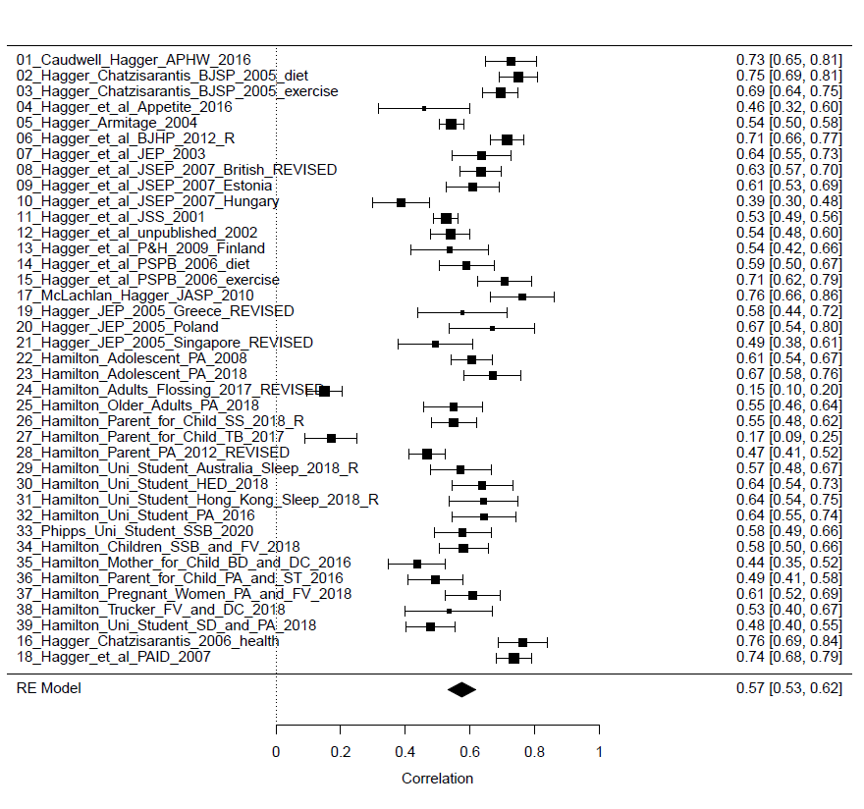

Figure G2. Forest plot of the subjective norm-intention correlation.
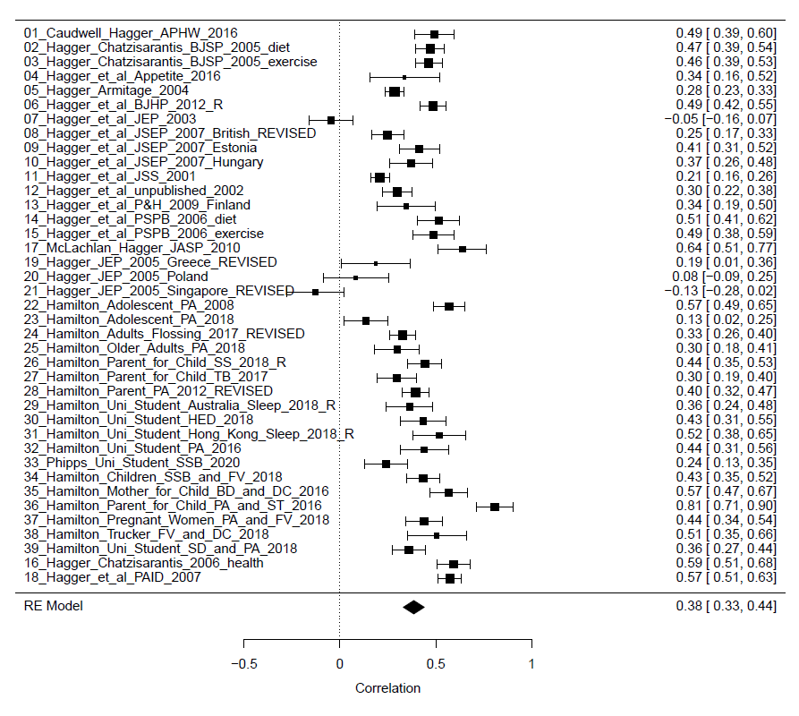

Figure G3. Forest plot of the perceived behavioral control-intention correlation.
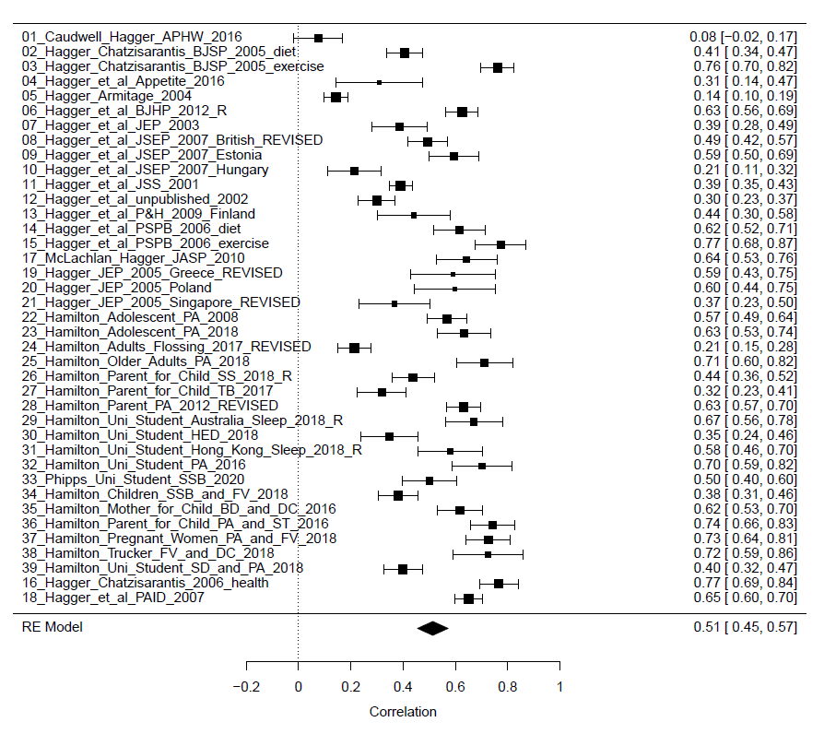

Figure G4. Forest plot of the behavior-intention correlation.
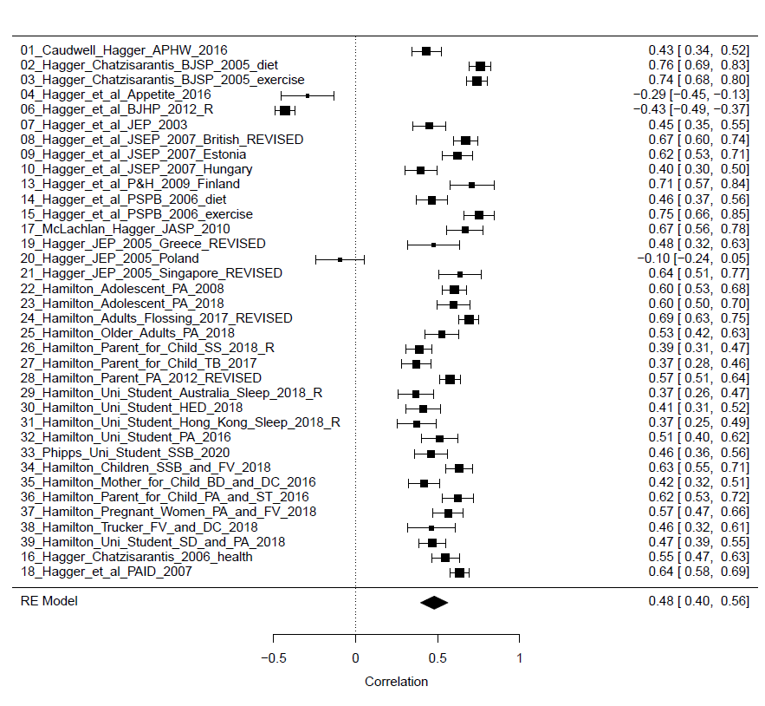

Figure G5. Forest plot of the subjective norm-attitude correlation.
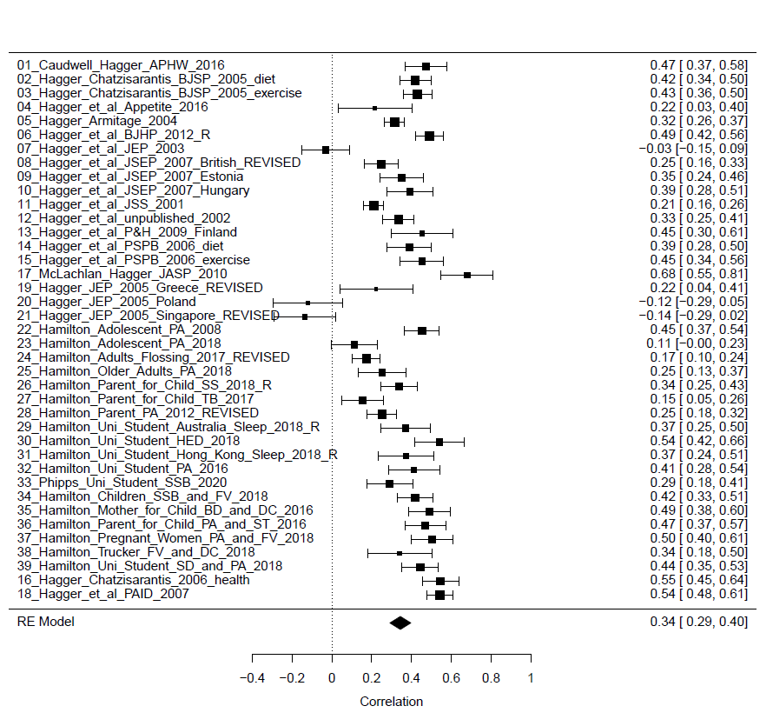

Figure G6. Forest plot of the perceived behavioral control-attitude correlation.
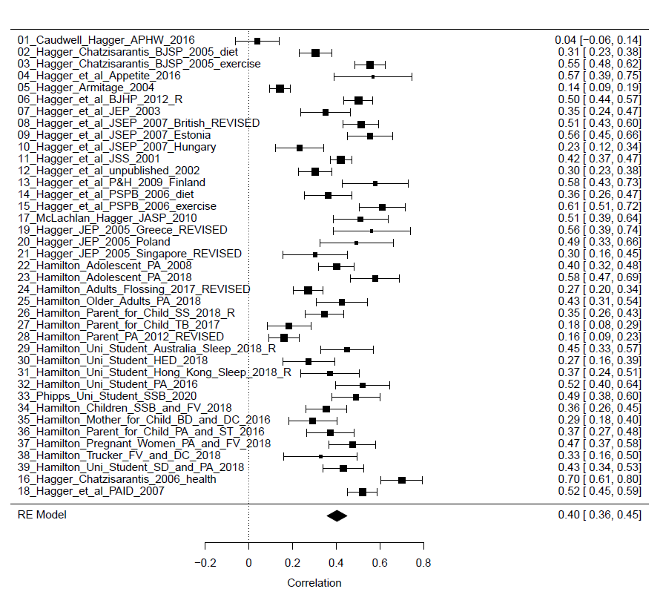

Figure G7. Forest plot of the behavior-attitude correlation.
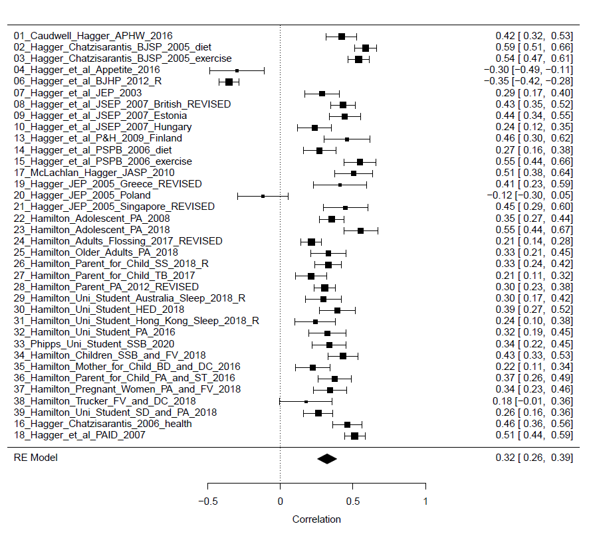

Figure G8. Forest plot of the perceived behavioral control-subjective norm correlation.
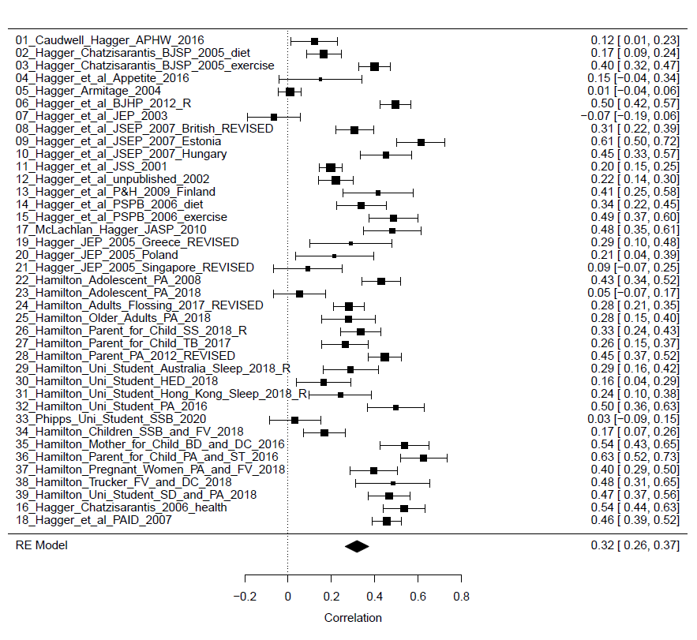

Figure G9. Forest plot of the behavior-subjective norm correlation.
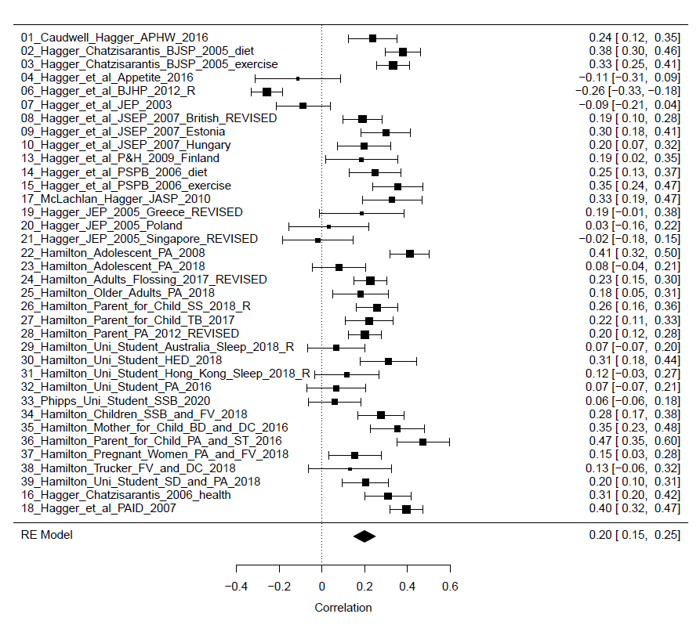

Figure G10. Forest plot of the behavior-perceived behavioral control correlation.
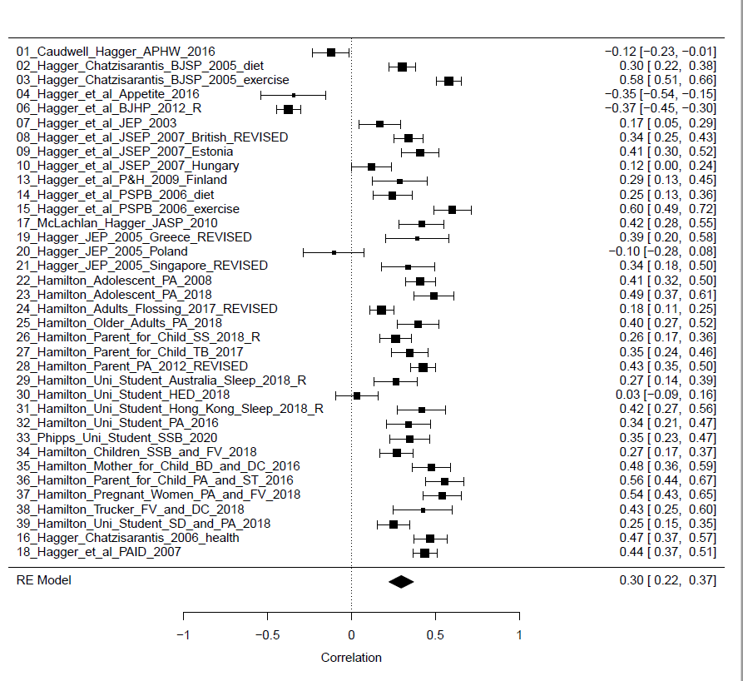

Appendix H: Results of Meta-Analytic Structural Equation Models Moderator Analyses

Table H1
Standardized Path Coefficients for the Meta-Analytic Structural Equation Model of the Theory of Planned Behavior Including Interaction Effects at Levels of the Behavior Type Moderator
Effect | Model in studies on ‘health promoting’ behaviors |  |  |  | Model in studies on ‘health compromising’ behaviors |  |  |  | Model differences
 | β | Wald CI₉₅ |  |  | β | Wald CI₉₅ |  |  | LRT | p
 |  | LL | UL |  |  | LL | UL
Direct effects
Att.→Int. | 0.394*** | 0.325 | 0.463 |  | 0.360*** | 0.219 | 0.500 |  | 0.248 | .618
SN→Int. | 0.153*** | 0.092 | 0.213 |  | 0.145* | 0.011 | 0.278 |  | 0.014 | .905
PBC→Int. | 0.331*** | 0.255 | 0.408 |  | 0.101 | -0.053 | 0.254 |  | 9.152 | .002
Int.→Beh. | 0.549*** | 0.458 | 0.641 |  | -0.031 | -0.190 | 0.127 |  | 48.333 | <.001
PBC→Beh. | 0.124** | 0.040 | 0.207 |  | -0.418*** | -0.551 | -0.285 |  | 52.528 | <.001
Interaction effects
Att. x PBC→Int. | -0.063 | -0.161 | 0.035 |  | 0.043 | -0.102 | 0.190 |  | 3.125 | .077
SN x PBC→Int. | 0.071 | -0.018 | 0.161 |  | 0.144* | 0.012 | 0.277 |  | 1.771 | .183
Int. x PBC→Beh. | 0.055* | 0.008 | 0.101 |  | 0.118* | 0.023 | 0.214 |  | 1.804 | .179
Indirect effects
Att.→Int.→Beh. | 0.191*** | 0.146 | 0.236 |  | 0.127** | 0.032 | 0.223 |  | − | −
SN→Int.→Beh. | 0.073*** | 0.041 | 0.106 |  | 0.042 | -0.031 | 0.115 |  | − | −
PBC→Int.→Beh. | 0.170*** | 0.115 | 0.224 |  | 0.244*** | 0.118 | 0.370 |  | − | −
Note. β = Standardized path coefficient; Wald CI₉₅ = Wald 95% confidence interval of path coefficient; LL = Lower limit of CI₉₅; UL = Upper limit of CI₉₅; LRT = Likelihood ratio test; Att. = Attitude; SN = Subjective norms; PBC = Perceived behavioral control; Int. = Intention; Beh. = Behavior.

Table H2
Standardized Path Coefficients for the Meta-Analytic Structural Equation Model of the Theory of Planned Behavior Including Interaction Effects at Levels of the Specific Behaviors Moderator
Effect | Model in studies on physical activity behaviors |  |  |  | Model in studies on dietary behaviors |  |  |  | Model in studies on ‘other’ health behaviors |  |  |  | Model differences
 | β | Wald CI₉₅ |  |  | Β | Wald CI₉₅ |  |  | β | Wald CI₉₅ |  |  | LRT | p
 |  | LL | UL |  |  | LL | UL |  |  | LL | UL
Direct effects
Att.→Int. | 0.431*** | 0.355 | 0.507 |  | 0.416*** | 0.307 | 0.525 |  | 0.338*** | 0.242 | 0.434 |  | 3.655 | .161
SN→Int. | 0.128*** | 0.061 | 0.195 |  | 0.211*** | 0.108 | 0.313 |  | 0.159** | 0.065 | 0.253 |  | 2.162 | .339
PBC→Int. | 0.330*** | 0.243 | 0.418 |  | 0.292*** | 0.167 | 0.417 |  | 0.193*** | 0.081 | 0.305 |  | 5.771 | .056
Int.→Beh. | 0.588^{***a} | 0.465 | 0.710 |  | 0.448*** | 0.289 | 0.608 |  | 0.331^{***a} | 0.188 | 0.474 |  | 13.267 | .001
PBC→Beh. | 0.126ª | -0.003 | 0.255 |  | 0.019 | -0.139 | 0.178 |  | -0.103ª | -0.248 | 0.043 |  | 11.585 | .003
Interaction effects
Att. x PBC→Int. | -0.074 | -0.169 | 0.022 |  | 0.024 | -0.106 | 0.153 |  | 0.004 | -0.112 | 0.120 |  | 4.325 | .115
SN x PBC→Int. | 0.049 | -0.037 | 0.135 |  | 0.065 | -0.044 | 0.174 |  | 0.080 | -0.019 | 0.179 |  | 0.547 | .761
Int. x PBC→Beh. | 0.053 | -0.004 | 0.110 |  | 0.036 | -0.045 | 0.117 |  | 0.072* | 0.004 | 0.141 |  | 0.579 | .749
Indirect effects
Att.→Int.→Beh. | 0.239*** | 0.165 | 0.312 |  | 0.234*** | 0.154 | 0.314 |  | 0.252*** | 0.158 | 0.346 |  | − | −
SN→Int.→Beh. | 0.052* | 0.009 | 0.094 |  | 0.036 | -0.023 | 0.095 |  | 0.020 | -0.045 | 0.087 |  | − | −
PBC→Int.→Beh. | 0.186*** | 0.102 | 0.271 |  | 0.191*** | 0.088 | 0.293 |  | 0.208*** | 0.090 | 0.326 |  | − | −
Note. β = Standardized path coefficient; Wald CI₉₅ = Wald 95% confidence interval of path coefficient; LL = Lower limit of CI₉₅; UL = Upper limit of CI₉₅; LRT = Likelihood ratio test; Att. = Attitude; SN = Subjective norms; PBC = Perceived behavioral control; Int. = Intention; Beh. = Behavior. Coefficients marked with similar superscripted letters are significantly different based on Schenker and Gentleman’s (2001) ‘standard method’ using confidence intervals about the mean difference (p < .05).

Table H3
Standardized Path Coefficients for the Meta-Analytic Structural Equation Model of the Theory of Planned Behavior Including Moderation Effects for the Attitude and Perceived Behavioral Control Scale Score Coverage Moderator
Effect | Model in studies with low percentage of scores above scale midpoint (high coverage) |  |  |  | Model in studies with high percentage of scores above scale midpoint (low coverage) |  |  |  | Model differences
 | β | Wald CI₉₅ |  |  | β | Wald CI₉₅ |  |  | LRT | p
 |  | LL | UL |  |  | LL | UL
Direct effects
Att.→Int. | 0.401*** | 0.297 | 0.504 |  | 0.414*** | 0.337 | 0.490 |  | 0.063 | .802
SN→Int. | 0.143** | 0.045 | 0.242 |  | 0.145*** | 0.077 | 0.213 |  | 0.001 | .975
PBC→Int. | 0.230*** | 0.111 | 0.347 |  | 0.302*** | 0.215 | 0.390 |  | 1.589 | .208
Int.→Beh. | 0.427*** | 0.259 | 0.596 |  | 0.509*** | 0.381 | 0.637 |  | 1.101 | .293
PBC→Beh. | 0.034 | -0.047 | 0.114 |  | 0.059** | 0.006 | 0.114 |  | 0.377 | .539
Interaction effects
Att. x PBC→Int. | 0.067 | -0.058 | 0.192 |  | -0.074 | -0.175 | 0.026 |  | 7.396 | .007
SN x PBC→Int. | 0.141** | 0.041 | 0.243 |  | 0.022 | -0.063 | 0.106 |  | 6.058 | .014
Int. x PBC→Beh. | 0.007 | -0.166 | 0.179 |  | 0.048 | -0.095 | 0.190 |  | 0.308 | .578
Indirect effects
Att.→Int.→Beh. | 0.192** | 0.071 | 0.314 |  | 0.179* | 0.042 | 0.318 |  | − | −
SN→Int.→Beh. | 0.064* | 0.007 | 0.120 |  | 0.061*** | 0.026 | 0.019 |  | − | −
PBC→Int.→Beh. | 0.098*** | 0.075 | 0.188 |  | 0.104** | 0.036 | 0.173 |  | − | −
Note. PBC = Perceived behavioral control; β = Standardized path coefficient; Wald CI₉₅ = Wald 95% confidence interval of path coefficient; LL = Lower limit of CI₉₅; UL = Upper limit of CI₉₅; LRT = Likelihood ratio test; Att. = Attitude; SN = Subjective norms; PBC = Perceived behavioral control; Int. = Intention; Beh. = Behavior.
*p < .05 **p < .01 ***p < .001

Table H4
Standardized Path Coefficients for the Meta-Analytic Structural Equation Model of the Theory of Planned Behavior Including Interaction Effects for the Subjective Norm and Perceived Behavioral Control Scale Variability Moderator
Effect | Model in studies with low percentage of scores above scale midpoint (high coverage) |  |  |  | Model in studies with high percentage of scores above scale midpoint (low coverage) |  |  |  | Model differences
 | β | Wald CI₉₅ |  |  | β | Wald CI₉₅ |  |  | LRT | p
 |  | LL | UL |  |  | LL | UL
Direct effects
Att.→Int. | 0.395*** | 0.311 | 0.480 |  | 0.426*** | 0.341 | 0.511 |  | 0.472 | .492
SN→Int. | 0.097** | 0.025 | 0.170 |  | 0.195*** | 0.121 | 0.269 |  | 5.130 | .024
PBC→Int. | 0.232*** | 0.139 | 0.324 |  | 0.341*** | 0.246 | 0.436 |  | 4.968 | .026
Int.→Beh. | 0.479*** | 0.337 | 0.621 |  | 0.499*** | 0.361 | 0.636 |  | 0.087 | .768
PBC→Beh. | 0.019 | -0.133 | 0.170 |  | 0.052 | -0.096 | 0.200 |  | 0.285 | .594
Interaction effects
Att. x PBC→Int. | -0.012 | -0.119 | 0.096 |  | -0.081 | -0.193 | 0.031 |  | 2.452 | .117
SN x PBC→Int. | 0.104* | 0.019 | 0.189 |  | 0.008 | -0.080 | 0.097 |  | 6.043 | .014
Int. x PBC→Beh. | 0.054 | -0.009 | 0.117 |  | 0.053 | -0.005 | 0.111 |  | <0.001 | .992
Indirect effects
Att.→Int.→Beh. | 0.222*** | 0.138 | 0.307 |  | 0.224*** | 0.126 | 0.323 |  | − | −
SN→Int.→Beh. | 0.052* | 0.009 | 0.094 |  | 0.050* | 0.006 | 0.094 |  | − | −
PBC→Int.→Beh. | 0.114** | 0.043 | 0.185 |  | 0.112** | 0.045 | 0.179 |  | − | −
Note. SN = Subjective norm; PBC = Perceived behavioral control; β = Standardized path coefficient; Wald CI₉₅ = Wald 95% confidence interval of path coefficient; LL = Lower limit of CI₉₅; UL = Upper limit of CI₉₅; LRT = Likelihood ratio test; Att. = Attitude; PBC = Perceived behavioral control; Int. = Intention; Beh. = Behavior; PB = Past behavior.

Table H5
Standardized Path Coefficients for the Meta-Analytic Structural Equation Model of the Theory of Planned Behavior Including Interaction Effects for the Intention and Perceived Behavioral Control Scale Variability Moderator
Effect | Model in studies with low percentage of scores above scale midpoint (high coverage) |  |  |  | Model in studies with high percentage of scores above scale midpoint (low coverage) |  |  |  | Model differences
 | β | Wald CI₉₅ |  |  | β | Wald CI₉₅ |  |  | LRT | p
 |  | LL | UL |  |  | LL | UL
Direct effects
Att.→Int. | 0.395*** | 0.311 | 0.479 |  | 0.430*** | 0.340 | 0.520 |  | 0.580 | .446
SN→Int. | 0.140*** | 0.065 | 0.215 |  | 0.150*** | 0.070 | 0.230 |  | 0.485 | .825
PBC→Int. | 0.225*** | 0.129 | 0.322 |  | 0.367*** | 0.260 | 0.474 |  | 7.241 | .007
Int.→Beh. | 0.439*** | 0.304 | 0.574 |  | 0.560*** | 0.414 | 0.707 |  | 3.240 | .072
PBC→Beh. | -0.038 | -0.185 | 0.109 |  | 0.131 | -0.021 | 0.285 |  | 7.320 | .007
Interaction effects
Att. x PBC→Int. | 0.068 | -0.019 | 0.156 |  | -0.201* | -0.294 | 0.107 |  | 41.122 | <.001
SN x PBC→Int. | 0.145** | 0.053 | 0.237 |  | -0.044 | -0.142 | 0.053 |  | 24.327 | <.001
Int. x PBC→Beh. | 0.101*** | 0.043 | 0.158 |  | -0.006 | -0.068 | 0.057 |  | 9.675 | .002
Indirect effects
Att.→Int.→Beh. | 0.238*** | 0.157 | 0.320 |  | 0.238*** | 0.131 | 0.343 |  | − | −
SN→Int.→Beh. | 0.075** | 0.030 | 0.119 |  | 0.075** | 0.030 | 0.119 |  | − | −
PBC→Int.→Beh. | 0.132** | 0.054 | 0.210 |  | 0.132*** | 0.060 | 0.205 |  | − | −
Note. PBC = Perceived behavioral control; β = Standardized path coefficient; Wald CI₉₅ = Wald 95% confidence interval of path coefficient; LL = Lower limit of CI₉₅; UL = Upper limit of CI₉₅; LRT = Likelihood ratio test; Att. = Attitude; SN = Subjective norms; Int. = Intention; Beh. = Behavior; PB = Past behavior.

Table H6
Standardized Path Coefficients for the Meta-Analytic Structural Equation Model of the Theory of Planned Behavior Including Interaction Effects for the Sample Age Moderator
Effect | Model in studies on younger samples |  |  |  | Model in studies on older samples |  |  |  | Model differences
 | β | Wald CI₉₅ |  |  | β | Wald CI₉₅ |  |  | LRT | p
 |  | LL | UL |  |  | LL | UL
Direct effects
Att.→Int. | 0.398*** | 0.326 | 0.471 |  | 0.361*** | 0.277 | 0.445 |  | 0.828 | .363
SN→Int. | 0.223*** | 0.161 | 0.285 |  | 0.059 | -0.014 | 0.131 |  | 17.166 | <.001
PBC→Int. | 0.352*** | 0.276 | 0.429 |  | 0.243*** | 0.153 | 0.333 |  | 5.840 | .016
Int.→Beh. | 0.467*** | 0.357 | 0.576 |  | 0.542*** | 0.411 | 0.673 |  | 1.737 | .188
PBC→Beh. | 0.049 | -0.074 | 0.172 |  | 0.105 | -0.038 | 0.249 |  | 1.037 | .309
Interaction effects
Att. x PBC→Int. | -0.031 | -0.130 | 0.069 |  | -0.078* | -0.182 | -0.026 |  | 1.444 | .229
SN x PBC→Int. | 0.065 | -0.026 | 0.157 |  | 0.092 | -0.008 | 0.192 |  | 0.535 | .465
Int. x PBC→Beh. | 0.078*** | 0.034 | 0.123 |  | 0.030 | -0.031 | 0.091 |  | 2.389 | .122
Indirect effects
Att.→Int.→Beh. | 0.165*** | 0.109 | 0.221 |  | 0.171*** | 0.123 | 0.219 |  | − | −
SN→Int.→Beh. | 0.098*** | 0.058 | 0.138 |  | 0.083** | 0.025 | 0.141 |  | − | −
PBC→Int.→Beh. | 0.161*** | 0.093 | 0.228 |  | 0.148*** | 0.069 | 0.227 |  | − | −
Note. PBC = Perceived behavioral control; β = Standardized path coefficient; Wald CI₉₅ = Wald 95% confidence interval of path coefficient; LL = Lower limit of CI₉₅; UL = Upper limit of CI₉₅; LRT = Likelihood ratio test; Att. = Attitude; SN = Subjective norms; Int. = Intention; Beh. = Behavior; PB = Past behavior.

Table H7
Standardized Path Coefficients for the Meta-Analytic Structural Equation Model of the Theory of Planned Behavior Including Interaction Effects for the Publication Status Moderator
Effect | Model in published studies |  |  |  | Model in unpublished studies |  |  |  | Model differences
 | β | Wald CI₉₅ |  |  | β | Wald CI₉₅ |  |  | LRT | p
 |  | LL | UL |  |  | LL | UL
Direct effects
Att.→Int. | 0.306*** | 0.214 | 0.399 |  | 0.406*** | 0.340 | 0.472 |  | 4.903 | .027
SN→Int. | 0.114* | 0.015 | 0.213 |  | 0.175*** | 0.109 | 0.241 |  | 1.541 | .214
PBC→Int. | 0.251*** | 0.141 | 0.360 |  | 0.330*** | 0.254 | 0.406 |  | 2.256 | .133
Int.→Beh. | 0.542*** | 0.395 | 0.688 |  | 0.476*** | 0.368 | 0.583 |  | 1.015 | .314
PBC→Beh. | 0.113 | -0.043 | 0.268 |  | 0.054 | -0.066 | 0.175 |  | 0.875 | .350
Interaction effects
Att. x PBC→Int. | -0.035 | -0.156 | 0.085 |  | -0.054 | -0.154 | 0.046 |  | 0.183 | .669
SN x PBC→Int. | 0.095 | -0.014 | 0.204 |  | 0.070 | -0.020 | 0.160 |  | 0.377 | .539
Int. x PBC→Beh. | 0.054 | -0.015 | 0.123 |  | 0.069** | 0.025 | 0.112 |  | 0.177 | .674
Indirect effects
Att.→Int.→Beh. | 0.145** | 0.057 | 0.233 |  | 0.138*** | 0.057 | 0.219 |  | − | −
SN→Int.→Beh. | 0.099** | 0.027 | 0.172 |  | 0.101* | 0.021 | 0.181 |  | − | −
PBC→Int.→Beh. | 0.155** | 0.043 | 0.268 |  | 0.154** | 0.039 | 0.269 |  | − | −
Note. PBC = Perceived behavioral control; β = Standardized path coefficient; Wald CI₉₅ = Wald 95% confidence interval of path coefficient; LL = Lower limit of CI₉₅; UL = Upper limit of CI₉₅; LRT = Likelihood ratio test; Att. = Attitude; SN = Subjective norms; Int. = Intention; Beh. = Behavior; PB = Past behavior.

