OSM 1: Supplementary Information on Included Studies

Lead Author, year  Table 1. Overview of included studies (k = 36) | Design | Location & Setting | Intervention features (n treatment sessions/ delivery across weeks. | PC & HO Measurement points (days after intervention exposure) | Type of PC (& measure) | Type of health outcome (& measure) | Participant characteristics | Pps included in analysis (k) & mean age (& SD) | % Female | Attrition (across entire study)
Aardoom et al., 2016 | Randomized controlled trial | Netherlands, Educational | Stress management (8/8): Online based psychoeducation intervention. | PC: 56  HO: 91 | Perseverative thinking (PTQ) | Binge eating (EDE-Q). | Opportunity sample of adults with dietary concerns. | k = 178, M = 24.2 (SD = 7.7) | 98.9% | 63.3%
Abbasi et al., 2012 | Randomized controlled trial | Israel, Medical | Pain management (7/7): In person spouse-assisted programme to alleviate back pain. | PC: 49  HO: 365 | Health Rumination (PCS - rumination subscale) | Physical pain (TSK; RDQ; VAS (1-10) of pain intensity for the week) | Referred to the GP with  lower back pain of greater than 6 months duration. | k = 21, M = 45 (SD = 10) | 87.88% | 10%
Brosschot et al., 2006 | Cluster randomized controlled trial | Netherlands, Educational | PC action plans (6/<1): In person Diary based worry postponement. | PC: 7  HO: 7 | Worry (PSWQ & tally of daily worry). | Physical health complaints (SCH) | Volunteer sample of final grade high school students from 25 different schools. | k = 171, M = 16.7 (range: 15 – 19) | 81.4% | 29%
Buntrock et al., 2015 | Randomized controlled trail | Germany, Academic | CBT (6/3): Online CBT to prevent relapse into depression | PC: 42  HO: 183 | Worry (PSWQ) | Insomnia severity (ISI) & functional impairment (SF-12v1) | Volunteer sample adults with minor depression. | K = 366, M, = 45 (SD = 11.9) | 73.9% | 19.9%
Buntrock et al., 2016 | Randomized controlled trail | Germany, Academic | CBT (6/<1): Online CBT to prevent relapse into depression | PC:40  HO:365 | Worry (PSWQ) | Insomnia severity (ISI) | Volunteer sample of adults with minor depression. | k = 336, M = 45 (SD = 11.9) | 73.9% | Not reported.
Carney & Waters, 2006 | Randomized controlled trail | USA, Academic | PC action plans (6/4): In person experimental pre-sleep constructive worry intervention. | PC: 7  HO: 7 | Worry (PSWQ; WDQ; PSAS- worry subscale). | Sleep (SOL, TST, TWT). | University students with the presence of 3 or more nights per week of sleep onset difficulty. | k = 33, M = 20.97 (SD = 3) | 78.78% | 3.1%
Christiansen et al., 2014 | Randomized controlled trial | Australia, Academic | CBT (10/10): Online CBT programme to reduce anxiety. | PC: 77  HO: 183 | Worry (PSWQ) | Alcohol dependence (AUDIT) | GP referred with elevated anxiety. | k = 133, M = 25.7 (SD = 3.1) | 82.9% | 35%
Conrad et al., 2008 | Randomized controlled trial | America, Medical | Mindfulness & Relaxation (12/12): In person applied relaxation to reduce worry. | PC: 7  HO: 7 | Worry (PSWQ) | Somatization (CSAI, somatic subscale) | Self-enrolled individuals with GAD. | k = 33, M = 44.6 (SD = 12.8) | 59% | 38%
Crain et al., 2017 | Randomized controlled trial | Canada/USA; Academic | Mindfulness & Relaxation (11/8): In person group based mindfulness sessions. | PC: 91  HO: 152 | Job rumination (2 Likert scales, from teacher stress scale) | Sleep (Likert scales on sleep quality, sleep quantity & daytime sleepiness). | Self-enrolling public school teachers. | k = 113, M = 46.9 (SD = 9.2) | 89% | Not reported
Digdon & Koble, 2011 | Randomized controlled trial | Canada, Academic | PC action plans (7/<1): Online constructive worry sessions to help with pre-sleep worry. | PC: 7  HO: 7 | Worry (daily sleep log; PSAS, worry subscale) | Sleep (SQS; sleep onset latency, sleep quantity and sleep quality) & somatic complaints (PSAS, somatic subscale). | Self-enrolled undergraduate students with pre-sleep worries. | k = 22, M = 23.22 (SD = 6.11) | 78.05% | 51.2%
Ebert et al., 2014 | Randomized controlled trial | Germany, Educational | Stress management (5/7): Online based, virtual instructor lead, problem solving therapy. | PC: 49  HO: 183 | Worry (PSWQ) | Burnout (MBI-D) & physical health (SF-12- PCS subscale). | School teachers with minor depression. | k = 150, M = 47.1 (SD = 8.2) | 83.3% | 15.3%
Ebert et al., 2015 | Randomized controlled trial | Germany, Educational | Detachment (6/8): Online based recovery training on work related stress. | PC: 56  HO: 56 | Worry (PSWQ-PW) & work related rumination (CI, rumination subscale) | Sleep (PSQI, ISI, SSI & GSI). | School teachers experiencing poor sleep and low levels of detachment from work. | k = 100, M = 48.5 (SD = 9.9) | 74.2% | 31.17%
Ebert et al., 2016 | Randomized controlled trial | Germany, Academic | Detachment (7/7): Online based, e-coach led, work detachment stress-management sessions. | PC: 49  HO: 183 | Worry (PSWQ-PW) | Sleep (ISI) & burnout (MBI, emotional exhaustion subscale) & physical health complaints (SF-12) | General population with elevated symptoms of stress. | k = 249, M = 42.9 (SD = 9.8) | 85.9% | 50.8%
Eilenberg et al., 2016 | Randomized controlled trial | Denmark, Medical | CBT (9/9): In person ACT to help with health anxiety | PC: 304  HO: 304 | Illness worry (IWS) | Somatic symptoms (90-item Symptom Checklist & SCL - somatization subscale). | Opportunity sample of patients with health anxiety. | k = 107, M = 36.23 (SD = 8.75) | 67% | 6%
Freshour et al., 2016 | Randomized controlled trial | USA, Medical | CBT (10/24): In person therapist led CBT reduce anxiety. | PC: 70  HO: 365 | Worry (PSWQ) | Patient health (PHQ-8) | Later-life individuals with GAD. | k = 224, M = 66.83 (SD = 6.38) | 54.57% | 12.5%
Harvey et al., 2017 | Randomized controlled trial | USA, Medical | CBT (8/8): In person CBT for chronic insomnia. | PC: 56  HO:183 | Pre-sleep worry (APSQ) | Insomnia severity (ISI) and sleep diary (BTv, RTv,  TIB). | Self-referred individuals with moderate insomnia. | k = 128, M = 47.4 (SD = 12.6) | 62.23% | 7.5%
Hazlett-Stevens & Oren, 2017 | Randomized controlled trial | USA, Academic | Mindfulness & relaxation (10/10): In person reflection and mindfulness workshops. | PC: 70  HO: 70 | Worry (PSWQ) | Physical health (WHOQOLBREF, physical subscale). | Self-enrolled students seeking stress reduction. | k = 68, M = 22.1 (SD = 4.7) | 75% | 26.1%
Jansson-Frojmark et al., 2012 | Randomized controlled trial | Sweden, Academic | PC action plans (4/4): In person worry construction and behavioural therapy to aid with sleep. | PC: 7  HO: 14 | Pre-sleep worry (APSQ) | Insomnia severity (ISI) | Self-enrolled individuals with primary insomnia from local care centres. | k = 21, M = 56.5 (SD = 12.7) | 52.5% | 9.1%
Jellesma et al., 2009 | Cluster randomized controlled trial | Netherlands, Educational | PC action plans (7<1): In person worry postponement to stop night time worriers.. | PC: 7  HO: 7 | Perseverative thoughts (CERQ-K, nightly tally) | Somatic complaints (SCL) | Children from grades 7 and 8 from seven primary schools. | k = 227, M = 11.4 (SD = .70) | 56.83% | 15.4%
Lokman et al., 2017 | Randomized controlled trial | Netherlands, Educational | CBT (7/4): Online CBT self-help to improve sleep and wellbeing. | PC: 91.25  HO:91.25 | Worry (PSWQ) | Sleep quality (JSEQ) | Self-enrolled individuals with mild depressive symptoms. | k = 237, M = 43 (SD = 12.93) | 75.7% | 54.4%
Magan et al., 2014 | Randomized controlled trial | USA, Academic | PC action plans (14/2): Online constructive plans on smoking-related consequences, negative thoughts and worry prevention. | PC: 14  HO: 14 | Worry (PSWQ, 2 Likert items on smoking worry) | Smoking addiction (FTND-R, and mean number of cigarettes smoked per week at baseline, compared to post-intervention) | Volunteer sample of university students who smoke on a daily basis. | k = 117, M = 29.6 (SD = 12.9) | 44.4% | Not reported.
McGowan & Behar, 2013 | Randomized controlled trial | USA, Academic | PC action plans (14/2): In person focused worry postponement to reduce anxiety. | PC: 14  HO: 14 | Worry (PSWQ) | Insomnia severity (ISI) | Volunteer sample of university students/ are high trait worriers | k = 46, M = 19.9 (SD = 3.8) | 82.6% | 16.9%
Mehlsen et al., 2017 | Randomized controlled trial | Denmark, Medical | Pain management (6/6): In person, therapist led, chronic pain self-management programme to improve wellbeing. | PC: 63  HO: 152 | Illness worries (Whiteley-7) | Physical health symptoms (SCL) & bodily pain (RDQ, a 1-100 pain intensity VAS). | Individuals with chronic pain for longer than 3 months from 75 different hospitals. | k = 399, M = 54 (SD = 13.05) | 72% | 8%
Michailidis and Cropley, 2019 | Randomized controlled trial | England, Academic | Expressive writing (3/<1): In person self-guided, expressive writing to reduce work-related rumination. | PC: 31  HO: 91 | Work-related rumination (WRRQ) | Sleep quality (ISI) | Full-time adult employees working in the UK from a wide range of occupations | k = 47, M = 34.22 (SD = 11.39) | 50% | 49%
Pech & O’Kearney, 2013 | Randomized controlled trial | Australia, Academic | Stress management (5/6): In person problem solving therapy to reduce stress and improve sleep quality. | PC: 7  HO: 70 | Worry (PSWQ) | Sleep quality (PSQI) and insomnia severity (ISI). | Individuals with primary insomnia for longer than 3 months. | k = 47, M = 39.21 (Range: 18-60) | 62.8% | 14.9%
Peters et al., 2017 | Randomized controlled trial | Netherlands/Belgium, Medical | CBT (8/8): Online CBT to reduce pain and intrusive thoughts. | PC: 65  HO: 65 | Perseverative thinking (PTQ) | Bodily pain (Likert 1-10 rating of pain intensity) | Volunteer sample of adults who had experienced musculoskeletal pain for longer than 3 months | k = 162, M = 48.6 (SD = 12) | 85% | 25.4%
Querstret et al., 2017 | Randomized controlled trial | England, Educational | Mindfulness (10/4): Online instructor-led, mindfulness to reduce work-related rumination/fatigue. | PC: 28  HO: 183 | Work-related rumination (WRRQ) | Sleep quality (PSQI) &  work-related fatigue (OFER, 2 subscales for chronic fatigue & acute fatigue) | Self-enrolling working adults with elevated levels of work-related rumination | k = 87, M = 40.68 (SD = 10.45) | 80.5% | 25%
Sabinga et al., 2013 | Randomized controlled trial | USA, Educational | Mindfulness (12/12): In person, instructor led, mindfulness based stress reduction to improve sleep and reduce negative physical health. | PC: 84  HO: 84 | Rumination (AMR, mindfulness inventory, rumination subscale) | Sleep quality (nightly sleep diary, and via ACTigraph 24 h/day during the 1-week). | Self-enrolling 7th and 8th grade boys at urban middle school. | k = 41, M = 12.5 (range 11–14) | 0% (all male) | 2.38%
Sabinga et al., 2016 | Cluster randomized controlled trial | USA, Educational | Mindfulness (12/12): In person, instructor led, mindfulness based stress reduction to improve physical health and reduce rumination. | PC: 84  HO: 84 | Rumination (CRSQ, rumination subscale) | Somatization symptoms (SCL) | Volunteer sample of 5th to 8th grade students in two public schools. | k = 300, M = 12 (unclear) | 50.7% | Unclear: between 25.2% and 27.2%
Sandlund et al., 2018 | Randomized controlled trial | Sweden, Medical | CBT (6/10): In person, nurse-led CBT to improve daytime symptomology of insomnia. | PC: 70  HO: 70 | Pre-sleep worry (1-100 VAS) | Sleep quality (USI, ISI) | Volunteer Individuals with primary insomnia. | k = 132, M = 54 (SD = 16) | 72.7% | 20%
Teismann et al., 2014 | Randomized controlled trial | Germany, Academic | Expressive writing (3/<1): In person, diary based, self-guided positive writing about personal life goals | PC: 3  HO: 3 | Perseverative thinking (PTQ) | Cortisol awakening response (CAR) | Volunteer sample of general population. | k = 64, M = 29.1 (SD = 8.42) | 62.5% | 0% (4 sets of missing data were excluded)
Thiart et al., 2015 | Randomized controlled trial | Germany, Academic | CBT (6/8): Online, mixed intervention based on CBT principles to improve wellbeing and sleep quality. | PC: 56  HO: 182 | Worry (PSWQ) & work-related rumination (IS, cognitive irritation subscale) | Insomnia severity (ISI) & recuperation in sleep (SF-AR) | Volunteer sample of school teachers with sleep complaints. | k = 118, M = 48 (SD = 9.9) | 74.2% | 7.2%
Topper et al., 2017 | Randomized controlled trial | Netherlands, Academic | CBT (6/6): Online, group based, CBT to prevent anxiety and depression | PC: 56  HO: 365 | Worry (PSWQ), rumination (RRS) & perseverative thinking (PTQ) | Alcohol consumption (QDS) & dietary screening (EDI-2-BU) | Self-enrolled high school children from final three grades in 13 schools. | k = 150, M = 17.43 (SD = 2.09) | 83.7% | 17%
Versluis et al., 2016 | Randomized controlled trial | Netherlands, Academic | PC action plans (6/<1): Online, worry postponement to reduce health complaints. | PC: 6  HO 6 | Worry (nightly diary for duration and frequency) | Subjective health complaints (SHC) | Volunteer sample of general population. | k = 351, M = 36.36 (SD = 12.97) | 84.76% | 64%
Versluis et al., 2018 | Randomized controlled trial | Netherlands, Academic | PC action plans (26/4): Smartphone-based, self-guided, worry-reduction training for stress reduction and emotion regulation. | PC: 14  HO: 27 | Worry (PSWQ & nightly diary recording of: duration, frequency, severity) | Cardiac activity (ambulatory measured continuously for the three test days via an ekgMove sensor). | Volunteer sample of adults who reported elevated levels of work-based stress | k = 79, M = 43.60 (SD = 11.39) | 74% | 8%
Woilizky-Taylor et al., 2010 | Randomized controlled trial | USA, Academic | Mindfulness and relaxation (12/4): In person, pulsed audio-photic  stimulation for relaxation to reduce worry. | PC: 12  HO: 12 | Worry (PSWQ & AQW) | General health (visits to health centres in the past semester). | Self-enrolled sample of university students concerned about assessments. | k = 41,(not reported, undergraduate university students) | 75.2% | 40.7%
Note: Bedtime variability (BTv), risetime variability (RTv), time in bed (TIB), visual analogue scale (VAS). Measures (note, references can be found at the bottom of this document): Academic worry questionnaire (AWQ, Wolitzky & Telch, 2005); Cognitive irritation (CI, Mohr et al., 2007); Eating Questionnaire (EDE-1; Fairburn & Beglin, 2008) Fagerström Test of Nicotine Dependence-Revised (FTND-R; Heatherton et al., 1991); Glasgow Sleep Inventory (GSI, Broomfield & Espie, 2014); Illness worrying scale (IWS, Fink et al., 1999); Maslach Burnout Inventory (MBI, Maslach, 1986);Patient Health Questionnaire (PHQ-8, Razykov et al., 2012); Penn State Worry Questionnaire (PSWQ, Meyer, Miller, Metzger & Borkovec, 1990); Pre-Sleep Arousal Scale (PSAS, Nicassio et al., 1985); Recooperation in sleep (SF-AR, Görtelmeyer et al., 2011); Roland and Morris Disability Questionnaire (RDQ; Roland & Fairbank, 2000);Ruminative Response Scale (RRS, Topper, Emmelkamp, Watkins, & Ehring, 2014);Standardized Sleep Inventory (SSI, Görtelmeyer, 2011); Tampa Scale of Kinesiophobia (TSK, Swinkels-Meewisse et al., 2003); The Children’s Response Style Questionnaire (CRSQ, Abela et al., 2007); Acceptance, mindfulness, and related processes in childhood (AMR, Greco, Dew & Ball, 2005); The Cognitive Irritation Scale (CIS, Mohr, Rigotti, & Müller, 2007); The Health Survey (SF-12, Gandek et al., 1998); The Insomnia Severity Index (ISI, Bastien et al., 2001); The Maslach Burnout Inventory for people working in human services (MBI-D, Büssing & Perrar, 1992); The Non-Productive Thoughts Questionnaire for Kids (CERQ-k, Garnefski et al., 2007); The Occupational Fatigue Exhaustion Recovery scale (OFER, Winwood, Bakker, & Winefield, 2007); The Pain Catastrophizing Scale (PCS; Sullivan et al., 1995); The Perseverative Thinking Questionnaire (PTQ, Ehring, Raes, Weidacker & Emmelkamp, 2012); The Pittsburgh Sleep Quality Index (PSQI, Buysse et al., 1989); The Sleep Quality Scale (SQS, Yi, Shin, & Shin, 2006); The Rumination-Reflection Questionnaire (RRQ; Trapnell & Campbell, 1999); The Somatic Complaints List (SCL, Jellesma et al., 2007); The Subjective Health Complaints Inventory (SHC, Eriksen et al., 1998); The Whiteley-7 (Conradt et al., 2006); The Work-Related Rumination Questionnaire (WRRQ, Cropley et al., 2012); The World Health Organization Quality of Life (WHOQOLBREF; World Health Organization, 2004); Upsala Sleep Inventory scale (USI, Liljenberg et al., 1988); Worry Domains Questionnaire (WDQ; Tallis, Eysenk, & Mathews, 1992).

Table 2. Sub-group analyses between intervention types and PC and health outcome variables.
Intervention type⦾ Outcome Test Statistic
 |  | Hedges g | Z | p
Pain management | PC (k = 2) | -.807 | 1.06 | .290
 | Worry (k = 0) | - | - | -
 | Rumination (k = 1) | -1.65 | 3.34 | .001**
 | HO (k = 2) | 0.213 | 0.87 | .382
 | HB (k = 0) | - | - | -
 | PHO (k = 2) | 0.283 | 0.87 | 0.382
 | Sleep (k = 0) | - | - | -
PC action plans | PC (k = 9) | -0.396 | 4.89 | .001***
 | Worry (k = 5) | -0.360 | 5.86 | .001***
 | Rumination (k = 0) | - | - | -
 | HO (k = 9) | 0.422 | 3.41 | .001**
 | HB (k = 4) | 0.635 | 3.59 | .001***
 | PHO (k = 6) | 0.203 | 2.01 | .044*
 | Sleep (k = 4) | 0.440 | 3.84 | .001**
Stress management | PC (k = 4) | -0.264 | 2.78 | .005**
 | Worry (k = 3) | -0.242 | 1.74 | .081
 | Rumination (k = 0) | - | - | -
 | HO (k = 4) | 0.190 | 3.56 | .001**
 | HB (k = 3) | 0.184 | 2.31 | .021*
 | PHO (k = 2) | 0.165 | 1.46 | .145
 | Sleep (k = 2) | 0.163 | 1.78 | .075
Mindfulness/relaxation | PC (k = 7) | -0.382 | 3.94 | .001***
 | Worry (k = 3) | -0.462 | 1.89 | .059
 | Rumination (k = 4) | -0.310 | 3.59 | .001***
 | HO (k = 7) | 0.246 | 4.33 | .001***
 | HB (k = 3) | 0.217 | 2.34 | .019*
 | PHO (k = 5) | 0.252 | 3.02 | .003**
 | Sleep (k = 3) | 0.214 | 2.60 | .009**
Psychological detachment | PC (k = 2) | -0.673 | 3.15 | .002**
 | Worry (k = 2) | -0.552 | 4.90 | .001***
 | Rumination (k = 1) | -1.100 | 5.16 | .001***
 | HO (k = 2 ) | 0.617 | 2.81 | .005**
 | HB (k = 2) | 0.623 | 2.73 | .006**
 | PHO (k = 1) | 0.429 | 4.47 | .001***
 | Sleep (k = 2) | 0.623 | 2.73 | .006**
CBT/ACT | PC (k = 10) | -0.450 | 5.39 | .001***
 | Worry (k = 6) | -0.432 | 4.09 | .001***
 | Rumination (k = 1) | -0.594 | 3.51 | .001***
 | HO (k = 10) | 0.216 | 6.31 | .001***
 | HB (k = 7) | 0.202 | 4.16 | .001***
 | PHO (k = 4) | 0.245 | 3.29 | .001**
 | Sleep (k = 5) | 0.201 | 3.02 | .003**
Expressive writing | PC (k = 2) | -0.361 | 1.91 | .056
 | Worry (k = 0) | - | - | -
 | Rumination (k = 1) | -0.424 | 4.37 | .145
 | HO (k = 2) | 0.416 | 2.20 | .028*
 | HB (k = 1) | 0.390 | 1.34 | .179
 | PHO (k = 1) | 0.435 | 1.74 | .082
 | Sleep (k = 1) | 0.390 | 1.34 | .179
Note: *p =.05; **p<.05; ***p<.001; ⦾ = the categorical predictors for these analyses are set as 1 (type present) and 0 (type not present);CBT/ACT = cognitive behavioural/acceptance and commitment style therapies; PC = perseverative cognition; HO = health outcomes (overall); HB = health behaviours; PHO = physical health outcomes; Hedges g statistic = effect size estimate; Z statistic = the distribution under the null hypothesis that can be approximated by a normal distribution (accompanied by a significance test, p).

Table 3. Associations between intervention types and study outcome effect sizes.
Intervention Outcome Test Statistic Heterogeneity
type⦾
 |  | B | SE | p | I²
Pain management | PC (k = 36) | .084 | .22 | .71 | 58.61
(k = 2) | Worry (k = 19) | - | - | - | -
 | Rumination (k = 8) | -1.14 | .56 | .09 | 60.98
 | HO (k = 36) | -.145 | .15 | .35 | 45.58
 | HB (k = 21) | - | - | - | -
 | PHO (k = 21) | -.125 | .12 | .32 | 18.12
 | Sleep (k = 17) | - | - | - | -
PC action plans | PC (k = 36) | -.004 | .12 | .97 | 60.81
(k = 9) | Worry (k = 19) | .029 | .13 | .83 | 50.38
 | Rumination (k = 8) | - | - | - | -
 | HO (k = 36) | .123 | .09 | .19 | 48.50
 | HB (k = 21) | .366 | .14 | .02** | 39.12
 | PHO (k = 21) | -.047 | .11 | .66 | 26.78
 | Sleep (k = 17) | .188 | .15 | .26 | 31.60
Stress management | PC (k = 36) | .171 | .15 | .25 | 59.27
(k = 4) | Worry (k = 19) | .199 | .15 | .19 | 44.29
 | Rumination (k = 8) | - | - | - | -
 | HO (k = 36) | -.135 | .11 | .19 | 48.44
 | HB (k = 21) | -.156 | .15 | .32 | 52.05
 | PHO (k = 21) | -.082 | .12 | .51 | 28.17
 | Sleep (k = 17) | -.144 | .14 | .31 | 34.30
Mindfulness/relaxation | PC (k = 36) | .027 | .13 | .84 | 60.86
(k = 7) | Worry (k = 19) | -.066 | .19 | .74 | 50.28
 | Rumination (k = 8) | .456 | .22 | .09 | 44.42
 | HO (k = 36) | -.034 | .10 | .73 | 49.59
 | HB (k = 21) | -.132 | .17 | .45 | 53.56
 | PHO (k = 21) | .012 | .11 | .86 | 27.90
 | Sleep (k = 17) | -.094 | .13 | .47 | 37.14
Psychological detachment | PC (k = 36) | -.263 | .19 | .18 | 58.63
(k = 2) | Worry (k = 19) | -.188 | .17 | .29 | 47.01
 | Rumination (k = 8) | -.652 | .33 | .09 | 47.92
 | HO (k = 36) | .304 | .18 | .01** | 36.63
 | HB (k = 21) | .332 | .16 | .05* | 42.19
 | PHO (k = 21) | .225 | .13 | .09 | 9.83
 | Sleep (k = 17) | .346 | .11 | .01*** | 3.21
CBT/ACT | PC (k = 36) | -.051 | .11 | .63 | 58.35
(k = 10) | Worry (k = 19) | -.031 | .11 | .79 | 49.97
 | Rumination (k = 8) | -.0002 | .44 | .99 | 70.81
 | HO (k = 36) | -.071 | .08 | .38 | 48.78
 | HB (k = 21) | -.195 | .11 | .09 | 47.57
 | PHO (k = 21) | .029 | .11 | .78 | 28.05
 | Sleep (k = 17) | -.134 | .10 | .19 | 31.73
Expressive writing | PC (k = 36) | -.056 | .26 | .83 | 60.98
(k = 2) | Worry (k = 19) | - | - | - | -
 | Rumination (k = 8) | .19 | .50 | .71 | 71.57
 | HO (k = 36) | .14 | .23 | .53 | 49.1
 | HB (k = 21) | .075 | .37 | .84 | 54.06
 | PHO (k = 21) | .208 | .27 | .45 | 26.32
 | Sleep (k = 17) | .108 | .33 | .74 | 38.08
Note: *p =.05; **p<.05; ***p<.001; ⦾ = the categorical predictors for these analyses are set as 1 (type present) and 0 (type not present);CBT/ACT = cognitive behavioural/acceptance and commitment style therapies; PC = perseverative cognition; HO = health outcomes (overall); HB = health behaviours; PHO = physical health outcomes; B statistic = standardized beta (accompanied by standard error, S.E and significance test, p); I² statistic = percentage of residual variation due to heterogeneity.

Table 4. Association between effect sizes and study characteristics
_____________________________________________________________
Outcome Predictor⦾ Test Statistic
B S.E.
_____________________________________________________________
PC Age -.003 .003
(k = 36) Sleep disturbance -.26 .09
GAD participants -.21 .18
% of participants female -.0002 .002
Adult’s vs children -.005 .13
Measure time-point -.0008 .001
Number of sessions -.15 .01
ITT analyses -.19 .02
Mode of delivery
Health-care professional -.39* .18
Self-administered -.02 .10
Self-administered with support .08 .11
Trained facilitator .10 .12
Intervention setting
Medical .06 .12
Educational -.04 .12
Academic -.01 .10
Hosted online vs In person -.06 .10
Active vs non-active control .05 .10
Individual vs group delivery -.002 .11
Student sample -.14 .12
Attrition .002 .003

Worry Age .002 .004
(k = 19) Sleep disturbance -.23 .16
GAD participants -.14 .11
% of participants female -.01 .06
Adult’s vs children .10 .17
Measure time-point .0007 .002
Number of sessions -.0002 .15
ITT analyses -.09 .11
Mode of delivery
Health-care professional ━ ━
Self-administered -.02 .10
Self-administered with support .15 .12
Trained facilitator .02 .16
Intervention setting
Medical .27 .18
Educational -.09 .13
Academic -.02 .12
Hosted online vs In person -.14 .12
Active vs non-active control -.16 .11
Individual vs group delivery .07 .12
Student sample -.35* .14
Attrition .07 .12

Rumination Age .003 .01
(k = 8) Sleep disturbance -.12 .02
GAD participants ━ ━
% of participants female -.0009 .01
Adult’s vs children -.18 .30
Measure time-point .006 .006
Number of sessions .05 .04
ITT analyses -.30 .33
Mode of delivery
Health-care professional -1.14† .56
Self-administered -.32 .33
Self-administered with support .17 .46
Trained facilitator .38 .26
Intervention setting
Medical -1.14† .56
Educational -.10 .32
Academic .34 .28
Hosted online vs In person -.23 .29
Active vs non-active control .26 .30
Individual vs group delivery -.08 .31
Student sample .18 .30
Attrition .009 .001

HO (k = 36) Age -.002 .002
Sleep disturbance -.14 .17
GAD participants -.12 .09
% of participants female -.002 .002
Adult’s vs children -.02 .10
Measure time-point -.0005 .0003
Number of sessions -.0007 .01
ITT analyses -.19 .08
Mode of delivery
Health-care professional .12 .15
Self-administered .18* .07
Self-administered with support -.14† .08
Trained facilitator -.11 .08
Intervention setting
Medical -.08 .08
Educational .14 .08
Academic -.05 .07
Hosted online vs In person .001 .07
Active vs non-active control -.02 .07
Individual vs group delivery -.16 .07
Student sample .07 .09
Attrition -.002 .002

HB (k = 21) Age -.004 .004
Sleep disturbance -.13 .11
GAD participants -.11 .12
% of participants female -.005 .004
Adult’s vs children .10 .25
Measure time-point -.001** .0003
Number of sessions .02 .02
ITT analyses .05 .12
Mode of delivery
Health-care professional ━ ━
Self-administered .26* .09
Self-administered with support -.17 .12
Trained facilitator -.15 .14
Intervention setting
Medical -.20 .18
Educational .22 .15
Academic -.02 .13
Hosted online vs In person .10 .12
Active vs non-active control -.08 .12
Individual vs group delivery -.25* .12
Student sample -.19 .13
Attrition .002 .004

PHO (k = 21) Age -.002 .003
Sleep disturbance .009 .006
GAD participants .002 .003
% participants female -.001 .001
Adult’s vs children -.15 .11
Measure time-point .0003 .005
Number of sessions -.002 .001
ITT analyses -.02 .001
Mode of delivery
Health-care professional .16 .13
Self-administered .09 .09
Self-administered with support -.14 .09
Trained facilitator -.05 .10
Intervention setting
Medical .01 .10
Educational .19** .07
Academic -.17* .08
Hosted online vs In person -.13 .09
Active vs non-active control .04 .09
Individual vs group delivery .002 .09
Student sample -.01 .12
Attrition -.004 .002
______________________________________________________________________
Note: *p < .05; **p < .01; *** p <.001; † = p>.05-.09; ━ = dropped due to collinearity issues; ⦾= the categorical predictors for these analyses are set as 1 (feature present) and 0 (feature not present); PC = perseverative cognition; HO: health outcomes (health behaviours and physical health outcomes combined); HB: health behaviours; PHO: physical health outcomes, Clin vs non-clin: whether participants derived of a clinical or . background; M time-point: point in time at which measures were taken; N sessions: number of sessions participants were exposed too; ITT analyses: whether the results influenced intention-to-treat analysis.
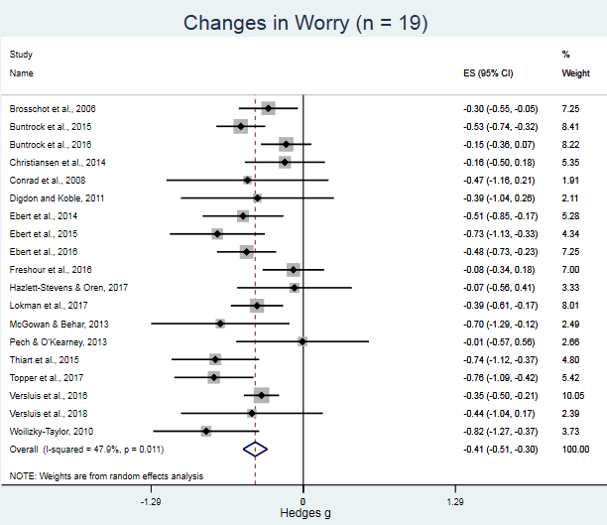
Figure 1. Worry forest plot.
Impact of interventions on worry (k = 19)

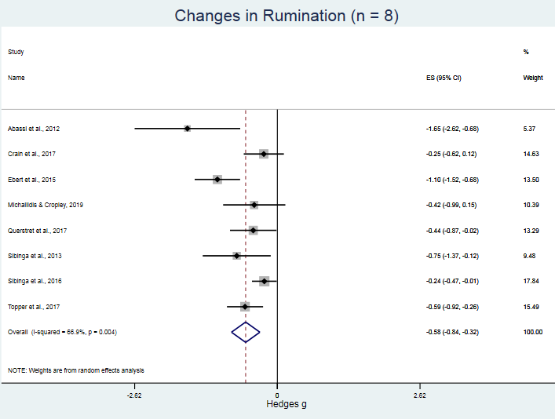
Figure 2. Rumination forest plot.
Impact of interventions on rumination (k = 8)

Figure 3. Funnel plot for health outcomes.
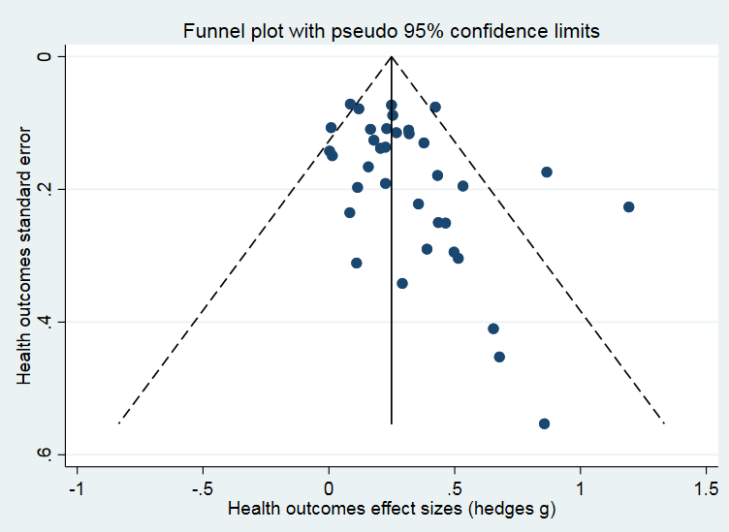

Figure 4. Graphical Display of Heterogeneity (GOSH) plot with PC effect sizes as a function of between-study heterogeneity across all studies (k = 36).
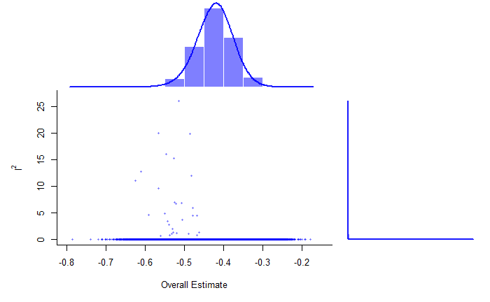
Pooled PC effect size estimate (Hedges g)
Between study Heterogeneity (I²)

Search Terms
1 Rumination.mp.
2 (Ruminat* and (thought* or thinking)).mp.
3 (perseverative and (thought* or thinking or cognition*)).mp.
4 (Repetitive and (thought* or thinking)).mp.
5 (Intrusive and (thought* or thinking)).mp
6 worr*.mp.
7 (Stress* and (thought* or thinking)).mp
8 (Self referential and (thought* or thinking)).mp.
9 brooding.mp.
10 reflection.mp.
11 (obsessive and (thought* or thinking)).mp
12 unconscious stress*.mp.
13 implicit stress*.mp.
14 anticipat* stress*.mp.
15 cognitive intrusion*.mp.
16 1 or 2 or 3 or 4 or 5 or 6 or 7 or 8 or 9 or 11 or 12 or 13 or 14 or 15
17 intervention*.tw.
18 random*.tw.
19 17 or 18
20 16 and 19
21 limit 20 to (English language and human)

References (for measures within Table 1)

Please contact corresponding author for list of references.

