Fig. 1. Principles, explanations, signs, message translations, and pre-test ratings of all seven posters tested in the field experiment.
*Item for the message rating: “How consistent is the message with the proposed principle?”;
**Item for the picture rating: “How consistent is the picture with the messages above?”
Both were rated on a seven-point scale from 1 (completely inconsistent) to 7 (completely consistent).
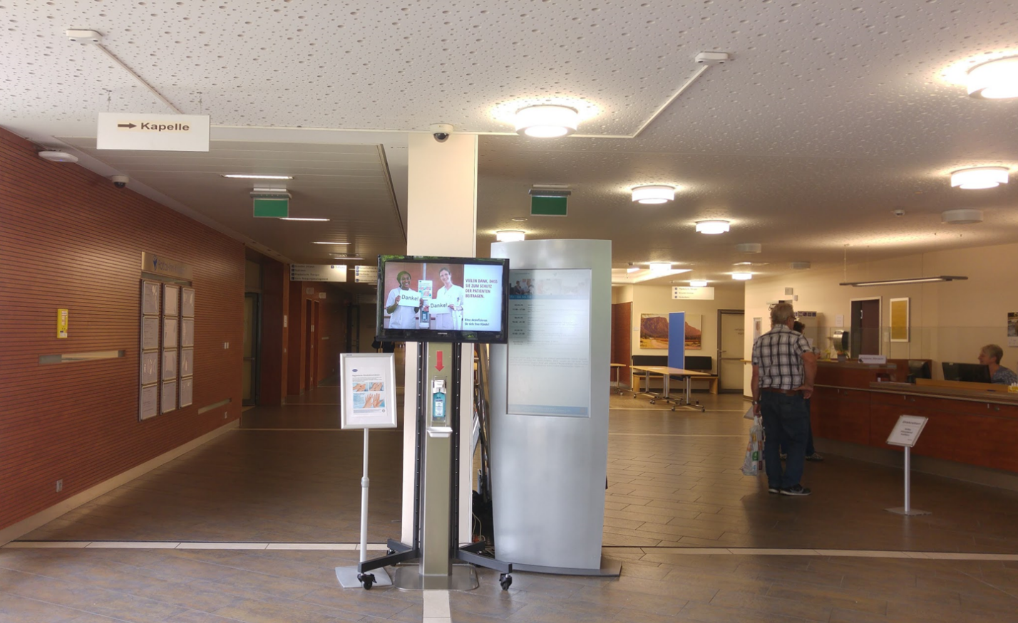

Fig. 2. Picture of the intervention setup. The grey information screen next to the dispenser could not be removed, as it is anchored to the floor.

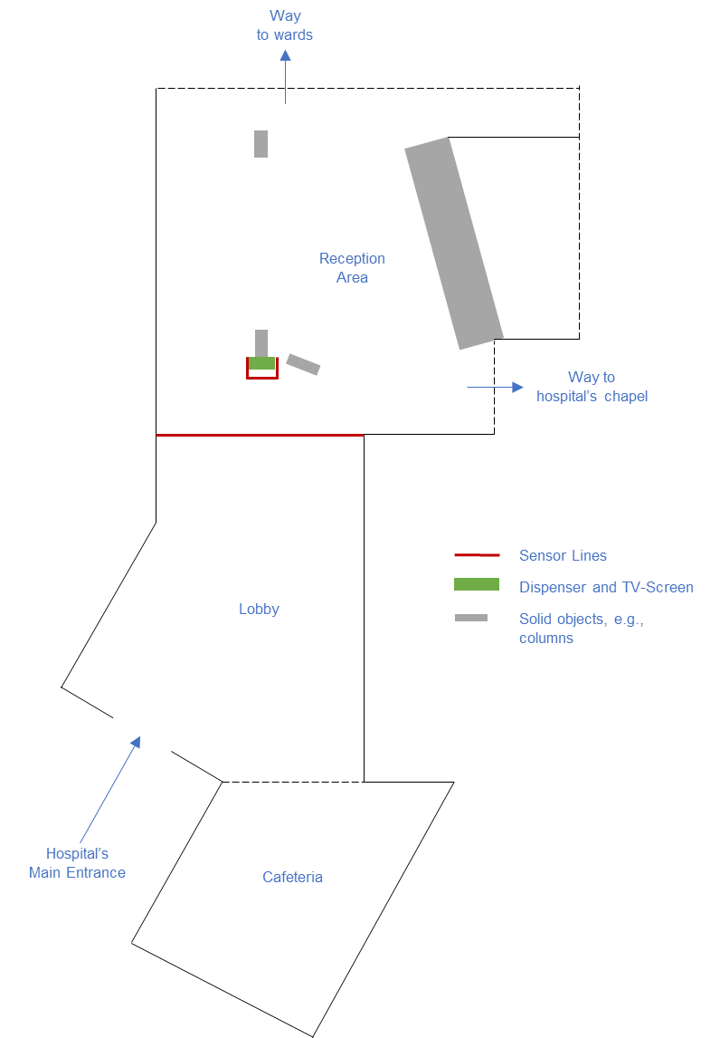

Fig. 3. Floorplan of the hospital lobby. The red lines represent the sensor system’s count lines

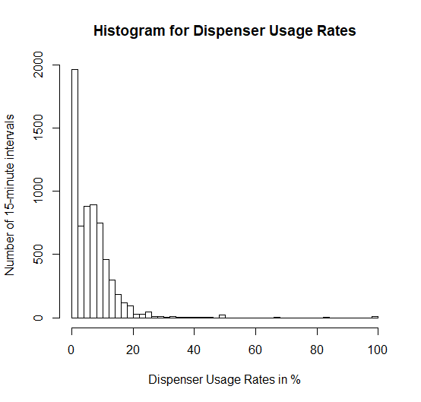

Fig. 4. Distribution of the hand-rub dispenser usage rate in % of the 6,551 15-minutes intervals over the entire study period. The y-axis depicts the number of 15-minute intervals falling into a usage-rate bin. The histogram indicates that the dependent variable is heavily skewed to the right and, therefore, not normally distributed.

TABLE 1: Descriptive Statistics for all Experimental Conditions
Week | # Intervals | # People | # Usage | M* | SD*
Baseline (1) | 409 | 14,175 | 942 | 6.2 | 9.2
Reciprocity | 476 | 15,908 | 1,068 | 5.9 | 6.5
Baseline (2) | 481 | 17,724 | 1,154 | 5.9 | 7.3
Consistency | 491 | 18,534 | 1,369 | 6.4 | 6.4
Baseline (3) | 478 | 18,432 | 1,134 | 5.6 | 5.7
Unity | 462 | 18,494 | 1,284 | 6.6 | 7.2
Baseline (4) | 472 | 17,400 | 1,194 | 6.1 | 6.3
Social-proof | 453 | 18,453 | 1,360 | 6.9 | 7.3
Baseline (5) | 462 | 17,699 | 1,132 | 5.8 | 7.3
Liking | 459 | 17,380 | 1,274 | 6.6 | 6.7
Baseline (6) | 486 | 15,967 | 1,142 | 6.4 | 8.9
Authority | 494 | 19,867 | 1,700 | 7.7 | 7.4
Baseline (7) | 460 | 18,026 | 1,236 | 6.3 | 6.3
Scarcity | 468 | 18,039 | 1,322 | 6.6 | 8.4
Note. # Intervals is the number of 15-minute intervals (with movement) recorded by the electronic monitoring system; # People is the number of people entering and leaving the hospital’s lobby;
# Usage is the number of people approaching the hand-rub dispenser in the lobby.
* M is the arithmetic mean of the usage rates of all 15-minute intervals within this week. Usage rate per 15-minute interval was calculated by multiplying the number of usages within these 15 minutes by 100 and dividing it by the number of people passing by. SD is the standard deviation of the usage rates of all 15-minutes intervals within this week.

