SUPPLEMENTAL MATERIALS

Table S1: Descriptive statistics
 | Survey Wave 1 |  | Survey Wave 2 |  | Survey Wave 3
Survey Wave 1 variable | Invitees completing in September 2011 (N=357) | Invitees not completing in September 2011 (N=224)ª | Survey  Wave 1  participants  completing  (N=338) | Survey  Wave 1  participants  not  completing  (N=19) | Survey  Wave 1  participants  completing  (N=216) | Survey  Wave 1  participants  not  completing  (N=141)
Mean (SD) age | 49.45  (15.41) | 43.87***  (15.44) | 49.79  (15.27) | 43.42⁺  (17.04) | 53.27  (13.26) | 43.60***  (16.64)
Percent (N) female | 50.98%  (182) | 54.46%  (122) | 50.59%  (171) | 57.89%  (11) | 51.85%  (112) | 49.65%  (70)
Percent (N) with college education | 45.66%  (163) | 35.71%*  (80) | 45.56%  (154) | 47.37%  (9) | 50.46%  (109) | 38.30%*  (54)
Percent (N) white | 88.52%  (316) | 79.46%**  (178) | 88.17%  (298) | 94.74%  (18) | 89.81%  (194) | 86.52%  (122)
Mean (SD) reported social circle vaccine coverage (0-100%) | 36.59%  (26.42) | 37.77%  (28.44) | 36.87%  (26.69) | 31.45%  (20.79) | 36.47%  (25.69) | 36.77%  (27.58)
Mean (SD) perceived flu risk without vaccination (0-100%) | 32.54%  (25.69) | 30.44%  (23.72) | 32.49%  (25.64) | 32.90%  (26.78) | 31.87%  (24.94) | 33.58%  (26.85)
Mean (SD) perceived flu risk  with vaccination (0-100%) | 19.65%  (22.54) | 22.77%  (22.57) | 19.22%  (21.98) | 27.42%  (30.61) | 19.17%  (22.33) | 20.40%  (22.91)
Mean (SD) perceived vaccine safety (1-7) | 4.22  (2.39) | 3.78*  (2.44) | 4.24  (2.38) | 4.24  (2.38) | 4.18  (2.41) | 4.28  (2.37)
Percent (N) who reported vaccinating in 2010-11 flu season | 42.86%  (153) | 35.12%⁺  (59) | 43.79%  (148) | 26.32%  (5) | 44.91%  (97) | 39.72%  (56)
Percent (N) who reported vaccinating in 2009-10 flu season | 42.58%  (152) | 29.81%**  (48) | 42.90%  (145) | 36.84%  (7) | 43.06%  (93) | 41.84%  (59)
ªNumber of participants who had missing data varied across the variables. Note: Differences between groups were tested by t-tests for reported means, and by chi-square tests for reported percentages. ⁺ p<.10; * p<.05; ** p<.01; *** p<.001
Table S2: Logistic regressions predicting reported vaccination behavior for the 2010-11 flu season (Odds Ratio; 95% confidence interval)
Predictor and control variables | Model  1A | Model  1B | Model  2A | Model  2B
Social circle vaccine coverage  in 2010-11 flu season (0-100%) | 1.05***  (1.03, 1.06) | 1.04***  (1.02, 1.06) | 1.03***  (1.01, 1.05) | 1.03**  (1.01, 1.05)
Perceived flu risk  without vaccination (0-100%) |  | 1.04^{***a}  (1.03, 1.06) | - | 1.04^{***a}  (1.02, 1.06)
Perceived flu risk  with vaccination (0-100%) |  | .97**  (.95, .99) | - | .98  (.96, 1.01)
Perceived vaccine safety (1-7) |  | 1.24^{**b}  (1.06, 1.44) | - | 1.10  (.90, 1.34)
Age | 1.06***  (1.03, 1.08) | 1.06***  (1.03, 1.09) | 1.05***  (1.01, 1.09) | 1.05*  (1.01, 1.09)
Female | 1.52  (.78, 2.95) | 1.21  (.56, 2.59) | 1.41  (.59, 3.38) | 1.03  (.40, 2.68)
College  Education | 2.24*  (1.14, 4.37) | 2.45*  (1.10, 5.45) | 1.02  (.41, 2.52) | 1.02  (.37, 2.83)
White | .65  (.22, 1.93) | .38  (.11, 1.32) | 1.05  (.24, 4.60) | .83  (.15, 4.45)
Past vaccination behavior  in 2009-10 flu season |  |  | 31.60***  (12.90, 77.40) | 25.86***  (9.68, 69.10)
Nagelkerke R² | .38 | .53 | .67 | .71
⁺ p<.10; * p<.05; ** p<.01; *** p<.001
ª Mediated the relationship between perceived 2010-11 social circle vaccine coverage and predicted vaccination behavior (p<.05)
^{b} Mediated the relationship between perceived 2010-11 social circle vaccine coverage and predicted vaccination behavior (p<.10)
Note: Analyses repeat those from Table 2, while limiting the sample to those 215 participants who completed all survey waves, as well as Survey Wave 1 in September 2011. All dependent and independent variables were reported in Survey Wave 1 in September 2011 before vaccine uptake among US adults took off for the 2011-12 flu season (Centers for Disease Control and Prevention, 2013)..

Table S3: Sobel z-test for mediation

 | 2010-11 Vaccination Behavior |  | 2011-12  Vaccination Behavior |  |  | 2015-16  Vaccination Behavior
Predictor variable | Figure S1A | Figure S1B | FigureS2A | Figure  2B | Figure  S2C | Figure S3A | Figure S3B | Figure S3C | Figure S3D
Perceived flu risk  without vaccination (0-100%) | 3.81*** | 2.16* | 3.79*** | 2.30* | 1.82⁺ | 2.55* | 1.65⁺ | .97 | .73
Perceived flu risk  with vaccination (0-100%) | -.47 | -.67 | -.52 | -.66 | -.60 | -1.12 | -.89 | -.69 | -.62
Perceived vaccine safety (1-7) | 2.55* | 1.18 | 1.84⁺ | .52 | .16 | 1.49 | .40 | .25 | .24
⁺ p<.10; * p<.05; ** p<.01; *** p<.001

Note: Mediation models correspond to Figures S1-S3. We computed Sobel tests to assess the significance of mediation patterns, because Sobel tests can handle the inclusion of linear regressions on the continuous mediator variables and logistic regressions on the dichotomous outcome variable (Herr, 2006). Sobel test results were replicated in bootstrapping mediation models with 5,000 bootstrap samples, which relied on linear regression estimates for both the continuous mediator variables and the dichotomous outcome variables (Hayes, 2018).

Figure S1: Mediation models predicting vaccination behavior in the 2010-11 flu season, controlling for (A) demographics and (B) vaccination behavior in the 2009-10 flu season

(A) (B)

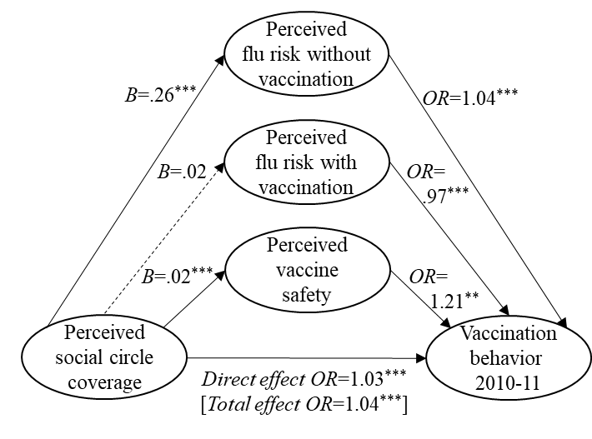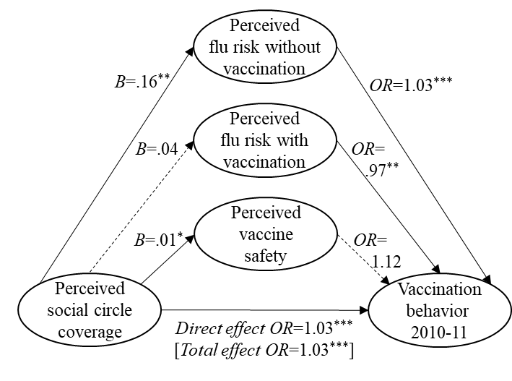

⁺ p<.10; * p<.05; ** p<.01; *** p<.001
Note: Associated Sobel mediation tests appear in Table S3. Linear regressions (unstandardized B) were used to predict each of the three continuous mediator variables (perceived flu risk without vaccination, perceived flu risk with mediation, and perceived vaccine safety). Logistic regressions (OR) were used to predict the dichotomous outcome variable (vaccination behavior in 2010-11), respectively corresponding to models 1A-B and 2A-B in Table 2. The direct effect [vs. total effect] of perceived social circle vaccine coverage on vaccination behavior in 2010-11 reflects the relationship between these variables after [vs. before] controlling for the three mediatior variables.

Figure S2: Mediation models predicting vaccination behavior in the 2011-12 flu season, controlling for (A) demographics, (B) vaccination behavior in the 2009-10 flu season, and (C) vaccination behavior in the 2010-11 flu season

(A) (B)

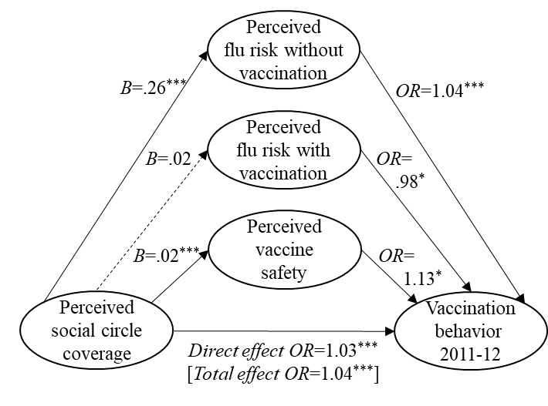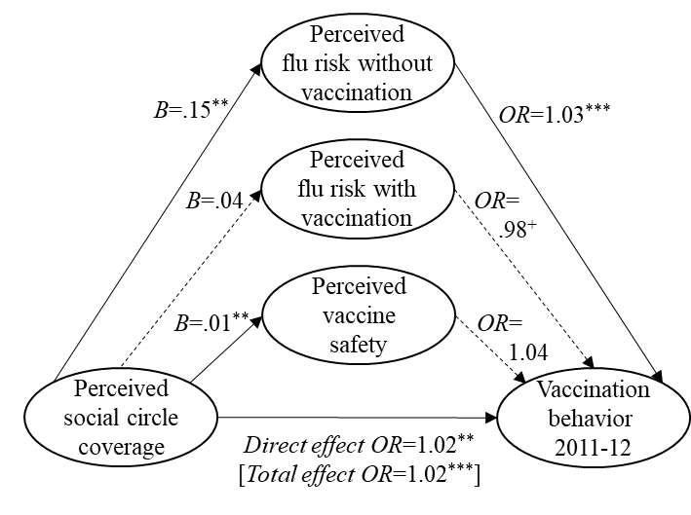

Figure S2 (contd.)

(C)

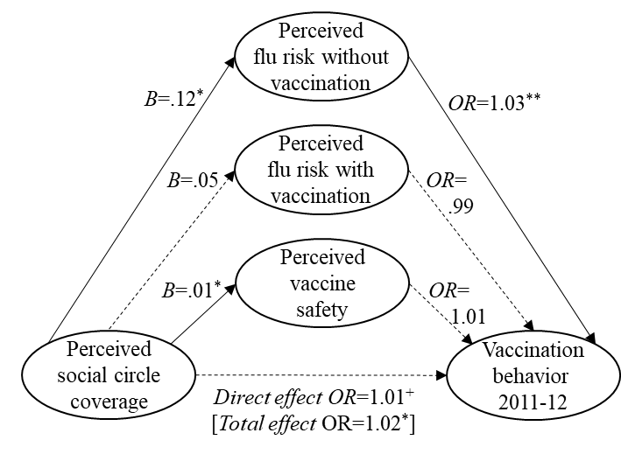
⁺ p<.10; * p<.05; ** p<.01; *** p<.001
Note: Associated Sobel mediation tests appear in Table S3. Linear regressions (unstandardized B) were used to predict each of the three continuous mediator variables (perceived flu risk without vaccination, perceived flu risk with mediation, and perceived vaccine safety). Logistic regressions (OR) were used to predict the dichotomous outcome variable (vaccination behavior in 2011-12), respectively corresponding to models 1A-B, 2A-B, and 3A-B in Table 3. The direct effect [vs. total effect] of perceived social circle vaccine coverage on vaccination behavior in 2010-11 reflects the relationship between these variables after [vs. before] controlling for the three mediatior variables.

Figure S3: Mediation models predicting vaccination behavior in the 2015-16 flu season, controlling for (A) demographics, (B) vaccination behavior in the 2009-10 flu season, (C) vaccination behavior in the 2010-11 flu season, and (D) vaccination behavior in the 2015-16 flu season.

(A) (B)
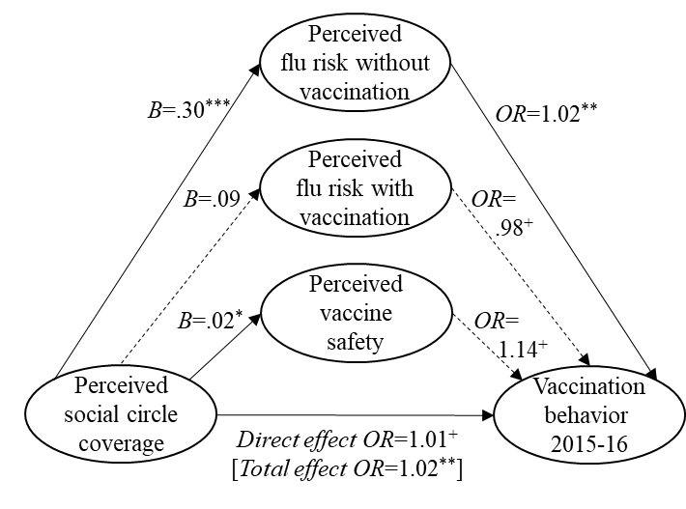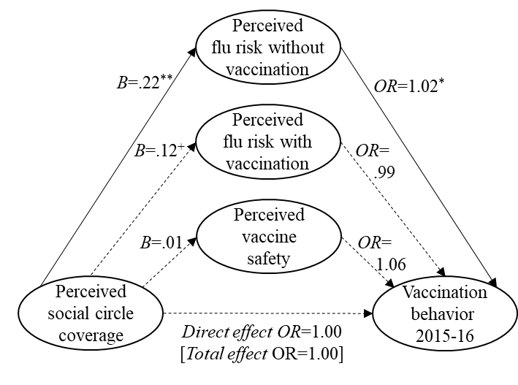

Figure S3 (contd.)

(C) (D)

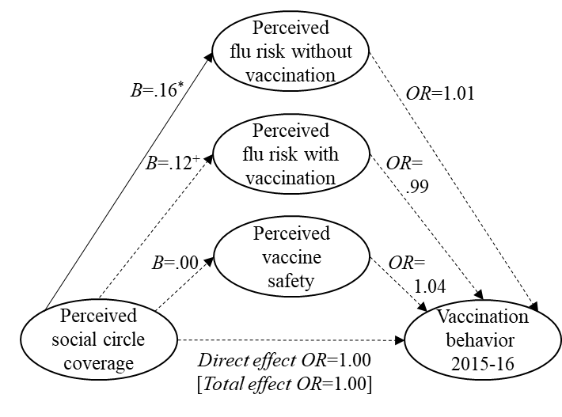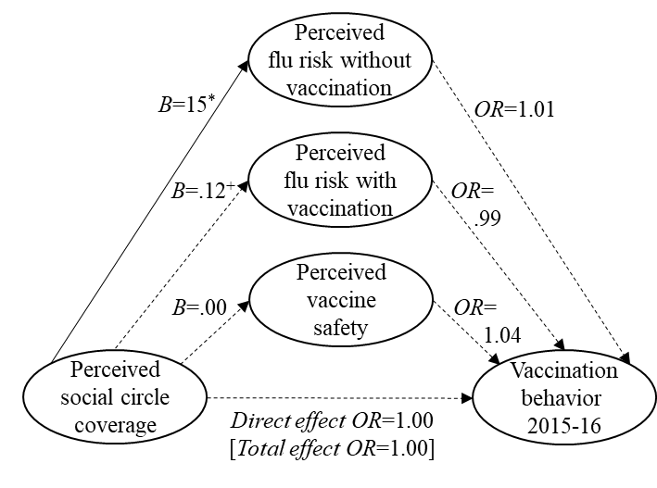

⁺ p<.10; * p<.05; ** p<.01; *** p<.001
Note: Associated Sobel mediation tests appear in Table S3. Linear regressions (unstandardized B) were used to predict each of the three continuous mediator variables (perceived flu risk without vaccination, perceived flu risk with mediation, and perceived vaccine safety). Logistic regressions (OR) were used to predict the dichotomous outcome variable (vaccination behavior in 2015-16), respectively corresponding to models 1A-B, 2A-B, 3A-B, and 4A-B in Table 4. The direct effect [vs. total effect] of perceived social circle vaccine coverage on vaccination behavior in 2010-11 reflects the relationship between these variables after [vs. before] controlling for the three mediatior variables.

