Correcting Neuromyths: A Comparison of Different Types of Refutations
Marcus P. G. Lithander, Lisa Geraci, Meltem Karaca, and Jason Rydberg
University of Massachusetts Lowell

Author Note
Marcus P. G. Lithander, Department of Psychology, University of Massachusetts Lowell, Lisa Geraci, Department of Psychology, University of Massachusetts Lowell, Meltem Karaca, Department of Psychology, University of Massachusetts Lowell, and Jason Rydberg, School of Criminology and Justice Studies, University of Massachusetts Lowell.
Correspondence should be sent to Marcus Lithander, Department of Psychology, University of Massachusetts Lowell, Lowell MA 01854. Email: Marcus_Lithander@uml.edu.
Portions of these data were presented at the 2018 Annual Meeting of the Psychonomic Society.
Word Count: 2368

Abstract
Research suggests that educators and students often hold erroneous beliefs about learning and brain function, referred to as neuromyths. The prevalence of these neuromyths may be problematic, leading people to spend resources on ineffective study methods and propagate misinformation. Therefore, we examined whether erroneous beliefs in neuromyths could be corrected using various forms of refutations. Across two experiments, participants indicated if statements about learning and brain function were true or false. Participants then received one of three types of corrections (refutation-only, refutation-explanation, refutation-explanation and image) or no correction (control). One week and one month later, participants again indicated their beliefs in the true statements and the neuromyths. Results showed that all three refutations were effective for correcting erroneous beliefs in neuromyths, and this corrective effect was present after one week and one month. These findings suggest that beliefs in neuromyths can be corrected and possibly lead to long-lasting knowledge revision.
Keywords: Refutation text, neuromyths, misconceptions, explanations, feedback, ﻿confidence

General Audience Summary

Educators and students hold erroneous beliefs about some aspects of learning and brain function, referred to as neuromyths. For example, one common neuromyth is that students learn better when instruction is adapted towards their preferred learning style (be it visual or verbal, etc.). Misconceptions such as this one can lead teachers and students alike to spend time and resources on ineffective strategies. As such, it's important to find ways to refute these learning misconceptions and to disseminate information regarding which refutation strategies work best, allowing educators and students access to evidence-based best practices. We investigated different methods for refuting neuromyths. Participants viewed a series of true and false (neuromyths) statements about learning and the brain. Participants received one of three different types of corrections. One group received feedback simply stating that the neuromyth was false. A second group received additional information explaining why each neuromyth was false, and a third group received the same explanations along with an image. Participants in the control condition did not receive any type of refutation. Participants returned after one week and one month to again evaluate the true and false statements. Results showed that all three types of refutations were equally effective in updating people's initial erroneous beliefs. In contrast to previous studies, updated beliefs were maintained one month after receiving the corrective refutations. These findings suggest that beliefs in neuromyths can be corrected and possibly lead to long-lasting knowledge revision.

Correcting Neuromyths: A Comparison of Different Types of Refutations
Growing evidence suggests that some students and teachers hold erroneous beliefs about learning and the brain, often called “neuromyths” (Dekker et al., 2012; Ferrero et al., 2016; Kowalski & Taylor, 2017; Macdonald et al., 2017; van Dijk & Lane, 2020). For example, a common misconception about learning is that people can be classified as either "left-brained," or "right-brained," and that this concept can help explain differences in how people learn. A recent survey suggests that almost 1 in 2 American educators believe in this neuromyth (Macdonald et al., 2017). The left-brain/right-brain misconception is a typical neuromyth in that it includes partially correct information—it is true that certain brain functions are lateralized, and individual differences in brain function exist (Nagel et al., 2013). However, this neuromyth also includes incorrect information, as there is no evidence that students can be categorized as either “left-brained” or “right-brained” and that this classification influences learning (Corballis, 2014; Nielsen et al., 2013; van Dijk & Lane, 2018). The right brain/left brain dominance myth is a good example of how facets of research can become decontextualized and find their way into the educational system, often persisting for decades.
Holding false beliefs about learning and memory can be problematic as these misconceptions may lead educators to spend time and resources on ineffective tools to improve learning, instead of using strategies that have been shown to be effective (Dunlosky et al., 2013). Similarly, students who hold erroneous beliefs about how to study may use sub-optimal learning strategies and experience poor academic outcomes (Dunlosky et al., 2013; Moreheadet al., 2016). Given the potential problems with holding erroneous beliefs about learning and memory, it is important to try to correct these beliefs.
Though correcting misconceptions is valuable, doing so has proven to be a challenge across many domains, including educational, legal, political, and public health (Guillory & Geraci, 2016; Lewandowsky et al., 2012; Sally Chan et al., 2017; Schwarz et al., 2016). For example, people have difficulty correcting their erroneous beliefs when these beliefs are self-produced during study (Howe, 1970), when they result from on-the-scene news reports about potential criminal events (Wilkes & Leatherbarrow, 1988), and when they involve political candidates (Nyhan & Reifler, 2010). Perhaps the most well-known instance of a failure to correct a misconception involved the widespread public health misconception that the MMR vaccination causes autism. The misconception has had deadly consequences, including several outbreaks of measles among unvaccinated people across the world (DeStefano & Shimabukuro, 2019). Today, various misconceptions about the novel coronavirus , COVID-19, abound, leading people to form erroneous beliefs and engage in inappropriate behaviors that may harm their health and well-being (Brennen et al., 2020; Kouzy et al., 2020).
Although correcting misconceptions in general is difficult and misinformation often continues to influence people even after debunking messages, some recent studies offer promising strategies for correcting misconceptions (Rich et al., 2017; Swire & Ecker, 2018; van Loon et al., 2015). One such strategy is to use refutations in which a misconception is first presented (e.g., "Bulls are enraged by the color red"), followed by a specific refutation (e.g., “Many people think that the color red enrages bulls, but this notion is false) (Rich et al., 2017; van Loon et al., 2015). The co-activation of the false and new (correct) information is theorized to facilitate knowledge revision (Kowalski & Taylor, 2017; Lewandowsky et al., 2012; van Loon et al., 2015). Furthermore, including the to-be-corrected myth together with corrective information is more effective than presenting the corrective information alone (Ecker et al., 2017). For example, two classroom studies showed that the refutation approach may be effective for correcting students’ misconceptions about climate change and the cause of seasonal changes on earth (Danielson et al., 2016; Mason et al., 2017). A third classroom study found possible support for the use of refutations for correcting psychological misconceptions (e.g., “Mozart’s music increases infant intelligence”; Kowalski & Taylor, 2017). Results from this study showed that students reported fewer misconceptions when they were taught about psychological misconceptions using a refutation approach compared to standard in-classroom teaching (misconceptions were mentioned but not explicitly emphasized and refuted). However, in this study, only three items per corrective condition were used, and the items were not counterbalanced across conditions, making it difficult to distinguish if possible effects of refutations were due to conditional factors or item-specific factors. Therefore, the authors suggested that experimental studies are needed to examine the use of refutations in correcting psychological misconceptions.
In the current studies, we examined whether erroneous beliefs about learning and the brain (neuromyths), could be corrected using refutations. In Experiment 1, community-samples of participants were tested online using Amazon’s Mechanical Turk. Experiment 2 was designed to replicate the results from Experiment 1 using undergraduate Introductory Psychology students as participants. The undergraduate sample was of interest as students often hold erroneous beliefs about learning and habitually use ineffective study strategies (Blasiman et al., 2017, Kowalski & Taylor, 2017; Tardif, 2015). We examined participants’ beliefs in neuromyths before and after receiving the particular refutation or no refutation (the control condition). We compared the effectiveness of three different types of refutations: refutation-only, refutation with explanation, and refutation with explanation plus an image. In the refutation only condition, participants received a simple refutation in which the neuromyth was presented along with a statement that the information was incorrect, as well as the correct information. In the refutation-explanation condition, participants received the refutation along with a scientific explanation and citation. We included this refutation-explanation condition as previous research suggests that providing explanations enhances the effectiveness of refutations for other types of misconceptions (e.g., van Loom et al., 2015, Rich et al., 2017). We also added a citation to accompany the explanation, as a means of increasing source credibility and trustworthiness, which have been shown to increase the effectiveness of a correction in other domains (Guillory & Geraci, 2013; Van Boekel et al., 2017). Finally, we included a refutation-explanation plus image condition, because previous research suggests that providing visual images may enhance the effectiveness of a refutation (e.g., about climate change, Danielson et al., 2016, and seasonal change, Mason et al., 2017). Further, studies show that combining images and text material enhances learning (see Brunyé et al., 2008; Clark & Paivio, 1991; Weinstein et al., 2018) and can increase the likelihood that people judge the information as true, although such effects may be small (Brashier & Marsh, 2020; Newman et al., 2012). We examined the effectiveness of the various types of refutations for correcting beliefs in neuromyths at two different time points: after one week and after one month.
Finally, we assessed the influence of a variety of other factors on whether people could correct their beliefs in neuromyths, including their initial confidence in the neuromyth. We assessed confidence as it has been shown to play a key role in whether misconceptions are corrected. On the one hand, research shows that it is more difficult to correct misconceptions that are held with high confidence than those held with lower confidence (Ecker et al., 2011; Lewandowsky et al., 2012). However, if people are highly confident about a misconception that is not deeply rooted in their worldview (such as a common fact; Butler et al., 2011; Metcalfe & Finn, 2012), the opposite pattern can occur. People who are more confident may be more likely to accept a correction compared to those who are less confident—the hypercorrection effect (Metcalfe, 2017; van Loon et al., 2015). To investigate whether confidence in neuromyths mediates the extent to which refutations are effective, we asked people to indicate their confidence in the statements (the facts and the neuromyths), and to indicate how much they relied on the neuromyth in their daily lives. We predicted that neuromyths that are held with high confidence and that people rely on in their daily lives, will be harder to correct than those that are held with high confidence but not used in daily life, or those that are held with low confidence. Finally, we included exploratory measures to assess the potential role of individual differences on acceptance of refutations.
Experiment 1
Method
Participants. Based on previous studies investigating the effects of refutations on correcting misinformation, we aimed to test 50 participants per condition (Rich et al., 2017; van Loon et al., 2015). Given that dropout rates for longitudinal studies conducted on MTurk are generally high, we aimed to recruit 100 participants per condition to obtain adequate power (Keith et al., 2017). In total 390 participants were recruited and initiated the study. We used the following criteria to recruit participants on MTurk: participants had to live in the United States, have accrued more than 500 human intelligence tasks (HITs), and have an approval-rating above 90% of previously conducted HITs. Participants who did not complete all three parts of the study (initial, one-week delay and one-month delay) or who had multiple attempts to take any part of the study were excluded from the final analyses. Participants were paid $1.00 for completing each part of the study following existing standards (Buhrmester et al., 2011).
In total 293 participants completed the full test in Part 1 of the study. Participants who did not complete the full test or who had a working ID that was registered twice were excluded (n = 59). Of these, 212 completed the second part, (the one-week delay test). For the third part, 161 participants returned for Part 3, the one-month delay test. No participants who returned to for Part 3 had to be excluded. In total, 161 participants completed all three parts of the study, (86 women; 20–79 years old, M = 43.4, SD = 13.2).
Design and materials. The study used a between-subjects design with four groups, a refutation-only (n = 35), refutation-explanation (n = 37), refutation-explanation and image (n = 44), and a no-refutation, control-group (n = 45). The dependent measure was accuracy (correctly indicating that a neuromyth is false) measured one week and one month after participants received a refutation or no refutation (control).
We used 20 true and 20 false statements (neuromyths) about learning and brain function. True and false statements were adapted from previous research investigating neuromyths and the relevant literature on learning (De Bruyckere et al., 2015; Dekker et al., 2012) (see Appendix).
We used three different types of refutations and a control (no-refutation) condition. The refutation-only condition consisted of re-presenting the statement together with a brief text stating: “This statement is false”. The refutation-explanation condition was modeled after Rich et al. (2017) and contained up to three sentences that varied in length between 36 and 80 words (M = 56.2) and included an in-text citation. For example, for the misconception “We only use 10% of our brain” the refutation explanation was as follows: This statement is false. We use all of the brain all the time–even when we are "doing nothing" neurons are firing all over the brain. No part of the brain is ever normally inactive in the sense that no blood flow is occurring (you would be very ill if only 10% of your brain were active; Jones, 2009). The refutation-explanation plus image condition was identical to the refutation-explanation condition, with the addition that a relevant image was presented alongside the refutation. Images were collected from various resources, including Google and Pixabay (pixabay.com). Image content ranged from images of classrooms to fMRI brain images. Images were selected based on the criteria that they could be associated with the statement and each statement was paired with a specific image (see Appendix). Because little is known about how adding visual material to refutations affects corrections, we chose to use a broad range of images to investigate whether visual material in general had an effect on the likelihood that people would accept the correction.
Procedure. Part 1 of the study consisted of three phases; an initial test, a distraction, and a refutation. For the initial, participants were presented with 20 true and 20 false statements, one at a time in random order. For each statement, participants indicated whether they thought the statement was true or false, following the procedure used in previous research investigating the correction of misconceptions (Rich et al., 2017; van Loon et al., 2015). Next, participants indicated their level of confidence in their answers on a scale from 0 (not at all confident) to 100 (absolutely confident). To measure the potential role that the belief has in participants’ lives, participants indicated if they strongly disagree (0) or strongly agree (100) with the following statement: This concept has influenced my behavior in daily life. We included this measure as previous research suggests that having a personal connection to information can influence how it is assessed and whether the information can be corrected (Lewandowsky et al., 2012; Wells et al., 2009). Following the initial test, participants completed a distractor task, which consisted of 20 simple mathematical problems (e.g., 100 - 50 + 8) that were displayed for 6 s each. Participants then proceeded to the refutation phase where they were again presented with all 40 statements, one at time (randomly intermixed and displayed for 25 s each). For false statements, depending on condition, each statement was accompanied with a refutation (refutation-only, refutation-explanation, refutation-explanation plus image) or no refutation (the initial statement was presented alone, as in the test-phase). For true statements, the same feedback was given, although instead of a refutation participants received confirmations of the true statements (names for confirmatory conditions are kept for consistency). For true statements, participants in the refutation-only condition were simply told that the statement was true (e.g. “This statement is true”). Participants in the refutation-explanation and refutation-explanation plus image were given the explanation were told that the statement was true and followed by the same explanations and images as given following the false statements. Finally, participants were reminded to return and participate in Part 2 a week later. All participants who completed Part 1 also received an email reminder asking them to complete Part 2 of the study, and were told to complete the study within 24 hours of receiving the reminder.
In Part 2, participants were again presented with all 40 (20 true and 20 false) statements presented in random order and asked to indicate whether each statement was true or false (same procedure as in the test-phase of Part 1). After responding to each statement, participants completed three scales: Short form of Big Five Inventory (6 items) (Soto & John, 2017), Critical Thinking (11 items) (Sosu, 2013) and Need for Cognition (18 items) (Cacioppo et al., 1984), as previous research suggests these traits may influence one’s tendency to believe in and correct these types of misconceptions (Bensley et al., 2014; Bensley & Lilienfeld, 2017; Swami et al., 2012). Participants also completed a demographic questionnaire including questions about gender, age, academic level, and income. Participants were not informed or reminded about an upcoming third part of the study.
Participants who had completed the Part 2 of the study (n = 212) received an invitation three weeks later to participate in Part 3 and were required to participate within 24 hours of receiving the invitation. Part 3 was identical to Part 2 of the study with the exception that participants did not complete the additional scales again.
To avoid automatically generated answers and bots on MTurk, the distraction-phase in Part 1 was also used as an attention task (e.g., “100 - 50 + 8”). Furthermore, a Completely Automated Public Turing test to tell Computers and Humans Apart (CAPTCHA) was used in Part 3 (von Ahn et al., 2008) to avoid data from non-human participants.
Analytical Plan. Because the aim of the study was to determine whether the refutations are effective at correcting participants’ beliefs in neuromyths, analyses were restricted to neuromyths that were inaccurately answered as “true” during the initial test for each participant (Rich et al., 2017). This analysis plan created a nested data structure in which each participant contributed data for varying numbers of statements (i.e., depending on how many were answered inaccurately on the initial test) and potentially different statements from other participants. Estimation of treatment effects was performed using a mixed effects logit regression, with a cross-classified random effects parameterization specifying random intercepts quantifying unobserved heterogeneity in accuracy 1) for each participant, 2) for each statement, and 3) for each combination of each participant and statement (Raudenbush & Bryk, 2002). Across the two measurement points (one-week and one-month tests), the analysis file consisted of 4,228 participant, statement, time-point combinations. A binomial likelihood with a logit link was used to model the probability of a correction, conditional on the assigned treatment condition. Our models also conditioned on initial confidence and life reliance, which are participant-mean standardized to reflect within-participant variation (Enders & Tofighi, 2007). Grand mean standardization was used for the Big 5 Inventory, critical thinking, and need for cognition scales.
Inference was performed using Bayesian statistical models, where parameter estimates create distributions reflecting the relative plausibility of parameters, conditional on the data and the model (McElreath, 2020). Models were fit using the R package brms (Bürkner, 2017; R Core Team, 2020), specifying weakly informative prior distributions centered on zero for the intercept (student-t(3, 0, 10)), slopes (student-t(3, 0, 2.5)), and random effects standard deviations (half-normal(0, 1)) (Ghosh, Li, & Mitra, 2018; McElreath, 2020). Posterior means were accompanied by highest density intervals (HDI) reflecting the smallest interval of parameters encompassing 95% of the posterior mass. Model comparison was performed via K-fold cross validation (Vehtari, Gelman, & Gabry, 2017), dividing the data into K blocks (we used K = 10), refitting each model K times leaving out one of the blocks, assessing the out-of-sample predictive accuracy as a trade-off with model complexity. We used a threshold of expected pointwise predictive density (ELPD) difference in excess of 2 standard errors to signify a meaningful improvement in fit.
Results and Discussion
Initial beliefs and descriptive statistics. Across all conditions, participants performed significantly worse than chance on the initial test when asked about their beliefs in neuromyths (M = 0.34, 95% HDI: 0.32, 0.36). Participants in the no-refutation (control) condition (M = 0.35 [0.31, 0.39]), the refutation-only condition (M = .38 [0.33, 0.43]), the refutation-explanation condition (M = 0.30 [0.25, 0.35]), and the refutation-explanation plus image condition (M = .33, [0.29, 0.38]) all scored significantly worse than chance on the initial test. Initial mean scores for beliefs in neuromyths did not differ across conditions, which was expected as the initial test preceded the refutation manipulation. Finally, initial beliefs did not correlate with any of the demographic variables, academic level, income, or age, and are not discussed further.
Effect of the correction. A baseline model was estimated containing main effects for all variables (see Table 1). Relative to the no refutation (control) condition, all refutation conditions induced a large increase in the likelihood of correction, multiplying the odds by 142 to 208 (95% HDI: 54-586). Outside of comparisons to the control, pairwise differences between the posteriors for each condition produced null effects, with posterior means close to zero and wide HDIs (Refute/Explain vs Feedback = -0.18 [-1.15, 0.79], Refute/Explain/Image vs Feedback = -0.38 [-1.36, 0.55], Refute/Explain/Image vs Refute/Explain = -0.20 [-1.09, 0.72]). This result suggested that the refutation types were equally effective at correcting participants’ beliefs in neuromyths.
As an alternative presentation of these results, we estimated a model based on using the proportion of neuromyths the respondent continued to believe following the correction. This model was based on a Gaussian distribution with random intercept for participants, and beta(4, 4) prior for the intercept, normal(0, 0.5) for the slopes, half-normal(0, 1) for the random intercept standard deviation, and exponential(1) for the residual standard deviation. At the first follow-up, participants in the control condition indicated belief in 87.7% of neuromyths presented (95% HDI: 80.9, 94.0), while those in the refutation conditions universally believed fewer of the neuromyths presented (feedback: 29.5% [22.3, 36.9]; refutation and explanation: 32.9% [25.8, 40.2]; refute, explain, image: 34.7% [28.0, 41.3]).
Change following delay. The baseline model suggested that between the one-week and the one-month delay, the likelihood of correcting neuromyth beliefs decreased by 29% (95% HDI: -41%, -14%) (Table 1). A second model included an interaction between treatment condition and delay to determine if the effect of the conditions was differentially affected by the delay. Expected posterior predictions from this model are displayed in Figure 1. This model was not an improvement in predictive accuracy relative to the baseline model (ELPDΔ = 16.9, SEΔ = 9.4), suggesting that each refutation condition remained similarly effective after the delay.
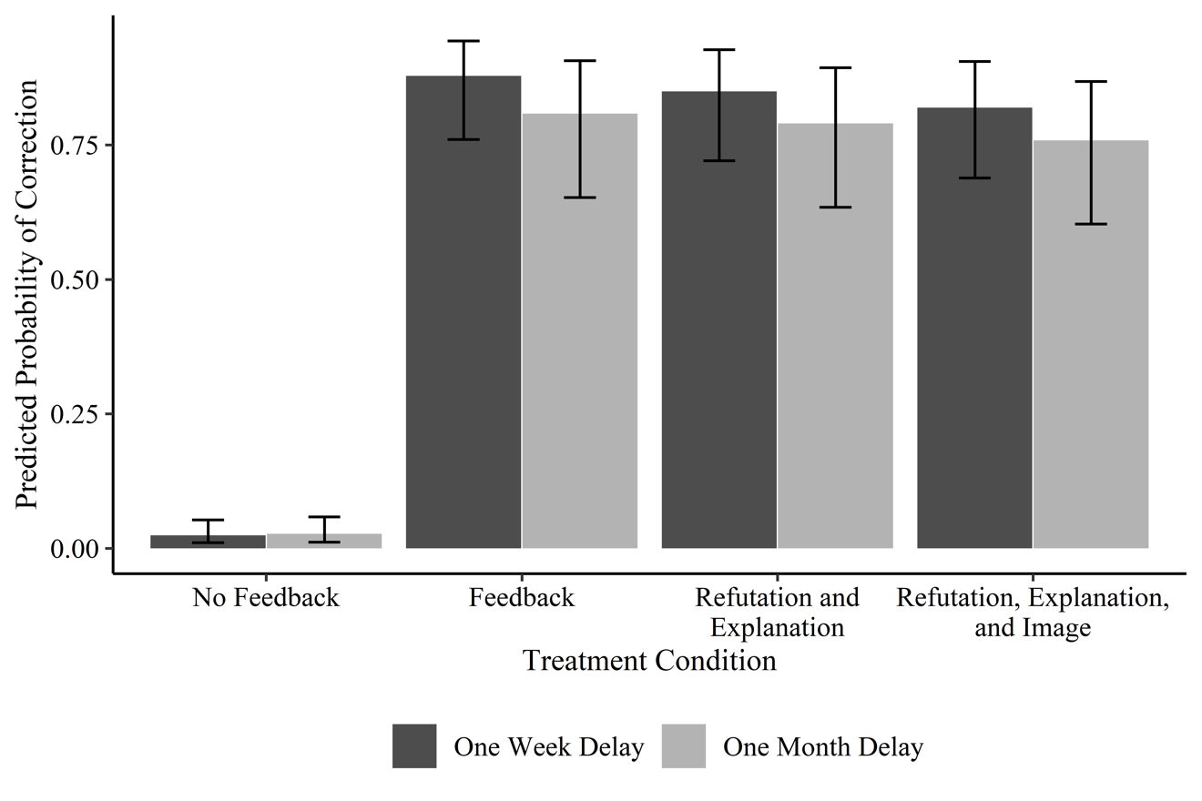
Figure 1. Probability of Correcting False Beliefs in Neuromyths after One-week and One-Month Delays in Experiment 1. Expected Posterior Means and 95% Highest Density Intervals.

Initial confidence and life influence. Results suggested that initial confidence in neuromyths was associated with a lower likelihood of correction. This effect size was relatively small, as a one-standard deviation increase in initial confidence within participants decreased the odds of correction by 16% (95% HDI: -28%, -2%) (Table 1). Similarly, small effects were observed for ratings of influence on daily life, where a one-standard deviation increase in this measure translated to a 19% decrease in the odds of correcting a false neuromyth belief (95% HDI: -32%, -5%). We further assessed whether specific types of refutations were more or less effective for correcting especially confident or influential beliefs by examining the interaction between these variables and the treatment conditions (predictive distributions in Figure S1). This model did not increase predictive accuracy over the baseline model (ELPDΔ = 7.0, SEΔ = 9.5), suggesting that the association between confidence, influence on daily life, and the likelihood of correction did not vary across treatment conditions. Based on earlier research suggesting that highly confident beliefs that are not rooted in worldviews may be easier to correct (Butler et al., 2011; Rich et al., 2017), we estimated an additional model specifying an interaction between confidence and influence on daily life. This model did not improve predictive accuracy over the additive effects of these factors (ELPDΔ = 4.0, SEΔ = 9.3).
For completeness, we also considered the effect of corrections for participants who had initially given a response of “false” to true statements. Although participants in the no refutation (control) condition had a relatively high probability of correcting their response at the follow-up periods (81%, 95% HDI: 67%, 93%), those in the refutation conditions were generally more likely to correct their responses (OR 95% HDIs from 0.65 to 16.48).
Experiment 2
Results from Experiment 1 showed that providing refutations to common neuromyths was an effective method of correcting them. Further, results showed that the three types of refutations were equally effective at correcting erroneous beliefs in neuromyths, and the effect of the refutations held after a delay. Specifically, participants who were in the refutation-only, refutation-explanation, and refutation-explanation plus image conditions were able to correct their responses to questions about neuromyths when tested after a one week and a one month. Given the promising results from Experiment 1, Experiment 2 was designed to attempt to replicate these results using a different sample of participants—undergraduate Introductory Psychology students instead of a community sample. In Experiment 2, we also examined reported sources of neuromyths.
Method
Participants. Based on previous research and estimates for adequate statistical power, we aimed to recruit 50 participants per condition to guarantee that we would have adequate number of participants per condition (Rich et al., 2017; van Loon et al., 2015). Participants were compensated with course credit for participation. In total 257 participants initiated the study.
Out of 208 participants who successfully completed Part 1 of the study, 182 participants completed Part 2 (the one-week delay test). Of these, 158 participants returned and completed Part 3 (the one-month delay test). Participants who did not finish the full study or who attempted the study more than once were excluded from the analyses. One participant was also removed due to lack of variation in confidence and life reliance responses. Consequently, a total of 157 participants (74 women;18–50 years old, M = 19.4 SD = 3.1) completed all parts of the study and were included in the following analyses.
Design and Materials. The study used a between-subjects design with four groups, a refutation-only (n = 41), refutation-explanation (n = 39), refutation-explanation plus image (n = 38), and a no refutation, control-group (n = 39). The dependent measure was accuracy (correct responses to indicate that a neuromyth was false) on the final tests occurring after one week and one month.
The materials used in Experiment 2 were identical to those used in Experiment 1, with the exception that during the initial test in Part 1 participants were asked to indicate the source of the information out of 7 possible options: I recognize this statement from: 1. Fiction (e.g., movies or literature) 2. Education (e.g., from a teacher or textbook) 3. Popular-Science (e.g., magazines or news articles) 4. Scientific Journal (peer-reviewed articles) 5. Friends and family (e.g., from your mom) 6. Other 7. I do not recognize this statement. I have not seen this statement before.
Procedure. The procedure was identical to the procedure used in Experiment 1 with the exception that participants in Experiment 2 were informed about the one-month delayed test before beginning the experiment and were asked about the source of their initial beliefs.
Analytic strategy. This study used an identical modeling strategy as Experiment 1, with treatment effects estimated via a mixed effects logit regression with random intercepts for each participant, question, and participant question combination. One difference between Experiment 2 and Experiment 1 was that there was a non-trivial degree of missing data among the Big Five, Critical Thinking, and Need for Cognition scales, with 16-37% of participants missing at least one item for a given scale. Therefore, plausible values for missing items were estimated via multiple imputation with chained equations (MICE) (van Buuren & Groothuis-Oudshoorn, 2011), based on observed values for these scales and participant demographics. Based on the need for computational efficiency, and because these scales were ancillary to the primary research objectives, a small number (n= 5) of imputations were produced. Model parameters were estimated using Bayesian statistical inference with identical priors to the first experiment, with imputed datasets providing additional posterior samples.
Results and Discussion
Initial beliefs: Similar to Experiment 1, participants performed significantly worse than chance in identifying neuromyths as false on the initial test (M = 0.40 95% HDI: 0.38, 0.42). The degree of belief in neuromyths was indistinguishable across conditions, as the posterior differences in false beliefs between no-refutation (control) condition (M = 0.39 [0.35, 0.43]), refutation only (M = 0.43 [0.39, 0.47]), refutation-explanation (M = 0.38 [0.34, 0.42]), and refutation-explanation-image conditions (M = 0.39 [0.35, 0.44]) were all centered on zero.
Effect of the correction: A baseline model for the main effects of the correction conditions (Table 2) produced similar results as Experiment 1. All conditions produced a sizable increase in the likelihood of correcting initial false beliefs in neuromyths relative to the no-refutation control condition. The size of these differences varied from the refutation only condition multiplying the odds of correction by 122 (95% HDI: 35.6, 431.2], to the refutation-explanation-image condition increasing such odds by a factor of 273 [95% HDI: 71.8, 1002.5]. Similar to Experiment 1, pairwise comparisons of posterior distributions between correction conditions suggested null effects, indicating that all conditions were equally effective at correcting participants’ beliefs in neuromyths.
Using the alternative parameterization with the proportion of neuromyths the respondent continued to believe as the outcome (same model and priors as Experiment 1), at first follow-up those in the control condition expressed belief in 87.5% of neuromyths (95% HDI: 79.7, 95.1). Those in the refutation conditions expressed belief in fewer neuromyths (feedback: 45.5% [38.1, 53.2]; refutation and explanation: 40.0% [32.4, 47.7]; refute, explain, image: 37.8% [29.6, 45.5]).
Change following delay: Following a delay of one month, participants in Experiment 2 demonstrated a decline in the odds of correction. This decline (-33%, 95% HDI: -46%, -17%) was similar in magnitude to the decline found in Experiment 1. A second model interacting the treatment conditions with the delay was estimated to determine whether the effect of test delay varied across treatments. This model (Figure 2) was not an improvement in predictive accuracy over the baseline model (ELPDΔ = -0.1, SEΔ = 3.0).
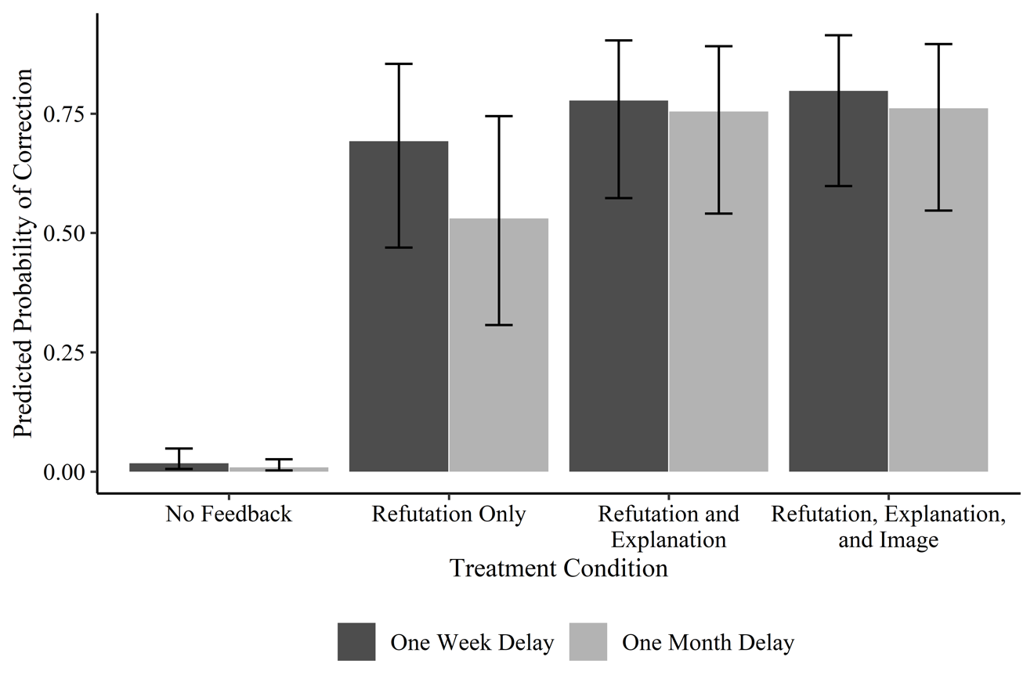
Figure 2. Probability of Correcting Beliefs in False Neuromyths after One-week and One-Month Delays in Experiment 2. Expected Posterior Means and 95% Highest Density Intervals.

Initial confidence and life influence: Unlike the results of Experiment 1, which showed that both initial confidence and influence on daily life were associated with small decreases in the likelihood of correction, results from Experiment 2 showed that these effects were smaller still and relatively more uncertain. A one-standard deviation increase in initial confidence was compatible with effects ranging from a 32% decrease in the odds of correction, to a 5% increase. Similarly, a one-standard deviation increase in reported life influence for the neuromyth was compatible with a 29% decrease in the odds of correction, to an 11% increase. A model interacting these terms with the treatment conditions (Figure S2) did not suggest that the effect of the refutations depended on initial confidence or life influence in the neuromyth (ELPDΔ = -0.4, SEΔ = 2.5).
Sources of Neuromyths: Self-reported sources of neuromyth beliefs are reported in Table 3. Of the 1,887 participant/neuromyth dyads, participants reported not recognizing the source of the statement 20% of the time. Most frequently, participants reported learning of a neuromyth from an educational source (36.2%), followed by popular science (12.7%), and friends and family (12.7%). Scientific journals were the least frequently-cited source for neuromyths (3.4%). Supplemental analyses showed that the source of the neuromyth was not associated with the likelihood of correction, and that neuromyths recognized from any source were held with higher confidence and were more often reported as being relied on in daily life than neuromyths that were not associated with a source.
General Discussion
We examined whether neuromyths could be corrected using three types of refutations (refutation-only, refutation-explanation, and refutation-explanation plus image) in two separate experiments. Results showed that all types of refutations were equally effective for correcting neuromyths in comparison to control. Because beliefs in neuromyths are pervasive and may lead people to spend time and resources on ineffective learning strategies (Dekker et al., 2012; Kowalski & Taylor, 2017; Macdonald et al., 2017), these results are promising in that they suggest that these misconceptions can be corrected using simple refutations.
It’s notable that in both experiments results showed that the refutation-only condition ("This statement is false") was as effective at changing initial erroneous beliefs as the refutation-explanation condition, and the refutation-explanation plus image conditions. These are surprising results as previous studies show that adding explanations provide a beneficial corrective effect (van Loon et al., 2015; Rich et al., 2017; Swire & Ecker, 2018). At present, we don’t have data to indicate why the refutation-only condition was as effective as the other conditions..
How details, and what types of details, affect correction success is unclear. Research shows that whereas providing detailed refutations is effective for correcting misconceptions initially (Walter & Tukachinsky, 2020), providing details may also lead to misinformation persistence (Chan et al., 2017). We speculate that it is also possible that the types of refutations used in the current study may be sufficient to change attitudes, but we don’t know if they are sufficient to change behaviors and inferential decisions–the continued influence effect (Guillory & Geraci, 2013, 2016; Lewandowsky et al., 2012). Future research might examine whether various types of detailed refutations lead to long-term behavioral changes, and which types of refutations are most effective for eliciting these changes.
Also, somewhat unexpected, in both experiments, was the finding that the three types of refutations remained equally effective even after 30 days, although the overall corrective effect decreased slightly (see Figures 1 and 2). These results stand in contrast to a recent study investigating the effect of textual refutations for correcting similar misconceptions (Ferrero et al., 2020). In the study by Ferrero and colleagues, results showed that textual refutations were effective after a one-week delay, but that erroneous beliefs returned to initial levels after 30 days. A possible reason for the difference in results across the current study and the one by Ferrero and colleagues may be that the samples differed; Ferrero and colleagues investigated teachers whereas we investigated the effects of corrections on students and a community sample of young adults. Though we can only speculate at this point, it may be that erroneous beliefs among teachers–who may recognize or have been relying on neuromyths for longer–are harder to correct than erroneous beliefs among students. As suggested, if erroneous beliefs are deeply integrated to one’s world-view and daily practice, such beliefs may be challenging to correct (Lewandowsky et al., 2012). On the other hand, teachers may be knowledgeable about which learning strategies are effective, or not. We know that people with a higher educational level (graduate degree or higher) are less likely to endorse neuromyths than those with a lower level of education (Macdonald et al., 2017). Because teachers have high educational levels with more than 50 percent of teachers in the United States having earned a graduate degree or higher (National Center for Education Statistics, 2019), it’s possible that they will be less likely than others to endorse neuromyths, and more likely to correct any they do endorse. Future research is needed to test these hypotheses.
In addition to examining the influence of the various types of refutations on participants’ ability to correct beliefs in neuromyths, we also examined how participants’ initial confidence and reliance on the neuromyths in daily life influenced their ability to accept a correction. Results suggested that participants’ initial confidence in and daily reliance on neuromyths had little influence on whether corrections were effective or not (see Figures S1 and S2). Previous results are somewhat mixed with regard to how these factors might affect corrections of misconceptions (Butler et al., 2011; Ecker et al., 2011; Lewandowsky et al., 2012; Metcalfe, 2016). On the one hand, having strong initial confidence in a misconception has been shown to lead to substantial corrective effects, a finding termed the hypercorrection effect (Butler et al., 2011; van Loon et al., 2015). On the other hand, having confident beliefs in misconceptions can also reduce the effectiveness of corrections, though some research suggests that adding explanations for refutations may be effective at correcting misconceptions that are held with high confidence (van Loon et al., 2015). Again, we did not find evidence that refutations were affected by or interacted with initial confidence in neuromyths. We did find that corrections were effective– no matter the initial confidence in the neuromyths or reliance on them in daily life.
We also examined the hypothesis that adding images may enhance the corrective effect of refutations (see Brashier & Marsh, 2020). However, we found no support for this hypothesis. Though speculative, it’s possible that there was no additional corrective benefit of adding images because the images we used did not include certain key features that might make them more persuasive. Future research might examine whether using particular types of images, such as those with more explanatory value or those that specifically represent the results from the studies (as graphs or brain images, etc.), might further increase the effectiveness of refutations.
One interesting finding from Experiment 2 was that most of the sources of neuromyths were reported to come from education. It’s possible that participants erroneously attributed their beliefs in neuromyths to educational sources. It’s also possible that participants did in fact learn of these neuromyths in classes and from teachers, which would be consistent with the research showing that these neuromyths are common amongst educators (Dekker et al., 2012, Ferrero et al., 2016; Macdonald et al., 2017; van Dijk & Lane, 2020). If the latter, then these results reinforce the finding that beliefs in neuromyths are common in the field of education and the need for effective techniques for correcting neuromyths. To avoid strengthening these false beliefs (Brashier & Marsh, 2020), it is crucial to use efficient corrective feedback, such as the refutation strategies presented here. Recent reports have highlighted the need to communicate and implement evidence-based learning strategies in educational programs and the importance of communicating common misconceptions about teaching and learning (Pomerance et al., 2016; Rose & Eriksson-Lee, 2017). Future studies should not only investigate how to reduce beliefs in neuromyths and other misconceptions, but also how to replace these neuromyths with evidence-based learning strategies.
To conclude, the current studies showed that neuromyths can be corrected and that these corrections can be long-lasting. Furthermore, corrections that contained a simple refutation (this statement is false) were as effective at changing misconceptions as those that contained scientific explanations, citations, and images. These results add to the growing literature offering effective techniques for correcting misconceptions and may have implications for classroom practice.
Marcus P. G. Lithander, Lisa Geraci and Meltem Karaca conceived and designed the studies. Marcus P. G. Lithander and Meltem Karaca collected the data. Data analyses were performed by Jason Rydberg and Marcus P. G. Lithander, and data interpretation was performed by all authors. All authors contributed to writing the manuscript and approved the final version.

References
Bensley, D. A., & Lilienfeld, S. O. (2017). Psychological Misconceptions: Recent Scientific Advances and Unresolved Issues. Current Directions in Psychological Science, 26(4), 377–382. https://doi.org/10.1177/0963721417699026
Bensley, D. A., Lilienfeld, S. O., & Powell, L. A. (2014). A new measure of psychological misconceptions: Relations with academic background, critical thinking, and acceptance of paranormal and pseudoscientific claims. Learning and Individual Differences, 36, 9-18. https://doi.org/10.1016/j.lindif.2014.07.009
Blasiman, R. N., Dunlosky, J., & Rawson, K. A. (2017). The what, how much, and when of study strategies: comparing intended versus actual study behaviour. Memory, 25(6), 784–792. https://doi.org/10.1080/09658211.2016.1221974
Brashier, N. M., & Marsh, E. J. (2020). Judging Truth. Annual Review of Psychology, 71(1), 1–17. https://doi.org/10.1146/annurev-psych-010419-050807
Brennen, J. S., Simon, F. M., Howard, P. N., & Nielsen, R. K. (2020). Types, Sources, and Claims of COVID-19 Misinformation. Oxford University Press (pp. 1–13). Retrieved from https://reutersinstitute.politics.ox.ac.uk/sites/default/files/2020-04/Brennen%20-%20COVID%2019%20Misinformation%20FINAL%20%283%29.pdf
Brunyé, T. T., Taylor, H. A., & Rapp, D. N. (2008). Repetition and dual coding in procedural multimedia presentations. Applied Cognitive Psychology: The Official Journal of the Society for Applied Research in Memory and Cognition, 22(7), 877-895.
https://doi.org/10.1002/acp.1396
Buhrmester, M., Kwang, T., & Gosling, S. D. (2011). Amazon’s mechanical Turk: A new source of inexpensive, yet high-quality, data? Perspectives on Psychological Science, 6(1), 3–5. https://doi.org/10.1177/1745691610393980
Bürkner, P. C. (2017). brms: An R package for Bayesian multilevel models using Stan. Journal of statistical software, 80(1), 1-28. https://doi.org/10.18637/jss.v080.i01
Butler, A. C., Fazio, L. K., & Marsh, E. J. (2011). The hypercorrection effect persists over a week, but high-confidence errors return. Psychonomic Bulletin & Review, 18(6), 1238-1244. https://doi.org/10.3758/s13423-011-0173-y
Cacioppo, J. T., Petty, R. E., & Feng Kao, C. (1984). The efficient assessment of need for cognition. Journal of personality assessment, 48(3), 306-307. https://doi.org/10.1207/s15327752jpa4803_13
Chan, M. P. S., Jones, C. R., Hall Jamieson, K., & Albarracín, D. (2017). Debunking: A meta-analysis of the psychological efficacy of messages countering misinformation. Psychological science, 28(11), 1531-1546.
Clark, J. M., & Paivio, A. (1991). Dual coding theory and education. Educational Psychology Review, 3(3), 149–210. https://doi.org/10.1007/BF01320076
Corballis, M. C. (2014). Left Brain, Right Brain: Facts and Fantasies. PLoS Biology, 12(1), Article e1001767. https://doi.org/10.1371/journal.pbio.1001767
Danielson, R. W., Sinatra, G. M., & Kendeou, P. (2016). Augmenting the Refutation Text Effect with Analogies and Graphics. Discourse Processes, 53(5–6), 392–414. https://doi.org/10.1080/0163853X.2016.1166334
De Bruyckere, P., Kirschner, P. A., & Hulshof, C. D. (2015). Urban myths about learning and education. Academic Press.
DeStefano, F., & Shimabukuro, T. T. (2019). The MMR vaccine and autism. Annual review of virology, 6(1), 585–600. https://doi.org/10.1146/annurev-virology-092818-015515
Dekker, S., Lee, N. C., Howard-Jones, P., & Jolles, J. (2012). Neuromyths in education: Prevalence and predictors of misconceptions among teachers. Frontiers in Psychology, 3, 429. http://dx.doi.org/10.3389/fpsyg.2012.00429
Dunlosky, J., Rawson, K. A., Marsh, E. J., Nathan, M. J., & Willingham, D. T. (2013). Improving Students’ Learning with Effective Learning Techniques. Psychological Science in the Public Interest, 14(1), 4–58. https://doi.org/10.1177/1529100612453266
Ecker, U. K. H., Hogan, J. L., & Lewandowsky, S. (2017). Reminders and Repetition of Misinformation: Helping or Hindering Its Retraction? Journal of Applied Research in Memory and Cognition, 6(2), 185–192. https://doi.org/10.1016/j.jarmac.2017.01.014
Ecker, U. K. H., Hogan, J. L., & Lewandowsky, S. (2017). Reminders and Repetition of Misinformation: Helping or Hindering Its Retraction? Journal of Applied Research in Memory and Cognition, 6(2), 185–192. https://doi.org/10.1016/j.jarmac.2017.01.014
Enders, C. K., & Tofighi, D. (2007). Centering predictor variables in cross-sectional multilevel models: a new look at an old issue. Psychological methods, 12(2), 121.
https://doi.org/10.1037/1082-989X.12.2.121
Ferrero, M., Garaizar, P., & Vadillo, M. A. (2016). Neuromyths in Education: Prevalence among Spanish Teachers and an Exploration of Cross-Cultural Variation. Frontiers in Human Neuroscience, 10, Article 496. https://doi.org/10.3389/fnhum.2016.00496
Ferrero, M., Hardwicke, T. E., Konstantinidis, E., & Vadillo, M. A. (2020). The effectiveness of refutation texts to correct misconceptions among educators. Journal of Experimental Psychology: Applied. https://doi.org/10.1037/xap0000258
Ghosh, J., Li, Y., & Mitra, R. (2018). On the use of Cauchy prior distributions for Bayesian logistic regression. Bayesian Analysis, 13(2), 359-383. https://doi.org/10.1214/17-BA1051
Guillory, J. J., & Geraci, L. (2013). Correcting erroneous inferences in memory: The role of source credibility. Journal of Applied Research in Memory and Cognition, 2(4), 201–209. https://doi.org/10.1016/j.jarmac.2013.10.001
Guillory, J. J., & Geraci, L. (2016). The Persistence of Erroneous Information in Memory: The Effect of Valence on the Acceptance of Corrected Information. Applied Cognitive Psychology, 30(2), 282–288. https://doi.org/10.1002/acp.3183
Howe, M. J. (1970). Repeated presentation and recall of meaningful prose. Journal of Educational Psychology, 61(3), 214–219. https://doi.org/10.1037/h0029102
Keith, M. G., Tay, L., & Harms, P. D. (2017). Systems perspective of Amazon Mechanical Turk for organizational research: Review and recommendations. Frontiers in Psychology, 8, Article 1359. https://doi.org/10.3389/fpsyg.2017.01359
Kouzy, R., Abi Jaoude, J., Kraitem, A., El Alam, M. B., Karam, B., Adib, E., ... & Baddour, K. (2020). Coronavirus goes viral: quantifying the COVID-19 misinformation epidemic on Twitter. Cureus, 12(3). https://doi.org/10.7759/cureus.7255
Kowalski, P., & Taylor, A. K. (2017). Reducing students’ misconceptions with refutational teaching: For long-term retention, comprehension matters. Scholarship of Teaching and Learning in Psychology, 3(2), 90–100. https://doi.org/http://dx.doi.org/10.1037/stl0000082
Lewandowsky, S., Ecker, U. K. H., Seifert, C. M., Schwarz, N., & Cook, J. (2012). Misinformation and Its Correction: Continued Influence and Successful Debiasing. Psychological Science in the Public Interest, 13(3), 106–131. https://doi.org/10.1177/1529100612451018
Macdonald, K., Germine, L., Anderson, A., Christodoulou, J., & McGrath, L. M. (2017). Dispelling the myth: Training in education or neuroscience decreases but does not eliminate beliefs in neuromyths. Frontiers in Psychology, 8, Article 1314. https://doi.org/10.3389/fpsyg.2017.01314
Mason, L., Baldi, R., Di Ronco, S., Scrimin, S., Danielson, R. W., & Sinatra, G. M. (2017). Textual and graphical refutations: Effects on conceptual change learning. Contemporary Educational Psychology, 49, 275–288. https://doi.org/10.1016/j.cedpsych.2017.03.007
McElreath, R. (2020). Statistical rethinking: A Bayesian course with examples in R and Stan. CRC press.
Metcalfe, J. (2017). Learning from errors. Annual review of psychology, 68, 465-489.
https://doi.org/10.1146/annurev-psych-010416-044022
Metcalfe, J., & Finn, B. (2011). People's hypercorrection of high-confidence errors: Did they know it all along?. Journal of Experimental Psychology: Learning, Memory, and Cognition, 37(2), 437. https://doi.org/10.1037/a0021962
Morehead, K., Rhodes, M. G., & DeLozier, S. (2016). Instructor and student knowledge of study strategies. Memory, 24(2), 257–271. https://doi.org/10.1080/09658211.2014.1001992
Nagel, B. J., Herting, M. M., Maxwell, E. C., Bruno, R., & Fair, D. (2013). Hemispheric lateralization of verbal and spatial working memory during adolescence. Brain and Cognition, 82(1), 58–68. https://doi.org/10.1016/j.bandc.2013.02.007
National Center for Education Statistics (2019). Number, highest degree, and years of teaching experience of teachers in public and private elementary and secondary schools, by selected teacher characteristics: Selected years, 1999-2000 through 2017-18. Retrieved March 3, 2021, from https://nces.ed.gov/programs/digest/d19/tables/dt19_209.20.asp?current=yes
Newman, E. J., Garry, M., Bernstein, D. M., Kantner, J., & Lindsay, D. S. (2012). Nonprobative photographs (or words) inflate truthiness. Psychonomic Bulletin & Review, 19(5), 969-974. https://doi.org/10.3758/s13423-012-0292-0
Nielsen, J. A., Zielinski, B. A., Ferguson, M. A., Lainhart, J. E., & Anderson, J. S. (2013). An Evaluation of the Left-Brain vs. Right-Brain Hypothesis with Resting State Functional Connectivity Magnetic Resonance Imaging. PLoS ONE, 8(8), Article e71275. https://doi.org/10.1371/journal.pone.0071275
Nyhan, B., & Reifler, J. (2010). When corrections fail: The persistence of political misperceptions. Political Behavior, 32(2), 303-330.
https://doi.org/10.1007/s11109-010-9112-2
Pomerance, L., Greenberg, J., & Walsh, K. (2016). Learning about Learning: What Every New Teacher Needs to Know. National Council on Teacher Quality. Retrieved from https://files.eric.ed.gov/fulltext/ED570861.pdf
R Core Team. (2020). R: A Language and Environment for Statistical Computing. Vienna, Austria. Retrieved from https://www.R-project.org/
Raudenbush, S. W., & Bryk, A. S. (2002). Hierarchical linear models: Applications and data analysis methods (2nd edition). Sage Publications, Inc.
Rich, P. R., Van Loon, M. H., Dunlosky, J., & Zaragoza, M. S. (2017). Belief in corrective feedback for common misconceptions: Implications for knowledge revision. Journal of Experimental Psychology: Learning Memory and Cognition, 43(3), 492–501. https://doi.org/10.1037/xlm0000322
Rose, N. & Eriksson-Lee, L. (2017) Putting evidence to work: how can we help new teachers use research evidence to inform their teaching?. Teach First. Retrieved from
https://www.teachfirst.org.uk/reports/putting-evidence-work
Sally Chan, M., Jones, C. R., Hall Jamieson, K., & Albarraci, D. (2017). Debunking: A Meta-Analysis of the Psychological Efficacy of Messages Countering Misinformation. Psychological Science, 28(11), 1531–1546. https://doi.org/10.1177/0956797617714579
Schwarz, N., Newman, E., & Leach, W. (2016). Making the truth stick & the myths fade: Lessons from cognitive psychology. Behavioral Science & Policy, 2(1), 85–95. https://doi.org/10.1353/bsp.2016.0009
Sosu, E. M. (2013). The development and psychometric validation of a Critical Thinking Disposition Scale. Thinking skills and creativity, 9, 107-119. https://doi.org/10.1016/j.tsc.2012.09.002
Soto, C. J., & John, O. P. (2017). Short and extra-short forms of the Big Five Inventory–2: The BFI-2-S and BFI-2-XS. Journal of Research in Personality, 68, 69-81. https://doi.org/10.1016/j.jrp.2017.02.004
Swami, V., Stieger, S., Pietschnig, J., Nader, I. W., & Voracek, M. (2012). Using more than 10% of our brains: Examining belief in science-related myths from an individual differences perspective. Learning and Individual Differences, 22(3), 404–408. https://doi.org/10.1016/j.lindif.2011.12.005
Swire B., Ecker, U. K. H. (2018). Misinformation and its correction: cognitive mechanisms and recommendations for mass communication. In Southwell, B. G., Thorson, E. A., & Sheble, L. (Eds.), Misinformation and mass audiences (pp. 195–211). University of Texas Press.
Tardif, E., Doudin, P. A., & Meylan, N. (2015). Neuromyths among teachers and student teachers. Mind, brain, and Education, 9(1), 50-59. https://doi.org/10.1111/mbe.12070
Van Boekel, M., Lassonde, K. A., O’Brien, E. J., & Kendeou, P. (2017). Source credibility and the processing of refutation texts. Memory and Cognition, 45(1), 168–181. https://doi.org/10.3758/s13421-016-0649-0
van Buuren, S., & Groothuis-Oudshoorn, C. G. M. (2011). mice: Multivariate Imputation by Chained Equations in R. Journal of statistical software, 45(3). https://doi.org/10.18637/jss.v045.i03
van Dijk, W., & Lane, H. B. (2018). The brain and the US education system: Perpetuation of neuromyths. Exceptionality 28(1), 16–29. https://doi.org/10.1080/09362835.2018.1480954
van Loon, M. H., Dunlosky, J., van Gog, T., van Merriënboer, J. J. G., & de Bruin, A. B. H. (2015). Refutations in science texts lead to hypercorrection of misconceptions held with high confidence. Contemporary Educational Psychology, 42, 39–48. https://doi.org/10.1016/j.cedpsych.2015.04.003
Vehtari, A., Gelman, A., & Gabry, J. (2017). Practical Bayesian model evaluation using leave-one-out cross-validation and WAIC. Statistics and computing, 27(5), 1413-1432. https://doi.org/10.1007/s11222-016-9709-3
von Ahn, L., Maurer, B., McMillen, C., Abraham, D., & Blum, M. (2008). reCAPTCHA: Human-based character recognition via web security measures. Science, 321(5895), https://doi.org/10.1126/science.1160379
Walter, N., & Tukachinsky, R. (2020). A Meta-Analytic Examination of the Continued Influence of Misinformation in the Face of Correction: How Powerful Is It, Why Does It Happen, and How to Stop It? Communication Research, 47(2), 155–177. https://doi.org/10.1177/0093650219854600
Wells, C., Reedy, J., Gastil, J., & Lee, C. (2009). Information distortion and voting choices: The origins and effects of factual beliefs in initiative elections. Political Psychology, 30(6), 953-969. https://doi.org/10.1111/j.1467-9221.2009.00735.x
Weinstein, Y., Madan, C. R., & Sumeracki, M. A. (2018). Teaching the science of learning. Cognitive Research: Principles and Implications, 3(1), 2. https://doi.org/10.1186/s41235-017-0087-y
Wilkes, A. L., & Leatherbarrow, M. (1988). Editing Episodic Memory Following the Identification of Error. The Quarterly Journal of Experimental Psychology, 40(2), 361–387. https://doi.org/10.1080/02724988843000168

Table 1
Estimates for Correctly Detecting Neuromyths.
Posterior Distributions for Cross-Classified Mixed Effect Logit Model Parameters in Experiment 1.
Parameter | Posterior Mean [95% HDI] | Odds Ratio [95% HDI]
No correction (Intercept) | -3.47 [-4.26, -2.67]
Refutation – Only | 5.34 [4.29, 6.37] | 207.77 [72.66, 585.53]
Refutation – Explanation | 5.15 [4.12, 6.14] | 172.99 [61.65, 465.52]
Refutation – Explanation - Image | 4.95 [3.99, 5.93] | 141.79 [54.00, 376.40]
One-Month Delay | -0.34 [-0.53, -0.15] | 0.71 [0.59, 0.86]
Initial Confidence | -0.17 [-0.33, -0.02] | 0.84 [0.72, 0.98]
Life Influence | -0.21 [-0.38, -0.05] | 0.81 [0.69, 0.95]
Big 5 | 0.25 [-0.19, 0.69] | 1.29 [0.83, 1.99]
Critical Thinking | -0.03 [-0.44, 0.41] | 0.97 [0.65, 1.50]
Need for Cognition | 0.08 [-0.29, 0.45] | 1.08 [0.75, 1.57]
Random Intercept SD
Question | 0.78 [0.52, 1.14]
Participant | 1.87 [1.58, 2.20]
Question × Participant | 1.65 [1.41, 1.91]
Note: N = 160, Q = 20, N × Q = 2,114, N × Q × T = 4,228; HDI = Highest density interval
Positive (higher) estimates indicate higher likelihood of detecting neuromyths

Table 2
Posterior Distributions for Cross-Classified Mixed Effect Logit Model Parameters in Experiment 2.
Parameter | Posterior Mean [95% HDI] | Odds Ratio [95% HDI]
No correction (Intercept) | -4.14 [-5.20, -3.09]
Refutation – Only | 4.80 [3.57, 6.07] | 122.30 [35.62, 431.19]
Refutation – Explanation | 5.53 [4.27, 6.80] | 250.78 [71.20, 896.05]
Refutation – Explanation - Image | 5.61 [4.32, 6.91] | 273.26 [74.84, 1002.5]
One-Month Delay | -0.41 [-0.62, -0.19] | 0.67 [0.54, 0.83]
Initial Confidence | -0.18 [-0.39, 0.05] | 0.83 [0.67, 1.05]
Life Influence | -0.13 [-0.35, 0.10] | 0.88 [0.71, 1.11]
Big 5 | -0.11 [-0.61, 0.34] | 0.88 [0.54, 1.41]
Critical Thinking | -0.13 [-0.54, 0.35] | 0.92 [0.58, 1.42]
Need for Cognition | 0.19 [-0.34, 0.61] | 1.14 [0.71, 1.83]
Random Intercept SD
Question | 1.04 [0.70, 1.52]
Participant | 2.29 [1.93, 2.71]
Question × Participant | 2.36 [2.06, 2.69]
Note: N = 157, Q = 20, N × Q = 1,887, N × Q × T = 3,774; HDI = Highest density interval

Table 3
Identified Sources of Neuromyths in Experiment 2.
Source | n (%)
Do not recognize statement | 380 (20.14)
Education (e.g., teacher or textbook) | 683 (36.20)
Fiction (e.g., movies or literature) | 98 (5.19)
Friends and Family | 239 (12.67)
Popular Science (e.g., magazines or news) | 240 (12.72)
Scientific Journal | 64 (3.39)
Other | 183 (9.70)
N = 157, Q = 20, N × Q = 1,887

Supplementary Materials
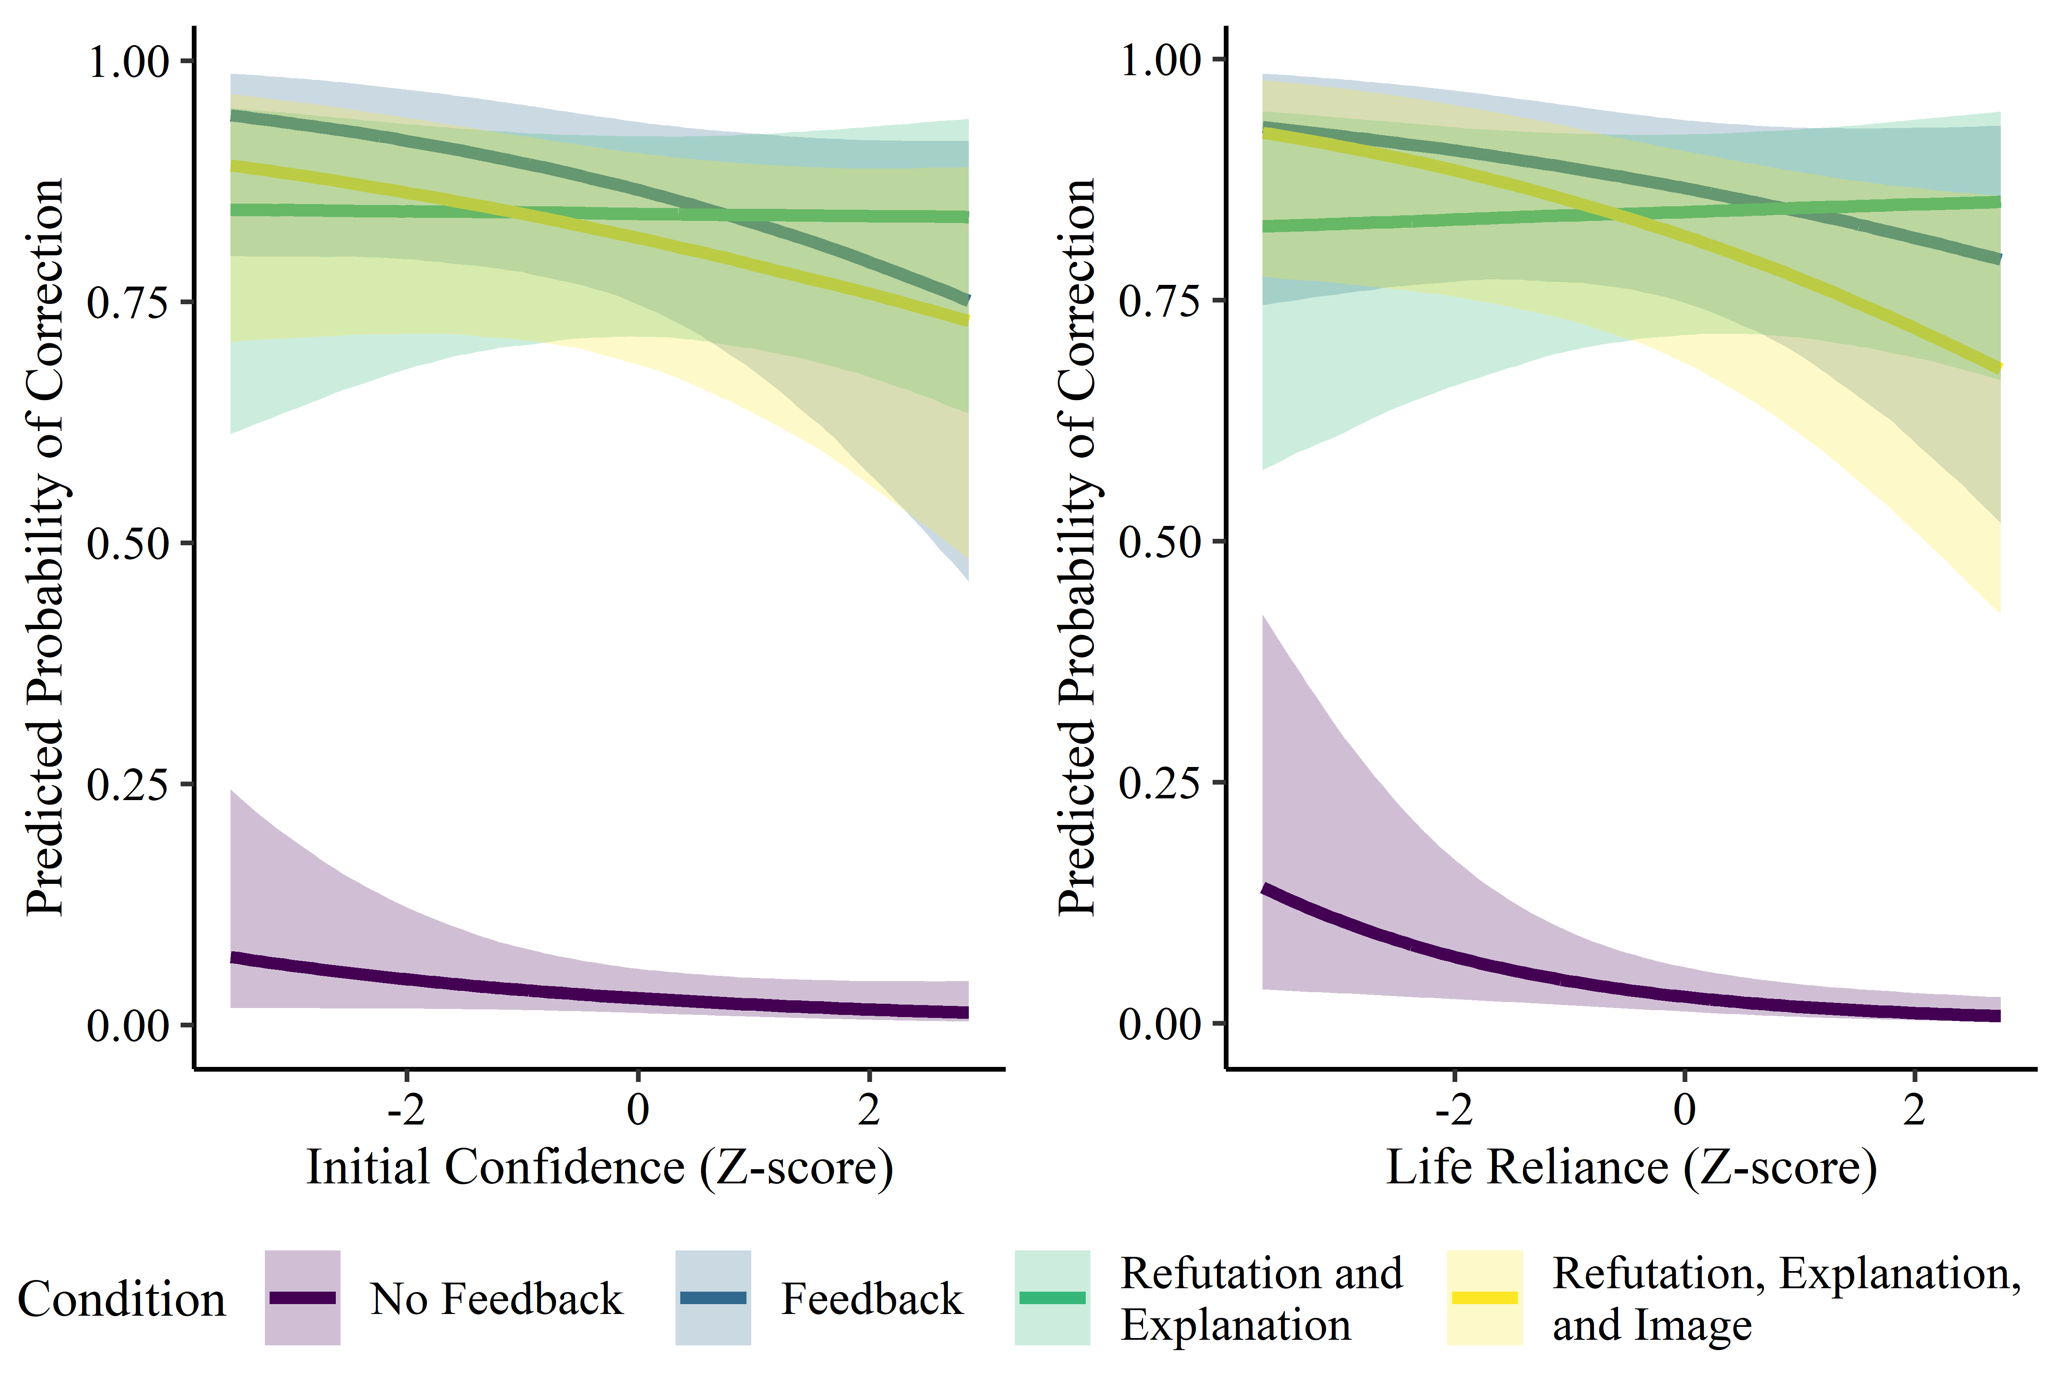
Figure S1. Predicted Probability of Correcting Beliefs in Neuromyths by Condition, Initial Confidence, and Life Reliance in Experiment 1. Posterior Means and 95% Highest Density Intervals.

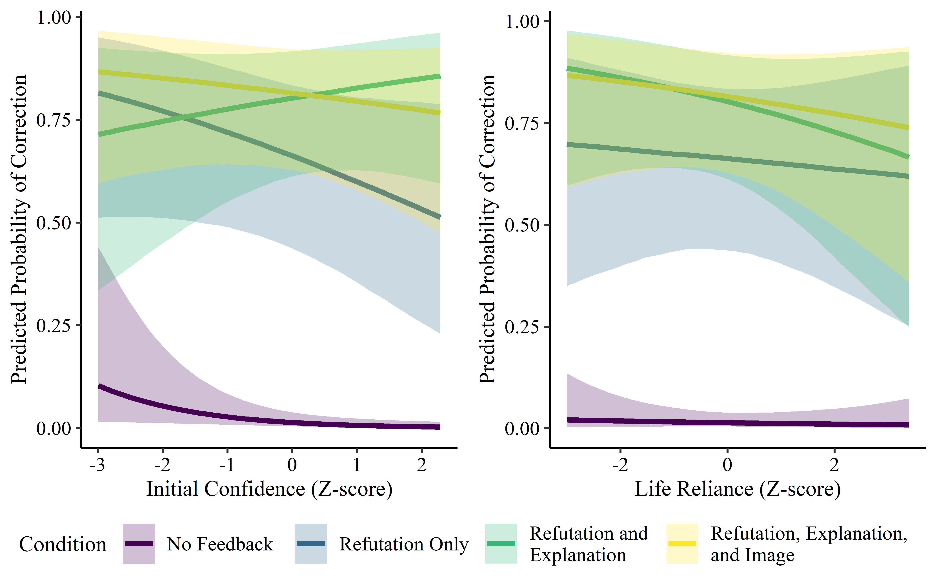
Figure S2. Predicted Probability of Correcting Beliefs in Neuromyths by Condition, Initial Confidence, and Life Reliance in Experiment 2. Posterior Means and 95% Highest Density Intervals.

Appendix
True statements
Statement 1: In general, boys have bigger brains than girls.
Refutation-only: This statement is true.
Refutation-explanation: It is true that boys, on average, have bigger brains than girls. Males, on average, have significantly larger total brain volume than females. Even when males and females have matching general intelligence scores (controlled for height) sex differences in brain size remain significant (Lindel, Dunkel, & Madison, 2017).
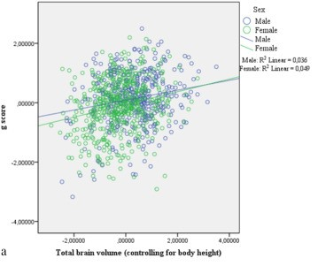
Statement 2: We store and distribute information throughout networks of cells within the brain.
Refutation: This statement is true.
Refutation-explanation: It is true that information storage is distributed through a network of cells across the brain rather than in a single part of the brain. Memories are stored in the brain, yet, these memories are distributed across a network of locations. These locations use some of the locations that are involved in the original experience (Miller, 2012; Miller et al., 2013).
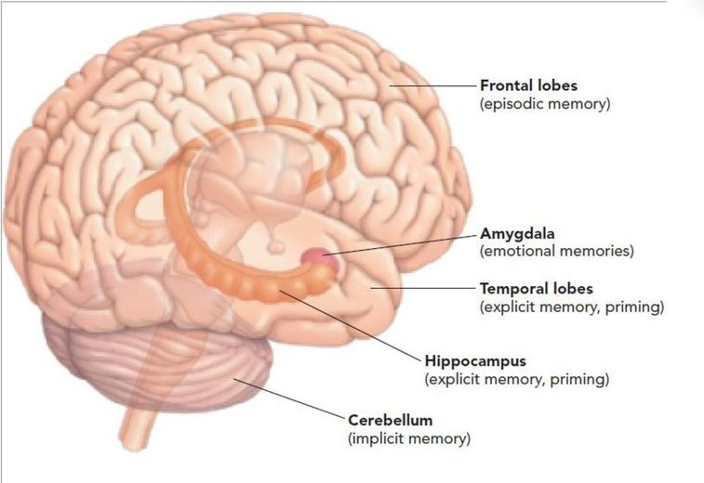
Statement 3: Bilingualism has benefits to general cognitive ability.
Refutation: This statement is true.
Refutation-explanation: It is true that being bilingual leads to some advantages in cognitive ability. Bilingual individuals have advantages with the flexibility to reconfigure their behavior. The advantage is more specifically related to executive function (the ability to regulate function). Neuroimaging investigations show greater activation in the basal ganglia relating to responses to changing task demands and leading to higher cognitive scores (Stocco & Pratt, 2014).
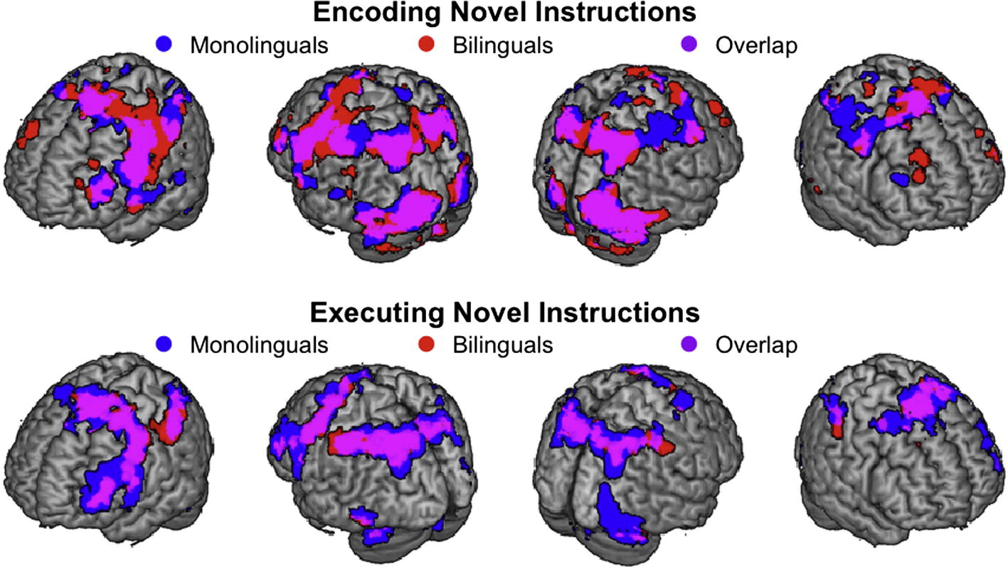

Statement 4: Learning occurs through modification of the brain's neural connections.
Refutation: This statement is true.
Refutation-explanation: This statement is true. Learning occurs through modification of the brain's neural connections. Neurons in the brain cluster into groups or neural networks. Neural connections can be modified. For example, neural connections can be strengthened if one experiences stimuli repeatedly (Myers & DeWall, 2018).
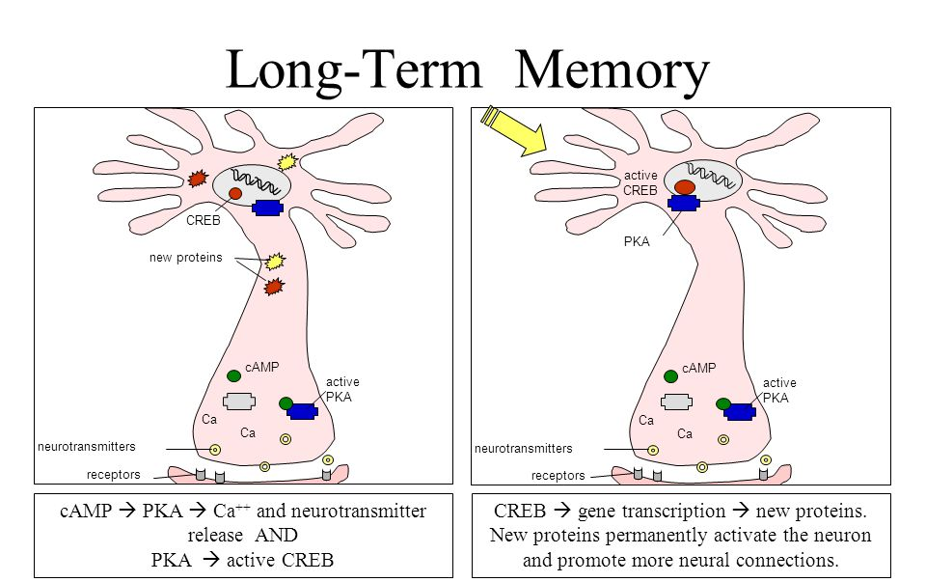
Statement 5: Normal development of the human brain involves the birth and death of brain cells.
Refutation: This statement is true.
Refutation-explanation: This statement is true. Normal development of the human brain involves the birth and death of brain cells. Due to the influence of adrenal hormones, billions of synaptic connections form. A process called pruning diminishes synaptic connections that are not in use (“use-it-or-lose-it”) (Paus, 2005).
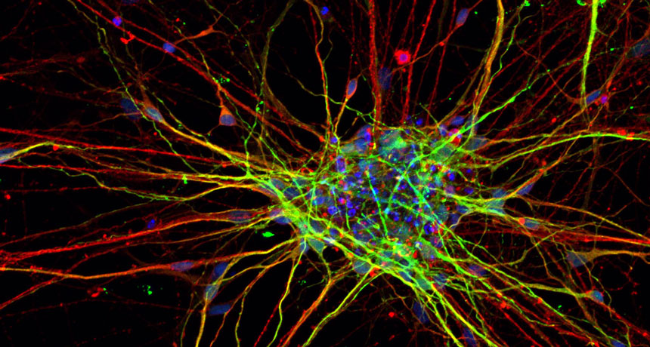
Statement 6: Vigorous exercise can improve mental function.
Refutation: This statement is true.
Refutation-explanation: It is true that exercise can improve mental function. A meta-analysis of 200 studies suggested that exercise has a small positive effect on cognition (Etnier, Salazar, Landers, & Petruzello, 1997).
Statement 7: Circadian rhythms (“body-clock”) shift during adolescence causing students to be tired during the first lessons of the school day.
Refutation: This statement is true.
Refutation-explanation: This statement is true. Circadian rhythms shift during adolescence, causing students to be tired during the first lessons of the school day. Sleep deprivation is due, in part, to changes in the homeostatic and circadian regulation of sleep. For example, the pre-pubertal gonadectomy of degus was found to block circadian phase changes around the time of puberty (Hagenauer, Perryman, Lee & Carskadon 2009).
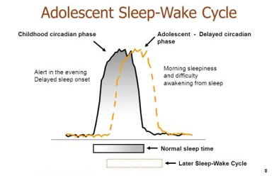
Statement 8: Production of new connections in the brain can continue into old age.
Refutation: This statement is true.
Refutation-explanation: It is true that the production of new connections in the brain can continue into old age. The brain's ability to build new pathways is called plasticity. Although this is strongest in childhood, it continues throughout life (Gutchess, 2014).
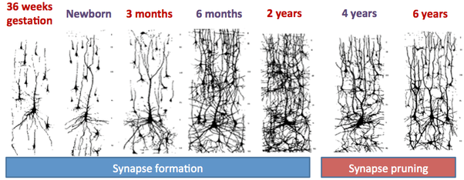
Statement 9: There are sensitive periods in childhood when it’s easier to learn particular things.
Refutation: This statement is true.
Refutation-explanation: It is true that some things are easier to learn during specific periods of development. For example, learning a second language is easier up to the age of puberty; after puberty, the ability to learn new information generally decreases. (Hartshorne, Tenenbaum & Pinker, 2018)
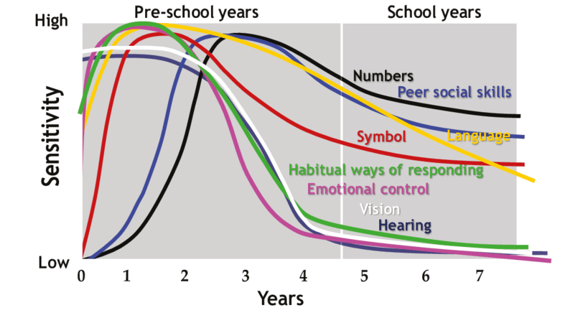
Statement 10: Spacing out five hours of study time over a couple of days promotes better learning compared to studying for five hours straight.
Refutation: This statement is true.
Refutation-explanation: It is true that spacing study is more beneficial than cramming (massed study) before a test. Studying for five hours over two weeks is better than studying for five hours at a time (Benjamin & Tulis, 2010).
Statement 11: Self-testing is an efficient way to learn.
Refutation: This statement is true.
Refutation-explanation: It is true that testing oneself is an effective method of learning information. Taking practice tests, using flashcards, and recalling words, definitions, and main ideas are all efficient ways to learn information (Roediger, Putnam, & Smith, 2011).
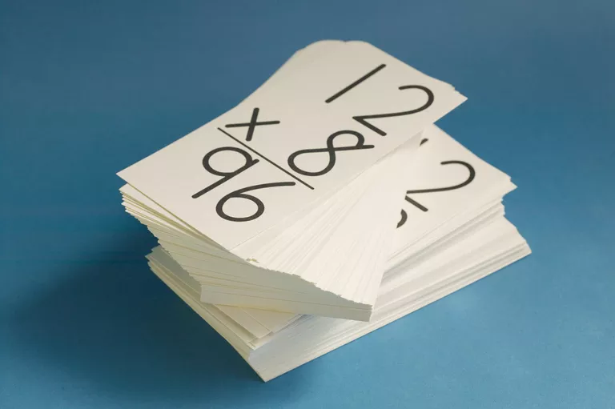

Statement 12: Creating your own examples and creating links between them is beneficial to the learning process.
Refutation: This statement is true.
Refutation-explanation: This statement is true. It is true that creating your own examples as well as creating links between them is beneficial to the learning process. Collecting concrete examples and linking the ideas to the examples can help you understand information. Creating your own examples is beneficial for learning (Rawson, Thomas, & Jacoby, 2014)
Statement 13: Combining words with visuals while studying is more effective than just doing one or the other.
Refutation: This statement is true.
Refutation-explanation: It is true that combining words with visual representations is more effective than studying either one (words or images) individually. Taking the information, you are trying to learn and creating/using visual aids to go along with it (infographics, timelines, or diagrams) helps aid memory via a process called dual coding (Mayer & Anderson, 1992).
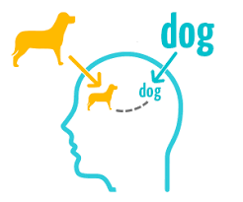
Statement 14: Cognitive and emotional systems are highly interlinked in the brain so emotional factors like depression and anxiety can negatively affect learning.
Refutation: This statement is true.
Refutation-explanation: It is true that there is a link between cognitive and emotional systems. One study investigated the relationship between negative affect, worry, working memory, and academic performance. The results showed that higher levels of anxiety and depression were associated with lower levels of academic performance (Owens, Stevenson, & Hadwin, 2012).
Statement 15: Explaining and describing ideas with many details is an efficient way to learn.
Refutation: This statement is true.
Refutation-explanation: It is true that explaining and describing ideas with many details is an efficient way to learn. Using elaboration (explaining and describing information) is beneficial to the learning process by creating more connections to help with the recall of information (McDaniel & Donnely, 1996).
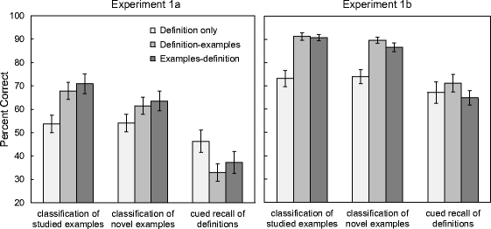
Statement 16: Asking “how” and “why” questions while studying is an effective way to learn.
Refutation: This statement is true.
Refutation-explanation: It is true that asking "how" and "why" questions can be an effective way to study. Asking questions can be used as a form of elaboration, which can aid understanding of the new information by making connections between different ideas (McDaniel & Donnely, 1996).
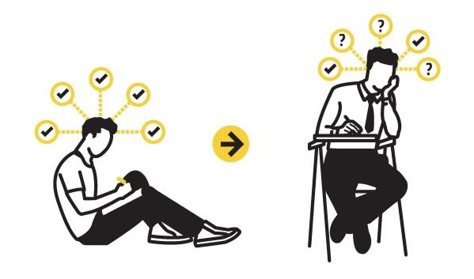
Statement 17: It is better to switch between ideas or problems while studying compared to studying one problem or idea at the time.
Refutation: This statement is true.
Refutation-explanation: It is true that interleaving, or switching between ideas or problems while studying, is beneficial for learning. Switching between different ideas will help make links between concepts and strengthen understanding of the information (Rohrer, 2012).
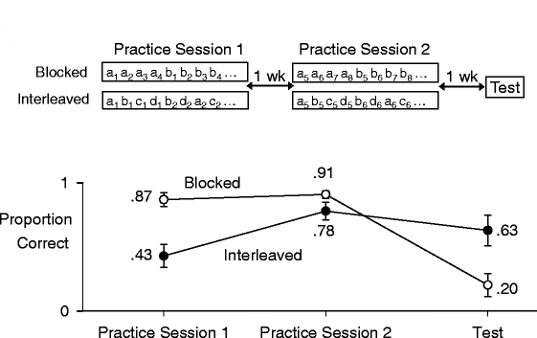
Statement 18: When seeing a loved one in pain, our brain mirrors that pain.
Refutation: This statement is true.
Refutation-explanation: It is true that pain is mirrored in the observer's brain. Seeing a romantic partner in pain triggers the same brain activity experienced as by loved one who is actually experiencing the pain (Singer et al. 2004).
Statement 19: People can construct false memories of episodes in their lives.
Refutation: This statement is true.
Refutation-explanation: It is true that people can create false memories of episodes in their life. Repeatedly imagining nonexistent actions and events can create false memories. In a study in which participants were repeatedly interviewed and asked to imagine to having committed a crime, participants later reported (falsely) having been involved in the crime (for review see Schacter, 1999).
Statement 20: A memory-master has been able to memorize and recall 300 digits when each digit was presented at a speed of 1 digit per second.
Refutation: This statement is true.
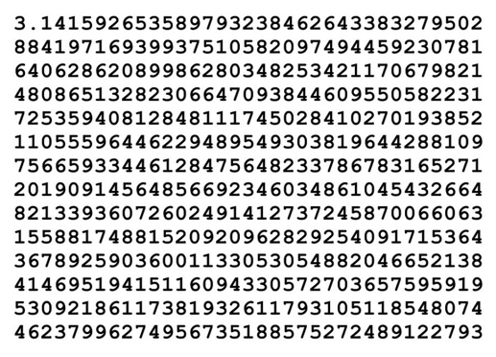
Refutation-explanation: It is true, the world champion in memory has been able to remember 300 digits, presented 1 digit/s. This extraordinary performance is explained by his acquisition of well-known mnemonic techniques and his training that focused on rapid memorization (Logie, 2018).

False statements (neuromyths)
Statement 1: Individuals learn better when they receive information in their preferred learning style (e.g., auditory, visual, kinesthetic).
Refutation: This statement is false.
Refutation-explanation: This statement is false. Although the concept of learning styles is widespread, individuals do not learn better when they receive information in their preferred learning style. It is true that students have personal preferences for different learning styles. However, the matching hypothesis of learning styles does not hold up. For example, students classified as “auditory learners” do not learn better by studying using auditory material compared to visual material (Pashler et al., 2008).
Statement 2: Differences in hemispheric dominance (left brain, right brain) can help explain individual differences among learners.
Refutation: This statement is false.
Refutation-explanation: This statement is false. No study has been able to show that differences in hemispheric dominance can explain individual differences amongst learners or that analytical thinking and creative thinking is isolated to the left and right hemisphere respectively. Performance in most everyday tasks, including learning, requires many regions in both hemispheres to work together. Several parts of both the left and right hemisphere of the brain are important for analytical as well as creative thinking (Nielsen, Zielinski, Ferguson, Lainhart, & Anderson, 2013).
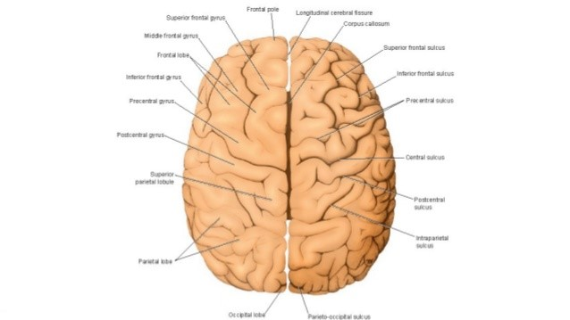
Statement 3: We only use 10% of our brain.
Refutation: This statement is false.
Refutation-explanation: This statement is false. Humans use all of their brain all the time - even when we are "doing nothing" neurons are firing throughout the brain. No part of the brain is normally inactive in the sense that no blood flow is occurring (you would be very ill if only 10% of your brain was active) (Jones, 2009).
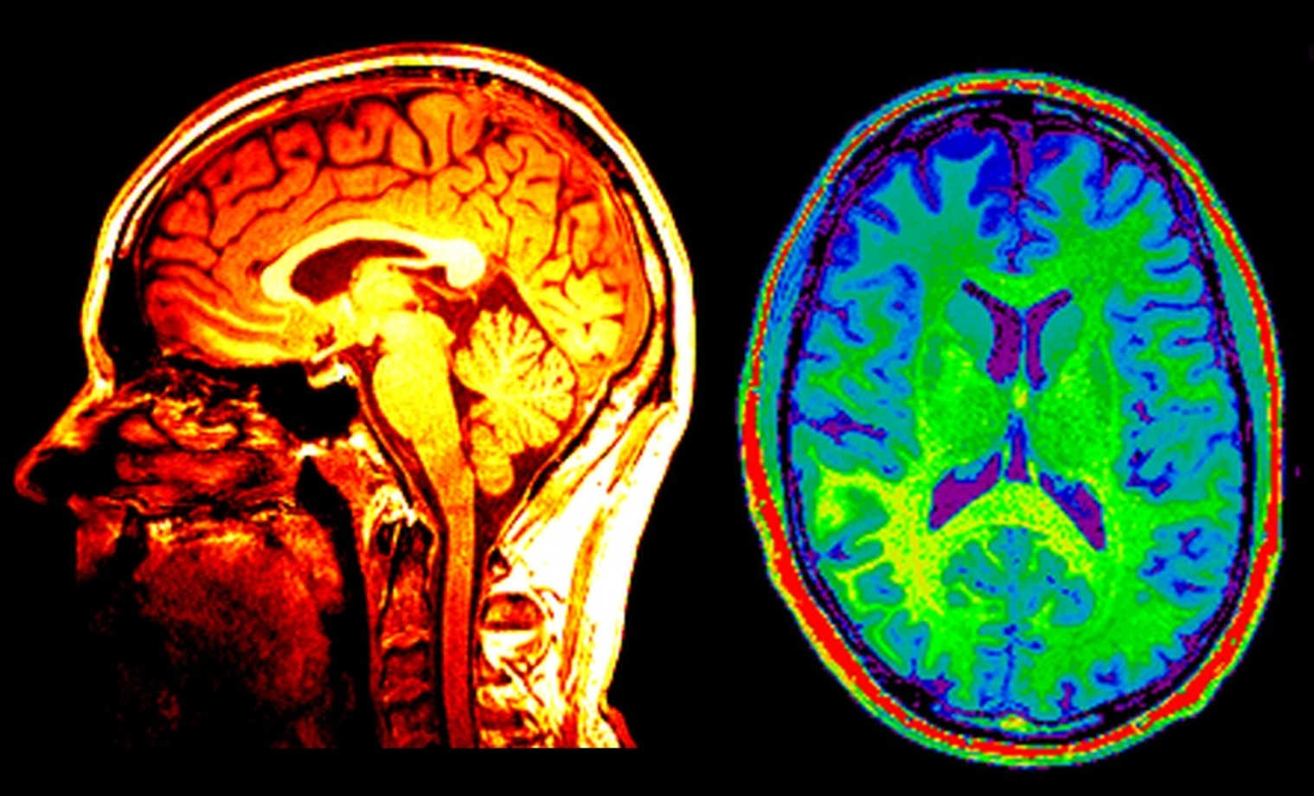
Statement 4: Children are less attentive after consuming sugary drinks and/or snacks than after consuming healthy snacks.
Refutation: This statement is false.
Refutation-explanation: This statement is false. Many people believe that consuming sugar leads to reduced attention. However, the research linking sugar and attention is mixed at best with some studies even showing benefits to attention. A review of 16 studies concluded that sugar does not affect behavior or cognition in children (Wolraich, Wilson & White, 1995).
Statement 5: If students do not drink sufficient amounts of water, their brains may shrink.
Refutation: This statement is false.
Refutation-explanation: This statement is false. Although it's true that dehydration can quickly reduce our mental abilities, in the absence of exercise or unusual heat, reports of dehydration among healthy children who have access to a quality water supply are very rare. There is scarce evidence of improved cognitive performance from drinking water. Drinking water when not thirsty is unlikely to raise grades and can even reduce mental ability (Rogers, Kainth & Smit 2001).

Statement 6: Exercises that rehearse the coordination of motor-perception skills improve literacy skills.
Refutation: This statement is false.
Refutation-explanation: This statement is false. Exercise is very good for the brain and good for learning. However, approaches that seek to integrate perceptual and motor skills do not appear to improve learning. Coordination exercises tend to be low in aerobic content. Furthermore, for a person who has a developmental coordination disorder (DCD), such a disorder can lead to motor difficulties, which may interfere with academic achievement or activities of daily living (Gibbs, Appleton, & Appleton, 2007). Exercises that rehearse the coordination for students in general have not shown to provide improved academic skills.
Statement 7: Rereading notes is an effective way to learn the material.
Refutation: ​ This statement is false.
Refutation-explanation: This statement is false. Rereading is not an effective way of studying. Instead, it is better for students to test themselves on the to-be-learned material. Rereading can give an illusion of fluency. Students may become familiar with the words and think they know the material although they cannot recall it later.
Statement 8: Educational kinesiology - exercises that focus on coordination - can improve integration between the left and right hemisphere, enhancing general cognitive abilities.
Refutation: This statement is false.
Refutation-explanation: This statement is false. Educational kinesiology is not an effective way to enhance learning in general. Crossover-hemispheric connections can be enhanced when children use both left and right side of the body to learn a new skill. However, this does not lead to improved general learning skills (Moore, Schaefer, Bastin, Roberts, & Overy, 2014).
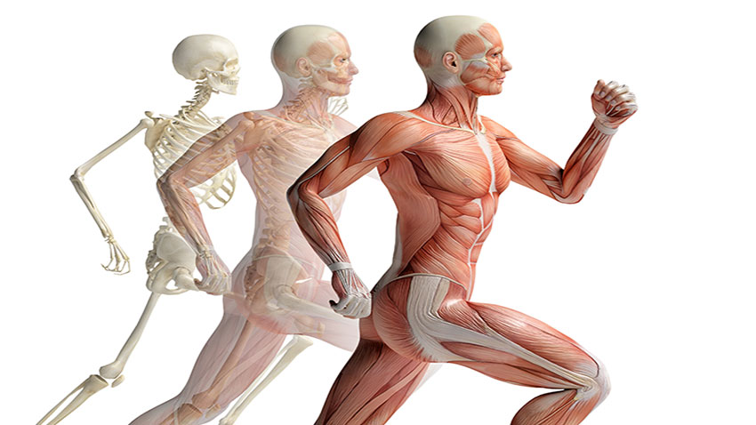
Statement 9: It has been scientifically proven that fatty acid supplements (omega-3 and omega-6) have a positive effect on academic achievement.
Refutation: This statement is false.
Refutation-explanation: This statement is false. No study has provided a direct link between the intake of omega 3 and academic achievement. Although, some studies have found that higher intake of omega-3 intake may reduce the risk of Alzheimer disease, supplementing omega-3 fatty acids in the diet of young children does not improve academic outcomes (Brew et al., 2014).
Statement 10: Memory is stored in the brain as in a computer.
Refutation: This statement is false.
Refutation-explanation: This statement is false. Memory is not stored in single units and memories are not perfectly retrieved, similar to a computer. Memories are stored throughout the brain. Networks of neurons create representations of perceptual experience that support a variety of cognitive functions, such as object recognition, social cognition, language, and the ability to remember the past and envision the future (Binder & Desai, 2011).
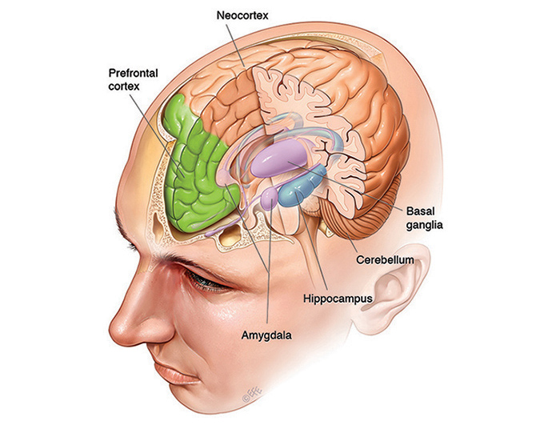

Statement 11: Brain activity depends entirely on the external environment: with no senses stimulated we don't see, hear or feel anything.
Refutation: This statement is false.
Refutation-explanation: This statement is false. Even when our senses are not stimulated our brain is still active. Studies have shown robust electrophysiological activity in the sensory cortex in the absence of stimuli or tasks (Nir et al., 2008).
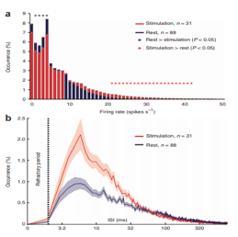
Statement 12: Playing Mozart's music to infants enhances their intelligence​ in later life.
Refutation: This statement is false.
Refutation-explanation: This statement is false. Although, the "Mozart-effect" arose from a legitimate research finding, the findings were debunked due to methodological flaws. There is no evidence that listening to Mozart's music increases intelligence. For example, a meta-analysis of all "Mozart effect" studies showed no effect in increased spatial ability after listening to Mozart (Chambris, 1999).
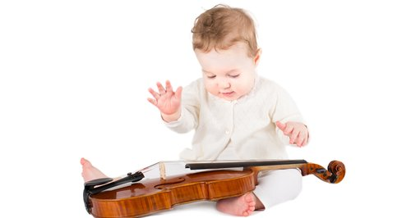
Statement 13: By the age of two years, humans have produced all of the brain cells they will ever have.
Refutation: This statement is false.
Refutation-explanation: This statement is false. Although the production of new neurons and synaptic connections occurs at the highest rate up until 2 years of age, new brain cells are generated throughout the life span. A recent study showed that even in old age, about 700 new neurons are produced in the hippocampus daily. It is now understood that new neurons can be created in some parts of the postnatal brain (Ericsson et al., 1998).
Statement 14: Modern students are effective multi-taskers​.
Refutation: This statement is false.
Refutation-explanation: This statement is false. The brain is unable to multitask very effectively. The brain actually switches back and forth between tasks, but there is a transaction cost for doing so, which makes multi-tasking less efficient than working on one task at a time (Borst, Taatgen & Van Rijn, 2010).
Statement 15: Brain games have been proven to enhance cognitive skills in general.
Refutation: This statement is false.
Refutation-explanation: This statement is false. Training on a specific cognitive task does not transfer to general cognitive enhancement. Training on one specific skill or test can improve performance on that specific test. However, a meta-analysis from 2016 showed that training does not lead to improved general cognitive skills (Simons et al., 2016).
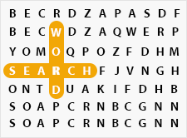
Statement 16: Multiple choice tests are an ineffective way of improving student learning.
Refutation: This statement is false.
Refutation-explanation: This statement is false. Although testing yourself on the material to be learned can be hard, effortfully processing the material you want to learn enhances learning. Overall, taking a multiple-choice test boosts performance on later tests compared to restudying. The effect of retrieving information is effective even if the information is retrieved during a multiple-choice test (Marsh, Roediger, Bjork & Bjork 2007).
Statement 17: Mental illness is caused by a chemical imbalance in the brain.
Refutation: This statement is false.
Refutation-explanation: This statement is false. Although the popular media often describes depression as resulting from a "chemical imbalance" this statement is not true. There are potentially many different causes of depression. Depression is not simply diagnosed via objective chemical tests, nor is treatment guided by any such tests. Depression is not caused only from a known chemical imbalance (France, Lysaker, & Robinson, 2007).
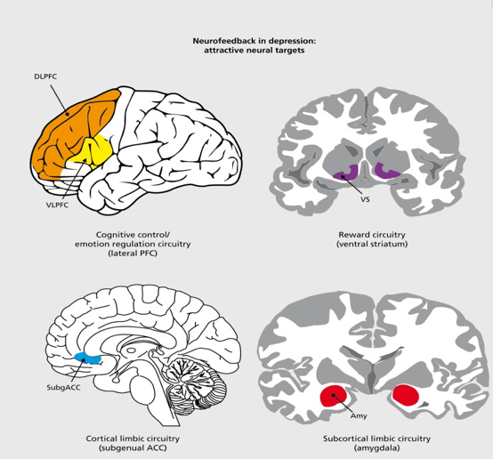
Statement 18: Neuro-linguistic programming can increase learning thanks to biofeedback.
Refutation: This statement is false.
Refutation-explanation: This statement is false. Numerous literature reviews and meta-analyses have failed to show evidence for neuro-linguistic programing assumptions or effectiveness of this technique as a therapeutic method. There are conditioning techniques that use EEG to provide biofeedback. However, due to a range of methodological limitations, a clear association between neurofeedback training and enhanced performance has yet to be established (Vernon, 2005).
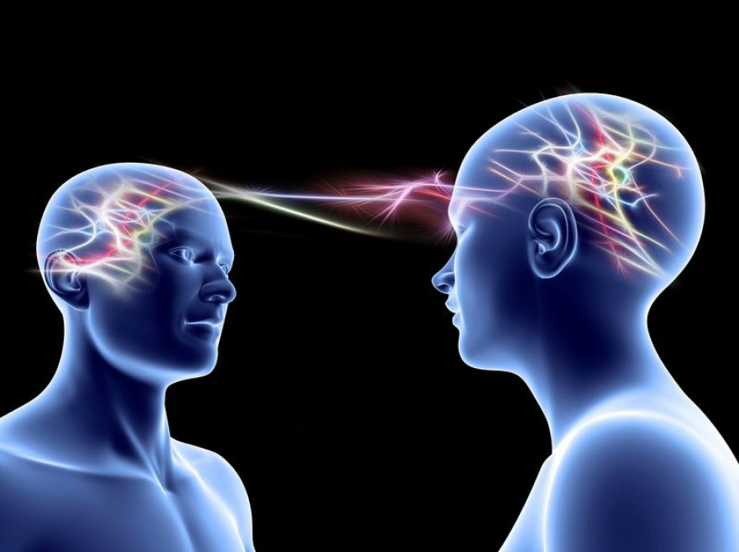
Statement 19: Excellent classical musicians are on average more intelligent than non-musical graduates of a university program. ​
Refutation: This statement is false.
Refutation-explanation: This statement is false. Classical musicians are not more intelligent than non-musical graduates. However, music education can improve some cognitive abilities, such as language skills (Düvel, Wolf & Kopiez, 2017).
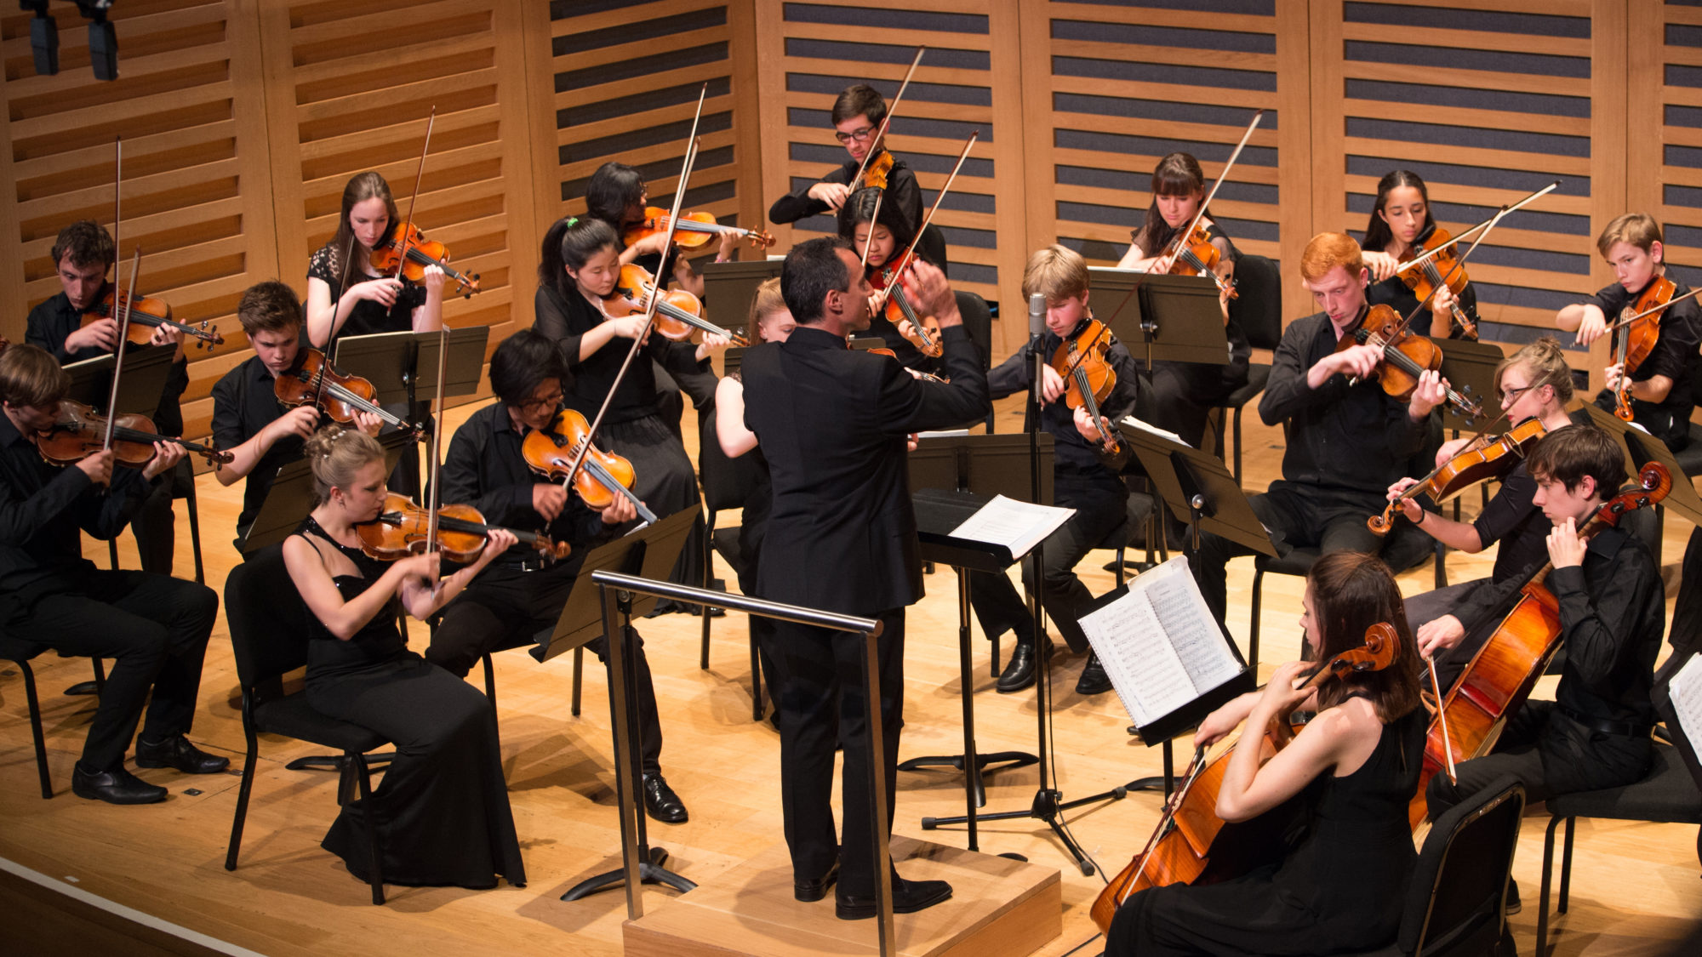

Statement 20: Classrooms that are rich in stimuli and visual material improve learning among pre-school children.
Refutation: This statement is false.
Refutation-explanation: This statement is false. Too much stimulation or "visually noisy" classrooms can lead to decreased learning performance. Too many visual stimuli can distract learners. Overly decorated classrooms can actually lead to a decrease in learning relative to more sparsely decorated classrooms (Fisher, Godwin, & Seltman, 2014).

