***Implementation Model and Process***

We used a five-stage implementation process based on nearly a decade of experience that was designed to maximize the likelihood of Collaborative Care Model (CoCM) implementation success. This implementation process was developed in a recursive manner – lessons gleaned from each implementation over that ten year timeframe informed the process for the next one. This culminated in an implementation method shown in Figure 1 consisting of five stages: (1) Initiate, (2) Plan, (3) Launch, (4) Execute, and (5) Sustain. The structure and flow of these five stages is similar to implementation frameworks that recognize implementation is a process rather than a single point in time (Aarons, Hurlburt, & Horwitz, 2011; Metz, Naoom, Halle, & Bartley, 2015; Meyers, Durlak, & Wandersman, 2012).

**Initiate.** Each clinic identified an implementation leader who dedicated a portion of his or her time to fulfilling this role. This role can be filled by the clinic manager, medical director, behavioral health director, quality improvement director, or similar. Necessary qualifications include the authority to make decisions and direct resources. This leader facilitates development of a shared vision among clinic stakeholders, a process that often reveals incongruence or hidden resistance that will undermine success if left unresolved. Clinics develop the business case for CoCM and organizations with more than one clinical delivery location identify one site for initial implementation.

**Plan**. The second stage includes a gap analysis at the clinic and clinician levels. Clinics receive tools to facilitate this process, helping them focus their attention on areas needing the most attention to prepare for practice change. Clinics develop a detailed clinical workflow that operationalizes the CoCM treatment pathway for patients and providers. This workflow should be concrete and specific, detailing which actions will occur, the sequencing, location, and personnel responsible. The most effective workflows are a graphical representation of the CoCM pathway that is created with input from affected staff. Clinics develop a plan for using a registry that facilitates efficient, population-based, treatment-to-target depression care. The typical CoCM caseload for a full-time care manager in an FQHC is 50-75 patients, making an effective registry critically important for success.

Clinics that need to hire CM(s) and/or a PC do that at this stage and are given example job descriptions to assist this process. Some clinics have existing, traditional co-located behavioral health services. These clinics typically redeploy some or all existing staff who replace usual care with CoCM. Clinics unable to redeploy or hire trained behavioral health providers can pair an onsite paraprofessional (e.g. medical assistant) with a telemedicine behavioral health provider, an approach that has been shown to be effective in prior studies (Fortney et al., 2013, 2015).

**Launch.** Clinics set a launch date, typically a day when the clinic is less busy and a date when the implementation leader and key members of the clinical team will be present. Training is a critically important component of this stage. Training is tailored to each role (primary care provider, care manager, psychiatric consultant). Primary care providers receive 1.5 hours of training , including a 30 minute CoCM overview during Stage 1 and a one hour training focused on the CoCM workflow and their role. Some clinics add periodic in-service training for PCPs to reinforce key components of their role and to address provider turnover. Psychiatric consultants (PCs) complete 4-8 hours of training that emphasizes ways CoCM consultation differs from traditional consultation learned during residency training (Huang & Barkil-Oteo, 2015). Some PCs participate in group calls/meetings with other PCs to share best practices and receive peer support for this non-traditional role. Turnover occurred in each type of positionat one or more clinics,, and when it did we attempted to offer previously recorded trainings to the new staff, trying to help them understand what the clinic was doing and their role in CoCM.

Care managers (CMs) receive the most training because they are the nexus of the CoCM team, typically 12-16 hours of training prior to program launch. Didactic content is provided online prior to in-person training which then focuses on applying this knowledge to various clinical situations and practicing new skills. Following program launch CMs participate in ongoing training described in the next stage.

**Execute.** Each clinic participates in a monthly one-hour implementation coaching call guided by reports from the CoCM registry. These reports show the level of patient clinical outcomes and processes of care achieved by each clinic in real time, as all of these have been shown to predict better and faster improvement in depression symptoms (Bao, Druss, Jung, Chan, & Unützer, 2016; Bower, Gilbody, Richards, Fletcher, & Sutton, 2006). If clinics were struggling to meet benchmarks of these variables, implementation staff recommended clinical flow changes and hiring changes that could improve clinic performance. Clinics review their progress in comparison to peer clinics and/or benchmarks, developing the clinic’s capacity to use this information to make program adjustments.

Post-launch CM training focuses on skill expansion. Each training topic is delivered over two months – the first month is a one-hour didactic webinar followed the next month by a 90-minute case call on the same topic. Post-launch training covers a wide range of CM skills, including comorbid anxiety disorders, chronic pain, distress tolerance, and trauma, among others.

As clinics prepare to exit implementation coaching, they create an organizational relapse prevention plan designed to help them identify early warning signs that essential components of CoCM may be slipping at their organization. This plan creates a process for regular monitoring of these indicators and interventions to get the program back on track.

**Sustain.** At this stage, clinics are independent. They train new clinical and administrative staff as turnover occurs and use their organizational relapse prevention and financial sustainability plans to monitor processes and make course corrections when needed.

**References**

Aarons, G. A., Hurlburt, M., & Horwitz, S. M. (2011). Advancing a conceptual model of evidence-cased practice implementation in public service sectors. *Administration and Policy in Mental Health*, *38*(1), 4–23. <https://doi.org/10.1007/s10488-010-0327-7>

Bao, Y., Druss, B., Jung, H.-Y., Chan, Y.-F., & Unützer, J. (2016). Unpacking collaborative care for depression: Examining two essential tasks for implementation. *Psychiatric Services*, *67*(4), 418–424. <https://doi.org/10.1176/appi.ps.201400577>

Bower, P., Gilbody, S., Richards, D., Fletcher, J., & Sutton, A. (2006). Collaborative care for depression in primary care. Making sense of a complex intervention: Systematic review and meta-regression. *The British Journal of Psychiatry*, *189*, 484–493. <https://doi.org/10.1192/bjp.bp.106.023655>

Fortney, J. C., Pyne, J. M., Mouden, S. B., Mittal, D., Hudson, T. J., Schroeder, G. W., … Rost, K. M. (2013). Practice-based versus telemedicine-based collaborative care for depression in rural federally qualified health centers: A pragmatic randomized comparative effectiveness trial. *American Journal of Psychiatry*, *170*(4), 414–425. <https://doi.org/10.1176/appi.ajp.2012.12050696>

Fortney, J. C., Pyne, J. M., Turner, E. E., Farris, K. M., Normoyle, T. M., Avery, M. D., … Unutzer, J. (2015). Telepsychiatry integration of mental health services into rural primary care settings. *International Review of Psychiatry*, *27*(6), 525–539. <https://doi.org/10.3109/09540261.2015.1085838>

Huang, H., & Barkil-Oteo, A. (2015). Teaching collaborative care in primary care settings for psychiatry residents. *Psychosomatics*, *56*(6), 658–661. https://doi.org/10.1016/j.psym.2015.03.006

Metz, A., Naoom, S., Halle, T., & Bartley, L. (2015). *An integrated stage-based framework for implementation of early childhood programs and systems*. (OPRE Research Brief 2015-48). Washington, DC: Office of Planning, Research and Evaluation, Administration for Children and Families, U.S. Department of Health and Human Services.

Meyers, D. C., Durlak, J. A., & Wandersman, A. (2012). The quality implementation framework: A synthesis of critical steps in the implementation process. *American Journal of Community Psychology*, *50*(3–4), 462–480. <https://doi.org/10.1007/s10464-012-9522-x>

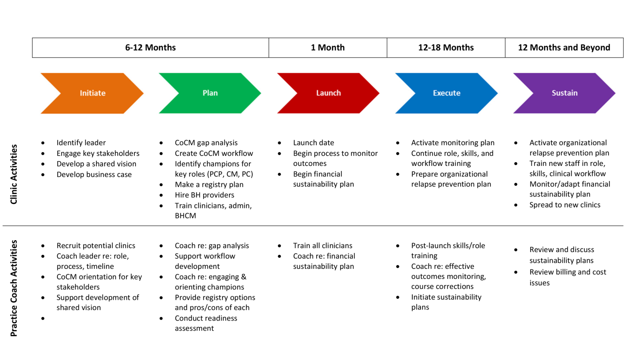

*Figure 1.* Collaborative care implementation process and activities. This figure illustrates the five stages of the implementation process for and associated activities for each stage.