Supplemental Material
Table 1
Linear Regression Analysis of Effort, Reward, and Overcommitment with Transformed Data
 | Step1 |  | Step2
Parental roles | .05 |  | .04
Monthly income | .08 | ** | .00
Effort |  |  | .14 | **
Reward |  |  | -.29 | **
Overcommitment |  |  | .07 | *
R² | .010 | ** | .171 | **
ΔR² | .010 | ** | .161 | **

Table 2
The Moderating Effect of Overcommitment with Transformed Data
 | Step1 |  | Step2 |  | Step3
Parental roles | .05 |  | .04 |  | .03
Monthly income | .08 | ** | .00 |  | .01
ERI |  |  | .32 | ** | .42 | **
Overcommitment |  |  | .07 | * | .02
Effort-Reward Imbalance × Overcommitment |  |  |  |  | -.18 | **
R² | .010 | ** | .131 | ** | .153 | **
ΔR² | .010 | ** | .121 | ** | .022 | **

Figure 1
The Moderating Effect of Overcommitment with Transformed Data
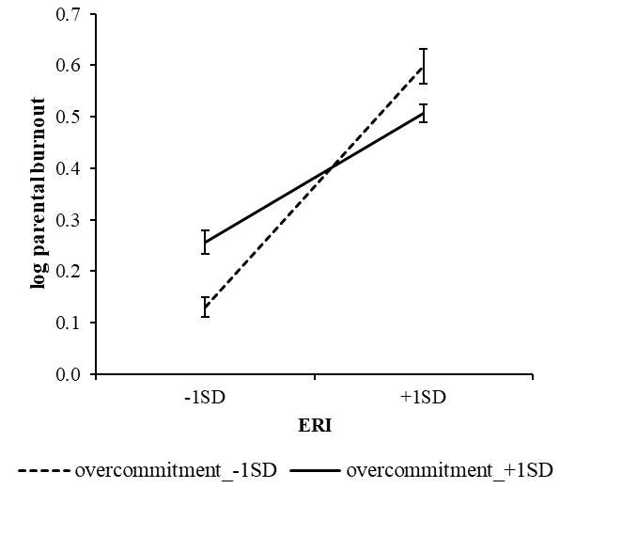
Note. The relationship between ERI and parental burnout is stronger when overcommitment was low (b = 0.74, p < .001) than the condition of overcommitment was high (b = .40, p < .001).

