Supplemental Materials for “A Latent Profile Analysis of Perceived Family Reactions to Youth LGBTQ Identity”

Table of Contents
Figures 2
Figure S1 Information Criteria Values for Latent Profile Analysis 2
Figure S2 Conceptual Model of Latent Profile Analysis and Correlates 3
Tables 4
Table S1 Family Member Knowledge of Youth LGBTQ Identity……………………………..4
Table S2 Within-Group Comparisons for Three-Profile Solution 5

Figures

Figure S1

Information Criteria Values for Latent Profile Analysis
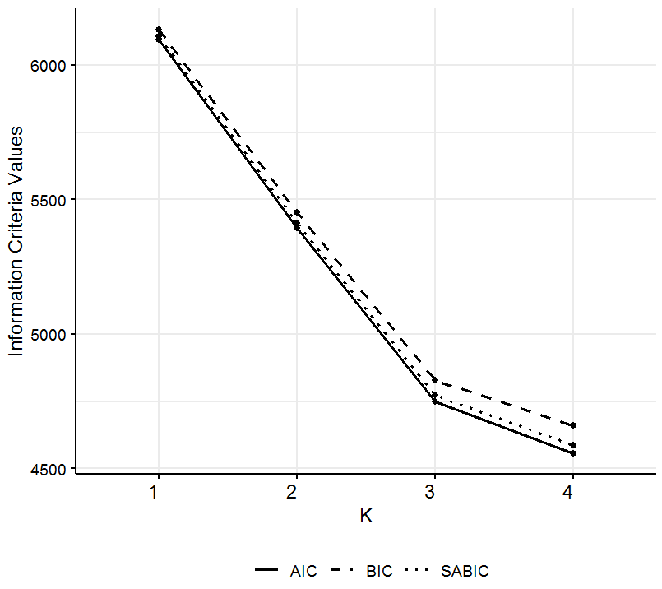

Figure S2

Conceptual Model of Latent Profile Analysis and Correlates
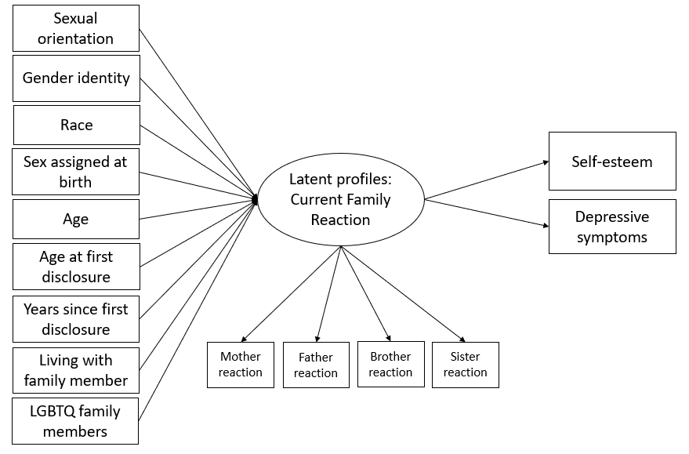

Note. Some elements are not shown, including regressions of distal outcomes on covariates. The relations among latent profile variable and distal outcomes represent profile-specific means.

Tables

Table S1
Family Member Knowledge of Youth LGBTQ Identity
Which family members know youth identity? |  | Frequency  n (%)
No family members | No one | 106 (14.5%)
One family member | Mother only | 18 (2.5%)
 | Father only | 7 (1.0%)
 | Sister only | 12 (1.6%)
 | Brother only | 5 (0.7%)
Two family members | Mother + father | 12 (1.6%)
 | Mother + sister | 19 (2.6%)
 | Mother + brother | 3 (0.4%)
 | Father + sister | 3 (0.4%)
 | Father + brother | 5 (0.7%)
 | Sister + brother | 16 (2.2%)
Three family members | Mother + father + sister | 14 (1.9%)
 | Mother + father + brother | 11 (1.5%)
 | Mother + sister + brother | 44 (6.0%)
 | Father + sister + brother | 2 (0.3%)
Four family members | Mother + father + sister + brother | 452 (62.0%)

Table S2

Within-Group Comparisons for Three-Profile Solution
 | Profile 1 (Negative) |  |  | Profile 2 (Moderately Positive) |  |  | Profile 3 (Very Positive)
 | M/Wald test | p - value |  | M/Wald test | p - value |  | M/Wald test | p - value
Standardized means
Mother reaction | -1.21 | < .001 |  | -0.06 | .259 |  | 0.68 | < .001
Father reaction | -1.10 | < .001 |  | -0.17 | .001 |  | 0.79 | < .001
Brother reaction | -1.79 | < .001 |  | -0.12 | < .001 |  | 1.06 | < .001
Sister reaction | -1.45 | < .001 |  | -0.13 | .001 |  | 0.90 | < .001
Omnibus Wald test | 60.24 | < .001 |  | 3.32 | .345 |  | 74.83 | < .001
Pairwise Wald tests
Mother v. Father | -0.11 | .35 |  | 0.11 | .07 |  | -0.10 | .14
Mother v. Brother | 0.58 | < .001 |  | 0.06 | .26 |  | -0.38 | < .001
Mother v. Sister | 0.23 | .11 |  | 0.07 | .28 |  | -0.22 | < .001
Father v. Brother | 0.69 | < .001 |  | -0.05 | .31 |  | -0.28 | < .001
Father v. Sister | 0.34 | .02 |  | -0.04 | .49 |  | -0.12 | .04
Brother v. Sister | -0.35 | .002 |  | 0.01 | .84 |  | 0.16 | < .001

